Supplemental Item S5: Binary graphic plots of oxides and elements of the Ibex Hollow Tuff and overlying and underlying tephra layers at Trapper Creek, Idaho. By Andrei M. Sarna-Wojcicki, U.S. Geological Survey, Menlo Park.

Graphic plots not included in the manuscript:

Below is an enlargement of the central part of Figure 7 shown in the manuscript, a plot of CaO vs. Fe₂O₃ from electron-microprobe analysis of individual glass shards. Each point on the graph represents from about 20 to 130 analyzed points. See Figs. 1, 2, and 11, and 13C in the manuscript for explanation of additional symbols and locations of sampling localities. Note that the figure numbers of the plots have been changed. The EMA data in this plot is taken from SM-B through D.

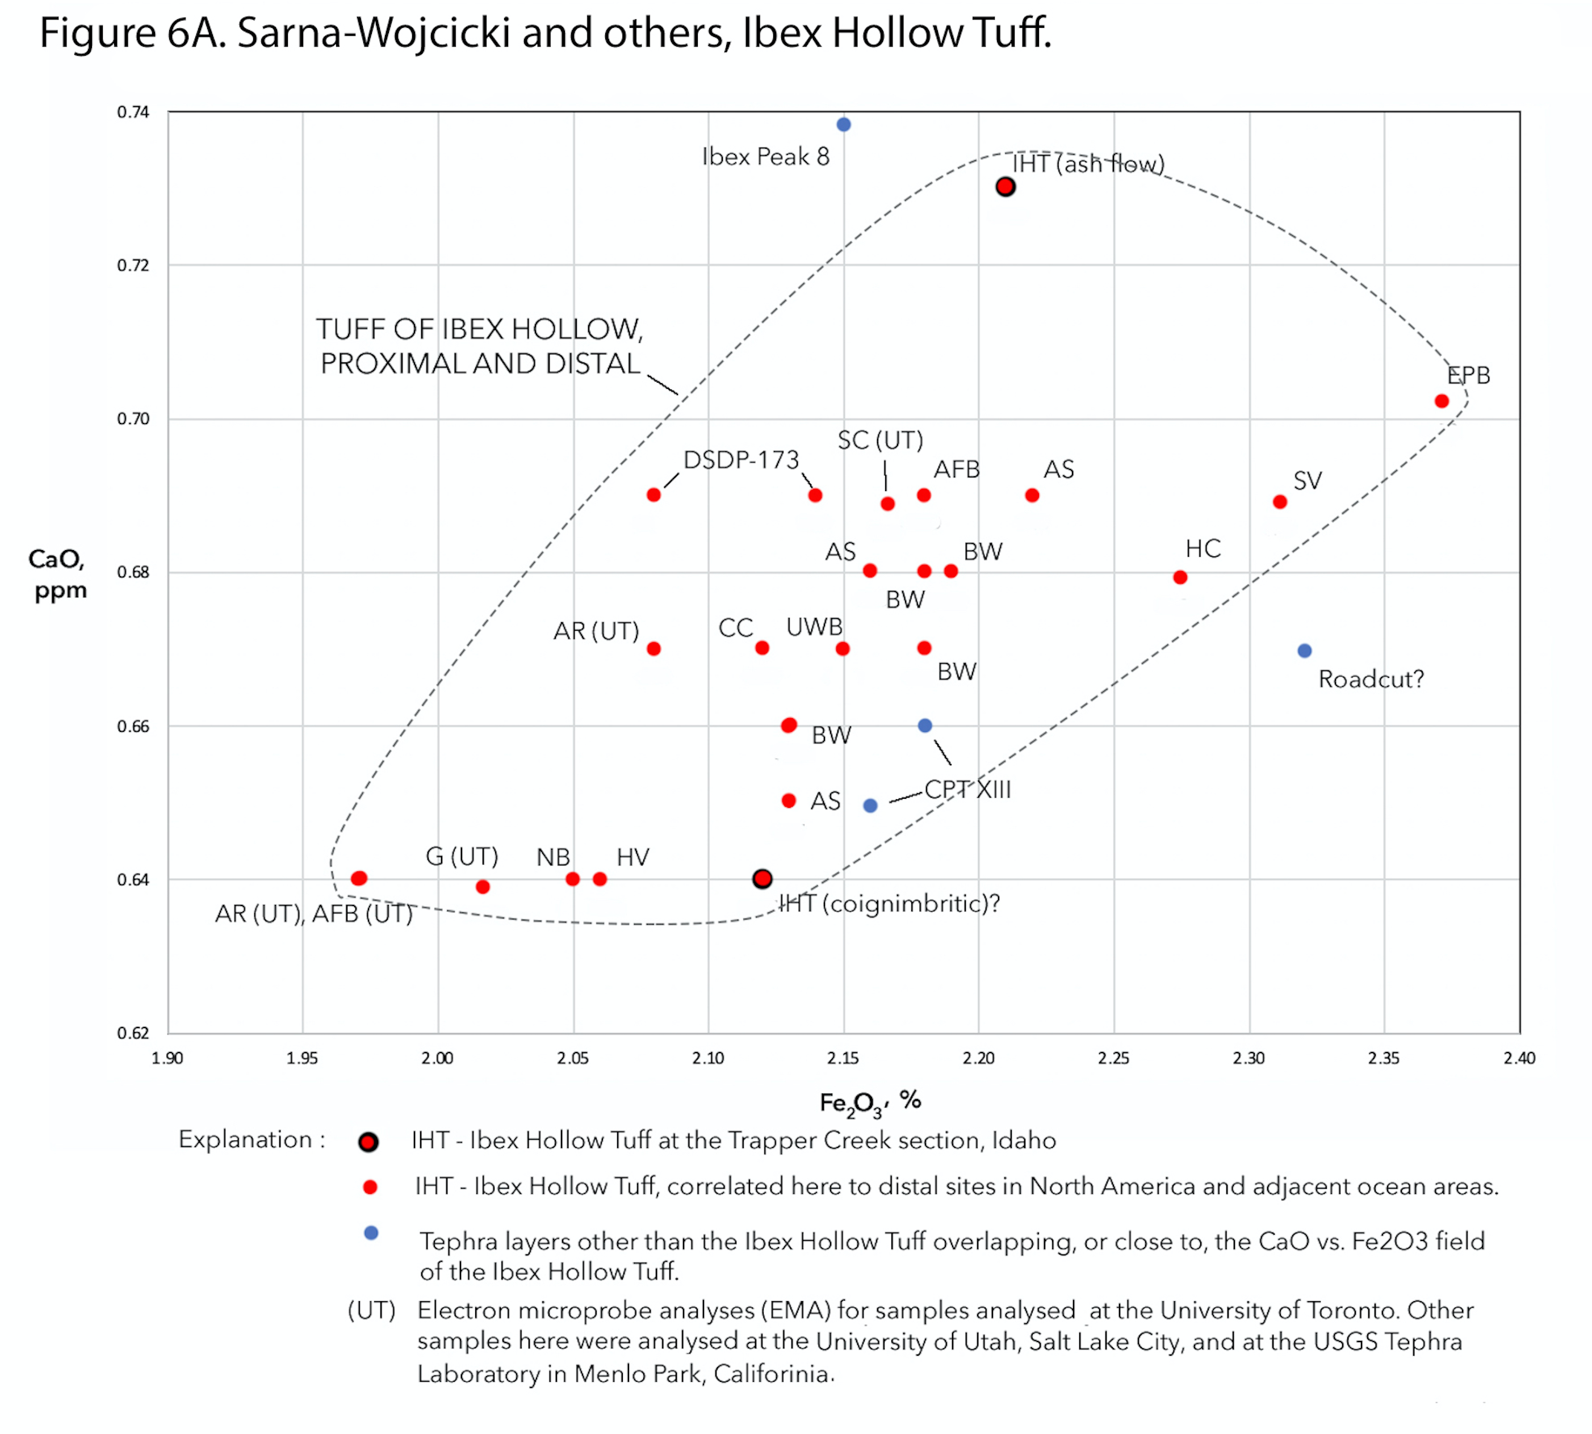

Figure showing plot of Ce vs. La, in ppm. Not included in the manuscript. Plot shows linear relationship of these two rare-earth elements, and also the offset between the LA-ICP-MS data from the INAA data for the Ibex Hollow Tuff.

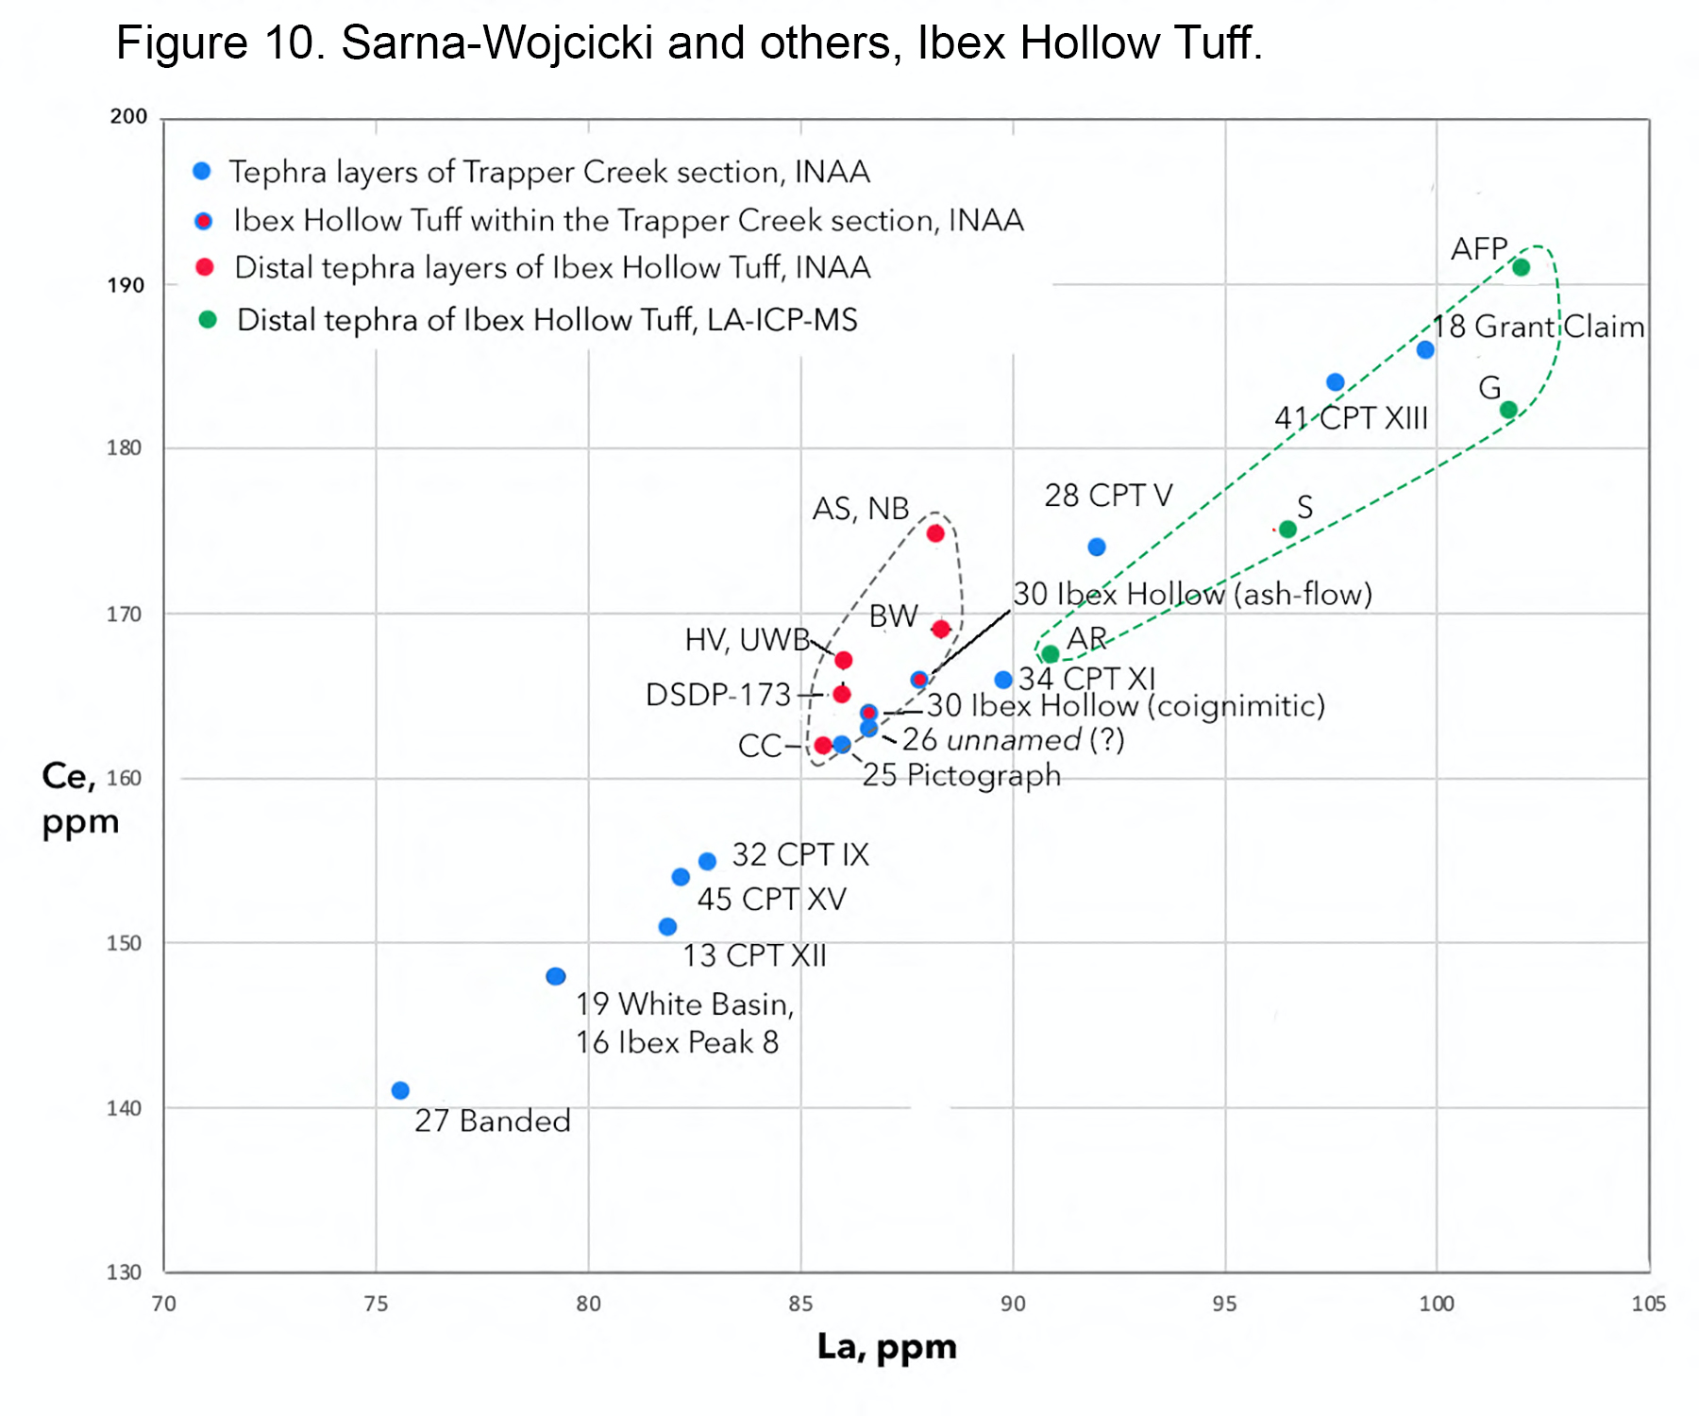

Figure showing plot of Ta vs Hf, in ppm. This plot was not included in the manuscript. The plot is based on INAA analyses only. It shows the separation of the samples of the Ibex Hollow Tuff from those of the other tephra layers in the Trapper Creek section (mostly the tephra layers of the compound Ibex Peak Tuff). The Ibex Hollow Tuff is within the lower middle part of the section, and the other tephra layers are both above and below it. See figures 1, 2, 11, and 13C of the manuscript.

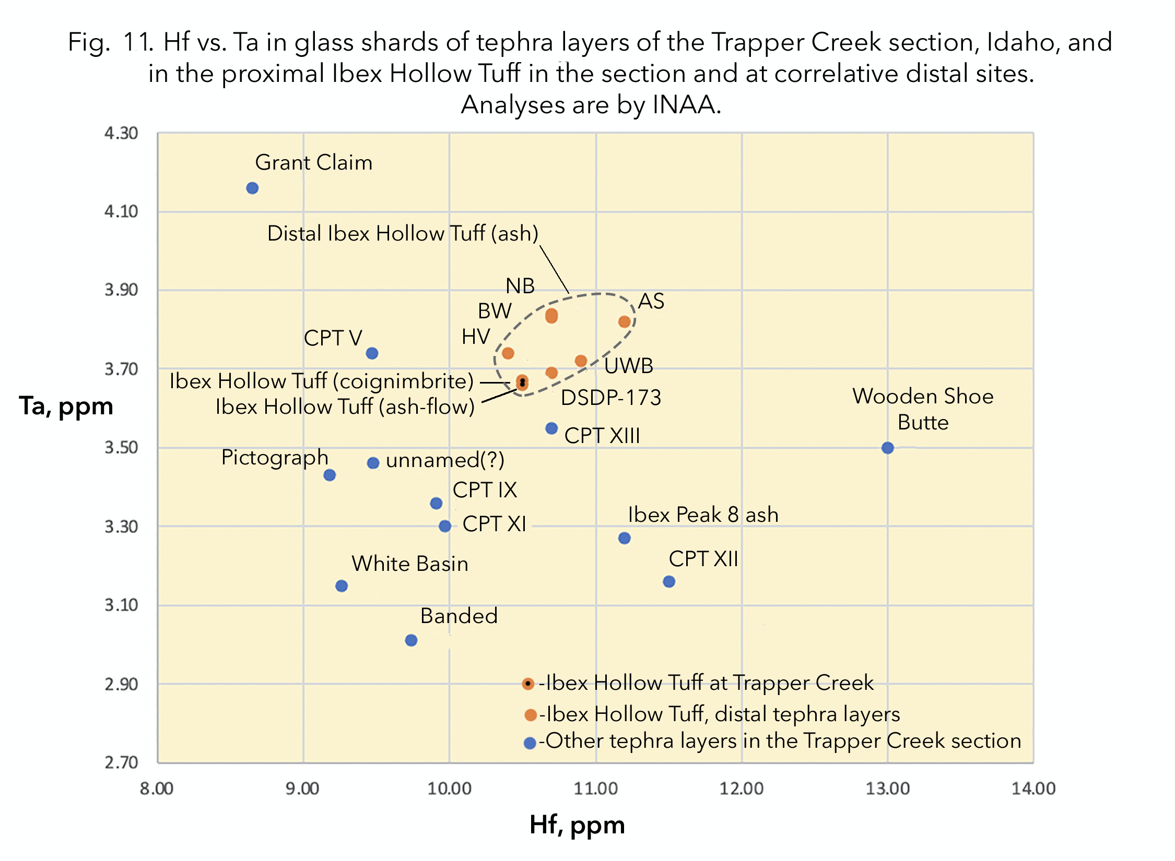

Figure showing a plot of Fe₂0_{3,} in percent (EMA analyses) vs Sc, in ppm (from INAA analysis). This plot was not used in the manuscript, and labelling of samples is not completed. Red dots are Ibex Hollow Tuff at Trapper Creek and at distal sites, blue dots are tephra layers in the Trapper Creek section above and below the IHT. LA-ICP-MS analyses were not available for Sc.

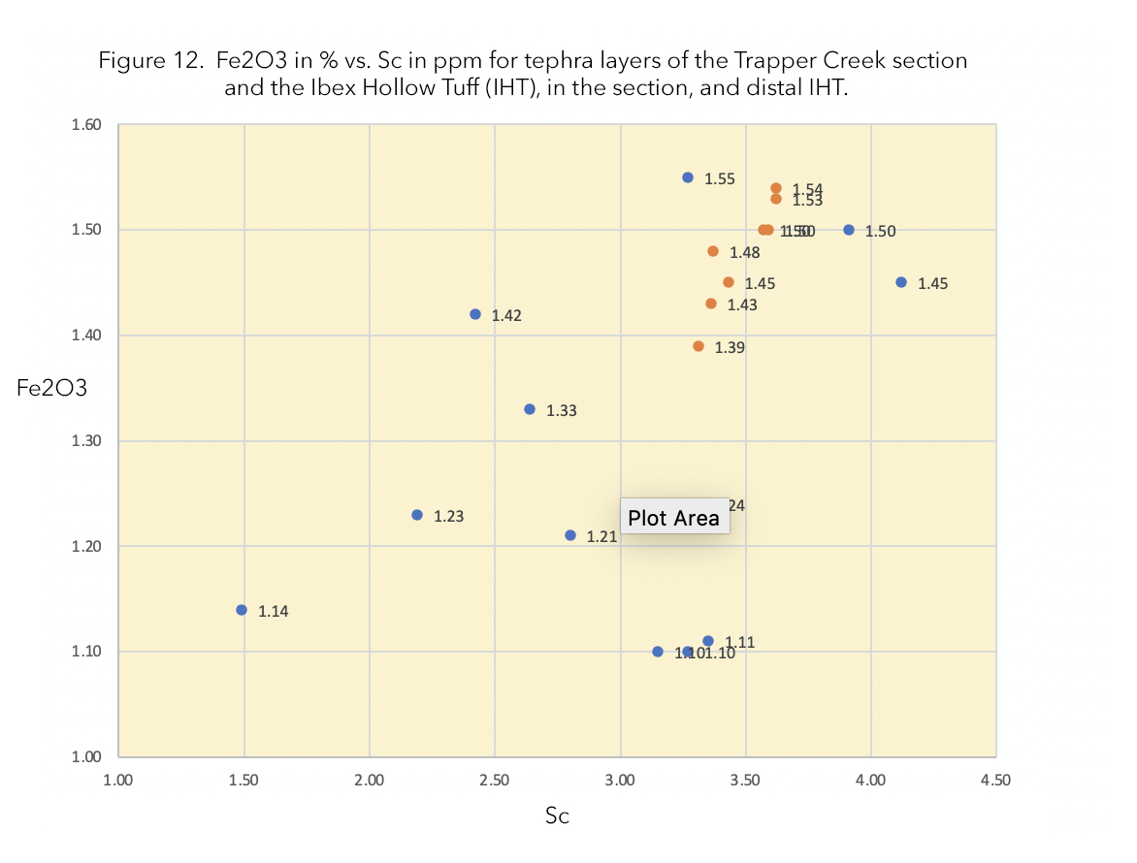

Figure showing plot of U vs. Th, in ppm. Data from INAA and LA-ICP-MS. This plot was not used in the manuscript. Plot shows large offset between INAA and LA-ICP-MS for the Ibex Hollow Tuff. There is less scatter in the INAA data compared to the LA-ICP-MS data.

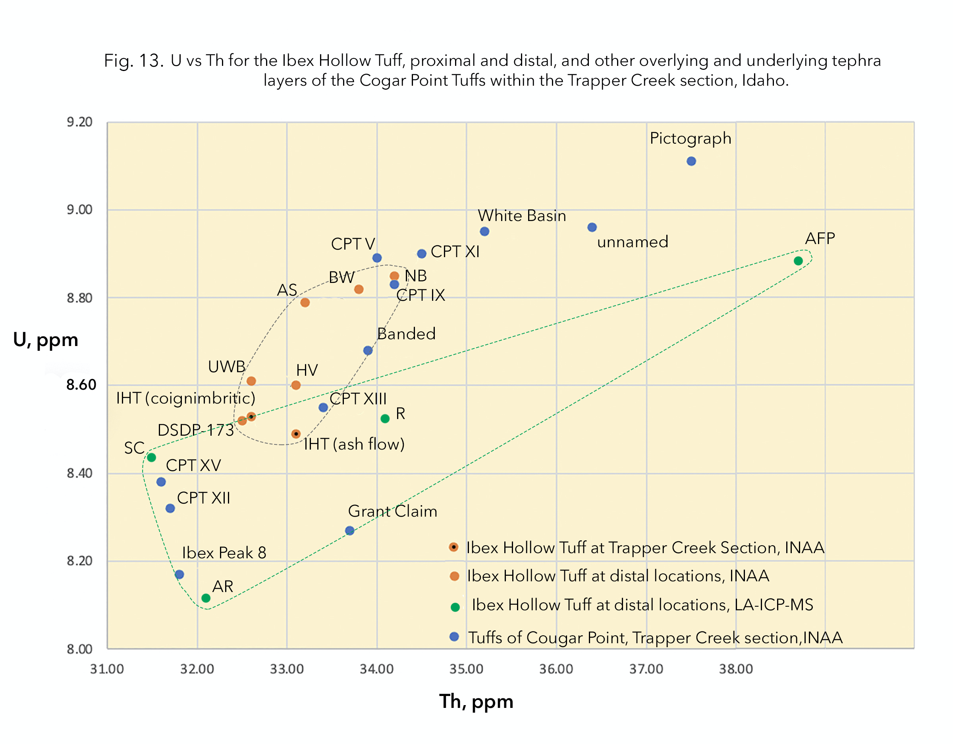

Figure showing plot of Cs vs Rb. This plot was not included in the manuscript. There is considerable scatter in both the INAA and LA-ICP-MS data sets for the Ibex Hollow Tuff, with some compositional overlap between the latter and other tephra layers in the Trapper Creek section that is not seen in several of the other binary comparisons. There is a strong possibility that the low Rb value for “CC” (Cobble Cuesta, Nevada site) is a result of leaching of Rb from the glass. See text of manuscript.

