Supporting Material for: Evaluating How Well Active Fault Mapping Predicts Earthquake Surface Rupture Locations

Chelsea Scott¹, Rachel Adam¹, Ramon Arrowsmith¹, Christopher Madugo², Joseph Powell¹, John Ford¹, Brian Gray³, Rich Koehler⁴, Stephen Thompson³, Alexandra Sarmiento^{5,6}, Timothy Dawson⁷, Albert Kottke², Elaine Young⁸, Alana Williams¹, Ozgar Kozaci⁹, Michael Oskin⁸, Reed Burgette¹⁰, Ashley Streig¹¹, Gordon Seitz⁷, William Page², Curtis Badin¹², Lorraine Carnes¹, Jacqueline Giblin¹, James McNeil⁴, Jenna Graham⁴, Daniel Chupik¹ and Sean Ingersoll⁴

¹ School of Earth and Space Exploration, Arizona State University, Tempe, AZ 85287, USA
² Pacific Gas and Electric, Geosciences Department, San Francisco, CA 94105
³ Lettis Consultants International, Inc., Concord, CA, USA 94520
⁴ Nevada Bureau of Mines and Geology, University of Nevada, Reno, 1664 N. Virginia St., MS 178, Reno, NV 89557
⁵ The B. John Garrick Institute for the Risk Sciences, University of California- Los Angeles California, Los Angeles, CA, USA 90095
⁶ GeoPentech, Inc., Irvine, CA, USA 92617
⁷ Seismic Hazard Assessment Program, California Geological Survey, San Mateo, California, USA 94403
⁸ Department of Earth and Planetary Sciences, University of California, Davis, 462 Crocker Lane, Davis, CA 95616, USA
⁹ Infra Terra, San Francisco, CA 94103, USA
¹⁰ Department of Geological Sciences, New Mexico State University, Las Cruces, NM USA, 88003 now at Oregon Department of Geology and Mineral Industries, Portland, OR USA
¹¹ Department of Geology, Portland State University, Portland, OR USA 97232
¹² Department of Geological Sciences, Stanford University, Stanford, CA 94305-2115, USA, now at Department of Earth and Planetary Science, University of California–Berkeley, Berkeley, CA 94720-4767, USA.

Section S1: Geomorphic Indicator Ranking

We mapped and quantified the geomorphic expression of active faults to place a confidence level (strong, distinct, weak, and uncertain) on each mapped fault segment. In Table S1, we list features indicative of active faulting with a ranking of 1 - 4 based on how well a feature indicates faulting. A rank of 4 indicates strong evidence for faulting, and a rank of 1 indicates low evidence. Modifiers are features that raise or lower the mappers' confidence and are given a rank of +1 (strengthen confidence) or -1 (weaken confidence). These features are only mapped when other, stronger features are also mapped. The features are listed in alphabetical order. See Figure 2 for a map showing some of these features.

Feature | Rank | Description | Justification as fault indicator
Anthropogenic Alteration (AA) | -1 | Alteration from infrastructure e.g., roads, farming & buildings | Obscures a fault’s precise location
Offset or cut Alluvial Fan Complex (AFc) | 3 | Series of fan-shaped alluvium deposits that are offset or cut by a fault | Faults can cut across and offset alluvial fans of different ages
Single Offset or cut Alluvial fan (AFs) | 1 | A single fan-shaped alluvium deposit that is offset or cut by a fault | Faults can cut across and offset a single alluvial fan unit
Alignment  (Algnmt) | +1 | The repeated appearance of a feature within ~1 km | Locally repeated and offset features may be due to faulting
Beheaded Drainages (BD) | 3 | Up- and down-stream channels are separated. | Fault-offset beheads down-stream channel
Colluvial Cover (CllCvr) | -1 | Loose and unconsolidated rock on hillslope base | Can obscure evidence of a fault scarp
Cross cut (CrsCt) | +1 | A lineation or other feature that cuts across the landscape | Faulting is responsible for some cross-cutting relationships
Depression/Sag Pond (D/SP) | 2 | Low elevation between strike-slip or normal faults, sometimes filled with water | Produced by extensional bends or stepovers along strike-slip faults
Deflected Stream (DS) | 2 | Diverted stream that runs parallel to the fault | Fault capture or blockage alters the stream course
Erosion (Er) | -1 | Sediment and rock are worn away by water and wind | Removes evidence of faulting
Landslides (LS) | +1 or -1 | Downward movement of sediment or rock | Form from coseismic shaking (+1) or cover faulting evidence (-1)
Linear Valley/ Drainage (LVD) | +1 | Extended linear patterns of streams, rivers, lakes, and valleys | Linear drainages often indicate faulting control.
Morphologic elements (ME) | +1 | Features such as ridges, slope breaks, troughs. | Increase confidence of faulting
Offset drainage channel (ODC) | 4 | A channel with two ~90° bends that is otherwise straight | Offset caused by differential translation of a stream by a fault
Unit Offset (OF) | 3 | Offset of bedrock or geomorphic units | Faulting is often responsible for offset
Over-steepened range front (OSRFn) | 3 | Dramatic change in slope near mountain base | Likely due to faulting when present along large topographic features
Offset Terraces (OT) | 4 | Laterally and obliquely offset fluvial terraces | Coseismic slip offsets terraces and terrace risers
Proximal Axial River (PAR) | 2 | A river or drainage system that runs parallel to a fault trace | Faulting can cause long linear patterns in a river
Pirated Chanel (PC) | +1 | A channel diverted from its own path and joins a neighboring channel | Fault offset or weaknesses in the bedrock can lead to stream capture
Proximity to active water (PrAW) | -1 | Fault traces located near active water | Water is an erosion agent and can remove the evidence of faulting
Scarp (Scp) | 3 | A linear cliff-like slope or face that breaks a surface. | Produced by dip-slip faulting or lateral offset of sloping surfaces
Saddle (Sdl) | +1 | A depression located along the ridge crest | Due to a dropped hanging wall or differential erosion across a ridge
Stream Knickpoint (SK) | 2 | Abrupt change in channel slope (i.e., a waterfall) | Faulting or folding causes stream disequilibrium, forming a knickpoint
Spring (Spr) | 2 | Upwelling of subsurface water | Caused by faulting that disrupts the groundwater and bedrock
Shutter ridge (SR) | 2 | A ridge that blocks or diverts a drainage | The ridge was translated by faulting
Topographic  Hills (TH) | 2 | Half-cylindrical-shaped hills | Blind reverse faults create sinuous topography
Triangular facet (TF) | 4 | A broad base and a upward pointing apex | Often formed by erosion of the fault plane along range fronts
Surface Unit Offset (SUO) | 2 | The original deposition order is obscured | Faulting offsets units
Vegetation lineament (VL) | +1 | Natural lines between high and low vegetation densities. | Can be caused by faulting
Wineglass canyons (WC) | +1 | The cross sectional shape resembles a wine glass. The base is the alluvial fan that slopes down the mountainside | Indicates recent uplift
Table S1. Geomorphic features (rank: 1- 4) and modifiers (rank: +1 or -1) with their definition and justification for indicating faulting.

Section S2: External Pre-Rupture Mapping Review

We include material associated with the external review completed for the pre-rupture mapping. The 5-page handout that we provided to each reviewer begins on the next page. Below that, we include the text from the pre-rupture mapping reviews submitted directly by the reviewers. This material is summarized in Table 2 in the main manuscript. The reviews are provided in chronological order of the earthquakes.

Pre-Rupture Mapping Peer-Review
Coordinated by Chelsea Scott and Ramon Arrowsmith, School of Earth and Space Exploration, Arizona State University, cpscott1@asu.edu

Introduction:
Thank you for peer-reviewing our pre-rupture fault maps. These maps are produced as part of a collaboration between Pacific Gas and Electric, Arizona State University, University of Nevada, and Lettis Consultants International, Inc. The project goal is to understand how well pre-rupture fault maps anticipate coseismic ruptures and serve as input into seismic hazard models. In this project, student and industry consultant mappers completed seven pre-rupture fault maps based on pre-rupture datasets along faults with subsequent earthquakes. The mappers strictly had no prior knowledge about the earthquakes so they could only “see” the rupture area as it was represented prior to the recent large earthquake. The map reviews from academic and industry experts will inform how we use the maps in subsequent analyses. We plan to submit the pre-rupture maps and the reviews for publication in a peer-review journal. Depending on your level of interest and contribution, we can include you as part of that publication.

Background:
Probability Fault Displacement Hazard Assessment (PFDHA): Anticipating earthquake ground rupture characteristics is an active area of research with activities focused on preparing coseismic fault displacements databases, developing empirical and physics-based models of on- and off- fault deformation, and updating of engineering guidelines (e.g., Chen and Petersen, 2011; Baize et al., 2019 and the UCLA Fault Displacement Hazards Initiative https://www.risksciences.ucla.edu/nhr3/fdhi/home). Pre-rupture fault maps are critical for anticipating the location of future fault ruptures and testingfault displacement hazard models.
Fault mapping: In Fall 2020, Chelsea Scott, Ramon Arrowsmith, and Rich Koehler co-taught a virtual pre-rupture mapping course at ASU and UNR. In the first month, geoscience students learned how to map faults from lectures and weekly assignments. Then, each student completed two pre-rupture fault maps. These maps are not included in this review. In the spring 2021, Arrowsmith and Scott hired and mentored three senior undergraduate students who together completed six pre-rupture maps, wrote reports about the mapping, and developed the geomorphic indicator ranking (see below). Brian Gray from LCI completed a seventh map. The pre-rupture mapping was completed for the 1987 M6.9 Borah Peak, 2004 M6 Parkfield, 2010 M7.2 El Mayor Cucapah, 2011 M6.7 Fukushima-Hamadori, 2014 M6 South Napa, 2016 M7 Kumamoto, and M7.8 Kaikoura earthquakes.

We faced a challenge of bringing the student mapping abilities and their products up to a professional standard of practice while at the same time minimizing anchoring and confirmation biases. This balance is reflected in what we think is an improved potential for the repeatability of the mapping but without engaging highly experienced experts in the map production.

Geomorphic Indicator Ranking (GIR): We developed the GIR approach as an objective way to assign a certainty level to the fault mapping based on the geomorphology, as described in the GIR document. In summary, the mappers map all geomorphic indicators that are potentially indicative of faulting, for example an offset drainage channel, shutter ridge, or vegetation lineation. Indicators are assigned a 1-4 ranking based on the likelihood that the feature indicates a fault. An offset drainage channel which is a high quality indicator for strike-slip faulting has a score of 4. A vegetation lineation alone provides very poor evidence for faulting has a score of 1. The scores along each 1-km long fault segment are summed and then scaled so that each segment is ranked strong, distinct, weak, or concealed. By default, the fault with the highest score is strong, and the lowest score is concealed. At present, the scores between different fault zones cannot be compared.

References:
Baize, S., Nurminen, F., Sarmiento, A., Dawson, T., Takao, M., Scotti, O., et al. (2019). A worldwide and unified database of surface ruptures (SURE) for fault displacement hazard analyses. In Seismological Research Letters. https://doi.org/10.1785/0220190144

Chen, R., & Petersen, M. D. (2011). Probabilistic fault displacement hazards for the southern San Andreas Fault using scenarios and empirical slips. Earthquake Spectra, 27(2), 293–313. https://doi.org/10.1193/1.3574226

Peer-review instructions:
We anticipate that each review will take 2-3 hours to complete and will consist of one page of written text based on the questions below. You may provide hand written notes and sketches if that is helpful. These can also be provided in a GIS file.

Linework organization: You have received a .zip file with the fault linework. With the exception of Kumamoto, the directory for each pre-rupture map contains a ‘Fault’ and ‘Everything’ folder. The ‘Fault’ folder has the fault line work saved as a shape, ArcMap layer and QGIS style file. The ‘Everything’ directory contains the geomorphologic mapping, also saved as a shape, ArcMap layer and QGIS style file. The fault linework is copied here as well. The Kumamoto mapping is also saved as an ArcMap layer and QGIS style file located in the Kumamoto folder. For several faults, the mapping was only completed over a portion of the future-rupture area. For these faults, a box is included in the linework to indicate the mapping boundary. The mapping should be reviewed only within this boundary.

How to open the linework and the associated style files: The line work is accessible in ArcMap and QGIS with layer and style files consistent with each software package. The linework is also accessible in Google Earth for areas where we used Google Earth to access older optical datasets (see section below). Generally, the linework can be accessed by dragging and dropping the .lyr files into ArcMap or opening the .shp files in QGIS. Kumamoto is a package layer which can be dragged and dropped into an ArcMap window. We provide more specific directions about file names in the Word Document in the Google Drive associated with each mapping area.

Access the pre-rupture datasets:
We sent a link to a Google Drive file for each pre-earthquake base map dataset. A Word document indicates which datasets were used and where they can be located.
Datasets include:
- Privately shaded topography datasets that are in the Google Drive folder. Please delete these datasets immediately when you have completed the review.
- Open topography datasets that were accessed from OpenTopography. There are located in the Google Drive folder. In the case of slow downloads, we have provided a link to the OpenTopography jobs where the identical datasets can be regenerated.
- Optical imagery on Google Earth: A large archive of imagery is available using the time button (https://support.google.com/earth/answer/148094?hl=en). Make sure to only assess data from priorto the specific earthquake.
- Kumamoto Optical Imagery: This imagery has been manually georeferenced and is available in the Google Drive Folder.

IMPORTANT: The mappers only used the datasets that you have access to. Reviewers are asked to judge the mapping based on these datasets only and must not consult any other pre- or post- earthquakes datasets, scientific publications, geologic maps, or other material. Please contact Chelsea Scott (cpscott1@asu.edu) if you have any questions or concerns about these guidelines.

Hillshades and slopeshades: We expect reviewers to compute hillshades, slopeshades or other derived raster products using ArcMap or QGIS or any other preferred GIS software. Please get in touch with Chelsea Scott if you need help generating these products.

Pre-rupture mapping explanation:
The explanation below is used for the pre-rupture fault mapping. Primary faults are colored with red, orange, or blue depending upon the certainty level. Secondary faults are mapped in black with certainty level indicated by the line-type.

Review Rubric:
The review questions should be answered relative to the pre-rupture datasets. Please add a few sentences for each of the categories to elaborate on your rating.
Is the mapping complete? | 3: Even coverage with no spatial gaps in the mapping. Use of morphologic and geomorphic units are correct and consistent and indicate a conceptual understanding of the geomorphology.
 | 2: Some holes or uneven focus in the mapping. Morphology and geomorphology are sometimes mislabeled or mislocated.
 | 1: Frequent gaps and/or errors in the mapping that lead to errors in the interpretation of the faulting.
Does the pre-rupture geomorphology support the fault mapping? | 3: The linework is well-supported by the geomorphology and bedrock geology. Mapping is complete.
 | 2: There are several locations of mis-interpretation by the mapper but the mapping is mostly complete and well-supported.
 | 1: Frequently, faults are either missed or mapped in the wrong place
Are the certainty rankings consistent with the geomorphology? | 3: Conceptually, the majority of fault rankings are supported by the geomorphology and the bedrock geology.
 | 2: Many fault rankings are supported by the geomorphology.
 | 1: The rankings are poorly supported by the geomorphology.
Overall ranking: | Excellent: The map is complete, of high quality, and can be used as-is is for subsequent analysis.
 | Adequate: Overall, the map is generally of medium to high quality. There are several substantive changes that would improve the map’s quality. List the changes required below.
 | Needs Revision:The map has many issues. It is incomplete in multiple areas or the geomorphology was frequently misinterpreted by the mapper. Describe the issues and areas of misinterpretation below.
Justification for overall ranking:

Add comments and other interpretations of the faulting:
Please add comments about the fault mapping or other interpretations for the faulting in a .shp file or other preferred GIS layer. Or map by hand on a printed base-map and send the map by email or by snail mail.

My name can/ cannot (please circle or bolden) be published with my review.

I would/ would not (please circle or bolden) like to continue to be involved in this work.

Involvement would include contributing to the manuscript in preparation for submission to a peer-reviewed journal.

Pre-rupture mapping reviews:

1983 Borah Peak Earthquake
Review by Michael Oskin, Professor, University of California- Davis

**Is the mapping complete?**
Rating 2: There are common errors in the location of faults and geomorphic unit boundaries. Many of these errors appear to arise from inattention to detail and mapping at scales coarser than permitted by the topography. I found several instances of faults mislocated by more than 100 meters. The unit designations are not clearly described, so the differentiation of individual units appears somewhat subjective in places (e.g.g colluvium versus steep alluvial fans, or young versus intermediate age alluvium).

**Does the pre- rupture geomorphology support the fault mapping?**
Rating 1. Faults are commonly mapped in the wrong place, not taking full advantage of the details and scarps evident in topography. As described above, there are several localities where the master fault is mislocated by more than 100 meters. There are also some areas where fault scarps were missed and instead the fault is mapped as concealed or there is a gap in mapping. There are very few secondary faults mapped, and these lines follow linear valleys or range fronts in the hanging wall that are bounded by axial streams. Thus there are no clear geomorphic indicators of precise secondary fault location.

**Are the certainty rankings consistent with the geomorphology? Overall ranking:**
Rating 2. Though a number of fault strands are not as carefully drafted or located as permissible form the data, the quality rankings are mostly in line with the geomorphology of fault-controlled topography. There are a few cases where buried faults are mapped where scarps are present nearby.

**Overall ranking:**
Adequate / Needs Revision.

**Justification for overall ranking:** The map appears to have been drafted at a coarse scale, with line vertices >100m apart. Thus the map is only useful for locating faults at approximately this level of certainty. The topographic data would permit a much higher resolution of mapping (easily 10 to 20 m distance between vertices) and more careful interpretation of unit boundaries and fault locations. It seems like the mapping uncertainty is an avoidable problem, and could be substantially reduced with revision.

1983 Borah Peak Earthquake

Review by Gordon Seitz, Engineering Geologist, California Geological Survey

Does the pre-rupture geomorphology support the fault mapping?
Evaluation: 2
Are the certainty rankings consistent with the geomorphology?
Evaluation: 2

Overall ranking:
Needs Revision.
Comments: The distinction between primary and secondary faults requires a more thoughtful definition. I provided my own mapping. In many places my mapped fault is a significant distance from the mapped trace. Often the mapped trace appears generalized. I used a combination of hill shades and slope shades that I generated, though I don’t think that is the reason for the difference. To test that one should use the same mapping base instead of everyone generating their own base. How significant is the difference in mapping largely depends on the purpose of the product? If this was to be used for actual determination of setbacks or engineering structures, then even meter scale differences matter.

2004 Parkfield Earthquake
By Ashley Streig, Assistant Professor, Portland State University
Is the mapping complete? Rank 2 (+)
Mapping is nearly complete, needs some review and revision. Some traces are missing, most are P2 or lower rank.
Does the pre-rupture geomorphology support the fault mapping? Rank 3
Triangular facets and sag ponds are well identified. Primary and secondary fault traces mapped are consistent with these features.
Are the certainty rankings consistent with the geomorphology? Rank 2-3
Certainty rankings agree well with the topography from the DEM and historic aerial imagery. There are only a couple of occurrences where I rank the feature differently than the mapper (primarily for a missed trace).
Overall ranking: (better than) Adequate
Many fault rankings are well supported by the topography from the DEM and historic aerial imagery. One trace with good geomorphic expression, including a prominent depression in 5/1994 Google Earth imagery was missing, see G.E. kmz and Parkfield_Streig.shp files.
Justification for overall ranking:
This mapping needs some review and revision, but overall the fault traces and rank of primary and secondary faults seemed consistent with the features identifiable with the SRTM DEM and historical (pre 2004) imagery. I think mapping and interpretations by me and the original mapper would be strengthened with the use of stereo paired historic air photos – where they exist in this region.

EL MAYOR CUCAPAH PRE-RUPTURE MAPPING REVIEW
By Ozgur Kozaci, PhD, PG
I reviewed the mapping for El Mayor Cucapah (EMC) pre-rupture region using mostly 2006-2007 Google Earth Pro imagery and GIS-based DEM for checking consistency and accuracy of application of the provided GIRs, consistency of mapping across the area of interest (AOI), and overall understanding of the geomorphic mapping towards identification of active faulting. I am not familiar with this region or the EMC earthquake at all and must admit that this is a complex region to map. Majority of the AOI appears to be covered with an actively deforming (uplifting in combination with strike slip faulting) range. Lack of Quaternary deposits through much of the range complicates identification of active faulting through it. However, linear valleys, alignment of consistent right-laterally offset channels, back-facing scarps, and juxtaposition of contrasting bedrock units provide basis for mapping active faults. My remarks are provided as the Google Earth EMC_Oz_Notes.kmz file. In this file I used flags (Placemarks) with letters to indicate potential issues and occasionally polygons to highlight areas. I made an attempt to duplicate remarks provided for a polygon also as placemarks for ease of finding. I did not remark on every single mapped feature but rather I tried to have an even sampling across the AOI to provide general sense of potential issues with the mapping.
Is the mapping complete?
Rating=1: Frequent gaps and errors in the mapping that lead to errors in the interpretation of the faulting. The NW and SE ends of the AOI are practically not mapped. In the SE part of the AOI, one of the most obvious errors is the tendency to follow the main valley margins into the tributary channels. Unless the environment is dominated by low angle faulting these mapped features do not reflect active faulting that would be expected to cross cut across the fluvial geomorphic features of tributary channels. The central section of the mapping seems to have more detail in line with a structurally complex fault geometry, although I don’t necessarily agree with many mapped features as faults. Mapping in the central section of the AOI, forming the range front where large fans have developed is the most agreeable per my observations.
Does the pre-rupture geomorphology support the fault mapping?
Rating=1: Frequently, faults are either missed or mapped in the wrong place. E.g., channel margins are frequently mapped as scarps. It would have been helpful if the intended type of faulting was somehow indicated as part of this mapping exercise. For example, many range fronts were mapped as scarps and triangular facets but these mapped “faults” often wrap around the range front into the tributary channels (see below for an example). Unless a low-angle fault is intended by this mapping, this type of mapping shows that the concepts for geomorphic features indicative of active faulting are not fully digested by the mappers.
Similarly, the mapping of individual geomorphic features seems disconnected from a big-picture mapping perspective. For example, in many locations range fronts are consistently mapped as scarps and triangular facets but the fan surfaces across the projection of these mapped “faults” left unmapped because no obvious faulting was observed. This is regardless the potential age of such fans suggesting that even when no faulting was observed across a seemingly old fan surface the adjacent range front faults are still considered active by the mapper. See below for an example of this issue.

Are the certainty rankings consistent with the overall geomorphology?
Rating=1: The rankings are poorly supported by the geomorphology. It must be noted that there are significant sections of the AOI without mapping. It should also be noted that majority of the AOI is dominated by bedrock exposures. Quaternary, especially Holocene deposits, are lacking complicating the mapping process. Regardless, the classifications and mapped linear features are generally inconsistent with active fault mapping. In some instances, multiple GIRs were assigned without a good basis. Not all similar features were mapped, or even if mapped they were not necessarily assigned similar GIRs which resulted in inconsistent ranking.
Overall ranking?
Needs Revision: The map has many issues. It is incomplete in multiple areas or the geomorphology was frequently misinterpreted by the mapper(s). I’m not necessarily criticizing the accuracy of the pre-rupture mapping in such a complex AOI but inconsistencies in how the criteria were applied and gaps in mapping are problematic. There are systematic inconsistencies across the mapping area. For example; one feature was mapped for X meters and although the same geomorphic signature extends on trend, the continuation of that feature was not mapped. Furthermore, in numerous locations geomorphic features were misinterpreted. The most obvious and pervasive one appears as mapping channel margins (in some cases terrace risers) as scarps.
My name can be published with my review.
I would like to continue to be involved in this work. This is an interesting study and very important for developing standards for our upcoming colleagues. I would be happy to contribute in any way that I can to help support this work including contribution to the manuscript preparation for submission to a peer-reviewed journal.
Please do not hesitate to contact me with any questions you might have regarding my review.
Ozgur Kozaci, PhD, PG
info@ozgurkozaci.com

2010 El Major Cucapah Earthquake
Review by Curtis Baden, Graduate Student, Stanford University

Overview:
After reviewing the pre-rupture mapping for the 2010 El Major Cucapah Earthquake, I feel that, overall, the original fault mapping effort was thorough and well-done. The fault mapping was consistent in density and assessment across the study area, and captured the majority of
geomorphically expressed fault features evident in the regional topography and its derivatives
(i.e. slope, hillshade). On this front, I am impressed with the fault map quality, and with the effort that must have gone into the fault mapping. However, the geomorphic feature mapping is not particularly even throughout the mapping area. While the included features are largely correctly located, the majority of the geomorphic mapping is focused in the center third of the study area.

Admittedly, geomorphic features in this central third are high in density, though the features outside of this central third seem to be largely excluded. In this sense, I found judging the fault confidence assignments to be a bit difficult where geomorphic features were absent from the map. I was, however, able to look at the attribute table and view the confidence assignments for each feature. Below, I list my assigned scores from the provided review rubric, alongside some short, general comments that explain my scores. Below the official rubric response, I list some additional observations and concerns pertaining to the mapping in this particular study area. I’ve included an additional fault interpretation shapefile (line features), and a regional comment shapefile (polygon features noting zones of interest) to supplement my review. The line features demarcate additional fault interpretations that I have made (comments in the attribute table indicate why I have made these interpretations), and the polygons denote areas of interest and/or concern pertaining to the study area, original mapping interpretations, and/or assigned confidence intervals. I discuss each of these a bit further below the rubric evaluation.

Rubric Evaluation:

(a) Is the mapping complete? Score: 2
The fault mapping and interpretation is largely complete, though there are gaps in the
mapped geomorphic features. Mapped geomorphic features seem to cluster in the central
third portion of the map, and are largely excluded in the northern and southern sections.
There are several mapped scarp features that I couldn’t personally identify in the
DEM/hillshade/slope map, and were either misidentified or correspond to minor features
that I didn’t pick up on. As might be expected, feature scale also appeared to bias
mapping efforts. For example, small wineglass canyons and triangular facets were
skipped (I merely mention this as an observation, and don’t intend to criticize the
immense effort that it must have taken to map these features).

(b) Does the pre-rupture geomorphology support the fault mapping? Score: 2
The fault mapping is largely supported by the geomorphic mapping, where present. As
mentioned above, the lack of geomorphic mapping in some portions of the map
complicated this evaluation. However, mapped fault lines seemed largely consistent with where I would personally interpret fault locations, and relevant geomorphic features, though unmapped, appeared in the attribute table.

(c) Are the certainty rankings consistent with the geomorphology? Score: 3
The mapped faults and their certainty rankings are consistent with how I would have
interpreted fault position and confidence from the pre-rupture data-sets. While there are
some mapped fault locations where I question whether the mapped feature is indeed a
fault (i.e., some features may be lithologically controlled), these locations are mapped
with low confidence. Overall, the confidence of mapped fault features appears to be
supported. There were additional features that were not included in the mapping that I
interpreted and mapped based largely on trends observed in the slope map and hillshade.

(d) Overall ranking: Adequate
I’ve ranked this fault map as adequate, because the extent of the geomorphic mapping
seems limited (unless I’ve missed something and/or loaded the materials incorrectly).
While the existing mapped fault features and their ratings seem largely appropriate, (see comments below for more detail), improvement in the mapping of geomorphic features throughout the study area would help to justify the fault interpretations and
classifications. However, geomorphic mapping aside (it sounds like the classified fault
maps are the primary and sought-after products of this exercise), the fault map
interpretations are strong. As mentioned above, I have added a series of additional
interpreted fault features which I may have personally included had I mapped this area,
which were largely based on distinct linearities seen in the hillshade and slope maps
derived from the DEM provided.

Additional Comments and Interpretations:

1. Many of the mapped faults do not cross drainage outlets. While I understand that the
trace of the fault may be obscured by alluvial fan deposition and/or erosion in these cases, it might be beneficial to extend a smaller, low-confidence fault trace across the outlet in these cases.

2. Several mapped faults do not extend along seemingly linear valleys when the geomorphic evidence for said faults becomes questionable. I understand these decisions (and the feeling of apparent ambiguity therein while mapping!), but feel that the fault confidence mapping should be used to capture these extensions, as opposed to not including these extensions at all.

3. Occasionally, mapped faults trace the outlets of drainages that dissect the fault plane.
These interpretations often trace the break in slope at the base of a valley, though a more linear interpretation of the fault trace across these drainage outlets might be more
Appropriate.

4. There are several mapped scarps that I wasn’t able to identify in the datasets provided, and a few of these aren’t mapped as features in the fault mapping. Could some of these features have been misinterpreted and/or mapped by accident?

5. There are many slope-breaks that express themselves clearly in the hillshade. In looking at the aerial imagery alone, it is unclear to me whether these are imparted by contrasts in layered lithologies in this particular field area, or whether these slope breaks are tectonically controlled. Additionally, the arid landscape may lend itself to geomorphic processes (i.e. pediment surface creation, valley infilling) that create sharp linear features that may not be tectonically controlled. All of this is to say, interpretation in this field area seems complicated!

6. Some of the features that I interpreted/added appeared to be subtle linear features that had only slight expressions in the slope map and/or the hillshade. If the authors disagree with my interpretations, please view these interpretations as optional suggestions. I am also open to discussing these interpretations/this review in more detail!

2011 Iwaki Earthquake
Review by Reed Burgette, Associate Professor, New Mexico State University

Mapping completeness
Score = 2 (or 1.5 if decimals allowed). Overall traces follow the prominent structural grain. Several of the traces follow scarps that I found convincing. In the geomorphic evidence part of the mapping, numerous scarps were placed along anthropogenic road cuts rather than fault scarps. Some of the traces mapped as prominent primary traces follow linear valley walls of major fluvial canyons. It seems possible that some of these valley fault traces could be real, but it would be hard to distinguish from strike-controlled river incision. A number of fault traces that seem more prominent to me than many of the mapped traces were not identified.

Geomorphic support for interpretations
Score = 1.5 (or 2). This is largely addressed in the previous response about completeness and errors. In many locations the mapped traces cross linear portions of ridgeline profiles and through low-relief surfaces that do not show significant separation. There are other locations offset across strike in many locations where there is stronger evidence of slope breaks and scarp-like landforms. A number of fault traces seem to follow anthropogenic features.

Ranking consistency with geomorphology
Score = 1. I generally did not see a strong correlation between distinctness of the landforms and the rankings of faults. I guess in some sense all of the primary fault traces are parallel, so if that is the primary criterion, then this score is too low. I particularly found the P,1 ranking to be mis-applied. I did not see much evidence for continuous through-going obvious fault traces. Most of the evidence is fairly subtle in my view and complicated by strike-controlled drainage network and human modification of the landscape. Many of the dashed extensions did not seem to follow fault-related topographic features.

Overall ranking
Needs revision. As noted above, the map has the most success in identifying traces that follow the main topographic grain and parallel trends of scarps that appear more prominent to me. The certainty rankings are the least strong component of the map. Many traces seem mis-located at the 10 m scale where following scarps and several traces that seem good candidates for past surface rupture were not identified by the map. Mis-interpretation of anthropogenic landforms is an issue in many places.
Other comments:
This feels like a challenging landscape for fault mapping! The topography is rugged and many of the edges of low-relief lowlands are modified by human development. It also feels like there is a strong topographic grain that could be controlled by resistant beds, etc.- a geologic map would help in assessing faults. The shape of the DEM guides the identification of the faults- I wonder if the mapper’s interpretation would have been different if given this area within a rectangular block.

2014 Napa Earthquake
Review by Reed Burgette, Associate Professor, New Mexico State University

Mapping completeness
Score = 2. Overall, traces follow the prominent structural grain. Most of the traces follow reasonable places in the topography. Some shorter secondary faults not mapped. Some faults mapped along the top edges of mesa-like landforms following top of what looks like erosional cliffs. Mapping generally seems to be evenly distributed. The most obvious-looking linear landforms generally identified as being bounded by faults, but there are some locations where likely faults are not identified.

Geomorphic support for interpretations
Score = 2. See some notes on this above. Many of the primary traces follow sensible parts of the topography. The mapping doesn’t explicitly note presence of beheaded gullies or stream deflections, which seem like most likely evidence in this area of strike-slip faulting. Some traces follow the crest of ridges rather than following bases of scarp-like land forms- also see note above about cliff edges. Some traces cut across topography rather than having a stepping geometry that might better represent the
fault network.

Ranking consistency with geomorphology
Score = 1.5 (or 1). Overall, the P,1 traces seem fairly unsupported. Most of the evidence seems pretty subtle, and some of the primary traces follow features that may be erosional valley walls. Some of the more clear lateral deflections are not along the faults mapped as more well-defined primary faults. The P,4 dashed traces are pretty extensive and not locally supported, but connect features along strike, so relatively reasonable if one assumes longer, connected fault strands. The hierarchy of some secondary faults is also a bit hard to understand.

Overall ranking
Adequate. In general, this map is of relatively good quality. Much of the geomorphic evidence is relatively subtle, but the fault traces generally follow reasonable positions and lineations in the landscape. Some of the minor fault traces follow geomorphic features that seem unlikely to be faults. It is somewhat difficult for me to see anything that I would definitively call a continuous fault with clear evidence of surface rupture. Many of the features follow river valley walls and or could represent differential erosion along NW-striking lithologic boundaries. More caution in identifying more certain surface rupture seems warranted here.

Other comments:
The strike-controlled drainage network makes unambiguous identification of fault scarps difficult here. Use of a geologic map would be helpful for thinking about what is a fault vs an erosional boundary.

2016 Kaikoura Earthquake
Review by Ashley Streig, Associate Professor, Portland State University

Is the mapping complete? Rank: 2
Mapping needs review and revision. Some traces are missing.
Does the pre-rupture geomorphology support the fault mapping? Rank 2
Largely yes, though fault traces are somewhat simplified to a single strand in places where topography is complex indicating secondary faults likely subparallel to the primary trace. In some places the primary trace isn’t aligned with the strongest topographic fault related features.
Are the certainty rankings consistent with the geomorphology? Rank 2
More than 90% of the certainty rankings are consistent with the geomorphology. The *.shp file and assorted kmz note files indicate specific places where I would change the certainty rankings of this mapping.
Overall ranking: Adequate.
Overall this is a very good map, reviewing more historical imagery, and using several different contour intervals and hillshades may have helped the mapper to identify secondary faults, old road structure (in one location mis-interpreted as the fault), and bedrock outcrops differentially exposed on one side of the fault over time. A complex of several generations of slope-failures and larger landslides added complexity to mapping the northeastern end of this fault, here the fault as mapped is arcuate following landslide morphology (see kmz notes).
Justification for overall ranking:
Mapping should be reviewed and revised in several key places. Primarily review regions with multiple strands. Contours generated from the DEM highlight topographic features that nicely align and bound broad depressions that contain the mapped sag ponds.

2016 Kumamoto Earthquake
Review by Michael Oskin, Professor, University of California Davis

**Is the mapping complete?**

Rating: 3, but with caveat that this map only contains fault traces, not geomorphic units. The mapping demonstrates a uniform conceptual understanding of how faults interact with he landscape, though I have some differences of interpretation for some fault strands. The level of detail is appropriate for the heavily vegetated and culturally modified landscape that prohibits locating small scarps indicative of precise fault location. However in some cases there are cases where cumulative scarps are evidence and mapping could be refined.

**Does the pre- rupture geomorphology support the fault mapping?**

Rating 2: Overall I think that the mapper captured the main fault zones, but in a number of cases strands are interpreted to follow fluvially embayed terrace edges, or drafted along cultural features without topographic evidence of a scarp, or not located as precisely as the high-resolution topography permits. I have indicated in the attached shape files how I would redraw and add some lines. I have also indicated some lines that I would remove for lack of evidence of a tectonically controlled scarp.

**Are the certainty rankings consistent with the geomorphology? Overall ranking:**

Rating 3. Most fault rankings are consistent with the geomorphology, though in a number of cases I would not interpret the features mapped as faults. There is no geomorphology mapped for this site or bedrock geology provided, so my assessment is with respect to the high-resolution topography, primarily, with secondary attention to the aerial imagery provided.

**Overall ranking:**

Overall: Adequate

**Justification for overall ranking:** The mapper made a diligent effort to locate tectonically controlled topographic escarpments and interpret these in the context of connected active faulting. There are a number of cases where the mapping hews too closely to the topographic escarpment where it has been embayed by stream erosion. It is reasonable to map the fault as buried under such an embayment and to connect linear scarp segments along strike. In some cases I think that the mapping has extrapolated features into non-tectonically controlled scarps. There is evidence for folding of the basin sediments NW of the main fault zone, producing uplifted terraces with incised channels and, locally, a wind gap. These features need not involve surface rupturing faults.

Section S3: Quantifying rupture-to-fault separation distances
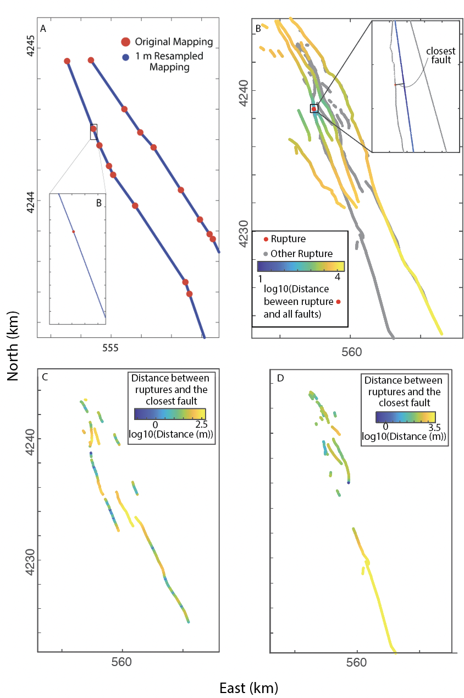
Figure S1: Rupture-to-fault separation distance for the 2014 M6 Napa Earthquake: (A) Linework resampled to a 1 m vertex spacing. (B) Example of the application of Equation 3 in the main manuscript to an individual rupture vertex (red). The colors show the mapped pre-rupture fault colored by the distance between each fault vertex and the red rupture vertex. The inset shows the red rupture vertex and the closest fault vertex. Note the distance between the gray rupture points appears to vary- this is because the rupture is discontinuous here. (C) Predicted ruptures colored by their distance to the closest pre-rupture fault. (D) Unpredicted ruptures colored by their distance to the closest pre-rupture fault.
Section S4: Borah Peak Repeatability
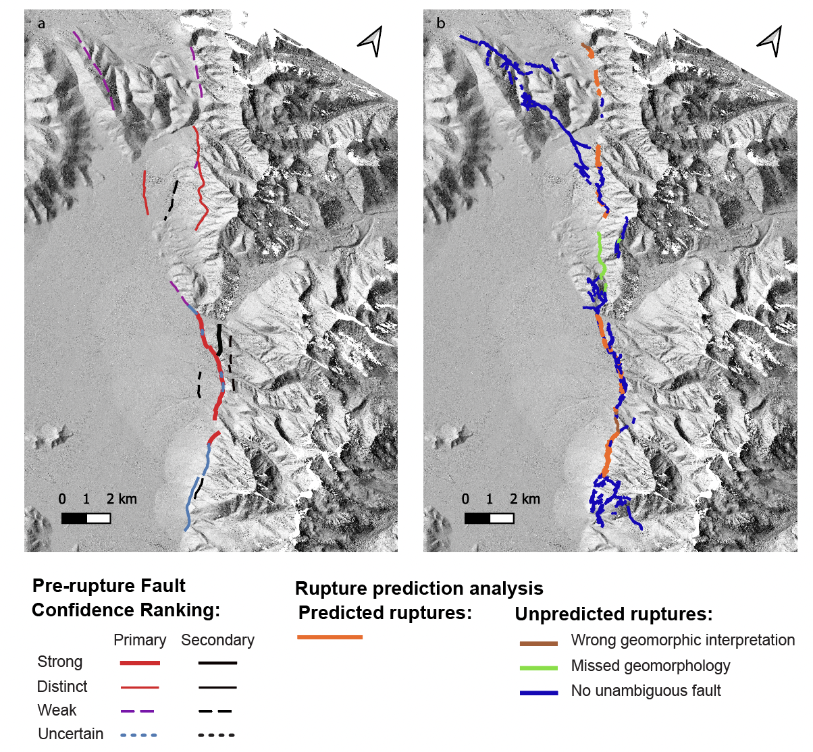
Figure S2: 1983 M6.9 Borah Peak Earthquake: (a) Pre-rupture fault (Borah Peak-1) and base map topographic hillshade (Reitman et al., 2015), (b) Coseismic ruptures (Crone et al., 1987) colored according to the rupture prediction analysis.

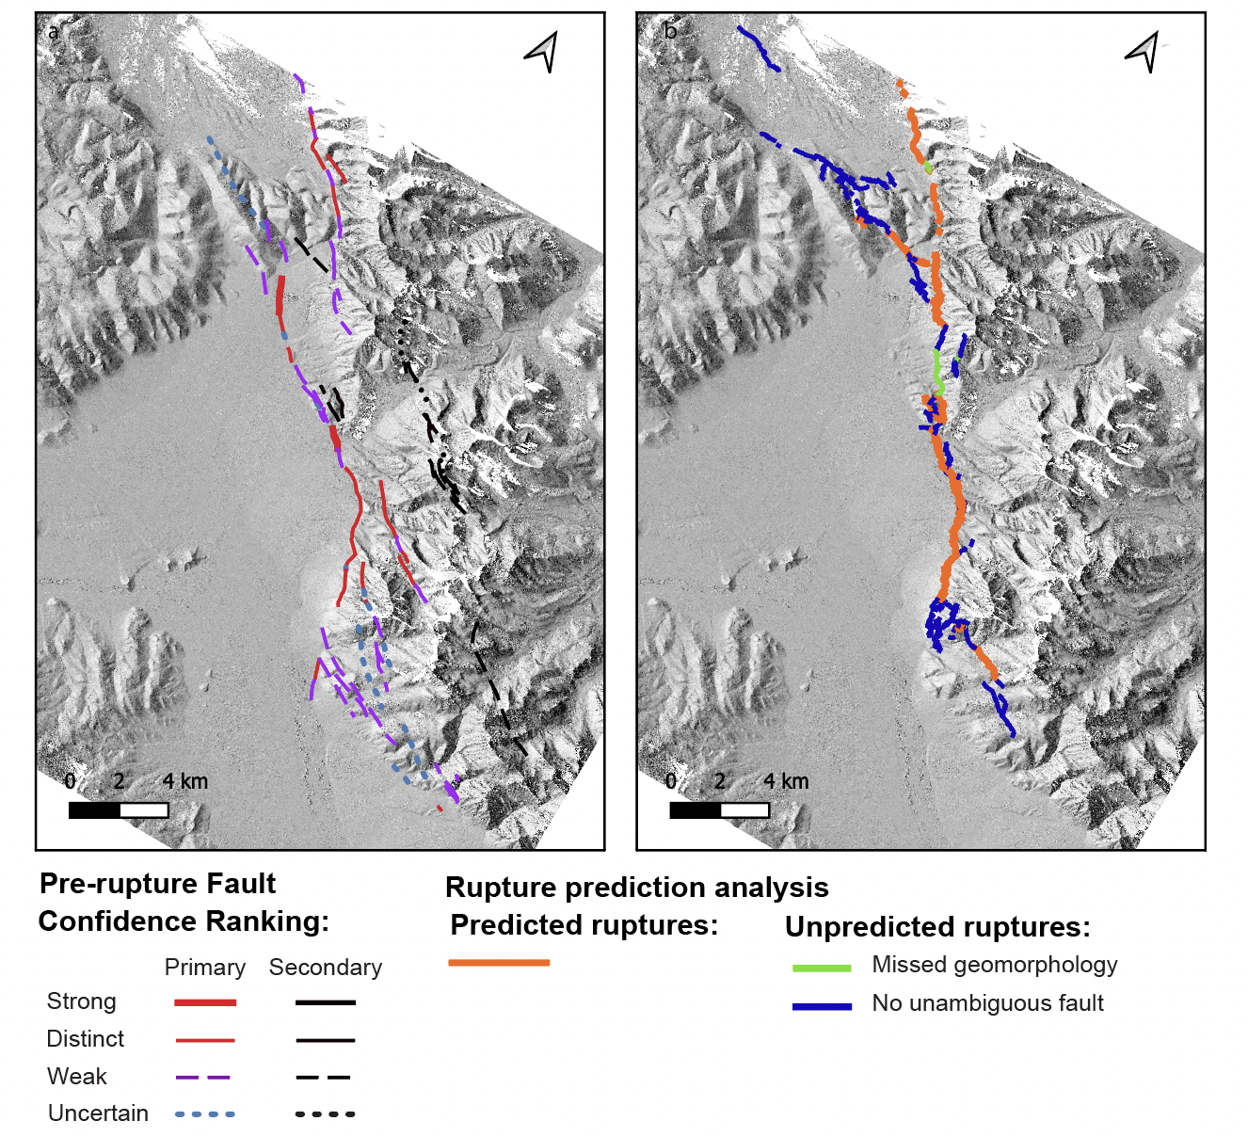Figure S3: 1983 M6.9 Borah Peak Earthquake: (a) Pre-rupture fault (Borah Peak-3) and base map topographic hillshade (Reitman et al., 2015), (b) Coseismic ruptures (Crone et al., 1987) colored according to the rupture prediction analysis.

Section S5: Rupture-to-fault separation distances semi-log line fits
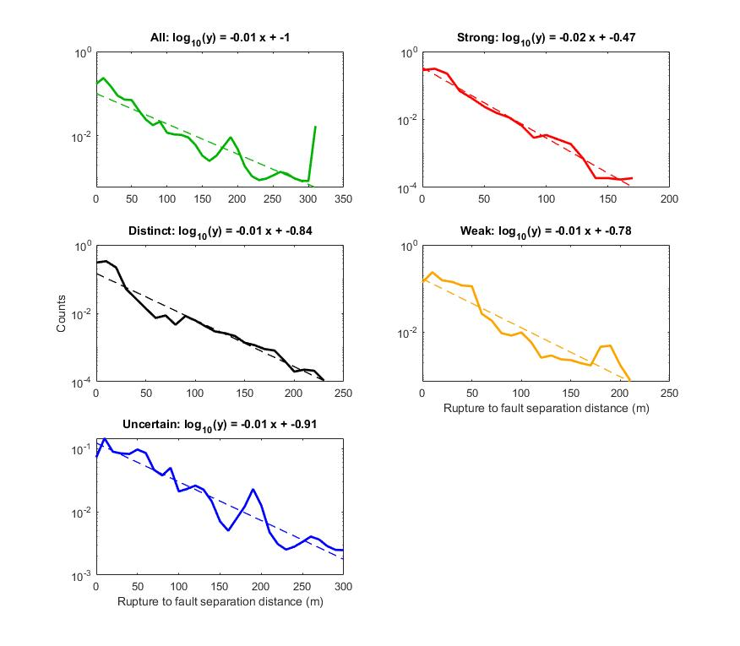
Figure S4: Linear-fits to semi-log relationships between the normalized counts and the rupture-to-fault separation distances for the predicted coseismic ruptures.
Section S6: One- and two-sided standard deviation of the rupture-to-fault separation distance
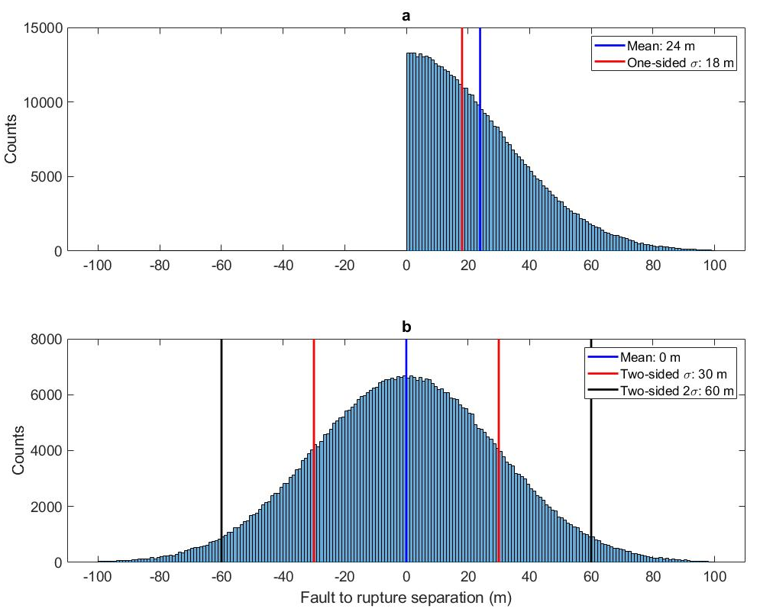
Figure S5: One- and two-sided standard deviation for unsigned (top) and signed (bottom) fault-to-rupture separation distance.

In our pre-rupture fault mapping performance analysis, we do not distinguish between ruptures on different sides of the mapped pre-rupture fault traces and thus all rupture-to-fault separation distances are positive. When performing calculations that assume that the separation distances follow a normal distribution, it is necessary to account for the fact that all measured distances are positive.
In Figure S5, we simulate 500,000 rupture-to-fault separation distances that follow a normal distribution with a mean of 0 m (centered on the fault) and a standard deviation of 30 m. These distances represent ruptures on both sides of the fault. In Figure S5a, we plot the distances as positive, reflecting the square-root calculation in Equation 3. While the initial distribution has a mean separation distance of 0 m, the mean separation of the unsigned distance is 24 m and the standard deviation is 18 m. The standard deviation of this distribution is called the “one-sided standard deviation,” because no distances are negative.
In Figure S5b, distances are plotted with their sign, and thus there is no bound at zero. As expected, the mean is 0 m (centered along the fault) and the standard deviation is 30 m, reflecting the input distribution. More formally, the 30 m value represents the two-sided standard deviation, which is consistent with the properties of a normal distribution.
When all distances are measured as positive, we can use Equation S1 to convert the one-sided standard deviation (σ’) to a two-sided standard deviation (σ),

$$σ = \sqrt{{σ’}^{2}+μ^{2}}$$ | (S1)
Where μ is the mean of the distribution.

If a normal distribution describes the data appropriately well and the fault ruptures, then a width of $±2σ$ would have a 95% chance of containing a rupture. For the example in Figure S5, the $± 2σ$ width spans a 120 m width centered on the fault.

Section S7: Pre-rupture fault mapping performance correlation
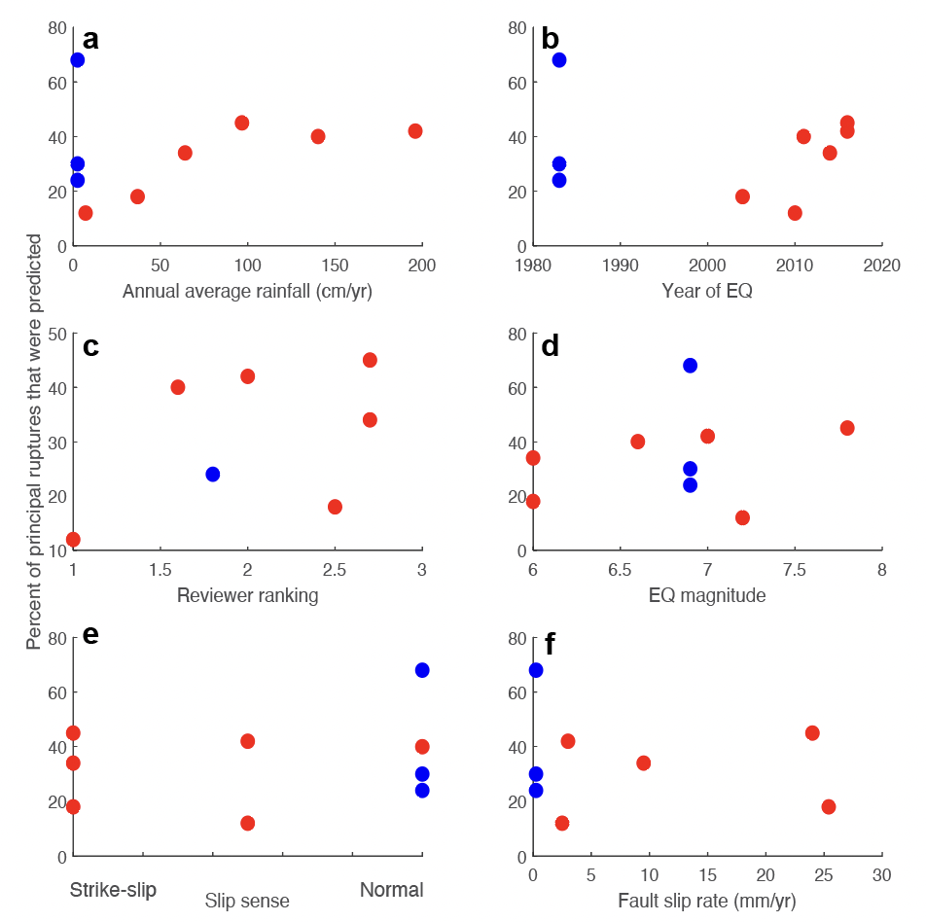

Figure S6: Pre-rupture fault mapping performance versus (a) annual rainfall, (b) earthquake year, (c) reviewer ranking, (d) earthquake magnitude, (e) slip-sense, and (f) fault slip rate. The blue points represent the three Borah Peak maps and the red points represent the other maps.
References: Rainfall: NOAA, (2022): Borah Peak, Parkfield. El Mayor-Cucapah/ Calexico
Weather and Climate: EMC, Fukushima-Hamadori, Napa, Kumamoto, Kaikoura
Slip rate: Borah Peak (Scott et al., 1985; Hanks and Schwartz, 1987), Parkfield (Toké et al., 2011), Laguna Salada fault in EMC (Mueller and Rockwell, 1995), Napa (Evans et al., 2012), Kumamoto (Ishimura, 2019), Kekerengu fault in Kaikoura (Little et al., 2018).

Figure S6 explores the correlation between the percentage of principal ruptures that were predicted and characteristics of the climate, fault, and mapping. With the exception of the Borah Peak maps, there is positive correlation between rainfall and fault mapping performance up to ~100 cm/yr of annual rainfall. Above ~100 cm/yr changes in rainfall have minimal impact on mapping performance. We caution that this relationship may be an artifact of our small data size. There is also a positive correlation between earthquake year (approximate metric for data quality) and mapping performance, suggesting that generally newer data improve mapping performance. We see no correlation between mapping performance and reviewer ranking, as explained in Sections 6.1 and 7.1. We also see no correlation between the earthquake magnitude, slip sense, and fault slip rate with our pre-rupture fault maps. We note though that these characteristics may generally correlate with mapping performance, but our dataset is too small and/or has too many simultaneously varying variables to constrain potential relationships.

Section S8: Read-me for mapped pre-rupture fault shapefiles

We include a read-me text for the associated shapefiles on pre-rupture fault mapping. We anticipate viewing our mapping linework on the open-source and free software program QGIS (https://www.qgis.org). The shape (shp) files are likely to open in ArcMap, but the styles may look different than intended.

Directory Structure (Level 1 > Level 2 > Level 3)

Pre-rupture Fault Mapping

The following files are located in the ‘Prerupture_Mapping’ folder for each mapping location:

- Shapefiles (.shp) for lines and polygon features are included in each folder for a given mapping area.

- Mapping styles (.qlr) for QGIS. These are needed to set the color and line thickness to display our certainty ranking (i.e., strong to concealed) and primary vs. secondary faulting.

>‘Prerupture_ShpFiles’ Folder includes:
> Faults > Contains the Fault Confidence Ranking .shp and style (.qlr) files for each
mapping area (BorahPeak1, BorahPeak2, BorahPeak3, EMC, Fukushima, Kaikoura,
Kumamoto, Napa, Parkfield)

> Mapping_Outlines> Contains the line .shp file for the mapping area boundaries of each
location

> Geomorph> Contains the shp files and style files for geomorphic mapping as
well as the shp file for the mapping outline

- Every shape file has an associated style file which should open automatically with the current directory structure. To open a style file manually, open the .qlr for each file within the associated folder.

Fault Confidence Ranking

Stylized shapefile with an attribute table explaining all metadata associated with the mapping including confidence ranking, location accuracy, classification, and geomorphic features associated with it (Metadata not included for ‘Kumamoto’ and ‘BorahPeak3’).

Geomorphic Mapping/Geomorphic Features

Varies from line to point to polygon shapefiles that illustrates geomorphic features the landscape

Google Earth Files

Uploaded from Google Earth Pro into QGIS using .kmz files, converted to shapefiles.

------------------------------------------------------------------------------------------------------------------
-------------------------------------------------------------------------------------------------------------------

The CRS for each shapefile:

Fault Confidence Ranking Shapefile (for all mapping areas):
CRS - EPSG: 4326 - WGS 84

EMC (2010) Files:
Geomorphic Features (Poly) & EMC 2021 Mapping Area
CRS - EPSG:4326 - WGS 84
Google Earth Files
CRS - EPSG:4326 - WGS 84
- Vegetation Lineation
- Urban Lineation (Anthropogenic Features)
- Tonal Contrast
- Scarps
- Lineament
- (SD)Qyay
- (SD)Qyao
- (SD)Qia(1)
- (SD)Qia(2)
- (SD)Qia(3)
- (SD)Bedrock

Parkfield (2004) Files:
All files:
CRS - EPSG:4326 - WGS84

Napa (2014) Files:
CRS - EPSG: 4326 - WGS84
-Mapping Outline
-Water 1
-Water 2
-Anthropogenic Alteration

CRS - EPSG: 3857 - WGS84
-Rangefront
-Drainages
-Apparent Lineation
-Qya
-Qia
-Qoa
-Vegetation Lineation

Kaikoura (2016) Files:
Geomorph:
- CRS - EPSG: 4167 - NZGD2000

Borah Peak (1984) Files:
All files:
CRS - EPSG:4326 - WGS84

Fukushima (2011)
Geomorph:
CRS - EPSG:2451 - JGD2000

Section S9: Readme for rupture analysis shapefiles

We include a read-me text for the associated shapefiles on rupture analysis. We anticipate viewing our mapping linework on the open-source and free software program QGIS (https://www.qgis.org). The shape (shp) files are likely to open in ArcMap, but the styles may look different than intended. The coseismic rupture linework was sourced from a project by Sarmiento et al. (https://www.risksciences.ucla.edu/girs-reports/2021/08) with the original references listed below.

Rupture Analysis

Directory Structure (Level 1 > Level 2 > Level 3)

>‘Rupture_Analysis’ Folder includes:
> BorahPeak1
> Rupture Reference: Crone et al. (1987)
>BorahPeak2
>Rupture Reference: Crone et al. (1987)
>BorahPeak3
>Rupture Reference: Crone et al. (1987)
>EMC
>Rupture Reference: Teran et al. (2015)
>Fukushima
>Rupture Reference: Mizoguchi et al. (2012) and Toda and Tsutsumi (2013)
>Kaikoura
>Rupture Reference: GNS Science (2018); Zinke et al. (2019)
>Kumamoto
>Rupture Reference: Shirahama et al. (2016) and Goto et al. (2017)
>Napa
>Rupture Reference: Ponti et al. (2019)
>Parkfield
>Rupture Reference: Rymer et al. (2006)

- The CRS for all shape files:
  - EPSG:4326 - WGS84

In each shape file, the “I” attribute reflects the rupture analysis:
I = 1: Predicted rupture
I = 2: Unpredicted rupture: Low mapping resolution

I = 3: Unpredicted rupture: Low data quality
I = 4: Unpredicted rupture: Wrong or incorrect geomorphic interpretation
I = 5: Unpredicted rupture: Missed geomorphology
I = 6: Unpredicted rupture: Limited preservation potential
I = 7: Unpredicted rupture: No unambiguous pre-rupture fault

