QTQt: Beyond the User Manual
Modified from Thermo 2021 Short Course
Alyssa Abbey & Mark Wildman
Key ref: Wolf et al., 1998

This tutorial will guide you through a few workflows for performing forward modelling and inverse modelling. Working through this tutorial should help you to become familiar with the QTQt software package and specifically know how to create and edit input files (data and forward model thermal histories), run forward and inverse models, and observe and interpret the output data.

Full details on the functionality of QTQt can be found in the User Guide, while details on the methodology behind the software can be found in Gallagher (2012). As well as several recorded videos made by Dr. Kerry Gallagher for the 2021 Thermochronology Conference. A few useful papers to read as you prepare to use QTQt for modeling thermochronometric data are: Jones, 1990; Wolf et al., 1996; Wolf et al., 1998; Reiners, 2005; Ketcham, 2005; Westgate et al., 2013; Payton & Carrapa, 2013; Guenthner et al., 2017; Gautheron et al., 2021, and many more. There are also now plenty of recent papers that you can access that describe the application of QTQt to different thermochronometers and different geological settings.

In this tutorial, is an application guide that was initially tested at Thermo21 in the QTQt workshop, offered Sunday September 12th, 2021. This tutorial does not describe the methodology in any great detail, but we will try to give background information on terminology and functions of the software that may not be clear if you are a new user.

We will first go through the process of forward modelling. In this procedure we will generate synthetic apatite fission track (AFT) data and apatite (U-Th-Sm)/He (AHe) data from a known thermal history. We will then use these synthetic data as example datasets to gain experience running inverse models.

Forward Modelling

Why Forward Modeling?
Forward models predict cooling ages (ZFT, ZHe, AFT, AHe) and/or track lengths (FT) given a single specific t-T history input by the user. These predictions are useful for a wide range of applications, including:
- comparing predicted data to measured data to:
  - systematically test specific hypothesized cooling histories
  - eliminate geologic scenarios that predict thermochronometric ages that are inconsistent with observations
- research planning, because the user can, for example:
  - test whether hypothetical rock tT histories can actually be distinguished from each other using thermochronology
  - evaluate how specific parameters (such as grain size and composition in the He system) or multi-chronometer approaches may more clearly constrain tT histories
  - explore the consequences of choosing to use one set of published kinetics over another during thermal history modeling.
- learning and teaching thermochronology:
  - because exploring hypothetical thermal histories and the cooling ages consistent with them is an excellent way gain some intuition about partial-retention behavior

Exercise 1: Opening QTQt and Building Data files
- First create a folder directory (for example in your computer documents folder) to use while working through this tutorial. This folder will be where we store data files to load into QTQt and where QTQt will add any created data and run files. Navigateto the shared Google Drive folder (link) and download each of the files for exercise 1; add those files to the directory folder you have created.
- Navigate to the folder where you have the QTQt application stored Open QTQt by double clicking on the QTQt icon (this is the one with the monkey symbol, it may have a longer name related to the version number e.g. QTQtPC64R5.7.1K.exe).
- Click on File > Build new QTQt data file.
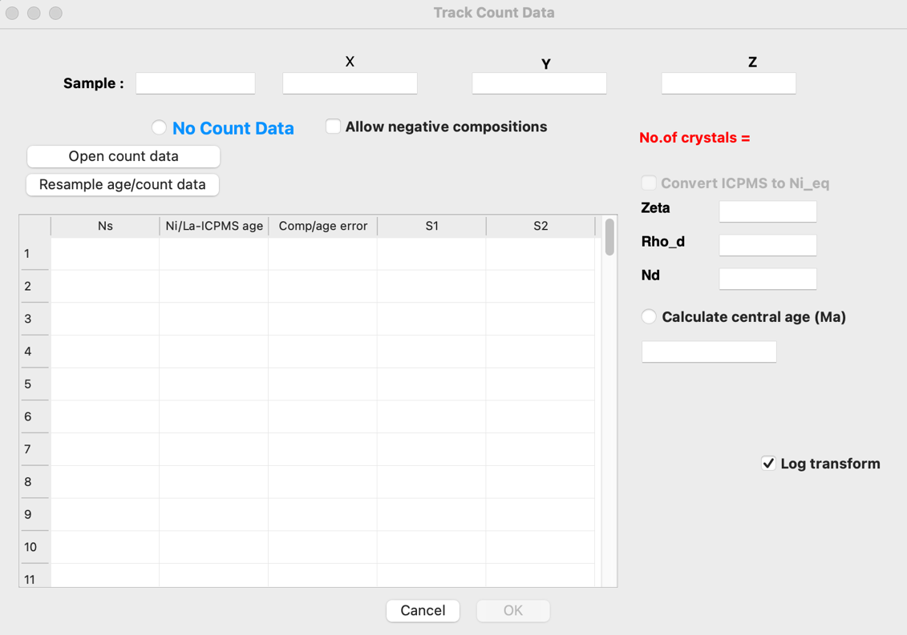
First data input window that pops up when building a new data file. In this case this is input data for AFT, if you do not have AFT data you can simply click the ‘No Count Data’ and move to the next window → which will be for length data, followed by a window for Helium data, then vitrinite reflectance data.
- Here we have provided a fake data set to use to build a fake file
- Open the “Exercise1_InputData.xlsx” spreadsheet. Copy the sample name, location information (X,Y, Z coordinates) and AFT count data (Ns, Ni, comp & Rho_d, zeta, Nd) into the appropriate boxes. You can click on the ‘Calculate central age (Ma)’ button and see the AFT age and some summary statistics appear.
- Click ‘OK’. Note, often the ‘OK’ box will be greyed out and unclickable. To move forward you may need to click in all the available input boxes, or press ‘enter’ on your keyboard.
- You should now be in the second dialogue box to add FT length data. Copy and paste the fission track lengths and c-axis angles into the table in QTQt and tick the box with the correct etchant. You have the option to use c-axis projected lengths; tick this box. You will see that in the QTQt table, individual lengths have been corrected for their c-axis orientation and, on the right, an MTL and SD for projected lengths is displayed below as ‘proj:’.
- Click ‘OK’ and you will now be in the helium dialogue box. Copy and paste the U, Th, Sm, and He concentrations and the Grain Dimensions into the white boxes. You can tick the box ‘calculate age’ to see the U-Th/He age for this grain (the Ft-corrected age and error is displayed beside the corrected age, in blue and red text, respectively). From the ‘radiation damage model’ drop down menu select ‘Flowers’.
- Click ‘OK’ and on the next page click the button for ‘no vitrinite data’ (at the top under the sample name).
- The final window allows you to specify additional time-temperature constraints for the sample (including present day temperature) and to select which annealing model and compositional proxy you wish to use to model the AFT data.
- Click ‘Save Data for Reload’ and save the file as “YOURNAME_Exercise1_InputData.txt”
- Click ‘OK’ to close the ‘Build New QTQt file’ window. If you have been unable to complete this exercise the final data file ‘Exercise1_InputData.txt’ has been provided.
- Click on File > Review Existing QTQt data file > Open File and select the “Exercise1_InputData.txt” file provided. Then click ‘Finish’.
- The Build QTQt file window opens but you will see it is now populated with data. You will also see several summary statistics presented relevant to that particular dataset.

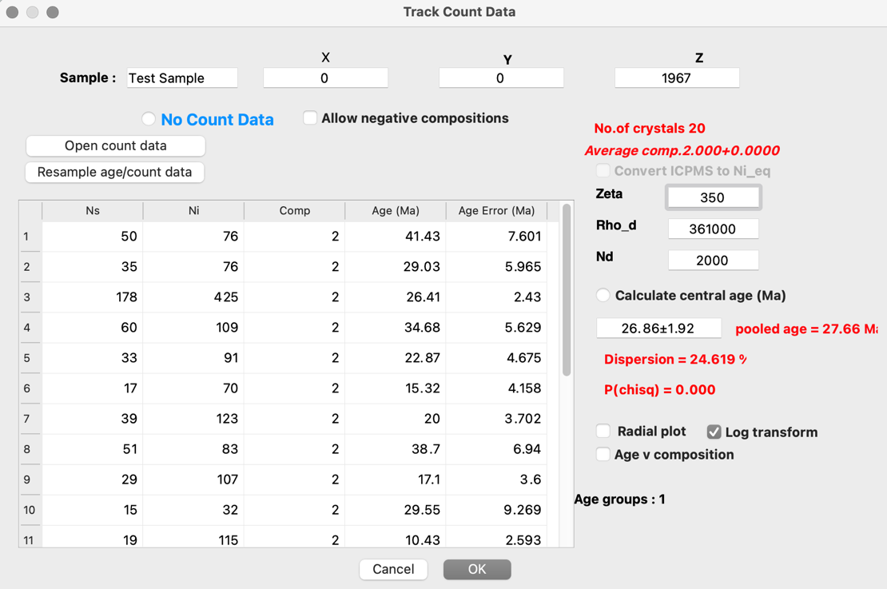
First data input window that pops up when reviewing an existing data file. Here you can see how QTQt reads your input file, and if you need to make any changes you can move to the next window by clicking ‘ok’ and work through the various data input windows and then re-save the file for loading and running.
- Click ‘OK’ to work through the windows and observe the data that has been entered, the boxes that have been toggled on or off (ticked or unticked) and options that have been selected from drop down menus.
- After building your file, you can click ‘Save Data for Reload’ and save your file as a .txt file. (You can do this if there was difficulty creating your own file before, but do not overwrite the original file. Name the file YOURNAME_Exercise1_InputData.txt).
Exercise 2: Forward Modelling Apatite Fission Track and Apatite (U-Th-Sm)/He data

Part 1: How to run a forward model.

- To run a Forward Model you need to load in a QTQt file that contains some data.
- The data the Forward Model produces will use information in that data file when generating synthetic data.
  - For example, if in the input file you specify 20 AFT grain counts, 100 AFT lengths, and 3 AHe ages with the Flowers et al. 2009 radiation damage model. You will generate 20 synthetic AFT grain counts, 100 synthetic AFT lengths and 3 synthetic AHe ages with the Flowers et al. 2009 radiation damage model.
- This can be useful if you have data from somewhere, e.g. your own or someone else’s data, and you want to test different thermal history hypotheses and see if you can match the observed data.
- However, you can input fake data and later choose to ignore the input data (this is what we do below) if you just want to run histories and see what data you get. Maybe you are doing some preliminary tests before you go out and get data.

- Open QTQt by double clicking on the QTQt icon. (This is the one with the monkey symbol, it may have a longer name related to the version number e.g. QTQtPC64R5.7.1K.exe).
- Click on File > Open existing QTQt date file(s).
- Navigate to your directory folder and open the file “Exercise2_InputData.qtqt” Note. sometimes files will be labeled with a .qtqt or a .txt, they both can be opened in QTQt the same way, if you want to view any .qtqt files prior to opening them in the program, specify that you want to open it with a text editor (e.g. notepad++, wordpad, textedit, or notepad,etc.)
- This file contains the same data as the last exercise with the addition of two more apatite (U-Th)/He ages) and then click ‘Finish’.
  - We treat this file as data we have measured in the lab, and we want to check whether our assumed thermal history would produce this dataset.
  - This file contains fake AFT and AHe data designed so that we can generate a synthetic dataset, from a thermal history that we input, with 20 AFT grains and 100 AFT lengths and AHe data with a mixture of grain sizes and eU values.
  - In the data file we have also specified that we are using the Ketcham et al (2007a) multikinetic annealing model, with c-axis projected angles (Ketcham et al., 2007b) and Dpar value as a proxy for composition and for the initial fission track length (Carlson et al., 1999)
  - We have also specified that we are using RDAAM kinetics.
- Enter a run title name: “Exercise2_FM” and then click ‘OK’.
  - Note that in the main QTQt window you will see some text printed that summarizes the data contained in the data file (e.g., AFT age, MTL, no. of He ages). This is useful for quickly checking if there are problems with your data file.
- Click on Thermal History Constraints > Draw Forward Thermal History
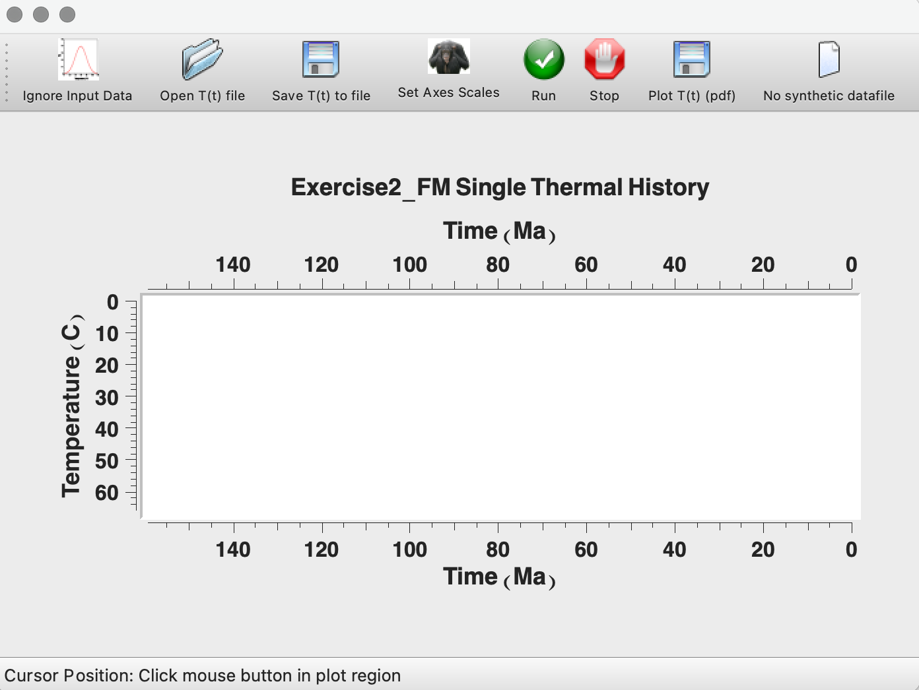
Window that pops up to draw or display a thermal history and run a forward model. Options along the top bar to ignore/plot input data, open a .txt file with Tt points, save the drawn thermal history to a text file, set the axes of the thermal history plot, run the forward model, stop the forward model, export a .pdf of the Tt path, and a button to generate a .qtqt file of synthetic data.

- In the window that appears you can draw a thermal history by clicking points in the time-temperature space. If you hover your mouse over the white area on the graph, you should see crosshairs.
  - Add a point – single click.
  - Move a point – click and drag. (note that when you click and drag a point you get a live update of the point coordinates in the bottom left-hand corner).
  - Delete a point – double click on the existing point.
- The t-T (Ma, °C) coordinates we will use for our exercise will be (100 Ma, 60°C); (20 Ma, 60°C); (19.9 Ma, 5°C); (0 Ma, 5°C). Try drawing your own model using these coordinates.
  - You can reduce the t-T space by clicking on ‘Set Axes Scales’. Set the ‘x-axis minimum’ to ‘100’ and the interval to ‘10’ and click ‘OK’. You can also adjust the y-axis if necessary.
  - Once you have drawn the history you have the option to ‘save T(t) to file’ (this will save the number of points and coordinates of those points in a text file) and or save a pdf plot of the thermal history.
- Click “Save T(t) to File”.
- Name and save the file in your working directory. Be sure to leave the forward modeling window open, or you’ll need to navigate back to this window (Thermal History Constraints > Draw Forward Thermal History)
  - You can navigate to this file and open it in any text editor.
  - You can see that the top line is the number of tT points and then the other lines are the coordinates that you set in the interactive window.
- You can also create your own .txt file for a thermal history, without drawing it. This file is provided to use for the rest of the tutorial. Click on ‘Open T(t) file’ in the ‘Draw Forward Thermal History’ window and open the file “Exercise2_FM_ThermalHistory.txt”

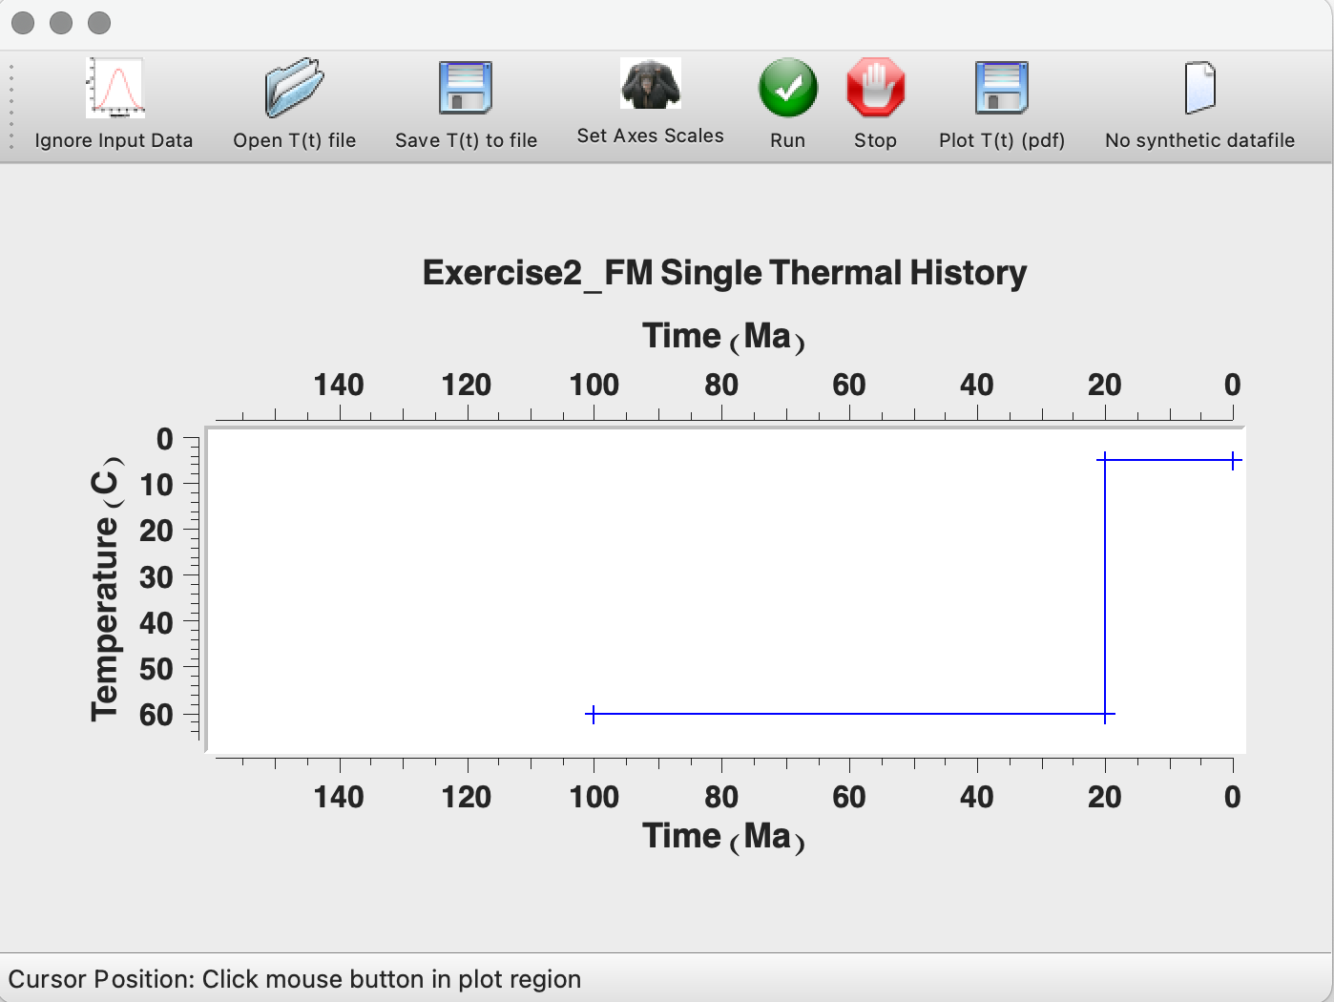
Visual display of the exact thermal history path used for this forward modelling exercise. Input forward model thermal history shows a time-temperature path with 4 points. Note, there is a live update of time and temperature coordinates at the bottom left when moving points.
- Click ‘Plot T(t) (pdf)’ save a .pdf of the forward model in your working directory.
- Click ‘Run’ (the green button with white tick).
- After the model runs, a data prediction window will appear.
  - You can compare the ‘O’ = “Observed values” (i.e., the ones based on your data in the input data file) against the ‘P’ = Predicted values (i.e., the data that would be produced given the thermal history and the kinetic parameters based on the data in your input data file).
  - The fission track length distribution is shown as a blue histogram for the observed values and a red curve for the trend of the predicted track length distribution.
  - You can click on ‘Plot Obs v Pred’ (at the top of the window next to the ‘print’ button) to visualize the AFT and AHe ages on a 1 to 1 plot.

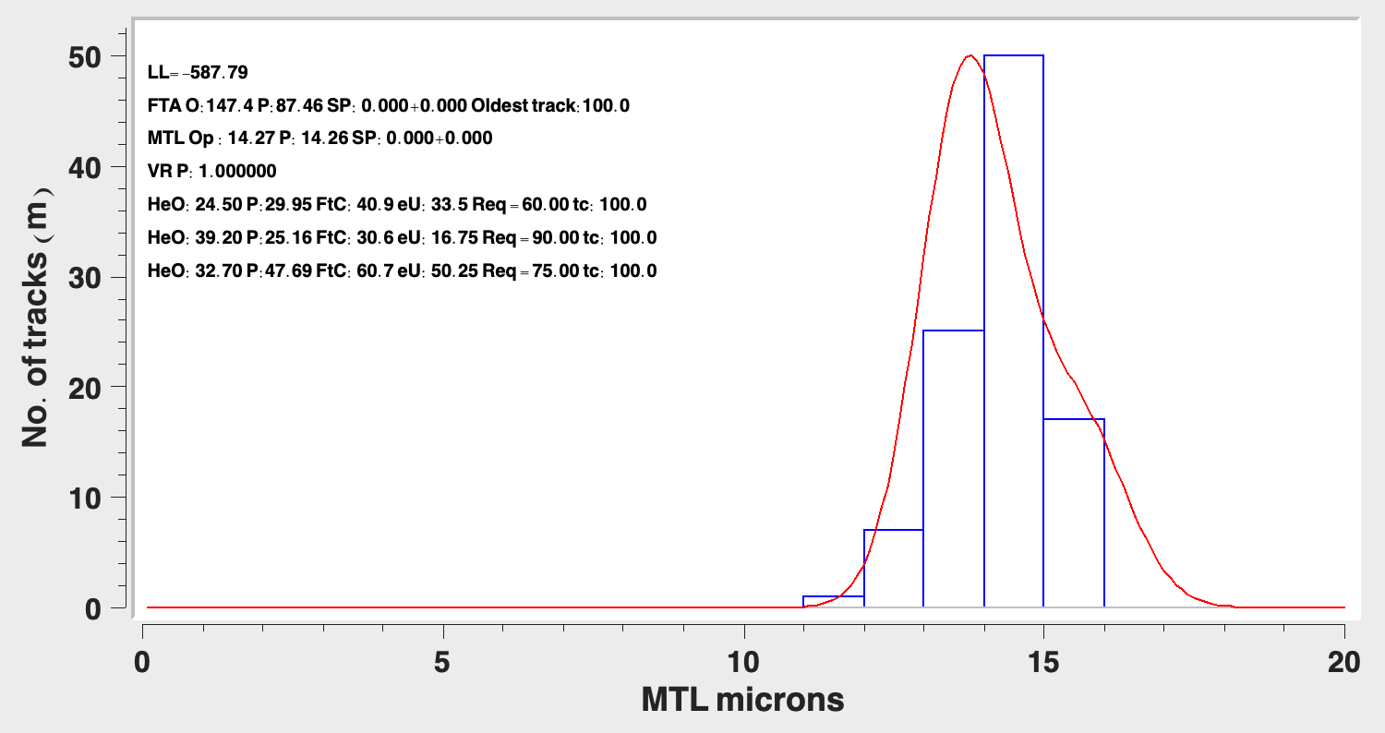
FTA = Fission track age; MTL = Mean Track Length; O = Observations; P: Predictions. Old Trk = oldest predicted fission track that is not entirely annealed. SP = Sampled predictions (not relevant for forward modelling). LL = Log likelihood. Blue histogram = histogram of observed track lengths. Red curve = predicted track length distribution.

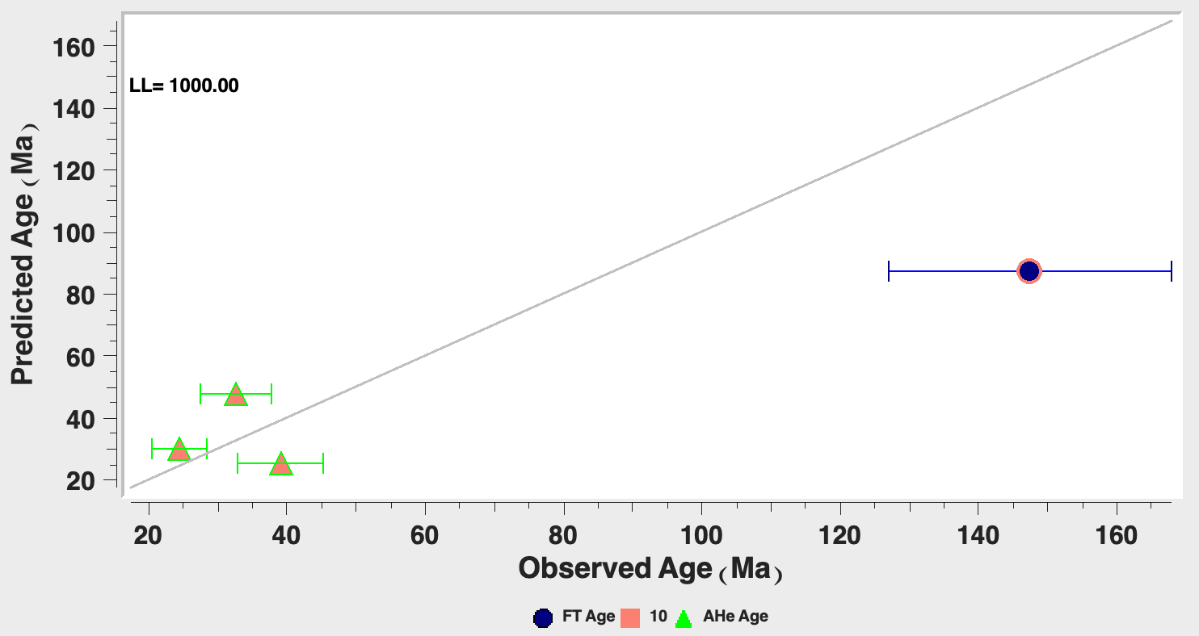
Plot of Predicted vs Observed ages with a 1-1 line for comparison

Do the data predicted by this thermal history fit the observed values?

- Close the model predictions window.
- In the example above, we treated the input data as data we measured in the lab. You may not have this data and instead are testing different thermal history scenarios to see how they change the predicted data. In this case, we do not really want to see the ‘observed data’ contained in our input file. In the main Forward Modelling window, click on the ‘Ignore Input Data’ button and then ‘Run’.
  - You will see in the data predictions window that no observed data is displayed, only the predictions.

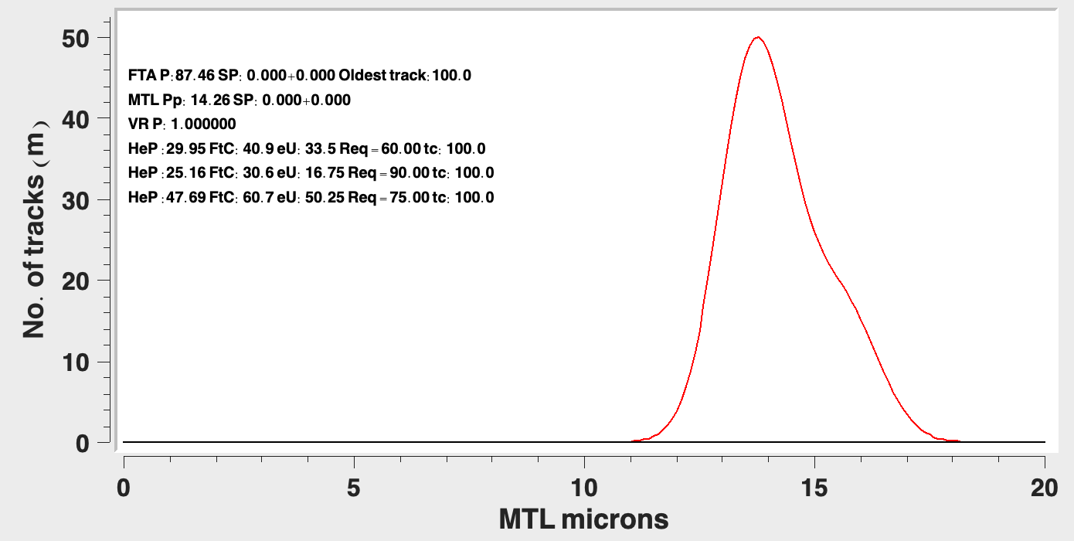
Data predictions from the forward model without the input/observed data.

- Take note of the predicted data (P: preceding the predicted age) and close the data predictions window.
- Modify your thermal history in some way (e.g., delete a point, add a point, and/or modify a point) and the ‘Run’.
How did the predicted data change?

- Do not close QTQt we will continue on from this point in Part 2.
Part 2: How to generate synthetic data from a forward model.

In this exercise we will generate some synthetic data based on thermal histories we are testing. This may be useful if you want to plot up components of the predicted data to show how you would discriminate between different thermal histories. In our case, we want to generate some synthetic data based on a known thermal history and then (in Exercise 3) see if we can use inverse modelling to retrieve the original thermal history. If we can’t do it with ‘perfect’ synthetic data, it will be challenging with real data, which will likely have more noise and perhaps more or different types of data/information will be required to constrain the model.
- We are still using the input file “Exercise2_InputData.qtqt” but in this example, we don’t care what the data in the file is, but we do care about the number of data and kinetic parameters of the AFT & AHe data in the input file as this will determine how much and the type of data we generate. For example, if the input file has 100 track lengths, specifies a Dpar of 2.5 µm and the Ketcham et al. (2009) annealing model – we will generate 100 tracks based on that composition and annealing model given the thermal history. For helium data, we specify the number of grains, the radiation damage model, the concentration of U, Th, Sm, and the grain geometry.
- Click on ‘Open T(t) file’ in the ‘Draw Forward Thermal History’ window and open the file “Exercise2_FM_ThermalHistory.txt”
- Click on the button that reads ‘No synthetic data file’.
  - A window will pop up asking you to add some errors to your helium/vitrinite data. This can be as a percentage or as an absolute error. Alternatively, you can skip this stage and edit the synthetic data text file after it is generated. We show this in the next exercise.
- Toggle on ‘Add errors to He/Ar single grain ages’ and enter a value of ‘5’ in the “% error box” and click ‘OK’

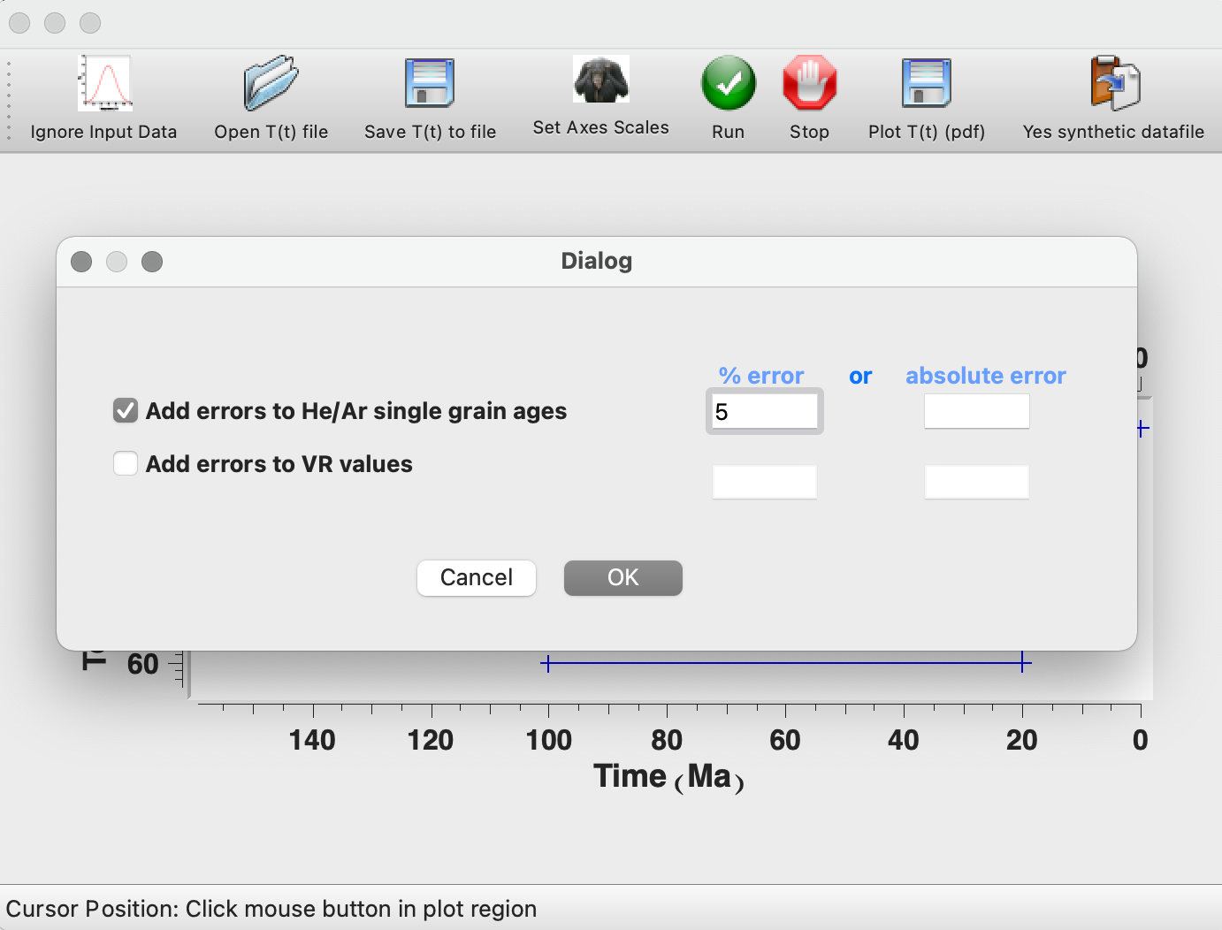
Window pop-up when ‘No synthetic datafile’ is clicked. A 5% error has been added to the helium data and now we will be generating a synthetic datafile (see top right corner).
- You will notice the ‘No synthetic data file’ has changed to read ‘Yes synthetic data file’.
- Click ‘Run’. As before, the predictions window will open, take a note of a few of the numbers (e.g., AFT age, MTL, AHe age) and close the window.
  - Running this will have created a new synthetic data file which is added to the folder where the input files are located (i.e. your working directory folder)
- In the QTQt Forward Modelling window, click ‘STOP’ and close the forward modelling window.
  - If you want to observe the plots of predicted data again, you can click on Plotting > Max. Likelihood Model > Plot Individual Predictions > Exercise2_Input.qtqt
- After you close the Forward Modelling window, you will notice that several files will be created in the same directory as the input file. These can be deleted, however the file “Exercise2_FM.txt” could be saved if you would like to reload the data predictions plots at a later date.
- Now let’s look at the synthetic file you created. Navigate to your working directory folder with the original input file, there will be a file called “Exercise2_InputDataSYN.qtqt”.
- Open this file (in a text editor to view it).
- Scroll through the data file and observe that you have an AFT age, MTL and AHe ages that match the predictions that were shown in QTQt. You can also open the original input data file and observe that in addition to the ages and MTL, the AFT single grain counts, and track lengths have been replaced with the synthetic data.
- Have a play around with the thermal history path and note how the predicted data changes. Before you do, click the button to turn off generating synthetic data as we only want synthetic data for the example described above. The example thermal history produces a unimodal track length distribution. Try to make:
- a unimodal and very narrow track length distribution
- a unimodal but very broad TLD
- a bi-modal distribution.
- Can you generate data where the AFT data and AHe data are almost the same?

- Change the timing of the second rapid cooling event (at 25 Ma in the example file). How does this affect the AFT data, how does this affect the AHe data?

Part 3: Examine predictions for a single grain from six different thermal histories
Here you will use your knowledge of how to create tT paths for forward models to create six different tT paths (Abbey et al., in prep.; Murray et al., in prep; modified from Wolf et al., 1998). With these paths you will run QTQt and obtain predicted helium ages for a single apatite crystal with a radius of 60um and an [eU] of 60 ppm.
- Open QTQt and load the fake data file (‘Ex2_pt3_40Ma_singlegrain.txt’) which contains fake data for our 60um sized crystal with an [eU] of 60ppm.
- Use the data table below with time and temperature points, to define the thermal
histories for these six scenarios.
- You can either use the drawing method as we did in part 2, by clicking in the ‘Draw Forward Thermal History’ box,
- Or you can use the .txt file provided in part 1 to make copies and directly input the tT info for each thermal history (“Exercise2_FM_ThermalHistory.txt”).
- Note you already have the tT for ‘Path 3’ (that’s the path we used in part 2).

Path 1 |  | Path 2 |  | Path 3 |  | Path 4 |  | Path 5 |  | Path 6
Time (Ma) | Temp (C) | Time (Ma) | Temp (C) | Time (Ma) | Temp (C) | Time (Ma) | Temp (C) | Time (Ma) | Temp (C) | Time (Ma) | Temp (C)
40 | 200 | 100 | 145 | 100 | 60 | 100 | 90 | 100 | 5 | 100 | 20
39.5 | 5 | 0 | 5 | 20 | 60 | 75 | 60 | 5 | 64 | 41 | 20
0 | 5 |  |  | 19.9 | 5 | 25.5 | 60 | 0 | 5 | 40.5 | 200
 |  |  |  | 0 | 5 | 0 | 5 |  |  | 40 | 5
 |  |  |  |  |  |  |  |  |  | 0 | 5
Age: |  | Age: |  | Age: |  | Age: |  | Age: |  | Age:
tT information for 6 different thermal histories. Use the final row of the table to record the predicted ages after each model run.
- Once you have created .txt files for each thermal history. Work through the process outlined in part 1 to: open the thermal history, run the forward model, and record the age predictions.
  - Note the predictions window gives helium ages three ways: as HeO (for observed ages – i.e. those from your input file), P: (predicted from the fwd model run), FtC: (corrected ages to account for radiation damage).
  - You do not need to close out of any windows after each forward model run. You can record the predictions or save them and then load a new tT and run it again.
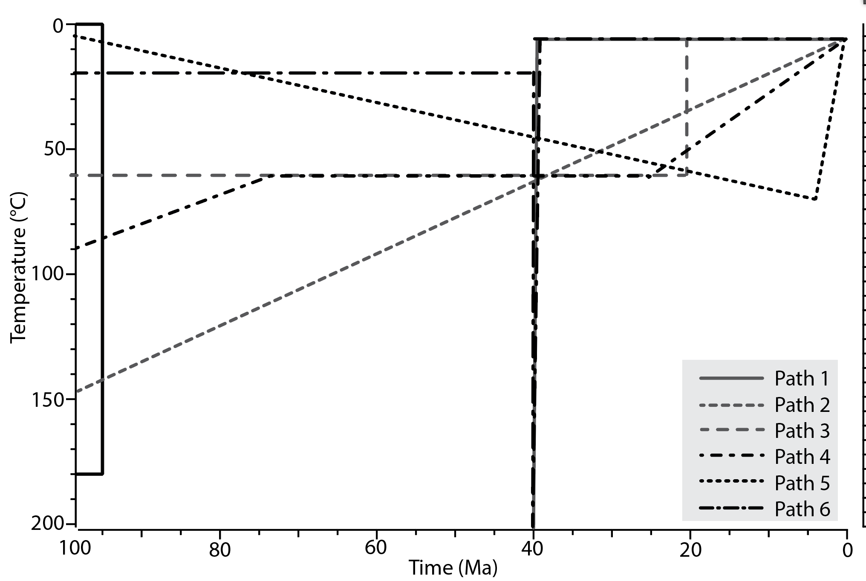
Paths for the 6 different tested thermal histories created from the tT points in the above table.
Use this visualization of the 6 different thermal history paths (above) and the forward model tests you just performed to predict a single crystal age, to reflect and answer the following questions:
(A) For each tT path, describe what is happening at 40 Ma (e.g. cooling rate relative to sample cooling history, heating, when is the start and end of cooling, etc.).

(B) In each case, is the He age telling you about the cooling ‘event’? Explain your answer.

(C) Is there something that all these paths have in common that causes them to yield a 40 Ma age? Explain your answer.

(D) All of these paths, except Path 1, start at 100 Ma. What are we assuming is true about the geologic history of this apatite grain by designing the model this way?

Take some time to run different forward models. Try running some thermal history models that are appropriate for your own study area and look at the data you obtain. Try building a QTQt file (full details on this are found in the QTQt user guide p. 13-23) using data that you have or can obtain from a publication and run some forward models to find the model(s) which fit the data ‘well’.

Inverse Modelling

Why Inverse Modeling?
Inverse models are an efficient way to explore t-T space. So, how well can inverse models resolve the 'true' t-T histories under ideal circumstances? Here we use the forward model path from Exercise #1, and the synthetic apatite He age-[eU] trends we generated from the forward models of these paths in Exercise #2, to explore this question.

Exercise 3: Inverse Modelling Apatite Fission Track and Apatite (U-Th-Sm)/He data

- Go to your working directory folder and open the file “Exercise2_InputDataSYN.qtqt”. (use any text editor application) This is the synthetic data file produced by your forward model in Exercise 2.
- In line 5, the first value you have is 0, which tells the software you want to estimate the initial length of a fission track based on the compositional proxy ‘Dpar’. The second value is the estimate of Dpar this value was set in the FM input file and has been retained. The third value is the standard deviation on the Dpar measurement. We are now pretending this synthetic data file is real data we have measured and want to invert. For real data you would have a standard deviation on the Dpar measurements you have made. For now, we will set this value to 10% of the average Dpar. So, in line 5, change the third value along from 0 to 0.205.
- Using the provided file check to make sure your edited file looks the same.
- Look at the data file and compare it with the table in Appendix 1 in the QTQt User Guide (p. 71). You will notice that in lines 10 to 12, the FT age/MTL/MTL St.Dev. have uncertainties almost = to the average value. These values are actually just summary data from the forward model e.g. MTL and the c-axis project MTL. QTQt doesn’t use these values in the modelling, it will take the information from the single grain age counts and the single length measurements. You can also find the AHe age and AHe age error. If you selected to add 10% errors to Helium ages in the Forward Model the uncertainty should be 10% of the age. If not, go to each of these uncertainty values and manually change the value to 10% of the age.
- After editing your errors make sure to SAVE and then close the file.
- Double click on the QTQt.exe file. (This is the one with the monkey symbol, it may have a longer name related to the version number e.g. QTQtPC64R5.7.1K.exe).
- Click on File > Open existing QTQt data file(s).
- Open the file “Exercise3_InputData.qtqt” this file is the same as the synthetic data file we created in the last exercise with one modification: we have added a 10% uncertainty to the Dpar value. This has been done to make the synthetic data more comparable to a real dataset and will allow the model to sample different values of Dpar within this uncertainty range. Click ‘Finish’.
- Enter a run title name: “Exercise3_IM_1” and then click ‘OK’.
  - It is useful to end the run name with a ‘1’. You will see below we load run files back into QTQt and the suffix to the sample name will increase by 1 each time.
- In the QTQt window, you will see that summary information for the input file is displayed. It should look like the figure below although the values may not be exactly the same (but they should be close).

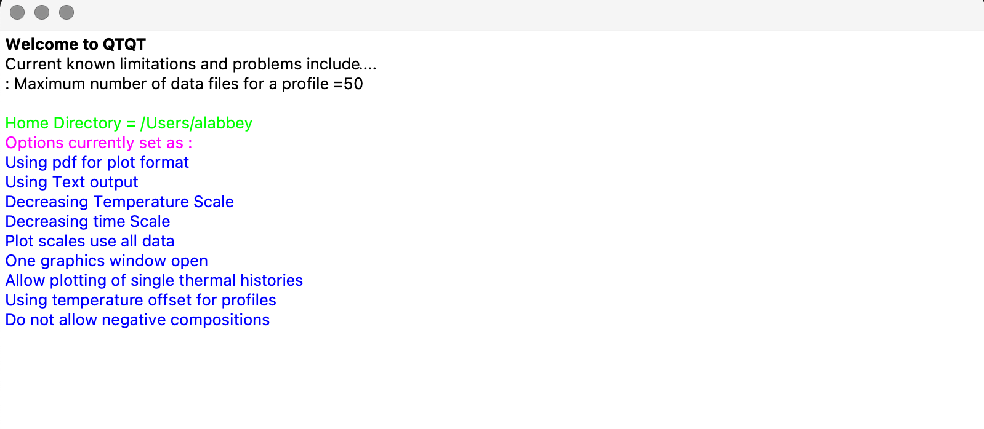
QTQt window after opening up a data file. Make sure that this all looks sensible. Check the FT age and MTL are what they should be, and that the No. of data is correct if you have AHe grains.
- Click on Thermal History Constraints > Inverse model prior.
- We first set the ‘Ranges for General Prior’. The default value for the time and uncertainty on time is set using the oldest age in your data (in this case it is the AFT age). The default for temperature is set to the 70 ± 70°C, which defines a temperature range that covers the AFT partial annealing zone and AHe partial retention zone.
  - It is in this range that the thermal history paths will be tested.
  - Important Note: Different versions of QTQt have different default priors. For example, a newer version may have a modified age range (i.e. smaller) to increase efficiency as we generally do not expect the thermal history to start so early (relative to the measured age)
    - Ultimately, the choice of prior is up to you, increasing the range will take more time to converge generally and it is the equivalent of saying we know less about the possible thermal histories. Decreasing the priors is not advisable.
    - This is mainly something to be aware of as you transition between different versions or if you are trying to replicate runs that were done on different versions of QTQt.
- Next, we specify the ‘Present day temperature °C’ and in this exercise we will accept the default of 10±10°C. It is essentially a constraint box with the time component at 0±0 Ma.
- At the bottom of this window are 5 rows for entering time-temperature constraints. This is where you would input information taken from your existing geological knowledge of the area. For this exercise, we will enter a constraint at 200 ± 5 Ma and 200 ± 5°C and we will discuss the impact of this initial constraint later.
  - Perhaps you have a basement rock that has been dated with additional geochronometers, you could enter this time-temperature information as a constraint.
  - Or, you have a sedimentary sample with a known stratigraphic age. Therefore, you need to constrain the sample at surface temperatures at some time in the past.
- Click ‘OK’.
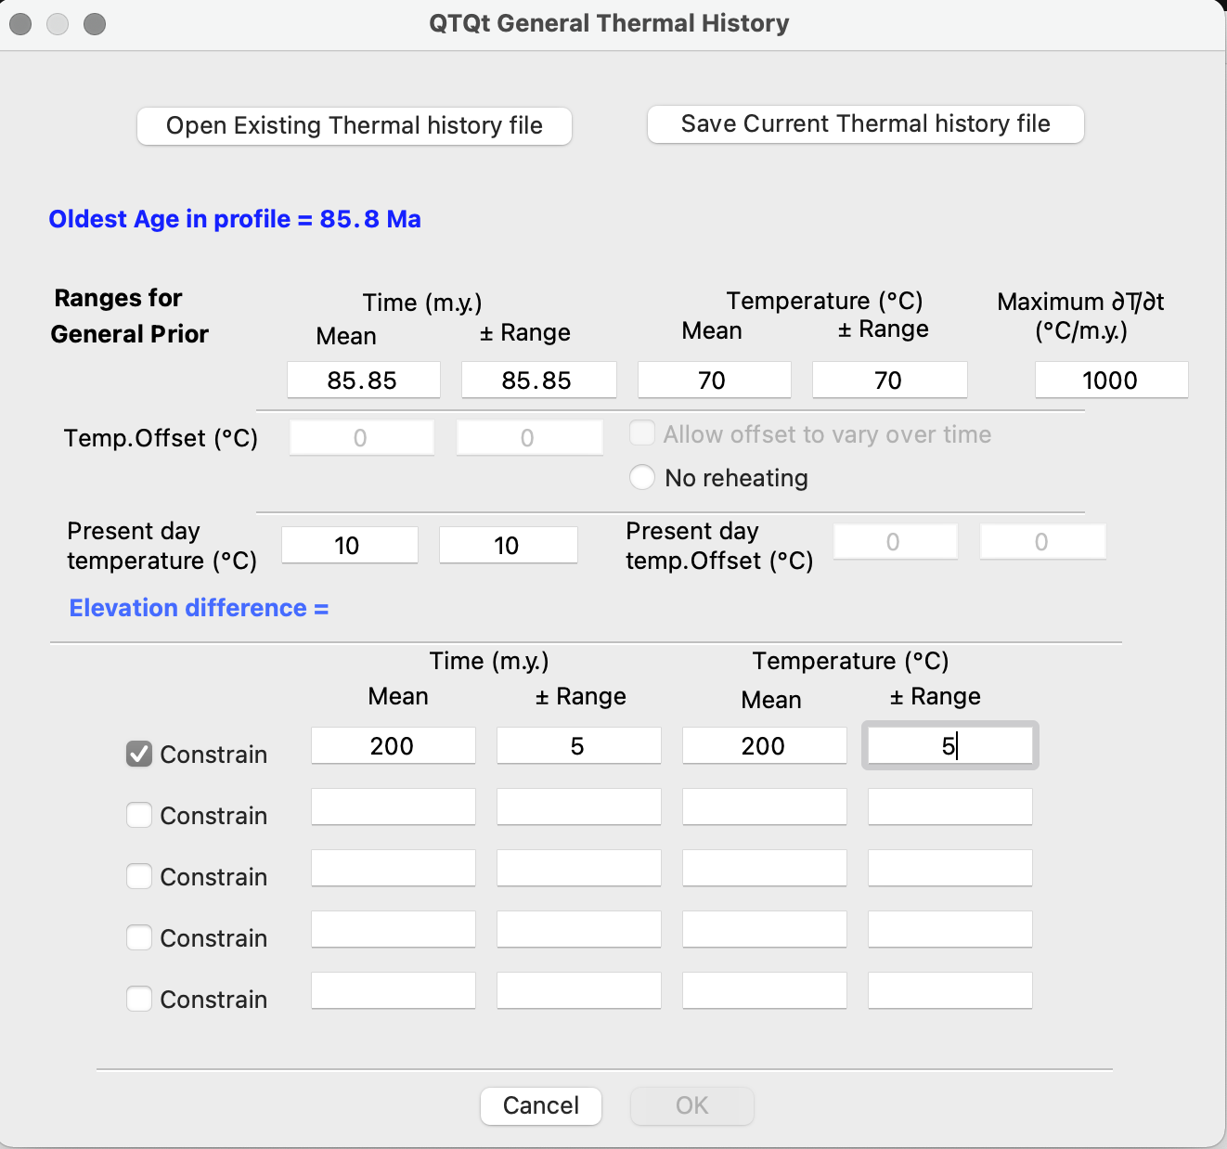
Setting up the General ranges for the prior window. Here we set an initial prior in which the thermal history models will be tested. A present-day temperature and, if we want to, constraints for the model.

- Click on MCMC Run > Set MCMC Parameters.
  - MCMC stands for Markov Chain Monte Carlo and it is the sampling algorithm that controls how new thermal history paths are proposed and accepted when searching for paths that fit the data.
  - New thermal histories are proposed by moving points in time or temperature, creating new points (birth), and deleting points (death).
- We will leave all of the MCMC parameters as default for the moment.
  - Burn-in: This is the number of models that will be tested and then deleted from the final output. This process helps the model find optimal solutions before saving the information.
  - Post-burn-in: This is the number of models that will be tested and will comprise the final output.
  - Thinning: This factor helps to reduce the file size by only taking one in every so many models for the output. For example, if it is set to 10 then 1 in every 10 models are saved. This is useful for reducing the file size if you are running millions of iterations.
  - Proposal Move Time/Temperature/Offset/Annealing/He Diffusion/Vitrine Refl: This value governs how big or small the moves are when sampling the temperature-time space or when sampling the data using for example the annealing or diffusion models.
  - Proposal Outside prior: This is for how you treat points when they are proposed outside of the prior box you set up you can: Resample, in which case you sample the point again. Or you can reject the point and delete it.
  - The acceptance rates tell you how many proposed points are accepted and are rejected. In order to fully sample the data and the time-temp space you want to ensure that you have a balance between accepting good models and rejecting bad ones.
  - The Birth and Death rates informs you about the rate at which new points are being proposed and being deleted.
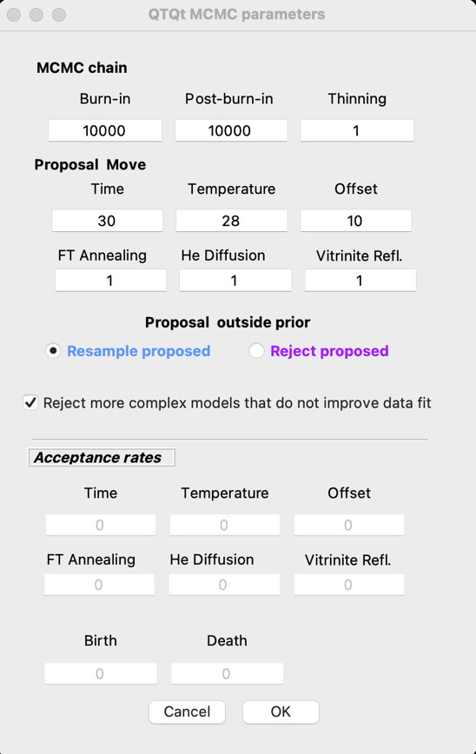MCMC parameters window before running the model.
- Click ‘OK’
- Click on MCMC Run > Run
  - The model will run. The run-time will vary depending on the data you are modelling, the number of iterations and computer speed.
  - After the run the MCMC parameters window reappears.
    - In the MCMC parameters window you will see that the acceptance rates are now populated with values. For the acceptance rates you are looking for values between 0.2 and 0.6.
    - By changing the proposal moves you can change the acceptance rates. If you make the move bigger, you will likely sample more bad models and therefore the acceptance rates go down, and if you decrease the move you will soon make smaller proposal moves when you find a good model. Therefore, the acceptance rate goes up.
    - You want the birth and death rate to be about the same.

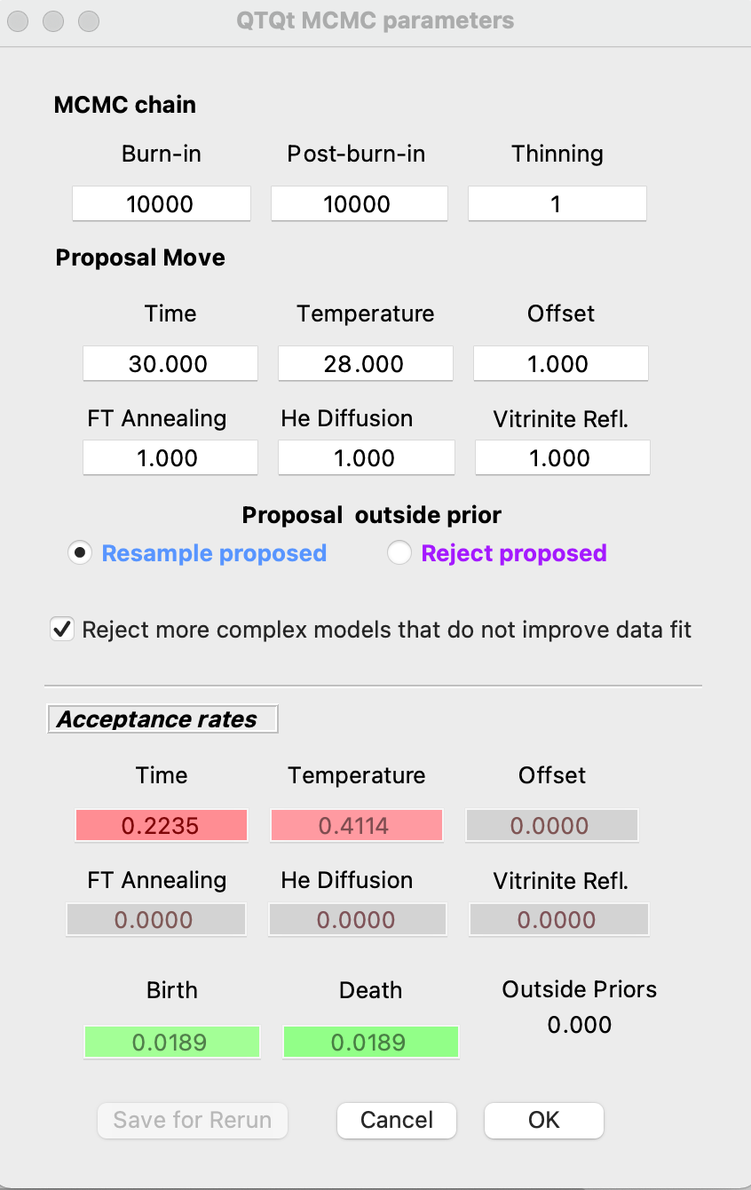MCMC parameters window after completing a run.

- Click ‘OK’
- Select Plotting > Examine Chain > Likelihood Chain/Posterior Chain.
  - These plots let you examine the performance of the MCMC sampling chain in terms of the log likelihood (Likelihood Chain) or log posterior (Posterior Chain) as a function of post-burn-in sampling (red/blue curve; left hand axis). On the same plot, you will see the number of time-temperature points (green curve; right hand axis). There should be no obvious trend in the likelihood/posterior chain (i.e., the mean value should be pretty much flat) and the values should change almost every iteration (i.e., it should not get stuck on the same value for too many iterations). If there is a trend or stasis on a number of t-T points, you will probably need to run the model for longer and modify the MCMC parameters.
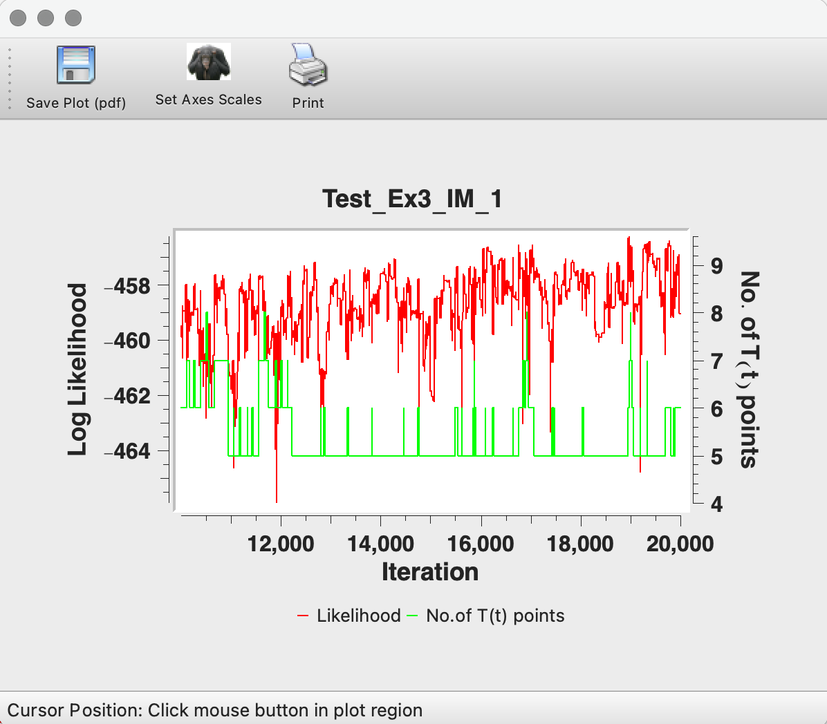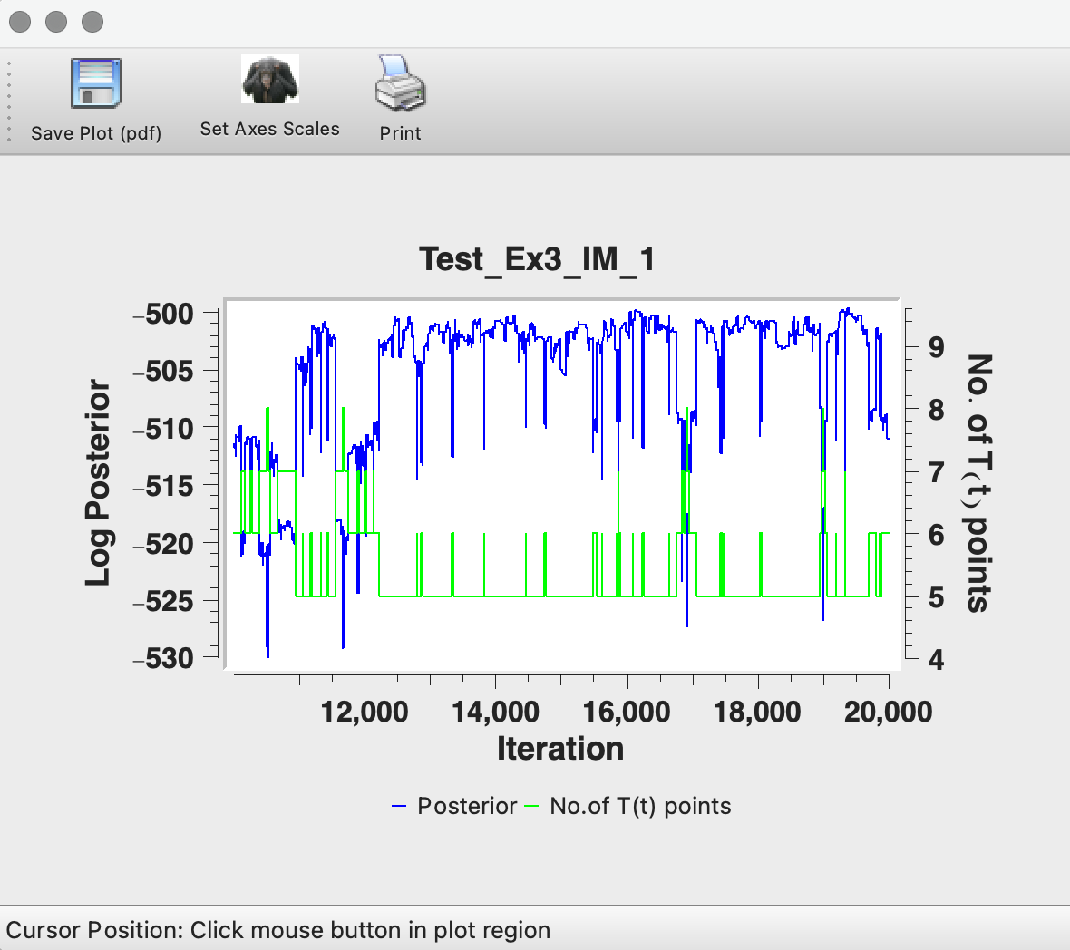
Left image shows Likelihood Chain (red & green) and the right image shows Posterior Chain (blue & green).

- We will be running the model for longer, but we can check the model plots briefly to check our progress.
- Select Plotting > Max. Likelihood Model > Thermal History
  - This is the model that fits the data the best, but will do so with no constraint on the complexity (i.e., number of t-T points) and will often be too complex to be geologically sensible and to be justified by the data.
- Select Plotting > Max. Posterior Model > Thermal History
  - The posterior probability is proportional to the likelihood multiplied by the prior. Due to the trans dimensional MCMC sampling employed by QTQt, this penalises complexity in the model and the maximum posterior model will have less t-T points than the maximum likelihood model.
- Select Plotting > Expected Model > Thermal History
  - In QTQt (with its Bayesian philosophy), the preferred single model is the Expected Model. This is effectively a weighted mean model, where the weighting is provided by the posterior probability for each model. In terms of complexity, it will generally lie between the maximum likelihood and the maximum posterior model.
  - The uncertainty for the expected model are 95% credible intervals where 2.5% of the parameter values lie below and above the limits defined by the range.
- Select Plotting > Expected Model > Plot Individual T(t) > Exercise3_InputData.qtqt
  - The expected model is shown as a black line, as are the 95% credible intervals. The latter are calculated directly from the probability distribution of the model parameter (i.e., the temperature at a given time) and can be asymmetric if the distribution is not symmetric. Underlying these is a colored plot showing the probability density of the thermal history (effectively the probability that the thermal history passes through a box of size 1°C x 1 million years or a time interval defined by dividing the current time range by 100). The probability scale is shown on the right of the plot, blue being low probability and red being higher probability. Also shown on this plot are the maximum likelihood model (red), the maximum posterior model (magenta) and the mode model (white).
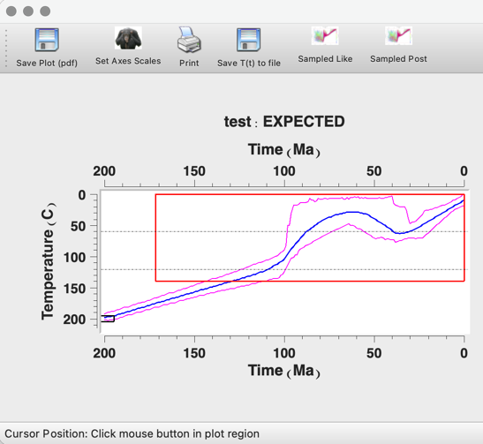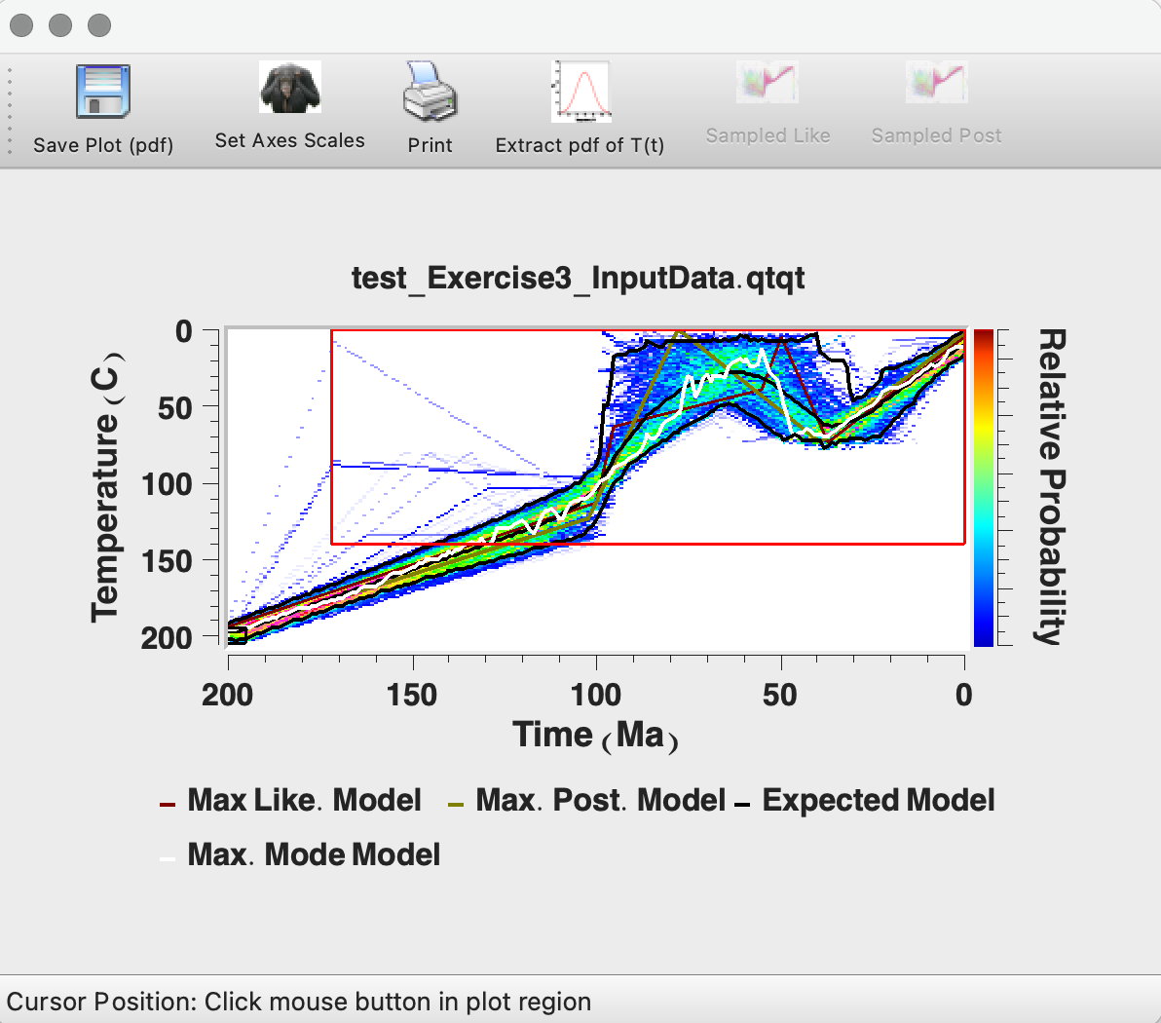
Left image shows the Expected Thermal History. Right images show the Individual T(t) plot.

- Click on Plotting > Expected Model > Plot Individual Predictions. In here you can assess how well the predicted data from the expected model compares with the observed data. Compare this with the predictions for the Posterior model and Likelihood model.
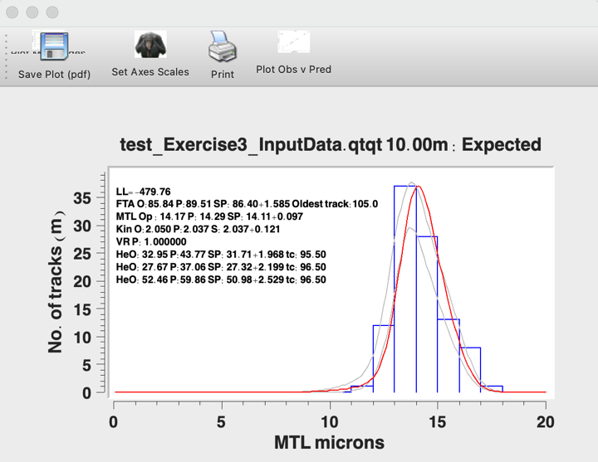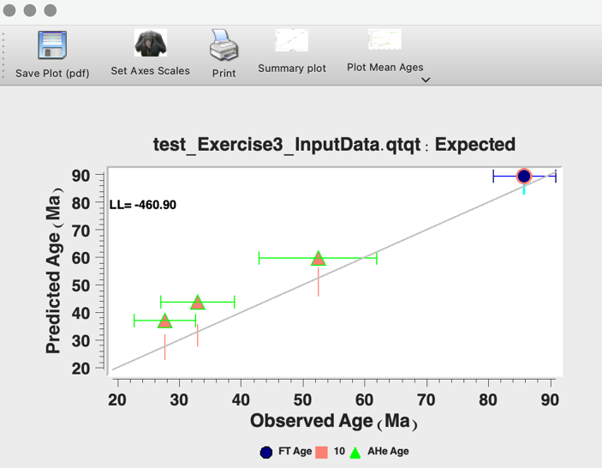
Data predictions for the ‘Expected model’.

- Click on File>Open Previous QTQt Run.
- Navigate to you working directory and open the last run file. In this case it was Exercise3_IM_1.run
  - The idea here is that we are going to continue to run the model after the 10,000 post-burn-in models we run in Run 1. In this way running 3 separate runs with 10,000 post-burn-in models is the same as running once with 30,000 post burn-in models.
  - This allows you to continue running the MCMC algorithm to find additional thermal paths. With the MCMC sampling approach, running 10x 1,000 iterations would be the equivalent of running 1x 10,000.
  - It is good to do short runs while you are tuning the acceptance rates and making sure everything is working and then you do a longer run.
- A dialog box will open asking you if you want to i) start from last model in previous run; ii) start from previous Max. Likelihood model; iii) Start from Random Model; iv) Enter starting model.
  - For this example, we will start from the last model in the previous run. Click ‘OK’
- The run title dialog box will appear. You will notice that if you ended your first run with a ‘1’ it will automatically be given the suffix ‘2’. Click ‘OK’.
- Click MCMC Run > Set MCMC Parameters.
  - The values in the white parameter boxes are carried over from the previous run.
  - The Acceptance Rates that are greyed out at the bottom of the window are the acceptance rates based on the parameters entered for the previous run.
- We will run this model for longer, change the burn-in and post-burn-in to 20,000.
- In our example, the acceptance rates were reasonable. However, as an exercise we will change these to demonstrate their effect.
- Change ‘Time’ from ‘30’ to ‘20’. Click ‘OK’.
- Click MCMC > Run
- After the run has completed you should notice that the acceptance rate for the time parameter has increased a little. Click ‘OK’.
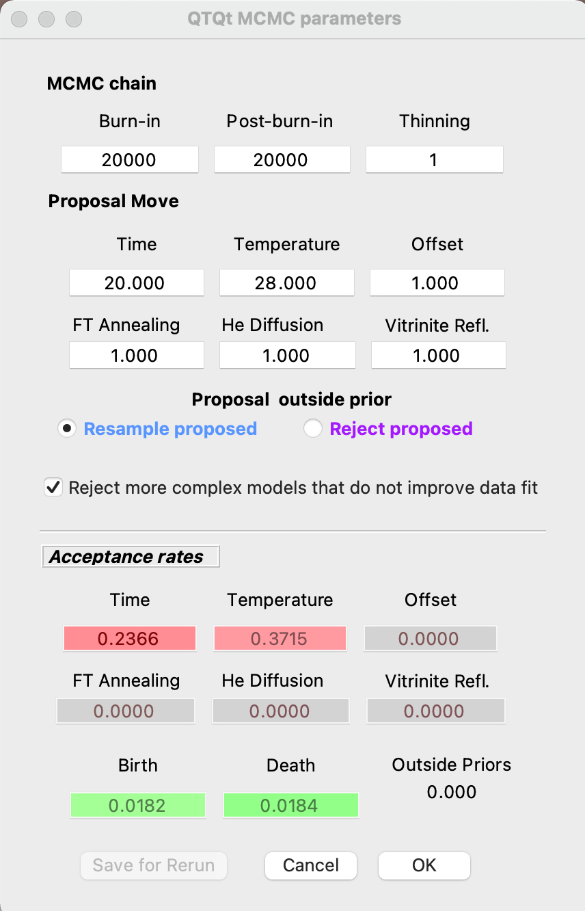

You can see that decreasing the temperature move and the FT annealing move that the acceptance rates have changed. Increasing the time move should normally decrease the acceptance rate but this may not have happened because i) there is a small impact of improving the acceptance rates on temperature and ii) you are still only doing a small number of runs so you may still not be sampling enough poor models.
- Look at the Chain plots and the thermal histories like we did above to see if there is any change in the output.

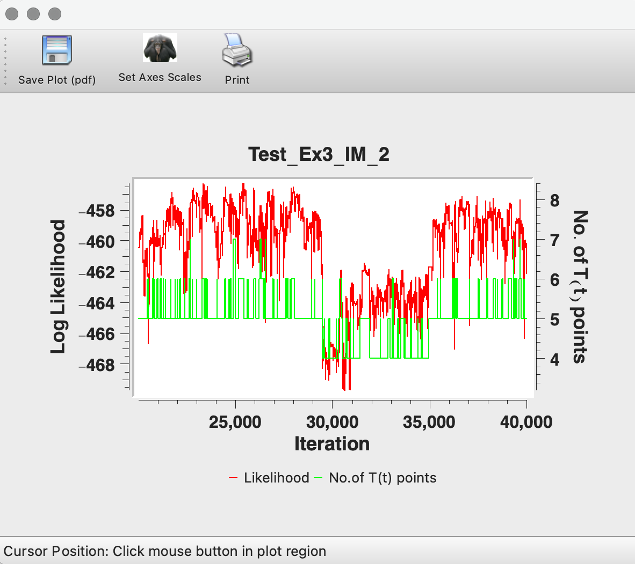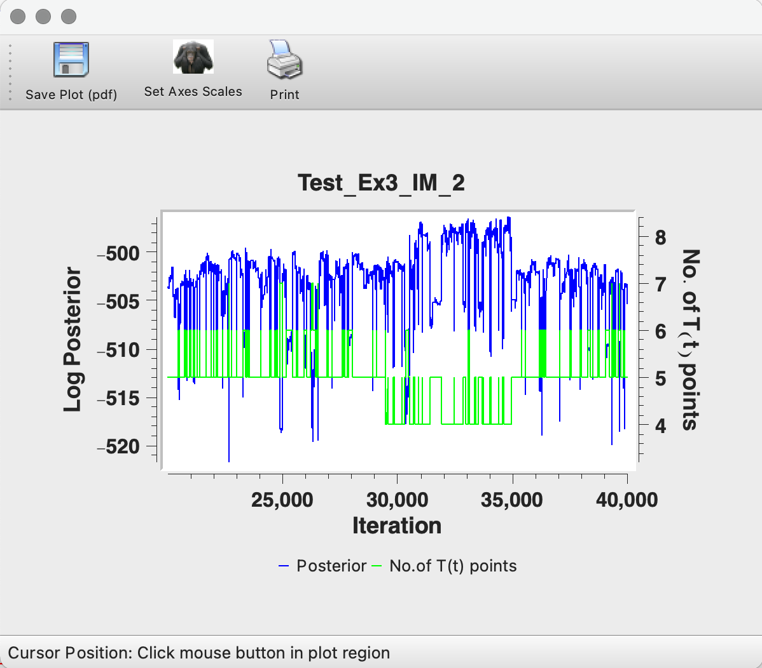
Left image shows Likelihood Chain (red & green) and the right image shows Posterior Chain (blue & green).
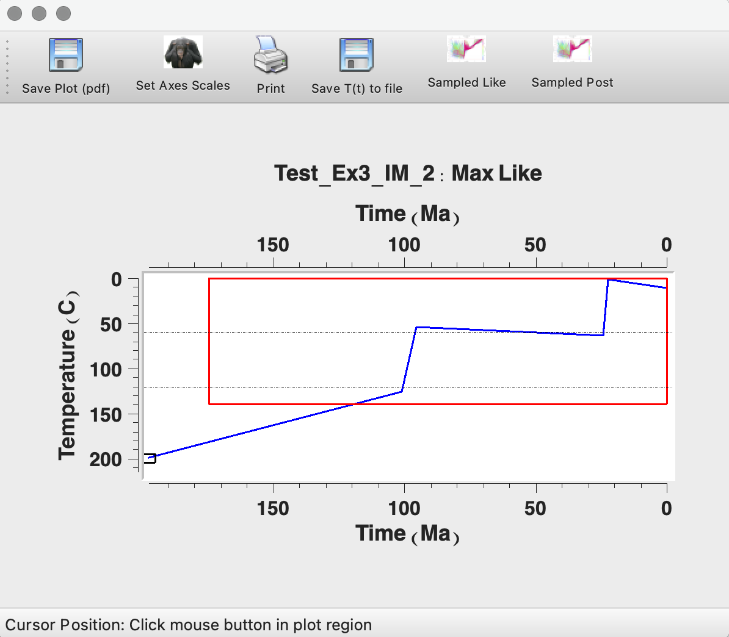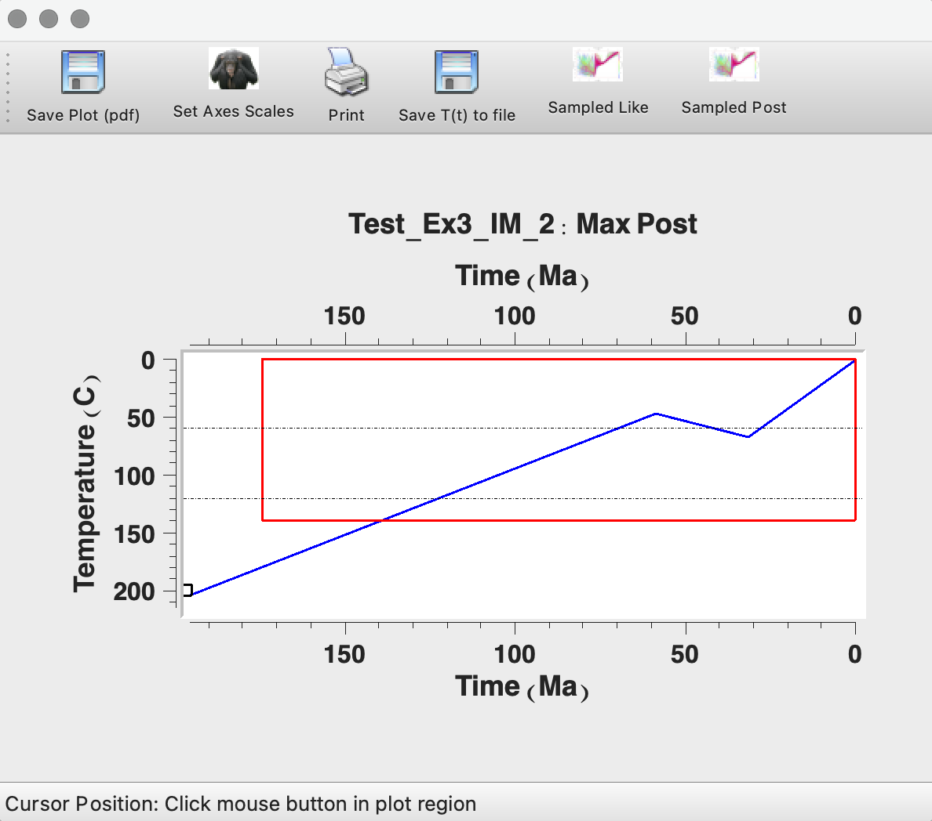
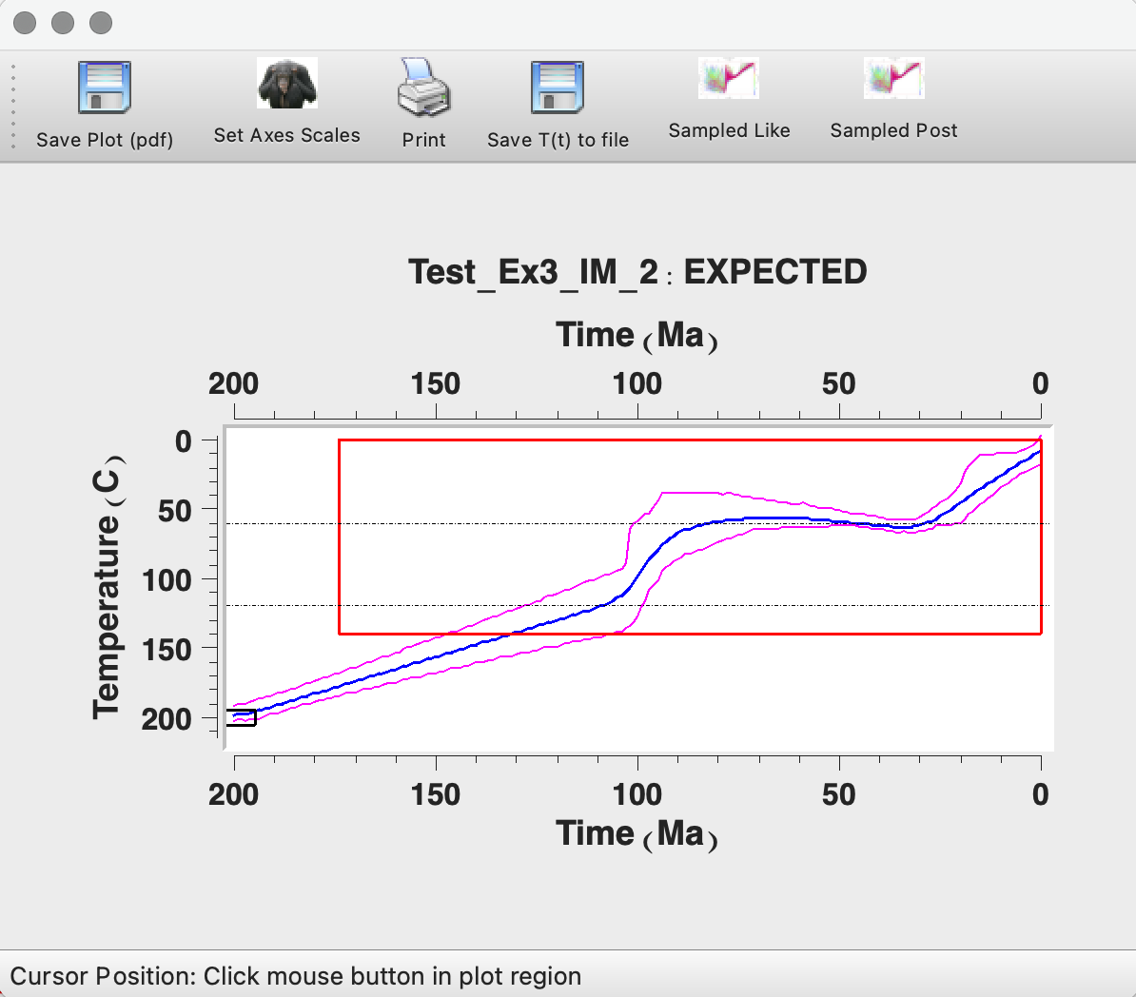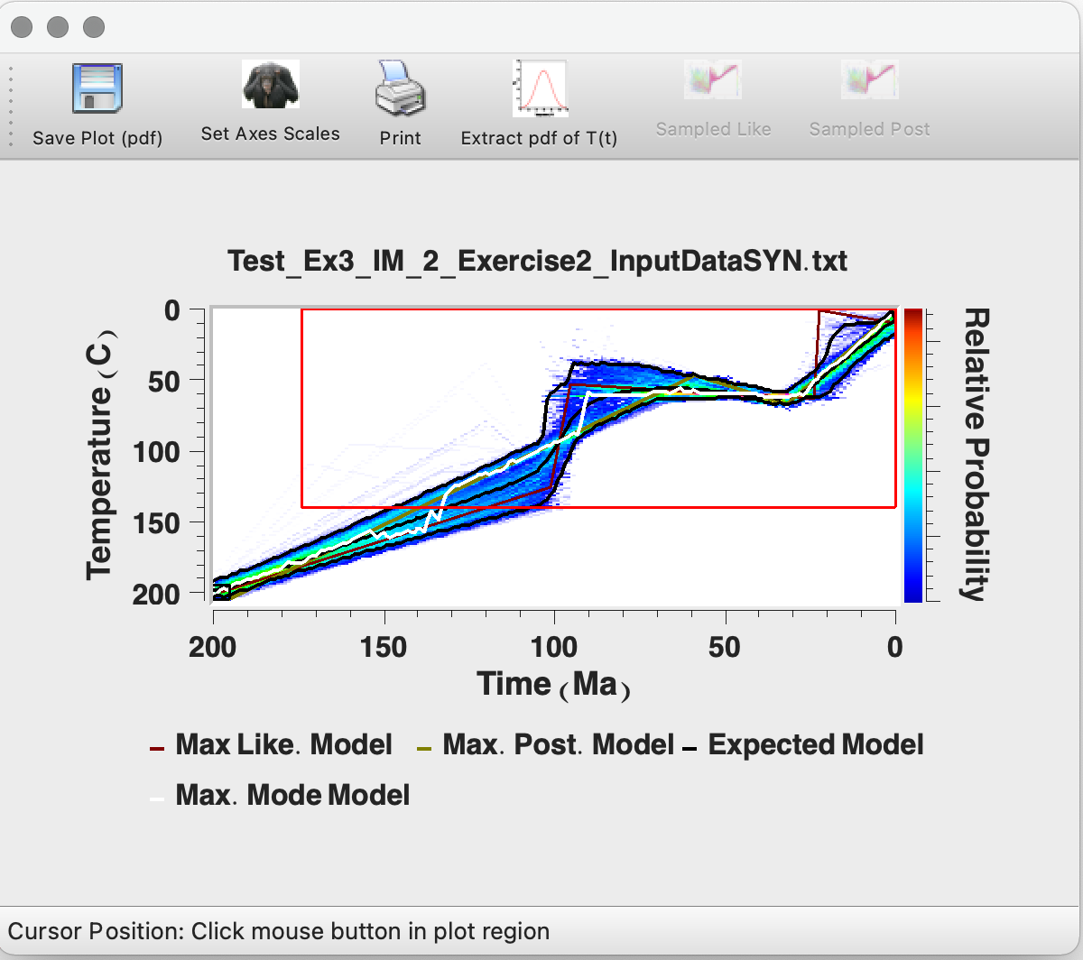
Examples of output thermal histories. Top left: Maximum likelihood model, Top right: Maximum posterior model, Bottom left: Expected model, Bottom right: Individual Tt model for the Expected model.
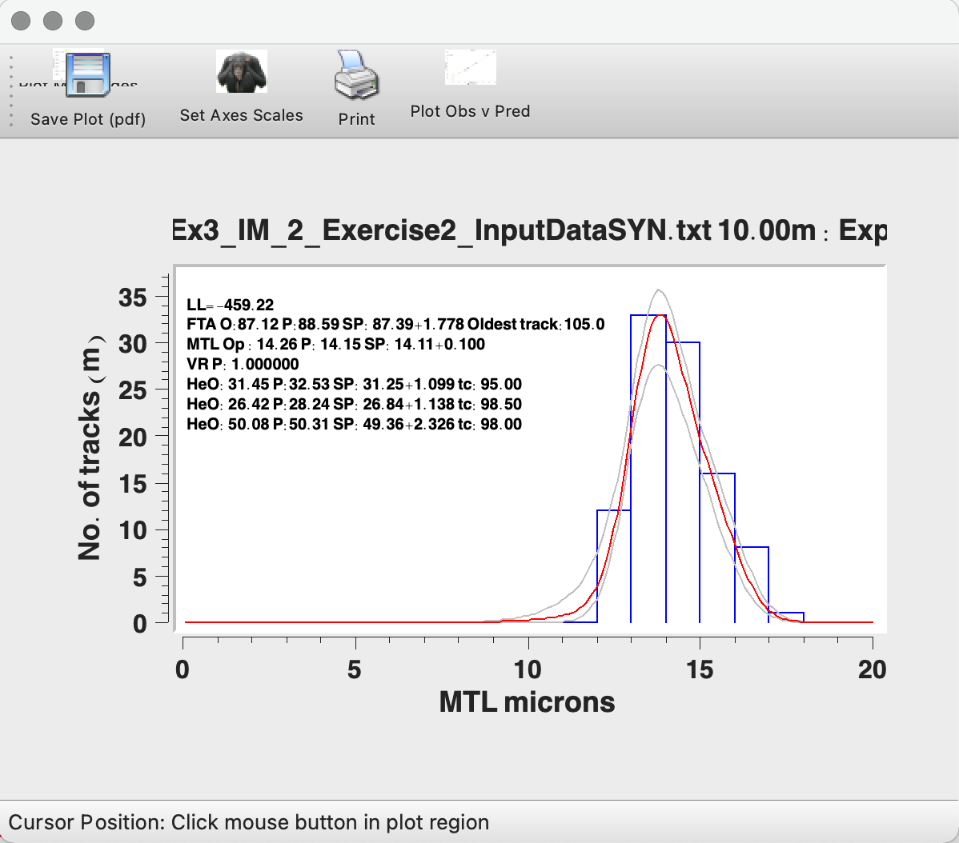
These plots include the track length distribution (observed and predicted, with the 95% credible intervals on the predicted values). They also summarize the predictions of AFT and AHe age and output of any sampling on the kinetic parameter and He ages. Each value is indicated by the following codes: O = observed, P = Predicted, SP = sampled values of the Predicted value, SO = sampled values of the observed value.
- Repeat the above steps but always open the last run you did and change the MCMC move values again to see how they increase and decrease.
- Once you have move values giving you acceptance rates of 0.2-0.6 and the chain looks stable. Do a run with lots of post-burn-in iterations (e.g. 50,000 burn in and 200,000 post burn in).
MCMC parameters window after completing the long run. 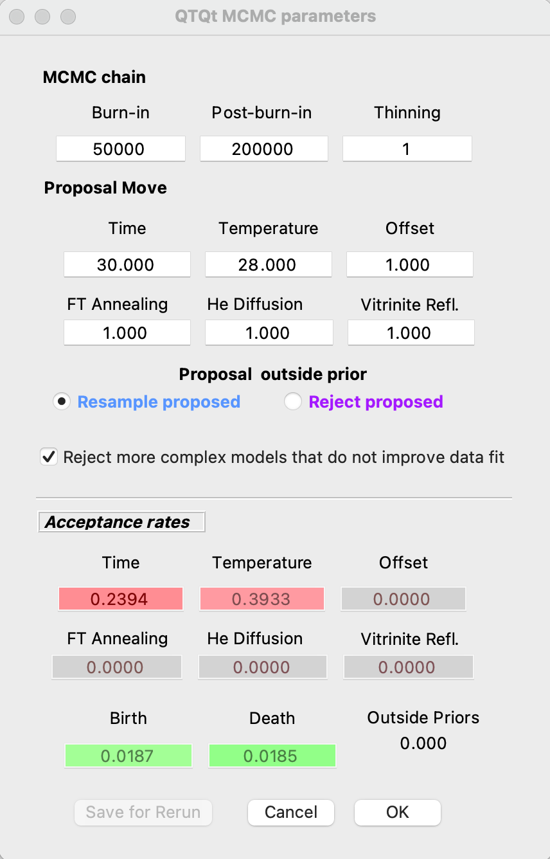

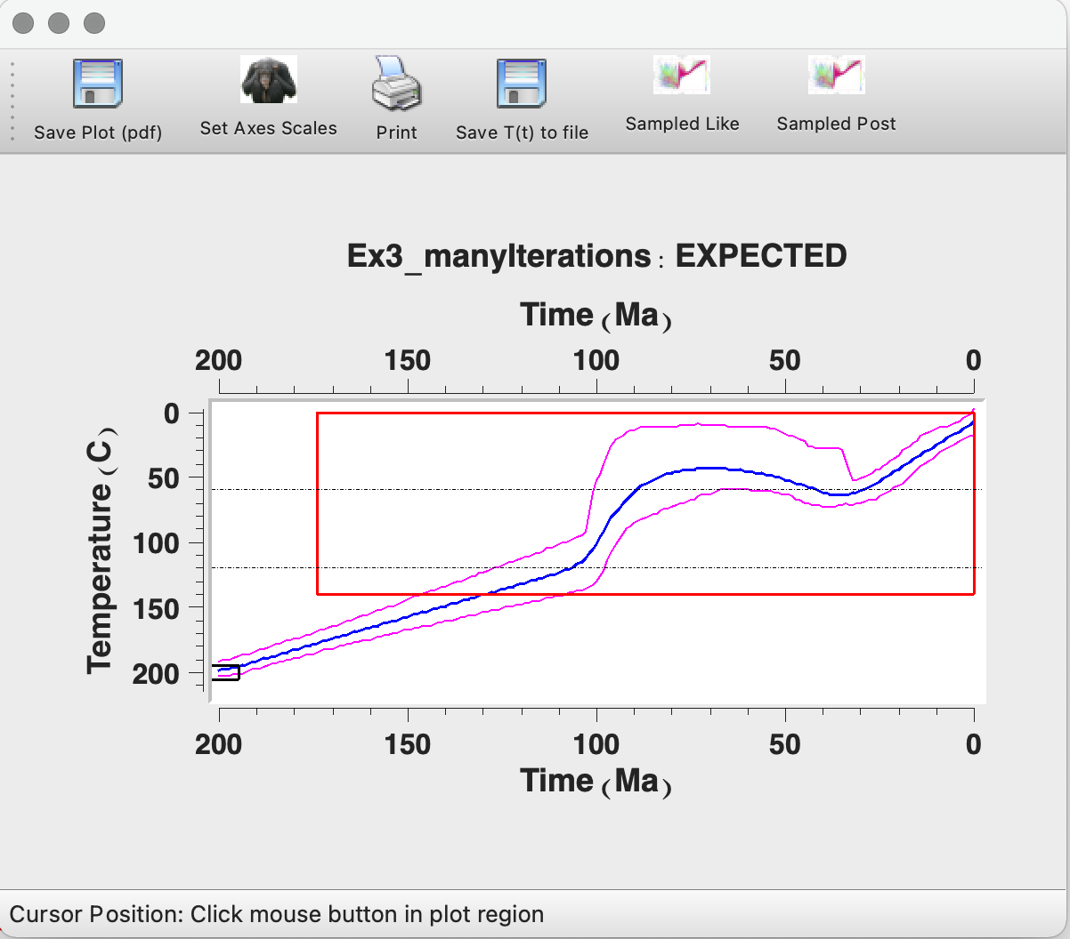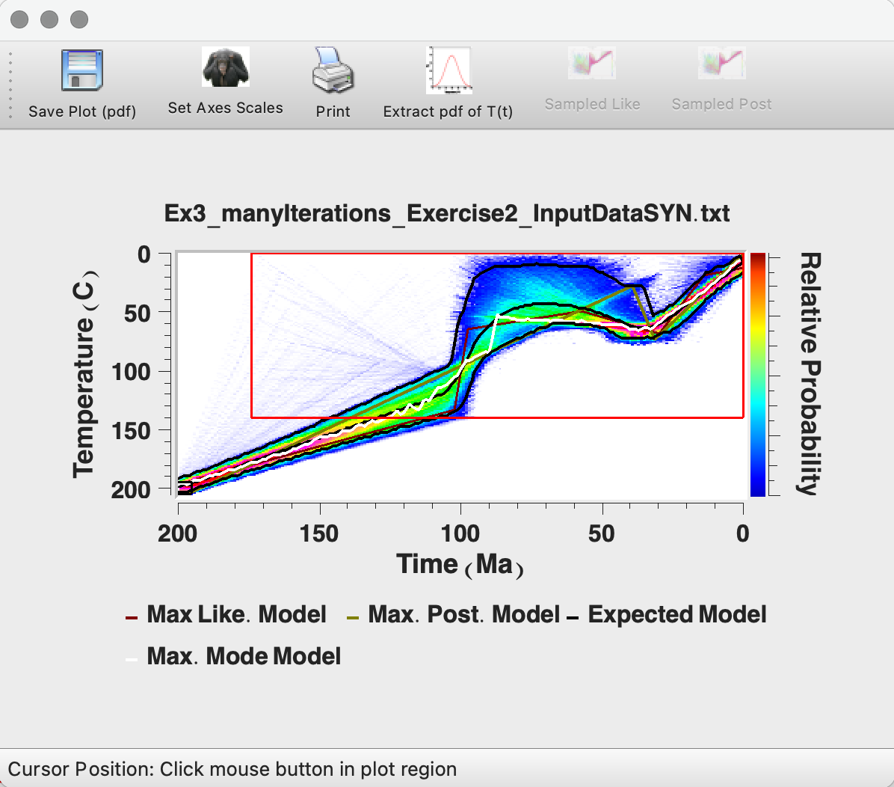
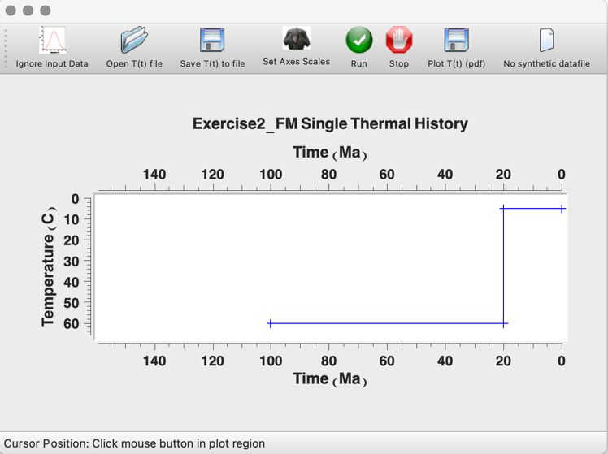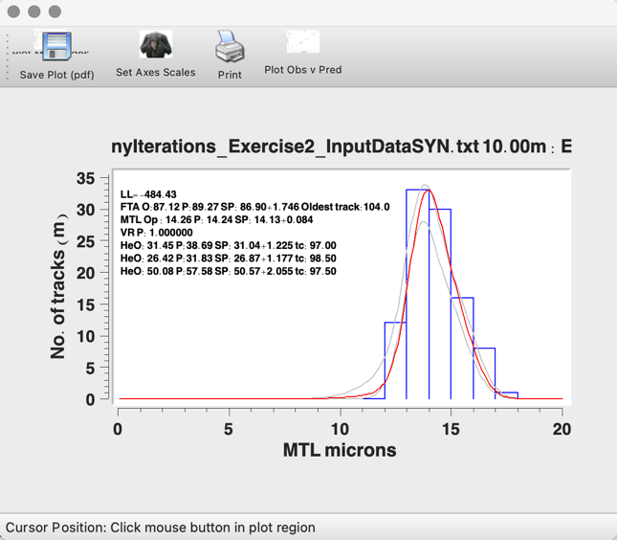
Top left: Expected model. Top right: Individual T(t). Bottom left: Initial Forward Model. Bottom right: Data predictions for expected model.
- Assess the thermal history obtained and the data predictions.
  - How does the expected model compare with the original input forward model?
  - How does the AFT and AHe inverse model compare with the AFT only inverse model and the AHe only inverse model?
  - Look at the Maximum Likelihood, Maximum Posterior and Expected thermal history and look at the predictions for each, what are the main differences?
- You can see that the thermal history does a reasonably good job of returning the initial forward model. The early part of the history, the cooling through the PAZ is retrieved well and the ending of this cooling at 100Ma is also retrieved. Sitting in the PRZ is retrieved well from 100Ma to 30Ma however, the final cooling in the original input didn’t begin until 20Ma. The final cooling event isn’t well retrieved but occurs through temperatures generally colder than the PAZ and PRZ and AFT and AHe are not sensitive to thermal changes at such low temperatures.

Exercise 4: Inverse Modelling 2: User decisions and sensitivity testing

Here will be doing various sensitivity tests to see how various decisions we make in terms of model inputs or parameters may affect the outputs.
We will test four different inputs:
- the initial constraint
- the general prior ranges
- the input data
- the data errors.
Part A: Modifying the initial constraint
- Open the file “Exercise4_InputData.qtqt” this file is the same input file as the last exercise.
- Enter a run title name: “Exercise4_PartA-1_1” and then click ‘OK’.
- Click on Thermal History Constraints > Inverse model prior.
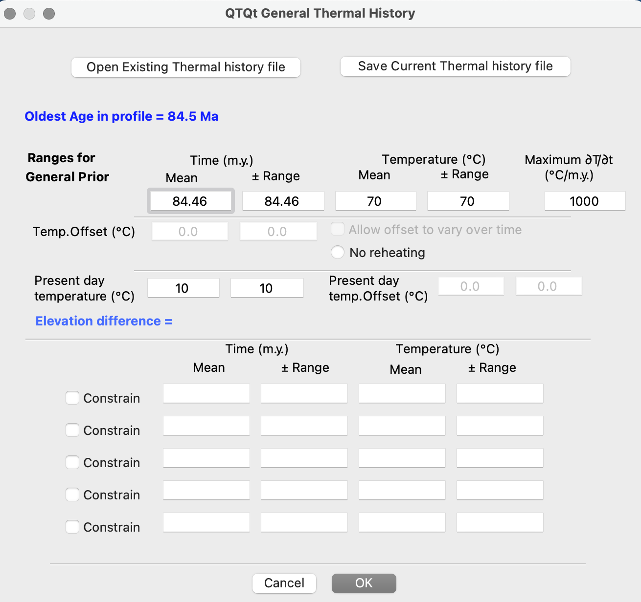
Thermal History Constraints: Inverse model prior information. All is kept at the default values and notice we do not have any constraint information added.
- Click ‘OK’, leaving the default for all options.
- Click on MCMC Run > Set MCMC Parameters.
- Change the number of burn-in runs and post-burn-in runs to 1000. Click ‘OK’
- Click on MCMC Run > Run. Click ‘OK’.
- QTQt will run the inversion. After the model has finished the MCMC parameters window will appear again. Before clicking ‘OK’ make an initial assessment on whether you have good acceptance rates (usually between 0.2 and 0.8 is good). Click ‘OK’.
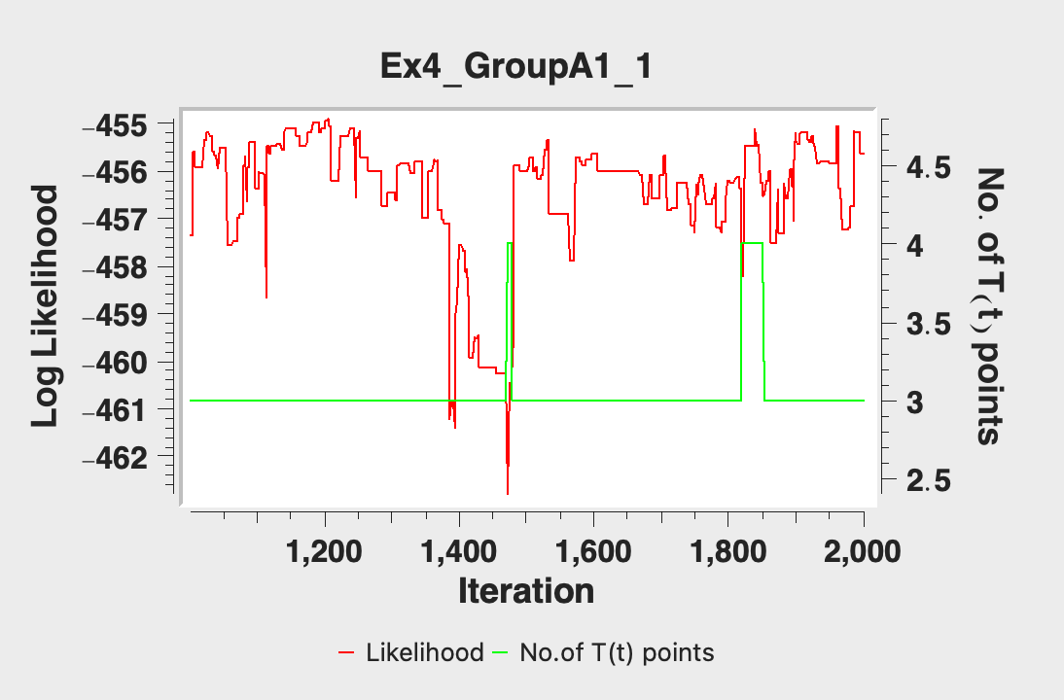
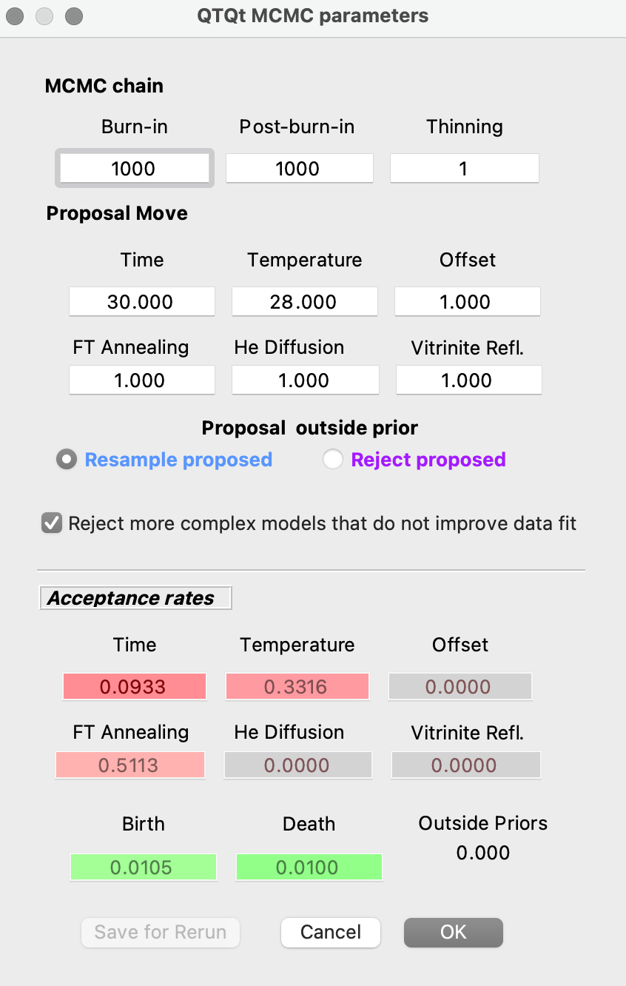
- Select Plotting > Examine Chain > Likelihood Chain/Posterior Chain and assess the stability of the chain.
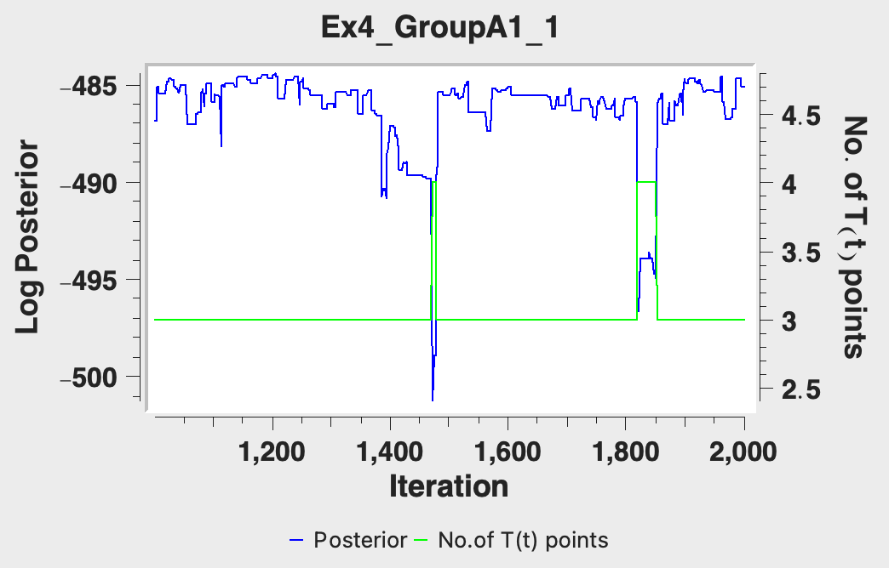
- Select Plotting and go through the same plotting options we explored in the last exercise.
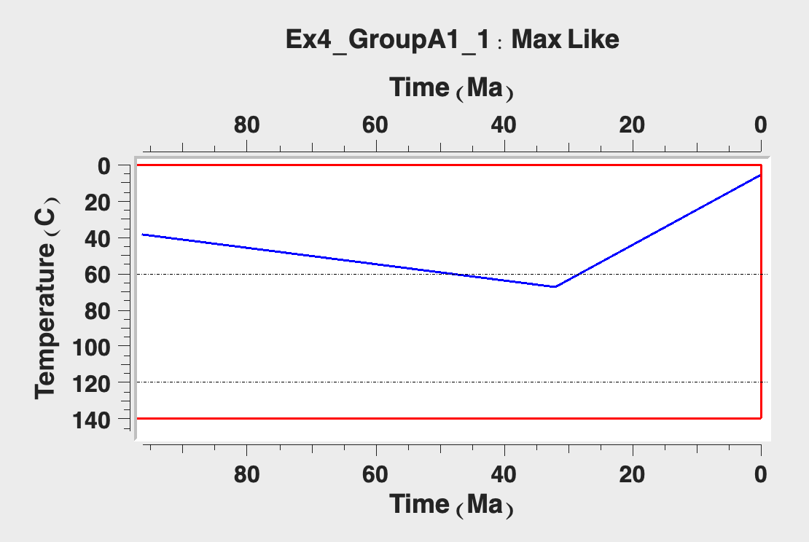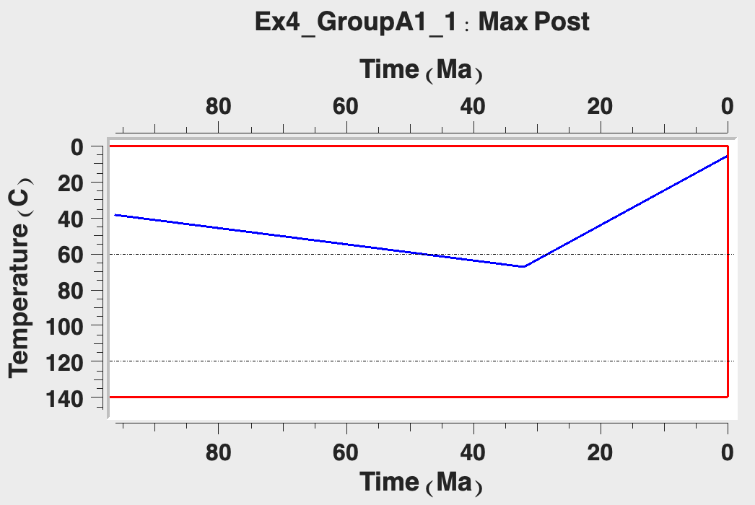
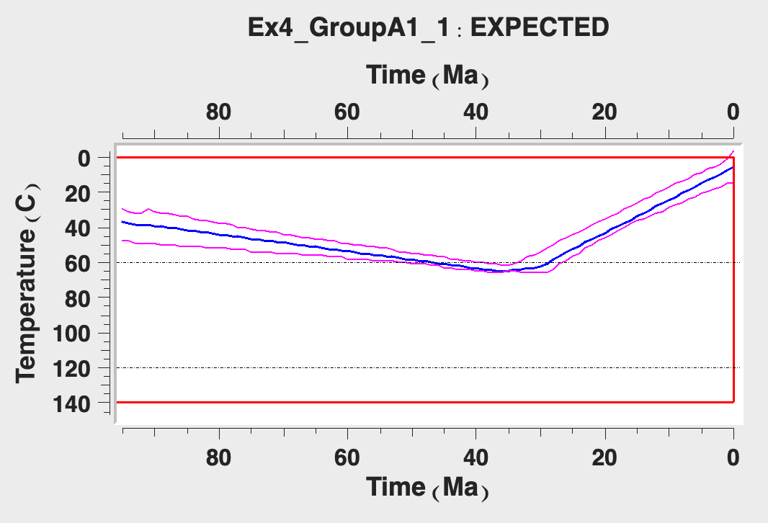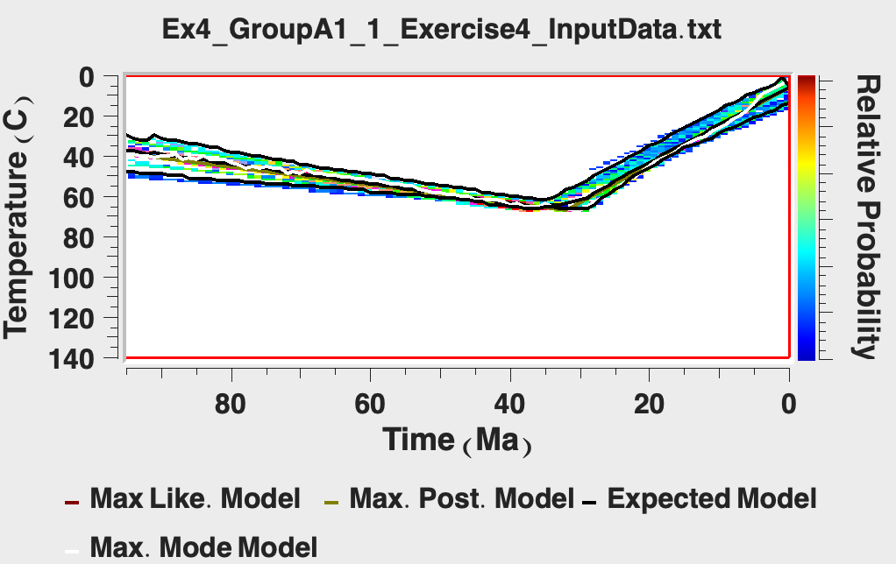
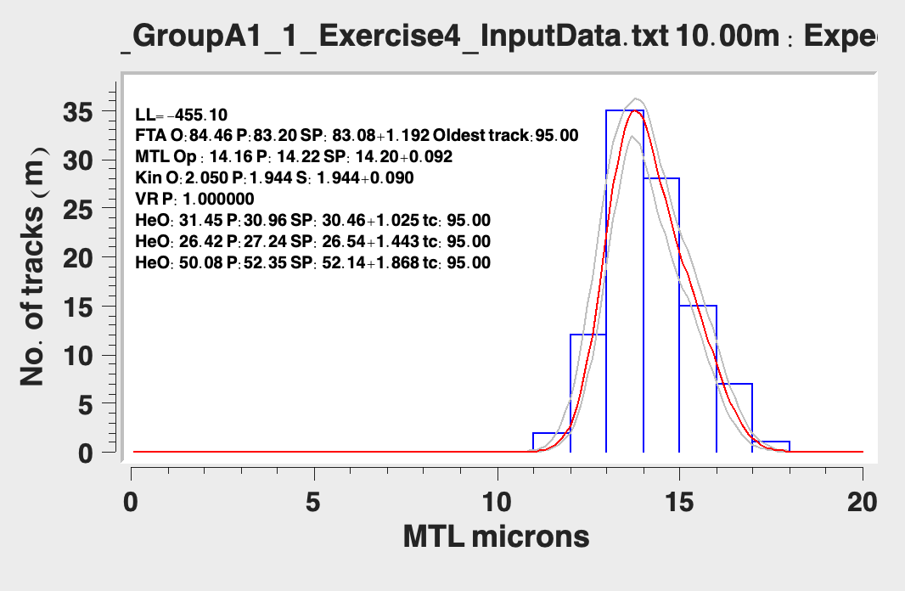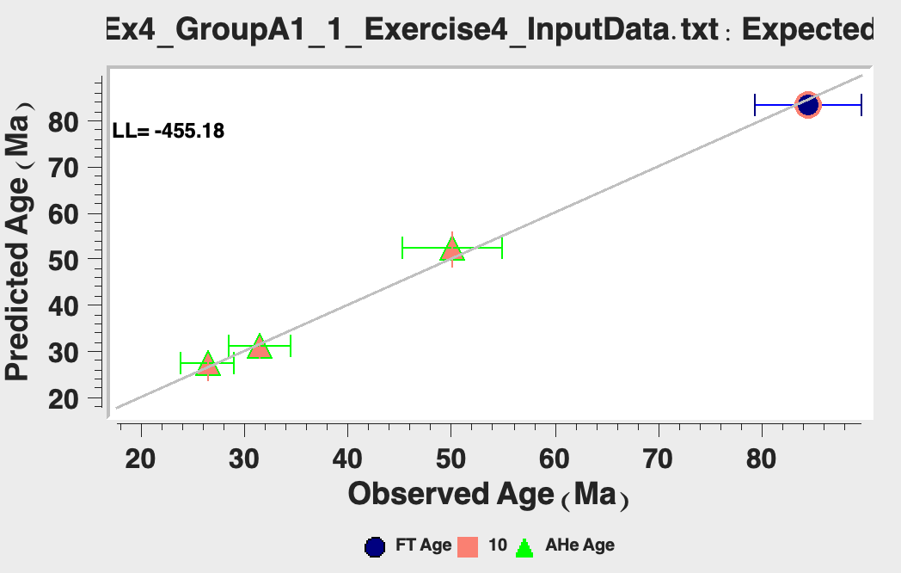
Top left: Maximum likelihood, Top right: Maximum posterior, Middle left: expected model, Middle right: Individual model predictions, Bottom left: Predictions, Bottom right: 1:1 observations vs. predictions.

- Save your plots to look over differences between this test and the following tests.
- Click File > Open Previous QTQt run and select and open the last run file to allow you to continue running the MCMC algorithm to find additional thermal paths and select “Start from last model in previous run”.
- The run title dialog box will appear. You will notice that if you ended your first run with a ‘1’ it will automatically be given the suffix ‘2’. Click ‘OK’.
- Click MCMC Run > Set MCMC Parameters.
- We will run this model for longer, change the burn-in and post-burn-in to 10,000.
- Change the MCMC parameters as required.
- Run the model checking your acceptance rates, likelihood/posterior chains, output models, and predictions.
- Save your plots to look over differences between this test and the following tests.
- Now do a run with 50,000 burn-in and 250,000 post-burn-in iterations.
- Look through the plots from your above runs and take note of the changes that occur based on the number of iterations, as well as how the ‘long run’ outputs compare to the model outputs from exercise 3.
- Repeat the exercise above, but this time name the run “Exercise4_PartA-2_1” and at ‘STEP 4’ enter a constraint at 500 ± 5 Ma, 200 ± 5°C.
- Compare the results from these tests with exercise 3 outputs.
  - What are some of the differences between the outputs, and how might those be explained?
Part B: Modifying the general prior ranges

- Open the file “Exercise4_InputData.qtqt” this file is the same input file as the last exercise.
- Enter a run title name: “Exercise4_PartB-1_1” and then click ‘OK’.
- Click on Thermal History Constraints > Inverse model prior.
- Change ranges for general prior to 500 ± 500 Ma, 150 ± 150°C. Set the same constraint from Exercise 3 (200 ± 5 Ma, 200 ± 5°C) so that you can compare the two outputs.
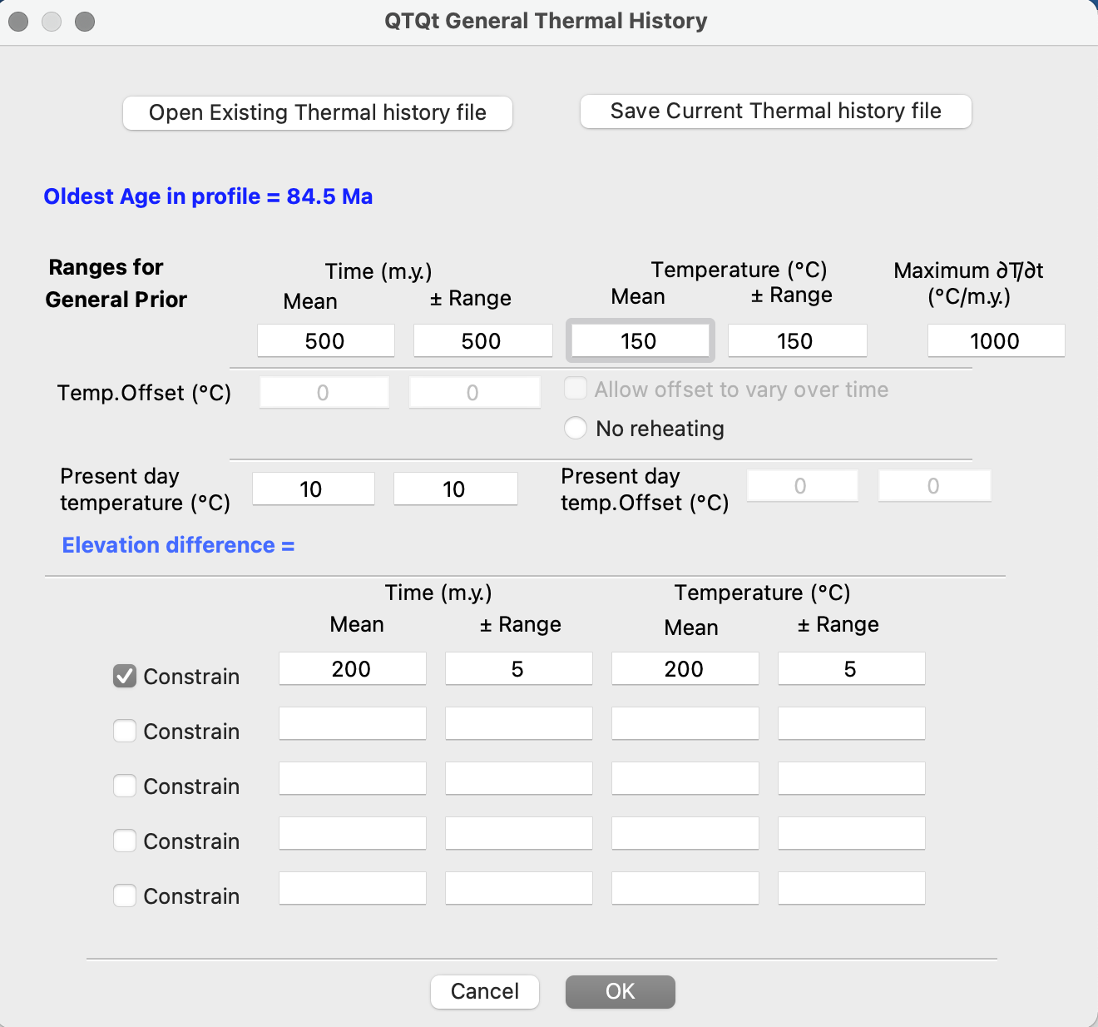
Thermal History Constraints: Inverse model prior information. The time and temperature ranges for the general prior are changes to be very large. Note, we are still adding a constraint box to compare with the outputs from exercise 3, which had the same constraint.
- Click on MCMC Run > Set MCMC Parameters.
- Change the number of burn-in runs and post-burn-in runs to 1000. Click ‘OK’
- Click on MCMC Run > Run. Click ‘OK’.
- QTQt will run the inversion. After the model has finished the MCMC parameters window will appear again. Before clicking ‘OK’ make an initial assessment on whether you have good acceptance rates. Click ‘OK’
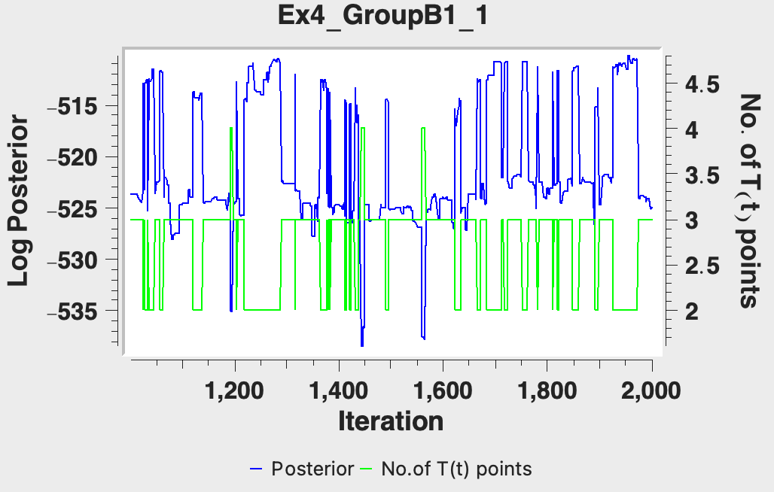
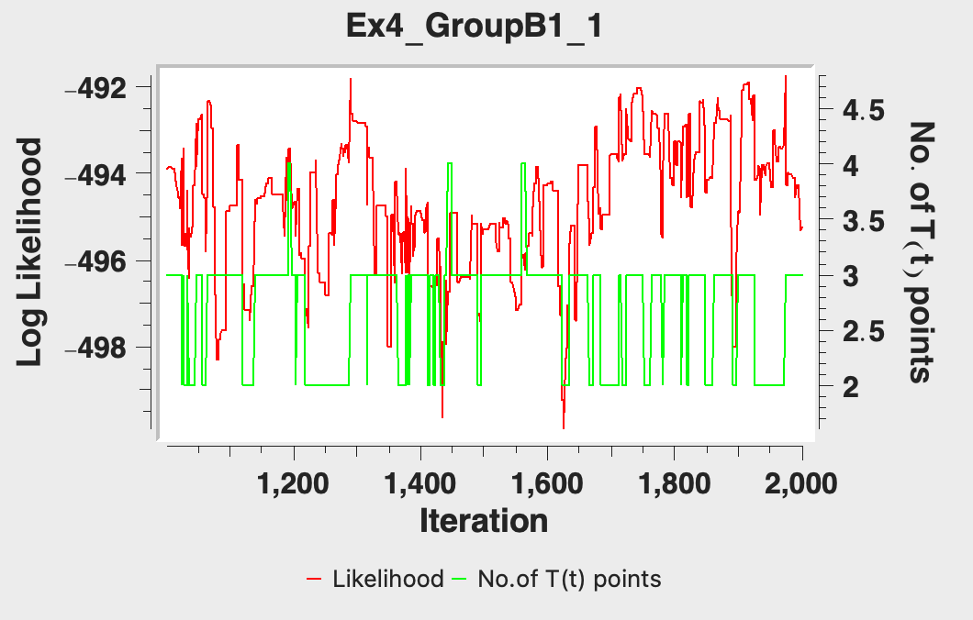
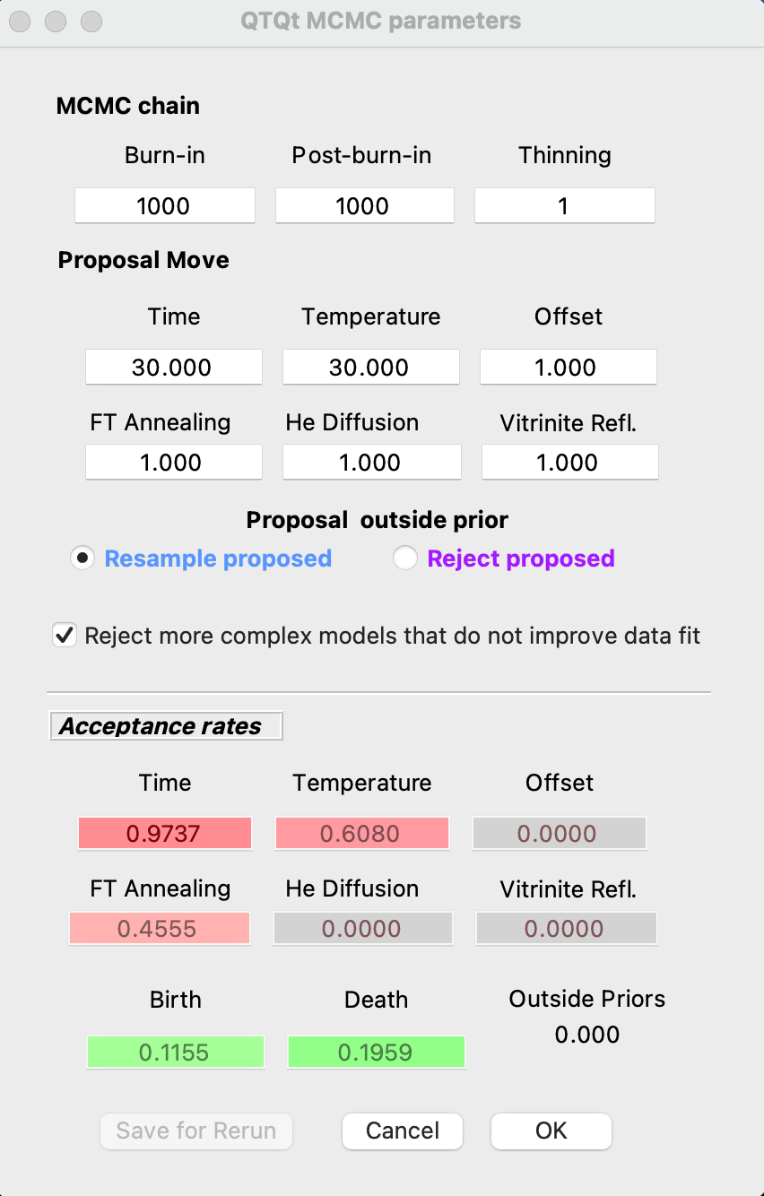
- Select Plotting > Examine Chain > Likelihood Chain/Posterior Chain and assess the stability of the chain.

- Select Plotting and go through the same plotting options we explored in the last exercise.
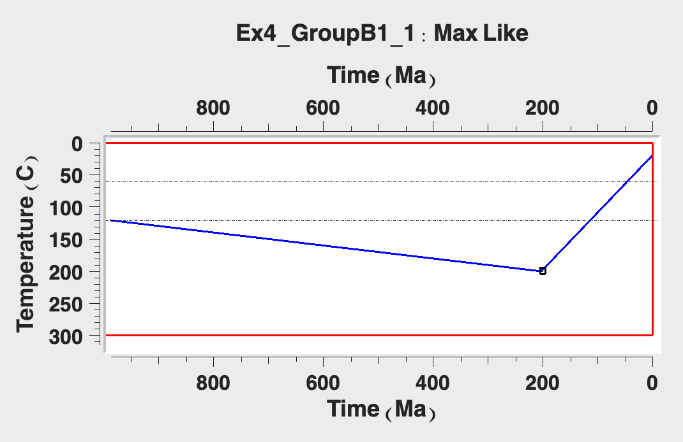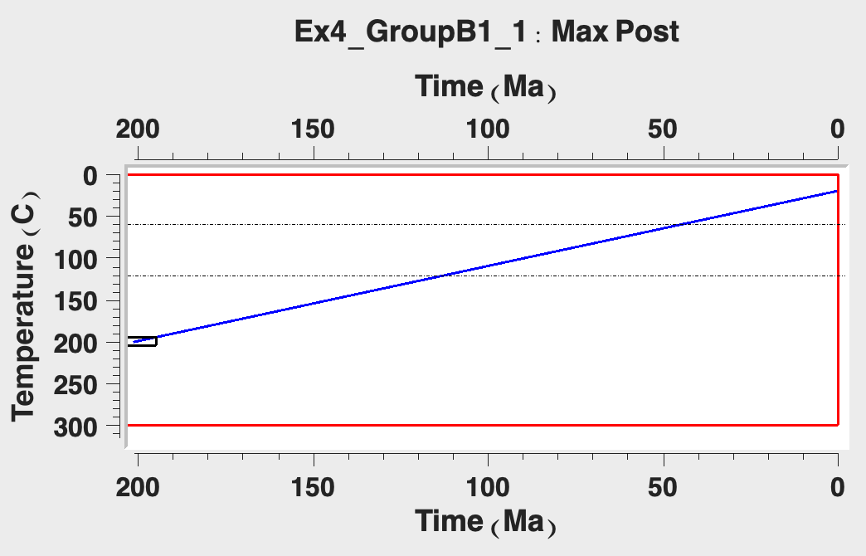
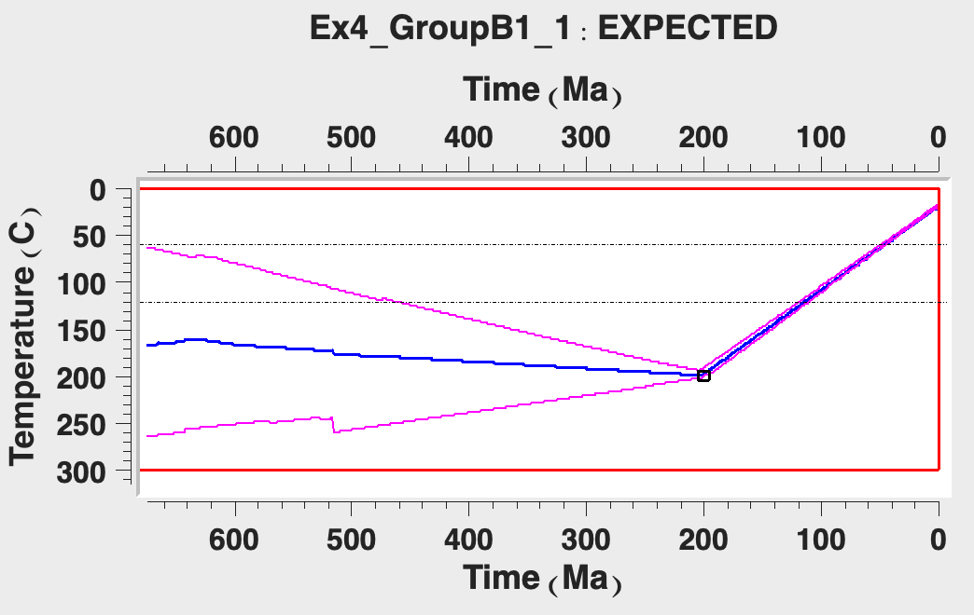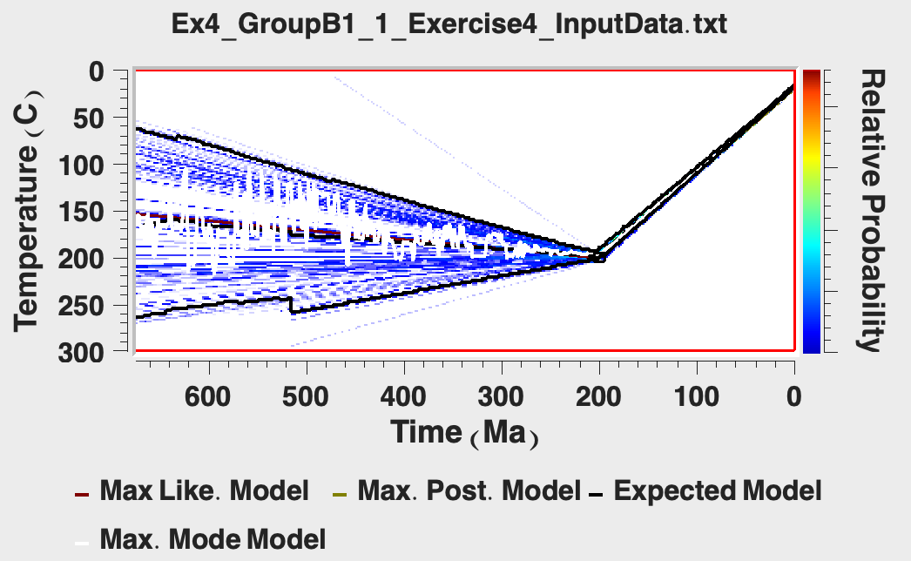
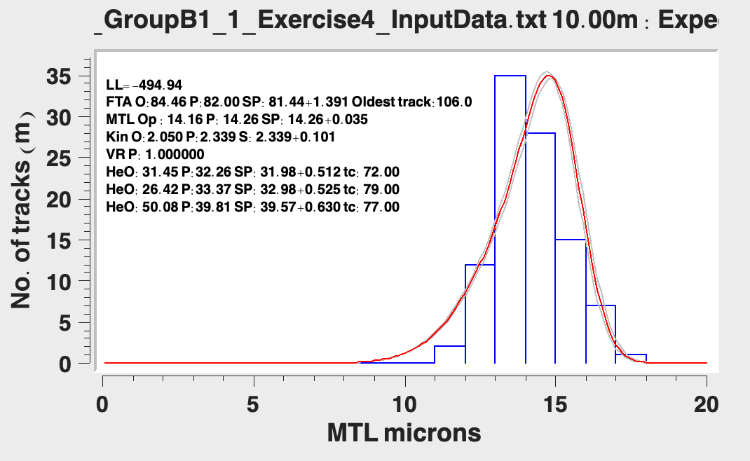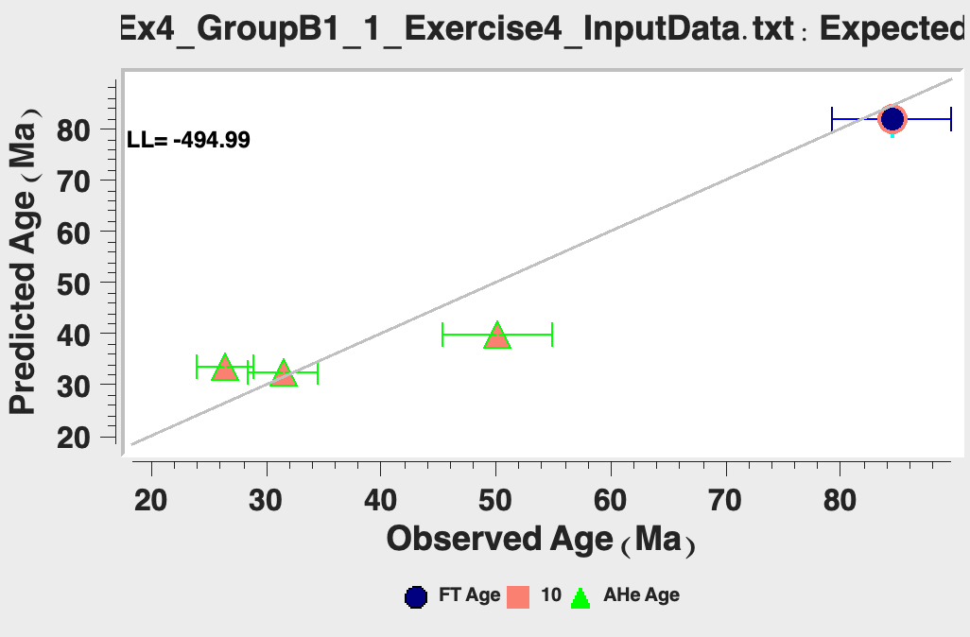
Top left: Maximum likelihood, Top right: Maximum posterior, Middle left: expected model, Middle right: Individual model predictions, Bottom left: Predictions, Bottom right: 1:1 observations vs. predictions.

- Save your plots to look through the differences between this test and the following tests.
- Click File > Open Previous QTQt run and select and open the last run file to allow you to continue running the MCMC algorithm to find additional thermal paths and select “Start from last model in previous run”.
- The run title dialog box will appear. You will notice that if you ended your first run with a ‘1’ it will automatically be given the suffix ‘2’. Click ‘OK’.
- Click MCMC Run > Set MCMC Parameters.
- We will run this model for longer, change the burn-in and post-burn-in to 10,000.
- Change the MCMC parameters as required.
- Click on MCMC Run > Run. Click ‘OK’.
- Save your plots to look over the differences between this test and the following tests.
- Now do a run with 50,000 burn-in and 250,000 post-burn-in iterations.
- Look through the plots from your above runs and take note of the changes that occur based on the number of iterations, as well as how the ‘long run’ outputs compare to the model outputs from exercise 3.
- Repeat the exercise above, but this time name the run “Exercise4_PartB-2_1” and at ‘STEP 4’ enter range for general prior of 50 ± 50 Ma, 70 ± 70°C.
- Compare the results from these tests with exercise 3 outputs.
  - What are some of the differences between the outputs, and how might those be explained?

Part C: Using different data inputs

- Open the file “Exercise4_InputData_UThHe_only_dataset1.txt” . This file is the same input file as the last exercise, but the AFT data has been removed leaving only the U-Th/He data.
- Enter a run title name: “Exercise4_PartC-1_1” and then click ‘OK’.
- Click on Thermal History Constraints > Inverse model prior.
- Set the same constraint from Exercise 3 (200 ± 5 Ma, 200 ± 5°C) so that you can compare the two outputs. Click ‘OK’, leaving the default for all other options.
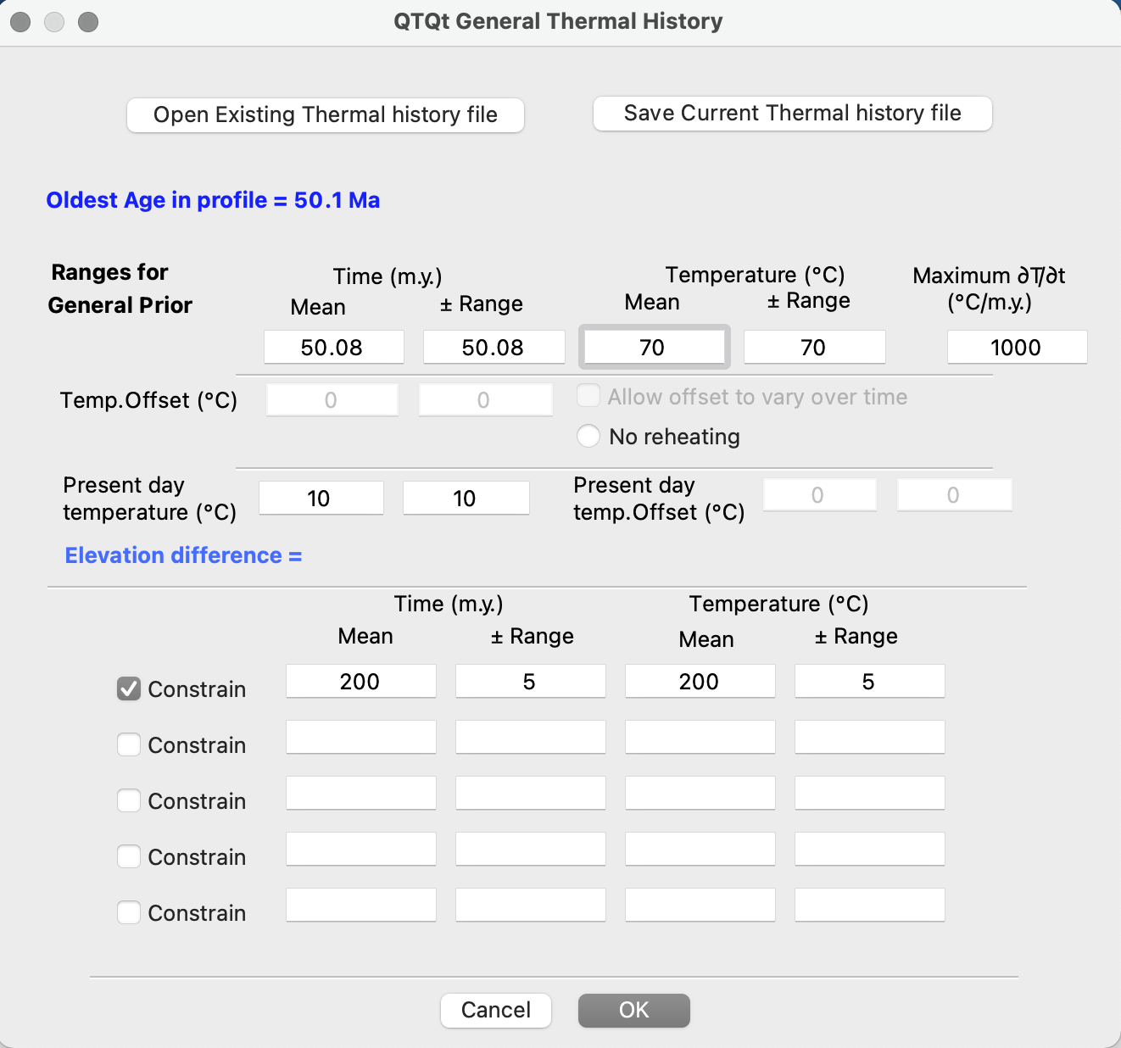
Thermal History Constraints: Inverse model prior information. All is kept at the default values, although we are still adding a constraint box to compare with the outputs from exercise 3, which had the same constraint.

- Click on MCMC Run > Set MCMC Parameters.
- Change the number of burn-in runs and post-burn-in runs to 1000. Click ‘OK’.
- Click on MCMC Run > Run. Click ‘OK’.
- QTQt will run the inversion. After the model has finished the MCMC parameters window will appear again. Before clicking ‘OK’ make an initial assessment on whether you have good acceptance rates. Click ‘OK’

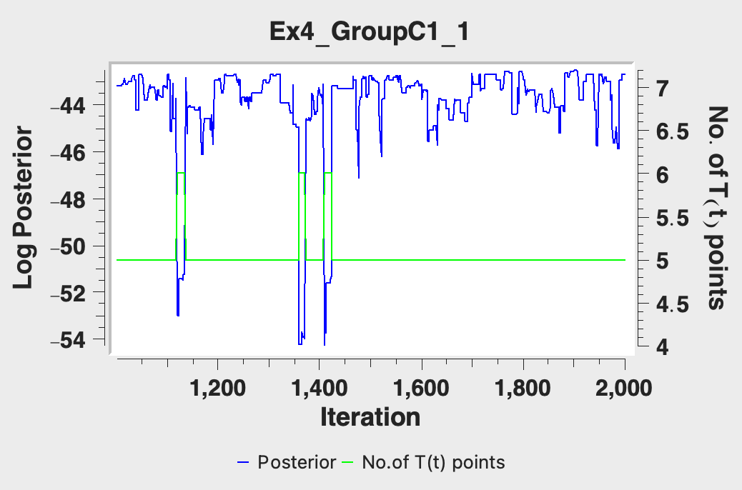
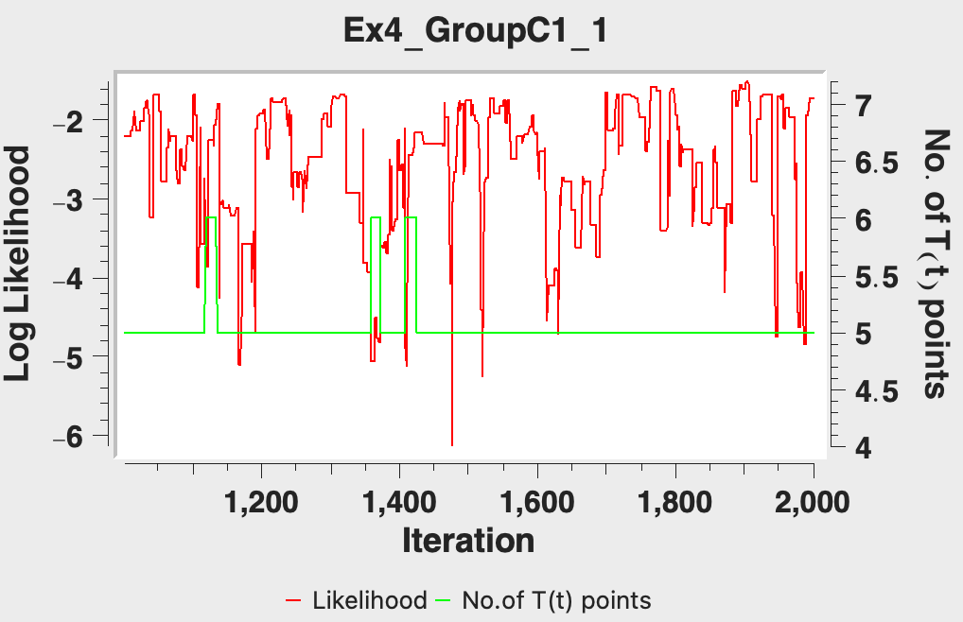
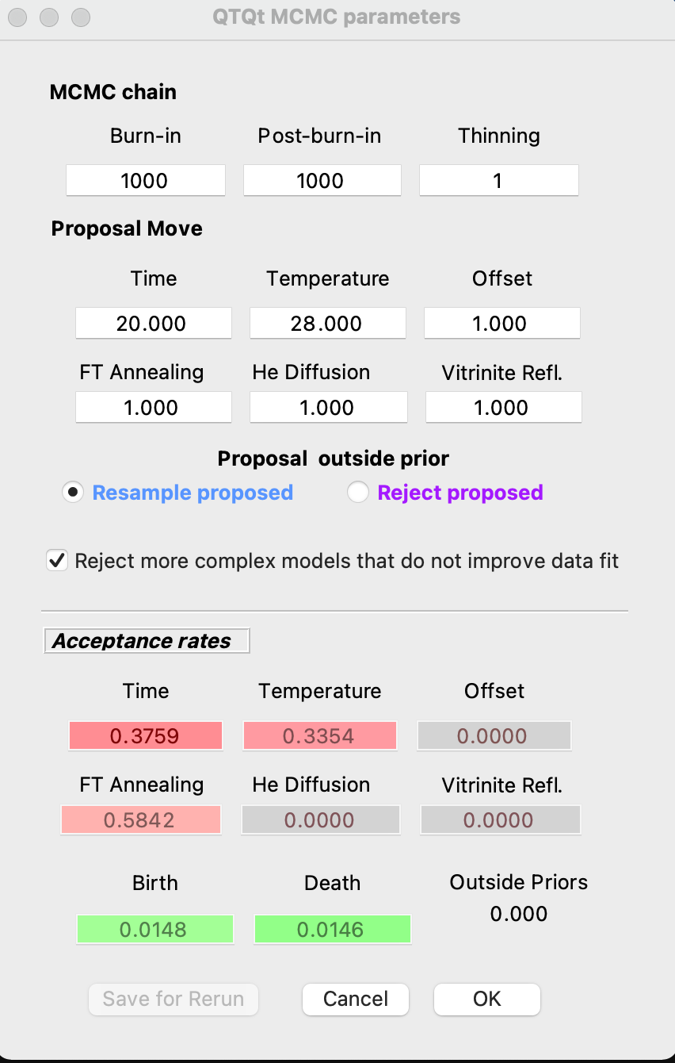
- Select Plotting > Examine Chain > Likelihood Chain/Posterior Chain and assess the stability of the chain.

- Select Plotting and go through the same plotting options we explored in the last exercise.
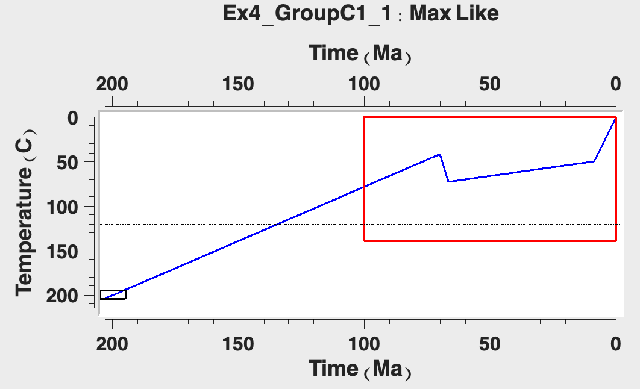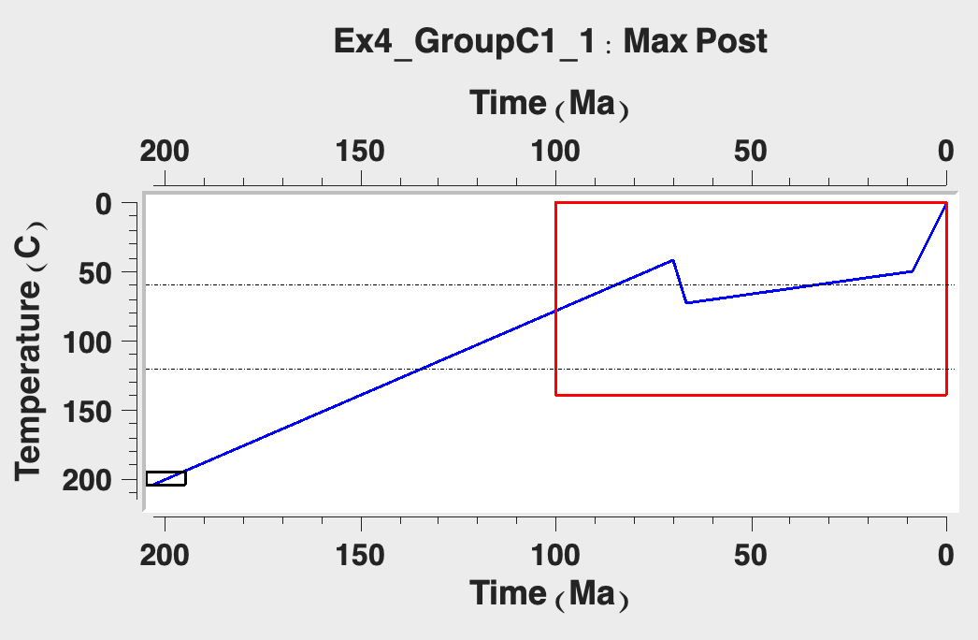
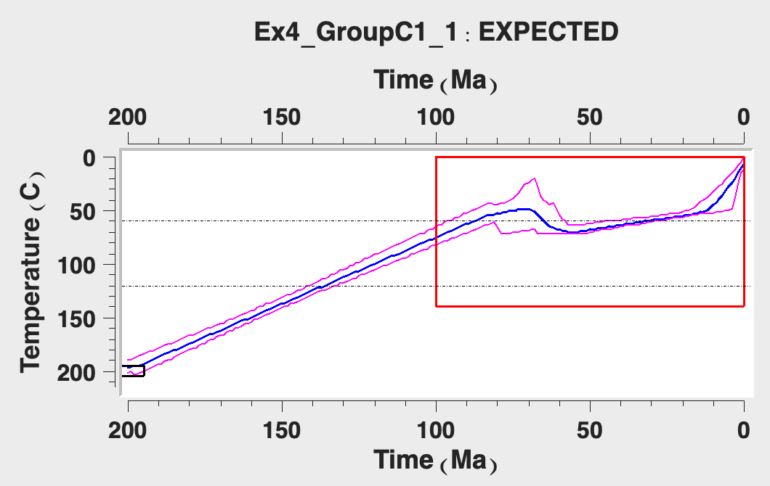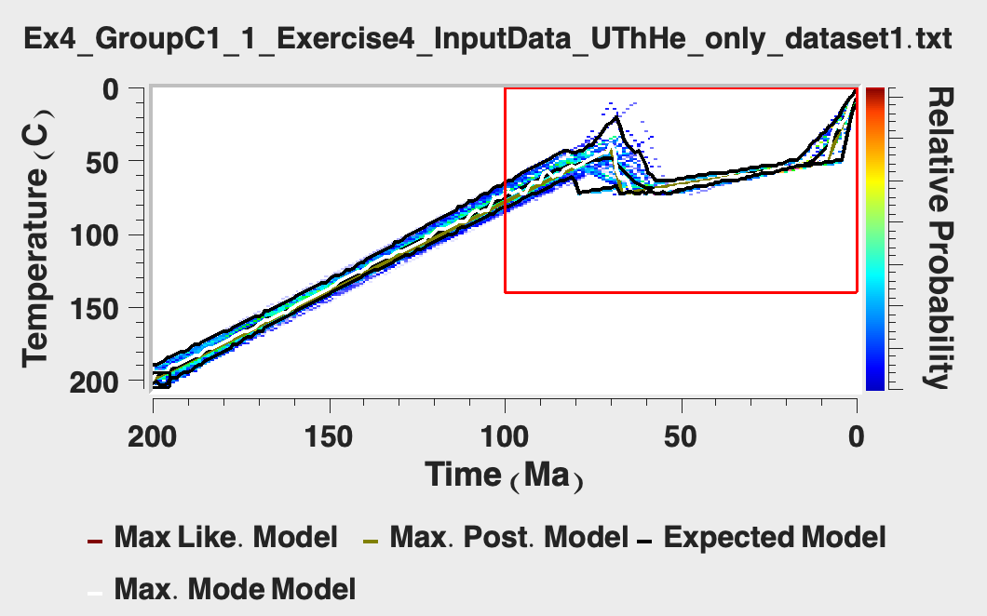
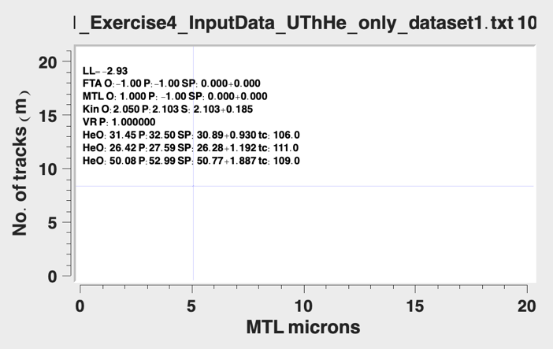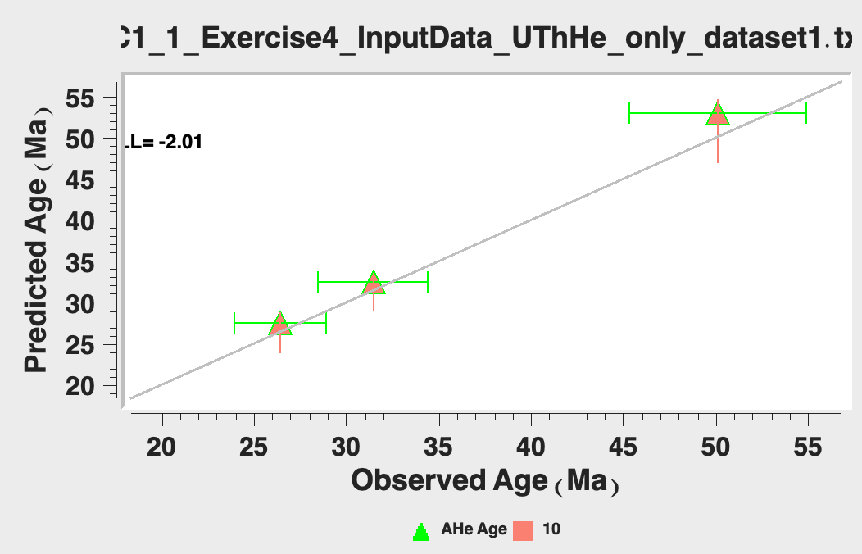
Top left: Maximum likelihood, Top right: Maximum posterior, Middle left: expected model, Middle right: Individual model predictions, Bottom left: Predictions, Bottom right: 1:1 observations vs. predictions.

- Save your plots to look through the differences between this test and the following tests.
- Click File > Open Previous QTQt run and select and open the last run file to allow you to continue running the MCMC algorithm to find additional thermal paths and select “Start from last model in previous run”.
- The run title dialog box will appear. You will notice that if you ended your first run with a ‘1’ it will automatically be given the suffix ‘2’. Click ‘OK’.
- Click MCMC Run > Set MCMC Parameters.
- We will run this model for longer, change the burn-in and post-burn-in to 10,000.
- Change the MCMC parameters as required.
- Click on MCMC Run > Run. Click ‘OK’.
- Save your plots to look over the differences between this test and the following tests.
- Now do a run with 50,000 burn-in and 250,000 post-burn-in iterations.
- Look through the plots from your above runs and take note of the changes that occur based on the number of iterations, as well as how the ‘long run’ outputs compare to the model outputs from exercise 3.
- Repeat the exercise above, but this time open the file “Exercise4_InputData_UThHe _only_dataset2.txt”, and name the run “Exercise4_PartC-2_1”.
- Compare the results from these tests with exercise 3 outputs.
- What are some of the differences between the outputs, and how might those be explained?

Part D: Modifying the data errors

- Open the file “Exercise4_InputData_smallErr_dataset.txt” this file is the same input file as the last exercise, but the 5% error on the AHe data has been reduced to a 1% error.
- Enter a run title name: “Exercise4_PartD-1_1” and then click ‘OK’.
- Click on Thermal History Constraints > Inverse model prior.
- Set the same constraint from Exercise 3 (200 ± 5 Ma, 200 ± 5°C) so that you can compare the two outputs. Click ‘OK’, leaving the default for all other options.
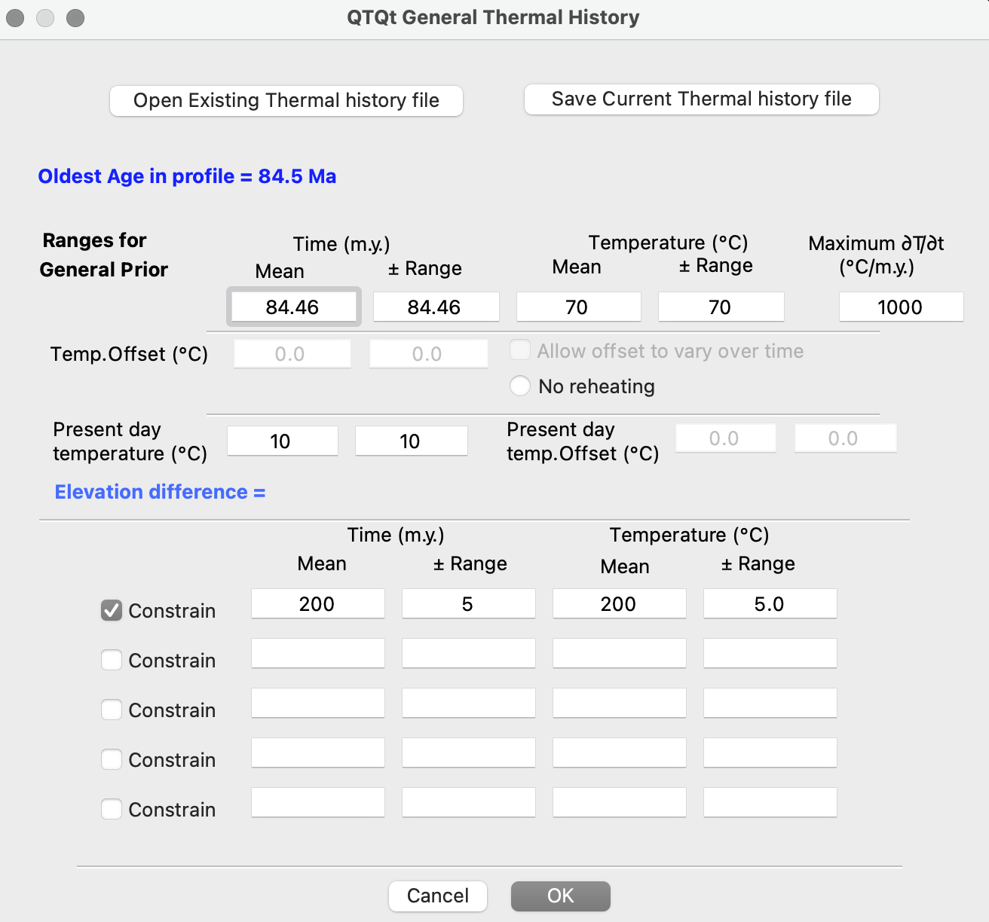
Thermal History Constraints: Inverse model prior information. All is kept at the default values, although we are still adding a constraint box to compare with the outputs from exercise 3, which had the same constraint.
- Click on MCMC Run > Set MCMC Parameters.
- Change the number of burn-in runs and post-burn-in runs to 1000. Click ‘OK’
- Click on MCMC Run > Run. Click ‘OK’.
- QTQt will run the inversion. After the model has finished the MCMC parameters window will appear again. Before clicking ‘OK’ make an initial assessment on whether you have good acceptance rates. Click ‘OK’
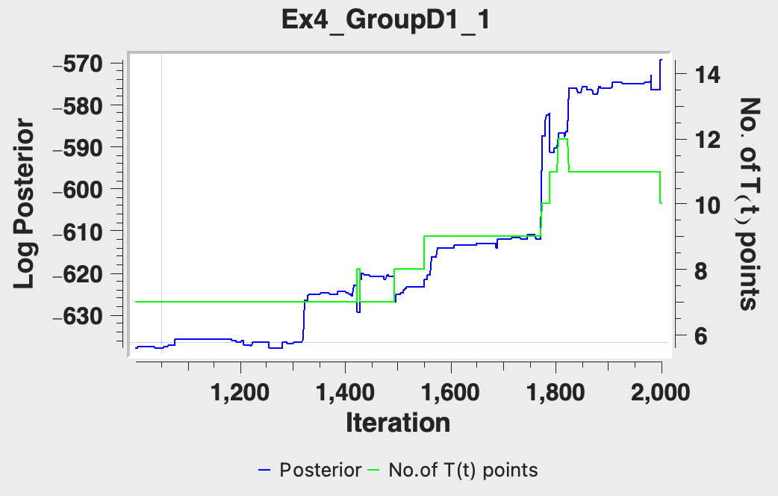
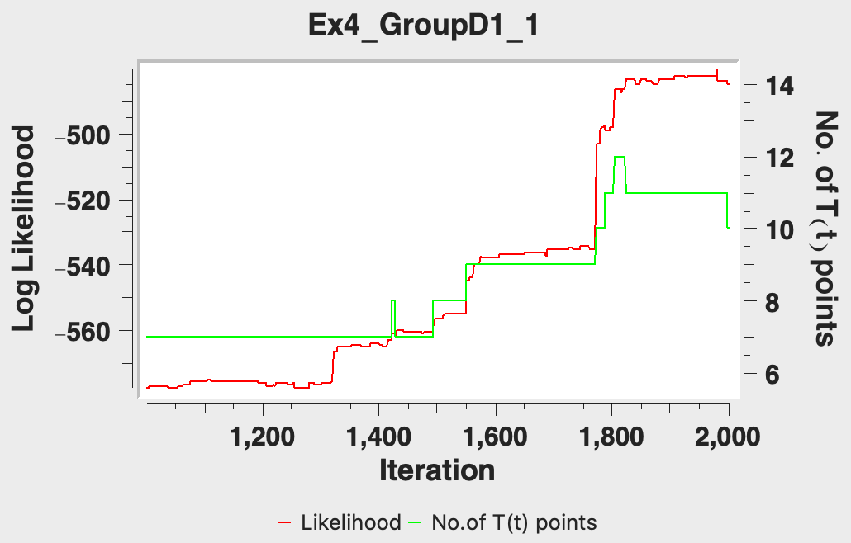
- Select Plotting > Examine Chain > Likelihood Chain/Posterior Chain and assess the stability of the chain.
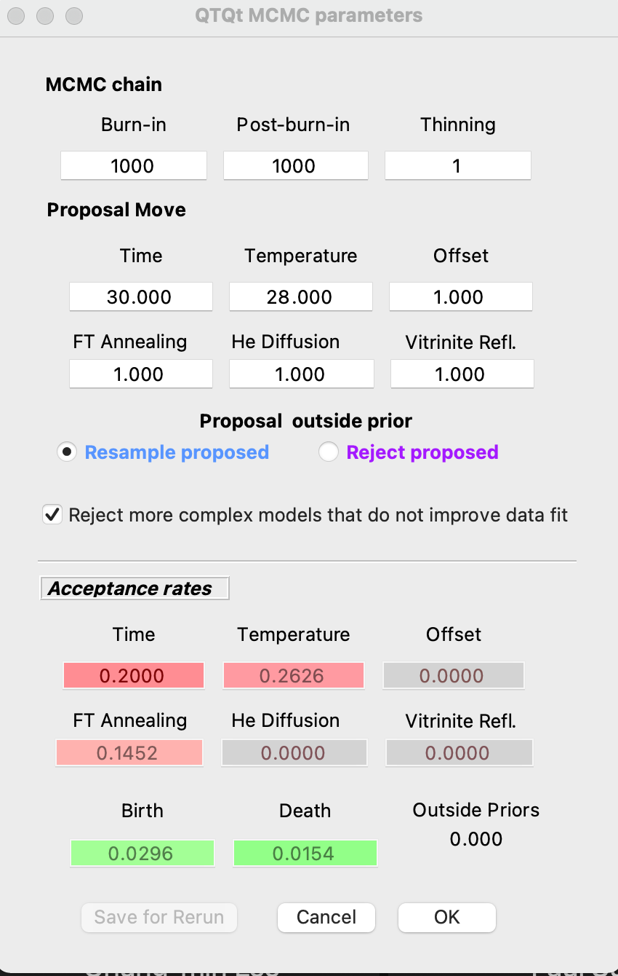
- Select Plotting and go through the same plotting options we explored in the last exercise.
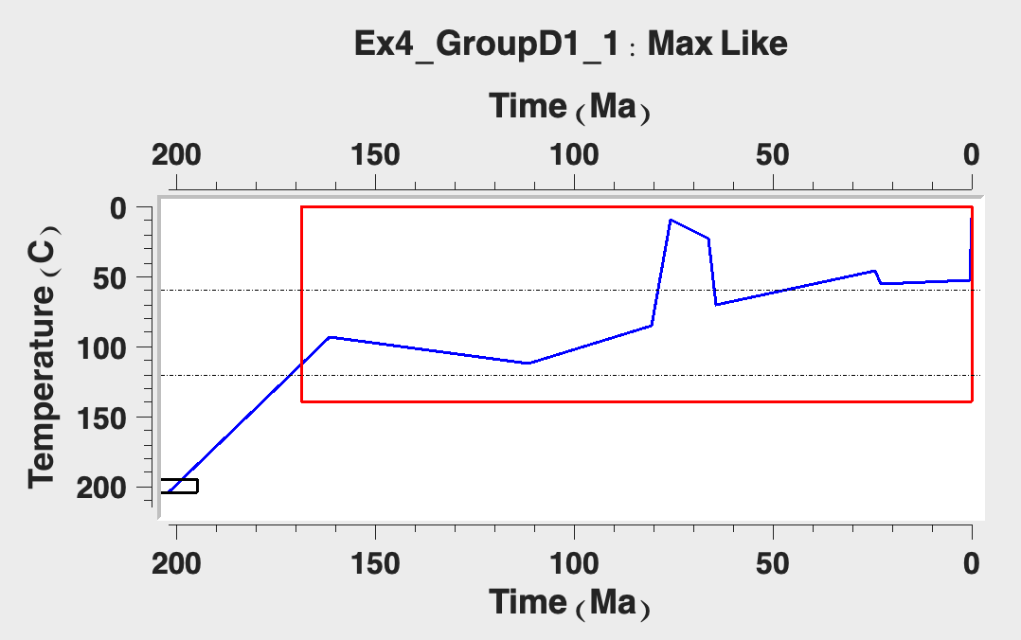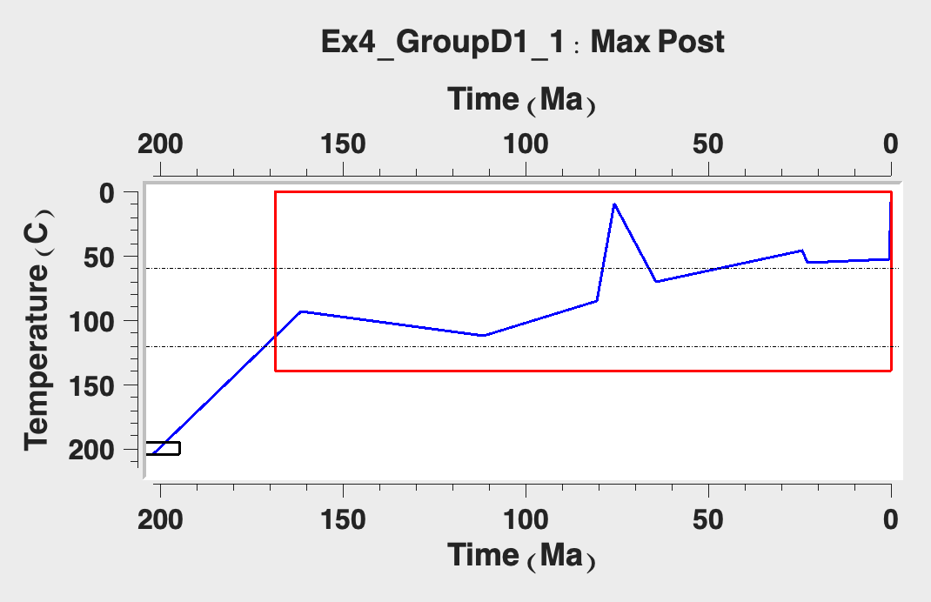
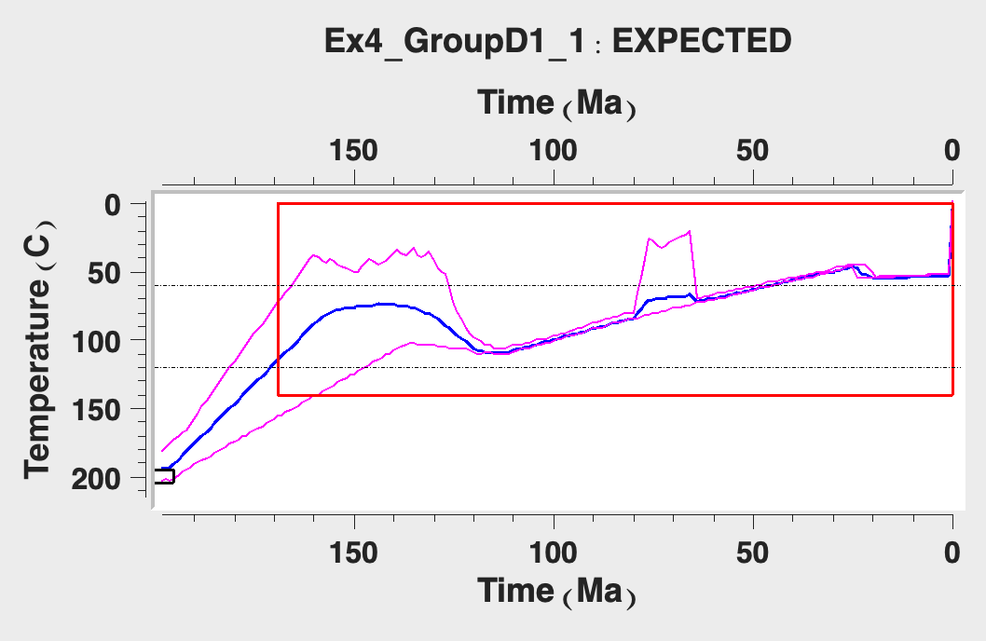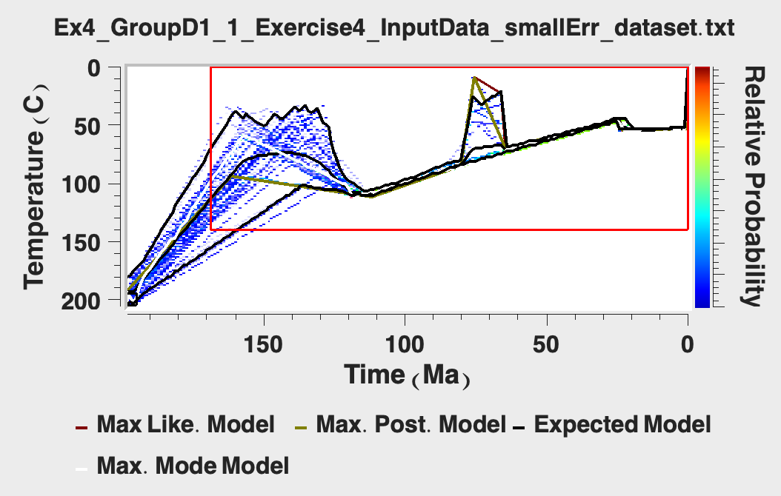
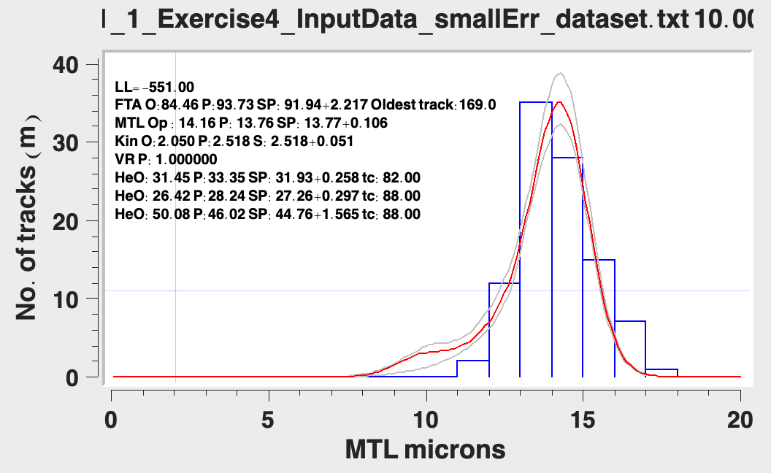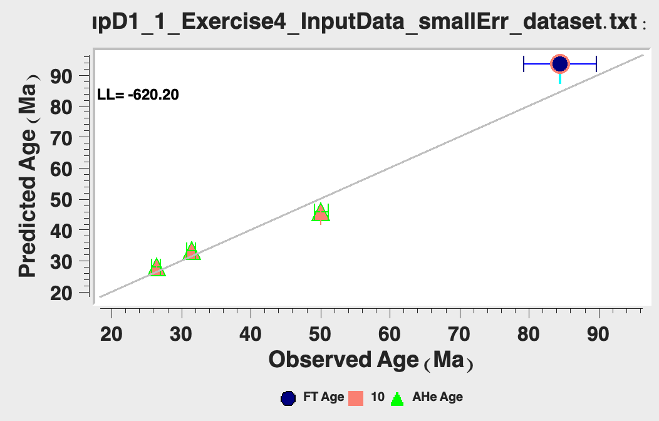
Top left: Maximum likelihood, Top right: Maximum posterior, Middle left: expected model, Middle right: Individual model predictions, Bottom left: Predictions, Bottom right: 1:1 observations vs. predictions.
- Save your plots to look through the differences between this test and the following tests.
- Click File > Open Previous QTQt run and select and open the last run file to allow you to continue running the MCMC algorithm to find additional thermal paths and select “Start from last model in previous run”.
- The run title dialog box will appear. You will notice that if you ended your first run with a ‘1’ it will automatically be given the suffix ‘2’. Click ‘OK’.
- Click MCMC Run > Set MCMC Parameters.
- We will run this model for longer, change the burn-in and post-burn-in to 10,000.
- Change the MCMC parameters as required.
- Click on MCMC Run > Run. Click ‘OK’.
- Save your plots to look over the differences between this test and the following tests.
- Now do a run with 50,000 burn-in and 250,000 post-burn-in iterations.
- Look through the plots from your above runs and take note of the changes that occur based on the number of iterations, as well as how the ‘long run’ outputs compare to the model outputs from exercise 3.
- Repeat the exercise above, but this time open the file “Exercise4_InputData_LargeErr _dataset.txt”, and name the run “Exercise4_PartD-2_1”.
- Compare the results from these tests with exercise 3 outputs.
- What are some of the differences between the outputs, and how might those be explained?

Exercise 5: Case study

Scenario
You have collected AFT and apatite (U-Th)/He data. You have 20 single grain AFT ages, 100 track lengths, a mean Dpar value and 5 single grain apatite (U-Th)/He ages.
First, you build your QTQt file using File > Build New QTQt data file by copying and pasting the data from Ex5_AFT_Dataset.txt and Ex5_AHe_Dataset.txt
- Just enter ‘0’ for the X, Y and Z values.
- When entering the track length information select the etchant of 5.5M.
- You are given ‘track lengths’ and ‘c-axis projected’ track lengths. If you enter the c-axis projected tracks, then paste in the c-axis projected tracks and tick the ‘use projected tracks’ button.
- You are only given the spherical equivalent grain radius for the apatite (U-Th)/He data. Enter this as the ‘length’ grain dimension and leave the other values blank.
Second, you run your QTQt input file without any additional constraints and use the default options for the MCMC parameters and confirm that the datafile has been built correctly and explore what information the data on their own are providing.
Next, you run your QTQt model after considering the following:
- Your sample has been taken from a surface exposure of an upper Permian – lower Triassic sandstone.
- There are two populations of detrital U-Pb zircon ages at 900–1000 Ma and 400–600 Ma and a small number of detrital apatite U-Pb ages ranging from 400 to 600 Ma and ZFT ages between 300 and 350 Ma.
- The accepted model for this basin is that deposition continued until the Early Cretaceous and then it has slowly been exhumed at an almost constant erosion rate until the present-day. Other research groups think that such a simple solution is unlikely, and that the basin has experienced several episodes of exhumation and burial.
- 100 km north of your sampling location, there is a small outcrop of middle to Late Cretaceous sediments overlying the basin you sampled from. Dr Wildman is convinced these sediments are 70 ± 2 Ma, his biggest academic rival Dr Abbey is certain these sediments are 110 ± 2 Ma. The wider scientific community isn’t convinced either is correct.
- One of your supervisors is skeptical about the fission-track etching methods, influence of apatite composition, fission-track annealing models and particularly dislikes correcting lengths for their c-axis angle and feels you should only focus on the apatite (U-Th)/He data.
- Your other supervisor, who often wears an “I love Fission-Tracks t-shirt”, feels that fission-track data will give you the best thermal history information and stresses the importance of radiation damage when modelling (U-Th)/He data and tells you to read up on the RDAAM models of Flowers, Gautheron and Willet….and choose your model carefully.
- When you look at your (U-Th)/He data, you notice that the standards you were analyzing are showing a greater variability than normal (about 7-9%).

