Item I. Igneous zircon cathodoluminescence image
Ia. BFB1.1 & 1.2
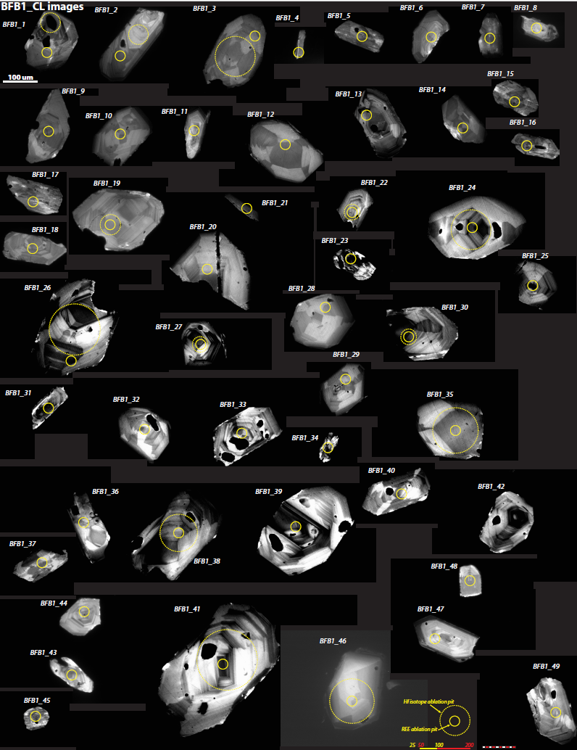

Ib. QM1.1 & 1.2
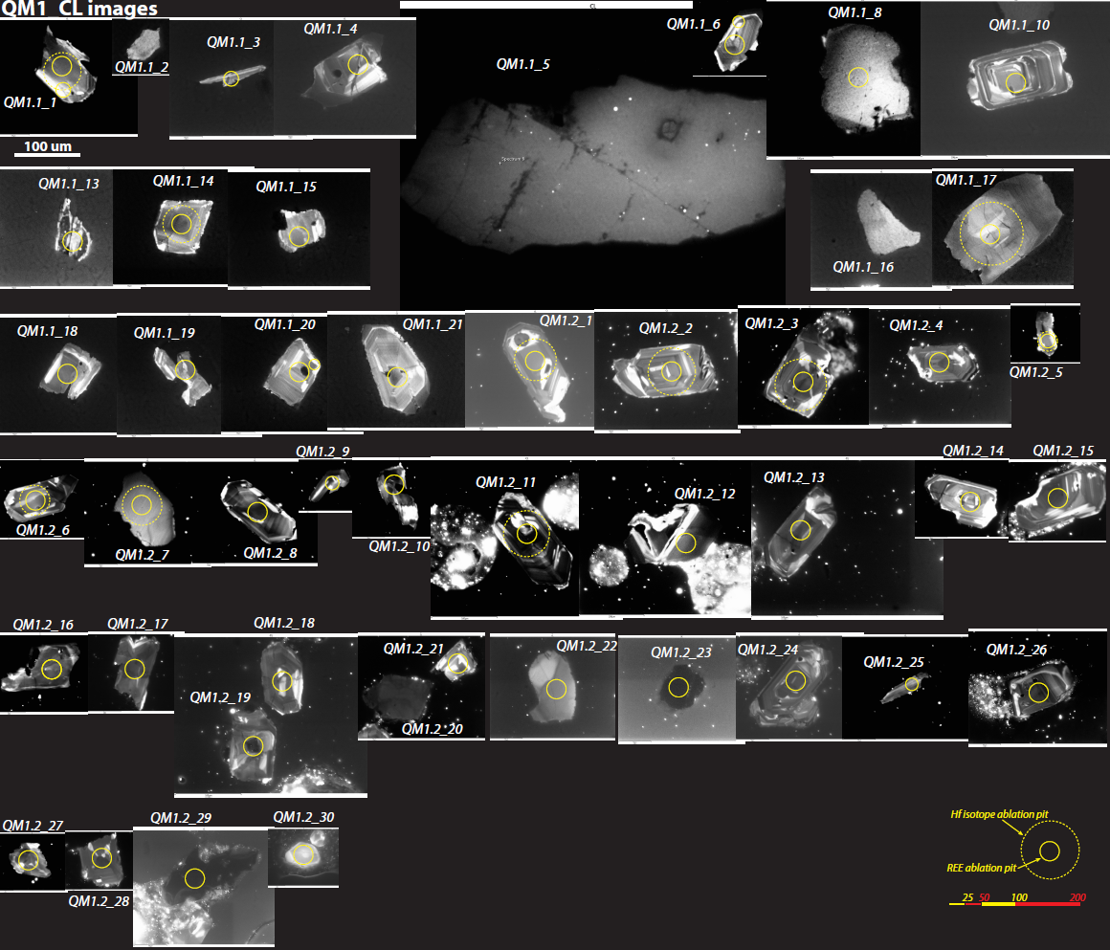

Ic. SHCR1.1 & 1.2
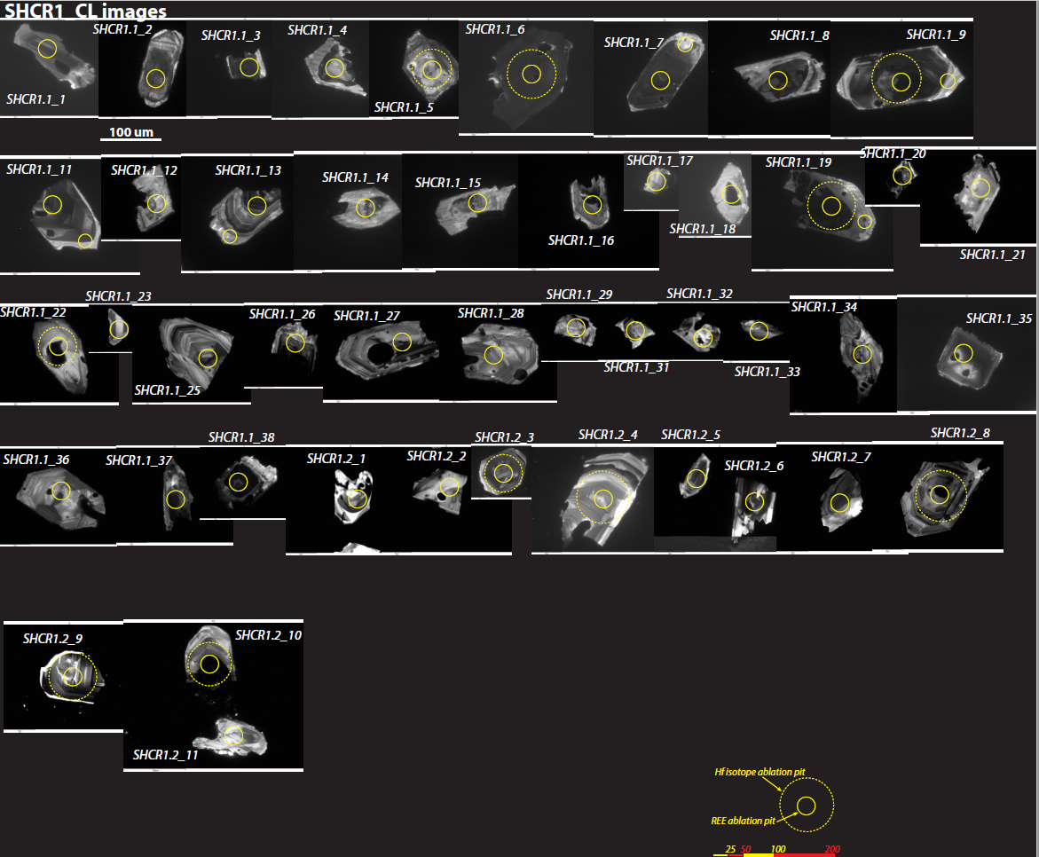

Id. WMG1.1 & 1.2
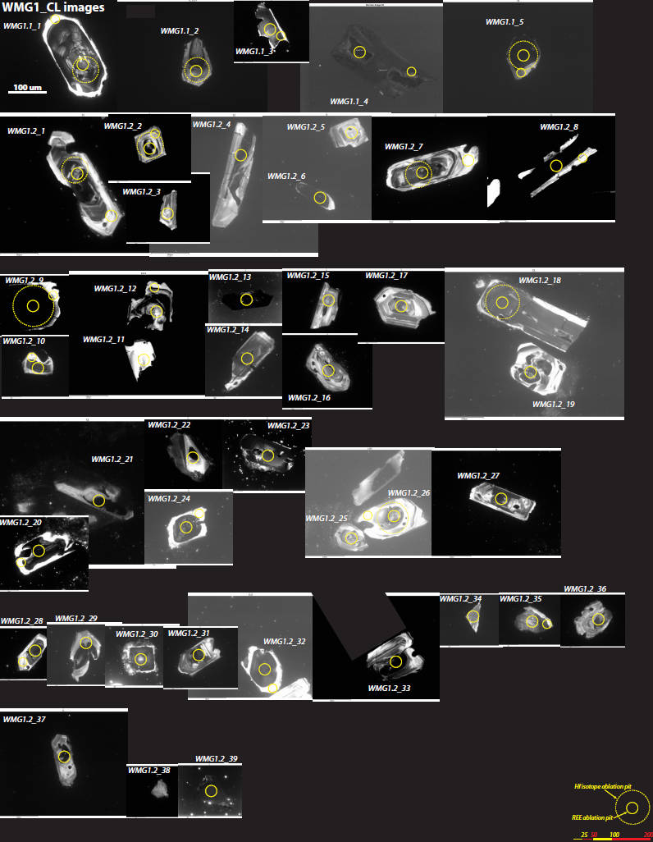

Ie. BFB1.2, QM1.3, WMG1.3, SHCR1.3, and SAFT8.2
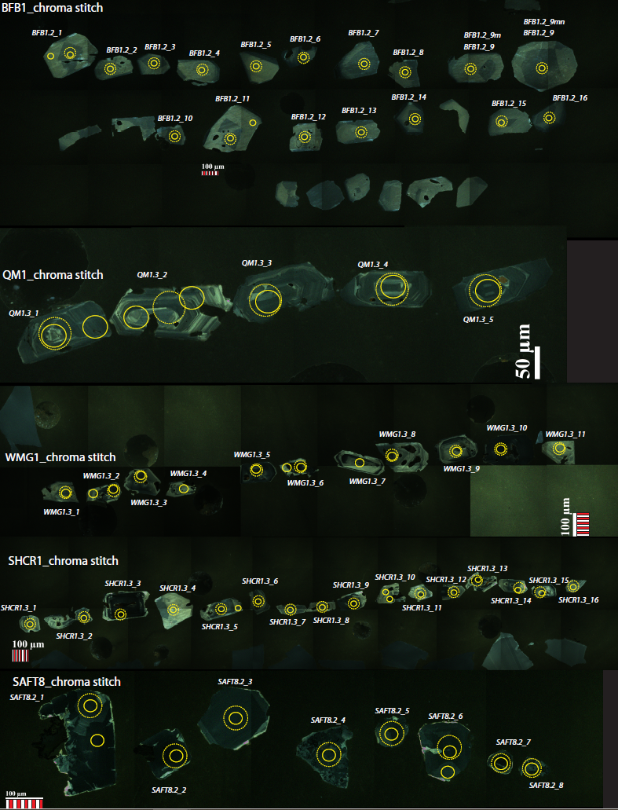
If. SAFT10 (includes spectral analyses on 3 inclusions in one zircon)
