Item A.
Item A table of contents
A.1. Methods details……………………………………………………………………………………p. 1
A.1.1. Zircon U-Pb analyses……………………………………………………………………p. 1
A.1.2. Zircon REE analyses………………………………………………………………….…p. 2
A.1.3. Zircon Hf analyses………………………………………………………………………p. 4
A.2. Sample descriptions & results details……………………………………………………...……p. 4
A.2.1. WMG1(Mount Scott Granite)……….…………………………………………..………p. 7
A.2.2. SHCR1 (Carlton Rhyolite)………….…………………………………..………………p. 8
A.2.3. QM1 (Lugert Granite)………….……………………………….………………………p. 9
A.2.4. BFB1 (Florida Mountains Syenite)…….………………………….……………………p. 9
A.2.5. SAFT8 (McClure Mountain Syenite, nepheline syenite)…….…….……………………p. 11
A.2.6. SAFT10 (McClure Mountain Syenite, biotite-horneblende syenite)……………………p. 12
A.2.7. AROM1 (Leadville Limestone Formation)…………..…………………………….……p. 14
A.2.8. 2SMBT4 (upper Kerber/lower Sharpsdale Formation)…….…………………….….…p. 14
A.2.9. 1SMBT4 (Minturn Formation)…………….………………………………..…….……p. 14
A.2.10. 1SMST9 (lower Sangre de Cristo Formation)……….………………………….……p. 15
A.2.11. 2SMST112 (lower Sangre de Cristo Formation)…….………………………….……p. 15
A.2.12. 4SMST778 (upper Sangre de Cristo Formation)……….…………………….………p. 16
A.3. Hf-isotopic standard results…………………………………………………………….………p. 16
References…………………………………………………………………………………….………p. 20
A.1. Methods details
A.1.1. Zircon U-Pb analyses
We corrected for inter- and intra-element fractionation (Gehrels et al., 2008) with a primary zircon standard: The Bohemian Massif potassic granulite Plešovice (337.13± 0.37 (2σ) Ma) (Sláma et al., 2008). We then confirmed the fractionation correction via analysis of a secondary standard: FC5z from the Duluth Complex (1099.1 ± 0.5 (2σ) Ma). Analyses of every 10 unknowns were separated by an analysis of the primary standard. In turn, every third analysis of the primary standard was coupled with secondary standard analysis.
For zircon grains > 600 Ma we adopted a -10% to 20% discordance (²⁰⁶Pb/²³⁸U and ²⁰⁷Pb/²³⁵U) and < 15% uncertainty filter. For detrital samples, in lieu of a common Pb correction (Stacey and Kramers, 1975), 15% uncertainty was added to ages < 600 Ma before applying a discordance filter.
A.1.2. Zircon REE analyses
Laser ablation data for 6 igneous samples are presented in this paper. These data were collected in 2018 and 2021 over 4 sessions, and most sample analyses are compiled from 2 or 3 different sessions (e.g., QM1.1, QM1.2, QM1.3 for sample QM1). Some of these REE data have been published in Ejembi et al. (2021), but we also present them in our supplemental data (Item D), in a format consistent with the rest of the data. A general shift of increased REE abundance is observed in SAFT8.2, QM1.3, BFB1.2, SHCR1.3, and WMG1.3 (analyses in 2021) in comparison to older analyses (2018). This is attributed to an upgrade in Photon Machine Excite 193nm ArF laser system with HelEx II eQCready cell between older analyses (2018) the more recent analyses (2021). However, while this upgrade resulted in increased the REE signal for the ICPMS to measure, REE ratios remained the same (Fig. A.1.2).

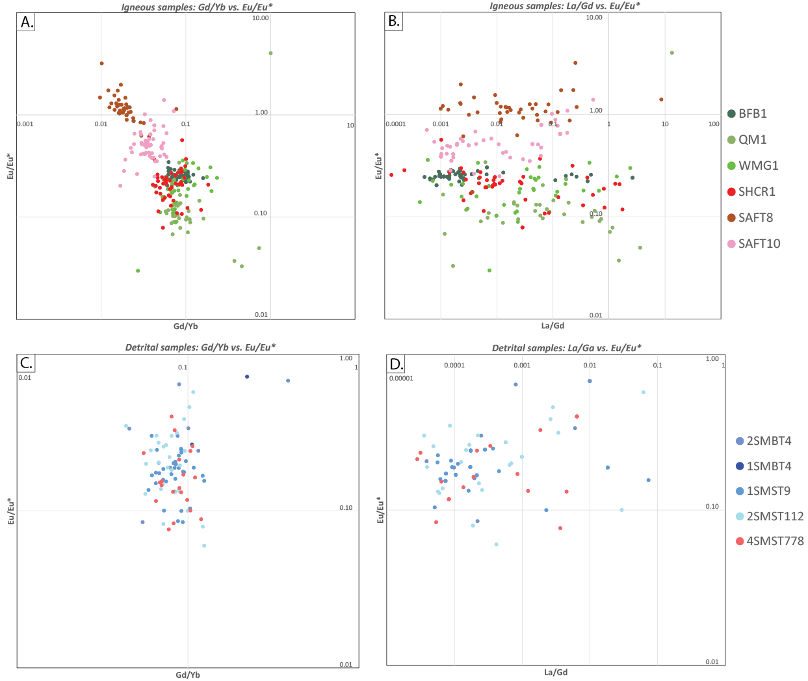
Figure. A.1.2. Discrimination plots for igneous (A, B) and detrital (C, D) REE analyses. Note that despite abundance change in laser lasing sessions due to laser system upgrade from 2018 to 2021 analyses, no intrasample grouping is evident.
We have included a table below (Table A.1.2) that details the analytical sessions for igneous grains because they were analyzed over several sessions, which span 3 years and the HelEx II eQCready cell upgrade described above, and several, but not all analytical sessions were published in Ejembi et al. (2021). Therefore, navigating the reduced data in Item D can be confusing without a table (Table A.1.2) explaining the timing and publication of these data. The samples to which they belong, and the original source of the data (original publication column) are included to make it easier for readers to explore the supplemental data tables.
Individual zircon grains were mounted and polished in an epoxy and lased with 300 shots at 10 Hz repetition rate and a 20-50 µm spot size, which depended on available surface area and, in the case of igneous grains, zonation. These parameters yielded 20 seconds for background measurement, followed by 30 seconds of ablation, and finally 10 seconds of washout. Inter- and intra-element fractionation was corrected for using a similar approach as discussed above, but included an external glass standard (NIST 612 50 ppm glass; Pearce et al., 1997) for trace element data. We also used an additional U-Pb secondary standard (Peixe; 564 ± 4 (2σ) Ma; Chang et al., 2006; Sundell et al., 2020) in some analyses for redundancy. The beginning and end of each full-mount laser ablation session entailed measurement of 1-3 secondary zircon standards, 3 primary zircon standards, and 4 glass standards, however, some sessions included more frequent analysis of secondary standards, which are documented in Appendices C and D. Detrital and igneous zircons were filtered using 15% uncertainty cutoffs and 20% and -10% discordance cutoffs.
Oxide weight percent of 32.0 and 72.0939 were used for SiO₂ in zircons and the glass standard, respectively, which were references for trace element abundances. Selection of background and analysis signal measurements were visually picked using GLITTER by assessing raw measurement intensities for individual analyses.
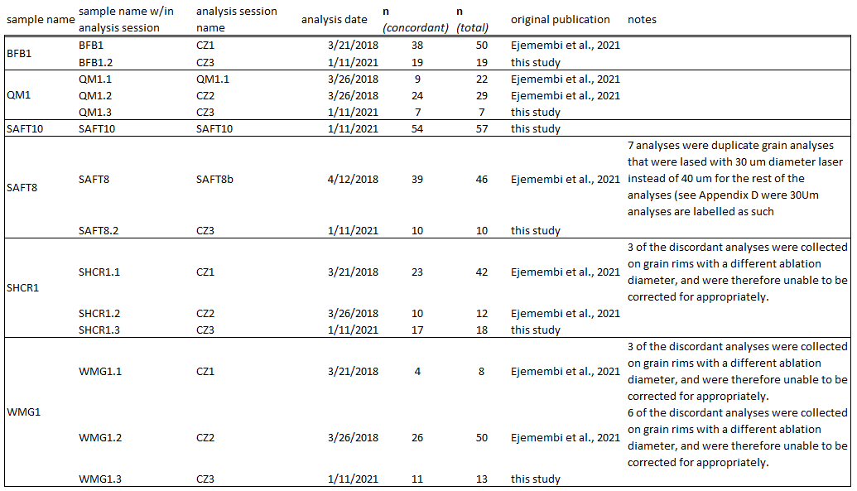
Table A.1.2. Table listing LA-ICP-MS analytical sessions for igneous grains, number of analyses (n), and location of original data publication.

A.1.3. Zircon Hf analyses
Similar to REE analyses, Hf isotopic data were collected over 3 sessions, split between 2018 and 2021, and are labeled in the Item F similarly (e.g., WMG1.1, WMG1.2, and WMG1.3 are analyses from the same sample, but separated by ablation session, and the results of which are combined). We provide zircon standard results for Hf isotopes from these sessions below. Ablate time and spot size for detrital grains were kept constant at 20 seconds and 50 µm except for several small grains that required smaller spot sizes (45-25 µm). For igneous samples, we maximized analysis signal by extending ablate times up to 60 seconds and increasing spot size up to 155 µm in grains that were sufficiently large. We allowed for ~17 second baseline, and data were internally reduced after each analysis, which provided at least a minute washout time.
A.2. Sample descriptions & results details
The following section contains descriptions and salient previous work for igneous and detrital samples, and associated units. Concordia plots for igneous zircon analyses across all sessions were calculated using IsoplotR (Vermeesch, 2018), and all samples, except for SAFT10 were corrected for common Pb (via Stacey and Kramers, 1975). Sections below include Terra Wasserburg concordia plots for individual samples.
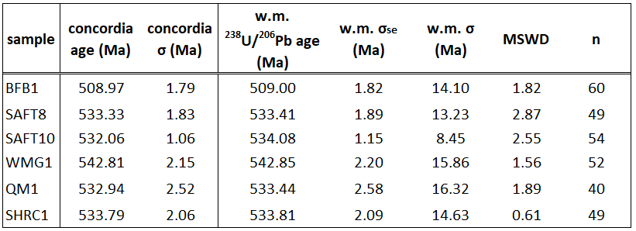
Table A.2-1. Table of common-Pb corrected (Stacey and Kramers, 1975) igneous sample concordia and ²³⁸U/²⁰⁶Pb ages, and variance calculated using IsoplotR (Vermeesch, 2018). Abbreviations/symbols: w.m. – weighted mean, σ_{se} – standard error, σ – standard deviation.
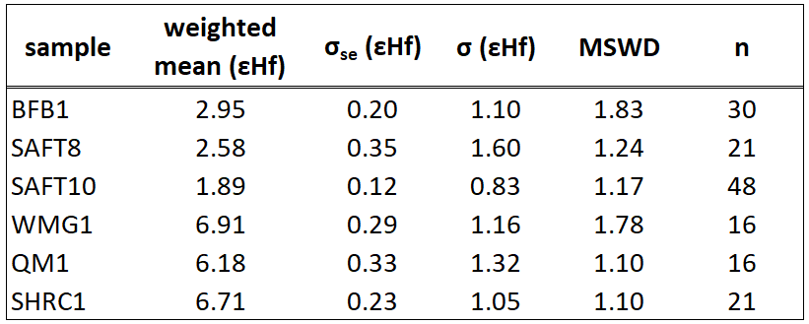
Table A.2-2. Table of igneous sample weighted mean ɛHf(t), and variance calculated using IsoplotR (Vermeesch, 2018). Abbreviations/symbols explained in Table A2-2.
A.2.1. WMG1(Mount Scott Granite)
Sample WMG1 was collected from the Mount Scott Granite in the Wichita Mountains. This unit is a laterally extensive (> 55 km), relatively thin (0.5 km), A-type granite sheet within the Wichita Granite Group (Hogan et al., 1995; Price, 1998; Hanson et al., 2013), which lies above a layered mafic complex (Glen Mountains group) and below a series of rhyolite flows of similar age (Carlton Rhyolite) (Hanson et al., 2013). A portion of this bimodal Cambrian igneous complex was exhumed in the late Paleozoic as part of the Amarillo-Wichita Uplift, and supplied Cambrian age detritus to the Anadarko Basin (Thomas et al., 2016). Petrographic observations reveal an alkali-feldspar (orthoclase and microcline) dominant granite, containing ovoid phenocrysts (~3 mm) of the same composition (Fig. 8A). Feldspars contain abundant sericite that is commonly concentrated along phenocryst rims. Quartz primarily occurs in a granophyric texture within feldspars and is commonly oriented perpendicular to the feldspar rim (Fig. 8A). Minor amounts of amphibole, biotite, and muscovite are also present.
Zircon U-Pb ages from WMG1 indicate the presence of common Pb, which was corrected for (Fig. A.2.1-1). The common-Pb corrected (Stacey and Kramers, 1975) weighted mean age (542.8 ± 4.3 (2σ_{se}), MSWD 1.56; Table A2; Fig. A.2.1-2) older than reported U-Pb ages for the Mount Scott Granite 533 ± 3 to 530 ± 1 Ma (Wright et al., 1996; Degeller et al., 1996; Hanson et al., 2013), but is within standard deviation (σ) (Table A2). However, the age range of WMG1 is consistent with a reported ⁴⁰Ar/³⁹Ar age (539 ± 2) of amphibole from the same granite (Hames et al., 1998) in the context of a linear crystallization-cooling trend. Discussion of this span of ages for the Wichita Mountain Granite Group is well beyond the scope of this paper; however, it may indicate a heterogenous crystallization and cooling history for this granite body. ɛHf(t) data exhibit a unimodal distribution with a weighted mean of 6.9 ± 0.6 (2σ_{se}) (Fig. A.2.1-2) and median of 7.4 (Fig. 6A; Item F), and is like other eastern igneous samples (Fig. A.2.1-4; Table A.2.1). There is a general increasing trend of REE abundance with increasing atomic number in most analyses. All analyses’ REE patterns exhibit negative Eu anomalies, and most exhibit positive Ce anomalies (Fig. 6A).
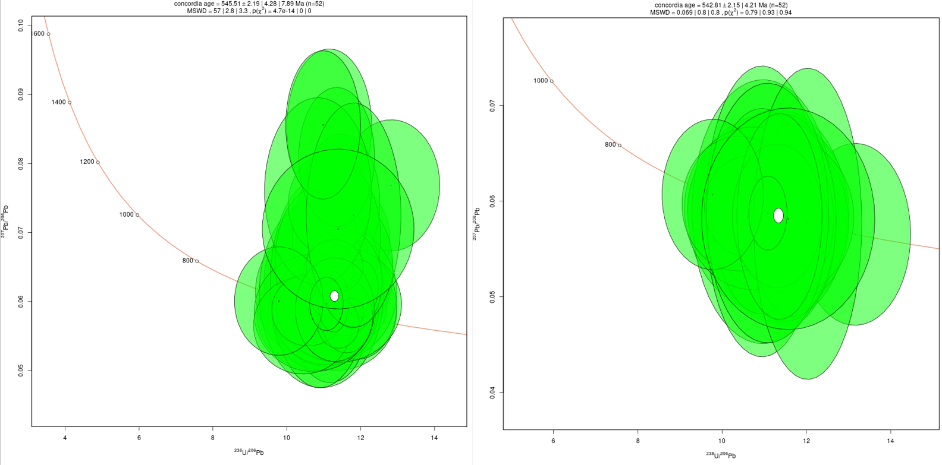
Figure. A.2.1-1. WMG1 Tera-Wasserburg concordias, concordia ages, and analytical uncertainty before (left side) and after (right side) Stacey and Kramers (1975) common-Pb correction. Plots made in IsoplotR (Vermeesch, 2018).
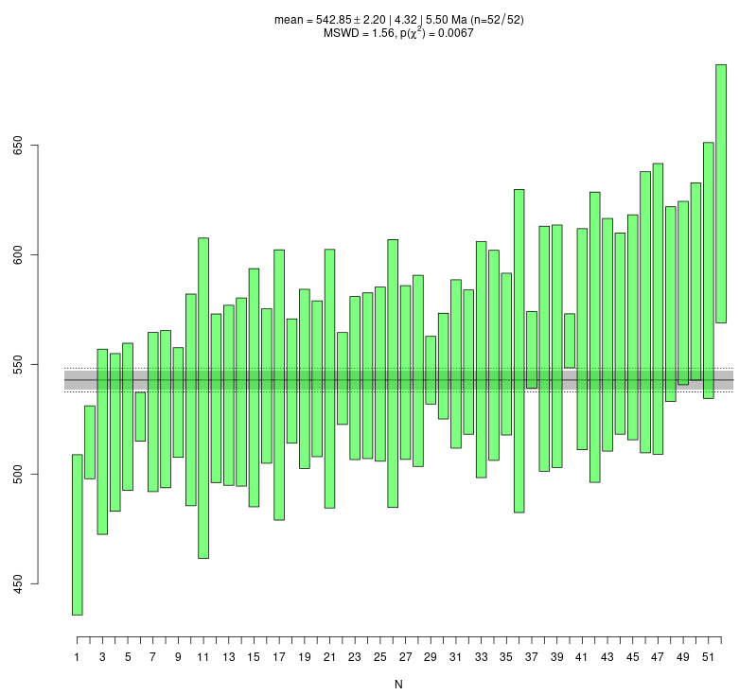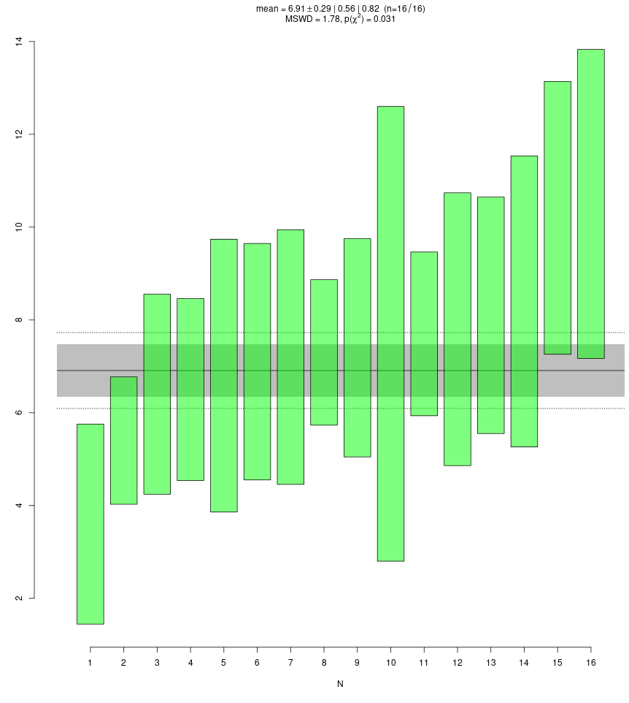
Figure. A.2.1-2. WMG1 common-Pb corrected age (left) and εHf (t) (right) weighted means and standard errors calculated and plotted in IsoplotR (Vermeesch, 2018).
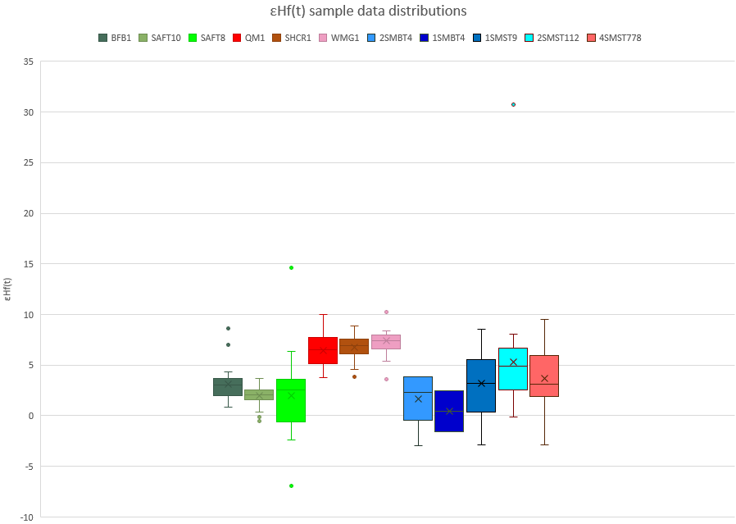
Figure A.2.1-4. εHf (t) sample analyses distributions displayed in box and whisker plots. X inside of box is the sample mean, the horizontal line in the box is the median, bottom edge of box is the 1st quartile, the top edge of the box is the is the 3rd quartile, the vertical lines that extend from the box indicate minimum and maximum values of sample, and the points outside of those lines are considered outlier values.
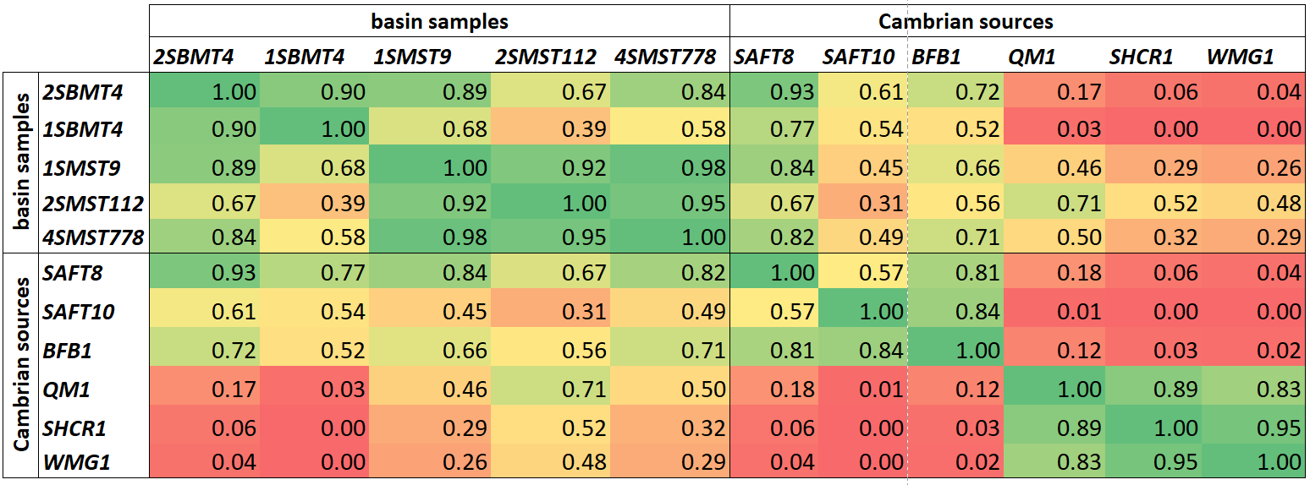
Table A.2.1. Cross-correlation table of detrital and igneous (i.e., possible Cambrian sources) sample ɛHf(t) values.
A.2.2. SHCR1 (Carlton Rhyolite)

Sample SHCR1 was collected from the Carlton Rhyolite in the Slick Hills, approximately 10 km north of the Wichita Mountains (Fig. 3). Similar to the Wichita Granite, the Carlton Rhyolite is an A-type felsic rock. It is the uppermost igneous rock in the Southern Oklahoma Aulacogen (Hanson et al., 2013). The groundmass of sample SHCR1 is primarily quartzo-feldspathic and exhibits radial crystal growth. Phenocrysts (2-4 mm) are predominantly feldspar, which include orthoclase, microcline, and plagioclase (Fig. 4B). Abundant inclusions and alteration in the feldspar phenocrysts are common. Quartz is present as euhedral monocrystalline phenocrysts (Fig. 4B), and as 1-2 mm zones of polycrystalline quartz. Magnetite is also present as a phenocryst in lower abundance.
SHCR1 sample exhibits common-Pb (Fig. A.2.2-1) and has a corrected (Stacey and Kramers, 1975) weighted mean age 533.8 ± 4.2 (2σ_{se}) Ma, MSWD 0.61 (Fig. A.2.2-2), which is consistent with published ages reported for the Carlton Rhyolite (539 ± 5 Ma and 536 ± 5 Ma; Thomas et al., 2012). ɛHf(t) data exhibits a unimodal distribution with a weighted mean of 6.7 ± 0.5 (2σ_{se}) and the median is 6.9 (Fig. A.2.2-2; Fig. 6B). The REE patterns and abundances are similar to those described for sample WMG1, with all analyses containing a negative Eu anomaly and most containing a positive Ce anomaly (Fig. 6B).
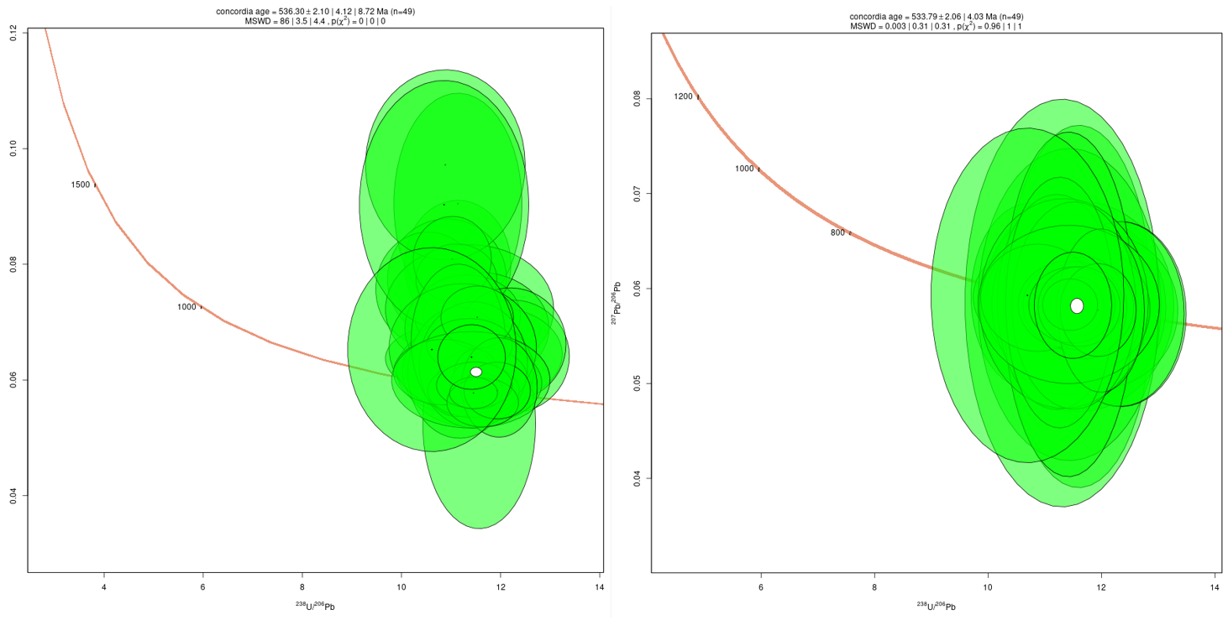
Figure. A.2.2-1. SHCR1 Tera-Wasserburg concordias, concordia ages, and analytical uncertainties before (left side) and after (right side) Stacey and Kramers (1975) common-Pb correction. Plots made in IsoplotR (Vermeesch, 2018).
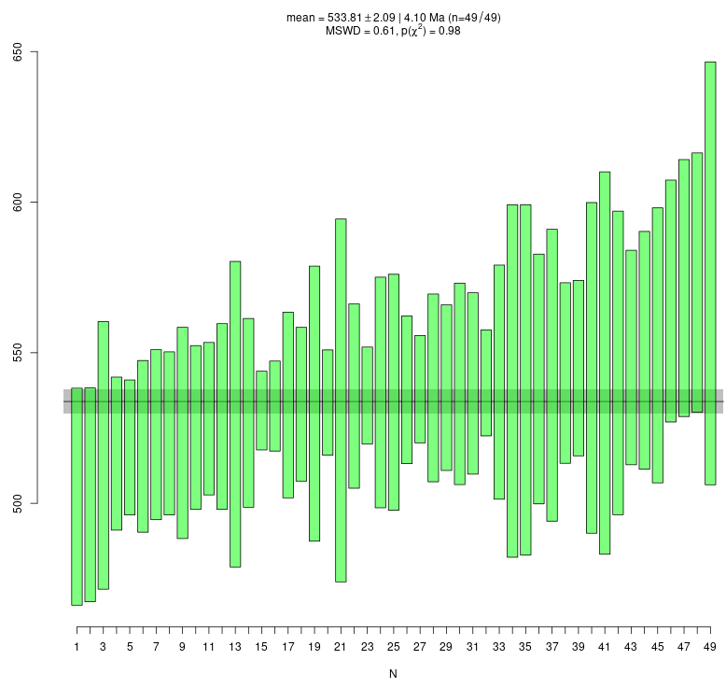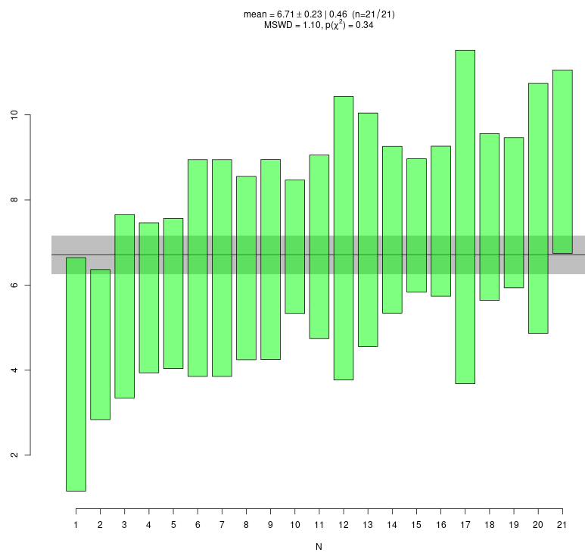
Figure. A.2.2-2. SHCR1 common-Pb corrected age (left) and εHf (t) (right) weighted means and standard errors calculated and plotted in IsoplotR (Vermeesch, 2018).
A.2.3. QM1 (Lugert Granite)

QM1 is from the Lugert Granite in the Quartz Mountains (Stanley and Miller, 2004), and was collected approximately 60 km west of the Wichita Mountains (Fig. 4). The Lugert Granite is part of the Wichita Granite group, to which the Mount Scott Granite also belongs, and is similar in composition and texture (Powell et al., 1980). QM1 thin section description is remarkably similar to WMG1, but its feldspars are less altered (Fig. 8C). Large (2-4 mm) orthoclase phenocrysts commonly exhibit a granophyric texture with monocrystalline quartz (Fig. 8C). Some granophyre in these phenocrysts appears to be zoned. Most alkali feldspars are untwinned and exhibit perthitic texture, but some exhibit grid-iron twinning. Minor amounts of biotite and magnetite are present.
QM1 sample exhibits common-Pb (Fig. A.2.3-1) and has a corrected (Stacey and Kramers, 1975) weighted mean age 533.4 ± 4.4 (2σ_{se}) Ma, MSWD 1.89 (Fig. A.2.3-2), which is consistent with broad range of ages reported for the Wichita Granite group (525 ± 25; Powell et al., 1980). Zircon ɛHf(t) data yield a weighted mean of 6.2 ± 0.7 (2σ_{se}), a median of 6.5, and exhibit a unimodal distribution with a low ɛHf(t) value shoulder (Fig. A.2.3-2; Fig. 6C). Most QM1 REE analyses are similar to those described for samples WMG1 and SHCR1 in that almost all analyses exhibit negative Eu anomalies, and contain a positive Ce anomaly. However, several analyses exhibit no Ce anomaly, high LREE:HREE ratios, and negative LREE slopes (Fig. 6C). 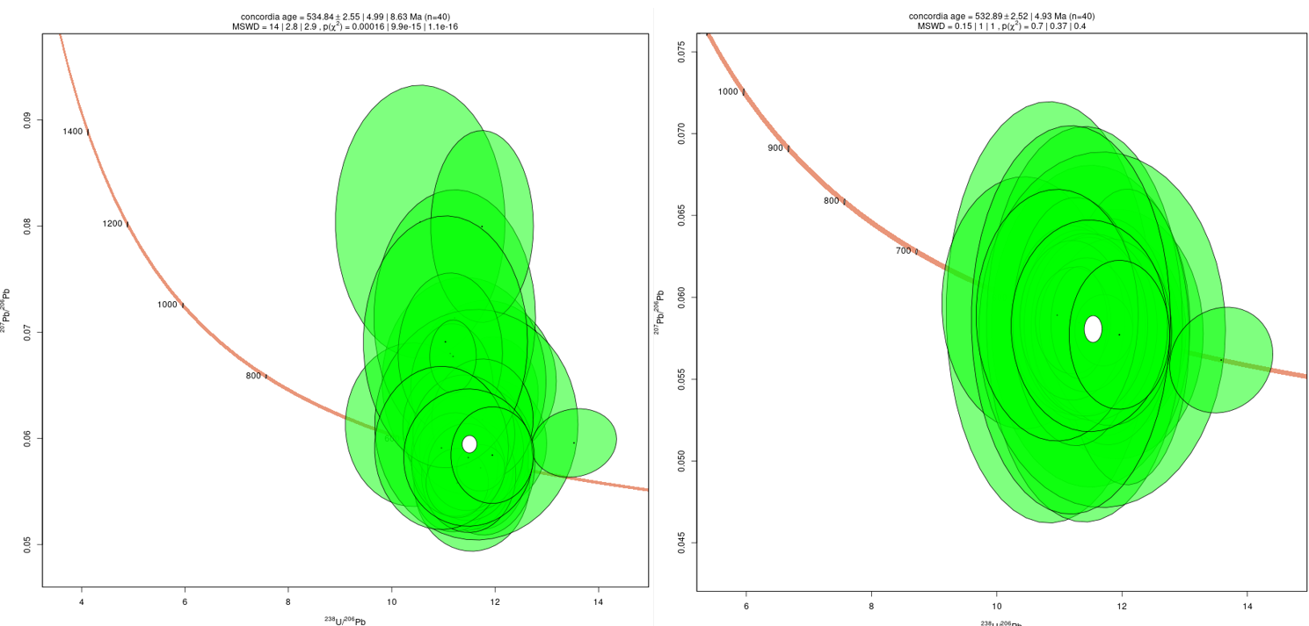
Figure. A.2.3-1. QM1 Tera-Wasserburg concordias, concordia ages, and analytical uncertainties before (left side) and after (right side) Stacey and Kramers (1975) common-Pb correction. Plots made in IsoplotR (Vermeesch, 2018).
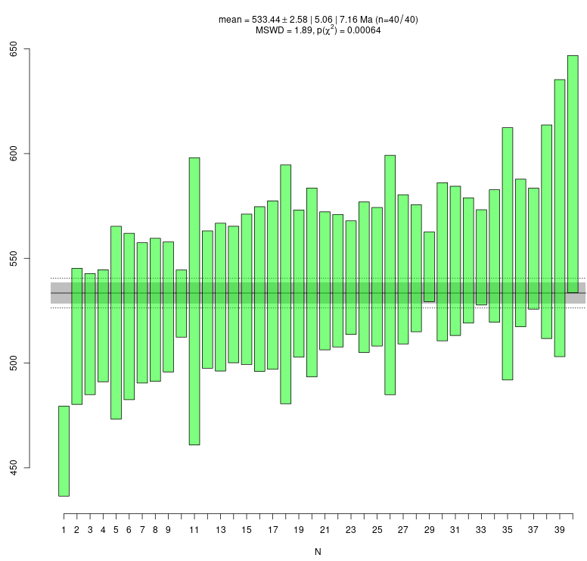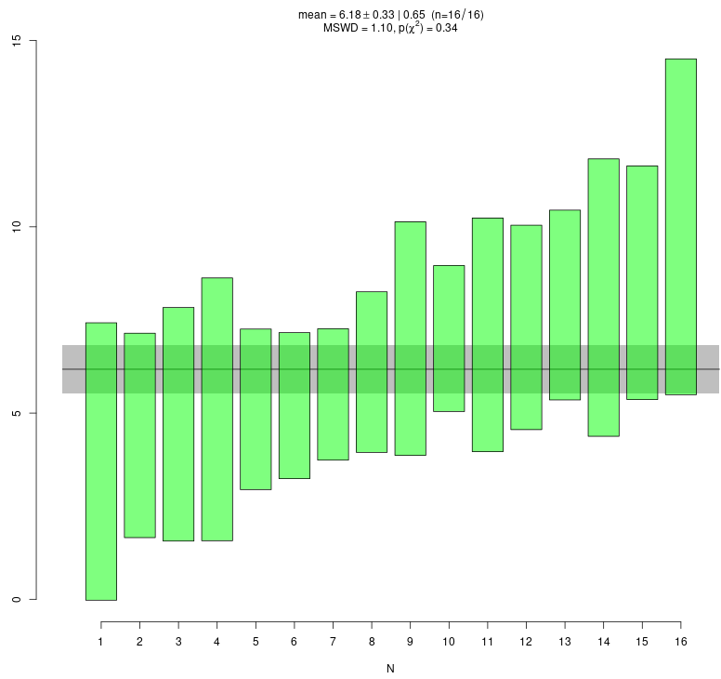
Figure. A.2.3-2. QM1 common-Pb corrected (left) and εHf (t) (right) weighted means and standard errors calculated and plotted in IsoplotR (Vermeesch, 2018).
A.2.4. BFB1 (Florida Mountains Syenite)
Sample BFB1 was collected from the Florida Mountains Syenite in southern New Mexico (Fig. 3). The syenite is part of a Cambrian-Ordovician alkalic igneous complex associated with a hypothesized early Paleozoic rift that extended from the transform or rifted Rodinian margin in Mexico into central Colorado (Evans and Clemmons, 1988; McMillan and McLemore, 2001). Sample BFB1 consists predominantly of large (2 mm-1 cm) microcline feldspars with pervasive perthitic texture (Fig. 4D). Feldspars are commonly fractured and contain abundant sericite. Quartz and magnetite occur in minor amounts. Quartz occurs in polycrystalline lineations and bundles (Fig. 4D).
BFB1 sample exhibits common-Pb (Fig. A.2.4-1) and has a corrected (Stacey and Kramers, 1975) weighted mean age of 509.0 ± 3.6 (2σ_{se}) Ma, MSWD 1.82 (Fig. A.2.4-2), which is consistent with the reported zircon U-Pb ages in the Florida Mountains igneous complex (503 ± 10 Ma and 514 ± 3 Ma; McMillan and McLemore, 2001). Zircon ɛHf(t) data yield a weighted mean of 3.0 ± 0.4 (2σ_{se}), a median of 3.0, and exhibit a unimodal distribution with a high ɛHf(t) value shoulder (Fig. 6D). REE patterns are similar to those described for sample WGM1 and SCHR1, in that all sample analyses exhibit a negative Eu anomaly, and most contain a positive Ce anomaly.
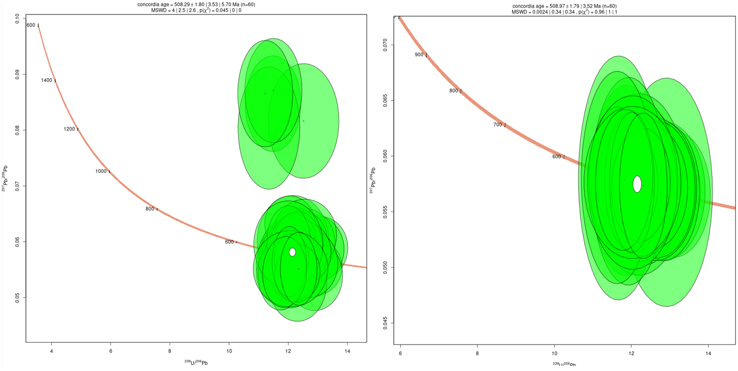
Figure. A.2.4-1. BFB1 Tera-Wasserburg concordias, concordia ages, and analytical uncertainties before (left side) and after (right side) Stacey and Kramers (1975) common-Pb correction. Plots made in IsoplotR (Vermeesch, 2018).
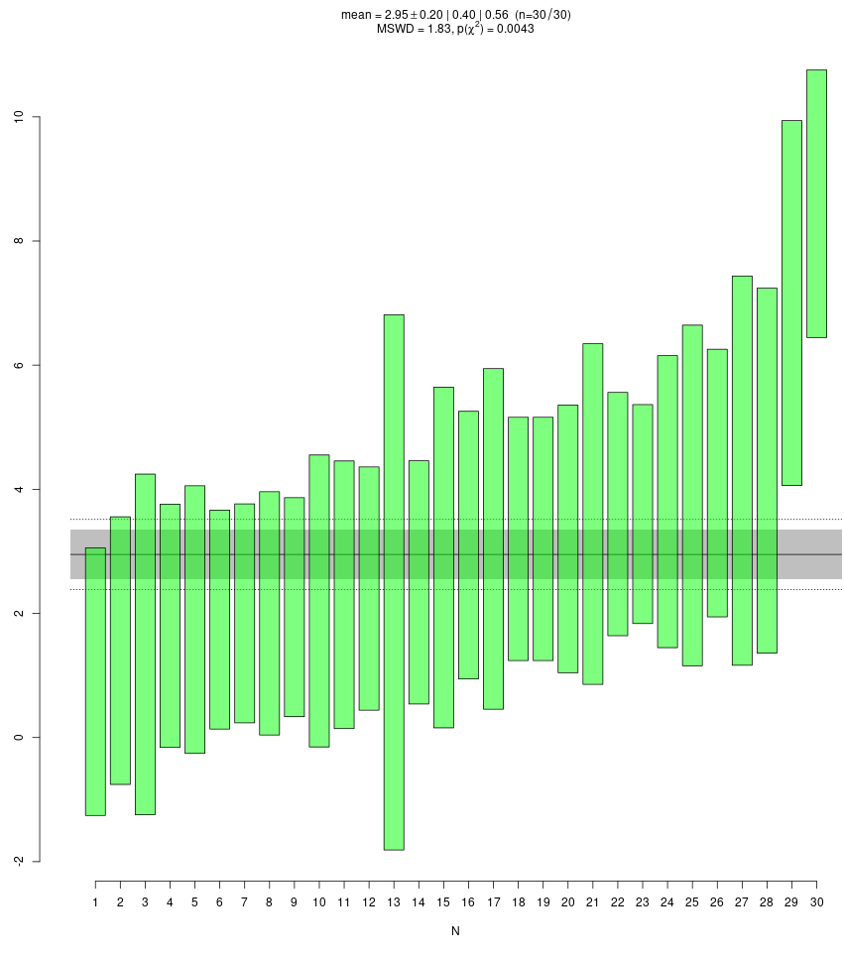
Figure. A.2.4-2. QM1 common-Pb corrected age (left) and εHf (t) (right) weighted means and standard errors calculated and plotted in IsoplotR (Vermeesch, 2018).
A.2.5. SAFT8 (McClure Mountain Syenite, nepheline syenite)
Sample SAFT8 was collected from a nepheline syenite, which is part of the McClure Mountain complex in the Wet Mountains, which is located at the north end of the Apishapa Uplift (Figs. 2 and 4). This alkaline intrusive suite is one of three related Cambrian intrusive complexes, clustered within a 130 km² area within the Wet Mountains of Colorado (Olson et al., 1977). Inboard projections of both the Southern Oklahoma and hypothesized New Mexico aulacogens intersect in this region of central Colorado, and the Wet Mountains alkaline-mafic igneous rocks are invoked as evidence for far-field rift activity for both systems (Loring and Armstrong, 1980; Larson et al., 1985; Evans and Clemons, 1988; McMillan and McLemore, 2001). The McClure Mountain Cambrian complex consists of gabbro, pyroxenite, anorthosite, biotite-hornblende syenite, and nepheline syenite (Olson et al., 1977). The thin section of sample SAFT8 is dominated by nepheline feldspathoid, untwined plagioclase, or a combination of both (Fig. 8E). A minor constituency of twinned plagioclase is also present. Calcite and biotite are common and observed in association. Minor amphibole and magnetite are preset as well.
SAFT8 sample exhibits common-Pb (Fig. A.2.5-1) and has a corrected (Stacey and Kramers, 1975) weighted mean age of 533.4 ± 3.8 (2σ_{se}) MSWD 2.87 Ma (Fig. A.2.5-2), SAFT8 is older than the reported zircon U-Pb age of the McClure Mountain Syenite complex of 523.98 ± 0.12 Ma (Schoene and Bowring, 2006), but were collected from different locations than the Schoene and Bowring (2006) and may indicate a more heterogenous Cambrian igneous body. Zircon ɛHf(t) data exhibit the broadest distribution in comparison to all other igneous samples in this study. The weighted mean of the ɛHf(t) value distribution is 2.9 ± 0.7 (2σ_{se}) and the median is 2.6. SAFT8 zircons exhibit no negative Eu anomalies (Fig. A.2.5-2; Fig. 6E), a unique characteristic in comparison to other igneous samples in this study. Most analyses also exhibit positive Ce anomalies, and REE abundances generally increase with atomic number. 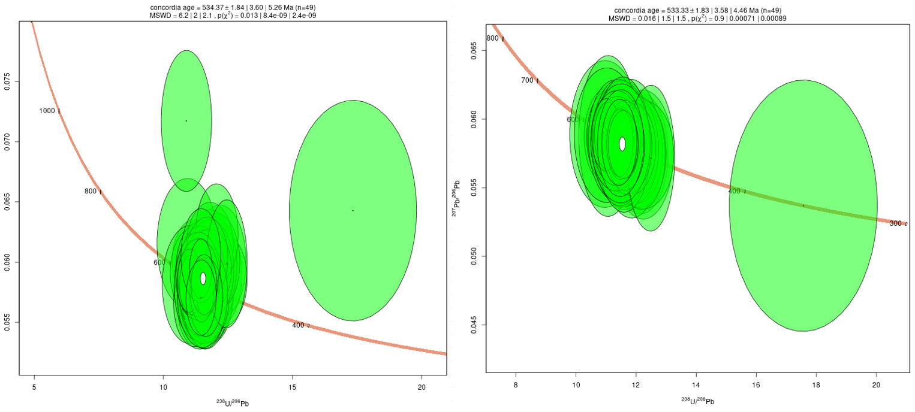
Figure. A.2.5-1. SAFT8 Tera-Wasserburg concordias, concordia ages, and analytical uncertainties before (left side) and after (right side) Stacey and Kramers (1975) common-Pb correction. Plots made in IsoplotR (Vermeesch, 2018).
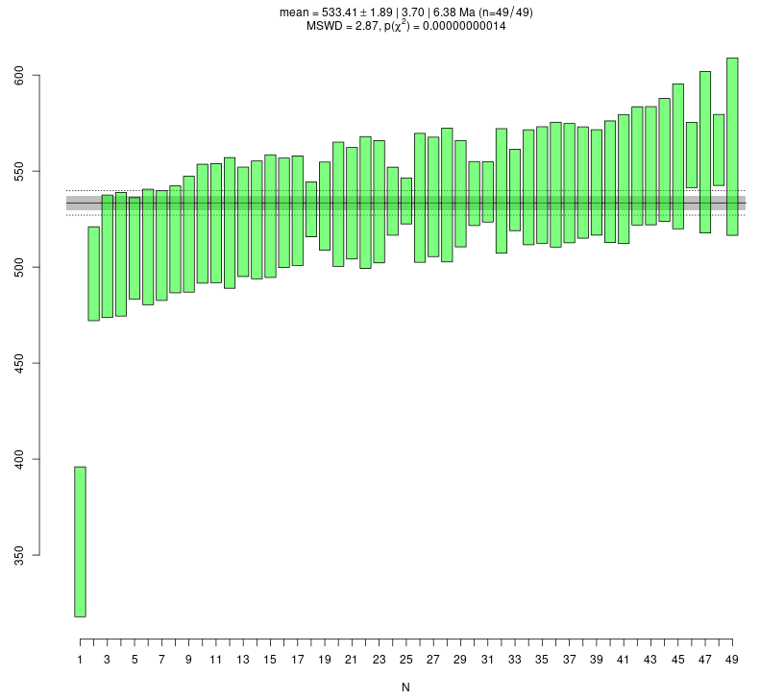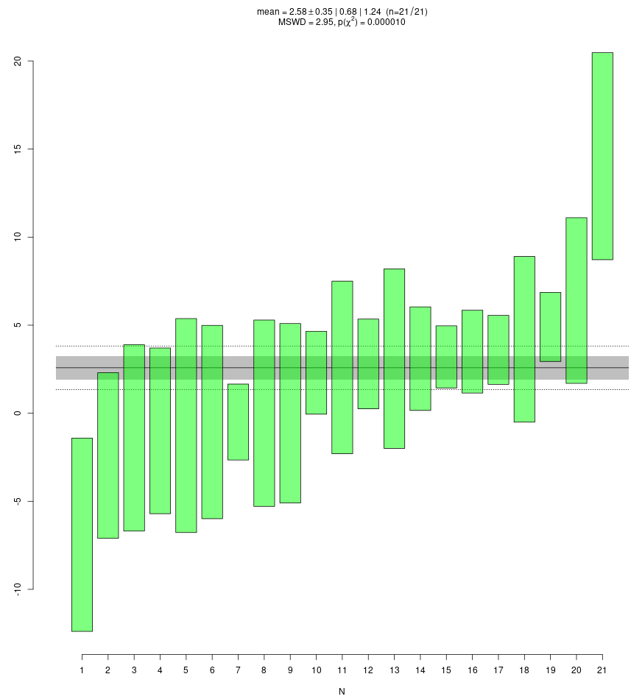
Figure. A.2.5-2. SAFT8 common-Pb corrected age (left) and εHf (t) (right) weighted means and standard errors calculated and plotted in IsoplotR (Vermeesch, 2018).
A.2.6. SAFT10 (McClure Mountain Syenite, biotite-horneblende syenite)
Sample SAFT10 was collected from a biotite-hornblende syenite 1.2 km southeast of the SAFT8 sample site (described above), which is part of the same McClure Mountain alkaline complex. SAFT10 thin section reveals large (>2 mm) orthoclase feldspar with exsolution laminae (Fig. 8F), untwinned plagioclase, biotite, and hornblende as major constituents. There are a smaller constituency of small (< 0.2 mm), dusty grains of low birefringence appear to be nepheline syenite. Other rare minerals include apatite, magnetite, and calcite, the latter of which is commonly observed in association with biotite.
SAFT10 sample exhibits low common-Pb (Fig. A.2.6-1) and was therefore not corrected. The weighted mean age of sample SAFT10 is 534.4 ± 0.8 (σ_{se}) Ma, MSWD 2.55 (Fig. A.2.6-2), which is similar to sample SAFT8, but older than the reported age of 523.98 ± 0.12 Ma from Schoene and Bowring (2006). Zircon ɛHf(t) values exhibit a unimodal distribution with the most negative weighted mean (1.9 ± 0.2 (2σ_{se})) and median (2.0) in comparison to other igneous samples in this study (Fig. A.2.6-2; Fig. 6F). Zircons from SAFT10 exhibit both the presence and absence of negative Eu anomalies. Analyses that have no negative Eu anomaly, also tend to have no positive Ce anomaly, and display high LREE:HREE ratios (Fig. 6F).
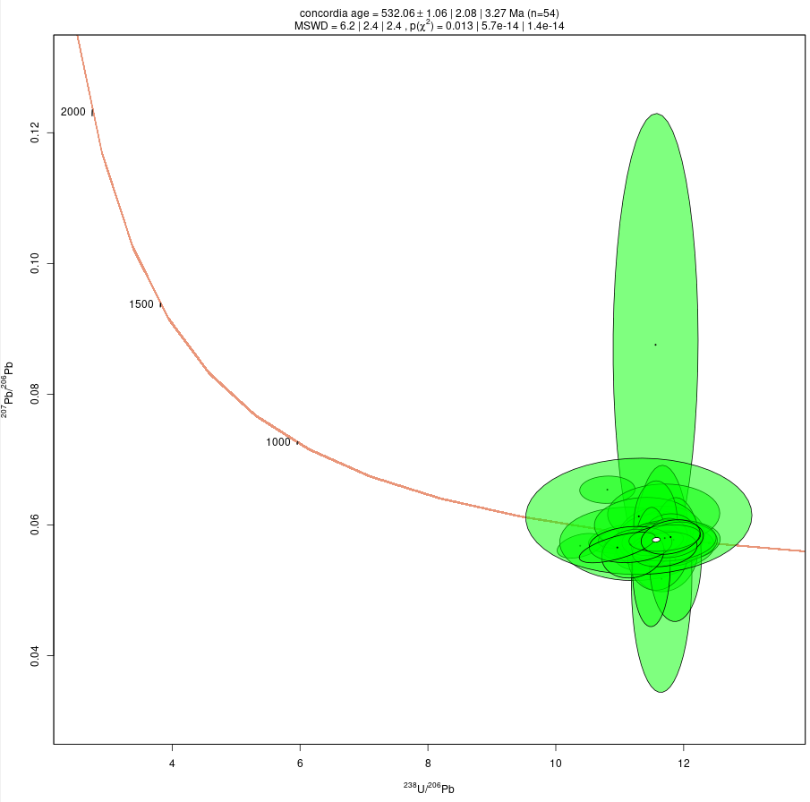
Figure. A.2.6-1. SAFT10 Tera-Wasserburg concordias, concordia ages, and analytical uncertainties. Plots made in IsoplotR (Vermeesch, 2018).
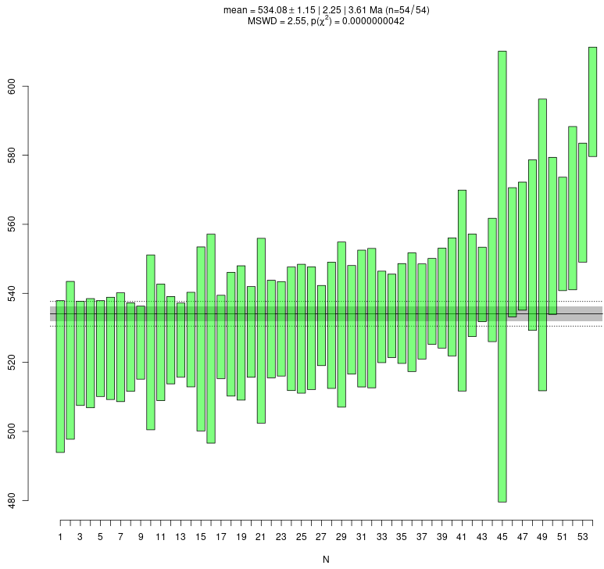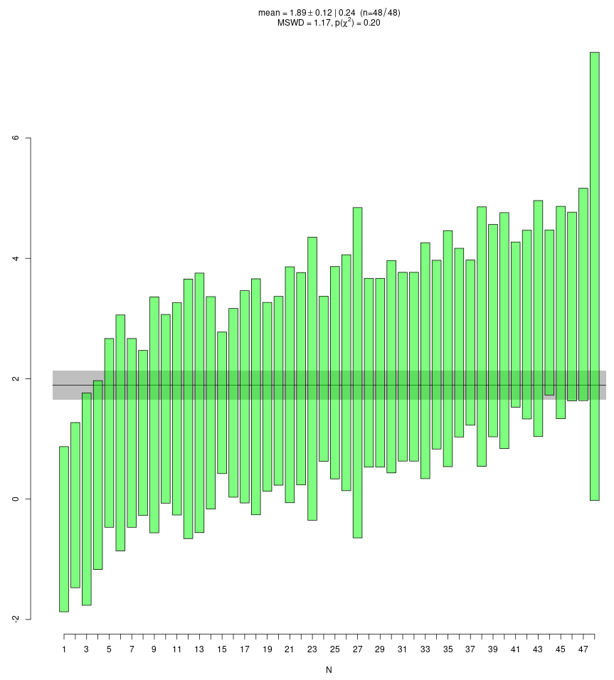
Figure. A.2.6-2. SAFT10 age (left) and εHf (t) (right) weighted means and standard errors calculated and plotted in IsoplotR (Vermeesch, 2018).
A.2.7. AROM1 (Leadville Limestone Formation)
Sample AROM1 was collected on the western edge of the study area (Fig. 5), from a ~1 m thick, channel-shaped, structureless fine grain sandstone bed with an erosional base and sharp top associated with dark gray/black micritic limestone above and below. Several thin sandstone lenses of similar character were observed in associated micrites and ranged from a few centimeters to a few meters in length. The sandstone is a poorly sorted quartz arenite (quartz:feldspar:lithic or Q:F:L of 98:2:0; Fig. 3B) with rounded grains (Fig. 8G). Microcrystalline calcite is the dominant cement, but some meniscate quartz cement is present. Quartz grains are predominantly monocrystalline and exhibit grain-on-grain contacts. The few feldspars present are heavily weathered, exhibit some calcite replacement, and are generally difficult to identify. Detrital zircon age spectra for sample AROM1 contains no Cambrian zircons. The sample exhibits two subequal dominant modes at 1.79 and 1.41 Ga, a 1.12 shoulder, a few single age peaks from the late Paleozoic (~400 Ma) to the Neoproterozoic (~600 Ma), and two minor Archean age modes (Fig. 3A).
A.2.8. 2SMBT4 (upper Kerber/lower Sharpsdale Formation)
Sample 2SBMT4 was collected at approximately the contact of the Kerber and Sharpsdale formations (De Voto et al., 1971). The sandstone’s subarkosic composition (77:22:1; Q:F:L; Fig. 3B) and associated reddish-brown, blocky-fractured, massive silty-mudstones are consistent with the gradational formation boundary described by De Voto et al. (1971) and Musgrave (2003). Conodont assemblages in the Kerber Formation indicate a late Morrowan–Atokan (323–312 Ma) age and the Sharpsdale Formation is Atokan (319–312 Ma) based on ostracod and conodont fossils (Musgrave, 2003). Sample 2SBMT4 sandstone is poorly sorted with a very fine and coarse-very coarse bimodal grain-size distribution (Fig. 8K). Grains are cemented by quartz overgrowths, but the original grain shape of the very fine fraction is rounded, whereas the larger grain-size fraction is sub-angular. Smaller grains are predominantly monocrystalline quartz with a lesser constituency of feldspars, which are pervasively weathered into sericite, and are difficult to identify. Larger grains consist of quartz and feldspar. Feldspars in this size fraction exhibit variable degrees of weathering (Fig. 8K), but are occasionally identifiable as either orthoclase or plagioclase. Minor muscovite and biotite are also present.
The zircon U-Pb age distribution of sample 2SMBT4 exhibits a dominant 1.67 Ga mode with a shoulder at 1.43 Ga, a minor 460-550 Ma mode, and several scattered Archean ages. The Kerber and Sharpsdale formations are poorly exposed in the study area and we only report a single trough axis orientation from the lower Sharpsdale Formation (020°), which we interpret cautiously due to the paucity of measurements. However, this measurement is consistent with regional Sharpsdale paleocurrent data (Waechter et al., 1989), and data that we collected upsection in the Minturn Formation. ɛHf(t) data exhibit a unimodal distribution with a weighted mean of 1.8 ± 10.1 (2σ) and median of 2.3 (Fig. 7E; Item F). There is a general increasing trend of REE abundance with increasing atomic number (Fig. 7E; Item E). Most REE spider plots contain a positive Ce and negative Eu anomalies, except for a few analyses, which contains a minor Ce anomaly and/or almost no negative Eu anomaly.
A.2.9. 1SMBT4 (Minturn Formation)
Sample 1SBMT4 was collected from the Minturn Formation (De Voto et al., 1971), on the south side of the Arkansas River (Fig. 5), where local conodont age control indicates Desmoinesian (312–306 Ma) deposition (Musgrave, 2003). The sandstone is coarse- to medium-grained, trough cross-bedded, very poorly sorted, sub-angular, and arkosic (59:32:9; Q:F:L; Fig. 3B). This sandstone is associated with silty, massive, red-brown mudstone below, and dark gray, fissile, clay-rich mudstone above. Similar sandstone and mudstone lithofacies stacking repeats for 10s of meters above the sample site, and include both coarsening-upward and fining upward profiles. Petrographic analysis reveals that plagioclase is the dominant feldspar type, but orthoclase and microcline are present in notable proportions, and all feldspars exhibit variable degrees of weathering (Fig. 8J). Monocrystalline quartz is the dominant grain-type. The minor population of lithic fragments are predominantly metamorphic and exhibit a high degree of weathering and compaction-related deformation. Accessory grain types include muscovite, biotite, and hematite.
Although there are fewer Archean zircon grains in sample 1SMBT4 relative to sample 2SBMT4, age spectra of the two samples are very similar, containing a dominant mode at 1.67 Ga with a shoulder at 1.43 Ga, and a minor age distribution between 460-580 Ma (Fig. 3A). Paleocurrent data indicate a northwest to north-northeast sediment-transport direction, and have a mean paleoflow of 340°. ɛHf(t) data exhibit a unimodal distribution with a weighted mean of 0.7 ± 8.9 (2σ) and median of 0.4 (Fig. 7D). Although sample 1SBMT4 has notably fewer analyses than sample 2SBMT (n=2 compared to n=11), both samples exhibit general increasing trends of REE abundances with increasing atomic number, and one analysis lacks a negative Eu anomaly (Fig. 7D).
A.2.10. 1SMST9 (lower Sangre de Cristo Formation)
The stratigraphic section of rock that sample 1SMST9 was collected from is approximately 250 m above the contact between the Sangre de Cristo and the Minturn formations (Fig. 5) (De Voto et al., 1971). This contact is in close association with a mappable gypsum bed (Taylor et al., 1975), which itself is associated with a ~40 m stratigraphic interval dominated by black shales and lesser amounts of tabular-bedded, coarsening-upward sandstones. The section above these black shale-dominated strata is member 1 of the lower Sangre de Cristo Formation (Wallace et al., 1997; 2000) and is assigned as Missourian age (306–304 Ma) based on vertebrate fossil age control (Vaughn, 1972; De Voto and Peel, 1972; De Voto, 1980). These rocks include the collection site of sample 1SMST9, and consist predominantly of trough-cross-bedded sandstones, interbedded red-brown mudstones, and occasional micritic limestones.
Sample 1SMST9 is a coarse- to medium-grained, poorly sorted, sub-angular to angular, arkosic sandstone (30:64:6; Q:F:L; Fig. 3B). This sandstone is part of an amalgamated package of erosively-based sandstones, and is associated with silty, massive, red-brown mudstones. Many feldspars exhibit a high degree of weathering indicated by the abundance of sericite. Feldspar is the dominant grain-type, and exhibits pervasive perthitic texture. Microcline is the dominant feldspar type, occasionally containing granophyric quartz (Fig. 8I). Orthoclase and plagioclase are also present, the latter commonly exhibits a high degree of weathering. A minor constituency of biotite, and heavily sericitized and deformed metamorphic lithic fragments are present as well.
Sample 1SMST9’s detrital zircon age distribution is defined by a dominant unimodal Cambrian age distribution (~510 Ma) with a minor age population centered at 1.67 Ga. Paleocurrent data indicate southwest-directed sediment-transport with a mean paleoflow of 264°. ɛHf(t) data exhibit a unimodal distribution with a weighted mean of 3.0 ± 9.7 (2σ) and median of 3.3. There is a general increasing trend of REE abundance with increasing atomic number (Fig. 7C). All analyses displayed on spider plots contain negative Eu anomalies, and most also exhibit positive Ce anomalies.
A.2.11. 2SMST112 (lower Sangre de Cristo Formation)
Sample 2SMST112 was collected within member 3 of the lower Sangre de Cristo Formation (Wallace et al., 1997; 2000), which is of probable Virgilian age (304–299 Ma) (De Voto and Peel, 1972; De Voto, 1980). The sample is a trough cross-bedded, coarse- to medium-grained with occasional granules, poorly sorted, sub-angular to angular, arkosic sandstone (24:75:1; Q:F:L; Fig. 3B). This sandstone is part of a ~7 m amalgamated package of erosively-based sandstones above a red-brown mudstone containing a nodular limestone horizon. Thin section analysis shows that feldspar is the dominant grain-type and that perthitic texture is common. Similar to sample 1SMST9, microcline is the dominant feldspar type, occasionally with a granophyric texture. Orthoclase, plagioclase, and monocrystalline quartz are also major constituents. Lithic fragments, muscovite and biotite are present in minor amounts.
Sample 2SMST112’s detrital zircon age distribution is almost identical to the age distribution of sample 1SMST9. It contains a dominant unimodal Cambrian age peak (~494 Ma) and a very minor age distributions centered around 1.43 Ma and 1.67 Ga. Paleocurrent data from members 2 and 3 of the lower Sangre de Cristo Formation (both considered Virgilian age (304–299 Ma); De Voto and Peel, 1972; De Voto, 1980) yield a southwest directed paleoflow and a mean orientation of 244°. ɛHf(t) data from Cambrian zircons exhibit a unimodal distribution with a weighted mean of 4.7 ± 0.4 (2σ) and median of 4.9. Most analyses exhibit an increasing trend of REE abundance with increasing atomic number (Fig.7B). However, one analysis lacks a Ce anomaly and shows a flat to slightly negative slope in LREE, with an inflection at Eu, and a positive slope in the HREE.
A.2.12. 4SMST778 (upper Sangre de Cristo Formation)
Sample 4SMST778 was collected from the middle of member 4 of the upper Sangre de Cristo Formation (Wallace et al., 1997; 2000), which is assigned Wolfcampian age (299–282 Ma) (De Voto and Peel, 1972; De Voto, 1980). The contact between the upper Sangre de Cristo Formation (member 4) and the lower Sangre de Cristo Formation (member 3) is an angular unconformity. The angular discordance decreases from 90° in the east, close to the Pleasant Valley Fault (Pierce, 1969; De Voto, 1980), to ~10° in in the west, only several km away (Fig. 5). The sample is a trough cross-bedded, coarse- to medium-grained with occasional granules, poorly sorted, angular, arkosic sandstone (40:59:1; Q:F:L; Fig.3B). This sandstone bed is at the top of an 18 m package of amalgamated, erosively-based sandstone beds. Petrographic analysis indicates that feldspar is the dominant grain-type, which includes microcline, orthoclase, and plagioclase. However, there is a notably higher percent of quartz (10-16%) than in the lower Sangre de Cristo samples (i.e., 1SMST9, 2SMST112). Most quartz grains are monocrystalline, but this sample contains a slightly larger constituency of polycrystalline quartz (13%) than other samples (Fig. 8G). Lithic fragments and muscovite are present in minor amounts.
The detrital zircon age spectra of sample 4SMST778 contains the unimodal Cambrian age peak (505 Ma), but is dominated by a bimodal age distribution with peaks at 1.43 Ga and 1.69 Ga. Paleocurrent data from members 4 and 5 (a.k.a., the upper Sangre de Cristo Formation) exhibit a broad, northwest to southwest distribution of paleocurrent directions with a mean orientation of 244°. ɛHf(t) data exhibit a unimodal distribution with a weighted mean of 3.6 ± 9.9 (2σ) and median of 3.1 (Fig. 7A). REE abundances of Cambrian age detrital zircons are similar to previous samples in that analyses exhibit consistent behavior with respect to increasing atomic number, and also contain positive Ce and negative Eu anomalies (Fig. 7A).
A.3. Hf-isotopic standard results
Below we include zircon standard measurements for the 3 analytical sessions in which we measured Hf isotopes via laser ablation on the Nu Plasma II MC ICP-MS. As discussed in the paper, we use 0.282482 ± 0.000012 for Plešovice (Sláma et al., 2008) and 0.282172 ± 0.000016 for FC5z (Woodhead and Hergt, 2005) for ¹⁷⁶Hf/¹⁷⁷Hf reference. We also include a summary table of standard weighted means form each session. Weighted mean plots (Figs. A3-1, -3, -5, -6) and calculation were performed using IsoplotR (Vermeesch, 2018).
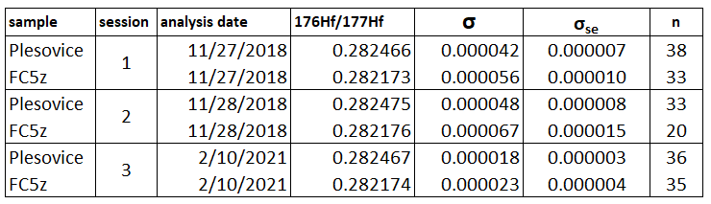
Table A.3. Summary table of standard analyses by day. 4 FC5z analyses were removed from calculation of session 3 due to burn-through/rim affects when lasing.
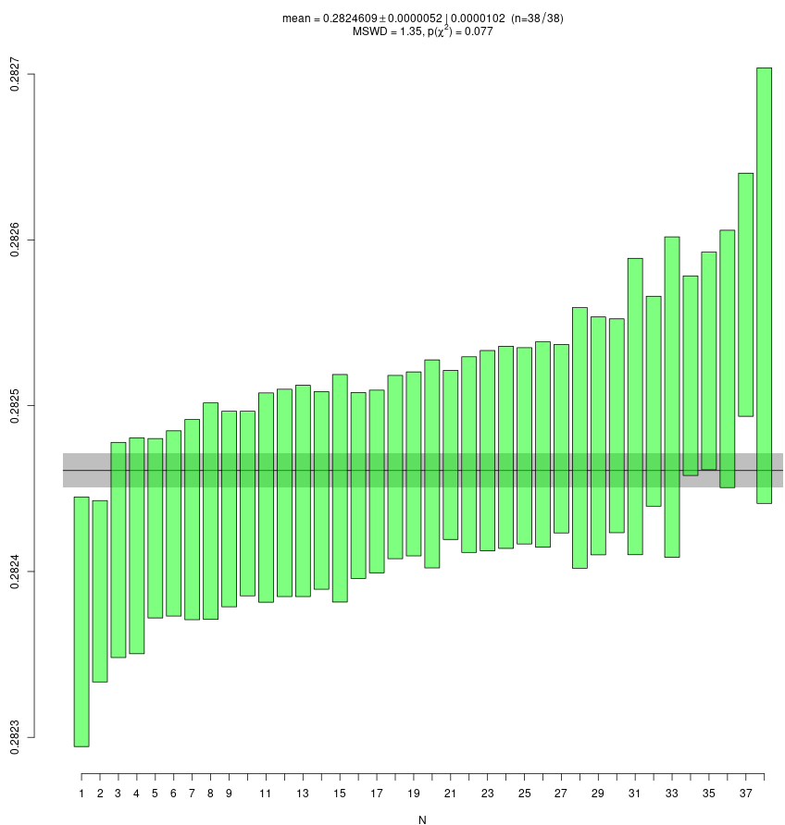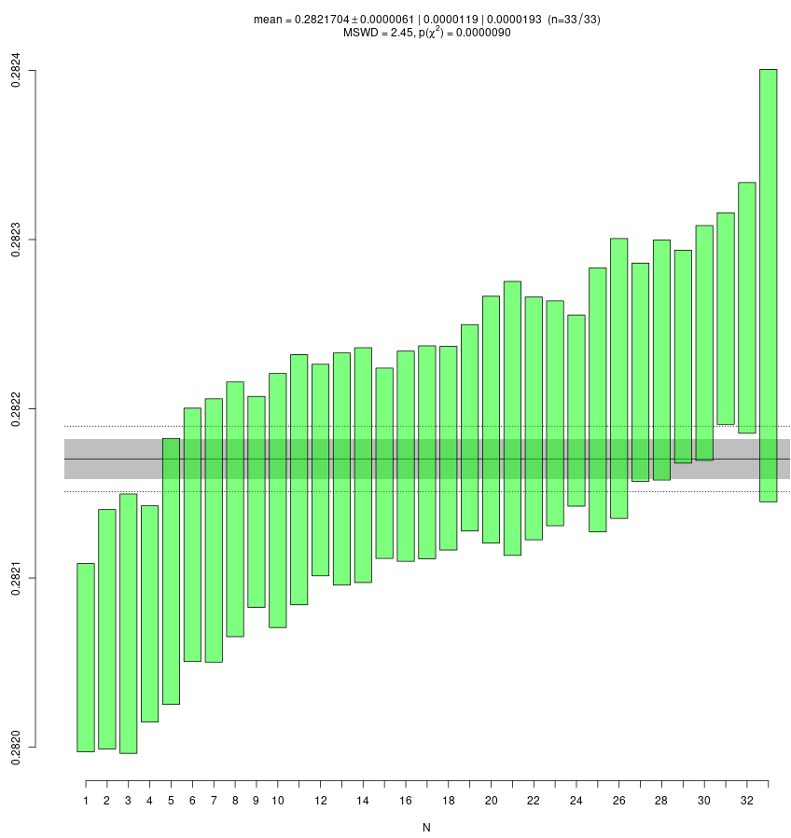
Figure A.3-1. Weighted mean plots of Hf isotopic ratios for Plešovice (left) and FC5z (right) weighted means for 11-27-2018 analyses (y-axes = ¹⁷⁶Hf/¹⁷⁷Hf).
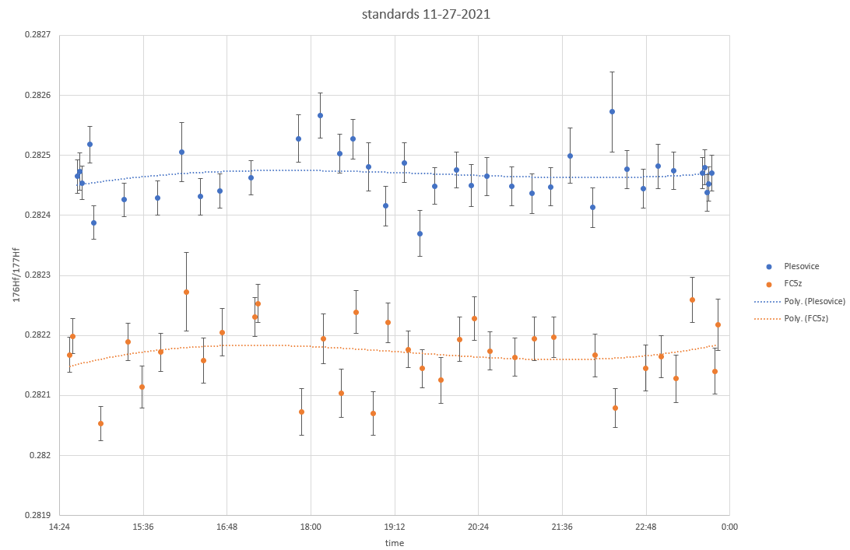
Figure A.3-2. Plešovice and FC5z Hf isotopic ratios from analyses throughout session for 11-27-2018.
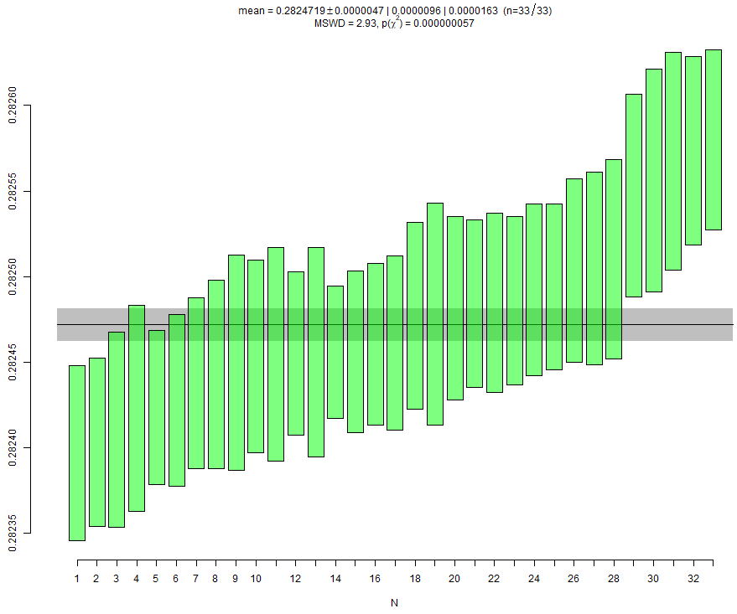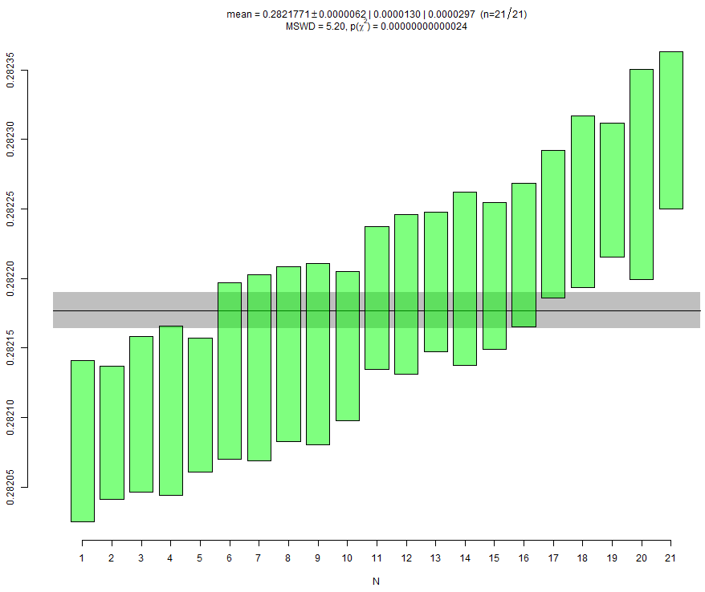
Figure A.3-3. Weighted mean plots of Hf isotopic ratios for Plešovice (left) and FC5z (right) weighted means for 11-28-2018 analyses (y-axes = ¹⁷⁶Hf/¹⁷⁷Hf).
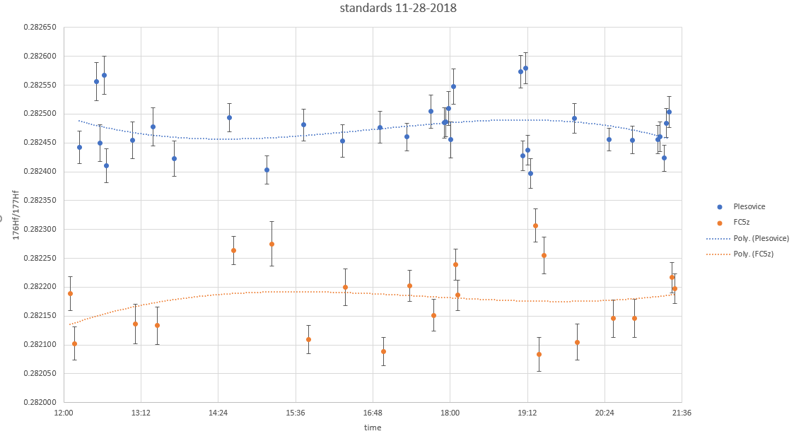
Figure A.3-4. Hf isotopic ratios for Plešovice and FC5z analyses throughout session for 11-28-2018.
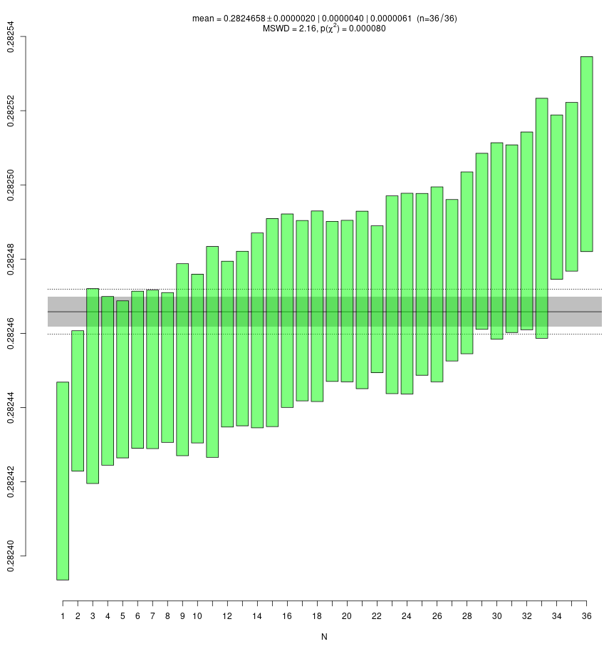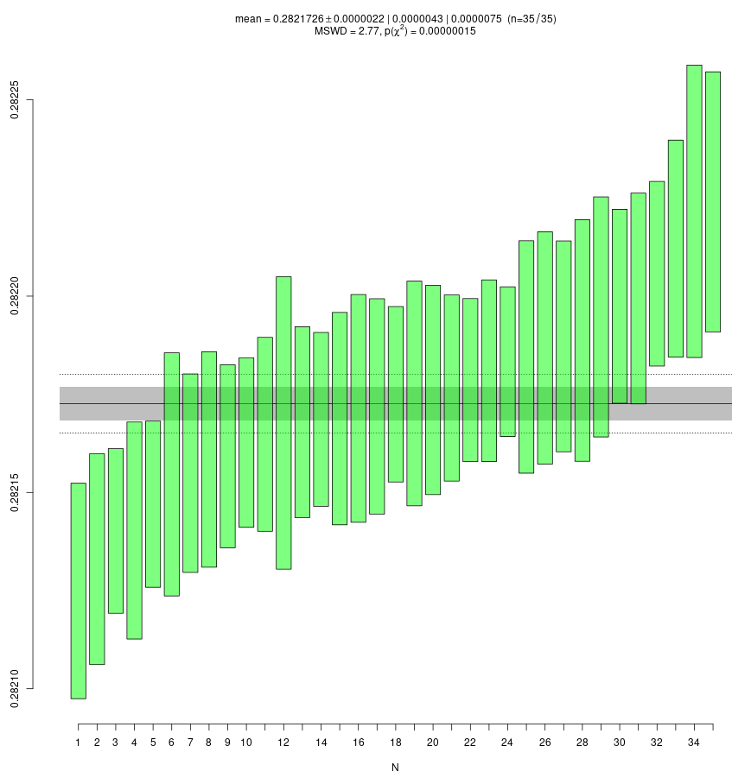
Figure A.3.-5. Weighted mean plots for Hf isotopic ratios of Plešovice (left) and FC5z (right) weighted means for 02-10-2021 analyses. FC5z data do not include grain analyses with grain burn through/rim issues.

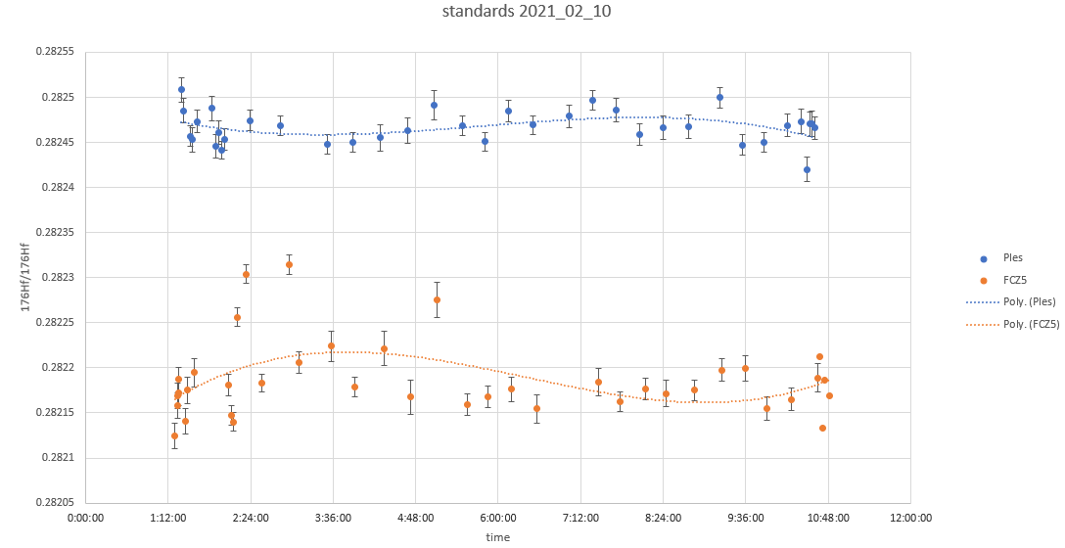
Figure A.3-7. Hf isotopic ratios for Plesovice and FC5z analyses throughout session for 02-10-2021. Note the 4 FC5z outliers, which are the burn-through/rim analyses are removed from the weighted mean plot directly above, as well as the FC5z* analysis summary in Table A.3.
References
Barbeau, D.L., 2003, A flexural model for the Paradox Basin: implications for the tectonics of the Ancestral Rocky Mountains: Basin Research, v. 15, no. 1, p. 97-115.
Chang, Z., Vervoort, J.D., McClelland, W.C., and Knaack, C., 2006, U-Pb dating of zircon by LA-ICP-MS: Geochemistry Geophysics Geosystems, v. 7, p. 1–14.
De Voto, R.H., Peel, F.A., and Pierce, W.H., 1971, Pennsylvanian and Permian stratigraphy, tectonism, and history, northern Sangre de Cristo Range, Colorado, in James, H.L., ed., New Mexico Geological Society, 22nd Annual Fall Field Conference Guidebook, p. 141–163.
De Voto, R.H., and Peel, F.A., 1972, Pennsylvanian and Permian stratigraphy and tectonism in central Colorado: Colorado School of Mines Quarterly, v. 67, no. 4, p. 139-185.
De Voto, R.H., 1980, Pennsylvanian stratigraphy and history of Colorado, in Kent, H.C., and Porter, K.W., eds., Colorado geology: Denver, Colorado, Rocky Mountain Association of Geologists, p. 71-101.
Ejembi, J.I., Potter-McIntyre, S.L., Sharman, G.R., Smith, T.M., Saylor, J.E., Hatfield, K., and Ferré, E.C., 2021, Detrital zircon geochronology and provenance of the Middle to Late Jurassic Paradox Basin and Central Colorado trough: Paleogeographic implications for southwestern Laurentia: Geosphere, v. 17.
Evans, K.V., and C`lemons, R.E., 1988, Cambrian–Ordovician (500Ma) alkalic plutonism in southwestern New Mexico—U-Th-Pb isotopic data from the Florida Mountains: American Journal of Science, v. 288, p. 735-755.
Gehrels, G.E., Valencia, V.A., and Ruiz, J., 2008, Enhanced precision, accuracy, efficiency, and spatial resolution of U‐Pb ages by laser ablation–multicollector-inductively coupled plasma–mass spectrometry: Geochemistry, Geophysics, Geosystems, v. 9, no. 3, p. 1-13.
Hanson, R.E., Puckett, R.E, Jr., Keller, G.R., Brueseke, M.E., Bulen, C.L., Mertzman, S.A., Finegan, S.A., and McCleery, D.A., 2013, Intraplate magmatism related to opening of the southern Iapetus Ocean: Cambrian Wichita igneous province in the Southern Oklahoma rift zone: Lithos, v. 174, p. 57-70.
Hogan, J.P., Gilbert, M.C., Price, J.D., and Wright, J.E., 1995, Petrogenesis of A-type sheet granites from an ancient rift, in Brown, M., and Piccoli, P.M., eds., The Origin of Granites and Related Rocks: Third Hutton Symposium Abstracts: U.S. Geological Survey Circular, v. 1129, p. 68–69.
Kluth, C.F., and Coney, P.J., 1981, Plate-Tectonics of the Ancestral Rocky Mountains: Geology, v. 9, no. 1, p. 10-15.
Lawton, T. F., Cashman, P. H., Trexler, J. H., and Taylor, W. J., 2017, The late Paleozoic Southwestern Laurentian Borderland: Geology, v. 45, no. 8, p. 675-678.
Larson E.E., Patterson, P.E., Curtis, G., Drake, R., Mutschler, F.E., 1985, Petrologic, paleomagnetic, and structural evidence of a Paleozoic rift system in Oklahoma, New Mexico, Colorado and Utah: Geological Society of America Bulletin, v. 96, p. 1364-1372.
Leary, R. J., Umhoefer, P., Smith, M. E., and Riggs, N., 2017, A three-sided orogen: A new tectonic model for Ancestral Rocky Mountain uplift and basin development: Geology, v. 45, no. 8, p. 735-738.
Loring, A.K., and Armstrong, D.G., 1980, Cambrian-Ordovician syenites of New Mexico, part of a regional alkali intrusive episode: Geology, v. 8, p. 344-348.
McMillan, N.J., and McLemore, V.T., 2001, Cambrian-Ordovician magmatism and extension in New Mexico and Colorado: New Mexico Bureau of Geology and Mineral Resources Bulletin, v. 160, p. 1-11.
Musgrave, B.E., 2003, Lower Pennsylvanian stratigraphy of the Central Colorado Trough [M.Sc. thesis] Texas Tech University, 150 p.
Olson, J.C., Marvin, R.F., Parker, R.L., and Mehnert, H.H., 1977, Age and tectonic setting of Lower Paleozoic alkalic and mafic rocks, carbonatites, and thorium veins in south central Colorado: U.S. Geological Society: Journal of Research, v. 5, p. 673–687.
Pearce, N.J., Perkins, W.T., Westgate, J.A., Gorton, M.P., Jackson, S.E., Neal, C R., & Chenery, S.P., 1997, A compilation of new and published major and trace element data for NIST SRM 610 and NIST SRM 612 glass reference materials: Geostandards Newsletter, v. 21, no. 1, p.115-144.
Powell, B.N., Gilbert, M.C., and Fischer, J.F., 1980, Lithostratigraphic classification of basement rocks of the Wichita province, Oklahoma: Geological Society of America Bulletin v. 91, Part I, Summary, p. 509-514, Part II, p. 1875-1994.
Price, J.D., 1998. Petrology of the Mount Scott Granite. Unpublished [Ph.D. dissertation]: University of Oklahoma, Norman, Oklahoma, 240 p.
Schoene, B., and Bowring, S.A., 2006, U-Pb systematics of the McClure Mountasin syenite: thermochronological constraints on the age of the 40Ar/39Ar standard MMhb: Contributions to Mineral Petrology, v. 151, p. 615-630.
Sláma, J., Košler, J., Condon, D. J., Crowley, J. L., Gerdes, A., Hanchar, J. M., Horstwood, M. S., Morris, G. A., Nasdala, L., and Norberg, N., 2008, Plešovice zircon—a new natural reference material for U–Pb and Hf isotopic microanalysis: Chemical Geology, v. 249, no. 1, p. 1-35.
Stacey, J.S., and Kramers, J., 1975, Approximation of terrestrial lead isotope evolution by a two-stage model: Earth and Planetary Science Letters, v. 26, no. 2, p. 207-221.
Stanley, T.M., and Miller, G.W., 2004, Geologic map of the Oklahoma part of the Altus 30’ x 60’ Quadrangle, Greer, Harmon, Jackson, Kiowa, and Tillman counties, Oklahoma: United States Geological Survey, OGQ-59, scale 1:100,000.
Sundell, K.E., Gehrels, G.E., and Pecha, M.E., 2020, Rapid U-Pb Geochronology by Laser Ablation Multi-Collector ICP-MS: Geostandards and Geoanalytical Research, v. 45, no. 1, p. 37-57.
Taylor, R.B., Scott, G.R., and Wobus, R.A., 1975, Reconnaissance geologic map of the Howard Quadrangle, central Colorado: United States Geological Survey, Miscellaneous Investigations Series, Map I-892, scale 1:62,500.
Thomas, W.A., 1991, The Appalachian-Ouachita rifted margin of southeastern North America: Geological Society of America Bulletin, v. 103, p. 415–431.
Thomas, W.A., Gehrels, G.E., and Romero, M.C., 2016, Detrital zircons from crystalline rocks along the Southern Oklahoma fault system, Wichita and Arbuckle Mountains, USA: Geosphere, v. 12, no. 4, p. 1-11.
Vaughn, P.P., 1972, More vertebrates, including a new microsaur, from the upper Pennsylvanian of central Colorado: Contributions in Science, Los Angeles County Museum, no. 223, p. 1-29.
Vermeesch, P., 2018, IsoplotR: A free and open toolbox for geochronology: Geoscience Frontiers, v. 9, p. 1479-1493.
Wallace C.A., Cappa, J.A., and Lawson, A.D., 1997, Geologic map of Salida East Quadrangle, Chaffee and Fremont counties, Colorado: Colorado Geological Survey, Open-File Report 97-6 scale 1:24,000.
Wallace, C.A., Apeland, A.D., and Cappa, J.A., 2000, Geologic map of the Jack Hill Mountain Quadrangle, Fremont County, Colorado: Colorado Geological Survey, Open-File Report 00-1, scale 1:24,000.
Waechter, Noel B. and De Voto, Richard H., 1989, Tectonic-Stratigraphic Framework and Petroleum Potential of the Late Paleozoic Central Colorado Trough, Northwestern Colorado in Lorenz, John C. and Lucas, Spencer G., ed., Energy Frontiers in the Rockies: Albuquerque, Rocky Mountain Section of the American Association of Petroleum Geologists and Albuquerque Geological Society, p. 91-100.
Woodhead, J., and Hergt, J., 2005, A preliminary appraisal of seven natural zircon materials for In Situ isotope determination. Geostandards and Geoanalytical Research, v. 29, no. 2, p. 183-195.

