SUPPLEMENTAL MATERIALS

Numerical Model Setup
Our model geometry is based on the Pampean flat-slab subduction in central Chile (~31˚S-33˚S). In this area, the Nazca plate subducts under the South America Plate and then unbends to become subhorizontal at ~110 km depth. The geometry of the subducting slab is well constrained by tomography and intra-slab earthquake locations (e.g., Kopp et al., 2004; Anderson et al., 2007; Porter et al., 2012).
The 2D model plane is oriented parallel to plate convergence direction along X-X’ in Figure 1. Figure S1 shows the initial model geometry. The model domain is 1800 km wide and 1200 km deep. The oceanic plate is on the left side of the model domain and the continental lithosphere is on the right side. The trench is located at 300 km from the left boundary. In this study, we report all distances with respect to the trench.
The subducting Nazca plate in the Pampean region has an age of 40 Ma at the trench (e.g., Müller et al., 2008). This corresponds to an 80 km thick oceanic lithosphere based on the GDH1 plate cooling model (Stein and Stein, 1992). At this latitude, the Nazca plate contains a linear aseismic oceanic ridge (a chain of volcanic islands and seamounts), the Juan Fernandez Ridge (e.g., Yáñez et al., 2002; Gans et al., 2011). Plate reconstructions show that the ridge started to subduct at ~ca. 12 Ma at ~32˚S, and the orientation of the ridge is in the direction of subduction (Yáñez et al., 2001). Seismic studies indicate that the crustal thickness of the aseismic ridge is 10 to 22 km (Gans et al., 2011), with a thinner crust for the offshore portion (Kopp et al., 2004) and a thicker crust for the subducted portion (Yáñez et al., 2002). In our models, the oceanic plate has a 1200 km long (along the subduction direction) oceanic ridge to represent the Juan Fernandez Ridge. The thickness of the ridge crust is 18 km for the east portion of the ridge (500 km in length), which will be fully subducted during the model run. The rest of the ridge has a crustal thickness of 12 km. The ridge is positioned so that its eastern end is located at the trench at the start of the model run (0 m.y.). The thickness of the normal oceanic crust is 8 km. For the entire oceanic plate, there is a layer of harzburgite that has twice the thickness of the overlying crust to represent melt-depleted mantle (van Hunen et al., 2004).
The continental plate is divided into a 120 km thick non-cratonic lithosphere adjacent to the plate margin and a 200 km thick lithosphere that starts 1000 km away from the margin (Fig. S1). The thick lithosphere represents the Rio de la Plata craton (Fig. 1), and the thickness of ~200 km is based on magnetotelluric data (e.g., Bologna et al., 2019). For simplicity, the continental crust has a thickness of 36 km for both parts of the continent (Assumpção et al., 2013; Perarnau et al., 2012). The continental crust is divided into a 24 km thick upper crust and 12 km thick lower crust. We also introduce five weak zones in the non-cratonic continental lithosphere. Their locations are based on the position of major terrane boundaries and suture zones in the Pampean region (Fig. 1). Surface observations and focal mechanisms studies show that the faults and shear zones within the terrane sutures have a dominantly east-dipping trend, with a dip angle of 20 ˚E to 60 ˚E (e.g., Jordan and Allmendinger, 1986; Regnier et al. 1992; Costa and Vita-Finzi, 1996; Ramos et al., 2002; Stevens-Goddard et al., 2018). Therefore, in the models, the weak zones dip toward the east (craton-ward) at 50˚. The width of each weak zone is 10 km and the tops of the five weak zones are 430 km, 490 km, 580 km, 740 km, and 860 km from the trench, respectively. We test the effects of weak zones that extend from the Earth’s surface to three different depths: 24 km, 36 km, and 72 km. This corresponds to weak zones that cut through the upper crust, upper and lower crust, and the entire crust plus uppermost mantle, respectively. For simplicity and modeling parameter control, the initial surface elevation is at 0 km (relative to the continental interior). The surface elevation changes in our model are due to isostatic adjustment, plate flexure, and deformation due to the subduction process.

Material properties
The thermal and mechanical properties of all model materials are listed in Table S1. These follow values used in our previous work (Liu and Currie, 2019; Liu et al., 2021). All materials undergo viscous-plastic deformation and have a temperature dependent density. Frictional-plastic deformation is determined by the Drucker-Prager yield criterion:
${J'}_{2}=Psinϕ_{eff}+C_{0}cosϕ_{eff}$, (1)
where ${J'}_{2}$ is the square root of the second invariant of the deviatoric stress tensor, $P$ is pressure, $ϕ_{eff}$ is the effective internal angle of friction and $C_{0}$ is cohesion. We include a decrease of the effective angle of friction from 15˚ to 2˚ with and cumulative strain from 0.5 to 1.5 to account for strain softening that may be caused by factors such as pore fluid pressure change (e.g., Beaumont et al., 2006; Warren et al., 2008). The weak zones have a low effective internal angle of friction of 1˚, with all other properties the same as the adjacent materials. In our model, deformation is modelled as power-law viscous creep by defining an effective viscosity. Viscous deformation occurs at stresses below frictional-plastic yield, with an effective viscosity of:
$η_{eff}=f\left(B^{*}\right){{\dot{I}'}_{2}}^{\frac{1-n}{n}}\exp\left[\frac{Q+PV^{*}}{nRT}\right]$, (2)
where ${\dot{I}'}_{2}$ is the square root of the second invariant of the strain rate tensor, $f$ is a scaling factor, $R$ is the gas constant, and $B^{*}$, $n$, $Q$ and $V^{*}$ are the pre-exponential viscosity parameter, stress exponent, activation energy and activation volume, respectively. We use laboratory-derived viscous rheologies with a linear scaling factor (f) to vary the strength of the model materials, in order to account for the effects of composition and hydration variations relative to the laboratory samples (Beaumont et al., 2006). We also include strain weakening through a decrease in f by a factor of 2 with cumulative strain to reflect weakening due to grain size reduction and other factors (e.g., Beaumont et al., 2006; Warren et al., 2008). The sub-lithospheric mantle has a wet olivine rheology, with f=1 to a depth of ~660 km and f=10 below, to represent the increase in viscosity in lower mantle (Karato, 1981; Karato and Wu, 1993). We do not model detailed phase changes through the mantle transition zone.
Models include a phase change of the oceanic crust from basalt to eclogite when the temperature and pressure conditions reach the eclogite stability field (Hacker et al., 2003). As oceanic crust enters the eclogite field, there is an increase in reference density from 2950 to 3500 kg/m³ but no other properties change. Normal oceanic crust undergoes full eclogitization, whereas the oceanic ridge crust undergoes 10% eclogitization to a reference density of 3125 kg/m³. This assumes that the oceanic ridge remains partially metastable due to its dryness; this allows the oceanic ridge to remain buoyant enough for slab flattening to occur (Liu and Currie, 2019).

Boundary conditions and model initialization
Figure S1 shows the model boundary conditions during the model run. We use a constant convergence rate of 8 cm/yr, consistent with the average convergence rate between the Nazca and South America plates in the last ~10 Ma (e.g., Müller et al., 2016). This is composed of an oceanic plate velocity (v_{o}= 3.3 cm/yr) and continental plate velocity (v_{c}= 4.7 cm/yr), based on the hotspot reference frame, HS3-NUVEL 1A (Gripp and Gordon, 2002). The plate velocities are applied to the lithosphere side boundaries. This is balanced by an outflux velocity along the sublithospheric mantle (v_{b}), to maintain a constant mass in the model domain (Fig. S1). Models are run in the continental reference frame; therefore, v_{c} is added to all the other boundaries toward the right. A geotherm corresponding to an oceanic plate age of 40 Ma (Stein and Stein, 1992) is assigned to the incoming oceanic lithosphere (Fig. S1B). The remaining side boundaries are no-slip, insulating boundaries. The top boundary is a stress-free surface and the bottom boundary is a closed, free-slip boundary. The temperatures of the top and bottom boundaries are 0˚C and 1780˚C, respectively. The bottom temperature is calculated based on a 1300˚C mantle adiabat with vertical gradient of 0.4˚C/km.
Model runs are divided into three phases. In phase one, the models undergo isostatic adjustment based on the initial thermal structure of the oceanic and continental plate (Fig. S1B), in which the dense oceanic plate subsides by ~4 km. There are no plate velocities in this phase. In phase two, a velocity of 5 cm/yr is applied to the oceanic plate in order to initiate subduction. This phase is run to 700 km convergence and results in the formation of a steep-angle subduction zone. By the end of phase two, the oceanic plateau is located at the trench. The models shown in this study start at this point (0 m.y.), corresponding to the third phase (e.g., Fig. 2). All times are reported relative to this time. Models are run for 12 m.y. in phase three with the convergence rate of 8 cm/yr described above.

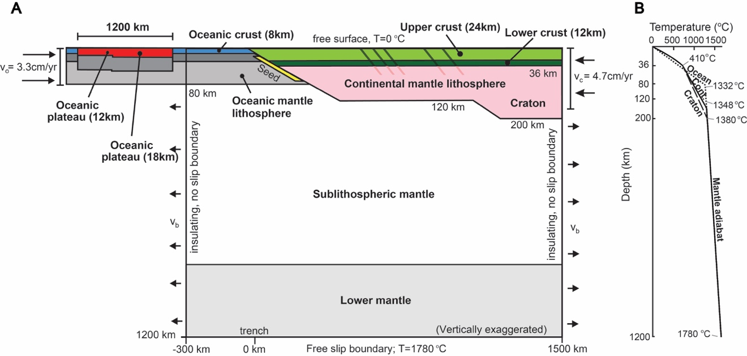
Figure S1. (A) Initial model geometry and boundary conditions. Inclined planes in the continent are weak zones. (B) Initial geotherms for the continental and oceanic lithosphere.

Model limitations
Models presented in this study are limited to a 2D domain, assuming plane strain, and therefore they do not address the effect of along strike processes. The subduction of the Juan Fernandez Ridge and Pampean flat-slab subduction has migrated from north (~ 27 ˚S) to south (~32 ˚S) since ~19 Ma, which corresponds to a southward migration of the deformation in the Sierras Pampeanas (e.g., Yáñez et al., 2001; Ramos et al., 2002). At 32 ˚S, subduction of the ridge started at ~12 Ma, and it is inferred that the ridge has subducted in the direction parallel to its length (e.g., Yáñez et al., 2001). Our 2D models only examine subduction along the subduction direction (X-X’ in Fig.1), where the Juan Fernandez Ridge enters the trench with the strike of the ridge parallel to the subduction direction at ~32˚S, similar to the inferred subduction history at this latitude (Yáñez et al., 2001). Owing to the 2D setup, the models do not allow for an examination of the effect of variations in along-strike width of the ridge, which may affect the overall buoyancy of this feature and its effects on continental uplift. Future work is needed to investigate the changes along strike using 3D models.
The Pampean region has a long deformation history with episodes of rifting and compressional events (e.g., Ramos and Kay, 1991; Schmidt et al., 1995; Richardson et al, 2013; Stevens-Goddard et al., 2018). This is inferred to have resulted in high surface elevation and thickened crust in the Precordillera and possible paleotopography in the Sierras Pampeanas before the Miocene (Stevens-Goddard and Carrapa, 2017; Stevens-Goddard et al., 2018). These pre-existing structures may have affected the deformation pattern in the Sierras Pampeanas during the Pampean flat-slab subduction by adding an elevation load and creating weak zones, and they may contribute to the present-day relief in the Sierras Pampeanas (e.g., Stevens-Goddard and Carrapa, 2017; Stevens-Goddard et al., 2018). Our models neglect the effects of paleotopography and assume an initially uniform crustal thickness and flat ground surface at the beginning of the model run. After model initiation in phases one and two, the topography at 0 m.y. is due to flexure caused by steep-angle subduction. Thus, our models allow us to explore the dynamic effect of the flat-slab subduction on the surface topography. The effect of pre-existing surface topography and crustal thickness variations on the deformation require future investigation.

Supplemental model plots and video
Figure S2 shows the full model domain for the model shown in Figure 2B, where there is a flat slab and continental weak zones. An animation of this model is shown in Movie S1 with a time increment of 0.5 m.y. between model frames. Figure S3 shows the surface maximum shear strain of model in Figure 2C which has continental weak zones and steep-angle subduction.
Figure S4 shows the effects of variations in the depth of the weak zones for models with a flat slab. In Figure S4A, the weak zones are limited to the upper continental crust. During the development and growth of the flat slab, there is negligible deformation of the continent. Figure S4B show a model in which the weak zones extend through the entire continental crust and the top 36 km of the mantle lithosphere. In this model, significant deformation occurs and causes over 6 km uplift and over 150 km shortening. With the large amount of shortening, the slab does not have enough time to from a flat geometry within 12 m.y. model run. When the buoyant ridge reaches the area beneath the seaward weak zones, dynamic surface uplift inhibits deformation in these zones. The two models in Figure S4 and the model shown in Figure 2B (weak zones to the base of the crust) demonstrate that the amount of deformation depends on the depth of the weak zones, with a greater amount of deformation as the weak zone depth increases. This is consistent with the strength profiles for the continent in our models (Figs. 3B and 3C). If the weak zones cut through at least the lower crust, the continent is susceptible to deformation.

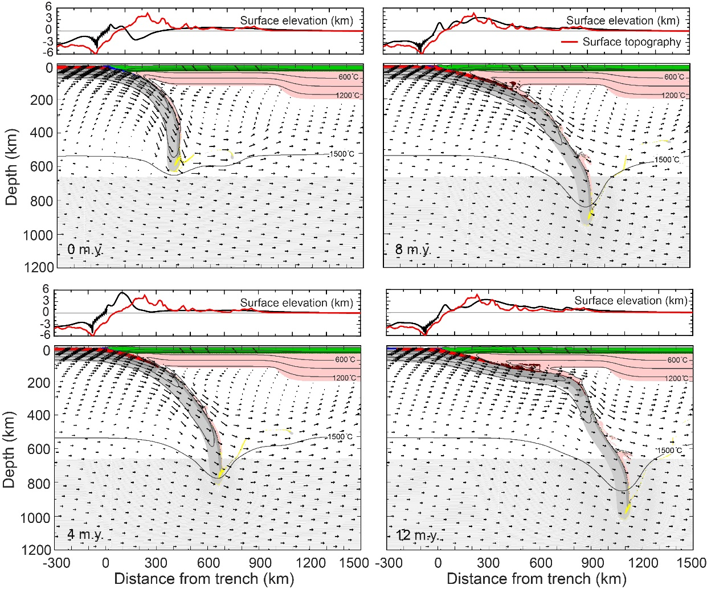
Figure S2. Evolution of the model in Figure 2B showing the full model domain. The top plots show the surface topography of the model at each time (black line), and red line is the observed present-day surface topography along X-X’ in Figure 1. The material colors follow those in Figure 2.

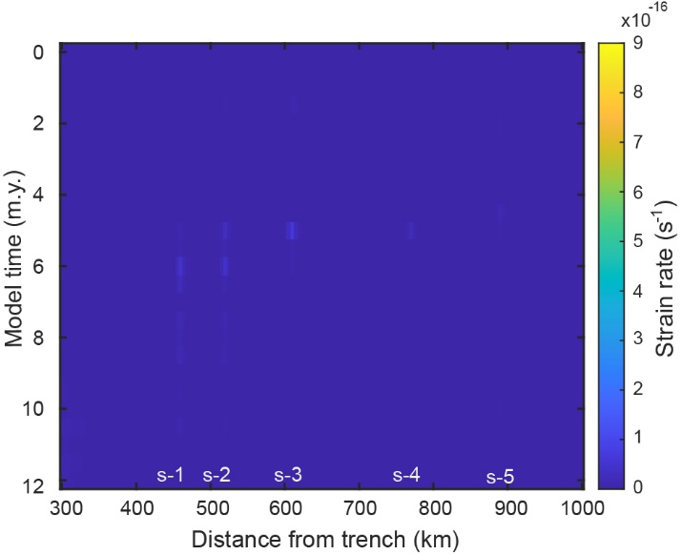
Figure S3. Surface maximum shear strain of model in Figure 2C that has continental weak zones in the upper and lower crust with a steep-angle subduction.

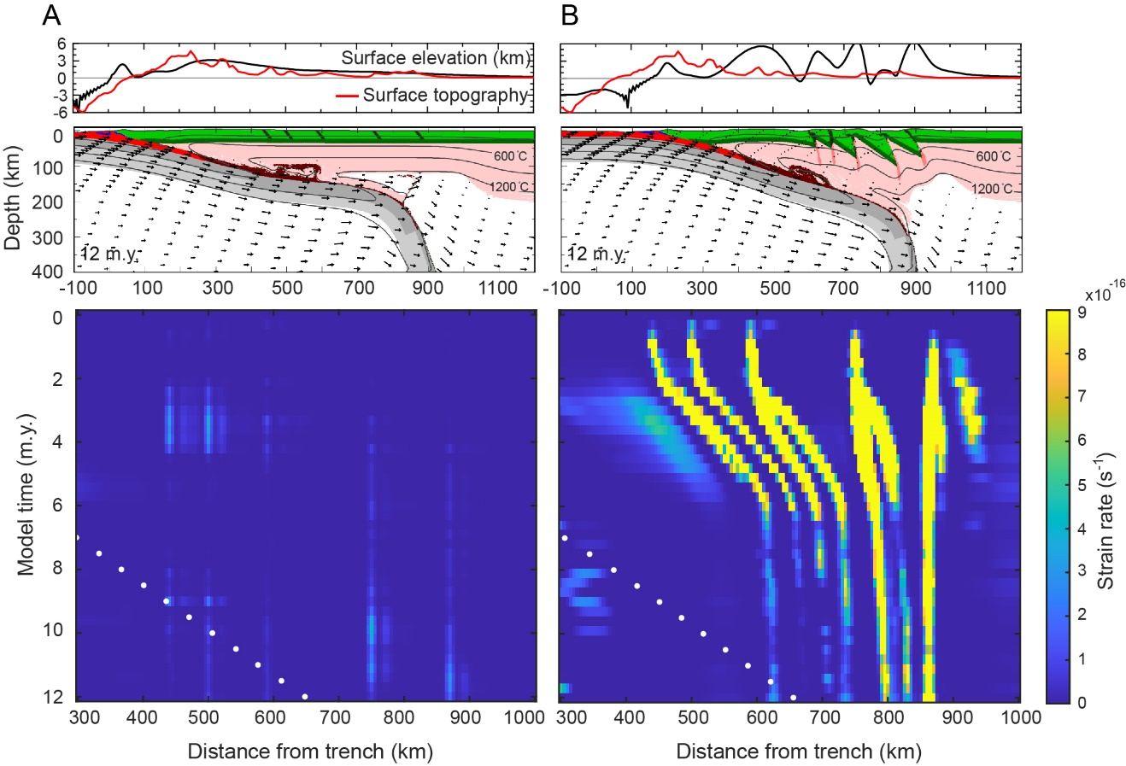
Figure S4. Model geometry at 12 m.y. and surface maximum shear strain rate of (A) a model with weak zones within the upper continental crust only (to a depth of 24 km) and (B) a model with weak zones that cut through the whole crust and the upper 36 km of the mantle lithosphere (to a depth of 72 km). The material colors follow those in Figure 2. The white dots show the trajectory of the center of the east portion of the ridge (500 km wide).

Captions for animations

Movie S1. Model evolution and surface topography of the model in Figure 2B. The bar shows the modeled time since the subduction of the oceanic ridge. The material colors follow those in Figure 2.

Movie S2. Horizontal deviatoric stress and maximum shear stress of the model shown in Figure 2B. The black dots show the locations of the oceanic Moho.

Table of model parameters

Table S1. Model parameters
 | Oceanic crust | Oceanic mantle lithosphere | Cont. upper crust | Cont. lower crust | Cont. mantle lithosphere | Sub-lithospheric mantle
Plastic rheology *
C_{o} (MPa) | 0 | 0 | 20 | 0 | 0 | 0
ϕ_{eff} | 15° † | 15° | 15° † | 15° † | 15° † | 15° †
Viscous rheology §
Material # | Dry Maryland diabase | Wet olivine | Wet quartzite | Dry Maryland diabase | Wet olivine | Wet olivine
f | 0.1 ** | 10 | 50 | 1 | 10 ** | 1 **
A_{ps} (Pa^{−n} s⁻¹) †† | 5.78×10⁻²⁷ | 1.76×10⁻¹⁴ | 8.57×10⁻²⁸ | 5.78×10⁻²⁷ | 1.76×10⁻¹⁴ | 1.76×10⁻¹⁴
B*(Pa^{−n} s⁻¹) †† | 1.91×10⁵ | 1.92×10⁴ | 2.92×10⁶ | 1.91×10⁵ | 1.92×10⁴ | 1.92×10⁴
n | 4.7 | 3.0 | 4.0 | 4.7 | 3.0 | 3.0
Q (kJ mol⁻¹) | 485 | 430 | 223 | 485 | 430 | 430
V* (cm³ mol⁻¹) | 0 | 10 | 0 | 0 | 10 | 10
Thermal parameters
k (Wm⁻¹ K⁻¹) §§ | 2.25 | 2.25 | 2.25 | 2.25 | 2.25 | 2.25
A (μWm⁻³) | 0 | 0 | 1.0 | 0.4 | 0 | 0
c_{p} (J kg⁻¹ K⁻¹) | 750 | 1250 | 750 | 750 | 1250 | 1250
α (K⁻¹) | 3.0×10⁻⁵ | 3.0×10⁻⁵ | 3.0×10⁻⁵ | 3.0×10⁻⁵ | 3.0×10⁻⁵ | 3.0×10⁻⁵
Density ##
ρ_{o} (kg m⁻³) | 2950 | 3250 | 2800 | 2900 | 3250 | 3250
T_{o} (°C) | 0 | 1344 | 200 | 500 | 1344 | 1344
Eclogite ρ_{o} (kg m⁻³⁾ | 3500 | — | — | — | — | —
Eclogite T₀ (°C) | 0 | — | — | — | — | —
* Frictional-plastic deformation uses the Drucker-Prager yield criterion:${({J'}_{2})}^{1/2}=Psinϕ_{eff}+C_{0}cosϕ_{eff}$, where J’₂ is second invariant of the deviatoric stress tensor, P is pressure, ϕ_{eff} is effective internal angle of friction, and C₀ is cohesion.
† Softens through a decrease in ϕ_{eff} from 15° to 2° over accumulated strain of 0.5 to 1.5 (Beaumont et al., 2006).
§ Effective viscosity: $η_{eff}=f\left(B^{*}\right){{\dot{I}'}_{2}}^{\frac{1-n}{2n}}\exp\left[\frac{Q+PV^{*}}{nRT}\right]$, where İ’₂ is the second invariant of the strain rate tensor, f is a scaling factor, R is the gas constant, and B*, n, Q and V* are the pre-exponential viscosity parameter, stress exponent, activation energy and activation volume, respectively.
# The rheologies are based on laboratory experiments, including wet quartzite (Gleason and Tullis, 1995), dry Maryland diabase (Mackwell et al., 1998), and wet olivine (Karato and Wu, 1993).
** Weakening through a decrease in f by a factor of 2 over accumulated strain of 2.0 to 5.0 (Warren et al., 2008).
†† $B^{*}=\frac{1}{2}{A_{ps}}^{-1/n}$. A_{ps} is the plane strain pre-exponential factor that converted from uniaxial laboratory experimented pre-exponential viscosity parameter (A_{uni}). $A_{ps}=\frac{1}{2}(3^{(n+1)/2}) A_{uni}$.
§§ Thermal conductivity at temperatures <1396°C; above this, thermal conductivity increases linearly to 54.25 Wm⁻¹ K⁻¹ at 1436°C (Pysklywec and Beaumont, 2004).
## Temperature dependent density:$ρ(T)=ρ_{0}[1-α(T-T_{0})]$, where $ρ_{0}$ is the reference density at temperature $T_{0}$ and $α$ is the volumetric thermal expansion coefficient.

References cited
Assumpção, M., Feng, M., Tassara, A. and Julià, J., 2013, Models of crustal thickness for South America from seismic refraction, receiver functions and surface wave tomography: Tectonophysics, v. 609, p. 82-96, https://doi.org/10.1016/j.tecto.2012.11.014.
Anderson, M., Alvarado, P., Zandt, G., and Beck, S., 2007, Geometry and brittle deformation of the subducting Nazca Plate, Central Chile and Argentina: Geophysical Journal International, v. 171, no. 1, p. 419–434, https://doi.org/10.1111/j.1365-246X.2007.03483.x.
Beaumont, C., Nguyen, M.H., Jamieson, R.A., and Ellis, S., 2006, Crustal flow modes in large hot orogens, in Law, R.D., Searle, M.P., and Godin, L., eds., Channel Flow, Ductile Extrusion and Exhumation in Continental Collision Zones: Geological Society, London, Special Publication 268, no. 1, p. 91-145, https://doi.org/10.1144/gsl.sp.2006.268.01.05.
Bologna, M.S., Dragone, G.N., Muzio, R., Peel, E., Nuñez‐Demarco, P. and Ussami, N., 2019, Electrical structure of the lithosphere from Rio de la Plata Craton to Paraná Basin: Amalgamation of cratonic and refertilized lithospheres in SW Gondwanaland: Tectonics, v. 38, no. 1, p.77-94. https://doi.org/10.1029/2018tc005148.
Costa, C.H. and Finzi, C.V., 1996, Late Holocene faulting in the southeast Sierras Pampeanas of Argentina: Geology, v. 24, no. 12, p. 1127-1130. https://doi.org/10.1130/0091-7613(1996)024<1127:lhfits>2.3.co;2.
Gans, C.R., Beck, S.L., Zandt, G., Gilbert, H., Alvarado, P., Anderson, M. and Linkimer, L., 2011, Continental and oceanic crustal structure of the Pampean flat slab region, western Argentina, using receiver function analysis: new high-resolution results: Geophysical Journal International, v. 186, no. 1, p. 45-58, https://doi.org/10.1111/j.1365-246x.2011.05023.x.
Gleason, G. C., & Tullis, J., 1995, A flow law for dislocation creep of quartz aggregates determined with the molten salt cell: Tectonophysics, v. 247, no. 1-4, p. 1-23, https://doi.org/10.1016/0040-1951(95)00011-b.
Gripp, A. E., and Gordon, R. G., 2002, Young tracks of hotspots and current plate velocities: Geophysical Journal International, v. 150, no. 2, p. 321-361, https://doi.org/10.1046/j.1365-246x.2002.01627.x.
Hacker, B.R., Abers, G.A., and Peacock, S.M., 2003, Subduction factory 1. Theoretical mineralogy, densities, seismic wave speeds, and H2O contents: Journal of Geophysical Research: Solid Earth, v. 108, https://doi.org/10.1029/2001JB001127.
Jordan, T.E. and Allmendinger, R.W., 1986, The Sierras Pampeanas of Argentina; a modern analogue of Rocky Mountain foreland deformation: American Journal of Science, v. 286, n. 10, p. 737-764, https://doi.org/10.2475/ajs.286.10.737.
Karato, S.I., 1981, Rheology of the lower mantle, Physics of the Earth and Planetary Interiors, v. 24, n.1, p.1-14, https://doi.org/10.1016/0031-9201(81)90074-1.
Karato, S.I., and Wu, P., 1993, Rheology of the upper mantle: A synthesis: Science, v. 260, no. 5109, p. 771–778, https://doi.org/10.1126/science.260.5109.771.
Kopp, H., Flueh, E.R., Papenberg, C., and Klaeschen, D., 2004, Seismic investigations of the O’Higgins Seamount Group and Juan Fernández Ridge: Aseismic ridge emplacement and lithosphere hydration: Tectonics, v. 23, no. 2, https://doi.org/10.1029/2003TC001590.
Liu, X., and Currie, C.A., 2019, Influence of upper plate structure on flat‐slab depth: Numerical modeling of subduction dynamics: Journal of Geophysical Research: Solid Earth, v. 124, no. 12, p. 13150-13167, https://doi.org/10.1029/2019JB018653.
Liu, X., Currie, C. A., & Wagner, L. S., 2021, Cooling of the continental plate during flat-slab subduction: Geosphere, v.18, no.1, p. 49-68, https://doi.org/10.1130/GES02402.1.
Mackwell, S. J., Zimmerman, M. E., & Kohlstedt, D. L., 1998, High‐temperature deformation of dry diabase with application to tectonics on Venus: Journal of Geophysical Research: Solid Earth, v. 103, no. B1, p.975-984, https://doi.org/10.1029/97jb02671.
Müller, R.D., Sdrolias, M., Gaina, C., and Roest, W.R., 2008, Age, spreading rates, and spreading asymmetry of the world’s ocean crust: Geochemistry, Geophysics, Geosystems, v. 9, no. 4, https://doi.org/10.1029/2007GC001743.
Perarnau, M., Gilbert, H., Alvarado, P., Martino, R. and Anderson, M., 2012, Crustal structure of the Eastern Sierras Pampeanas of Argentina using high frequency local receiver functions, Tectonophysics, v. 580, p. 208-217, https://doi.org/10.1016/j.tecto.2012.09.021.
Porter, R., Gilbert, H., Zandt, G., Beck, S., Warren, L., Calkins, J., Alvarado, P., and Anderson, M., 2012, Shear wave velocities in the Pampean flat‐slab region from Rayleigh wave tomography: Implications for slab and upper mantle hydration: Journal of Geophysical Research: Solid Earth, v. 117, https://doi.org/10.1029/2012jb009350.
Pysklywec, R. N., & Beaumont, C., 2004. Intraplate tectonics: feedback between radioactive thermal weakening and crustal deformation driven by mantle lithosphere instabilities: Earth and Planetary Science Letters, v. 221, no. 1-4, p.275-292, https://doi.org/10.1016/s0012-821x(04)00098-6.
Ramos, V.A., Cristallini, E.O. and Pérez, D.J., 2002, The Pampean flat-slab of the Central Andes: Journal of South American earth sciences, v. 15, no. 1, p. 59-78, https://doi.org/10.1016/j.tecto.2015.11.019.
Ramos, V.A. and Kay, S.M., 1991, Triassic rifting and associated basalts in the Cuyo basin, central Argentina, In Andean magmatism and its tectonic setting: Boulder: Geological Society of America, v. 265, p. 79-91.
Regnier, M., Chatelain, J.L., Smalley Jr, R., Chiu, J.M., Isacks, B.L. and Araujo, M., 1992, Seismotectonics of Sierra Pie de Palo, a basement block uplift in the Andean foreland of Argentina: Bulletin of the Seismological Society of America, v. 82, no. 6, p. 2549-2571.
Richardson, T., Ridgway, K.D., Gilbert, H., Martino, R., Enkelmann, E., Anderson, M. and Alvarado, P., 2013, Neogene and Quaternary tectonics of the Eastern Sierras Pampeanas, Argentina: Active intraplate deformation inboard of flat-slab subduction: Tectonics, v. 32, no. 3, p. 780-796, https://doi.org/10.1002/tect.20054.
Schmidt, C.J., Astini, R.A., Costa, C.H., Gardini, C.E. and Kraemer, P.E., 1995, Cretaceous rifting, alluvial fan sedimentation, and Neogene inversion, southern Sierras Pampeanas, Argentina: Petroleum Basins of South America, v. 62, p. 341-358.
Stein, C.A., and Stein, S., 1992, A model for the global variation in oceanic depth and heat flow with lithospheric age: Nature, v. 359, no. 6391, p. 123-129, https://doi.org/10.1038/359123a0.
Stevens Goddard, A.L., and Carrapa, B., 2017, Using basin thermal history to evaluate the role of Miocene-Pliocene flat-slab subduction in the southern Central Andes (27°S-30°S): Basin Research, v. 30, no. 3, p. 564-585, https:// doi.org /10.1111 /bre.12265.
Stevens Goddard, A.L., Larrovere, M.A., Carrapa, B., Aciar, R.H. and Alvarado, P., 2018, Reconstructing the thermal and exhumation history of the Sierras Pampeanas through low-temperature thermochronology: A case study from the Sierra de Velasco, Bulletin, v. 130, no.11-12, p.1842-1858, https://doi.org/10.1130/B31935.1.
Yáñez, G., Cembrano, J., Pardo, M., Ranero, C. and Selles, D., 2002, The Challenger–Juan Fernández–Maipo major tectonic transition of the Nazca–Andean subduction system at 33–34 S: geodynamic evidence and implications: Journal of South American Earth Sciences, v. 15, no. 1, p. 23-38, https://doi.org/10.1016/s0895-9811(02)00004-4.
Yáñez, G.A., Ranero, C.R., von Huene, R., and Díaz, J., 2001, Magnetic anomaly interpretation across the southern central Andes (32–34°S): The role of the Juan Fernández Ridge in the late Tertiary evolution of the margin: Journal of Geophysical Research: Solid Earth, v. 106, p. 6325–6345, https://doi.org/10.1029/2000JB900337.
van Hunen, J., van den Berg, A. P., & Vlaar, N. J., 2004, Various mechanisms to induce present-day shallow flat subduction and implications for the younger Earth: a numerical parameter study: Physics of the Earth and Planetary Interiors, v. 146, no. 1-2, p. 179-194, https://doi.org/10.1016/j.pepi.2003.07.027.
Warren, C. J., Beaumont, C., & Jamieson, R. A., 2008, Formation and exhumation of ultra‐high‐pressure rocks during continental collision: Role of detachment in the subduction channel: Geochemistry, Geophysics, Geosystems, v. 9, no. Q04019, https://doi.org/10.1029/ 2007GC001839.

