Lacroix, B., et al., 2022, Raman thermometry and (U‐Th)/He thermochronometry reveal Neogene transpressional exhumation in the Nacimiento block of central California, USA: Geology, https://doi.org/10.1130/G49882.1

SUPPLEMENTAL MATERIAL

RAMAN THERMOMETRY AND (U‐TH)/HE THERMOCHRONOMETRY REVEAL NEOGENE TRANSPRESSIONAL EXHUMATION IN THE NACIMIENTO BLOCK OF CENTRAL CALIFORNIA

Raman Spectroscopy of Carbonaceous Material (RSCM)
We performed RSCM analyses on 47 samples (Tables S1, S2, S3). The Raman spectra of carbonaceous materials (CM) were obtained using polished petrographic thin sections. Raman spectroscopy analyses of CM grains were conducted following the method of Lahfid et al. (2010) using an Invia Reflex Renishaw microspectrometer equipped with an argon laser (λ₀ = 532 nm, source power 20 mW). We used a 100X objective (NA = 0.90) to focus the laser beam with a power of about 1 mW at the sample surface. The Raman spectrometer was operated using centered scanning mode at 1500 cm⁻¹, covering a spectral window from 650 to 1950 cm⁻¹. At least 15 spectra were recorded for each sample to ensure CM homogeneity. Representative CM Raman spectra are shown in Figure S2. The CM Raman spectra obtained in this study are composed of two broad bands. The relative intensity maxima of these bands, so-called D and G (Lahfid et al., 2010), are respectively ~1350 cm⁻¹ and ~1600 cm⁻¹.
Peak temperatures for each sample were calculated using the parameter RA1 (RA1 = (D1+D4)/ (D1+D2+D3+D4+G)) proposed by Lahfid et al. (2010), which has been empirically calibrated in the range 200 − 350°C (Table S1, S2 and S3). We recognize that other calibrations exist, e.g., Beyssac et al. (2002); Rahl et al. (2005). However, the choice to use the calibration from Lahfid et al. (2010) is motivated by the expected maximum temperature range (~180-315˚C) within the Nacimiento block, which has been previously investigated by Underwood et al. (1995) based on vitrinite reflectance. In addition, although Rahl’s calibration partially covers the temperature range investigated in this study, we favored the calibration from Lahfid et al. (2010) as it has been calibrated using a larger number of samples and a greater number of temperature constraints.

From south to north along the Nacimiento block, we observe changes in the CM spectra, particularly a narrowing of G and D band widths (Fig. S2) and a decrease in the relative intensity of the signal between D and G bands at about 1500 cm⁻¹. In the southern part of the study area (region of San Simeon), the peak sample temperatures range between <150°C and 180°C (Fig. S1). Given that the RSCM thermometer employed here was calibrated for a temperature range of 200˚C − 350˚C (Lahfid et al., 2010), it is possible that the lower temperatures calculated for the southern area have a higher uncertainty than the higher temperature estimates (Table S3).

TABLE S1. LOCATION OF RSCM SAMPLES
Sample ID | Latitude (˚N) | Longitude (˚E) | RSCM
 |  |  | Temperature | S.D
BG15-02 | 35.98542 | -121.48823 | 279.5 | 17.4
BG15-03 | 35.99221 | -121.48537 | 242.6 | 11.5
BG15-05 | 36.00394 | -121.458675 | 507.0 | 35.0
BG15-08 | 36.01427 | -121.41206 | 469.0 | 24.0
BG15-10 | 35.97451 | -121.44157 | 220.3 | 10.5
BG15-11 | 35.98011 | -121.4632 | 242.6 | 13.5
BG15-13 | 35.91383 | -121.4399 | 294.1 | 10.2
BG15-15 | 35.88767 | -121.46001 | 326.1 | 6.1
BG15-17 | 35.89155 | -121.37543 | 256.2 | 12.1
BG15-18 | 35.907496 | -121.364175 | 180* | 20.0
BG15-19 | 35.91008 | -121.36363 | 222.0 | 17.5
BG15-21 | 35.95504 | -121.42441 | 581.0 | 35.0
BG15-22 | 35.96794 | -121.3918 | 170* | 20.0
BG15-25 | 35.65224 | -121.22265 | 140* | 20.0
BG15-26 | 35.69255 | -121.28899 | 160* | 20.0
BG15-27 | 35.76979 | -121.32155 | 282.2 | 15.6
BG15-28 | 35.78547 | -121.33331 | 231.5 | 44.3
BG15-29 | 35.81158 | -121.35851 | 231.0 | 11.9
BG15-30 | 35.8455 | -121.40537 | 258.3 | 10.3
BG15-31 | 35.85868 | -121.41723 | 268.0 | 13.6
BG15-32 | 35.89729 | -121.45968 | 335.9 | 15.2
BG15-33 | 35.96047 | -121.48322 | 308.1 | 8.3
BG15-34 | 36.00496 | -121.50803 | 295.4 | 5.5
BG15-35 | 36.01651 | -121.53415 | 293.8 | 14.8
BG15-36 | 36.03388 | -121.57701 | 305.2 | 9.9
BG15-37 | 36.05057 | -121.58858 | 317.8 | 8.5
BG15-38 | 36.5816 | -121.82842 | 130* | 20.0
BG15-39 | 35.64557 | -121.04495 | 160* | 20.0
BG15-40 | 35.89014 | -121.43314 | 290.6 | 18.5
BG15-42 | 35.8787 | -121.38486 | 265.4 | 17.0
BG15-44 | 35.88193 | -121.38493 | 284.3 | 7.1
BG 15-46 | 35.88313 | -121.38432 | 237.9 | 16.5
BG15-47 | 35.8871 | -121.37231 | 239.5 | 14.6
BG15-48 | 35.88012 | -121.37071 | 238.3 | 11.9
BG15-49 | 35.84735 | -121.27617 | 170* | 20.0
BG15-50 | 35.84567 | -121.29659 | 239.9 | 7.1
BG15-54 | 35.61427 | -121.14768 | 191* | 12.0
BG15-55 | 35.652688 | -121.242116 | 170* | 20.0
BG15-58 | 35.889146 | -121.433305 | 321.7 | 6.2
BG15-59 | 35.884693 | -121.42299 | 305.9 | 6.6
BG15-5B | 36.0041 | -121.45885 | 507.0 | 35.0
BG15-60 | 35.886957 | -121.407289 | 317.2 | 8.7
BG15-61 | 35.88399 | -121.396436 | 305.2 | 4.1
BG16-63 | 36.021597 | -121.563145 | 299.5 | 10.3
BG16-66 | 35.614126 | -121.071391 | 80-100 | -
BG16-70 | 35.853058 | -121.410199 | 270.4 | 17.5
BG16-73 | 35.833347 | -121.241416 | 80-100 | -
* RSCM Temperature (Lahfid et al., 2010) below the calibrated temperature range (200˚C-350˚C)

Table S2. RSCM ANALYTICAL DATA
Sample # | Spectrum # | RA1 | Mean | S.D | T˚C (RSCM) | Mean | S.D | S.E
BG15-02
 | 1n | 0.602 |  |  | 282.7
 | 2n | 0.575 |  |  | 249.3
 | 3n | 0.578 |  |  | 253.0
 | 4n | 0.600 |  |  | 280.4
 | 5n | 0.606 |  |  | 287.5
 | 6n | 0.615 |  |  | 297.7
 | 7n | 0.616 |  |  | 299.9
 | 8n | 0.591 |  |  | 269.1
 | 9n | 0.602 |  |  | 282.4
 | 10n | 0.611 | 0.600 | 0.014 | 293.2 | 279.5 | 17.4 | 5.5
BG15-03
 | 1n | 0.563 |  |  | 234.9
 | 2n | 0.579 |  |  | 254.2
 | 3n | 0.568 |  |  | 240.6
 | 4n | 0.552 |  |  | 221.6
 | 5n | 0.573 |  |  | 247.2
 | 6n | 0.558 |  |  | 229.1
 | 7n | 0.576 |  |  | 250.8
 | 8n | 0.575 |  |  | 249.4
 | 9n | 0.582 |  |  | 257.6
 | 10n | 0.568 | 0.569 | 0.009 | 240.8 | 242.6 | 11.5 | 3.6
BG15-10
 | 1n | 0.544 |  |  | 212.3
 | 2n | 0.564 |  |  | 235.7
 | 3n | 0.544 |  |  | 212.2
 | 4n | 0.549 |  |  | 217.4
 | 5n | 0.562 |  |  | 233.7
 | 6n | 0.548 |  |  | 216.2
 | 7n | 0.549 |  |  | 217.5
 | 8n | 0.560 |  |  | 230.8
 | 9n | 0.554 |  |  | 223.8
 | 10n | 0.537 | 0.551 | 0.009 | 203.2 | 220.3 | 10.5 | 2.4
BG15-11
 | 1n | 0.570 |  |  | 243.1
 | 2n | 0.579 |  |  | 254.7
 | 3n | 0.566 |  |  | 238.2
 | 4n | 0.551 |  |  | 220.2
 | 5n | 0.570 |  |  | 243.1
 | 6n | 0.573 |  |  | 246.7
 | 7n | 0.578 |  |  | 253.1
 | 8n | 0.578 |  |  | 252.8
 | 9n | 0.550 |  |  | 218.9
 | 10n | 0.580 | 0.569 | 0.011 | 255.5 | 242.6 | 13.5 | 3.1
BG15-13
 | 1n | 0.610 |  |  | 292.1
 | 2n | 0.605 |  |  | 285.8
 | 3n | 0.599 |  |  | 279.1
 | 4n | 0.606 |  |  | 287.4
 | 5n | 0.615 |  |  | 298.7
 | 6n | 0.615 |  |  | 297.7
 | 7n | 0.624 |  |  | 309.4
 | 8n | 0.609 |  |  | 290.8
 | 9n | 0.625 |  |  | 310.9
 | 10n | 0.607 | 0.612 | 0.008 | 288.7 | 294.1 | 10.2 | 3.2
BG15-15
 | 1n | 0.639 |  |  | 326.9
 | 2n | 0.628 |  |  | 314.1
 | 3n | 0.635 |  |  | 322.4
 | 4n | 0.640 |  |  | 328.8
 | 5n | 0.632 |  |  | 319.1
 | 6n | 0.641 |  |  | 330.3
 | 7n | 0.639 |  |  | 327.5
 | 8n | 0.644 |  |  | 333.4
 | 9n | 0.638 |  |  | 326.1
 | 10n | 0.643 | 0.638 | 0.005 | 332.8 | 326.1 | 6.1 | 1.9
BG15-17
 | 1n | 0.587 |  |  | 264.3
 | 2n | 0.583 |  |  | 259.5
 | 3n | 0.579 |  |  | 254.7
 | 4n | 0.573 |  |  | 246.9
 | 5n | 0.585 |  |  | 261.8
 | 6n | 0.558 |  |  | 228.4
 | 7n | 0.588 |  |  | 265.1
 | 8n | 0.572 |  |  | 246.0
 | 9n | 0.577 |  |  | 251.9
 | 10n | 0.593 |  |  | 271.4
 | 11n | 0.593 |  |  | 270.8
 | 12n | 0.581 | 0.580 | 0.013 | 256.2 | 256.4 | 12.1 | 3.5
BG15-19
 | 1n | 0.552 |  |  | 220.9
 | 2n | 0.538 |  |  | 203.9
 | 3n | 0.571 |  |  | 244.3
 | 4n | 0.568 |  |  | 241.1
 | 5n | 0.571 |  |  | 244.7
 | 6n | 0.547 |  |  | 215.2
 | 7n | 0.567 |  |  | 239.2
 | 8n | 0.568 |  |  | 240.5
 | 9n | 0.568 |  |  | 240.6
 | 10n | 0.577 | 0.566 | 0.009 | 251.4 | 234.2 | 15.3 | 4.9
BG15-27
 | 1n | 0.617 |  |  | 300.4
 | 2n | 0.593 |  |  | 271.6
 | 3n | 0.600 |  |  | 279.3
 | 4n | 0.599 |  |  | 278.8
 | 5n | 0.620 |  |  | 304.4
 | 6n | 0.583 |  |  | 258.9
 | 7n | 0.597 |  |  | 276.6
 | 8n | 0.599 |  |  | 279.1
 | 9n | 0.621 |  |  | 305.3
 | 10n | 0.593 | 0.602 | 0.013 | 271.4 | 282.6 | 15.6 | 4.7
BG15-28
 | 1n | 0.545 |  |  | 212.7
 | 2n | 0.572 |  |  | 245.8
 | 3n | 0.518 |  |  | 180.6
 | 4n | 0.526 |  |  | 189.4
 | 5n | 0.577108 |  |  | 252.0
 | 6n | 0.530 | 0.560 | 0.036 | 194.4 | 231.5 | 44.3 | 10.2
BG15-29
 | 1n | 0.569 |  |  | 242.4
 | 2n | 0.570 |  |  | 243.2
 | 3n | 0.568 |  |  | 240.5
 | 4n | 0.572 |  |  | 246.3
 | 5n | 0.548 |  |  | 216.7
 | 6n | 0.543 |  |  | 210.4
 | 7n | 0.559 |  |  | 230.4
 | 8n | 0.556 |  |  | 226.0
 | 9n | 0.558 |  |  | 229.0
 | 10n | 0.551 |  |  | 219.9
 | 11n | 0.564 | 0.560 | 0.010 | 235.7 | 231.0 | 11.9 | 3.6
BG15-30
 | 1n | 0.562 |  |  | 233.8
 | 2n | 0.589 |  |  | 266.0
 | 3n | 0.588 |  |  | 265.7
 | 4n | 0.591 |  |  | 268.6
 | 5n | 0.590 |  |  | 267.2
 | 6n | 0.578 |  |  | 252.7
 | 7n | 0.583 |  |  | 259.7
 | 8n | 0.576 |  |  | 251.1
 | 9n | 0.578 |  |  | 252.6
 | 10n | 0.586 |  |  | 263.4
 | 11n | 0.584 | 0.582 | 0.008 | 260.7 | 258.3 | 10.3 | 3.1
BG15-31
 | 1n | 0.597 |  |  | 276.0
 | 2n | 0.584 |  |  | 260.0
 | 3n | 0.592 |  |  | 269.8
 | 4n | 0.566 |  |  | 239.0
 | 5n | 0.576 |  |  | 251.0
 | 6n | 0.597 |  |  | 275.8
 | 7n | 0.598 |  |  | 277.1
 | 8n | 0.595 |  |  | 273.8
 | 9n | 0.599 |  |  | 279.0
 | 10n | 0.599 | 0.590 | 0.011 | 278.8 | 268.0 | 13.6 | 4.3
BG15-32
 | 1n | 0.641 |  |  | 330.4
 | 2n | 0.661 |  |  | 354.5
 | 3n | 0.655 |  |  | 346.7
 | 4n | 0.652 |  |  | 343.7
 | 5n | 0.655 |  |  | 346.5
 | 6n | 0.660 |  |  | 353.1
 | 7n | 0.638 |  |  | 326.7
 | 8n | 0.641 |  |  | 330.3
 | 9n | 0.628 |  |  | 314.0
 | 10n | 0.627 | 0.646 | 0.012 | 313.3 | 335.9 | 15.2 | 4.8
BG15-33
 | 1n | 0.611 |  |  | 293.2
 | 2n | 0.630 |  |  | 316.7
 | 3n | 0.630 |  |  | 316.7
 | 4n | 0.624 |  |  | 309.2
 | 5n | 0.622 |  |  | 306.7
 | 6n | 0.615 |  |  | 298.2
 | 7n | 0.631 |  |  | 317.5
 | 8n | 0.629 |  |  | 315.4
 | 9n | 0.617 |  |  | 300.2
 | 10n | 0.625 |  |  | 310.5
 | 11n | 0.621 | 0.624 | 0.006 | 305.3 | 308.1 | 8.3 | 2.5
BG15-34
 | 1n | 0.614 |  |  | 297.5
 | 2n | 0.608 |  |  | 289.5
 | 3n | 0.615 |  |  | 298.3
 | 4n | 0.613 |  |  | 295.4
 | 5n | 0.623 |  |  | 307.8
 | 6n | 0.611 |  |  | 292.8
 | 7n | 0.614 |  |  | 296.4
 | 8n | 0.613 |  |  | 295.9
 | 9n | 0.610 |  |  | 291.7
 | 10n | 0.607 | 0.613 | 0.005 | 288.5 | 295.4 | 5.5 | 1.7
BG15-35
 | 1n | 0.631 |  |  | 318.2
 | 2n | 0.622 |  |  | 306.8
 | 3n | 0.620 |  |  | 304.0
 | 4n | 0.608 |  |  | 289.3
 | 5n | 0.602 |  |  | 282.0
 | 6n | 0.593 |  |  | 271.0
 | 7n | 0.621 |  |  | 305.4
 | 8n | 0.598 |  |  | 278.0
 | 9n | 0.607 |  |  | 288.3
 | 10n | 0.613 | 0.611 | 0.012 | 295.4 | 293.8 | 14.8 | 4.7
BG15-36
 | 1n | 0.629 |  |  | 314.9
 | 2n | 0.624 |  |  | 309.3
 | 3n | 0.629 |  |  | 314.8
 | 4n | 0.626 |  |  | 312.0
 | 5n | 0.624 |  |  | 309.5
 | 6n | 0.614 |  |  | 296.7
 | 7n | 0.625 |  |  | 310.8
 | 8n | 0.614 |  |  | 297.1
 | 9n | 0.619 |  |  | 303.1
 | 10n | 0.604 | 0.621 | 0.008 | 284.3 | 305.2 | 9.9 | 2.3
BG15-37
 | 1n | 0.636 |  |  | 324.0
 | 2n | 0.621 |  |  | 305.8
 | 3n | 0.626 |  |  | 311.2
 | 4n | 0.631 |  |  | 317.1
 | 5n | 0.628 |  |  | 313.5
 | 6n | 0.625 |  |  | 310.6
 | 7n | 0.629 |  |  | 315.2
 | 8n | 0.633 |  |  | 320.1
 | 9n | 0.645 |  |  | 334.3
 | 10n | 0.638 | 0.631 | 0.007 | 326.3 | 317.8 | 8.5 | 2.7
BG15-40
 | 1n | 0.595 |  |  | 273.6
 | 2n | 0.604 |  |  | 285.2
 | 3n | 0.582 |  |  | 257.5
 | 4n | 0.622 |  |  | 307.0
 | 5n | 0.617 |  |  | 301.0
 | 6n | 0.614 |  |  | 296.8
 | 7n | 0.608 |  |  | 289.8
 | 8n | 0.637 |  |  | 324.3
 | 9n | 0.609 |  |  | 290.3
 | 10n | 0.601 | 0.609 | 0.015 | 280.9 | 290.6 | 18.5 | 5.8
BG15-42
 | 1n | 0.605 |  |  | 286.2
 | 2n | 0.594 |  |  | 272.2
 | 3n | 0.574 |  |  | 248.2
 | 4n | 0.588 |  |  | 265.1
 | 5n | 0.568 |  |  | 240.4
 | 6n | 0.571 |  |  | 244.3
 | 7n | 0.602 |  |  | 282.3
 | 8n | 0.605 |  |  | 286.3
 | 9n | 0.591 |  |  | 268.6
 | 10n | 0.584 | 0.588 | 0.014 | 260.6 | 265.4 | 17.0 | 5.4
BG15-44
 | 1n | 0.598 |  |  | 276.9
 | 2n | 0.597 |  |  | 276.6
 | 3n | 0.605 |  |  | 285.5
 | 4n | 0.605 |  |  | 286.3
 | 5n | 0.609 |  |  | 290.5
 | 6n | 0.606 |  |  | 287.1
 | 7n | 0.608 |  |  | 290.1
 | 8n | 0.608 |  |  | 289.3
 | 9n | 0.613 |  |  | 295.7
 | 10n | 0.599 |  |  | 278.1
 | 11n | 0.593 |  |  | 271.7
 | 12n | 0.603 | 0.604 | 0.006 | 283.7 | 284.3 | 7.1 | 2.0
BG 15-46
 | 1n | 0.587 |  |  | 263.9
 | 2n | 0.548 |  |  | 217.0
 | 3n | 0.561 |  |  | 232.7
 | 4n | 0.550 |  |  | 218.5
 | 5n | 0.588 |  |  | 265.0
 | 6n | 0.563 |  |  | 235.1
 | 7n | 0.557 |  |  | 227.3
 | 8n | 0.570 |  |  | 243.2
 | 9n | 0.561 |  |  | 232.6
 | 10n | 0.570 | 0.566 | 0.014 | 243.8 | 237.9 | 16.5 | 5.2
BG15-47
 | 1n | 0.569 |  |  | 242.4
 | 2n | 0.549 |  |  | 217.6
 | 3n | 0.560 |  |  | 231.3
 | 4n | 0.553 |  |  | 222.3
 | 5n | 0.580 |  |  | 256.1
 | 6n | 0.561 |  |  | 232.6
 | 7n | 0.588 |  |  | 265.3
 | 8n | 0.566 |  |  | 238.0
 | 9n | 0.573 |  |  | 247.5
 | 10n | 0.569 | 0.567 | 0.012 | 242.4 | 239.5 | 14.6 | 4.6
BG15-48
 | 1n | 0.562 |  |  | 233.3
 | 2n | 0.566 |  |  | 238.4
 | 3n | 0.570 |  |  | 243.0
 | 4n | 0.572 |  |  | 245.7
 | 5n | 0.554 |  |  | 223.9
 | 6n | 0.556 |  |  | 226.1
 | 7n | 0.566 |  |  | 238.9
 | 8n | 0.553 |  |  | 223.1
 | 9n | 0.580 |  |  | 255.0
 | 10n | 0.580 | 0.566 | 0.010 | 255.9 | 238.3 | 11.9 | 3.8
BG15-50
 | 1n | 0.566 |  |  | 238.2
 | 2n | 0.569 |  |  | 241.9
 | 3n | 0.558 |  |  | 229.1
 | 4n | 0.558 |  |  | 229.1
 | 5n | 0.565 |  |  | 236.9
 | 6n | 0.570 |  |  | 243.6
 | 7n | 0.573 |  |  | 247.5
 | 8n | 0.576 |  |  | 251.0
 | 9n | 0.566 |  |  | 238.9
 | 10n | 0.570 | 0.567 | 0.006 | 243.0 | 239.9 | 7.1 | 2.2
BG15-58
 | 1n | 0.631 |  |  | 317.6
 | 2n | 0.635 |  |  | 322.9
 | 3n | 0.636 |  |  | 323.3
 | 4n | 0.644 |  |  | 332.9
 | 5n | 0.634 |  |  | 320.7
 | 6n | 0.629 |  |  | 314.9
 | 7n | 0.631 |  |  | 317.9
 | 8n | 0.638 |  |  | 326.2
 | 9n | 0.625 |  |  | 310.9
 | 10n | 0.636 |  |  | 323.9
 | 11n | 0.639 | 0.634 | 0.005 | 327.2 | 321.7 | 6.2 | 1.9
BG15-59
 | 1n | 0.627 |  |  | 313.1
 | 2n | 0.619 |  |  | 302.9
 | 3n | 0.624 |  |  | 308.8
 | 4n | 0.624 |  |  | 308.8
 | 5n | 0.595
 | 6n | 0.613 | 0.617 | 0.012 | 296.1 | 305.9 | 6.6 | 1.5
BG15-60
 | 1n | 0.622 |  |  | 306.5
 | 2n | 0.648 |  |  | 338.2
 | 3n | 0.633 |  |  | 320.6
 | 4n | 0.628 |  |  | 314.3
 | 5n | 0.628 |  |  | 314.5
 | 6n | 0.628 |  |  | 314.6
 | 7n | 0.626 |  |  | 312.1
 | 8n | 0.627 |  |  | 312.5
 | 9n | 0.636 |  |  | 323.7
 | 10n | 0.629 | 0.631 | 0.007 | 315.4 | 317.2 | 8.7 | 2.7
BG15-61
 | 1n | 0.623 |  |  | 307.7
 | 2n | 0.620 |  |  | 304.6
 | 3n | 0.618 |  |  | 301.9
 | 4n | 0.620 |  |  | 304.5
 | 5n | 0.616 |  |  | 299.8
 | 6n | 0.620 |  |  | 304.5
 | 7n | 0.624 |  |  | 308.8
 | 8n | 0.628 |  |  | 314.0
 | 9n | 0.619 |  |  | 302.7
 | 10n | 0.619 | 0.621 | 0.003 | 303.5 | 305.2 | 4.1 | 1.3
BG16-63
 | 1n | 0.638 |  |  | 326.1
 | 2n | 0.565 |  |  | 237.4
 | 3n | 0.607 |  |  | 289.0
 | 4n | 0.602 |  |  | 282.0
 | 5n | 0.636 |  |  | 324.2
 | 6n | 0.663 |  |  | 357.1
 | 7n | 0.658 |  |  | 350.4
 | 8n | 0.615 |  |  | 298.4
 | 9n | 0.560 | 0.616 | 0.037 | 230.8 | 299.5 | 45.0 | 10.3
BG16-64
 | 1n | 0.605 |  |  | 286.6
 | 2n | 0.611 |  |  | 293.2
 | 3n | 0.647 |  |  | 337.3
 | 4n | 0.551 |  |  | 220.7
 | 5n | 0.591 |  |  | 269.1
 | 6n | 0.611 | 0.603 | 0.031 | 292.9 | 283.3 | 38.1 | 8.7
BG16-70
 | 1n | 0.577 |  |  | 251.9
 | 2n | 0.603 |  |  | 283.6
 | 3n | 0.608 |  |  | 289.9
 | 4n | 0.586 |  |  | 263.3
 | 5n | 0.606 |  |  | 286.8
 | 6n | 0.594 |  |  | 272.0
 | 7n | 0.572 | 0.592 | 0.014 | 245.3 | 270.4 | 17.5 | 4.0

Table S3. RSCM TEMPERATURES OUTSIDE THE CURRENT CALIBRATION
sample | RSCM Temp | SD
BG15-05 | 507 | 35
BG15-08 | 469 | 24
BG 15-18 | 180 | 20
BG 15-22 | 170 | 20
BG 15-25 | 140 | 20
BG 15-26 | 160 | 20
BG 15-38 | 130 | 20
BG 15-39 | 160 | 20
BG 15-49 | 170 | 20
BG 15-54 | 190 | 20
BG 15-55 | 170 | 20
BG15-21 | 581 | 35
BG16-66 | 80-100
BG16-73 | 80-100
Figure S1. Distribution map of the analyzed samples. Numbers refer to the TRSCM (see Tables S2 and S3)

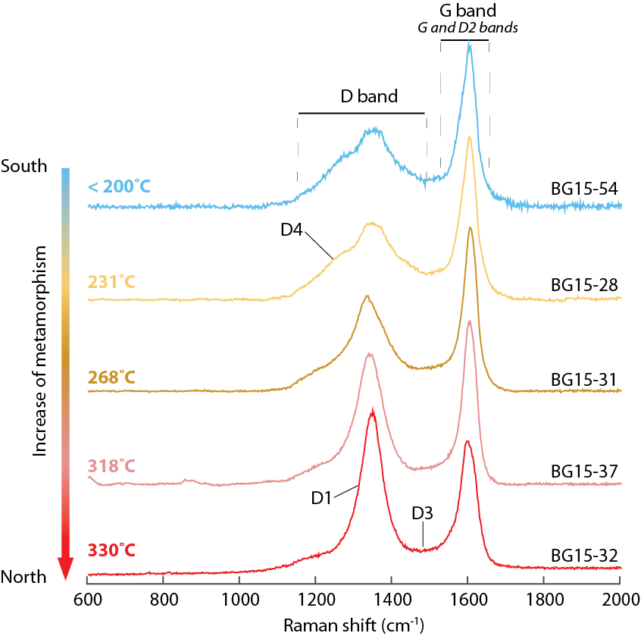
Figure S2. Selection of representative Raman spectra of carbonaceous materials and corresponding temperatures.

(U-Th-Sm)/He analytical procedures
We present (U-Th-[Sm])/He thermochronological analyses from 19 greywacke and sandstone samples (Table S4).
Apatite and zircon grain concentrates were generated by crushing, sieving and separating mineral grains using standard magnetic and density separation techniques. Individual mineral grains were hand selected under a high-power binocular microscope for optimal clarity, crystal morphology and minimal inclusions of other potential radiogenic minerals. Selected grains were photographed and measured, then packaged into individual Pt (apatite) or Nb (zircon) tubes. Apatite grains were heated for 5 minutes at 900°C using a diode laser. Zircon grains were heated for 10 minutes at 1200°C. Evolved 4He was spiked with 3He and the 4He/3He ratio was measured on quadrupole mass spectrometer to determine the quantity of 4He in the mineral grains. Following initial 4He measurement, the above analytical procedures were repeated to check for any additional extraction of 4He that might be indicative of micro-inclusions of high-temperature radiogenic minerals that were not observed optically during the grain selection stage. If helium yield is above blank levels during this second heating step, the analysis is identified as such in the data table. The Durango apatite and the Fish Canyon Tuff zircon standards were analyzed along with apatite (zircon) grains of unknown age in order to ensure accuracy of measurements of unknown age. After extraction and measurement of 4He, the apatite and zircon grains were dissolved and analyzed for U, Th and Sm concentrations via inductively-coupled plasma mass spectrometry. Corrected ages were calculated using the alpha-ejection correction of Farley (1996).
Analyses from the Los Burros Mine area (Ward, 2021) were undertaken at the University of Michigan on an ASI Alphachron Instrument following procedures outlined in Niemi and Clark (2018). U, Th, and Sm analyses were complete at the University of Arizona, following the procedures outlined in Reiners and Nicolescu (2006).
Analyses from the south-central Coast Range (Lori, 2016) were completed at the University of Colorado on an ASI Alphachron Instrument following the procedures described in Peak et al. (2021).
Analyses from Salmon Creek (Steely, 2016) were completed at the University of California, Santa Cruz, on a bespoke helium extraction system, but with general procedures the same as for the other two datasets (Steely, 2016).
Thermochronology data tables of Ward, Lori and Steely Data

TABLE S4. APATITE AND ZIRCON LOW-TEMPERATURE TERMOCHRONOLOGY RESULTS
Sample ID | Latitude | Longitude | Elevation | Mean Age and Standard Error (Ma)
 | (°N) | (°W) | (m) | Apatite (U-Th-Sm)/He | Zircon (U-Th)/He
Los Burros Mine
NB19-004 | 35.884 | 121.414 | 810 | – | 11.77 ± 2.0
NB19-015 | 35.881 | 121.371 | 1057 | 5.95 ± 0.2 | 32.84 ± 8.9
NB19-019 | 35.864 | 121.339 | 935 | 6.41 ± 0.9† | 21.19 ± 2.6
NB19-021 | 35.847 | 121.276 | 781 | 6.34 ± 0.3 | 78.15 ± 19.8
NB19-025 | 35.614 | 121.071 | 59 | 8.10 ± 1.6 | 85.13 ± 13.1
NB19-032 | 35.857 | 121.415 | 30 | 3.87 ± 0.3 | 13.75 ± 2.6
South-central Coast Ranges
11SL1 | 36.022 | 121.560 | 89 | – | 7.31 ± 0.22
13NB1 | 35.693 | 121.291 | 4 | – | 65.32 ± 4.61
SLO-387 | 35.744 | 121.194 | 216 | – | 111.38 ± 4.24
SLO-401 | 35.762 | 121.181 | 463 | – | 83.19 ± 2.65
11MB5 | 35.569 | 121.111 | 3 | – | 87.34 ± 3.14
Salmon Creek
AS026 | 35.855 | 121.323 | 980 | – | 19.76 ± 4.52
AS027 | 35.856 | 121.330 | 897 | 5.29 ± 1.10 | 38.24 ± 6.74
AS029 | 35.847 | 121.337 | 635 | 5.03 ± 0.59* | 13.82 ± 1.32
AS030 | 35.835 | 121.340 | 442 | 4.84 ± 0.13 | 68.85 ± 15.08
AS031 | 35.827 | 121.344 | 402 | 4.02 ± 0.25* | 31.04 ± 5.17
AS032 | 35.816 | 121.351 | 320 | 4.40 ± 0.26 | 24.53 ± 2.80
AS033 | 35.813 | 121.357 | 150 | 3.35 ± 0.41 | 26.21± 7.17
AS047 | 35.808 | 121.363 | 817 | 23.46 ± 0.50 | 69.70 ± 2.16
Note: Salmon Creek samples from Steely (2016). These samples were analyzed by laser ablation and Sm was not measured. Mean ages and standard deviations recalculated from individual grain data using Ft correction of Farley et al., (1996). South-central Coast Ranges from Lori (2016). Ages recalculated after removing outliers using the Q-test (Dean and Dixon, 1951).
*Samples for which mean age and standard error are based on fewer than three replicate analyses.
†Samples with individual grain [U] < 5 ppm.
Thermal Modeling
We performed inverse thermal modeling along 4 locations of the Nacimiento block (Alder Peak, Salmon Creek, Lottie Potrero and San Simeon, Fig. 2). Both apatite and zircon thermochronometric data was incorporated into the inverse thermal models.
Thermal Model Inputs
Thermal modeling was undertaken using QTQt version 5.4.4 (Gallagher, 2012) on a Macintosh computer. Time-temperature histories for each transect were determined by inverse modeling of all of the samples in that transect simultaneously. The samples were treated as a vertical transect and were modeled independently following two different approaches. In the first approach, the present-day elevation of each sample was used to define the vertical separation between samples. In the second approach, the stratigraphic separation between the samples, as derived from a geologic cross section, was used to define the vertical separation between samples.
Raw age and grain size information was entered into QTQt for each apatite and zircon grain, and the software calculated Ft (alpha-ejection) corrected He ages. MCMC (Markov Chain Monte Carlo) resampling of grain age errors was enabled to account for observed differences between analytical uncertainties in individual grain ages and intra-sample reproducibility of ages (e.g. McDowell et al., 2005). The RDAAM (Radiation Damage and Annealing Model) model of Flowers et al. (2009) was implemented for all apatite samples. Guenthner et al.’s (2013) radiation damage model was implemented for all zircon samples.
Initiation points for the inverse modeling were drawn from the age range of 0 – 100 Ma and from the temperature range of 0 – 200 °C. No other time or temperature constraints were imposed on the QTQt thermal model. Models were run with a burn-in of 20,000 iterations, and then sampled over 80,000 iterations with a thinning of 1.
Thermal Model Assumptions
For each sample, two thermal constraints were imposed:
- Samples were at the surface (5 ± 5 °C) at the time of deposition;
- Samples are at a present-day surface temperature of 12 ± 5 °C (mean annual temperature in Gorda, CA).
For each transect modeled, two additional constraints were imposed:
- The geothermal gradient was constrained to the range 30 °C and was allowed to vary between iterations of the model but was held fixed for any given iteration (modern geothermal gradient, see text below for further discussion).
- The maximum present-day temperature difference between the highest and lowest samples in each transect was constrained to 5 ± 5 °C (based on typical atmospheric lapse rate and sample elevation differences).

TABLE S5. APATITE (U-TH-SM)/HE THERMOCHRONOLOGY ANALYTICAL DATA
Sample | Aliquot | Length | Radius | Shape* | U | Th |  | Sm | He | (U-Th-Sm)/He Age (Ma)
 |  | (um) | (um) |  | (ppm) | (ppm) |  | (ppm) | (ncc) | Uncorr | Error | Corr.†
Los Burros Mine
NB19-015 | a | 148.9 | 50.8 | nn | 32.82 | 13.43 | 224.57 |  | 0.0608 | 4.33 | 0.06 | 5.67
 | b | 97.2 | 50.4 | pp | 5.58 | 16.64 | 158.19 |  | 0.0130 | 4.68 | 0.07 | 6.27
 | c | 130.8 | 51.0 | np | 7.63 | 12.41 | 238.23 |  | 0.0182 | 4.49 | 0.08 | 5.90
NB19-019 | a | 159.9 | 57.0 | nn | 1.90 | 4.57 | 22.44 |  | 0.0118 | 6.36 | 0.09 | 8.08
 | b | 132.5 | 61.6 | np | 4.76 | 12.59 | 166.62 |  | 0.0208 | 4.79 | 0.07 | 6.03
 | c | 117.0 | 43.3 | pp | 12.50 | 27.68 | 168.41 |  | 0.0174 | 3.71 | 0.05 | 5.14
NB19- 021 | b | 178.0 | 46.4 | nn | 29.48 | 10.12 | 209.83 |  | 0.0571 | 4.60 | 0.06 | 6.13
 | c | 150.6 | 64.1 | pp | 9.35 | 30.67 | 60.72 |  | 0.0548 | 5.25 | 0.05 | 6.51
 | e | 147.5 | 55.7 | pp | 14.24 | 28.47 | 83.58 |  | 0.0428 | 4.35 | 0.06 | 5.56
 | f | 115.7 | 56.3 | pp | 23.80 | 74.05 | 124.67 |  | 0.0843 | 5.55 | 0.06 | 7.15
NB19-025 | a | 91.0 | 47.3 | pp | 16.04 | 9.41 | 54.76 |  | 0.0272 | 6.92 | 0.10 | 9.46
 | b | 132.5 | 51.0 | np | 35.36 | 5.44 | 24.88 |  | 0.0660 | 5.20 | 0.08 | 6.83
 | c | 140.0 | 52.6 | np | 14.30 | 20.02 | 66.04 |  | 0.0262 | 3.35 | 0.04 | 4.36
 | d | 104.7 | 42.0 | np | 78.71 | 41.06 | 88.53 |  | 0.1347 | 8.35 | 0.11 | 11.75
NB19-032 | a | 120.2 | 61.6 | np | 9.55 | 23.19 | 152.36 |  | 0.0220 | 2.95 | 0.04 | 3.72
 | b | 135.6 | 42.6 | nn | 90.33 | 173.75 | 147.59 |  | 0.1094 | 3.40 | 0.04 | 4.70
 | c | 86.6 | 41.7 | pp | 113.97 | 177.44 | 257.77 |  | 0.0585 | 2.46 | 0.03 | 3.51
 | d | 143.5 | 48.8 | np | 53.01 | 85.59 | 171.32 |  | 0.0678 | 2.69 | 0.03 | 3.56
Salmon Creek
AS027 | a | 125.7 | 44.2 |  | 57.30 | 61.90 |  |  | 0.0717 | 4.05 | 0.05 | 5.54
 | b | 213.6 | 51.9 |  | 10.90 | 15.10 |  |  | 0.0538 | 6.45 | 0.07 | 8.29
 | c | 115.8 | 37.6 |  | 10.60 | 18.50 |  |  | 0.0067 | 2.73 | 0.03 | 3.97
 | d | 108.6 | 36.2 |  | 10.00 | 16.60 |  |  | 0.0045 | 2.26 | 0.03 | 3.34
AS029 | a | 168.9 | 36.7 |  | 16.10 | 39.60 |  |  | 0.0202 | 3.48 | 0.04 | 5.03
AS030 | a | 302.9 | 92.5 |  | 15.70 | 26.70 |  |  | 0.2330 | 4.07 | 0.05 | 4.68
 | b | 184.4 | 62.2 |  | 52.50 | 84.20 |  |  | 0.2128 | 4.11 | 0.05 | 5.09
 | c | 243.6 | 69.3 |  | 28.20 | 37.10 |  |  | 0.1702 | 3.93 | 0.05 | 4.75
AS031 | a | 161.0 | 44.0 |  | 26.00 | 25.30 |  |  | 0.0314 | 3.15 | 0.04 | 4.28
 | b | 192.6 | 51.8 |  | 28.30 | 20.90 |  |  | 0.0717 | 2.92 | 0.04 | 3.77
 | c§ | 217.0 | 71.6 |  | 31.60 | 11.30 |  |  | 0.0179 | 0.47 | 0.01 | 0.57
AS032 | a | 297.2 | 97.5 |  | 51.20 | 40.10 |  |  | 0.6026 | 3.51 | 0.04 | 4.01
 | b | 154.4 | 40.4 |  | 109.90 | 40.20 |  |  | 0.1053 | 3.50 | 0.05 | 4.89
 | c | 203.7 | 54.6 |  | 35.80 | 24.30 |  |  | 0.0851 | 3.37 | 0.04 | 4.29
AS033 | a | 174.5 | 50.4 |  | 35.20 | 80.50 |  |  | 0.0672 | 2.79 | 0.03 | 3.63
 | b | 146.0 | 50.7 |  | 25.50 | 30.00 |  |  | 0.0202 | 1.65 | 0.02 | 2.16
 | c | 171.7 | 43.5 |  | 17.60 | 46.60 |  |  | 0.0381 | 4.09 | 0.04 | 5.57
 | d | 123.9 | 41.3 |  | 32.60 | 16.10 |  |  | 0.0112 | 1.46 | 0.02 | 2.04
 | e§ | 238.0 | 75.8 |  | 10.10 | 14.10 |  |  | 0.0493 | 2.68 | 0.03 | 3.19
AS047 | a | 220.3 | 61.6 |  | 54.40 | 77.40 |  |  | 1.1066 | 18.19 | 0.21 | 22.50
 | b | 203.0 | 62.6 |  | 57.00 | 85.30 |  |  | 1.2051 | 19.59 | 0.23 | 24.20
 | c‡ | 246.2 | 52.5 |  | 69.20 | 100.20 |  |  | 1.1715 | 18.52 | 0.22 | 23.68
Note: Salmon Creek analytical data from Steely (2016). No Sm was measurements or grain shapes were reported. Ages are recalculated from original analytical data using the Ft correction of Farley (1996).
*nn = two pyramidal grain terminations, np = 1 pyramidal termination, pp = no pyramidal terminations
†Corrected age using the alpha-ejection (Ft) correction of Farley (1996)
§These aliquots are excluded from calculation of the mean sample age. Exclusion of these aliquots based on notation of instrumental error or other concerns reported in the original data tables of Steely (2016). Ages are not excluded on the basis of outlier test criteria.

TABLE S6. ZIRCON (U-TH)/HE THERMOCHRONOLOGY ANALYTICAL DATA
Sample | Aliquot | Length | Radius | Shape* | U | Th | He | (U-Th)/He Age (Ma)
 |  | (um) | (um) |  | (ppm) | (ppm) | (ncc) | Uncorr | Error | Corr.†
Los Burros Mine
NB19-004 | a | 150.6 | 40.2 | nn | 325.33 | 283.51 | 0.5187 | 5.56 | 0.07 | 7.80
 | b | 129.0 | 44.8 | nn | 441.15 | 349.12 | 1.2977 | 9.80 | 0.12 | 13.36
 | c | 102.9 | 43.3 | nn | 1158.47 | 686.11 | 2.5204 | 10.15 | 0.14 | 14.15
NB19-015 | a | 230.2 | 51.7 | nn | 2219.99 | 1217.72 | 24.5553 | 16.36 | 0.22 | 21.03
 | b | 252.2 | 50.1 | nn | 328.70 | 299.01 | 5.1835 | 21.00 | 0.26 | 27.15
 | c | 217.8 | 56.3 | nn | 2087.89 | 1276.08 | 64.2698 | 39.90 | 0.51 | 50.32
NB19-019 | a | 197.9 | 42.4 | nn | 1478.98 | 952.22 | 9.2204 | 15.62 | 0.19 | 21.32
 | b | 173.1 | 50.4 | np | 403.24 | 244.45 | 2.5035 | 12.70 | 0.16 | 16.56
 | c | 130.8 | 40.2 | nn | 830.84 | 707.43 | 3.7422 | 18.21 | 0.23 | 25.69
NB19-021 | a | 220.4 | 52.3 | nn | 707.51 | 446.28 | 40.3463 | 83.92 | 1.04 | 107.66
 | b | 220.6 | 43.5 | nn | 960.30 | 572.79 | 28.5572 | 63.86 | 0.82 | 86.21
 | c | 191.7 | 52.3 | nn | 113.89 | 102.78 | 2.2330 | 31.53 | 0.39 | 40.60
NB19-025 | a | 238.8 | 60.1 | nn | 434.57 | 142.75 | 26.2220 | 66.47 | 0.89 | 82.47
 | b | 225.3 | 53.9 | nn | 334.74 | 273.46 | 21.9108 | 85.63 | 1.04 | 109.02
 | c | 245.1 | 72.2 | nn | 282.54 | 184.87 | 21.7402 | 53.36 | 0.69 | 63.90
NB19-032 | a | 148.9 | 48.6 | nn | 1561.89 | 1131.95 | 8.2448 | 13.16 | 0.17 | 17.42
 | b | 199.2 | 47.0 | nn | 1906.12 | 1176.92 | 6.2287 | 6.65 | 0.09 | 8.79
 | c | 159.9 | 41.1 | nn | 2030.08 | 1014.55 | 6.4556 | 10.83 | 0.14 | 15.04
Salmon Creek
AS026 | a | 245.5 | 56.5 |  | 323.80 | 120.20 | 10.5078 | 23.27 | 0.31 | 29.24
 | b | 193.8 | 44.5 |  | 665.80 | 168.30 | 2.8672 | 6.34 | 0.09 | 8.53
 | c | 186.4 | 48.7 |  | 988.90 | 399.80 | 15.4874 | 18.54 | 0.26 | 24.34
 | d | 176.8 | 36.3 |  | 492.20 | 174.70 | 2.5155 | 11.69 | 0.16 | 16.93
AS027 | a | 289.2 | 68.9 |  | 97.00 | 31.60 | 11.4218 | 45.80 | 0.63 | 55.11
 | b | 331.0 | 65.1 |  | 126.10 | 51.50 | 9.5290 | 31.36 | 0.42 | 38.04
 | c | 263.6 | 66.4 |  | 180.70 | 73.10 | 6.4198 | 18.24 | 0.24 | 22.13
 | d | 264.3 | 54.7 |  | 185.20 | 72.50 | 8.1155 | 29.79 | 0.40 | 37.66
AS029 | a | 236.6 | 42.4 |  | 422.70 | 166.90 | 3.9446 | 11.13 | 0.15 | 15.12
 | b | 194.3 | 40.2 |  | 406.80 | 151.10 | 2.3139 | 9.89 | 0.13 | 13.75
 | c | 241.6 | 46.7 |  | 114.00 | 34.40 | 1.3574 | 12.30 | 0.17 | 16.23
 | d | 196.5 | 29.7 |  | 419.20 | 232.70 | 0.9744 | 6.44 | 0.08 | 10.17
AS030 | a | 356.9 | 57.7 |  | 261.00 | 82.80 | 17.1562 | 28.00 | 0.38 | 34.78
 | b | 278.9 | 54.7 |  | 85.70 | 31.90 | 5.5306 | 42.45 | 0.57 | 53.60
 | c | 371.1 | 60.6 |  | 355.20 | 162.80 | 69.2160 | 69.78 | 0.94 | 85.72
 | d | 333.2 | 60.7 |  | 273.00 | 153.40 | 54.6784 | 82.34 | 1.07 | 101.29
AS031 | a | 314.8 | 83.8 |  | 82.10 | 30.70 | 7.0829 | 21.94 | 0.29 | 25.55
 | b | 268.2 | 57.9 |  | 27.90 | 7.50 | 1.4134 | 34.33 | 0.47 | 42.82
 | c | 256.4 | 52.6 |  | 276.80 | 79.00 | 9.8762 | 28.19 | 0.38 | 35.99
 | d | 242.9 | 63.5 |  | 63.10 | 18.30 | 1.6419 | 16.13 | 0.22 | 19.79
AS032 | a | 306.9 | 70.5 |  | 547.50 | 34.60 | 18.0029 | 14.52 | 0.21 | 17.38
 | b | 403.4 | 64.6 |  | 368.80 | 63.10 | 23.9008 | 21.37 | 0.30 | 25.89
 | c | 338.5 | 47.7 |  | 307.70 | 131.20 | 8.8323 | 18.37 | 0.25 | 23.93
 | d | 305.9 | 57.4 |  | 287.70 | 124.10 | 12.7770 | 24.82 | 0.33 | 30.94
AS033 | a | 229.4 | 44.0 |  | 311.90 | 78.00 | 2.1974 | 8.93 | 0.12 | 12.00
 | b | 260.0 | 47.2 |  | 386.60 | 137.90 | 20.1152 | 45.27 | 0.61 | 59.45
 | c | 344.0 | 66.3 |  | 318.50 | 95.90 | 11.4509 | 13.12 | 0.17 | 15.86
 | d | 196.4 | 40.7 |  | 419.70 | 133.30 | 4.2851 | 17.01 | 0.24 | 23.55
 | e | 173.2 | 33.2 |  | 316.70 | 56.50 | 0.8154 | 7.44 | 0.10 | 11.19
 | f | 237.8 | 50.4 |  | 349.50 | 135.70 | 13.5520 | 35.60 | 0.47 | 46.03
 | g | 241.6 | 55.8 |  | 626.80 | 137.00 | 10.0128 | 12.21 | 0.17 | 15.39
AS047 | a | 365.6 | 60.7 |  | 824.60 | 282.40 | 116.2560 | 53.27 | 0.73 | 65.44
 | b | 395.3 | 53.1 |  | 692.30 | 265.60 | 87.5616 | 57.30 | 0.77 | 72.42
 | c | 220.9 | 42.4 |  | 825.00 | 250.10 | 32.4800 | 52.34 | 0.71 | 71.25
 | d§ | 320.7 | 56.8 |  | 138.10 | 29.70 | 59.3600 | 214.51 | 2.96 | 267.79
South-central Coast Ranges
11SL1 | 4 | 216.6 | 46.5 | nn | 340.93 | 110.57 | 1.3201 | 4.79 | 0.43 | 6.00
 | 94 | 230.2 | 36.4 | nn | 529.51 | 123.82 | 1.3925 | 4.60 | 0.74 | 6.07
 | 70 | 154.1 | 27.6 | nn | 1016.51 | 456.28 | 0.9515 | 4.39 | 1.51 | 6.43
 | 30 | 135.2 | 30.8 | nn | 534.60 | 211.56 | 0.5333 | 4.58 | 1.21 | 6.52
 | 48 | 160.6 | 30.3 | nn | 655.53 | 266.99 | 0.8577 | 4.84 | 1.33 | 6.84
 | 19 | 271.9 | 41.2 | nn | 171.89 | 53.85 | 0.8271 | 5.70 | 0.64 | 7.26
 | 9 | 282.6 | 56.7 | nn | 294.98 | 93.88 | 2.8652 | 6.06 | 0.53 | 7.26
 | 99 | 212.1 | 41.4 | nn | 241.48 | 70.35 | 0.8977 | 5.78 | 0.65 | 7.41
 | 10 | 254.0 | 53.9 | nn | 104.11 | 43.47 | 0.8353 | 6.31 | 0.55 | 7.65
 | 20 | 139.1 | 37.6 | nn | 339.90 | 97.16 | 0.9130 | 5.75 | 0.86 | 7.73
 | 83 | 200.4 | 34.7 | nn | 187.13 | 75.28 | 0.5055 | 5.92 | 1.11 | 7.97
 | 35 | 231.4 | 35.6 | nn | 131.28 | 49.84 | 0.5743 | 6.19 | 1.06 | 8.21
 | 56 | 238.0 | 36.4 | nn | 442.95 | 108.12 | 1.6591 | 6.28 | 1.01 | 8.27
 | 57 | 161.9 | 32.6 | nn | 901.17 | 371.66 | 1.7186 | 6.27 | 1.42 | 8.67
 | 84§ | 159.8 | 39.9 | nn | 402.36 | 123.66 | 2.3980 | 14.64 | 1.84 | 19.16
387 | 68 | 205.5 | 47.0 | nn | 97.14 | 46.21 | 7.5368 | 68.25 | 6.15 | 85.55
 | 53 | 249.8 | 39.0 | nn | 1370.17 | 596.45 | 86.5300 | 73.98 | 9.61 | 95.82
 | 82 | 239.6 | 51.6 | nn | 279.73 | 106.24 | 36.5540 | 83.03 | 7.31 | 101.71
 | 10 | 172.7 | 28.7 | nn | 214.70 | 73.04 | 5.1696 | 73.14 | 22.79 | 104.91
 | 57 | 203.6 | 38.1 | nn | 181.92 | 100.42 | 11.2218 | 81.85 | 11.53 | 107.38
 | 44 | 304.3 | 26.6 | nn | 475.70 | 209.67 | 17.0045 | 76.35 | 27.52 | 109.67
 | 88 | 214.2 | 33.2 | nn | 212.32 | 98.16 | 10.1103 | 81.22 | 17.24 | 110.31
 | 3 | 156.3 | 40.2 | nn | 703.70 | 230.71 | 37.8425 | 88.27 | 10.72 | 115.78
 | 92 | 168.8 | 47.0 | nn | 560.82 | 192.48 | 49.2583 | 96.14 | 8.43 | 119.36
 | 91 | 131.8 | 18.4 | nn | 646.28 | 306.46 | 3.8994 | 67.61 | 50.46 | 119.77
 | 79 | 270.9 | 72.4 | nn | 32.40 | 21.34 | 12.6879 | 105.66 | 8.92 | 122.90
 | 39 | 211.5 | 30.6 | nn | 481.43 | 176.67 | 18.8291 | 103.11 | 27.00 | 143.35
 | 85§ | 134.5 | 24.0 | nn | 125.00 | 82.65 | 3.5537 | 160.07 | 74.91 | 249.53
401 | 16 | 231.9 | 51.5 | nn | 134.11 | 36.04 | 11.3697 | 57.41 | 5.12 | 70.37
 | 73 | 172.9 | 55.1 | nn | 93.99 | 30.94 | 7.1467 | 59.56 | 5.17 | 72.88
 | 14 | 151.3 | 48.4 | nn | 1068.93 | 179.22 | 49.6695 | 57.60 | 5.22 | 73.23
 | 40 | 144.7 | 26.4 | nn | 132.16 | 48.56 | 1.4657 | 50.34 | 19.13 | 74.86
 | 2 | 388.7 | 91.8 | nn | 88.50 | 29.55 | 46.8622 | 70.00 | 5.53 | 78.40
 | 65 | 134.7 | 34.7 | nn | 129.98 | 36.52 | 3.0332 | 59.87 | 11.14 | 80.37
 | 57 | 239.5 | 48.6 | nn | 209.97 | 112.30 | 19.6023 | 66.73 | 5.89 | 82.67
 | 78 | 153.3 | 26.6 | nn | 92.76 | 38.01 | 1.4145 | 57.69 | 21.43 | 85.45
 | 59 | 193.9 | 47.8 | nn | 86.46 | 40.07 | 6.5601 | 68.26 | 6.07 | 85.56
 | 10 | 172.2 | 36.6 | nn | 180.52 | 116.21 | 6.1802 | 66.08 | 10.62 | 88.26
 | 10 | 199.4 | 47.2 | nn | 110.17 | 42.75 | 8.4537 | 72.88 | 6.57 | 91.39
 | 96 | 115.8 | 56.6 | nn | 106.34 | 33.30 | 7.3159 | 76.45 | 6.89 | 96.01
 | 10 | 180.0 | 42.1 | nn | 155.03 | 60.85 | 9.6551 | 79.19 | 8.57 | 102.04
 | 55§ | 200.9 | 51.1 | nn | 146.83 | 79.91 | 22.8656 | 116.21 | 10.05 | 141.55
13NB1 | 5 | 85.9 | 24.9 | nn | 498.72 | 298.20 | 1.1317 | 27.02 | 12.03 | 42.72
 | 6 | 108.1 | 21.4 | nn | 413.35 | 264.78 | 1.0219 | 26.26 | 6.62 | 44.16
 | 12 | 117.1 | 30.8 | nn | 305.52 | 190.39 | 1.8842 | 33.69 | 9.06 | 48.53
 | 59 | 149.1 | 29.9 | nn | 157.79 | 96.31 | 1.3501 | 34.01 | 9.67 | 48.59
 | 2 | 94.4 | 18.9 | nn | 463.38 | 166.96 | 0.7937 | 28.45 | 20.82 | 51.03
 | 76 | 131.6 | 25.1 | nn | 451.81 | 344.35 | 2.8522 | 38.60 | 4.75 | 59.36
 | 71 | 130.9 | 24.3 | nn | 484.24 | 162.31 | 2.5580 | 38.16 | 4.76 | 59.51
 | 1 | 144.5 | 32.1 | nn | 374.24 | 128.58 | 4.3655 | 45.69 | 10.76 | 63.83
 | 39 | 112.5 | 24.4 | nn | 622.40 | 361.95 | 3.0803 | 41.06 | 5.20 | 65.03
 | 31 | 180.8 | 28.0 | nn | 834.54 | 328.96 | 9.2650 | 46.97 | 5.00 | 71.50
 | 14 | 129.8 | 20.0 | nn | 532.21 | 336.55 | 2.4480 | 43.03 | 28.01 | 73.16
 | 15 | 104.7 | 18.6 | nn | 749.50 | 409.67 | 2.2122 | 42.08 | 31.44 | 75.59
 | 82 | 93.2 | 26.4 | nn | 346.71 | 269.41 | 1.8273 | 51.18 | 7.45 | 82.75
 | 10 | 120.6 | 25.7 | nn | 764.20 | 936.99 | 7.1870 | 57.12 | 7.08 | 88.53
 | 25§ | 167.0 | 29.5 | nn | 581.19 | 110.57 | 11.2650 | 74.27 | 21.70 | 105.52
11MB4 | 21 | 93.4 | 32.3 | nn | 196.66 | 87.26 | 2.6025 | 55.00 | 13.21 | 79.11
 | 17 | 147.7 | 24.0 | nn | 271.30 | 88.10 | 3.3769 | 60.48 | 27.96 | 93.42
 | 22 | 167.0 | 26.5 | nn | 250.93 | 116.87 | 4.7300 | 64.89 | 24.35 | 95.82
 | 8 | 138.4 | 26.5 | nn | 445.44 | 180.23 | 6.8893 | 65.23 | 24.65 | 97.39
 | 13 | 181.7 | 38.5 | nn | 389.72 | 148.69 | 19.3950 | 75.29 | 10.33 | 99.05
 | 7 | 182.6 | 32.4 | nn | 314.61 | 124.09 | 10.6162 | 73.96 | 16.86 | 101.82
 | 35 | 178.5 | 60.4 | nn | 460.98 | 180.41 | 64.4528 | 87.00 | 7.30 | 102.97
 | 30 | 244.8 | 36.5 | nn | 432.86 | 185.94 | 22.1404 | 79.16 | 12.64 | 104.23
 | 14 | 160.5 | 21.9 | nn | 656.87 | 55.57 | 7.5514 | 65.74 | 35.65 | 104.61
 | 33 | 198.2 | 48.6 | nn | 236.34 | 86.52 | 22.5139 | 83.96 | 7.42 | 104.74
 | 29 | 118.1 | 29.3 | nn | 88.96 | 52.16 | 1.6766 | 72.48 | 21.93 | 105.47
 | 18 | 96.3 | 23.4 | nn | 308.08 | 106.45 | 2.7897 | 70.61 | 35.35 | 113.74
 | 1 | 167.4 | 30.9 | nn | 332.48 | 184.45 | 11.2365 | 82.57 | 21.37 | 115.98
 | 34 | 157.2 | 37.9 | nn | 549.44 | 344.23 | 30.4870 | 94.89 | 13.73 | 126.03
 | 19§ | 205.2 | 36.1 | nn | 299.91 | 119.81 | 19.3646 | 98.26 | 16.37 | 130.66
Note: Salmon Creek analytical data from Steely (2016). No grain shapes were reported. Ages are recalculated from original analytical data using the Ft correction of Farley (1996). South-central Coast Ranges data are from Lori (2016). Ages are recalculated using Dean and Dixon (1951) Q-test outlier criteria.
*nn = two pyramidal grain terminations, np = 1 pyramidal termination, pp = no pyramidal terminations
†Corrected age using the alpha-ejection (Ft) correction of Farley (1996)
§These aliquots are excluded from calculation of the mean sample age on the basis of outlier test criteria (Dean and Dixon, 1951)

Thermal Model Sensitivity Tests
In order to test the veracity of the thermal models, two sensitivity tests have been done.

Burial History Sensitivity test
Forward models were run from surface temperature (0°C) at 85 Ma (depositional constraint from detrital zircon ages to peak burial temperature (~230°C) derived from Raman Spectroscopy of Carbonaceous Materials. All forward models in this suite of sensitivity tests initiated exhumation to the surface at 30 Ma, the preferred onset of exhumation determined from inverse modeling of the thermochronometric data. Forward models tested a range of burial scenarios, from rapid burial shortly after deposition to an extended burial history from deposition until just prior to exhumation. Time-temperature paths that were tested in the forward models are shown in a various colors in panel A. Mean apatite and zircon (U-Th)/He ages were calculated for the observed suite of ages from samples NB19-015 and NB19-032 for each forward model. These mean ages are plotted in panel B, where the value on the x-axis of that plot represents the time at which the forward model time-temperature history (see panel A) first reached the maximum burial temperature. The results of this forward modeling study illustrate the insensitivity of the thermal models of the low-temperature thermochronometry data to the burial history. The peak temperature achieved by these samples, ~230°C, is sufficient to fully reset both the apatite and zircon (U-Th)/He systems regardless of the duration at which the samples are held at this temperature. Additional thermochronometric data, particularly biotite or muscovite 39Ar/40Ar data, which are sensitive to diffusion near the peak burial temperatures of these samples, may constrain the pre-exhumational history of the samples studied here, but these sensitivity tests clearly illustrate that the inverse thermal models are selecting the simplest (e.g. linear) burial history for the samples because the samples contain no information relevant to constraining the burial history (Figure S3).
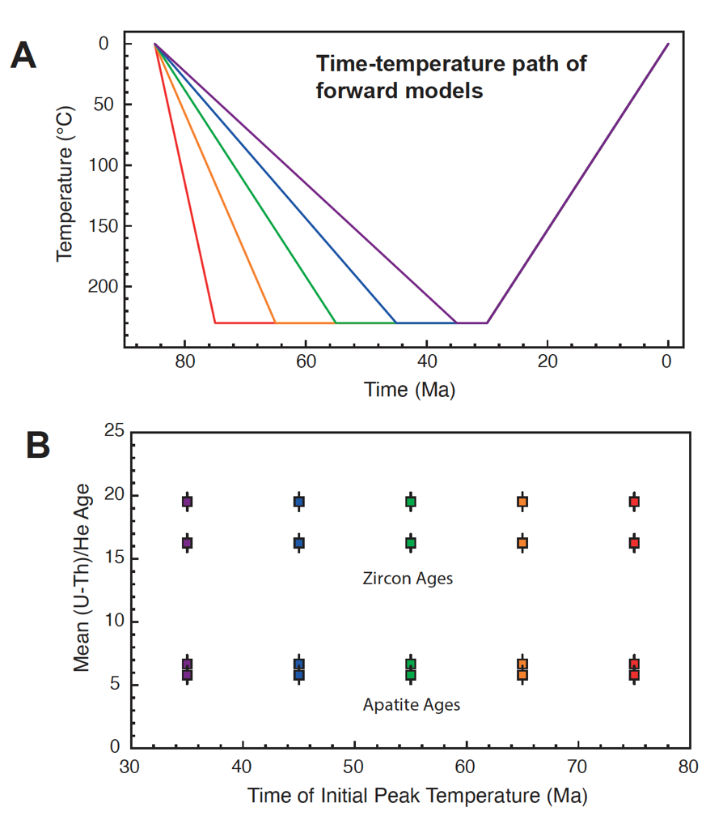
Figure S3. Forward models of apatite and zircon (U-Th)/He ages from Alder Peak (samples NB19-015 and NB19-032) to test sensitivity to rate, duration and timing of burial.
Exhumation History Sensitivity Test
Forward models were run from surface temperature (0°C) at 85 Ma (depositional constraint from detrital zircon ages to peak burial temperature (~230°C) derived from Raman Spectroscopy of Carbonaceous Materials. All forward models in this suite of sensitivity tests were buried rapidly after deposition, reaching peak burial temperatures by 75 Ma. Forward models tested a range of exhumation scenarios, from exhumation initiating shortly after burial until the inverse preferred onset of exhumation at 30 Ma. Time-temperature paths that were tested in the forward models are shown in a variety of colors in panel A. Mean apatite and zircon (U-Th)/He ages were calculated for the observed suite of ages from samples NB19-015 and NB19-032 for each forward model. These mean ages are plotted in panel B, where the value on the x-axis of that plot represents the time at which the forward model time-temperature history (see panel A) began to exhume. The results of this forward modeling study illustrate the sensitivity of the thernal models of the low-temperature thermochronometry data to the timing of onset of exhumation. The peak temperature achieved by these samples, ~230°C, is sufficient to fully reset both the apatite and zircon (U-Th)/He systems regardless of the duration at which the samples are held at this temperature. As such, the thermochronometric data exclusively record information reflecting the exhumation history of these samples. The inverse modeling results are therefore most sensitive to this parameter, and optimize an exhumation history that most closely matched the observed thermochronometric ages. We conclude that the timing of exhumation derived from the inverse thermal modeling is well-resolved, despite the pre-exhumation history being largely under-constrained (Figure S4).
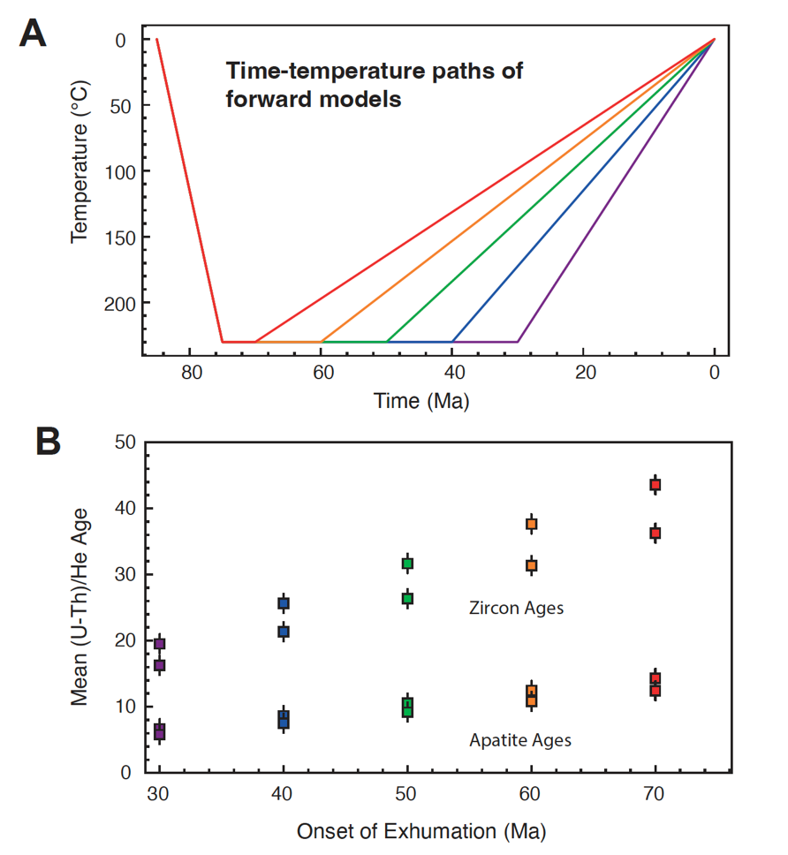
Figure S4. Forward models of apatite and zircon (U-Th)/He ages from Alder Peak (samples
NB19-015 and NB19-032) to test sensitivity to rate, duration and timing of exhumation.

References
Dean, R. B., & Dixon, W. J., 1951, Simplified statistics for small numbers of observations. Analytical chemistry, 23(4), 636-638.

Farley, K. A., Wolf, R. A., & Silver, L. T., 1996, The effects of long alpha-stopping distances on (U‐Th)/He ages. Geochimica et cosmochimica acta, 60(21), 4223-4229.

Flowers, R. M., Ketcham, R. A., Shuster, D. L., & Farley, K. A., 2009, Apatite (U–Th)/He thermochronometry using a radiation damage accumulation and annealing model. Geochimica et Cosmochimica acta, 73(8), 2347-2365.

Gallagher, K., 2012, Transdimensional inverse thermal history modeling for quantitative thermochronology. Journal of Geophysical Research: Solid Earth, 117(B2).

Guenthner, W. R., Reiners, P. W., Ketcham, R. A., Nasdala, L., & Giester, G., 2013, Helium diffusion in natural zircon: Radiation damage, anisotropy, and the interpretation of zircon (U-Th)/He thermochronology. American Journal of Science, 313(3), 145-198.

Lahfid, A., Beyssac, O., Deville, E., Negro, F., Chopin, C., and Goffé, B., 2010, Evolution of the Raman spectrum of carbonaceous material in low‐grade metasediments of the Glarus Alps (Switzerland). Terra nova, 22(5), 354-360.

Lori, L.M.A., 2016, Exhumation of the Nacimiento block: A thermochronologic analysis. M.S. Thesis. Missouri University of Science and Technology. Rolla. 138 p.

McDowell, F. W., McIntosh, W. C., & Farley, K. A., 2005, A precise 40Ar–39Ar reference age for the Durango apatite (U–Th)/He and fission-track dating standard. Chemical Geology, 214(3-4), 249-263.

Niemi, N. A. and Clark, M. K., 2018, Long-term exhumation rates exceed paleoseismic slip rates in the central Santa Monica Mountains, Los Angeles County, California. Geology, 46(1), 63-66.

Peak, B. A., Flowers, R. M., Macdonald, F. A., & Cottle, J. M., 2021. Zircon (U-Th)/He thermochronology reveals pre-Great Unconformity paleotopography in the Grand Canyon region, USA. Geology, 49(12), 1462-1466.

Reiners, P. W., & Nicolescu, S., 2006, ARHDL Report. Measurement, 8, 124-143.

Steely, A. N., 2016, Fault-controlled patterns of uplift in the central California Coast Range and laser-ablation depth-profile analysis of zircon (Doctoral dissertation, UC Santa Cruz).

Ward, C. M., 2020, Thermal anomaly in the Nacimiento Block, Monterey County, Central California: differential uplift or hydrothermal event? (Master dissertation, Kansas State University).

