Supplementary Material for

Magmatic processes and compositional variation in granitic pluton construction: the Buya intrusion of West Kunlun, northwestern China
Chao Wang^{1,2}*, Liang Liu¹, Wen-qiang Yang¹, Yu-ting Cao², R. Hugh Smithies³
¹ State Key Laboratory of Continental Dynamics, Department of Geology, Northwest University, Xi’an 710069, P R China
² Shandong Provincial Key Laboratory of Depositional Mineralization & Sedimentary Minerals, Shandong University of Science and Technology, Qingdao 266590, China;
³ Geological Survey of Western Australia, 100 Plain Street, East Perth, WA 6004, Australia

*Correspondence information: Chao Wang, E-mail address: Chaowang@nwu.edu.cn

Appendix A. Methods
Zircon grains were separated from a representative sample of PQS, FG and ME by heavy-liquid and magnetic techniques followed by hand picking under a binocular microscope. Zircon grains were mounted in epoxy resin discs, and then polished and coated with carbon. Cathodoluminescence (CL) images of the zircons were taken using a Mono CL3+ microprobe prior to U–Pb dating and Lu–Hf analysis at the State Key Laboratory of Continental Dynamics at Northwest University, China.
Samples 18YL-1, 07HT-38 and 07HT-39 of PQS were conducted by U-Pb dating at the State Key Laboratory of Continental Dynamics at Northwest University, China. We conducted U-Pb spot dating of zircons using an Agilent 7500a ICP-MS. The ICP-MS equipped with unique Shield Torch brought about higher sensitivity. Zircon Hf isotope analysis was conducted on a Nu PlasmaHR MC-ICP-MS (Nu Instruments Ltd., UK), using a GeoLas 200M laser ablation system consisting of a ComPex102 (193 nm ArF-excimer laser, Lambda Physik) and an optical system (MicroLas). U-Pb dating of FG (Sample 12TK-16) was carried out using a New Wave-193 nm ArF-excimer laser-ablation system linked to a Neptune multiple-collector inductively coupled plasma mass spectrometer (LA-MC-ICP-MS) at Tianjin Centre of China Geological Survey. Before analysis, ICP-MS operating conditions were generally optimized using continuous ablation of reference glass NIST SRM 610, to provide maximum sensitivity for the high masses while maintaining low oxide formation (ThO+/Th+<2%) and low background. Five sample analyses were followed by one zircon 91500 and one NIST610 measurements. U, Th and Pb concentrations were calibrated by using ²⁹Si as the internal standard and NIST SRM 610 as the external standard. ²⁰⁷Pb/²⁰⁶Pb and ²⁰⁶Pb/²³⁸U ratios were calculated using the GLITTER 4.0 program. The ²⁰⁷Pb/²³⁵U ratio was calculated from the values of ²⁰⁷Pb/²⁰⁶Pb and ²⁰⁶Pb/²³⁸U. In order to check the data quality, standard zircons 91500 and GJ-1 were added, respectively, which are in good agreement with the recommended ID-TIMS age of 1062.4±0.6 Ma (2σ) (Wiedenbeck et al. 1995) and 608.53±0.37 Ma (2σ) (Simon et al. 2004). Apparent and discordia U-Pb ages were calculated using the ISOPLOT (Ludwig K R, 2003). The detailed instrumental parameters and analytical procedures are documented by Yuan et al (2008).
For Lu-Hf isotope analyses of 07HT-38 and 07HT-39, conducted at the State Key Laboratory of Continental Dynamics at Northwest University, China interference of ¹⁷⁶Lu on ¹⁷⁶Hf was corrected by measuring the intensity of interference-free ¹⁷⁵Lu isotope and the recommended ¹⁷⁶Lu /¹⁷⁵Lu ratio of 0.02669 was applied (De Biévre and Taylor 1993). Similarly, the interference of ¹⁷⁶Yb on ¹⁷⁶Hf was corrected by measuring ¹⁷²Yb and using ¹⁷⁶Lu /¹⁷²Yb ratio of 0.5886 (Chu et al. 2002). Standard zircons 91500 and GJ-1 were used as the reference standards for calibration and monitoring the condition of analytical instrumentation. The obtained ¹⁷⁶Hf/¹⁷⁷Hf ratios are 0.282295±0.000027 (n=14, 2σ) for 91500 and 0.282734±0.000015 (n=16, 2σ) for GJ-1. These results are in good agreement with the recommended ¹⁷⁶Hf/¹⁷⁷Hf ratios of 0.2823075±58 (2σ) (Wu et al., 2006) and 0.282015±0.000019 (2σ) (Elhlou et al., 2006) for the two standards. The detailed analytical technique is described by Yuan et al. (2008). A decay constant for ¹⁷⁶Lu of 1.865×10⁻¹¹ a (Scherer et al, 2001), the present-day chondritic ratios of ¹⁷⁶Hf/¹⁷⁷Hf = 0.282772 and¹⁷⁶Lu /¹⁷⁷Hf = 0.0332 (Blichert-Toft and Albarede F, 1997) were adopted to calculate εHf(t) values. The notations of εHf(t), T_{DM1} and T_{DM2} are defined as same as those in Yang et al. (2007), with interpretations of single-stage depleted mantle model ages (T_{DM1}) for positive εHf(t) values whereas two-stage crustal model ages (T_{DM2}) were used for negative εHf(t) values. T_{DM1} was calculated using the measured Lu/Hf ratios and the present-day ¹⁷⁶Hf/¹⁷⁷Hf ratio of 0.28325 and ¹⁷⁶Lu/¹⁷⁷Hf of 0.0384 (Griffin et al. 2000) of depleted mantle. T_{DM2} was obtained under the assumption that the protolith of the host rock of a given zircon was derived from the depleted mantle and had the composition of the average continental crust with ¹⁷⁶Lu/¹⁷⁷Hf of 0.015 (Griffin et al. 2002). The zircon U–Pb and Lu–Hf isotopic data are presented in Tables S1 and S2.
Samples of the Buya pluton were analyzed at the State Key Laboratory of Continental Dynamics in Northwest University, Xi'an. Fresh whole rock chips were powdered to 200 mesh-size using a tungsten carbide ball mill. Major and trace elements were analyzed by XRF (Rikagu RIX 2100) and ICPMS (Agilent 7500a), respectively. Analyses of USGS and Chinese national rock standards (BCR-2, GSR-1 and GSR-3) indicate that analytical precision and accuracy for major elements are generally better than 5%. For trace element analysis, sample powders were digested using an HF+HNO₃ mixture in high-pressure Teflon bombs at 190 °C for 48 h. Analytical precision is better than 10% for most trace elements. The geochemical data are showed in Table 1.

References
Blichert-Toft J, Albarède F (1997) The Lu–Hf isotope geochemistry of chondrites and the evolution of the mantle-crust system. Earth and Planetary Science Letters 148: 243–258
Chu NC, Taylor RN, Chavagnac V, Nesbitt RW, Boella RM, Milton JA, German CR, Bayon G, Burton K (2002) Hf isotope ratio analysis using multi-collector inductively coupled plasma mass spectrometry: an evaluation of isobaric interference corrections. Journal of Analytical Atomic Spectrometry 17: 1567–1574
De Biévre P, Taylor PDP (1993) Table of the isotopic compositions of the elements. International Journal of Mass Spectrometry and Ion Processes 123: 149–166.
Elhlou S, Belousova E, Griffin W.L, Pearson, N. J.; O'Reilly, S. Y. (2006). Trace Element and Isotopic Composition of GJ Red Zircon Standard by Laser Ablation. Geochim Cosmochim Acta, 70 (Suppl. 1), A158, 2006, 06.1383.
Griffin, W.L., Pearson, N.J., Belousova, E., Jackson, S.E., van Achterbergh, E., O'Reilly, S.Y., Shee, S.R., (2000) The Hf isotope composition of cratonic mantle: LAM–MC–ICPMS analysis of zircon megacrysts in kimberlites. Geochimica et Cosmochimica Acta 64, 133–147.
Griffin, W.L., Wang, X., Jackson, S.E., Pearson, N.J., O'Reilly, S.Y., Xu, X., Zhou, X., 2002. Zircon chemistry and magma genesis, SE China: in-situ analysis ofHfisotopes, Pingtan and Tonglu igneous complexes. Lithos 61, 237–269.Scherer, E., Münker, C., Mezger, K. (2001). Calibration of the lutetium-hafnium clock. Science 293, 683–687.
Ludwig KR (2003) Isoplot 30-A geochronological toolkit for Micro-soft Excel. Berkeley Geochronology Center Spec Pub 1–70
Simon EJ, Norman JP, William LG, Belousova W (2004) The application of laser ablation-inductively coupled plasma-mass spectrometry to in-situ U-Pb zircon geochronology. Chem Geol, 211:47-69.
Scherer E, Münker C, Mezger K (2001) Calibration of the lutetium-hafnium clock. Science 293:683–687
Yuan HL, Gao S, Dai MN, Zong CL, Günther D, Fontaine GH, Liu XM, DiWu CR (2008) Simultaneous determinations of U–Pb age, Hf isotopes and trace element compositions of zircon by excimer laser ablation quadrupole and multiple collector ICP–MS. Chemistry Geology 247:100–118
Yang JH, Wu FY, Wilde SA, Xie LW, Yang YH, Liu XM (2007) Tracing magma mixing in granite genesis: in situ U–Pb dating and Hf-isotope analysis of zircons. Contributions to Mineralogy and Petrology 153:177–190
Wiedenbeck M, Alle P, Griffin WL, Meier M, Oberli F, von Quadt, A.,Roddick, JC, Spiegel W (1995) Three natural zircon standards for U-Th-Pb, Lu-Hf, trace element and REE analyses. Geostand Newsl, 19: 1-23
Griffin WL, Pearson NJ, Belousova E, Jackson SE, O’Reilly SY, van Acherberg E, Shee SR (2000) The Hf iso- tope composition of cratonic mantle: LAM-MC-ICPMS analysis of zircon megacrysts in kimberlites. Geochimica et Cosmochimica Acta 64: 133-147
Griffin WL,Wang X, Jackson SE, Pearson NJ, O’Reilly SY, Xu X, Zhou X (2002) Zircon chemistry and magma mixing, SE China: In situ analysis of Hf isotopes, Tonglu and Pingtan igneous complexes. Lithos 61: 237-269

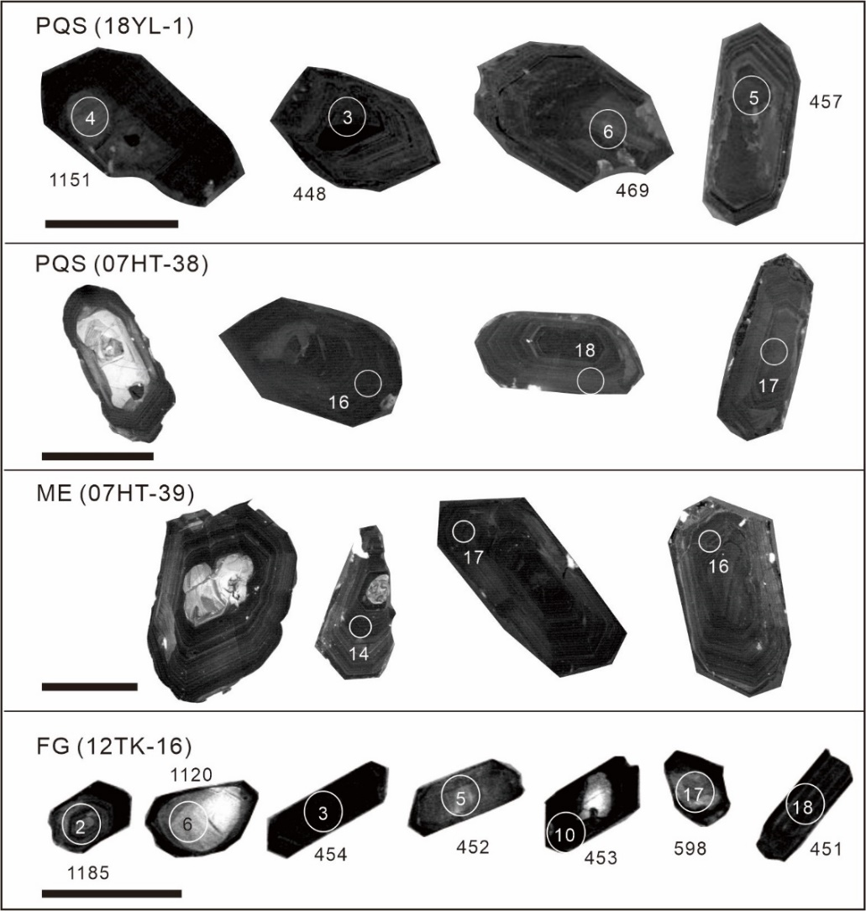

Figure S1. Cathodoluminescence (CL) images of representative zircon crystals with locations of LA-ICP-MS analyses. The gray scale bar in each image represents 100 μm.

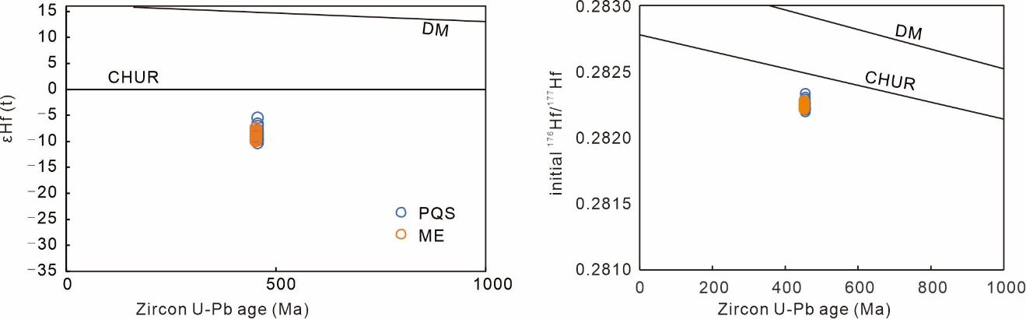

Figure S2. Zircon Lu–Hf isotopic compositions of PQS and ME, showing the εHf(t) (a) and initial ¹⁷⁶Hf/¹⁷⁷Hf (b) versus zircon crystallization age.

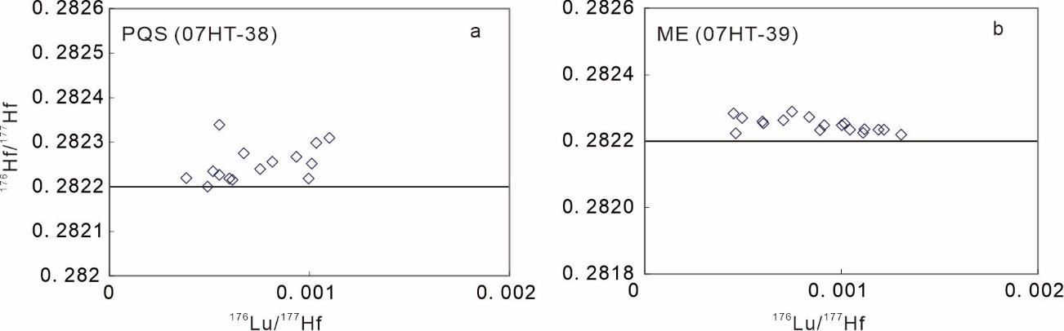
Figure S3. Zircon Lu–Hf isotopic compositions of PQS and ME, showing the ¹⁷⁶Lu/¹⁷⁷Hf–¹⁷⁶Hf/¹⁷⁷Hf variations (a) and histograms of two-stage Hf model ages (d). The depleted mantle (DM) evolution curve was calculated using mean present-day values of ¹⁷⁶Lu/¹⁷⁷Hf = 0.0384 and ¹⁷⁶Hf/¹⁷⁷Hf = 0.28325, after Griffin et al. (2002).

