Supplemental material to
Geochemical indications for the Paleocene-Eocene Thermal Maximum (PETM) and Eocene Thermal Maximum 2 (ETM-2) hyperthermals in terrestrial sediments of the Canadian Arctic
by
Reinhardt, L., von Gosen, W., Lückge, A., Blumenberg, M., Galloway, J.M., West, C.K., Sudermann, M., and Dolezych, M.,
published in Geosphere (2021).
Supplemental Material
Figure S1: Comparison of most depleted δ¹³C values of selected records of early Eocene hyperthermals in terrestrial or terrestrial to shallow marine settings.
Figure S2: Age of volcanic ash layer MA-1 including graphical representation of error ranges in relation to astronomically calibrated age of the I-1 hyperthermal (all hyperthermal ages according to the current astronomical timescale of the Ypresian by Westerhold et al., 2017).
Table S1: Bulk coal carbon isotope data as δ¹³C (VPDB, ‰) of late Paleocene outcrop at eastern shore of Stenkul Fiord.
Table S2: Organic carbon content (C_{org} weight %) and bulk coal carbon isotope data as δ¹³C (VPDB, ‰) of the coal seam at outcrop LR17-030 with volcanic-ash layer MA-1 therein.
Table S3: Organic carbon content (C_{org} weight %), bulk carbon isotope data as δ¹³C (VPDB, ‰), and δ¹³C n-C₃₁ (VPDB, in ‰) of the Stenkul Fiord section.
Table S4: Thicknesses of clastic intervals of the Stenkul Fiord section (except white quartz sandstone).
Table S5: Results of three individual U-Pb zircon analyses (ID-TIMS) from samples of volcanic ash layer MA-1.
Figure S1:
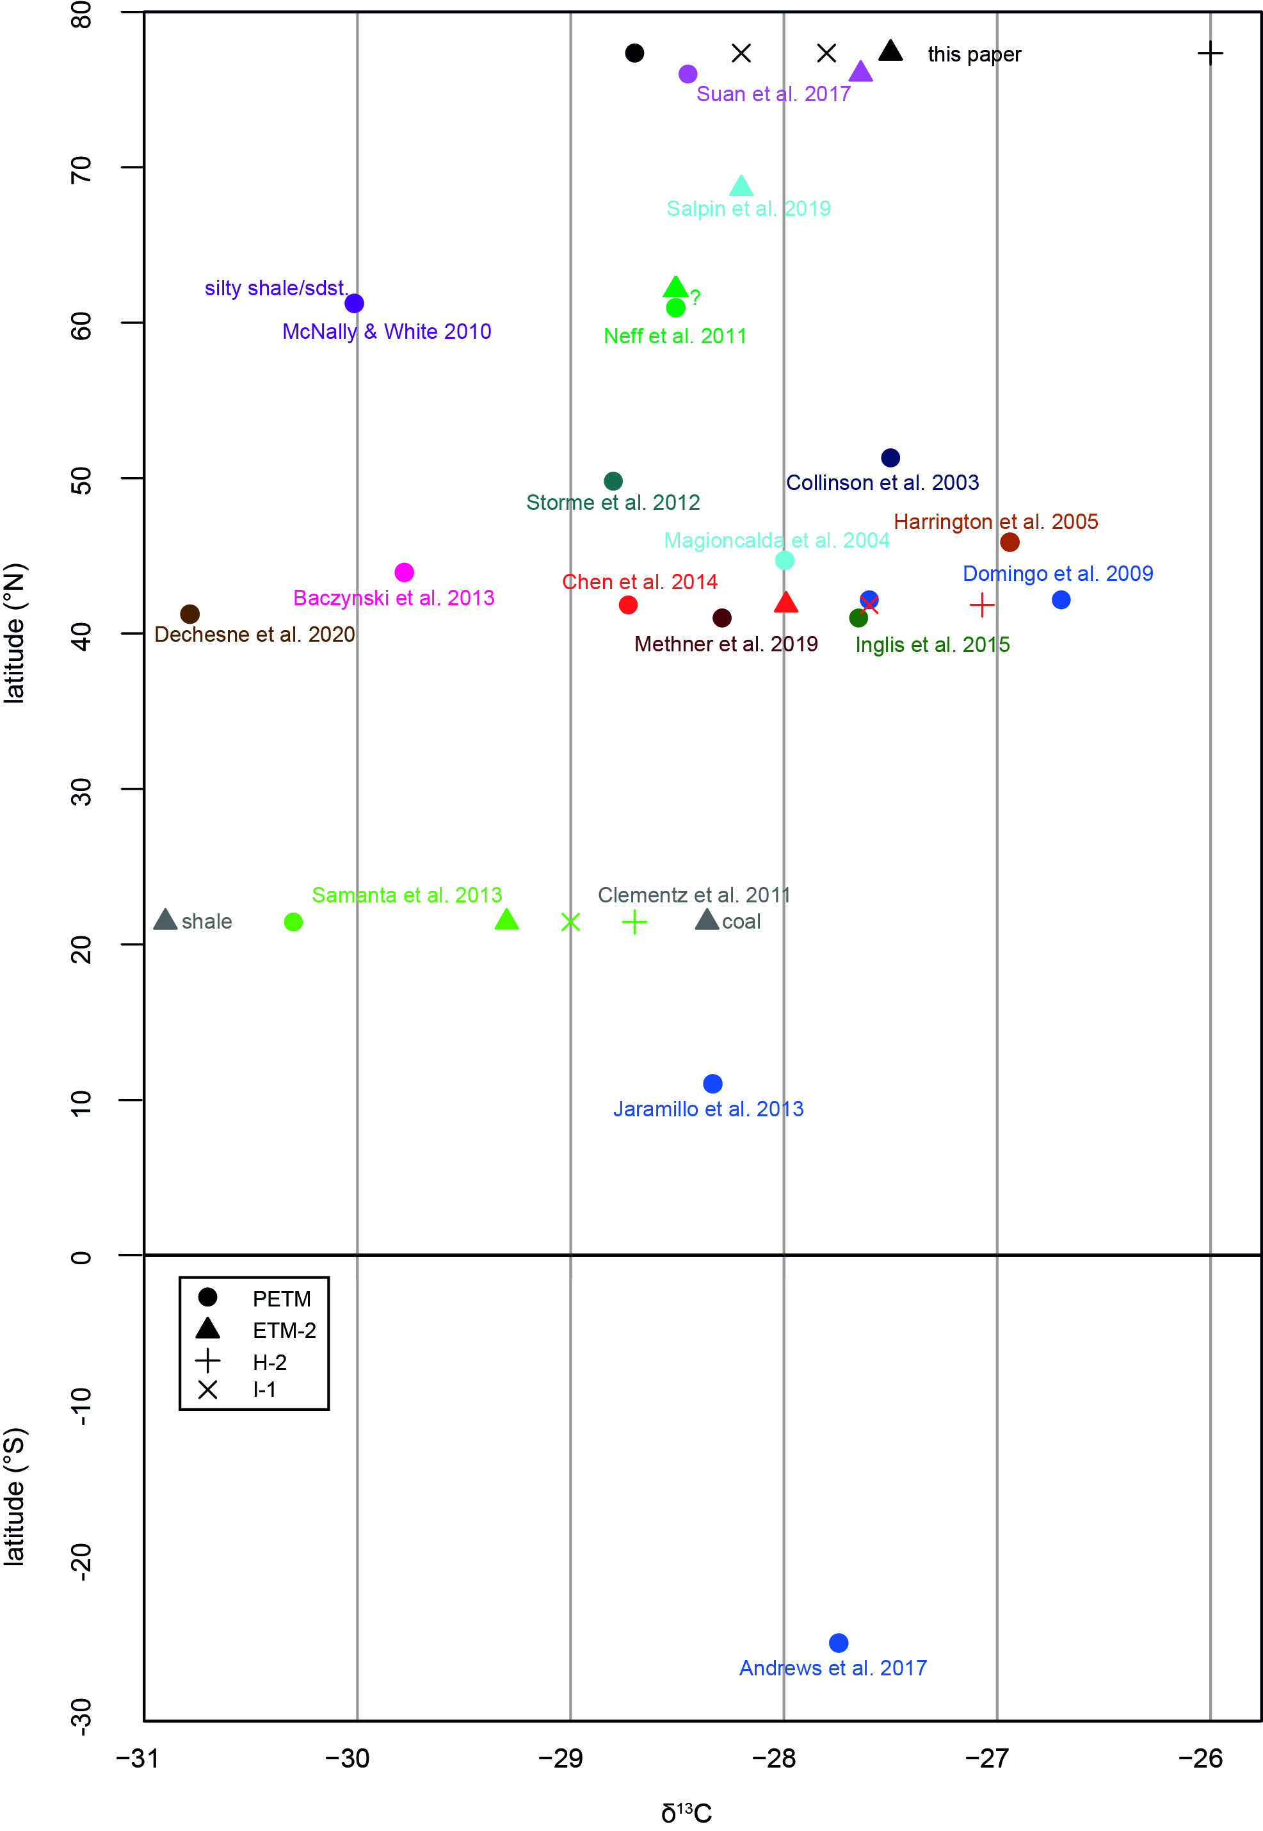

Figure S1: The latitude (in degrees) is given with respect to the modern position, which in general has only slightly changed since the Paleogene. Dots indicate PETM, triangles ETM-2, crosses H-2, and x-symbols I-1 δ¹³C values. All values were measured in coals or organic-rich sediments, except those from Magioncalda et al. (2004), Domingo et al. (2009), McNally and White (2010), Baczynski et al. (2013), Jaramillo et al. (2013), Andrews et al. (2017), and Salpin et al. (2019), which were measured as bulk carbon from more clastic (fluvial system) deposits. The two contrasting values from Clementz et al. (2011) are from a shale and the closest coal seam in the section, respectively (eventual facies dependency is unclear). Negative carbon isotope excursion in Neff et al. (2011) likely indicates one of the larger hyperthermal events PETM/ETM-2/ETM-3 in the Chickaloon Formation. The respective hyperthermal events of the different references are color coded; see reference list at the end of supplemental file for complete citations.
All values together indicate considerable differences in their absolute δ¹³C values for individual hyperthermal events. Typically, the recorded δ¹³C values depend on the completeness of the respective stratigraphic record and/or sampling bias. According to Diefendorf et al. (2010) and Kohn (2010), who analyzed carbon isotope compositions of C3 plants, an increase in δ¹³C generally correlates with decreasing mean annual precipitation (MAP), which may explain differences between geographic areas.

Figure S2:
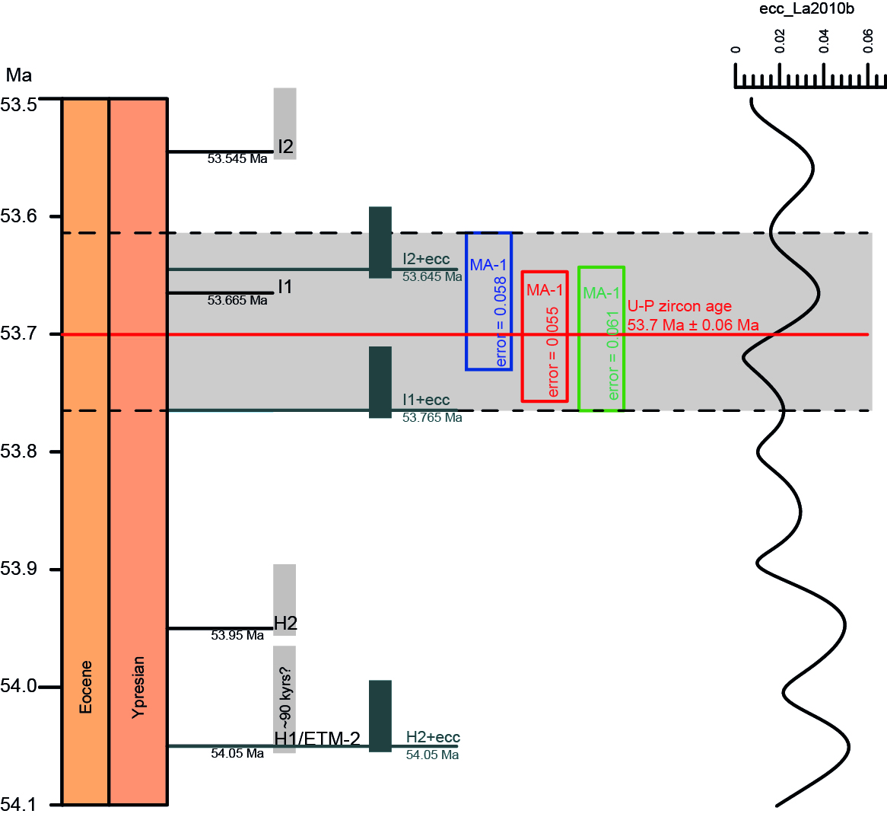

Figure S2: Age of volcanic ash layer MA-1 including graphical representation of error ranges (horizontal grey field with analytical error of the three samples, see table S5) in relation to astronomically calibrated age of the I-1 hyperthermal. All hyperthermal ages according to the current astronomical timescale of the Ypresian by Westerhold et al. (2017). The vertical grey boxes indicate assumed durations of ~70 kyrs for the H and I hyperthermal events and ~90 kyrs for the ETM-2 hyperthermal event, respectively.
The positions of I and H hyperthermal events are hypothetically shifted +100 kyrs (i.e., ~one eccentricity cycle, simplification / not correlated to eccentricity curve), represented by blue vertical rectangles). The scenario keeps the position of the hypothetically older I-1 hyperthermal in range of the U-Pb zircon age of 53.7 Ma ± 0.06 Ma. The hypothetically older I-1 hyperthermal touches the error limit of the zircon age. This suggests an interpretation of the negative carbon isotope excursion occurring ca. 56 cm above the ash layer MA-1 as hyperthermal I-2 to become more likely, but our preferred interpretation as hyperthermal event I-1 remains possible.

Table S1. bulk coal carbon isotope data as δ¹³C (VPDB, ‰) of late paleocene outcrop at eastern shore of stenkul fiord
No. | Sample identification | C_{org} weight % | δ¹³C (VPDB) ‰
32 | LR17-043_32 | 50.2 | -25.5
31 | LR17-043_31 | 48.7 | -25,3
30 | LR17-043_30 | 47.3 | -25,3
29 | LR17-043_29 | 51.2 | -25,3
28 | LR17-043_28 | 55.1 | -25.6
27 | LR17-043_27 | 56.6 | -25.4
26 | LR17-043_26 | 25.7 | -25.6
25 | LR17-043_25 | 29.9 | -25.1
24 | LR17-043_24 | 55.3 | -25.9
23 | LR17-043_23 | 28.3 | -24.7
22 | LR17-043_22 | 30.7 | -26.2
21 | LR17-043_21 | 29.4 | -26.5
20 | LR17-043_20 | 24.9 | -25.2
19 | LR17-043_19 | 34.3 | -24.9
18 | LR17-043_18 | 51.0 | -24.8
17 | LR17-043_17 | 46.4 | -25.1
16 | LR17-043_16 | 50.6 | -25.8
15 | LR17-043_15 | 47.2 | -25.1
14 | LR17-043_14 | 52.8 | -25.3
13 | LR17-043_13 | 58.2 | -24.6
12 | LR17-043_12 | 53.6 | -25.2
11 | LR17-043_11 | 32.2 | -25.2
10 | LR17-043_10 | 51.3 | -26.1
9 | LR17-043_9 | 53.3 | -25.8
8 | LR17-043_8 | 36.2 | -25.6
7 | LR17-043_7 | 33.7 | -26.3
6 | LR17-043_6 | 31.2 | -26.3
5 | LR17-043_5 | 50.1 | -24.5
4 | LR17-043_4 | 58.2 | -24.0
3 | LR17-043_3 | 13.2 | -27.8
2 | LR17-043_2 | 29.8 | -26.3
1 | LR17-043_1 | 50.1 | -25.3
Notes: Base of late Paleocene section is located at position LR17-043 (latitude N 77.34815, longitude W 83.44457), situated ca. 2.5 km to the east of the early Eocene section at Stenkul Fiord. Own unpublished data, from a comparable fluvial to fluvio-deltaic depositional setting. Late Paleocene age based on palynology (section CR-83-10 of Riediger, 1985; Riediger and Bustin, 1987; and Kalkreuth et al., 1996). Samples are from coals and organic-rich sediments. Mean value = -25.5 ‰ (± 0.7 ‰), median value =-25.3 ‰. The values range between -27.8 ‰ to 24.0 ‰. Subtracting 1 σ standard deviation from the average value results in a value of -26.2 ‰, used as an orientation to identify relevant early Eocene carbon isotope excursions.

Table S2. Organic carbon content (C_{org,} weight %) and bulk coal carbon isotope data as δ¹³C (VPDB, ‰) of the coal seam at outcrop LR17-030 with volcanic-ash layer MA-1 therein
No. | sample identification | C_{org} weight % | δ¹³C (VPDB) ‰
42 | LR17_30_124_127 | 48.0 | -24.2
41 | LR17_30_121_124 | 49.3 | -26.5
40 | LR17_30_118_121 | 44.8 | -27.0
39 | LR17_30_115_118 | 48.0 | -26.5
38 | LR17_30_112_115 | 31.9 | -26.3
37 | LR17_30_109_112 | 29.5 | -27.0
36 | LR17_30_106_109 | 33.4 | -27.1
35 | LR17_30_103_106 | 36.1 | -26.3
34 | LR17_30_100_103 | 16.8 | -27.1
33 | LR17_30_97_100 | 16.9 | -27.4
32 | LR17_30_94_97 | 13.2 | -27.2
31 | LR17_30_91_94 | 50.0 | -28.2
30 | LR17_30_88_91 | 26.5 | -27.0
29 | LR17_30_85_88 | 38.4 | -26.4
28 | LR17_30_82_85 | 29.5 | -26.7
27 | LR17_30_79_82 | 27.6 | -26.5
26 | LR17_30_76_79 | 2.97 | -26.9
25 | LR17_30_73_76 | 5.56 | -26.3
24 | LR17_30_70_73 | 48.2 | -25.7
23 | LR17_30_67_70 | 44.6 | -25.8
22 | LR17_30_64_67 | 42.8 | -26.1
21 | LR17_30_61_64 | 46.8 | -26.0
20 | LR17_30_58_61 | 41.7 | -26.6
19 | LR17_30_55_58 | 45.9 | -26.6
18 | LR17_30_52_55 | 47.5 | -26.5
17 | LR17_30_49_52 | 48.2 | -25.9
16 | LR17_30_46_49 | 52.0 | -26.0
15 | LR17_30_43_46 | 51.4 | -25.3
14 | LR17_30_40_43 | 42.2 | -26.0
13 | LR17_30_37_40 | 54.3 | -26.0
12 | LR17_30_34_37 | 47.8 | -25.7
11 | LR17_30_31_34 | 53.5 | -25.3
10 | LR17_30_28_31 | 50.3 | -25.8
9 | LR17_30_25_28 | 48.8 | -26.0
8 | LR17_30_22_25 | 50.0 | -26.3
7 | LR17_30_19_22 | 41.0 | -26.8
6 | LR17_30_16_19 | 37.8 | -26.0
5 | LR17_30_13_16 | 36.1 | -25.7
4 | LR17_30_10_13 | 55.4 | -26.9
3 | LR17_30_7_10 | 54.2 | -25.1
2 | LR17_30_4_7 | 54.6 | -25.1
1 | LR17_30_1_4 | 55.4 | -26.0
Notes: Volcanic ash layer MA-1 occurs between samples 11 and 12. The interval 10 cm above the volcanic ash layer comprises samples 14 to 18 (n = 5). See text for discussion.

Table S3. Organic carbon content (C_{org,} weight %), bulk carbon isotope data as δ¹³C (VPDB, ‰), and δ¹³C n-C₃₁ (VPDB, ‰) of the Stenkul Fiord section
No. | meter in section | material if other than coal | sample identification | C_{org} weight % | δ ¹³C (VPDB) ‰ | δ¹³C n-C₃₁  (VPDB) ‰
125 | 176.10 | plant remain | LR17-020_12300 | 47.40 | -27.9
124 | 175.50 | plant remain | P16 | N.D.* | -25.9
123 | 173.60 | plant remain | LR17-020_12050 | 52.10 | -26.4
122 | 163.30 | plant remain | LR17-020_11020 | 5.45 | -26.7
121 | 162.60 | plant remain | LR17-020_10950 | 54.80 | -25.4
120 | 158.60 | plant remain | LR17-020_10550 | 46.20 | -23.6
119 | 157.10 | plant remain | LR17-020_10400 | 48.40 | -24.1
118 | 152.10 | plant remain | LR17-020_9900 | 49.40 | -24.5
117 | 145.60 | coal particles | LR17-020_9250 | 40.80 | -25.7
116 | 144.10 | plant remains | LR17-020_9100 | N.D.* | -22.0
115 | 143.10 | plant remain | LR17-020_9000 | 49.00 | -23.5
114 | 142.10 | plant remain | LR17-020_8900 | 48.80 | -22.6
113 | 140.60 | plant remain | LR17-020_8750 | 48.80 | -21.5
112 | 138.60 | plant remain | LR17-020_8550 | 46.30 | -22.4
111 | 135.60 | plant remain | LR17-020_8250 | 48.00 | -22.7
110 | 135.10 |  | LR17-020_8200 | 54.10 | -25.8
109 | 135.00 |  | P15 | N.D.* | -25.6
108 | 134.80 |  | LR17-020_8150 | 47.80 | -25.2
107 | 134.60 |  | P14 | N.D.* | -25.1
106 | 134.50 |  | LR17-020_8100 | 37.10 | -25.6
105 | 134.20 |  | LR17-020_8050 | 41.40 | -25.5
104 | 133.90 |  | LR17-020_8000 | N.D.* | -23.7
103 | 133.60 |  | LR17-020_7950 | 10.80 | -24.6
102 | 133.30 |  | LR17-020_7900 | 44.30 | -23.9
101 | 133.10 |  | P13 | N.D.* | -23.5
100 | 133.00 |  | P12 | N.D.* | -23.6
99 | 133.00 |  | LR17-020_7850 | 27.30 | -25.0
98 | 132.60 |  | LR17-020_7800 | 19.10 | -24.1
97 | 132.10 |  | LR17-020_7750 | 23.80 | -24.7
96 | 131.60 |  | LR17-020_7700 | 26.80 | -26.3
95 | 131.10 |  | LR17-020_7650 | 31.50 | -26.0
94 | 130.60 |  | LR17-020_7600 | 47.70 | -26.4
93 | 130.50 |  | LR17-020_7550 | 47.40 | -25.4
92 | 129.10 |  | P11 | N.D.* | -25.5
91 | 122.60 |  | LR17-020_6750 | 21.60 | -24.6
90 | 120.10 |  | LR17-020_6500 | N.D.* | -23.5
89 | 118.00 |  | P10 | N.D.* | -23.5
88 | 117.60 |  | LR17-020_6250 | 41.80 | -24.7
87 | 117.10 |  | LR17-020_6200 | 34.90 | -24.5
86 | 116.60 |  | LR17-020_6150 | 46.80 | -24.2
85 | 116.10 |  | LR17-020_6100 | 46.50 | -24.4
84 | 113.40 |  | LR17-020_5820 | 47.30 | -24.3
83 | 113.20 |  | LR17-020_5800 | 45.70 | -26.4
82 | 113.00 |  | P09 | N.D.* | -26.0
81 | 112.70 |  | LR17-020_5750 | 45.30 | -25.5
80 | 110.20 |  | LR17-020_5500 | 46.80 | -23.7
79 | 107.70 |  | LR17-020_5250 | 47.50 | -27.8
78 | 107.20 |  | LR17-020_5200 | 42.30 | -26.7
77 | 106.80 |  | LR17-020_5160 | 35.50 | -26.0 | -32.2
76 | 106.60 |  | P08 | N.D.* | -25.5
75 | 94.20 |  | LR17-020_3900 | 43.00 | -22.5
74 | 92.70 |  | LR17-020_3750 | 48.10 | -24.4
73 | 91.00 |  | LR17-020_3600 | 47.90 | -25.5
72 | 90.70 |  | LR17-020_3570 | 35.70 | -26.0
71 | 90.50 |  | P07 | N.D.* | -25.6
70 | 86.60 |  | LR17-020_3500 | 39.90 | -25.3
69 | 84.62 |  | LR17-020_2950 | 44.10 | -27.5
68 | 83.50 |  | LR17-020_2800 | 45.60 | -27.5 | -31.0
67 | 80.50 |  | LR17-020_2500 | 39.80 | -27.1
66 | 80.00 |  | LR17-020_2450 | 46.20 | -26.5 | -33.1
65 | 79.75 |  | P06 | N.D.* | -26.2
64 | 78.50 |  | LR17-020_2300 | 50.80 | -27.0
63 | 78.00 |  | LR17-020_2250 | N.D.* | -26.2 | -32.7
62 | 77.75 |  | P05 | N.D.* | -26.3
61 | 77.50 |  | LR17-020_2200 | 48.10 | -25.9
60 | 77.00 |  | LR17-020_2150 | N.D.* | -25.0
59 | 76.50 |  | LR17-020_2100 | 55.00 | -25.6
58 | 75.70 |  | LR17-020_2050 | 48.50 | -24.7 | -31.4
57 | 74.80 |  | LR17-020_1960 | 45.50 | -24.8
56 | 74.75 |  | LR17-020_1955 | 28.70 | -25.4 | -32,2
55 | 74.70 |  | LR17-020_1950 | 42.50 | -25.5
54 | 74.20 |  | P04 | N.D.* | -26.5
53 | 73.85 |  | LR17-020_1865 | N.D.* | -25.3 | -31.6
52 | 73.50 |  | LR17-020_1850 | N.D.* | -22.5 | -29.8
51 | 73.00 |  | P03 | N.D.* | -24.7
50 | 72.70 |  | LR17-020_1770 | 38.90 | -25.8
49 | 70.50 |  | LR17-020_1550 | N.D.* | -24.1
48 | 69.50 |  | LR17-020_1450 | N.D.* | -25.6 | -31.8
47 | 67.40 |  | LR17-020_1240 | 49.60 | -25.7
46 | 67.00 |  | LR17-020_1200 | 43.00 | -24.7
45 | 66.75 |  | LR17-020_1175 | N.D.* | -25.1 | -32.2
44 | 66.50 |  | LR17-020_1150 | 34.00 | -24.9
43 | 65.30 |  | LR17-020_1030 | 48.10 | -25.7
42 | 65.00 |  | LR17-020_1000 | 37.80 | -24.5 | -30.7
41 | 64.80 |  | LR17-020_980 | N.D.* | -23.1
40 | 64.10 |  | P02 | N.D.* | -23.9
39 | 64.00 |  | LR17-020_900 | N.D.* | -25.0
38 | 62.60 |  | LR17-020_750 | N.D.* | -26.6 | -30.6
37 | 60.95 |  | LR17-020_595 | 28.20 | -25.5
36 | 59.10 | coal particles | LR17-020_400 | 28.20 | -24.9
35 | 57.10 | coal particles | LR17-020_200 | 35.90 | -24.3
34 | 56.10 | coal particles | LR17-020_100 | 32.20 | -22.8
33 | 55.10 |  | LR17-020_0 | 52.10 | -26.8 | -33.2
32 | 54.70 |  | P01 | N.D.* | -25.5
31 | 54.30 |  | LR17-011_80 | 47.50 | -25.3
30 | 49.30 | argillaceous sandst., dark color | LR17-011_below | N.D.* | -25.3
29 | 36.30 | argillaceous sandst., dark color | LR17-010_above | 37.50 | -25.4
28 | 33.30 |  | LR17-010_150 | 51.00 | -28.2 | -34.0
27 | 32.55 |  | LR17-010_75 | 52.20 | -27.7 | -33.7
26 | 31.80 |  | LR17-010_0 | N.D.* | -27.6
25 | 29.55 | argillaceous sandst., dark color | LR17-009 middle | N.D.* | -26.7 | -32.6
24 | 27.30 |  | LR17-009_550 | 43.80 | -25.8
23 | 26.80 |  | LR17-009_500 | 48.70 | -26.7 | -33.9
22 | 25.80 |  | LR17-009_400 | 26.00 | -27.9
21 | 24.80 |  | LR17-009_300 | 37.50 | -27.2 | -34.5
20 | 23.80 |  | LR17-009_200 | 51.20 | -27.8
19 | 22.80 |  | LR17-009_100 | N.D.* | -27.5 | -32.8
18 | 21.80 |  | LR17-009_0 | 40.00 | -28.7
17 | 19.55 | argillaceous sandst., dark color | LR-008 middle | 33.40 | -23.5 | -32.1
16 | 16.30 |  | LR17-008_450 | 41.70 | -26.8
15 | 15.80 |  | LR17-008_400 | 51.70 | -26.8 | -35.1
14 | 14.80 |  | LR17-008_300 | 41.10 | -26.8
13 | 13.80 |  | LR17-008_200 | 50.90 | -27.5 | -34.1
12 | 12.80 |  | LR17-008_100 | 42.80 | -27.5
11 | 11.80 |  | LR17-008_0 | 47.00 | -26.9 | -33.7
10 | 10.80 | argillaceous sandst., dark color | LR17-007 middle | N.D.* | -27.3
9 | 9.55 |  | LR17-007_525 | N.D.* | -26.0 | -33.8
8 | 8.30 |  | LR17-007_400 | 47.80 | -26.3
7 | 7.30 |  | LR17-007_300 | 41.90 | -26.2 | -33.7
6 | 6.30 |  | LR17-007_200 | 39.00 | -27.8
5 | 5.30 |  | LR17-007_100 | 54.80 | -27.2 | -34.0
4 | 4.30 |  | LR17-007_0 | 49.20 | -28.1
3 | 1.80 |  | LR17-006_80 | 31.60 | -27.7 | -33.6
2 | 1.40 |  | LR17-006_40 | 46.30 | -27.9
1 | 1.00 |  | LR17-006_0 | 44.70 | -25.1 | -33.3
Notes: Base of section is located at position LR17-006, cf. Table 2).
*N.D. = not determined.

Table S4: Thicknesses of clastic intervals of the stenkul fiord section (except White Quartz sandstone)
No. | Lithology | Thickness (m) | x 0.55
35 | sandstone (inserted) | 3.00 | 1.65
34 | sandstone (inserted) | 3.00 | 1.65
33 | sandstone (inserted) | 3.00 | 1.65
32 | sandstone | 3.00 | 1.65
31 | siltstone / mudstone | 0.40 | 0.22
30 | sandstone | 1.88 | 1.03
29 | siltstone / mudstone | 0.05 | 0.03
28 | sandstone | 0.57 | 0.31
27 | siltstone / mudstone | 1.00 | 0.55
26 | siltstone / mudstone | 2.40 | 1.32
25 | sandstone | 0.50 | 0.28
24 | siltstone / mudstone | 0.20 | 0.11
23 | siltstone / mudstone | 1.50 | 0.83
22 | siltstone / mudstone | 1.00 | 0.55
21 | sandstone | 0.10 | 0.06
20 | sandstone | 0.10 | 0.06
19 | siltstone / mudstone | 0.25 | 0.14
18 | sandstone | 0.10 | 0.06
17 | siltstone / mudstone | 1.00 | 0.55
16 | sandstone | 1.50 | 0.83
15 | siltstone / mudstone | 2.00 | 1.10
14 | siltstone / mudstone | 0.50 | 0.28
13 | siltstone / mudstone | 1.50 | 0.83
12 | siltstone / mudstone | 0.65 | 0.36
11 | sandstone | 3.00 | 1.65
10 | sandstone (inserted) | 4.20 | 2.31
9 | sandstone (inserted) | 4.20 | 2.31
8 | sandstone (inserted) | 4.20 | 2.31
7 | sandstone (inserted) | 4.20 | 2.31
6 | sandstone (inserted) | 4.20 | 2.31
5 | sandstone | 4.50 | 2.48
4 | sandstone | 5.50 | 3.03
3 | sandstone | 2.25 | 1.24
2 | sandstone | 2.50 | 1.38
1 | sandstone | 1.00 | 0.55
Notes: sandstone (inserted) indicates estimated unit thicknesses replacing undifferentiated intervals of 21 (no. 6-10) and 9 (no. 33-35) meters, respectively. Column x 0.55 indicates the correction factor of Fielding and Crane (1987) to calculate channel depth from total thickness of a clastic body. The mean value of all clastic body thicknesses is 2.4 m (including overlooked multistory units and including the undifferentiated intervals of 9 meters and 21 meters, see above). The median value of the same data set is 1 m. Including differentiated sand bodies of 9 and 21 m in artificial subunits (respective thickness oriented at the thickest measured sand bodies below the undifferentiated units), results in an average value of 1.97 m and a median of 1.5 m. Applying the correction factor of Fielding and Crane (1987) results in a mean value of 1.09 m.

Table S5: Results of Three individual U-Pb zircon analyses (ID-TIMS) From Samples of volcanic ash layer MA-1
Sample | Wtd. mean age (Ma)  (analytical uncertainty) | n | MSWD | Probability fit
CASE16-P08/SF14-17 | 53.704 ± 0.061 | 4 | 0.53 | 0.6601
CASE16-ASH2 | 53.702 ± 0.055 | 4 | 1.51 | 0.2093
CASE12-019 | 53.672 ± 0.058 | 5 | 1.40 | 0.2325
Notes: From von Gosen et al. (2019) for additional details of the individual ID-TIMS measurements, see there.

References
Andrews, E., White, T., and del Papa, C., 2017, Paleosol-based paleoclimate reconstruction of the Paleocene-Eocene Thermal Maximum, northern Argentina: Palaeogeography, Palaeoclimatology, Palaeoecology, v. 471, p. 181-195, doi:/10.1016/j.palaeo.2017.01.042.

Baczynski, A.A., McInerney, F., Wing, S., Kraus, M., Bloch, J.I., Boyer, D.M., Secord, R., Morse, P.E., and Fricke, H.C., 2013, Chemostratigraphic implications of spatial variation in the Paleocene-Eocene Thermal Maximum carbon isotope excursion, SE Bighorn Basin, Wyoming: Geochemistry, Geophysics, Geosystems, v. 14, no. 10, p. 4133–4152, doi:10.1002/ggge.20265.

Chen, Z., Ding, Z., Tang, Z., Wang, X., and Yang, S., 2014, Early Eocene carbon isotope excursions: Evidence from the terrestrial coal seam in the Fushun Basin, Northeast China: Geophysical Research Letters, v. 41, no. 10, p. 3559–3564, doi:10.1002/2014GL059808.

Clementz, M., Bajpai, S., Ravikant, V., Thewissen, J.G.M., Saravanan, N., Singh, I.B., and Prasad, V., 2011, Early Eocene warming events and the timing of terrestrial faunal exchange between India and Asia: Geology, v. 39, no. 1, p. 15–18, doi:10.1130/g31585.1.

Collinson, M.E., Hooker, J.J., and Groecke, D.R., 2003, Cobham lignite bed and penecontemporaneous macrofloras of southern England: A record of vegetation and fire across the Paleocene-Eocene Thermal Maximum, in Wing, S.L., Gingerich, P.D., Schmitz, B., and Thomas, E., eds., Causes and consequences of globally warm climates in the early Paleogene, Volume 369, Boulder, Geological Society of America, p. 333–349, doi:10.1130/0-8137-2369-8.333.

Dechesne, M., Currano, E.D., Dunn, R.E., Higgins, P., Hartman, J.H., Chamberlain, K.R., and Holm-Denoma, C.S., 2020, A new stratigraphic framework and constraints for the position of the Paleocene–Eocene boundary in the rapidly subsiding Hanna Basin, Wyoming: Geosphere, v. 16, no. 2, p. 594–618, doi:10.1130/GES02118.1.

Diefendorf, A.F., Mueller, K.E., Wing, S.L., Koch, P.L., and Freeman, K.H., 2010, Global patterns in leaf ¹³C discrimination and implications for studies of past and future climate: Proceedings of the National Academy of Sciences, v. 107, no. 13, p. 5738–5743, doi:10.1073/pnas.0910513107.

Domingo, L., López-Martínez, N., Leng, M.J., and Grimes, S.T., 2009, The Paleocene–Eocene Thermal Maximum record in the organic matter of the Claret and Tendruy continental sections (South-central Pyrenees, Lleida, Spain): Earth and Planetary Science Letters, v. 281, no. 3-4, p. 226–237, doi:10.1016/j.epsl.2009.02.025.

Fielding, C.R., and Crane, R.C., 1987, An Application of Statistical Modelling to the Prediction of Hydrocarbon Recovery Factors in Fluvial Reservoir Sequences, in Ethridge, F.G., Flores, R.M., and Harvey, M.D., eds., Recent Developments in Fluvial Sedimentology, Volume 39, SEPM Society for Sedimentary Geology, p. 321–327, doi:10.2110/pec.87.39.0321.

Harrington, G.J., Clechenko, E.R., and Kelly, D.C., 2005, Palynology and organic-carbon isotope ratios across a terrestrial Palaeocene/Eocene boundary section in the Williston Basin, North Dakota, USA: Palaeogeography, Palaeoclimatology, Palaeoecology, v. 226, no. 3, p. 214–232, doi:10.1016/j.palaeo.2005.05.013.

Inglis, G.N., Collinson, M.E., Riegel, W., Wilde, V., Robson, B.E., Lenz, O.K., and Pancost, R.D., 2015, Ecological and biogeochemical change in an early Paleogene peat-forming environment: Linking biomarkers and palynology: Palaeogeography, Palaeoclimatology, Palaeoecology, v. 438, p. 245–255, doi:10.1016/j.palaeo.2015.08.001.

Jaramillo, C., Ochoa, D., Contreras, L., Pagani, M., Carvajal-Ortiz, H., Pratt, L. M., Krishnan, S., Cardona, A., Romero, M., Quiroz, L., Rodriguez, G., Rueda, M. J., de la Parra, F., Morón, S., Green, W., Bayona, G., Montes, C., Quintero, O., Ramirez, R., Mora, G., Schouten, S., Bermudez, H., Navarrete, R., Parra, F., Alvarán, M., Osorno, J., Crowley, J. L., Valencia, V., and Vervoort, J., 2010, Effects of Rapid Global Warming at the Paleocene-Eocene Boundary on Neotropical Vegetation: Science, v. 330, p. 957–961, doi:10.1126/science.1193833.

Kalkreuth, W.D., Riediger, C.L., McIntyre, D.J., Richardson, R.J.H., Fowler, M.G., and Marchioni, D., 1996, Petrological, palynological and geochemical characteristics of Eureka Sound Group coals (Stenkul Fiord, southern Ellesmere Island, Arctic Canada): International Journal of Coal Geology, v. 30, no. 1–2, p. 151–182, doi:10.1016/0166-5162(96)00005-5.

Kohn, M.J., 2010, Carbon isotope compositions of terrestrial C3 plants as indicators of (paleo)ecology and (paleo)climate: Proceedings of the National Academy of Sciences, v. 107, no. 46, p. 19691–19695, doi:10.1073/pnas.1004933107.

McNally, C.P., and White, T., 2010, Chemostratigraphic (δ¹³C) analysis of a prominent paleosol within the Paleogene Kootznahoo Formation, Admiralty and Kuiu Islands, Alaska, 23rd Annual Keck Research Symposium in Geology, Proceedings, p. 52–56.

Magioncalda, R., Dupuis, C., Smith, T., Steurbaut, E., and Gingerich, P.D., 2004, Paleocene-Eocene carbon isotope excursion in organic carbon and pedogenic carbonate: Direct comparison in a continental stratigraphic section: Geology, v. 32, no. 7, p. 553–556, doi:10.1130/g20476.1.

Methner, K., Lenz, O., Riegel, W., Wilde, V., and Mulch, A., 2019, Palaeoenvironmental response of mid-latitudinal wetlands to PETM climate change (Schöningen lignite deposits, Germany): Climate of the Past, v. 15, p. 1741–1755, doi:10.5194/cp-15-1741-2019.

Neff, J.L., Hagadorn, J.W., Sunderlin, D., and Williams, C.J., 2011, Sedimentology, facies architecture and chemostratigraphy of a continental high-latitude Paleocene–Eocene succession—The Chickaloon Formation, Alaska: Sedimentary Geology, v. 240, no. 1, p. 14–29, doi:10.1016/j.sedgeo.2011.07.002.

Riediger, C.L., 1985, Sedimentology of the Eureka Sound and Beaufort formations and tectonic implications, south-central Ellesmere Island, Arctic Canada [MS thesis]: Vancouver, The University of British Columbia, 182 p.

Riediger, C.L., and Bustin, R.M., 1987, The Eureka Sound Formation, southern Ellesmere Island: Bulletin of Canadian Petroleum Geology, v. 35, no. 2, p. 123–142, doi:10.35767/gscpgbull.35.2.123.

Salpin, M., Schnyder, J., Baudin, F., Suan, G., Suc, J.-P., Popescu, S.-M., Fauquette, S., Reinhardt, L., Schmitz, M.D., and Labrousse, L., 2019, Evidence for subtropical warmth in the Canadian Arctic (Beaufort-Mackenzie, Northwest Territories, Canada) during the early Eocene, in Piepjohn, K., Strauss, J.V., Reinhardt, L., and McClelland, W.C., eds., Circum-Arctic Structural Events: Tectonic Evolution of the Arctic Margins and Trans-Arctic Links with Adjacent Orogens: Geological Society of America Special Paper 541, p. 637–664, doi:10.1130/2018.2541(27).

Samanta, A., Bera, M.K., Ghosh, R., Bera, S., Filley, T., Pande, K., Rathore, S.S., Rai, J., and Sarkar, A., 2013, Do the large carbon isotopic excursions in terrestrial organic matter across Paleocene–Eocene boundary in India indicate intensification of tropical precipitation?: Palaeogeography, Palaeoclimatology, Palaeoecology, v. 387, p. 91–103, doi:10.1016/j.palaeo.2013.07.008.

Storme, J.-Y., Dupuis, C., Schnyder, J., Quesnel, F., Garel, S., Iakovleva, A.I., Iacumin, P., Di Matteo, A., Sebilo, M., and Yans, J., 2012, Cycles of humid-dry climate conditions around the P/E boundary: new stable isotope data from terrestrial organic matter in Vasterival section (NW France), v. 24, no. 2, p. 114–122, doi:10.1111/j.1365-3121.2011.01044.x.

Suan, G., Popescu, S.-M., Suc, J.-P., Schnyder, J., Fauquette, S., Baudin, F., Yoon, D., Piepjohn, K., Sobolev, N.N., and Labrousse, L., 2017, Subtropical climate conditions and mangrove growth in Arctic Siberia during the early Eocene: Geology, v. 45, no. 6, p. 539–542, doi:10.1130/G38547.1.

von Gosen, W., Reinhardt, L., Piepjohn, K., and Schmitz, M.D., 2019, Paleogene sedimentation and Eurekan deformation in the Stenkul Fiord area of southeastern Ellesmere Island (Canadian Arctic): evidence for a polyphase history, in Piepjohn, K., Strauss, J.V., Reinhardt, L., and McClelland, W.C., eds., Circum-Arctic Structural Events: Tectonic Evolution of the Arctic Margins and Trans-Arctic Links with Adjacent Orogens: Geological Society of America Special Paper 541, p. 325–348, doi:10.1130/2018.2541(16).

Westerhold, T., Röhl, U., Frederichs, T., Agnini, C., Raffi, I., Zachos, J.C., and Wilkens, R.H., 2017, Astronomical calibration of the Ypresian timescale: implications for seafloor spreading rates and the chaotic behavior of the solar system?: Climate of the Past, v. 13, p. 1129–1152, doi:10.5194/cp-13-1129-2017.

