Sweet, M.L., et al., 2021, How fast do submarine fans grow? Insights from the Quaternary Golo fans, offshore Corsica: Geology, v. 49, https://doi.org/10.1130/G48911.1

Table 1. Luminescence Age Information
Core number,  Sample interval | USU num. | Num. of aliquots¹ | OSL/ IRSL² | Dose rate (Gy/ka) | Equivalent Dose³ ± 2σ (Gy) | Age ± 2σ (ka)
Core GDEC-6:
12.53-12.65 mbsf | USU-1013 | 25 (50) | OSL | 2.26 ± 0.09 | 37.70 ± 2.89 | 16.66 ± 1.64
20.10-20.20 mbsf | USU-1014 | 26 (50) | OSL | 2.04 ± 0.08 | 43.21 ± 4.73 | 21.19 ± 2.67
28.60-28.75 mbsf | USU-1015 | 26 (53) | OSL | 1.85 ± 0.07 | 41.15 ± 6.53 | 22.22 ± 3.79
34.53-34.66 mbsf | USU-1016 | 21 (62) | OSL | 1.80 ± 0.07 | 43.20 ± 9.86 | 24.03 ± 5.69
40.15-40.30 mbsf | USU-1017 | 23 (50) | OSL | 1.95 ± 0.07 | 56.52 ± 9.61 | 28.97 ± 5.25
46.50-46.65 mbsf | USU-1018 | 25 (62) | OSL | 1.69 ± 0.06 | 51.80 ± 6.03 | 36.67 ± 4.05
Core GDEC-8:
38.35-38.50 mbsf | USU-1007 | 15 (21) | IRSL | 3.22 ± 0.35 | 111.59 ± 6.94 | 62.12 ± 8.88
61.98-62.10 mbsf | USU-1008 | 21 (24) | IRSL | 2.58 ± 0.28 | 108.81 ± 8.07 | 65.63 ± 9.31
82.30-82.45 mbsf | USU-1009 | 22 (22) | IRSL | 2.45 ± 0.26 | 149.70 ± 14.44 | 105.1 ± 16.9
88.40-88.55 mbsf | USU-1012 | 24 (33) | IRSL | 2.34 ± 0.25 | 133.07 ± 11.74 | 103.5 ± 15.6
90.00-90.15 mbsf | USU-1010 | 28 (33) | IRSL | 2.16 ± 0.23 | 139.97 ± 5.91 | 119.1 ± 17.1
98.80-98.95 mbsf | USU-1011 | 22 (22) | IRSL | 2.17 ± 0.24 | 149.19 ± 10.10 | 126.9 ± 18.3
¹ Number of aliquots used in age calculation and number of aliquots analyzed in parentheses.
² Optically stimulated luminescence (OSL) age analysis using the single-aliquot regenerative-dose procedure of Murray and Wintle (2000) on 2 mm small-aliquots of quartz sand; or infrared stimulated luminescence (IRSL) age analysis at 50°C following Wallinga et al. (2000). IRSL ages corrected for fading following the methods by Auclair et al. (2003) and Huntley and Lamothe (2001).
³ Equivalent dose (D_{E}) calculated using the Central Age Model (CAM) Galbraith and Roberts (2012).

Table 2. Dose rate information
Lab-# | Grain size (µm) | H₂O content (wt. %) | K (%) | Rb (ppm) | Th (ppm) | U (ppm)
USU-1007 | 150-250 | 40.4 | 2.15 | 103.5 | 8.0 | 1.3
USU-1008 | 75-150 | 40.4 | 1.98 | 99.4 | 5.8 | 0.8
USU-1009 | 75-150 | 40.4 | 1.81 | 92.0 | 5.7 | 0.8
USU-1010 | 75-150 | 40.4 | 1.42 | 71.8 | 5.5 | 0.8
USU-1011 | 75-150 | 40.4 | 1.43 | 72.2 | 5.6 | 0.8
USU-1012 | 150-250 | 40.4 | 1.45 | 72.6 | 5.6 | 0.8
USU-1013 | 75-150 | 41.2 | 2.09 | 121.4 | 10.6 | 2.1
USU-1014 | 150-250 | 36.3 | 2.08 | 113.0 | 9.1 | 1.0
USU-1015 | 150-250 | 38.8 | 2.05 | 103.0 | 6.5 | 1.0
USU-1016 | 150-250 | 36.3 | 2.01 | 112.0 | 5.8 | 0.8
USU-1017 | 150-250 | 20.6 | 1.96 | 92.9 | 4.4 | 0.8
USU-1018 | 150-250 | 43.9 | 1.91 | 103.5 | 6.2 | 1.1

Radial plots of Equivalent Dose (De) Distributions for OSL samples and fading corrected ages for IRSL ages. The scatter, overdispersion (OD), in data is also presented.
IRSL Age (ka)
USU-1007, OSL
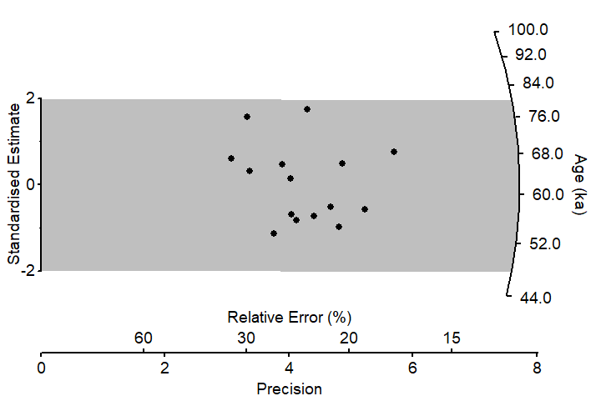
n =15 (21)
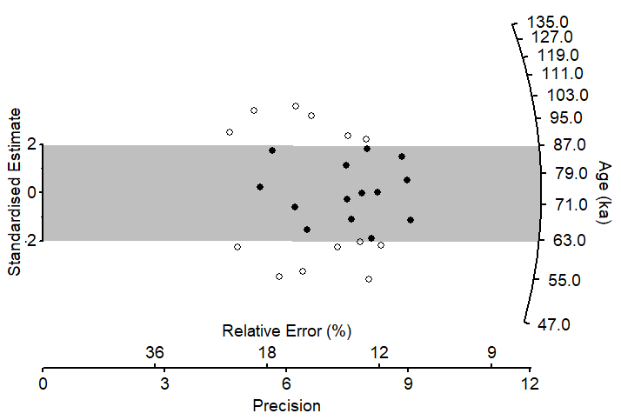
CAM
OD = 2.5%
CAM
OD = 28.7%
USU-1008, IRSL USU-1009, IRSL
n= 21 (24) n =22 (22)
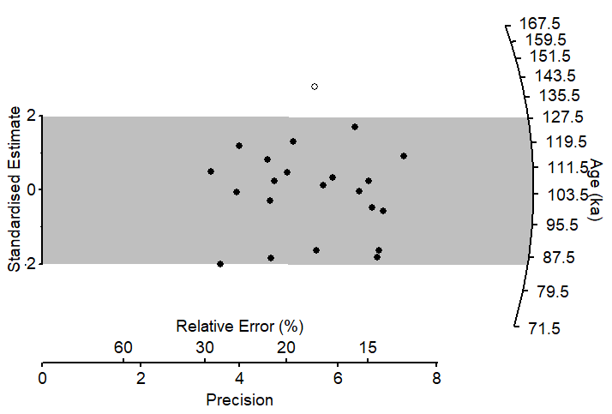
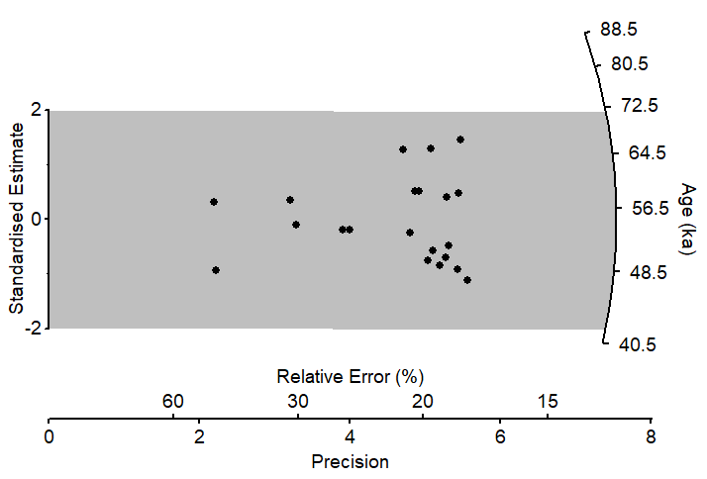
CAM
OD = 20 %
CAM
OD = 0 %
USU-1010, IRSL USU-1011, IRSL
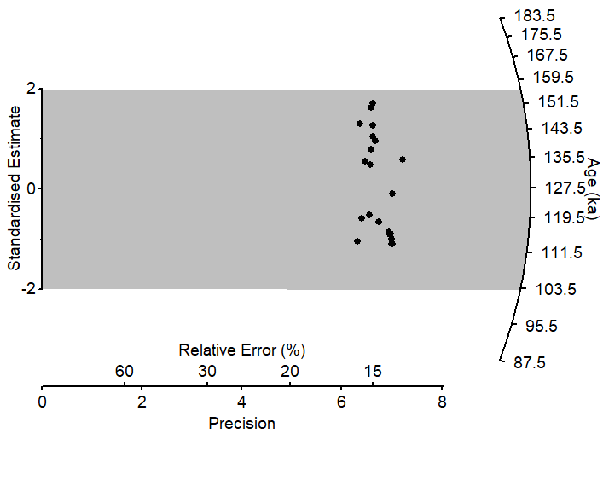
n= 32 (33) n =22 (22)
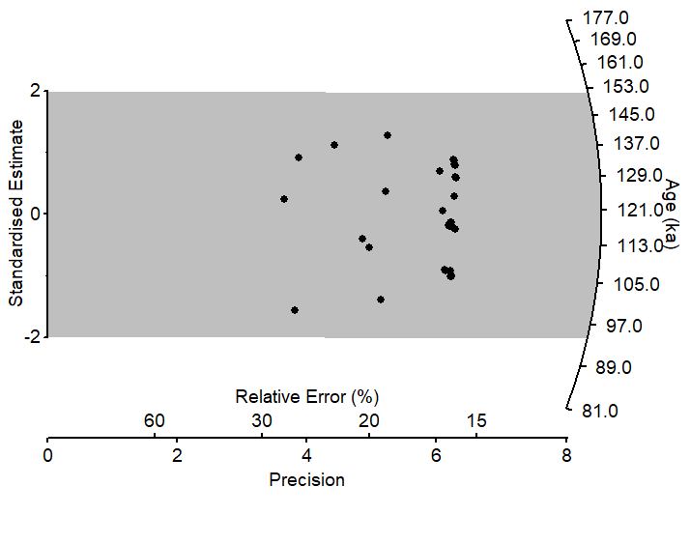
CAM
OD = 13.8 %
CAM
OD = 7.8 %
USU-1012, IRSL USU-1013, OSL
n= 30 (33) n =25 (50)
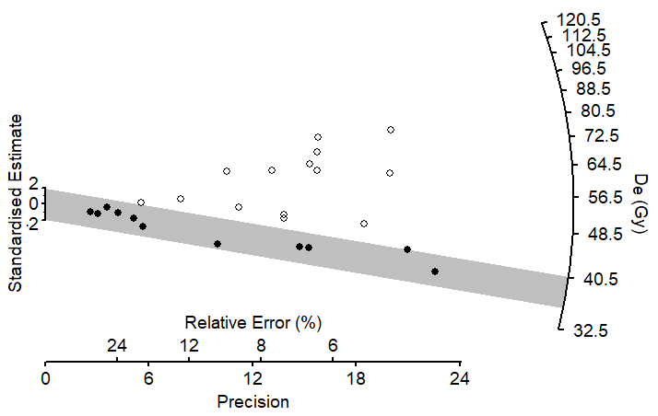
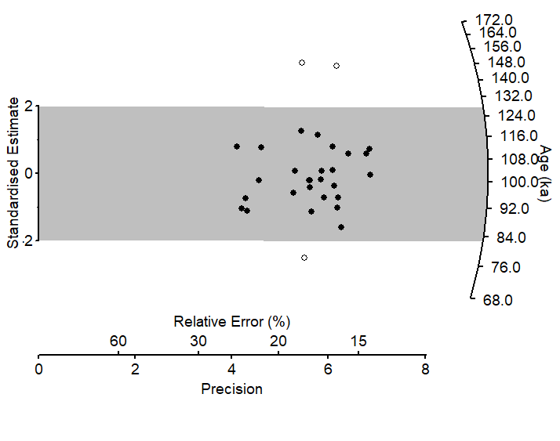
MAM
OD = 31.3 %
CAM
OD = 18.4 %

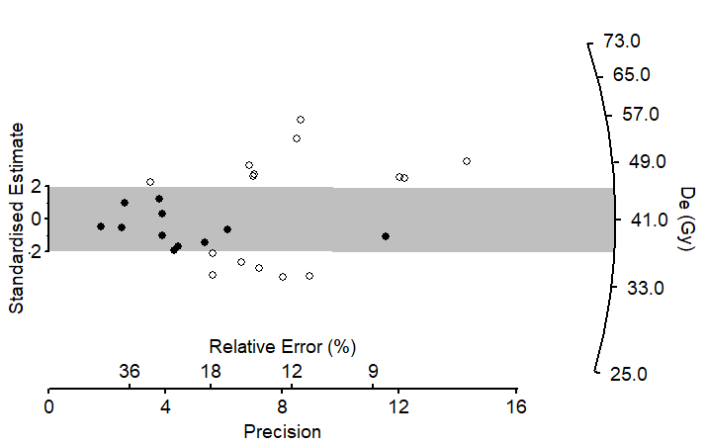
USU-1014, OSL USU-1015, OSL
n= 23 (50) n =26 (53)
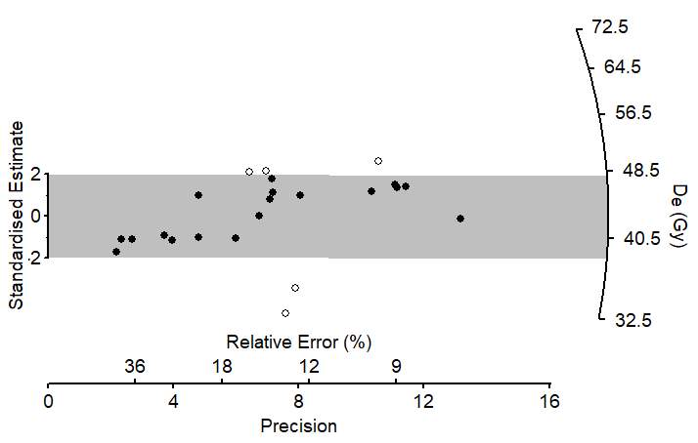
CAM
OD = 35.6 %
CAM
OD = 20.7 %

USU-1016, OSL USU-1017, OSL
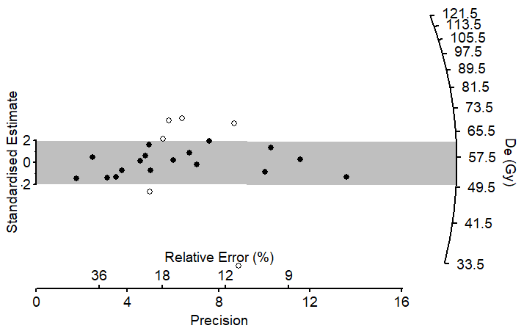
n= 21 (62) n =23 (50)
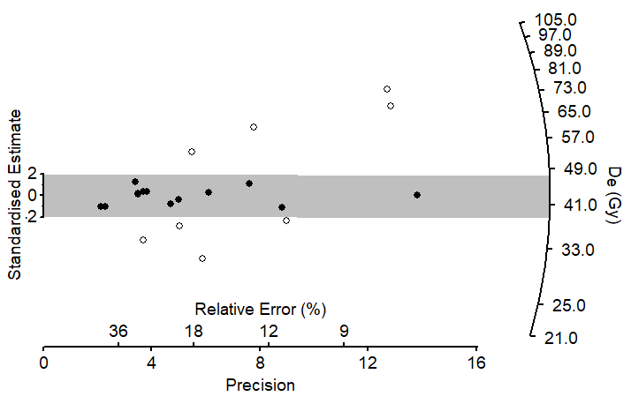
CAM
OD = 35.8 %
CAM
OD = 47.6 %

USU-1018, OSL
n= 31 (62)
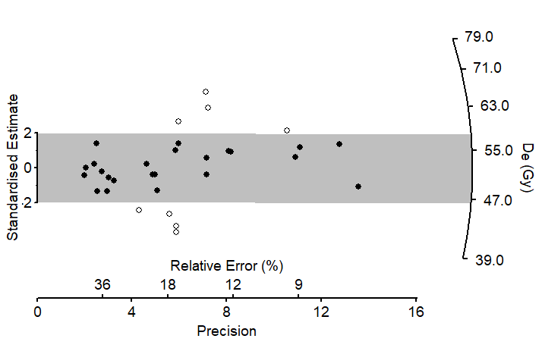
CAM
OD = 25.4 %

