Supplementary Information for Castillo et al. (2020): Prehistoric earthquakes on the Banning strand of the San Andreas Fault, https://doi.org/10.1130/GES02237.1

This supplement provides details of the luminescence dating methods and results, as well as details about each indicator for each paleoseismic event in the 18th Avenue trench.

DETAILS OF THE LUMINESCENCE DATING METHOD AND RESULTS

K-feldspar grains of 175–200 µm diameter were isolated from the sedimentary samples under dim amber LED light conditions. Subsamples were wet-sieved and separated by density with lithium metatungstate (ρ <2.565 g/cm³; Rhodes, 2015). Luminescence measurements were carried out using a TL-DA-20 Risø automated reader equipped with a single-grain IR laser (830 nm, at 90% of 150 mW; Bøtter-Jensen et al., 2003) and a ⁹⁰Sr/⁹⁰Y beta source. Emissions were detected using a photomultiplier tube with the IRSL signal passing through a Schott BG3- BG39 filter combination. Samples were mounted on aluminum single-grain discs with 100 holes. The gamma dose-rate was measured in situ using a calibrated, portable NaI gamma spectrometer, except for one sample (L11).
The U and Th concentrations were measured with inductively-coupled plasma mass spectrometry (ICP-MS), and the K concentration was measured using inductively-coupled plasma optical emission spectrometry (ICP-OES). These values were used to calculate the total beta dose rate contribution using the conversion factors of Liritzis et al. (2013). A value of 12.5 ± 0.12 wt. % K content was used in calculating the internal dose-rate (Huntley and Baril, 1997). The cosmic ray contribution was calculated from the burial depth and the latitude and altitude of the samples (Prescott and
Hutton, 1994; Table 2). We determined the water content for each sample from its weights before and after drying. The total geologic dose rate was calculated using the DRAC online calculator (v.1.2; Durcan et al., 2015).
A post-IR IRSL protocol (Buylaert et al., 2009) was used to measure the equivalent dose (D_{e}) values for individual grains. Each grain was stimulated first at 50° C for 3 s, and then at 225° C for 3 s to measure the more time-stable post-IR IRSL signal. A preheat of 250° C for 60 s was used before natural and regenerative measurements, and a hot bleach with IR diodes at 290° C for 40 s was added to the end of each SAR cycle (Wintle and Murray, 2006).
Samples were given a beta dose of 22 Gy, preheated at 250° C for 60 s and left at room temperature for timescales ranging from about 300 s to 7 days to test for the presence of athermal fading (Huntley and Lamothe, 2001). None of the 17 samples faded on these timescales. We used strict rejection criteria to select single grains for further analysis: 10% recycling ratio and maximum test dose error, and maximum recuperation of 5% of the natural signal intensity.
Except for one sample (L03), most of the samples show a high degree of overdispersion for single-grain D_{e} values, suggesting incomplete bleaching. Sample L03 is likely to be well-bleached with an overdispersion (OD) of 9.1 ± 5.6%), whereas, for the rest of the samples, solar resetting during deposition was likely incomplete (OD of 21–85 %; Fig. A1). Since the samples were collected from a small (~20 m wide) graben that formed within a large flood plain, incomplete bleaching is unsurprising (Schielein and Lomax, 2013). A central age model (CAM; Galbraith et al., 1999), therefore, was used only to estimate the burial dose of the well-bleached sample L03. For the partially bleached samples, we preferred a minimum age model (MAM; Galbraith et al., 1999) using three parameters and assuming an overdispersion of 15%, typical of K-feldspar single-grain results from Southern California (Rhodes, 2015). All the analyses were performed in the R statistical package for luminescence dating (Kreutzer et al., 2012).

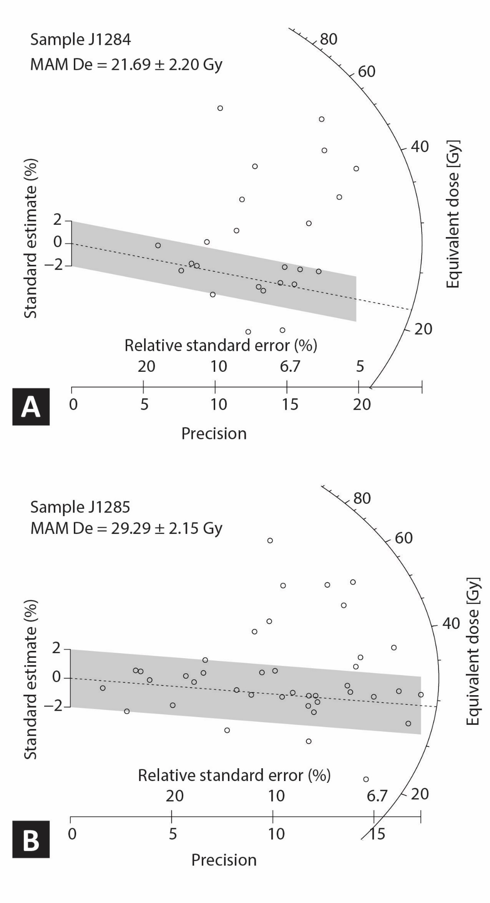
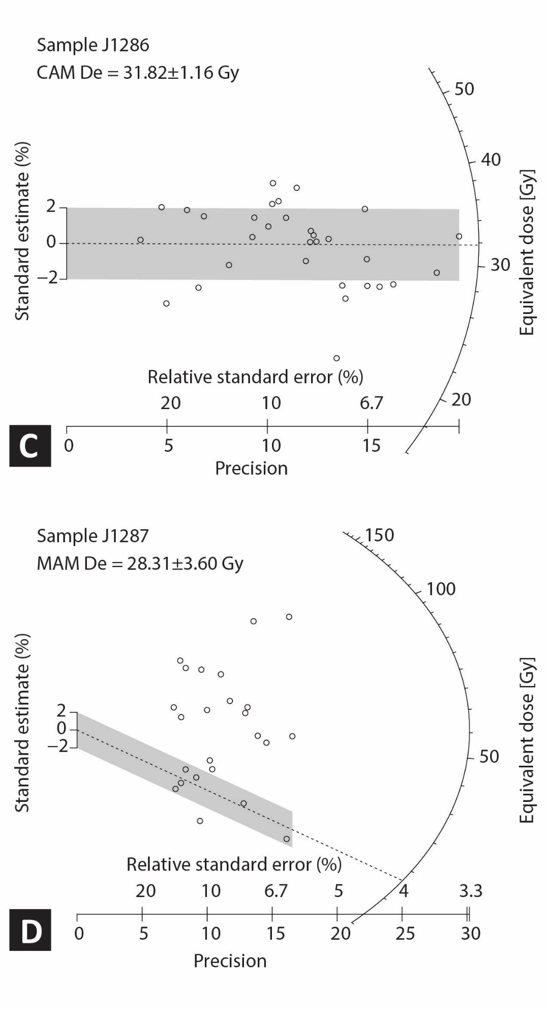
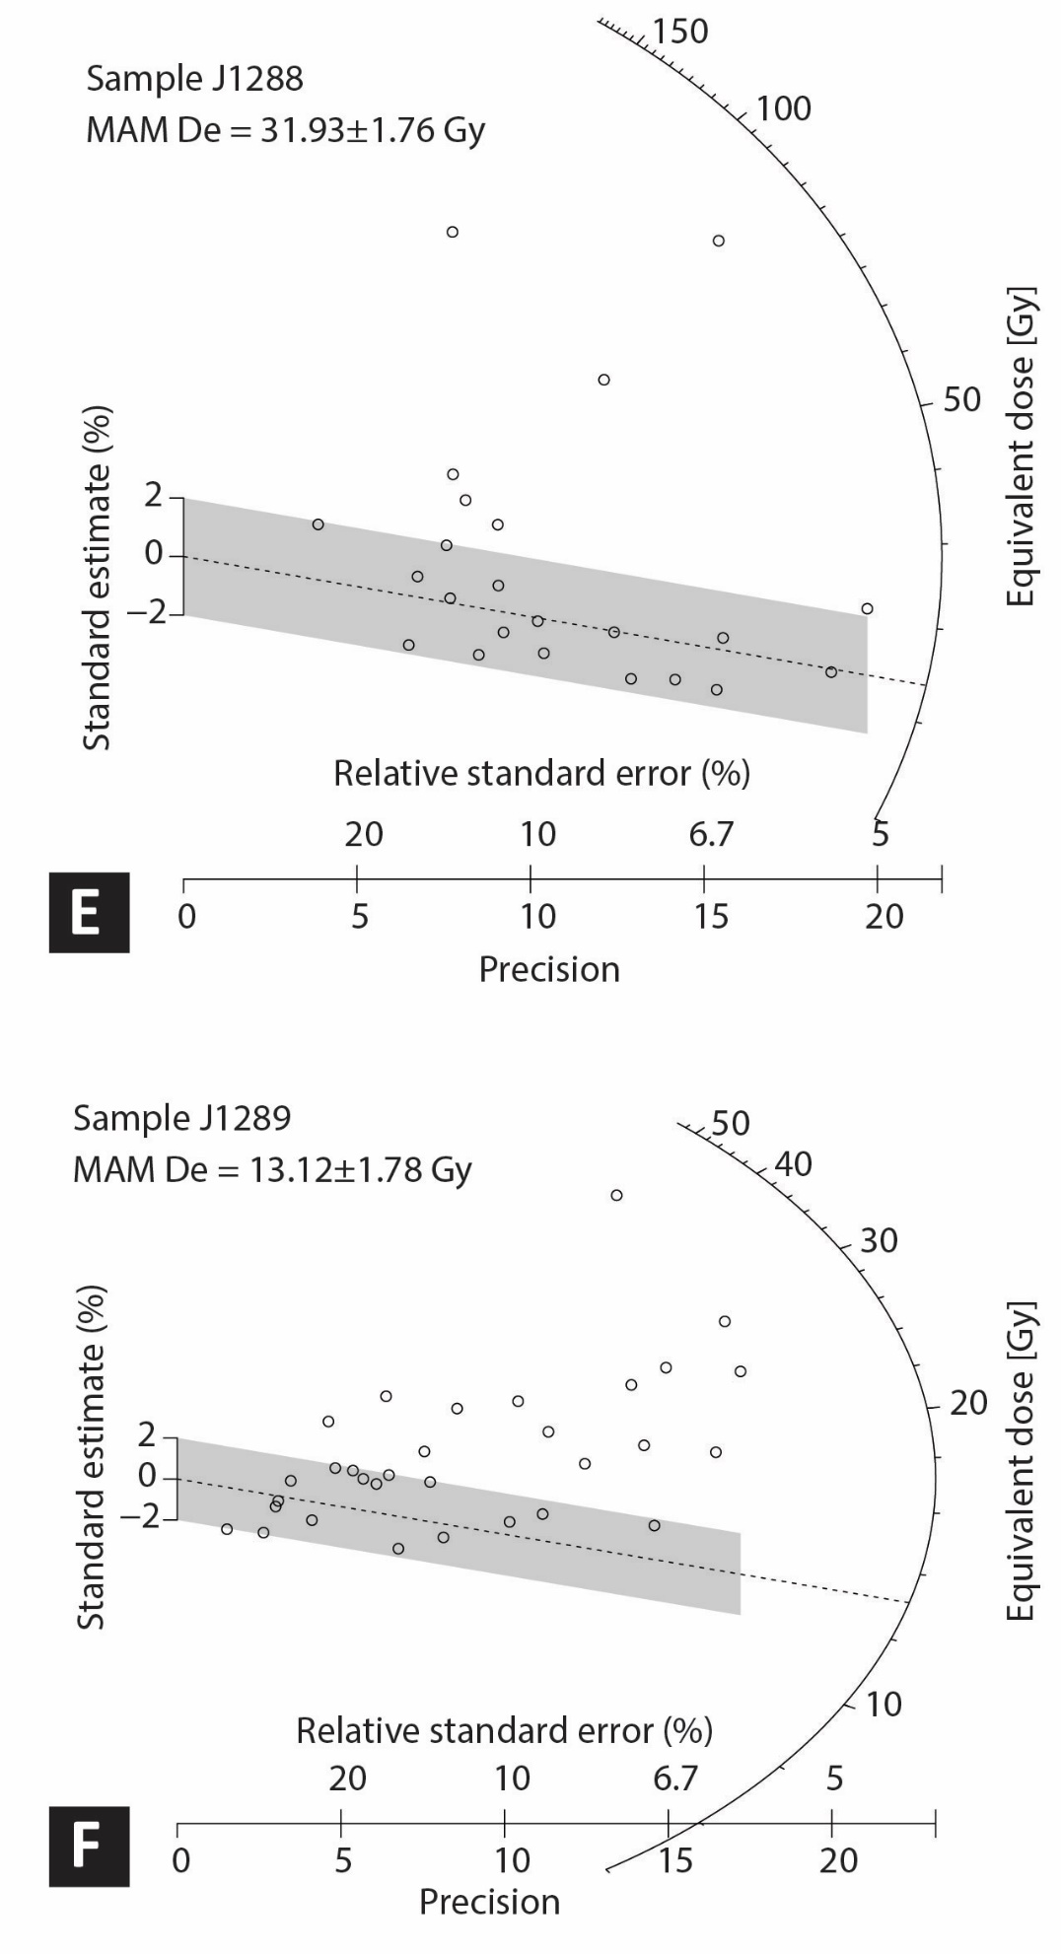
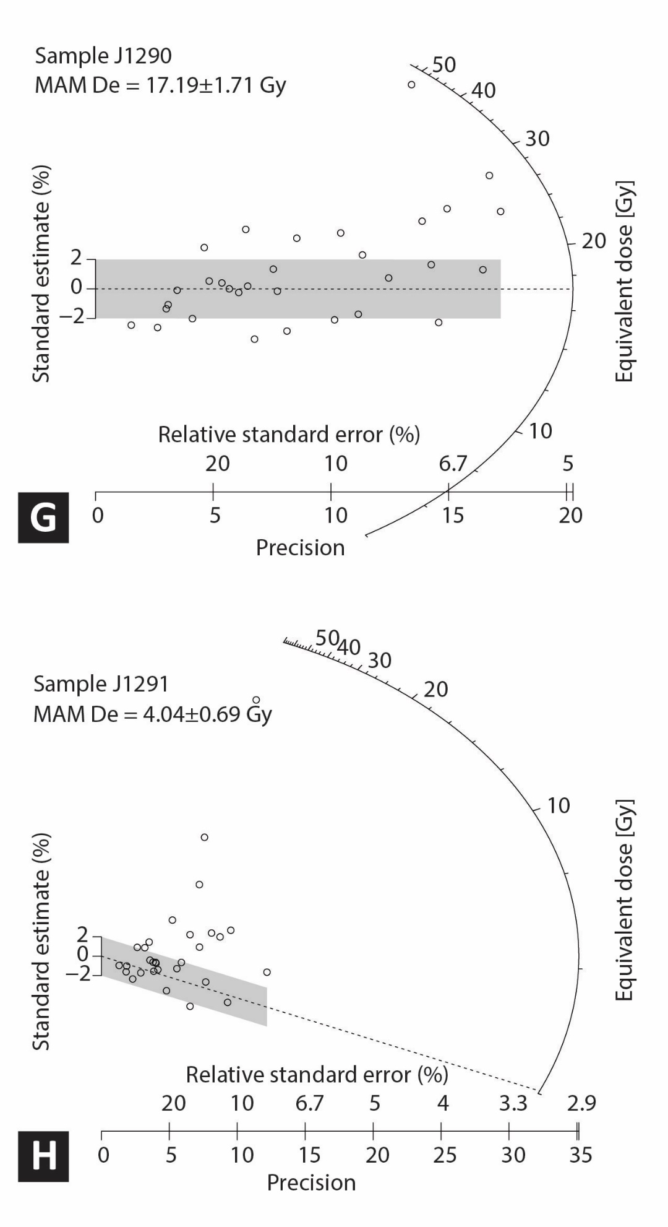
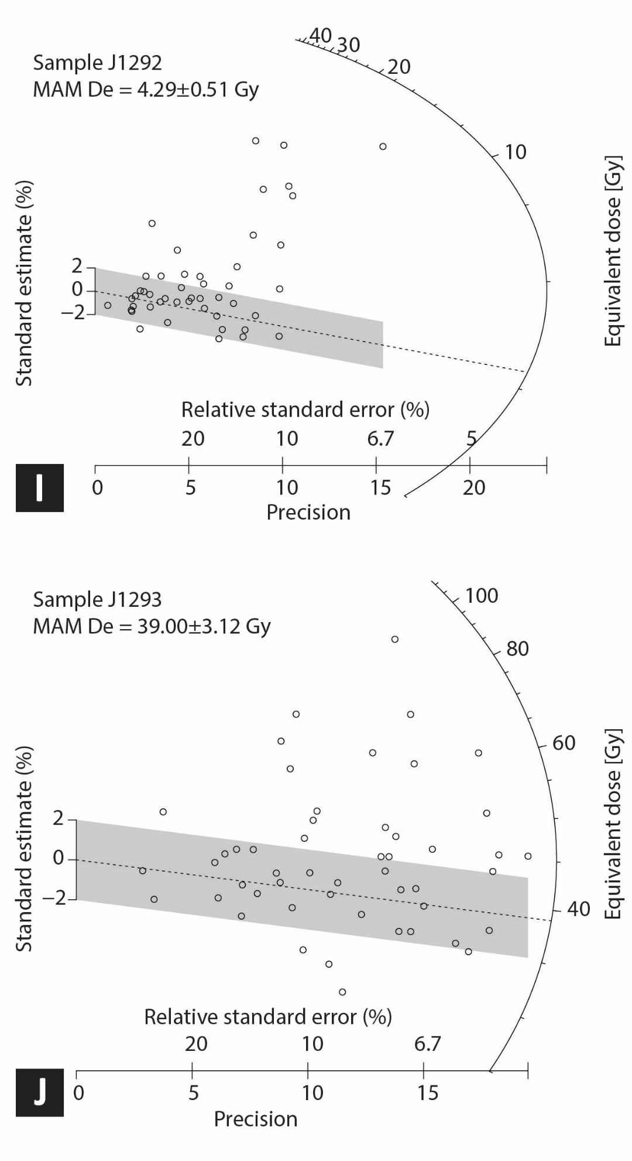
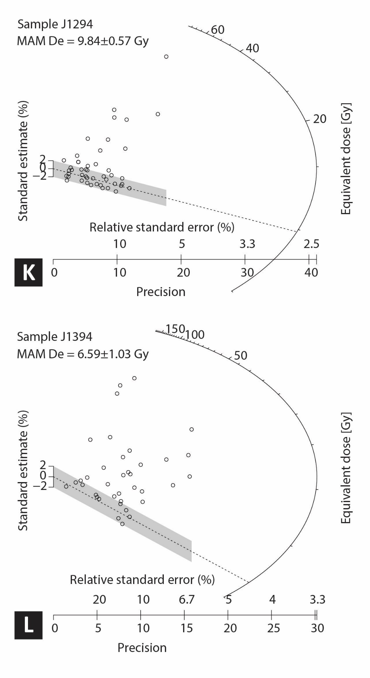
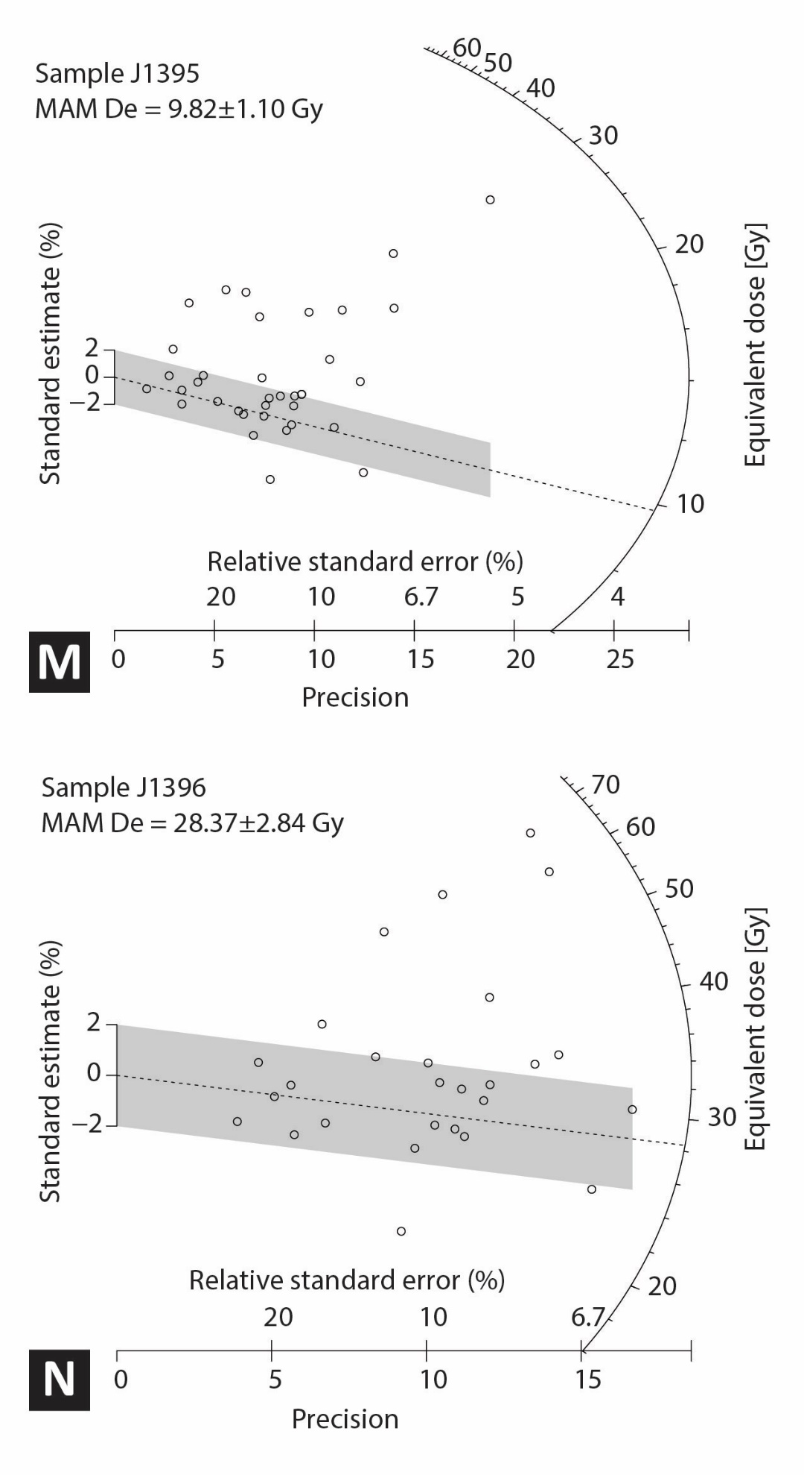
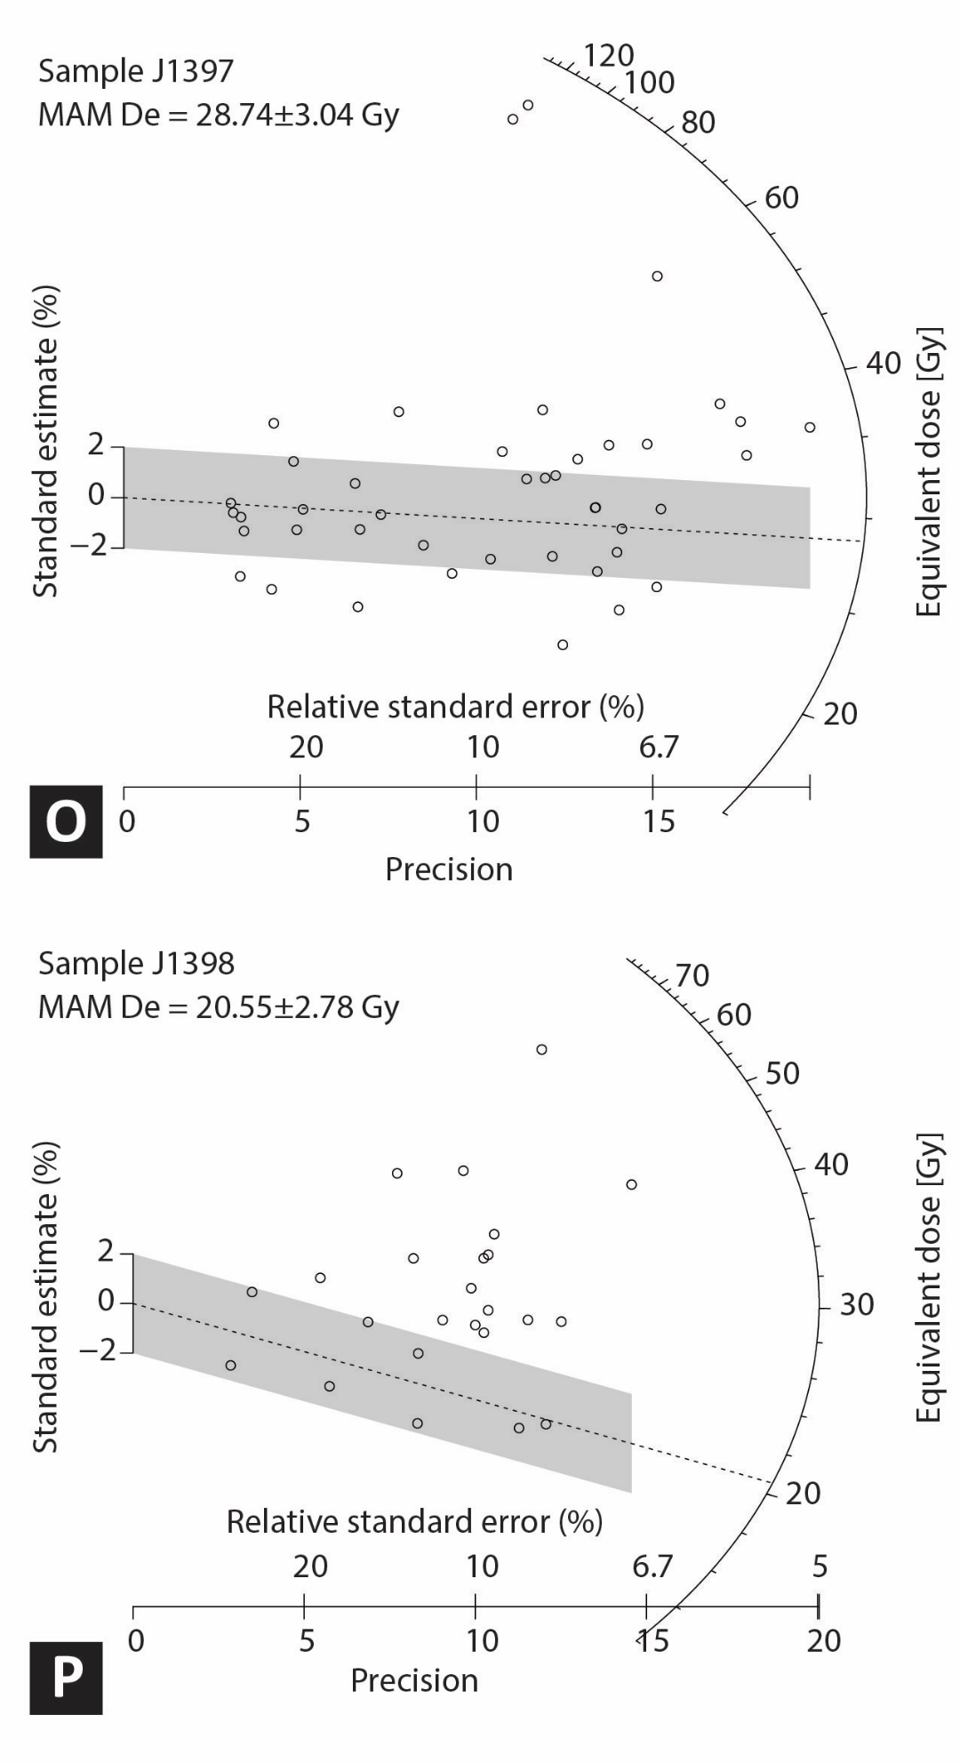
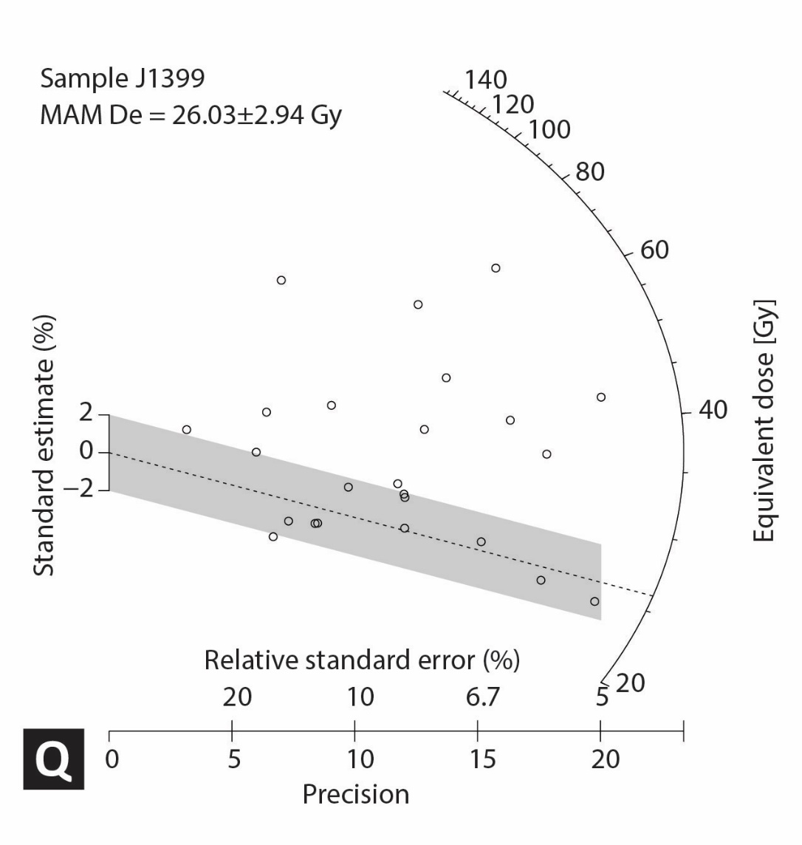
Figure S1: Radial plots (Galbraith et al., 1999) of the distributions of single-grain equivalent dose (De) values are shown for all samples (A–Q). Each circle represents an individual grain. The Central Age Model (CAM) is used for sample L03 (Fig. A1C), and for all other samples, Minimum Age Model (MAM) is used (Galbraith et al., 1999).

Figure S2. Diagrams A–Q showing anomalous fading results for feldspar single grain and aliquot samples (sample name noted at top of plot). Normalized IRSL intensities (Lx/Tx) are plotted against the time since irradiation in the laboratory. The g-values indicate the percentage fading loss per decade and are deduced from the slope of the weighted linear regression. No discernible fading is recorded during the laboratory measurements.

TABLE OF EVENT INDICATORS
Event | Wall | Tier | Meter | Evidence and Justification for Quality Rating. | Quality Ranking | Stratigraphic correlation rank | Justification for Stratigraphic Correlation Rating
 |  |  |  | Event 1
E1 | West | 1 | 18 | Upward fault termination. Correlation between layers across fault was difficult suggesting at least moderate lateral slip. | 3 | 3 | This indicator cannot be physically traced to the "secondary type locale" at 9 m on west wall because the event horizon crosses a bench, within an area of discontinuous stratigraphy. The correlation with the secondary type locale is fairly certain, but the secondary type locale is on the opposite wall from the primary type locale and is not near one of the units that has been correlated between walls.
E1 | West | 2 | 9 | Upward fault termination. Correlation between layers across fault was difficult suggesting significant lateral slip. | 3 | 4 | On opposite wall from type locale, but we assume the most recent event on both walls is the same.
E1 | West | 2 | 18 | Fault with 8 cm vertical separation that loses visibility between event horizons 1 and 2. There are no clear contacts that prevent the fault from extending up to the E1 horizon. | 2 | 1 | Could be E1 or E2 because the location of the E2 horizon is uncertain in this area and could be located at the upward termination of this fault.
E1 | West | 1 | 41 | Fault with 12 cm of vertical separation on layer W208F or W218F extends to within 31 cm from the surface with precise location of termination unclear. | 2 | 1 | Could be E1 or E2 because the location of the E2 horizon is uncertain in this area and could be located at the upward termination of this fault.
E1 | East | 1 | 20.5 | Fault with vertical separation measured in the tier below (tier 2) is 16 cm on southernmost strand and layers cannot be correlated across the fault suggesting at least moderate lateral slip. | 3 | 4 | Event horizon crosses a bench twice between the indicator and the type locale, but correlation is "fairly certain".
E1 | East | 1 | 20 | Northern strand only has minor offset. | 1 | 4 | Event horizon crosses a bench twice between the indicator and the type locale, but correlation is "fairly certain".
E1 | East | 1 | 30 | Fault that terminates within 24 cm below the E1 horizon. Offset in E1 is unknown because stratigraphy could not be correlated. However, in tier 2, vertical separation is 28 cm potentially accumulated in multiple events. | 2 | 3 | The E1 horizon crosses a bench twice and an area of poor stratigraphy between the indicator and the type locale, leading to a somewhat uncertain correlation, but it is still more likely that this indicator correlates with E1 than with any other recognized event.
E1 | East | 1 | 36 | Fault with moderate vertical separation (22 cm?) but upward termination is not distinct. This could be associated with events 1 or 2. The E2 horizon cannot be traced this far south, and the stratigraphy is compressed in this region, such that the E1-E3 horizons may all lie within 30-50 cm of each other. | 0 | 2 | The E1 horizon crosses a bench twice and several areas of poor stratigraphy between the indicator and the type locale, leading to a relatively high level of uncertainty, including the possibility that the indicator could correlate with an event other than the proposed event.
E1 | East | 1 | 42 | Evidence of a fault that clearly offsets δ (purple) layer and could extend very close to the surface. This could potentially be E1 or E2. The E2 horizon cannot be traced this far south, and the stratigraphy is compressed in this region, such that the E1-E3 horizons may all lie within 30-50 cm of each other. | 0 | 2 | The E1 horizon crosses a bench twice and several areas of poor stratigraphy between the indicator and the type locale, leading to a relatively high level of uncertainty, including the possibility that the indicator could correlate with an event other than the proposed event.
E1 | East | 1 | 8 | Upward fault termination. Correlation between layers across fault was difficult suggesting at least moderate lateral slip. | 4 | 5 | Type section.
E1 | East | 1 | 4 | Probable fault with minor vertical separation that terminates within ~20 cm below the E1 horizon. | 2 | 3 | Poor stratigraphy between the indicator and the type locale, which is on the same wall, resulting in a "somewhat uncertain" correlation, but still more likely to be E1 than any other event.
E1 | East | 2 | 10 | Fault with 28 cm of vertical separation terminates within ~40 cm below the E1 horizon. | 2 | 4 | Event indicator is across a bench from the type locale, but correlation is "fairly certain".
E1 | East | 2 | 9 | Fault with minor offset terminates within a few tens of cm below the E1 horizon. | 1 | 4 | Event indicator is across a bench from the type locale, but correlation is "fairly certain".
E1 | East | 1 | 16-32 | Units E40 through E80 gradually thin and pinch towards against stratigraphy uplifted on south side during E1. | 4 | 4 | Event horizon crosses a bench twice between the indicator and the type locale, but correlation is "fairly certain".
E1 | East | 2 | 11 | Fault with moderate vertical separation (24 cm) extends upward to within 32 cm of E1 horizon. | 1 | 4 | Event indicator is across a bench from the type locale, but correlation is "fairly certain".
E1 | East | 2 | 12 | Fault with minor offset. | 1 | 4 | Event indicator is across a bench from the type locale, but correlation is "fairly certain".
 |  |  |  | Event 2
E2 | West | 1 | 22 | Two possible fault strands with minor offset near the base of tier 1 but no clear downward continuation of the fault in tier 2. Upward termination is also unclear, but could be E2. | 0 | 4 | Layer W220E(alpha) is located 0-20 cm below the indicator and can be traced continuously to the type locale. However, the layers above this indicator are discontinuous.
E2 | West | 3 | 7 | Two fault with minor offset and upward fault termination. | 1 | 2
E2 | West | 1 | 28 | Layers W210E and W220E are vertically separated about 40 cm across a zone of 4 faults. Layer W170E is on top of a scour surface that appears to cap the faults, but earlier logging interpreted this layer as offset. Layer W108E thins and pinches out over this scarp, and definitely caps E2. | 3 | 5 | Type Locale
E2 | West | 3 | 14 | Fold with 4-5 cm amplitude affects basal layers within the charcoal rich silt layer (layer W290). No clear faulting below this fold on the same tier, but there is a fault on tier 4. Top of silt layer does not appear to be folded, but contact is not sharp. A sharp contact marked by green nails is present about 10-15 cm above the top of the layer W290 and is not faulted. The folding could be a result of liquefaction after E3, during E2 or possibly during E1 or during an aftershock of E2. Or there could be fault hear that slipped during E2 fault but died out before reaching the ground surface. | 0 | 2 | The E2 horizon crosses two benches, two faults and areas of discontinuous stratigraphy between the type locale to this indicator, resulting in a relatively high level of uncertainty in exactly where the E2 horizon should be above this indicator.
E2 | East | 2 | 19 | Upward fault termination at the base of a scoured channel with moderate offset (12 cm). | 3 | 3 | The E2 horizon on the east wall is only ~30 cm above layer E290, which can be correlated to the west wall of the trench. The correlation is thus somewhat uncertain but there is not another event that this is more likely to correlate with.
E2 | East | 3 | 14 | Fault with moderate offset of layer E290 stops at bench level in between tiers 2 and 3. Probably slipped in E2. Poor stratigraphy above fault, could either E1 or E2. | 0 | 1 | Fault terminates within the package of sediments above E290 and below E1 horizon. Correlation of E290 between east and west walls is strong (4); correlation of E1 horizon between east and west walls moderate (3)
 |  |  |  | Event 3
E3 | West | 2 & 3 | 6-14m (T3); 16-18 (T2) | We interpret that fault scarps that were formed during E3 down dropped blocks to the north creating a closed depression where water flowed and came to a halt depositing very fine grained material (charcoal rich silt). | 3 | 5 | Type Locale
E3 | East | 3 | 12-20m | Silt layer E290 is thickest in area where units are down dropped the most between faults. Layer E290 appears to thin out towards the south but the exact location of the pinch out is not clear. | 1 | 4 | Layer 290 can be correlated between the two walls with a high degree of certainty based on is thickness, grain size and presence of abundant charcoal.
E3 | East | 2 | 27 | Fault with minor displacement terminates within tier 2, and is capped by a contact that could potentially be the base of a debris flow which may correlate the E3 horizon to the north. | 1 | 1 | Layer 290 does not exist this far south, and our preferred interpretation of where it would be is uncertain. Stratigraphic distance between the E2 and E3 horizons here is < 0.5 m, making it hard to rule out the possibility that this indicator could have formed during E2.
E3 | East | 3 | 19 | Fault with major vertical separation that is visible to the top of tier 3 but not visible in tier 2. The E3 horizon lies at the base of tier 2, so this fault probably ruptured during E3. | 2 | 4 | These faults are potentially capped but E290 which can be correlated to W290 with a high degree of certainty.
E3 | East | 3 | 18 | Fault with major vertical separation that may extend to the top of tier 3 but Is not visible in tier 2. Probably slipped in E3. | 2 | 4 | These faults are potentially capped but E290 which can be correlated to W290 with a high degree of certainty.
 |  |  |  | Event 4
E4 | West | 1 | 32 | In the dugout 30-32 m in Tier 1, a fault with moderate vertical separation of a layer nailed purple-white and is capped by a scour nailed double green that formed at the base of a sandy channel. Quality ranking is 2 because it is not clear whether the sharp scour contact is present across the fault zone. | 2 | 5 | Type Locale
E4 | West | 2 | 23 | Fault with moderate offset (~6 cm) of vertical separation capped by layer W390. | 2 | 3 | The E4 horizon lies at the base of Layer W390C which can be well traced throughout tier 2 but jumps a fault and a bench onto tier 1. On Tier 1, layer W390C cannot be located with certainty. Because of this, the correlation to the type locale is somewhat uncertain.
E4 | West | 2 | 22 | Upward fault termination with moderate offset, but no clear location on the upward termination of the fault. Fault could be capped by layer W470C or could continue onto base of tier 2 and be capped by the E4 horizon. | 0 | 3 | The E4 horizon lies at the base of Layer W390C which can be well traced throughout tier 2 but jumps a fault and a bench onto tier 1. On Tier 1, layer W390C cannot be located with certainty. Because of this, the correlation to the type locale is somewhat uncertain.
E4 | East | 2 | 32 | Fault terminates upward with minor offset. | 1 | 2 | This event indicator is located above one of our correlable layers (E610) and is on the same tier as layer E610 but it is unclear at whether stratigraphic horizon at which this event indicator terminates is the same exact horizon as E4 at the type locale on the opposite wall. The indicator is not bracketed between two correlable layers, because location of layer E290 is unclear. While our preferred interpretation is E4, we cannot fully rule out the possibility it can be E5 (or E3). Therefore, the stratigraphic correlation has a high level of uncertainty.
E4 | East | 2 | 36 | Fault terminates upward with minor offset. | 1 | 2 | " "
E4 | East | 3 | 24 | A fault with minor offset originally mapped as capped by unit E480, but may extend upward and correlate with a fault in tier 2. Could potentially be E3 | 1 | 2 | This event indicator is located above one of our correlable layers (E610), but is not bracketed between two correlable layers, because location of layer E290 is unclear. While our preferred interpretation is E4, we cannot fully rule out the possibility it can be event 3. Therefore, the stratigraphic correlation has a high level of uncertainty.
 |  |  |  | Event 5
E5 | West | 1 | 50 | Four faults with minor vertical separation of layer W590D capped by W490D. Total vertical separation across the zone is ~ 10 cm. Therefore, we consider this moderate offset. Upward termination is indistinct, but there is a sharp capping layer about 30 cm above the faults. Our preferred interpretation is that this is a younger event than E6, but we cannot rule out whether this indicator could have formed during E6. | 2 | 4 | Type Locale. Our preferred interpretation is that this is a younger event than E6, but we cannot rule out whether this indicator could have formed during E6. Therefore we assign correlation rating of 4 instead 5 for the type locale.
E5 | East | 2 | 32 | Fault splay with very minor offset gets capped by layer E440. | 0 | 3 | At this event indicator we are fairly certain that the event indicator lies above layer E610(the top of this layer is the E6 horizon) and below the E4 indicator. The only uncertainty here, is that the type locale is on the opposite wall.
E5 | East | 3 | 26 | Minor offset on a faults that down drops debris flow layer E520 into a small graben that is capped by muddy silt layer E490. | 1 | 3 | This event indicator lies < 1 m above layer E610. We cannot see where the E4 horizon lies above this event indicator, which causes some uncertainty. Our preferred interpretation is that this event indicator is at the E5 horizon.
E5 | East | 3 | 24 | Fault with minor offset. | 1 | 3 | " "
E5 | East | 3 | 25 | Fault with minor offset. | 1 | 3 | " "
E5 | East | 3 | 23 | A fracture in layer E520 that is weathering out and may connect downward to a fault. Better than a 0 because there is a distinct upward termination but not a 1 because there is no measureable offset. | 0.5 | 3 | " "
 |  |  |  | Event 6
E6 | East | 3 | 22-27 | Layers E520 and E525 thin from 60 cm at 23 m to 20 cm at 26 m. Note: cannot be linked to a causative fault. | 3 | 5 | Type Locale
E6 | West | 2 | 38 | Minor vertical separation of layer W604C (~ 2 cm) capped by layer W590C. | 1 | 2 | The E6 horizon lies above one of our correlable layers (610). This event indicator is above layer 610 but the location of the E5 horizon above this event indicator is uncertain and correlation of the E6 horizon across the fault at 32 m is very uncertain. This allows the possibility that this indicator could of formed in a different event.
E6 | West | 2 | 39 | Minor vertical separation of layer W604C (~ 2 cm) capped by layer W590C. | 1 | 2 | The E6 horizon lies above one of our correlable layers (610). This event indicator is above layer 610 but the location of the E5 horizon above this event indicator is uncertain and correlation of the E6 horizon across the fault at 32 m is very uncertain. This allows the possibility that this indicator could of formed in a different event.
E6 | West | 4 | 23 | A fault with minor vertical separation capped by layer W590. | 1 | 4 | This event horizon is just above layer 610, which can be correlated between the two walls. It is also well below the interpreted position of the E5 horizon.
E6 | West | 4 | 23 | A faults with minor vertical separation capped by layer W590. | 1 | 4 | This event horizon is just above layer 610, which can be correlated between the two walls. It is also well below the interpreted position of the E5 horizon.
 |  |  |  | Event 7
E7 | East | 3 | 36 | Fault with 5 cm vertical separation in upper part of tier 4 (pebble layer E710) is capped by an unfaulted fine sand layer (E690) at base of tier 3. We did not dig this out, so we never saw the fault and the capping layer on the same tier. | 2 | 4 | The fine sand layer (E690) that caps this indicator can be correlated with a fair degree of certainty across one fault from the type locale.
E7 | East | 4 | 32 | An 80-cm-thick package of very fine sand, silt and clay (E670-E690) thins to 10-15 cm (E690) across a fault and then pinches out to south. The causative fault has re-ruptured in younger earthquakes. | 3 | 5 | Type Locale.
E7 | West | 4 | 28 | Layer W690 thins to the south and pinches out but there is no clear causative fault. | 1 | 2 | The fine sand layer that caps this indicator (W690) is below W610 and above W850, both of which can be correlated to the opposite wall of the trench. However, it is not particularly close to either of these correleable layers, so it is hard to tell for certain whether this capping layer correlates with E690 at the type locale.
 |  |  |  | Event 8
E8 | East | 4 | 36 | Layers E780 and E790 thin and pinch out to the south. We interpret this as growth strata. The causative fault (34 m) has 40 cm of vertical separation on layer E840B (below the growth strata) but only 5 cm of vertical separation on layer E710 above the growth strata. | 2 | 2 | This indicator and the type locale are both probably above unit 850, but that unit cannot be physically traced to either of these indicators.
E8 | West | 4 | 32 | Fault with moderate vertical separation (22 cm) of layer W815-W815B. Capped by layer of fine sand (layer W790C). | 2 | 3 | Fine sand layer capping this indicator (W790C) probably correlates with unit W790 capping the type locale, but there is some uncertainty due to crossing and area of poor stratigraphy and crossing a fault.
E8 | West | 4 | 36 | Fine sand layer W790C thins towards the south and pinches out against a fault. | 2 | 5 | Type Locale

Table S1. Table of every event indicator recorded at the 18th ave paleoseismic trench.

