Fast Pliocene integration of the Central Anatolian Plateau drainage: evidence, processes, and driving forces:

Supplementary Methods

Any use of trade, product, or firm names is for descriptive purposes only and does not imply endorsement by the U.S. Government.

Supplementary Methods S1: Middle Miocene surface

Sedimentation during the late Miocene laps onto a basal unconformity that separates sedimentary rocks deposited during this phase from usually deformed older sedimentary rocks. In the basin of Lake Tuz, sedimentation started during Tortonian times [Fernandez-Blanco et al., 2013]. In the basins of Emmiler [Dirik, 2001], Sivas and Kangal [Yılmaz and Yılmaz, 2006] (Fig. 2B, 10), the unconformity is covered by upper Miocene and Pliocene sedimentary rocks, but in the basins of Emmiler and Elbistan, a later unconformity separates folded Mio-Pliocene lacustrine limestones from Pliocene to Plio-Quaternary sedimentary rocks [Dirik, 2001; Yusufoğlu, 2013]. Miocene to Pliocene sedimentation may have been more continuous in the Malatya Basin [Kaymakci et al., 2006]. Generally, the basal unconformity is folded at wavelengths of 30-100 km. Overall, the upper Miocene-Pliocene phase of sedimentation was widespread and started before the rise of the CAP or during the early stages of surface uplift.
The basal Mio-Pliocene unconformity is a low-relief surface that was preserved from erosion by burial under the Mio-Pliocene sediments (e.g. Fig. S1-1C). Away from the Mio-Pliocene depocenters, this low-relief erosional surface has been exposed to further erosion during Pliocene and Quaternary times. Many low-relief surfaces are perched on the tops of mountain ranges that surround the Mio-Pliocene depocenters (e.g. Fig. S1-1D). They are separated from one another, and from the Mio-Pliocene depocenters, by deeply dissected areas. They represent the remnants of a once more extensive, regional surface, which, given its lateral continuity with the basal Mio-Pliocene unconformity, is likely of late Miocene age. Given that the amplitude of the local relief on the perched low-relief surfaces is comparable to the amplitude of the local relief on the buried Mio-Pliocene unconformity, it is also likelythat the flatness of the basal Mio-Pliocene unconformity was not acquired at the time of burial, under the action of fluvial or marine agents of planation, such as the ones that generate river straths and shore platforms, but, instead, that Mio-Pliocene sedimentation buried a subdued topography. At the most extensively preserved locations, the relict late Miocene surface includes residual reliefs a few hundred meters high, surrounded by very flat ground (e.g. Fig. S1-1 B, D). In areas were the low-relief surface has been entirely dismantled by erosion, its past presence can be inferred from the accordance of summits (e.g. in the Aladağ, Fig. 10 [Klimchouk et al., 2004]) The low-relief surface is amply folded at wavelengths of several tens of kilometers in the Kozaklı and Sivas Basins and south of the Lake Tuz Basin, where it defines a broad arch (Fig. 5B), similar to the arch reconstructed using upper Miocene marine carbonates [Schildgen et al., 2012]. The basal Mio-Pliocene unconformity levels folded Eocene-Oligocene sedimentary rocks in the Aktoprak Basin [Meijers et al., 2016], and Miocene sedimentary rocks in the basins of Elbistan [Yusufoğlu, 2013], Malatya [Kaymakci et al., 2006], and Altınapa [Koç et al., 2012]. This unconformity also leveled ridges and valleys that characterized the steep middle Miocene topography, for example in the Dikme Basin (Fig. S1-1A) and along the paleovalley of the Göksu River (Fig. S1-1B).
Figure S1-1. Local relief reduction and amplification since the middle Miocene in the Dikme Basin (A), along the Göksu River (B) where steep paleovalleys within the pre-Neogene basement are filled with middle Miocene continental sediments; along the southeastern margin of the basin of Lake Tuz (C), and on top of the Bolkar Dağlar (D). See Fig. 2B for location. Formations: M2: continental middle Miocene, M2-M3: marine middle-upper Miocene, M3-Pl: continental upper Miocene to Pliocene, P-Ev: Palocene-Eocene volcanics, P-Es: Paleocene- Eocene sedimentary rocks, J-K: Jurassic-Cretaceous sedimentary basement. R: river, S: subdued late Miocene topographic surface, V: valley. Horizontal scale set at the location of the vertical black arrows. Images: A, C, D: © 2019 CNES/Airbus; 3D-visualization with Google Earth; B: multispectral images WordView 02, scenes 10SEP080844384/73 and 11SEP020852416/04; 3D visualization with ArcScene10 on AW3D30 DEM (©JAXA).

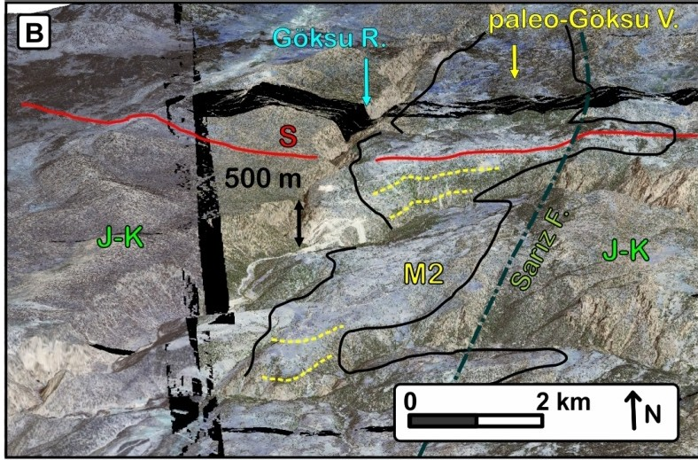
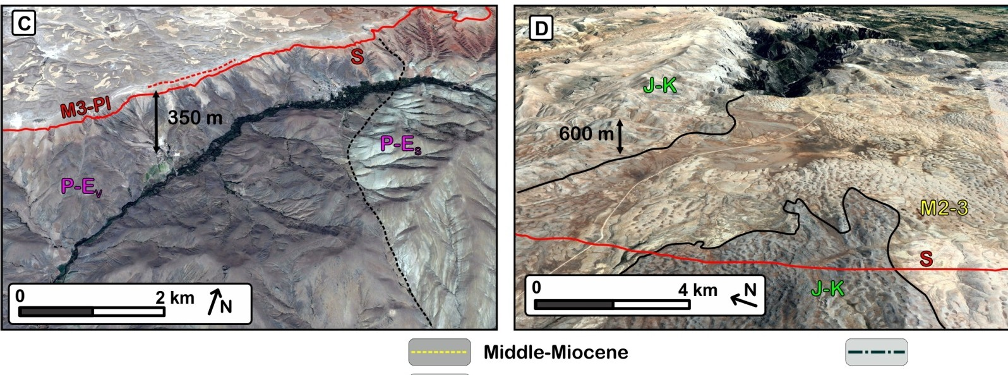
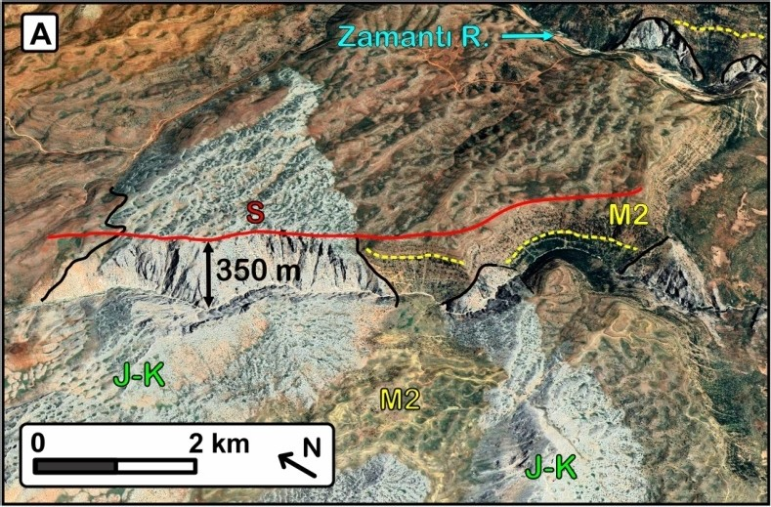
Bedding:
[ --------) Mio-Pliocene
fault

Unconformities: [- - - ) late Miocene Middle-Miocene [----------) Earlier

References

Dirik, K. (2001), Neotectonic evolution of the northwestward arched segment of the Central Anatolian Fault Zone, Central Anatolia, Turkey, Geodinamica Acta, 14(1-3), 147-158.
Fernandez-Blanco, D., G. Bertotti, and A. Çiner (2013), Cenozoic tectonics of the Tuz Gölü Basin (Central Anatolia Plateau, Turkey), Turkish Journal of Earth Sciences, 22(5), 715-738.
Kaymakci, N., M. Inceoez, and P. Ertepinar (2006), 3D-architecture and Neogene evolution of the Malatya Basin: inferences for the kinematics of the Malatya and Ovacık fault zones, Turkish Journal of Earth Sciences, 15(2), 123-154.
Klimchouk, A., L. Nazik, S. Bayari, K. Tork, and Y. Kasjan (2004), Kuzgun Cave and its Context: the first super- deep cave in the Aladaglar Massif, Turkey, edited.
Koç, A., N. Kaymakci, D. J. van Hinsbergen, K. F. Kuiper, and R. L. Vissers (2012), Tectono-Sedimentary evolution and geochronology of the Middle Miocene Altınapa Basin, and implications for the Late Cenozoic uplift history of the Taurides, southern Turkey, Tectonophysics, 532, 134-155.
Meijers, M. J., B. E. Strauss, M. Özkaptan, J. M. Feinberg, A. Mulch, D. L. Whitney, and N. Kaymakçı (2016), Age and paleoenvironmental reconstruction of partially remagnetized lacustrine sedimentary rocks (O ligocene A ktoprak basin, central A natolia, T urkey), Geochemistry, Geophysics, Geosystems, 17(3), 914-939.
Schildgen, T. F., D. Cosentino, B. Bookhagen, S. Niedermann, C. Yıldırım, H. Echtler, H. Wittmann, and M. R. Strecker (2012), Multi-phased uplift of the southern margin of the Central Anatolian plateau, Turkey: A record of tectonic and upper mantle processes, Earth and Planetary Science Letters, 317, 85-95.
Yılmaz, A., and H. Yılmaz (2006), Characteristic features and structural evolution of a post collisional basin: The
Sivas Basin, Central Anatolia, Turkey, Journal of Asian Earth Sciences, 27(2), 164-176.
Yusufoğlu, H. (2013), An intramontane pull-apart basin in tectonic escape deformation: Elbistan Basin, Eastern Taurides, Turkey, Journal of Geodynamics, 65, 308-329.

Supplementary Methods S2: ⁴⁰Ar/³⁹Ar Dating

Whole rock samples were crushed, washed, and handpicked. Rock powders were irradiated at the USGS TRIGA reactor [Dalrymple, 1981] together with standards in three separate irradiations (at 0.5, 3, and 5 MWH) in central thimble position while rotated at 1 rpm. Following irradiation, the samples and standards were loaded onto a stainless steel sample holder and placed into a laser chamber with an externally pumped ZnSe window. The volume of ~450 cc of the mostly stainless steel vacuum extraction line includes a cryogenic trap operated at −130°C, and two SAES™ GP50 getters (one operated at room temperature, one operated at 2.2A). A combination of turbo molecular pumps and ion pumps maintains steady pressures of <1.33 x 10-7 Pa within the extraction line. The reported incremental heating steps represent results from individual rock fragments. Samples were incrementally heated in steps of 90 seconds by controlling the power output of a 50W CO2 laser equipped with a beam-homogenizing lens projecting uniform energy over the entire sample surface. During laser heating, any gas released by the sample was exposed to cryogenic trapping and further purified for an additional 120 seconds by exposure to both the cryogenic trap and the SAES getters. The gas thus extracted was expanded into a Thermo Scientific ARGUS VI™ mass spectrometer. Argon isotopes were analysed simultaneously using four faraday detectors (40Ar, 39Ar, 38Ar, 37Ar) and one ion counter (36Ar). The faraday detectors were calibrated using a fixed reference voltage. The ion counter was calibrated relative to the faraday detectors by regular air pipette measurements, and the detector discrimination was monitored by the 40Ar/39Ar ratios of Fish Canyon sanidine measurements. After 10 minutes of data acquisition, time zero intercepts were fit to the data using parabolic and/or linear best fits, and then corrected for backgrounds, detector inter- calibrations, and nucleogenic interferences. We used the computer program Masspec (A. Deino, Berkeley Geochronology Center) for data acquisition, age calculations, and plotting.

All the 40Ar/39Ar ages reported in Table S2-1 and Figure S2-1 are calculated relative to an age of 28.201 ± 0.046 My for the Fish Canyon sanidine [Kuiper et al., 2008], using the decay constants of [Min et al., 2000], and an atmospheric 40Ar/36Ar ratio of 298.56 ± 0.31 [Lee et al., 2006]. Laser fusion of >10 individual Fish Canyon Tuff sanidine crystals at each closely monitored position within the irradiation package resulted in neutron flux ratios reproducible to ≤ 0.25 % (2σ). Isotopic production ratios were determined from irradiated CaF2 and KCl salts. For the present study the following values were measured: (36Ar/37Ar)Ca = (2.4±0.05) x10-4; (39Ar/37Ar)Ca
= (6.59±0.10) x10-4; and (38Ar/39Ar)K = (1.29±0.03) x10-2. Cadmium shielding during irradiation prevented any measurable (40Ar/39Ar)K. 40Ar/39Ar plateau ages (and uncertainties) are considered the best estimate of the cooling age of the minerals and were calculated from samples if three or more consecutive heating steps released ≥ 50 % of the total 39Ar and also had statistically (2σ) indistinguishable 40Ar/39Ar ages.

Lab sample # | Site #⁽¹⁾ | Site | Latitude | Longitude | Elevation | 39Ar/40Ar | Age(2) | 2σ
 |  |  | (°) | (°) | (m) |  | (Ma)
CDCATGB-120621-2 | [1] | Karahalka basalt near vent | 38.8637 | 36.8600 | 1,880 | whole rock | 5.11 | 0.06
CDCATGB-120621-3 | [2] | Kaşköy basalt flow | 38.7539 | 37.1453 | 1,712 | whole rock | 4.64 | 0.06
CDCAT-GB140605-7 | [3] | Amarat basalt flow | 39.0475 | 35.6774 | 1,600 | whole rock | 4.216 | 0.015
CDCAT-GB140605-7A | [3] | Amarat basalt flow | 39.0475 | 35.6774 | 1,600 | whole rock | 4.22 | 0.02
CDCAT-GB140619-1 | [4] | Karakaya basalt flow | 38.9766 | 35.7222 | 1,685 | whole rock | 4.23 | 0.02
CDCATGB-140601-3 | [5] | Çaltepe basalt flow | 38.9067 | 35.455 | 1.375 | whole rock | 4.88 | 0.04
CDCAT-GB140618-20 | [6] | Güzelce middle of the basalt flow pile | 38.4378 | 36.0463 | 1,478 | whole rock | 11.92 | 0.05
CDCAT-GB140618-22 | [7] | Güzelce base of the basalt flow pile | 38.4407 | 36.0497 | 1,455 | whole rock | 12.23 | 0.11
CDCAT-GB140618-5 | [8] | Yaylacik basalt boulder in volcanic breccia | 38.1631 | 35.8009 | 1,384 | whole rock | 6.11 | 0.06
CDCAT-GB140618-1B | [9] | Tasçı basalt boulder in volcanic breccia | 38.2245 | 35.7866 | 1,362 | whole rock | 6.12 | 0.06
CDCATGB-120613-1 | [10] | Kale-North Dikme ignimbrite | 38.1325 | 35.6646 | 1,530 | biotite | 2.9 | 1.1
12CAT15 | [11] | Karaköy-Dikme | 38.0352 | 35.5814 | 1,380 | biotite | 5.42 | 0.09
CDCATGB-120623-1 | [12] | Lake Tuz basin, lower ignimbrite | 37.7797 | 34.6286 | 1,223 | biotite | 6.85 | 0.19
Table S2-1. 40Ar/39Ar ages. (1) Site numbers reported on Figs. 2B, 6, 11, and 12. Note that one single site number [3] is used for two runs of the Amarat flow sample. (2): plateau age, or integrated age if plateau involves less than three consecutive steps.

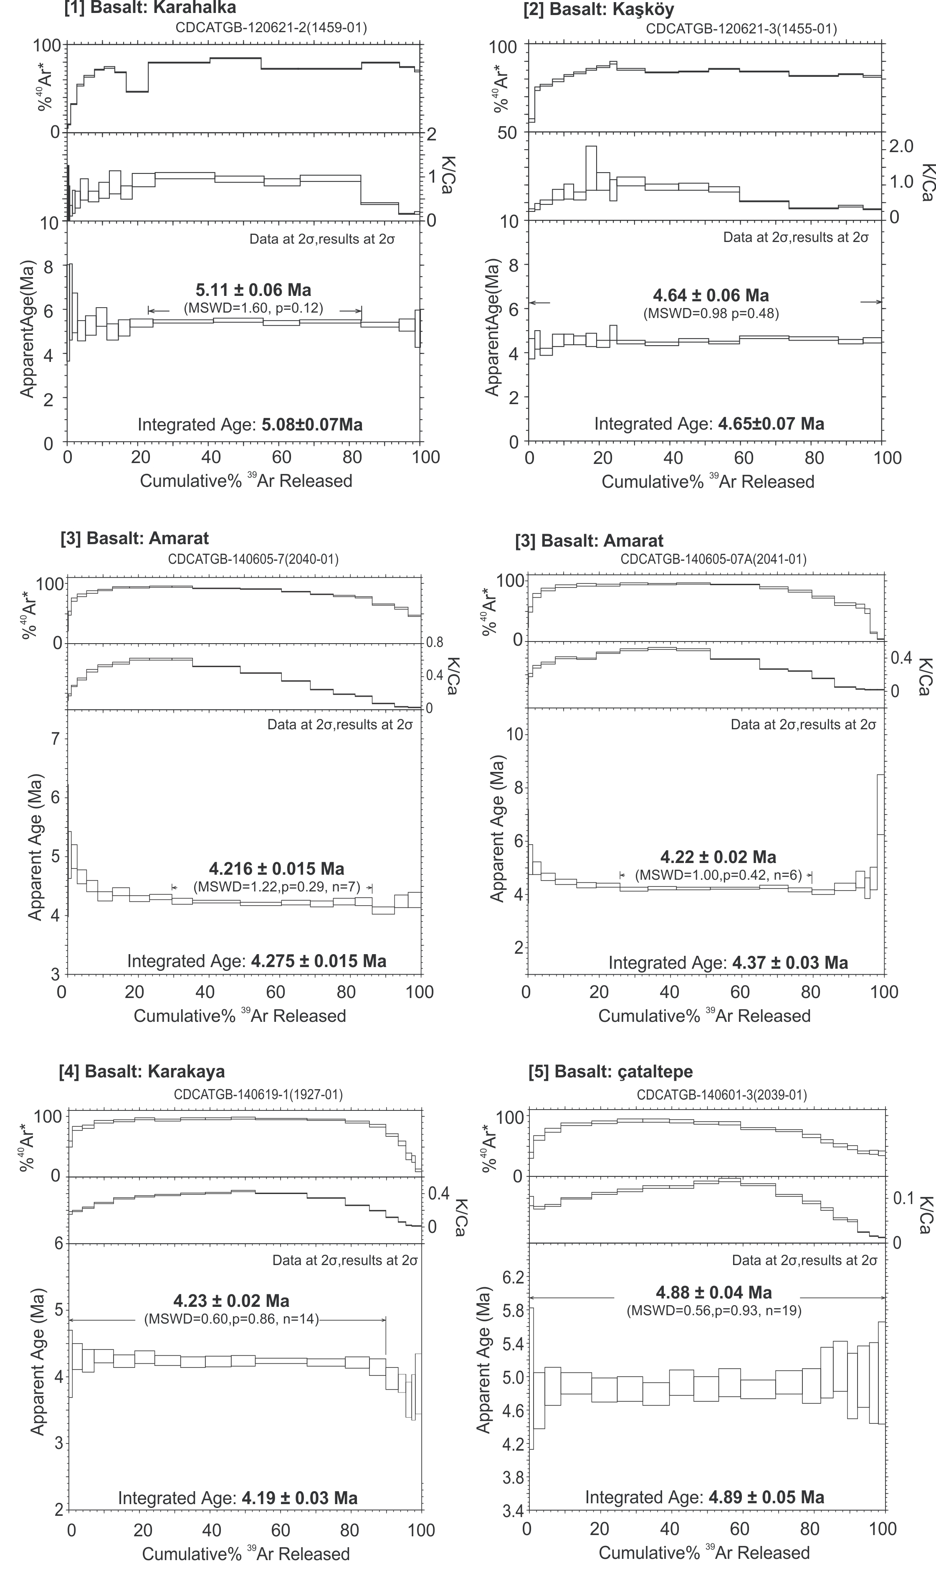
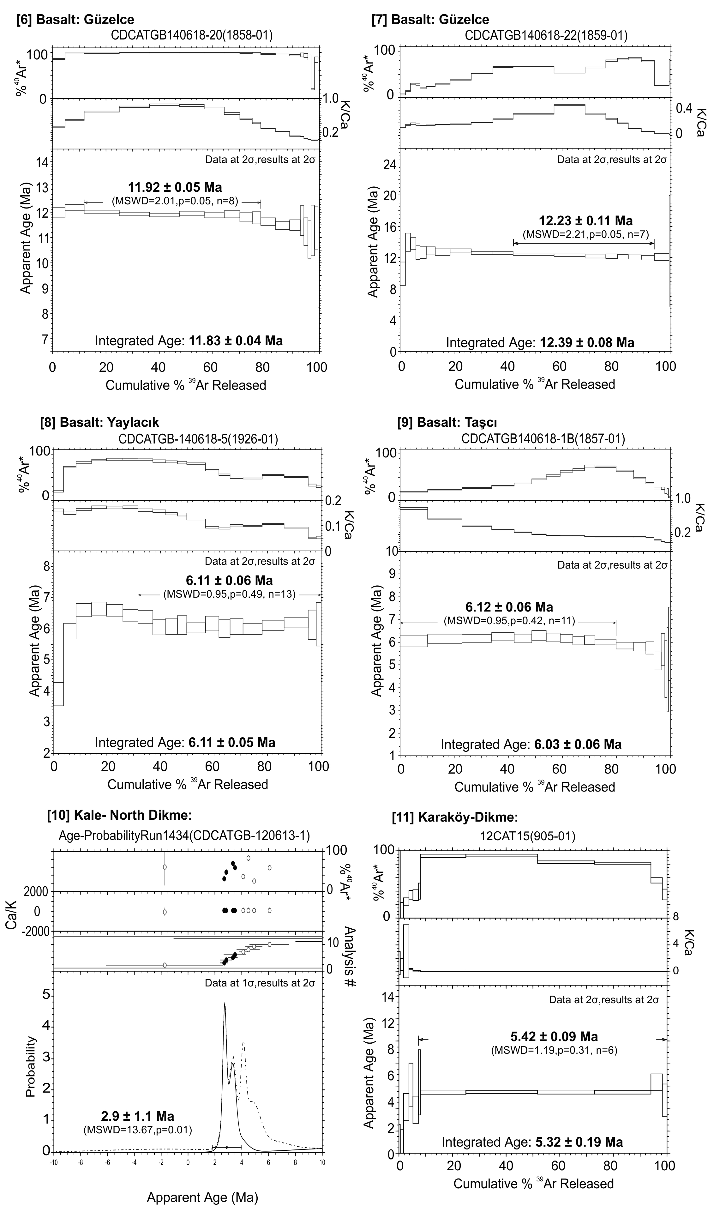
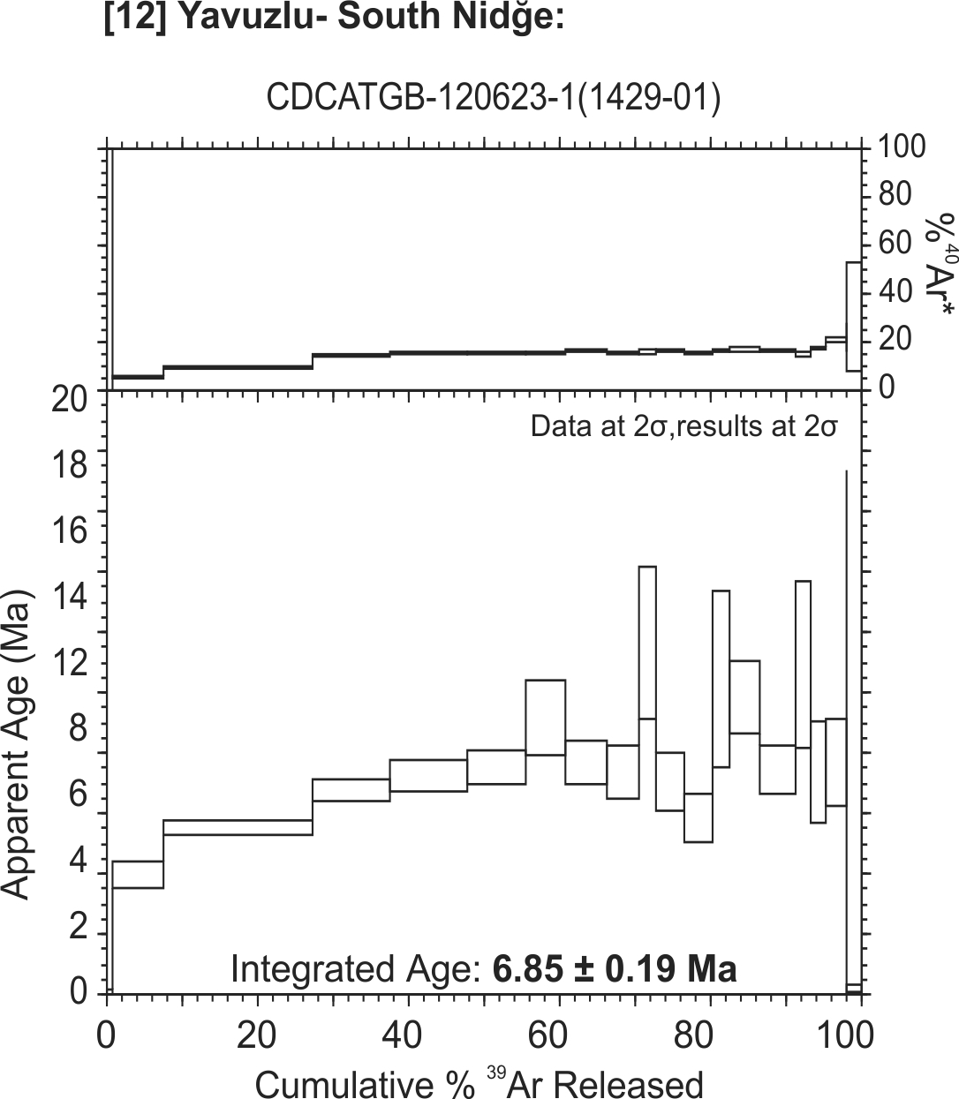
Figure S2-1. Ar-Ar heating spectra.

Dalrymple, G. B. (1981), Irradiation of samples for^< 40> Ar/^< 39> Ar dating using the Geological Survey TRIGA reactor, United States Geological Survey Professional Paper, 1176, 1-55.
Kuiper, K., A. Deino, F. Hilgen, W. Krijgsman, P. Renne, Wijbrans, and JR (2008), Synchronizing rock clocks of Earth history, science, 320(5875), 500-504.
Lee, J.-Y., K. Marti, J. P. Severinghaus, K. Kawamura, H.-S. Yoo, J. B. Lee, and J. S. Kim (2006), A redetermination of the isotopic abundances of atmospheric Ar, Geochimica et Cosmochimica Acta, 70(17), 4507-4512.
Min, K., R. Mundil, P. R. Renne, and K. R. Ludwig (2000), A test for systematic errors in 40Ar/39Ar geochronology through

Supplementary Methods S3. ¹⁰Be sampling, processing, measurement and conversion to denudation rates

We measured the concentration of 10Be in the quartz bedload of three rivers. The concentration of ¹⁰Be in riverborne quartz reflects the mean erosion rate in its feeding catchments [Lal, 1991]. Quartz extraction and processing follows the protocol of Kohl and Nishiizumi, [1992]. The analyses were conducted on the standard 250-500 µm sand fraction was of rivers [a] and [b] (table S3-1, Fig.6). The high steepness of stream [c] (table S3-1, Fig.6) prevents the deposition of sand along the streambed. The analysis was therefore conducted on gravel deposited on the streambed. The dataset also includes four local slope denudation measurements obtained from rocky surfaces exposed on slopes flanking the Ceyhan River gorge ([d], table S3-1; “slope” on Fig.6).
Samples were prepared at the University of Pennsylvania Cosmogenic Isotope Laboratory (PennCIL). Soils and stream sediments were sieved into phi-scale size fractions. Rock samples were crushed and sieved to retrieve the 250-250 µm fraction. Quartz isolation, purification and dissolution, ion exchange extraction and precipitation of beryllium were performed following an adaptation of the technique of [Kohl and Nishiizumi, 1992]. A 9Be carrier (Scharlau BE03450100) with a measured 10Be/9Be ratio of 1.5.10-15 was added to each sample. Beryllium hydroxide was precipitated at pH 8- 9, oxidized to BeO over an open butane-propane flame and mixed with Nb powder. The 10Be/9Be ratio was measured by accelerator mass spectrometry (AMS) at PRIME lab, Purdue University. Results were normalized to the 07KNSTD standard [Nishiizumi et al., 2007] with an assumed 10Be/9Be ratio of 2.79.10-11 [Balco, 2009]. The 10Be/9Be ratio of the procedural blank was 3.5 ± 0.1.10-15 (n=7, 1σ). Reported one-sigma uncertainties (Tables S3-1) encompass uncertainties on Purdue AMS measurement, primary standard, blank corrections.

Sample | Easting | Northing | Elevation (0) | Quartz used | [10Be] | Drainage area | Shielding factor(1) | Pμ (2) | Pspal(3) | Integrated bulk density | Erosion rate
 | (°) | (°) | (m) | (g) | (104 at g-1) | (km2) | (at g-1 yr-1) |  | (at.g-1 yr-1) | (g cm-3) | m/My
GOKS [a] | 38.0049 | 36.4617 | 1,632 | 37.8 | 24.4 ± 0.7 | 30.0 | 0.999 | 0.31 | 14.08 | 2.1 ± 0.1 | 54.4 ± 4.2
RIVf [b] | 37.9301 | 37.0561 | 2,033 | 12.2 | 42.5 ± 1.5 | 4.2 | 0.998 | 0.35 | 17.66 | 2.1 ± 0.1 | 38.2 ± 3.1
RIVc [c] | 37.9788 | 37.1473 | 1,862 | 25.6 | 42.4 ± 1.1 | 43.0 | 0.999 | 0.33 | 16.70 | 2.1 ± 0.1 | 36.4 ± 2.9
HILL [d] | 37.9777 | 37.1512 | 1,535 | 12.3 | 14.5 ± 0.5 | - | 0.986 | 0.30 | 13.57 | 2.65 ± 0.05 | 69.0 ± 5.4
BQZ [d] | 37.9333 | 37.0808 | 1,725 | 32.5 | 384.0 ± 10.7 | - | 0.987 | 0.32 | 15.53 | 2.65 ± 0.05 | 2.6 ± 0.3
TOR [d] | 37.9338 | 37.0799 | 1,752 | 23.6 | 24.0 ± 0.9 | - | 0.987 | 0.32 | 15.49 | 2.65 ± 0.05 | 46.3 ± 3.8
PEGM [d] | 37.9333 | 37.0762 | 1,715 | 10.2 | 35.1 ± 2.5 | - | 0.984 | 0.32 | 15.29 | 2.65 ± 0.05 | 31.5 ± 3.2

Table S3-1. 10Be sample locations, concentrations and environmental parameters used for the calculation of denudation rates. [a-c]: catchment numbers reported on Fig. 6, [d]: rocky surfaces. [0]: elevation is the sample location for rock and soil slope samples, and the average quartz feeding catchment elevation for river sediment samples, [1]: Includes topographic and vegetation shielding assuming an above ground biomass of 2 g.cm-2, [2 and 3]: production rates for neutrons (Pspal) and muons (Pμ) were calculated using the CRONUS calculator, for a polar sea-level 10Be production rate of 5.1 at.g-1.y-1 [Balco et -al., 2008], for indicated shielding.

Topographic shielding was estimated using the ArcGIS insulation function and to the ALOS World 3D-30m (AW3D30) 30 meters resolution DEM (©JAXA).10Be production rate is affected by variations in atmospheric pressure and the Earth’s magnetic field, however denudation rates are averaged over the time required to erode 160 g.cm-2 of ground. Over the past few tens of thousands of years, variations in the Earth’s magnetic field strength have resulted in a time-integrated increase of 0- 8% of the 10Be production rates [Masarik et al., 2001]. This effect is taken into account in CRONUS calculations [Balco, 2009; Balco et al., 2008].
The method of [Codilean, 2006] was applied to the ALOS World 3D-30m (AW3D30) 30 meters resolution DEM (©JAXA) to calculate topographic shielding (https://www.eorc.jaxa.jp/ALOS/en/aw3d30/index.htm). Two alternate methods where then used to obtain catchment- integrated production rates. Basin-averaged elevation and shielding values were entered in CRONUS to calculate erosion rates.
References

Balco, G. (2009), 26Al-10Be exposure age/erosion rate calculators: update from v. 2.1 to v. 2.2, CRONUS Online Calculator, http://hess.ess.washington.edu. Balco, G., J. O. Stone, N. A. Lifton, and T. J. Dunai (2008), A complete and easily accessible means of calculating surface exposure ages or erosion rates from (10)Be and (26)Al measurements, Quaternary Geochronology, 3(3), 174-195, doi:10.1016/j.quageo.2007.12.001.
Codilean, A. T. (2006), Calculation of the cosmogenic nuclide production topographic shielding scaling factor for large areas using DEMs, Earth Surface Processes and Landforms, 31(6), 785-794.
Kohl, C. P., and K. Nishiizumi (1992), CHEMICAL ISOLATION OF QUARTZ FOR MEASUREMENT OF INSITU-PRODUCED COSMOGENIC NUCLIDES, Geochimica Et Cosmochimica Acta, 56(9), 3583-3587, doi:10.1016/0016-7037(92)90401-4.
Lal, D. (1991), Cosmic-ray labeling of erosion surfaces - insitu nuclide production-rates and erosion models, Earth and Planetary Science Letters, 104(2-4), 424-439, doi:10.1016/0012-821x(91)90220-c.
Masarik, J., M. Frank, J. M. Schäfer, and R. Wieler (2001), Correction of in situ cosmogenic nuclide production rates for geomagnetic field intensity variations during the past 800,000 years, Geochimica et Cosmochimica Acta, 65(17), 2995-3003.
Nishiizumi, K., M. Imamura, M. W. Caffee, J. R. Southon, R. C. Finkel, and J. McAninch (2007), Absolute calibration of 10 Be AMS standards, Nuclear Instruments and Methods in Physics Research Section B: Beam Interactions with Materials and Atoms, 258(2), 403-413.

Supplementary Material S4: Termination of sedimentation

The age of termination of sedimentation is appraised using a variety of markers summarized in table S4-1. We also used the age of two widespread markers: the Incesu-Valibaba Tepe and the Kızılkaya ignimbrites, for which many ages have been reported. The Valibaba Tepe has been dated at 2.52 ± 0.49 Ma (40Ar/39Ar on feldspar [Aydar et al., 2012]), 2.73 ± 0.08 Ma (40Ar/39Ar on sanidine [Higgins et al., 2015]), 2.9 ± 1.1 (40Ar/39Ar on biotite, this study), 3.04 ± 0.05 Ma (40Ar/39Ar on amphibole, this study), and 2.7±0.1 to 3.0± 0.1 Ma (K/Ar, [Innocenti et al., 1975]), for which we use a pooled age of 2.7±0.2 Ma. The Kızılkaya ignimbrite has been dated between 4.3 and 4.5 ± 0.2 by K/Ar [Schumacher and Mues-Schumacher, 1996], 4.9 ± 0.2 to
5.48 ± 0.18 by 40Ar/39Ar [Aydar et al., 2012; Lepetit et al., 2014; Whitney et al., 2008], and 5.11 ± 0.37 by U-Pb on zircon [Aydar et al., 2012], for which we retain a pooled age of 5.0±0.3 Ma.
Depocenter | Location |  |  | Minimum age (Ma) |  | Maximum age (Ma) |  | additional constraints | Most likely
 | Nearby locality | Lon (°) | Lat (°) | Marker type | Age | Marker type | Age |  | Age
Kangal East (Kangal) | Kumarlı | 37.20 | 39.21 | 40Ar/39Ar basalt(1) | 4.8 ±0.1(1) | biochronology(2) | 6.8 - 5.3(2) | magnetostratigraphy(1) | 4.8 - 5.2(1)
Kangal West (Örenşehir) | Karakuyu | 36.74 | 38.91 |  |  | Ar39/Ar40 basalt | 5.2 ± 0.1[1] |  | < 5.2 ± 0.1
Akçakışla-Düzyayla(3) (Sivas N) | Haliminhanı | 36.84 | 39.75 |  |  | mam., mag st.(4*) | 6.9 ± 0.9(4) | sedimentation rate(5) | 4.8 ± 0.9
Akçakışla-Düzyayla(3) (Sivas W) | Özvatan | 35.76 | 39.14 | 40Ar/39Ar basalt[3] | 4.2 ± 0.1[3] | mam st.(4*) | 5.2 ± 0.6(4) |  | 4.2 - 5.2
Emmiler-Hırkaköy(6) | Taşhan | 35.41 | 38.93 | 40Ar/39Ar basalt[4] | 4.9 ± 0.1[4] | 40Ar/39Ar ignimbrite(5) | 7.3 ± 0.6(5) | sedimentation rate(5) | 4.8 - 5.4
Kayseri | Molu | 35.38 | 38.80 | Incesu-VT ignimbrite | 2.7 ± 0.2 | K/Ar basalt | 5.8 ± 0.2
Kozaklı | Kozaklı | 34.87 | 39.21 | Incesu-VT ignimbrite | 2.7 ± 0.2 | Ar39/Ar40 ignimbrite(5) | 7.2 ± 0.4(5) | sedimentation rate(5) | 6.3 ± 0.4
Kızılırmak | Aksaklı | 34.39 | 38.98 | Karaburna basalt(8)(c) | 1.2 ± 0.1 | Kızılkaya ignimbrite(7) | 5.0 ± 0.3 | sedimentation rate(5) | 4.5 ± 0.3
Tuz Gölü fault footwall | Boğazlıyan | 33.88 | 38.61 | ostracod(4*) | ~3(4*) | Ar39/Ar40 ignimbrite(9) | 5.0 ± 0.2(9) | sedimentation rate(5) | 3.6 ± 0.3
Tuz Gölü Southwest | Postallı | 34.73 | 37.74 | Kızılkaya ignimbrite | 5.0 ± 0.3 | Ar39/Ar40 ignimbrite[12] | 6.9 ± 0.2[12] | sedimentation rate(5) | 5.7 ± 0.5
Cappadocia West (Aksaray) | Uzunkaya | 34.22 | 38.29 | Hasan neovolcano(10) | > 0.58 | Kızılkaya ignimbrite | 5.0 ± 0.3 | sedimentation rate(5) | 4.6 ± 0.3
Cappadocia East (Yeşilhisar) | Güzelöz | 34.97 | 38.40 |  |  | Kızılkaya ignimbrite | 5.0 ± 0.3 | sedimentation rate(5) | 4.2 ± 0.3
Cappadocia NorthEast (Ürgüp) |  |  |  | Incesu-VT ignimbrite | 2.7 ± 0.2 | Kızılkaya ignimbrite | 5.0 ± 0.3 | sedimentation rate(5)
Zamantı West | Taşcı-Yaylacık | 35.79 | 38.22 | Incesu-VT ignimbrite | 2.7 ± 0.2 | Ar39/Ar40 basalt[8-9] | 6.1 ± 0.1[8-9] | sedimentation rate(5) | < 4.8 ± 0.2
Zamantı East | Akzemar-Güzelce | 36.00 | 38.46 | Incesu-VT ignimbrite | 2.7 ± 0.2 | basalt tephra(5) | 5.6 ± 0.2(5) | sedimentation rate(5) | 5.4 ± 0.3
Elbistan | Kişlaköy | 37.08 | 38.34 |  |  | mam. St.(11) | 4.7 ± 0.2 |  | < 4.7 ± 0.2
Darende | Günpınar | 37.43 | 38.56 | MioPliocene (12) |  | Kepez Dağ(12) | 15.8 ± 0.2(13) |  | Pliocene
Table S4-1. Age of termination of sedimentation in various depocenters across the plateau. Mam: mammal assemblage, mag st.: magnetostratigraphy. No (#): this study; 1: [Meijers et al., 2018b], 2: [Ünay et al., 2003], 3: [Yılmaz and Yılmaz, 2006], 4: [Meijers et al., 2019] 4* see compilation therein, 5: [Meijers et al., 2018a], 6:[Uygun, 1976], 7: [Le Pennec et al., 1994], 8: [Doğan, 2011], 9: [Özsayın et al., 2013], 10:[Aydar and Gourgaud, 1998],11:[Yusufoğlu, 2013], 12: [Booth et al., 2013]13: [Kürüm et al., 2008]. a: terminal formation (Kireçtaşı) sealed by basalt, b: terminal formation (Karakaya-Tüzköy) laps on basalt, c: basalt in connected valley

References

Aydar, E., and A. Gourgaud (1998), The geology of Mount Hasan stratovolcano, central Anatolia, Turkey, Journal of Volcanology and Geothermal Research, 85(1-4), 129-152.
Aydar, E., A. K. Schmitt, H. E. Çubukçu, L. Akin, O. Ersoy, E. Sen, R. A. Duncan, and G. Atici (2012), Correlation of ignimbrites in the central Anatolian volcanic province using zircon and plagioclase ages and zircon compositions, Journal of Volcanology and Geothermal Research, 213, 83-97.
Booth, M. G., A. H. Robertson, K. Tasli, N. İnan, U. C. Ünlügenç, and S. Vincent (2013), Two-stage development of the Late Cretaceous to Late Eocene Darende Basin: implications for closure of Neotethys in central eastern Anatolia (Turkey), Geological Society, London, Special Publications, 372(1), 385-419.
Doğan, U. (2011), Climate-controlled river terrace formation in the Kızılırmak Valley, Cappadocia section, Turkey: inferred from Ar–Ar dating of Quaternary basalts and terraces stratigraphy, Geomorphology, 126(1-2), 66-81.
Higgins, M., L. M. Schoenbohm, G. Brocard, N. Kaymakci, J. C. Gosse, and M. A. Cosca (2015), New kinematic and geochronologic evidence for the Quaternary evolution of the Central Anatolian fault zone (CAFZ), Tectonics, 34(10), 2118-2141.
Innocenti, F., R. Mazzuoli, G. Pasquare, F. R. Di Brozolo, and L. Villari (1975), The Neogene calcalkaline volcanism of Central Anatolia: geochronological data on Kayseri—Nigde area, Geological Magazine, 112(4), 349-360.
Kürüm, S., A. Önal, D. Boztuğ, T. Spell, and M. Arslan (2008), 40Ar/39Ar age and geochemistry of the post-collisional Miocene Yamadağ volcanics in the Arapkir area
(Malatya Province), eastern Anatolia, Turkey, Journal of Asian Earth Sciences, 33(3-4), 229-251.
Le Pennec, J.-L., J.-L. Bourdier, J.-L. Froger, A. Temel, G. Camus, and A. Gourgaud (1994), Neogene ignimbrites of the Nevsehir plateau (central Turkey): stratigraphy, distribution and source constraints, Journal of Volcanology and Geothermal Research, 63(1), 59-87.
Lepetit, P., L. Viereck, J. D. Piper, M. Sudo, A. Gürel, I. Çopuroğlu, M. Gruber, B. Mayer, M. Koch, and O. Tatar (2014), 40 Ar/39 Ar dating of ignimbrites and plinian air- fall layers from Cappadocia, Central Turkey: Implications to chronostratigraphic and Eastern Mediterranean palaeoenvironmental record, Chemie der Erde- Geochemistry, 74(3), 471-488.
Meijers, M., G. Brocard, T. Lüdecke, M. Cosca, C. Teyssier, D. Whitney, and A. Mulch (2018a), Rapid Late Miocene Surface Uplift of the Central Anatolian Plateau Margin., Earth and Planetary Research Letters.
Meijers, M., G. Brocard, D. Whitney, and A. Mulch (2019), Paleoenvironment and evolution of the Miocene to Pliocene central Anatolian lake system.
Meijers, M. J., A. A. Peynircioğlu, M. A. Cosca, G. Y. Brocard, D. L. Whitney, C. G. Langereis, and A. Mulch (2018b), Climate stability in central Anatolia during the Messinian Salinity Crisis, Palaeogeography, palaeoclimatology, palaeoecology, 498, 53-67.
Özsayın, E., A. Çiner, B. Rojay, K. Dirik, D. Melnick, D. Fernandez-Blanco, G. Bertotti, T. F. Schildgen, Y. Garcin, and M. R. Strecker (2013), Plio-Quaternary extensional tectonics of the Central Anatolian Plateau: a case study from the Tuz Gölü Basin, Turkey, Turkish Journal of Earth Sciences, 22(5), 691-714.
Schumacher, R., and U. Mues-Schumacher (1996), The Kizilkaya ignimbrite—an unusual low-aspect-ratio ignimbrite from Cappadocia, central Turkey, Journal of Volcanology and Geothermal Research, 70(1-2), 107-121.
Ünay, E., H. De Bruijn, and G. Saraç (2003), A preliminary zonation of the continental Neogene of Anatolia based on rodents, Deinsea, 10(1), 539-548. Uygun, A. (1976), Geologie und Diatomit-Vorkommen des Neogen-Beckens von Emmiler-Hirka, Kayseri-Türkei, Verlag nicht ermittelbar.
Whitney, D. L., P. J. Umhoefer, C. Teyssier, and A. K. Fayon (2008), Yo-yo tectonics of the Niğde Massif during wrenching in Central Anatolia, Turkish Journal of Earth Sciences, 17(2), 209-217.
Yılmaz, A., and H. Yılmaz (2006), Characteristic features and structural evolution of a post collisional basin: The Sivas Basin, Central Anatolia, Turkey, Journal of Asian Earth Sciences, 27(2), 164-176.
Yusufoğlu, H. (2013), An intramontane pull-apart basin in tectonic escape deformation: Elbistan Basin, Eastern Taurides, Turkey, Journal of Geodynamics, 65, 308- 329.

Supplementary Material S5: Incision rates

Site | Latitude | Longitude | Elevation above valley floor | Marker age | Incision rate
 | (°) | (°) | (m) | (My) | (m/My)
Kumarli (Kangal E) | 39.199 | 37.195 | 180 ± 8 | 4.8 ± 0.1(1) | 38 ± 2
Alişar (Ceyan gorge) | 38.010 | 37.093 | 310 ± 53 | 4.7 ± 0.2(2) | 66 ± 12
Goksu gorge | 37.854 | 36.119 | 700 ± 28 | 4.5 ± 0.5(a) | 160 ± 20
Amarat (Kızılırmak) | 39.051 | 35.672 | 500 ± 20 | 4.22 ± 0.01[3] | 118 ± 6
Çevril(Kızılırmak) | 38.908 | 35.417 | 270 ± 30 | 4.88 ± 0.02[4] | 55 ± 6
Tüzköyü (Kizilirmak) | 38.764 | 34.522 | 80 ± 8 | 1.98 ± 0.03(3) | 40 ± 4
Karaburna (Kizilirmak) | 38.847 | 34.371 | 130 ± 8 | 1.23 ± 0.05(3) | 106 ± 7
Tüzköyü (Kizilirmak) | 38.783 | 34.526 | 40 ± 8 | 0.41 ± 0.01(3) | 100 ± 20
Haşcı (Zamantı W) | 38.217 | 35.771 | 120 ± 13 | 4.8 ± 0.2[9] | 25 ± 3
Haliminhanı (Sivas N) | 39.764 | 36.917 | 385 ± 13 | 4.8 ± 0.9* | 80 ± 15
Mancılık (Kangal S) | 39.073 | 37.210 | 140 ± 8 | 4.99 ± 0.2(4) | 28 ± 2
Kaşkoy | 38.751 | 37.065 | 130 ± 8 | 4.51 ± 0.02[2] | 29 ± 2
Postallı (Tuz Gölü SE) | 37.742 | 34.737 | 590 ± 28 | 5.7 ± 0.5* | 105 ± 10
Günpınar (Darende) | 38.516 | 37.622 | 750 ± 53 | 3 ± 1(a) | 250 ± 90
Kozaklı | 39.210 | 34.866 | 115 ± 13 | 6.3 ± 0.4* | 18 ± 2
Table S5-1. River incision rates across the southern Central Anatolian plateau. [#]: rates obtained from ages in table S1-1. (#): rates obtained using ages in: 1: [Meijers et al., 2018], 2:[Yusufoğlu, 2013], 3: [Doğan, 2011], 4: [Reid et al., 2019]. (a): average of termination of sedimentation.

References:
Doğan, U. (2011), Climate-controlled river terrace formation in the Kızılırmak Valley, Cappadocia section, Turkey: inferred from Ar–Ar dating of Quaternary basalts and terraces stratigraphy, Geomorphology, 126(1-2), 66-81.
Meijers, M. J., A. A. Peynircioğlu, M. A. Cosca, G. Y. Brocard, D. L. Whitney, C. G. Langereis, and A. Mulch (2018), Climate stability in central Anatolia during the Messinian Salinity Crisis, Palaeogeography, palaeoclimatology, palaeoecology, 498, 53-67.
Reid, M., J. Delph, M. Cosca, W. Schleiffarth, and G. G. Kuşcu (2019), Melt equilibration depths as sensors of lithospheric thickness during Eurasia-Arabia collision and the uplift of the Anatolian Plateau, Geology, 47(10), 943-947.
Yusufoğlu, H. (2013), An intramontane pull-apart basin in tectonic escape deformation: Elbistan Basin, Eastern Taurides, Turkey, Journal of Geodynamics, 65, 308-329.

