Brennan, D.T., et al., 2021, Recalibrating Rodinian rifting in the northwestern United States: Geology, v. 49, https://doi.org/10.1130/G48435.1

Recalibrating Rodinian rifting in northwestern USA

Daniel T. Brennan1*, Zheng-Xiang Li1, Kai Rankenburg2, Noreen Evans2, Paul K. Link3, Adam R. Nordsvan4,1, Christopher L. Kirkland5, J. Brian Mahoney6, Tim Johnson5, Bradley J. McDonald2

1Earth Dynamics Research Group, School of Earth and Planetary Sciences, Curtin University, GPO Box U1987, WA 6845, Australia

2School of Earth and Planetary Sciences, John de Laeter Centre, Curtin University, Bentley, Western Australia, Australia

3Department of Geosciences, Idaho State University, Pocatello, ID, USA

4Department of Earth Sciences, University of Hong Kong, Pokfulam, Hong Kong

5School of Earth and Planetary Sciences, The Institute for Geoscience Research (TIGeR), Curtin University, WA, Australia

6Department of Geology, University of Wisconsin–Eau Claire, Eau Claire WI, USA

*corresponding author: [daniel.brennan1@postgrad.curtin.edu.au](mailto:daniel.brennan1@postgrad.curtin.edu.au)

**Supporting Information Table of Contents**

**Page**

**Additional field and stratigraphic results**……………………………………...... **3**

**Figure S1**: *Buffalo Hump field photos*……...*…..*………………………….. 3

**Figure S2**: *Buffalo Hump measured stratigraphic section 1*……………….. 4

**Figure S3**: *Buffalo Hump measured stratigraphic section 2*……………….. 5

**Figure S4**: *Buffalo Hump preferred sequence stratigraphy model*..……….. 6

**Figure S5**: *Buffalo Hump preferred basin model*…………...*…..*…………… 7

**Paleocurrent measurements methodology and results …………...**……………... 8

**Table S1**: *Paleocurrent measurement results…..*………………………….. 8

**Individual sample DZ U-Pb results**…………………..……….………………… 9

**Figure S6**: *DZ results for individual samples BH1, 03, 04, 05DTB19*…… 9

**Alternative maximum depositional age calculations**…………………………… 10

**Table S2**: *Alternative maximum depositional age calculations based off other published methods*………………………………………………………………….. 10

**Laser ablation split stream analysis (LA-SS-ICPMS) of Hf isotopes (LA-MC-ICPMS) and U-Pb ages (LA-Q-ICPMS)**……………………………………….. 11  
 **Table S3**: *Recommended 176Hf/177Hf value for zircon reference materials and weighted mean standard corrected ratio obtained in each analytical session*……. 12  
 **Table S4**: *Recommended ages for zircon reference materials and weighted mean standard corrected ages obtained in each analytical session………………………… 13*

**Rapid laser ablation analysis (LA-Q-ICPMS) of U-Pb ages and discussion of results compared to conventional analysis**……………………………………………….. 14

**Figure S7**: *Rapid vs. conventional discordance*…………………………… 16

**Additional acknowledgements**…………………………………………………….. 17

**References**…………………………………………………………………………… 17

**Additional Supporting Tables (captions on page number, files uploaded separately in single excel file)**

**Table S5:** Locations and designations for samples analyzed in this paper

**Table S6:** Conventional LA-ICP-MS U-Pb analysis results for all samples

**Table S7:** Lu-Hf results for all samples.

**Table S8:** Rapid LA-ICP-MS U-Pb analysis results for all samples   
**Table S9:** Grains <850 Ma considered for MDA calculations

**Table S10:** Complied DZ U-Pb data from published sources shown in Fig. 2 and 3

**Additional Field and Stratigraphic Results**

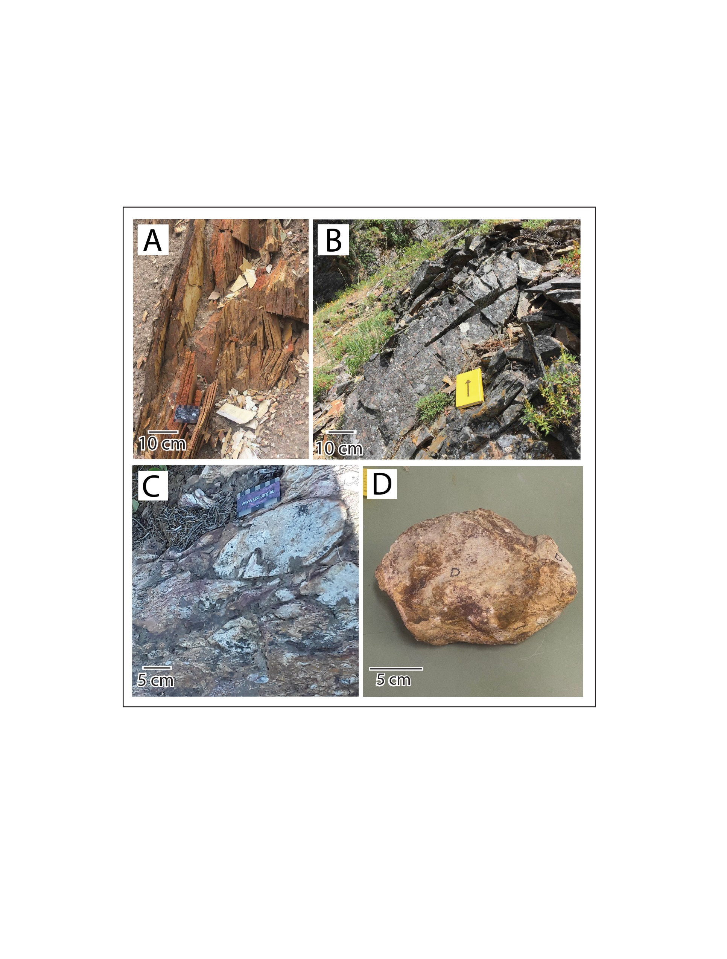

**Figure S1**: Field photos showing the lithologies that characterize the Buffalo Hump Formation within the study region. Photos include (A) Argillite interval showing pervasive cleavage, (B) Channelization within a coarser sandy interval, (C) Coarse cobble within the conglomeratic facies, and (D) Intact cobble (sample 34DTB19) collected from the conglomerate facies which was separated and analyzed.

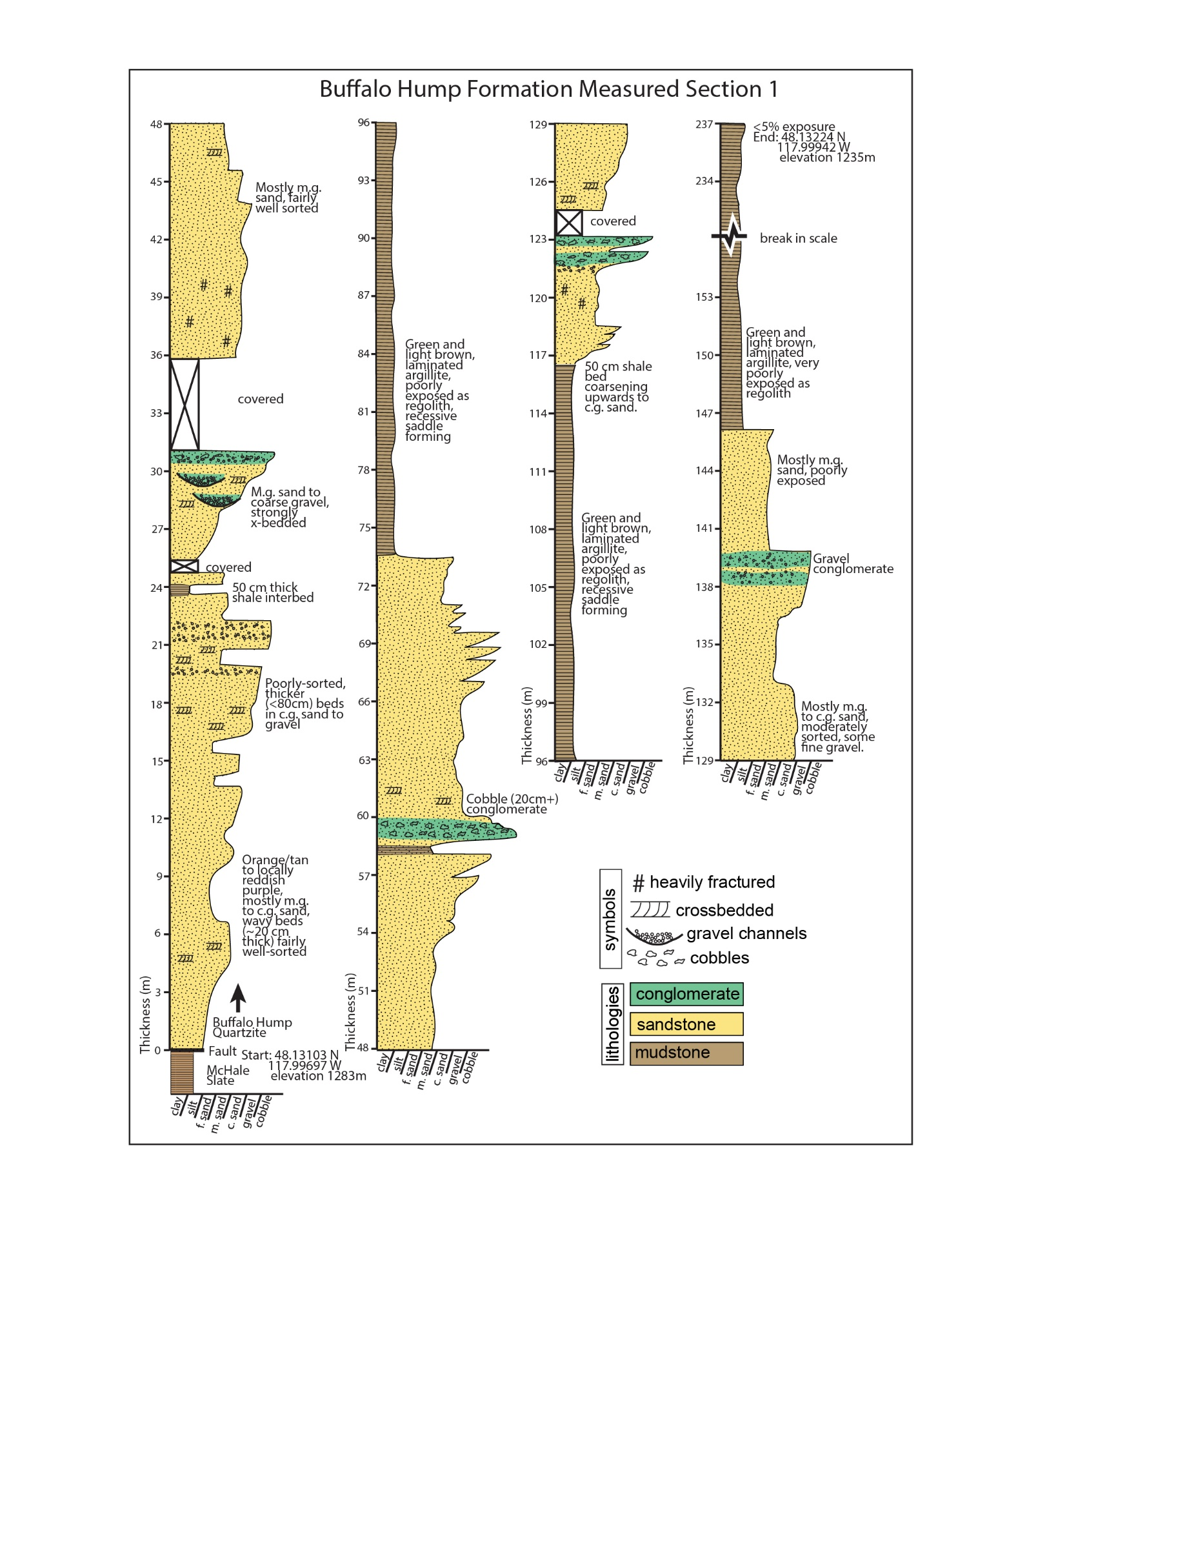

**Figure S2**: Measured stratigraphic section of ~240 m of the Buffalo Hump Formation. Overall, the section consists of coarsening upwards sandstone to conglomerate and mudstone bundles. Generally, exposure decreases up-section reflecting the increased prevalence of recessive mudstone intervals. At this location, Buffalo Hump Formation is in fault contact above upper Deer Trail Group (McHale Slate; Miller, 1996; Campbell and Loofbourow, 1964).

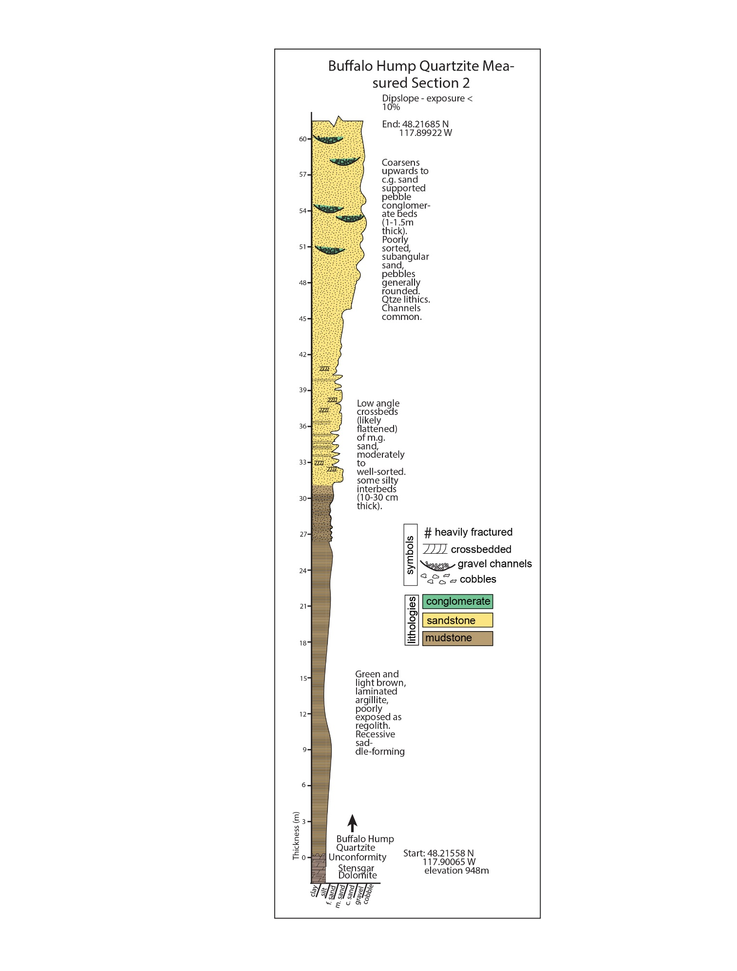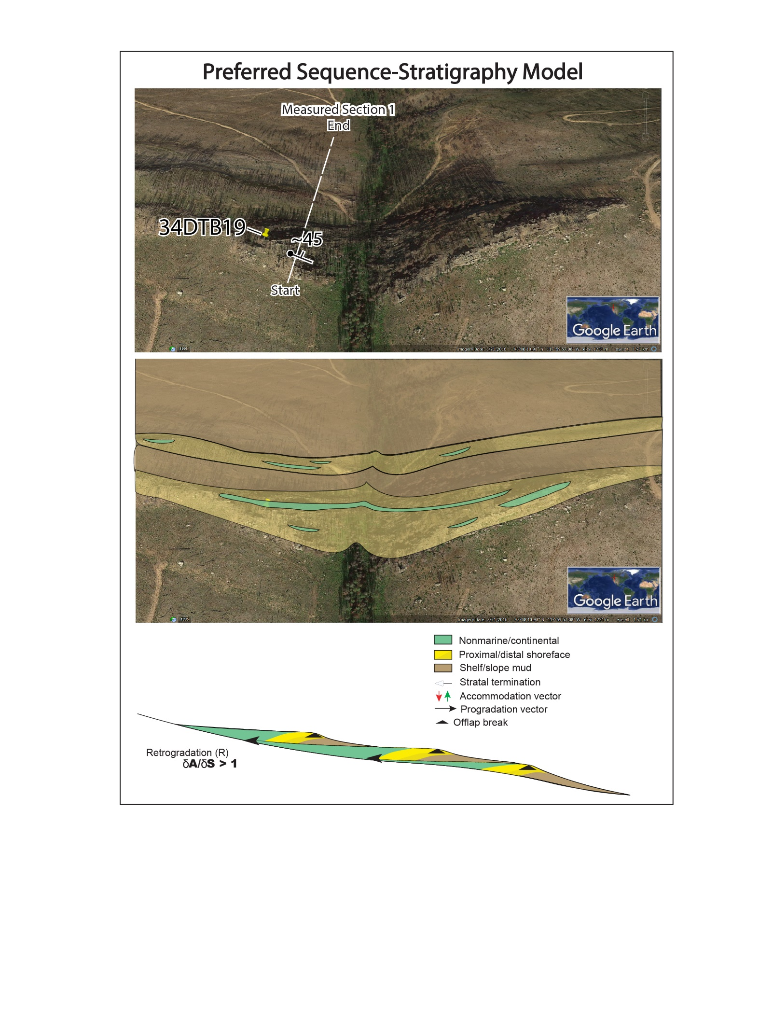

**Figure S3**: Measured stratigraphic section of ~60 m of the Buffalo Hump Formation. Overall, this section consists of a single coarsening upwards mudstone to sandstone with local gravel channel sequences. At the top of the section, a dip-slope and limited exposure precluded further stratigraphic measurements. At this location, Buffalo Hump Formation unconformably overlies uppermost Deer Trail Group rocks (Stensgar Dolomite; Miller, 1996). Miller and Whipple (1989) report localized argillaceous matrix-supported conglomerate at the base of the Buffalo Hump Formation.

**Figure S4**: Where observed, the stratigraphy of the Buffalo Hump Formation is consistent with a shallow marine through fluvial-deltaic succession in a basin that gained accommodation space faster than sediment infill, resulting in retrogradation stacking (or transgressive systems tract; after Neal and Abreu, 2009). Similar depositional sequences in the coeval Uinta Mountain Group record a long-scale retrogradational system of large-lateral extent lithofacies across a broad, low-gradient basin floor in an epicontinental sea (Kingsbury-Stewart et al., 2013).

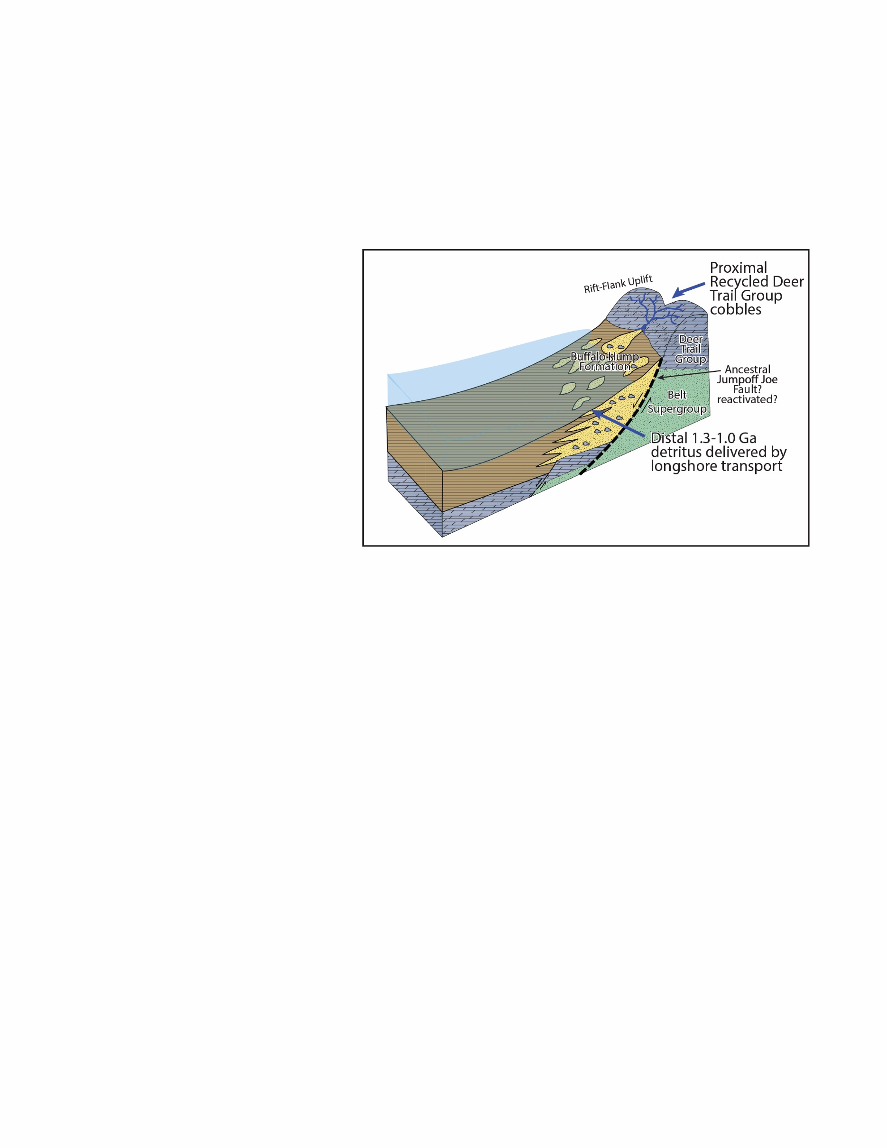  
**Figure S5**: Cartoon basin model for the Buffalo Hump Formation. Detrital zircon and stratigraphic results are consistent with deposition of the Buffalo Hump Formation in an extensional basin, possibly a half-graben resulting from a Northeast-Southwest striking (NW dipping) ancestral Jump-off Joe normal Fault. We suggest this basin exhumed Deer Trail group rocks on its footwall.

**Paleocurrent measurements methodology and results**

Ripple foresets (mostly trough crossbeds, described by Evans, 1987 as festoon) were measured from within the sandy, likely deltaic, facies of both stratigraphic sections (Figs. S2, S3) following methods similar to those described in DeCelles et al., (1983). Foreset measurements were corrected for the dip of the beds using Stereonet 11 (<http://www.geo.cornell.edu/geology/faculty/RWA/programs/stereonet.html>; Allmendinger et al., 2013; Cardozo and Allmendinger, 2013).

**Table S1:** Ripple foreset and bedding measurements from both stratigraphic sections. Note measurements are in dip-direction, and dip.

|  |  |  |  |  |  |  |  |  |
| --- | --- | --- | --- | --- | --- | --- | --- | --- |
| Section 1 Paleocurrent Measurements | | | |  | Section 2 Paleocurrent Measurements | | | |
| ripple foreset (dd) | | bedding (dd) | |  | ripple foreset (dd) | | bedding (dd) | |
| dd | dip | dd | dip |  | dd | dip | dd | dip |
| 315 | 63 | 333 | 54 |  | 315 | 50 | 324 | 46 |
| 295 | 63 | 313 | 56 |  | 339 | 66 | 324 | 46 |
| 297 | 58 | 313 | 64 |  | 342 | 45 | 308 | 43 |
| 349 | 64 | 345 | 66 |  | 310 | 47 | 317 | 42 |
| 312 | 88 | 320 | 74 |  | 322 | 35 | 300 | 48 |
| 310 | 74 | 298 | 72 |  | 331 | 41 | 316 | 45 |
| 315 | 45 | 345 | 41 |  | 311 | 46 | 309 | 37 |
| 315 | 56 | 312 | 50 |  | 292 | 61 | 330 | 43 |
| 290 | 87 | 293 | 82 |  | 319 | 53 | 282 | 50 |
| 302 | 80 | 300 | 58 |  | 278 | 30 | 294 | 46 |
| 305 | 64 | 298 | 77 |  | 305 | 41 | 276 | 45 |
| 281 | 72 | 295 | 78 |  | 308 | 39 | 304 | 34 |
| 289 | 65 | 290 | 58 |  | 292 | 40 | 297 | 37 |
| 308 | 57 | 295 | 63 |  | 321 | 35 | 308 | 42 |
| 294 | 75 | 315 | 58 |  | 298 | 51 | 270 | 52 |
| 322 | 38 | 302 | 58 |  | 330 | 44 | 302 | 36 |
| 295 | 89 | 289 | 75 |  | 286 | 30 | 313 | 22 |
| 284 | 86 | 272 | 78 |  |  |  |  |  |
| 340 | 43 | 302 | 66 |  |  |  |  |  |
| 280 | 64 | 285 | 57 |  |  |  |  |  |
| 300 | 58 | 297 | 78 |  |  |  |  |  |
| 304 | 54 | 300 | 63 |  |  |  |  |  |
| 300 | 85 | 304 | 75 |  |  |  |  |  |
| 303 | 83 | 284 | 57 |  |  |  |  |  |
| 295 | 78 | 290 | 72 |  |  |  |  |  |
| 287 | 86 | 295 | 47 |  |  |  |  |  |

**Individual sample DZ U-Pb results  
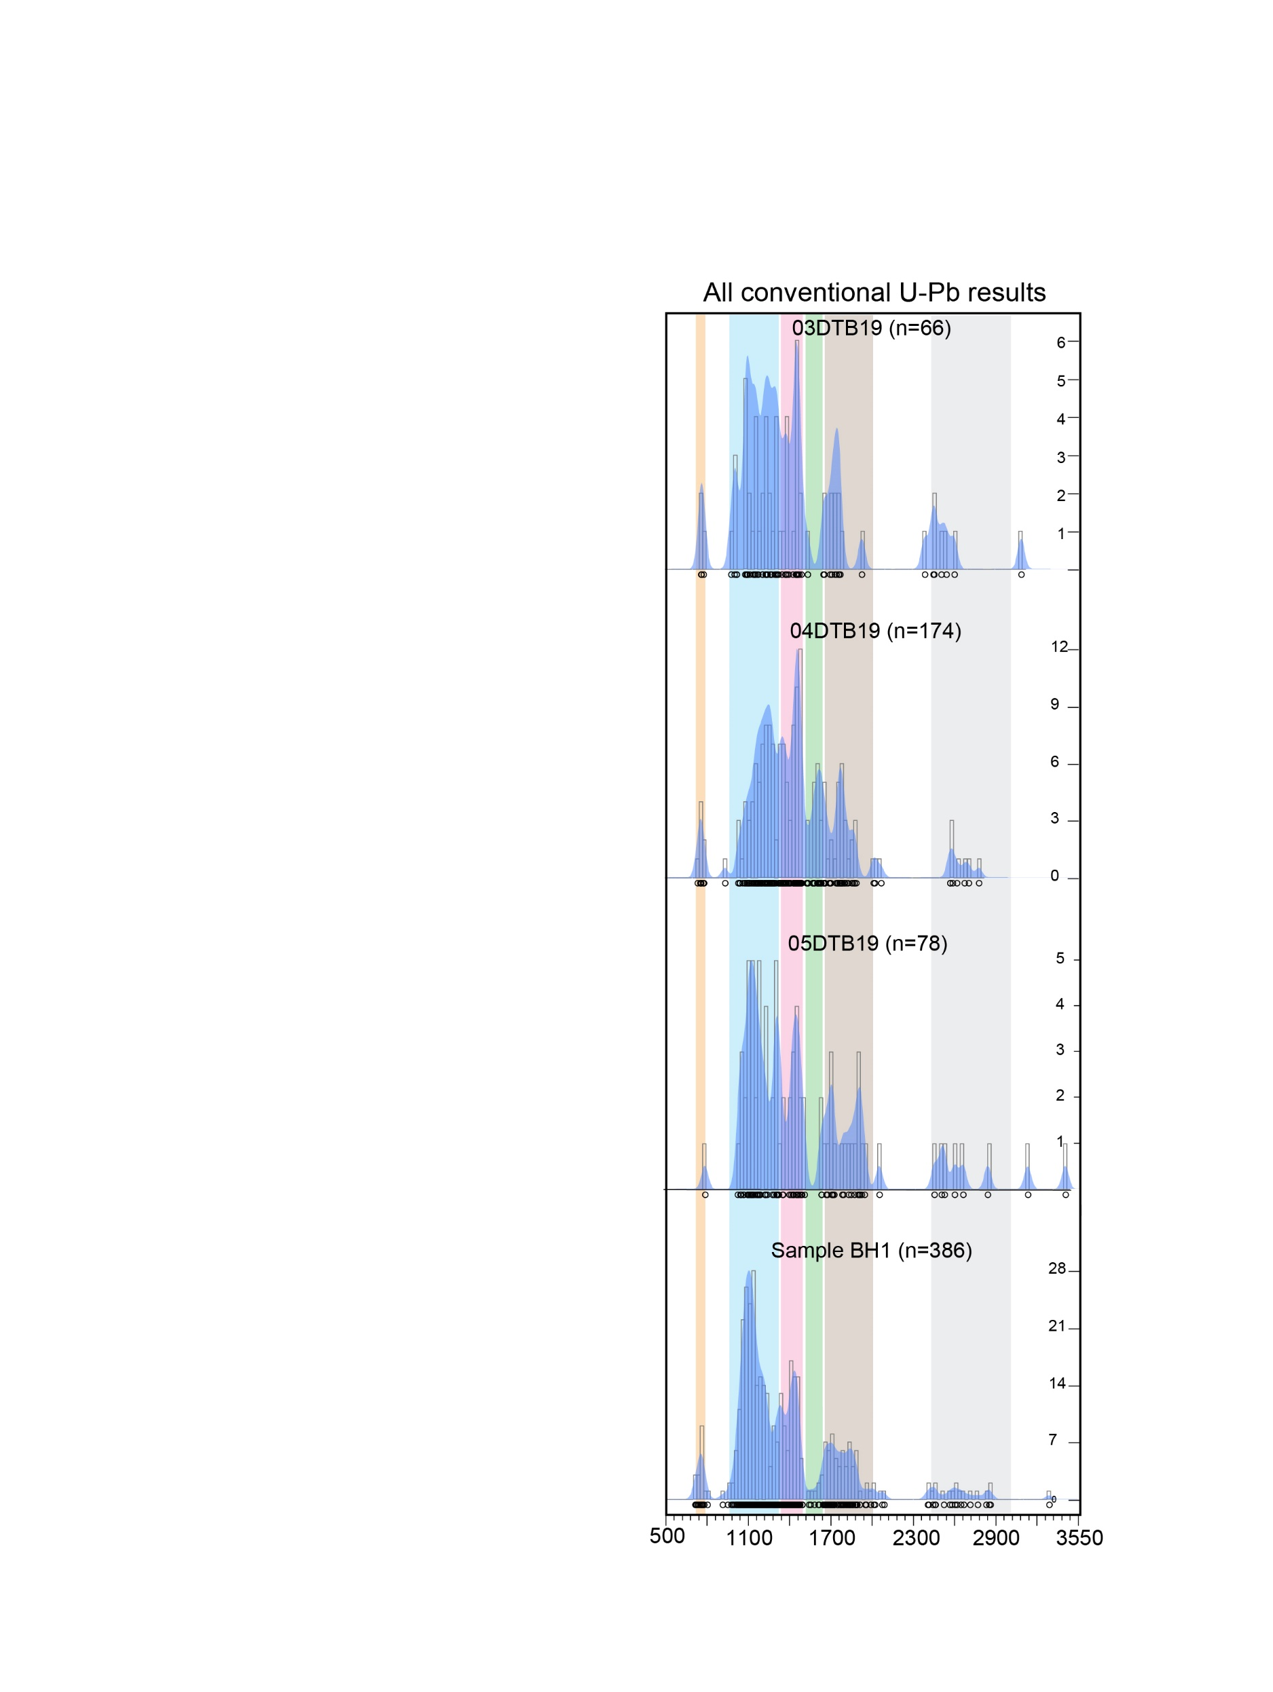**

**Figure S6**: Individual Kernel Density plots for the grouped Buffalo samples in Figures 2. Note ca. 1.3-1.0 Ga “Grenville,” ca. 1.45 midcontinent Granite-Rhyolite and ca. 1.9-1.6 age-components dominate (>80%) the population of all samples. Age-spectra are shown in kernel density estimates (KDE) with 25 myr band and binwidths (DensityPlotter8.5, Vermeesch, 2012). Ca. 760 Ma detrital zircon populations are over-represented due to our targeted sampling strategy. See Table S2 for various individual sample maximum depositional-age calculations. Colored age-fields are the same as Fig. 2.

**Alternative maximum depositional age calculations**



**Table S2**: Additional maximum depositional ages calculations for each individual Buffalo Hump sandstone sample. Our preferred maximum depositional ages is 758±7 Ma for the Buffalo Hump Formation. Green boxes are maximum depositional ages calculations that overlap (within 2σ uncertainty) with our preferred maximum depositional ages. Samples shown in blue boxes calculated maximum depositional ages that are older than our preferred age (within 2σ uncertainty). Only sample BH1 records MDA calculations that are younger than our preferred maximum depositional age (within 2σ uncertainty; yellow boxes). This may reflect the greater sample size of BH1 compared to the other samples and thus greater likelihood of sampling either A) very rare (likely <0.2%) ca. 720-740 Ma grains or B) ca. 760 Ma grains that experienced minor Pb-loss.

# Laser ablation split stream analysis (LA-SS-ICPMS) of Hf isotopes (LA-MC-ICPMS) and U-Pb ages (LA-Q-ICPMS)

Zircon was concentrated using standard crushing and heavy liquid techniques and all laser ablation work was performed on individual mineral grains, mounted and polished to approximately the grain center in 1″ epoxy rounds. Note: BH1 was separated and mounted by A.R. Nordsvan ~9 months prior to when D.T. Brennan separated the remaining samples, making contamination by the same ca. 760 ma DZ grains highly unlikely. After polishing, mounts were carbon coated and cathodoluminescence imaged with a TESCAN MIRA scanning electron microscope at the Microscopy and Microanalysis Facility in the John de Laeter Centre, for targeting of homogenous zircon zones.

Hf isotopes and U-Pb ages in zircon were simultaneously measured by laser ablation split stream at the Geohistory Facility in the John de Laeter Centre across three analytical sessions. Zircon crystals mounted in 1” epoxy rounds were ablated using a Resonetics RESOlution SE 193nm laser incorporating a dual volume S155 sample cell, coupled to a Nu Plasma II multi-collector inductively coupled plasma mass spectrometer (MC-ICPMS) for Hf isotope determination and an Agilent 7700 or Agilent 8900 quadrupole inductively coupled plasma mass spectrometer (Q-ICPMS) for age determination. Following two cleaning pulses and a 40s period of background analysis, samples were spot ablated for 35-40 s at a 7-10Hz repetition rate using a 38 or 50 μm beam and laser energy at the sample surface of 3.0 J cm-2. An additional 15s of baseline was collected after ablation. The sample cell was flushed with ultrahigh purity He (320 mL min-1) and N2 (1.2 mL min-1) and high purity Ar was employed as the plasma carrier gas, split to each mass spectrometer.

For Hf isotope analysis, all isotopes (180Hf, 179Hf, 178Hf, 177Hf, 176Hf, 175Lu, 174Hf, 173Yb, 172Yb and 171Yb) were counted on the Faraday collector array. Time resolved data was baseline subtracted and reduced using Iolite (DRS after Woodhead et al., 2004), where 176Yb and 176Lu were removed from the 176 mass signal using 176Yb/173Yb = 0.7962 (Chu et al., 2002 and 176Lu/175Lu = 0.02655 (Chu et al., 2002) with an exponential law mass bias correction assuming 172Yb/173Yb = 1.35274 (Chu et al., 2002). An effective 176Yb/173Yb correction factor was determined for each session by iteratively adjusting the 176Yb/173Yb ratio until standard corrected ratios on secondary zircon reference materials with varying Yb content yielded values within the recommended range. No correlation was apparent between the abundance of interfering isotopes (Yb or Lu) and corrected 176Hf/177Hf ratios. The interference corrected 176Hf/177Hf was normalized to 179Hf/177Hf = 0.7325 (Patchett and Tatsumoto, 1980) for mass bias correction. Zircons from the Mud Tank carbonatite locality were analysed together with the samples in each session to provide standard referenced 176Hf/177Hf ratios (Table S3, below). In all cases, Mud Tank analyses reproduced the recommended value (0.282505 ± 44; Woodhead and Hergt, 2005) within uncertainty. Data for secondary standards is also provided in Table S3. All standards reproduced accepted values within uncertainty for each session. In addition, the corrected 178Hf/177Hf ratio was calculated to monitor the accuracy of the mass bias correction and yielded an average value of 1.4671504 ± 0.0000056 (MSWD = 0.35), which is within the range of values reported by Thirlwall and Anczkiewicz (2004). Calculation of εHf values employed the decay constant of Scherer et al. (2001) and the Chondritic Uniform Reservior (CHUR) values of Bouvier et al., (2008).

**Table S3**: Recommended 176Hf/177Hf value for zircon reference materials and weighted mean standard corrected ratio obtained in each analytical session (Mud Tank primary reference material).

|  |  |  |  |  |
| --- | --- | --- | --- | --- |
| **Zircon standard** | **Recommended 176Hf/177Hf** | **Weighted mean for session 1 (3/12/2018)** | **Weighted mean for session 2 (09/05/2019)** | **Weighted mean for session 3 (17/03/2020)** |
| **Mud Tank** | 0.282505 ± 0.000044  (Woodhead and Hergt, 2005) | 0.282507 ± 0.000006  (MSWD = 0.47,  n = 17) | 0.282507 ± 0.000004 (MSWD = 0.89,  n = 20) | 0.282507 ± 0.00009  (MSWD = 0.11,  n = 20) |
| **GJ-1** | 0.282000 ± 0.00005, (Morel et al., 2008) | 0.282027 ± 0.000008 (MSWD = 0.21,  n = 16) | 0.282011 ± 0.000005 (MSWD = 1.00,  n = 19) | 0.282013 ± 0.00005  (MSWD = 0.30,  n = 19) |
| **Plešovice** | 0.282482 ± 0.000013  (Sláma et al., 2008) | 0.282485 ± 0.000009  (MSWD = 0.52,  n = 10) | 0.282473 ± 0.000006 (MSWD = 0.77,  n = 8) | 0.282477 ± 0.000006 (MSWD = 0.55,  n = 9) |
| **91500** | 0.282306 ± 0.000311  (Woodhead et al., 2004) | 0.282300 ± 0.000009  (MSWD = 0.18,  n = 15) | 0.282303 ± 0.000006 (MSWD = 1.03,  n = 18) | 0.282306 ± 0.000005 (MSWD = 0.59,  n = 19) |

Ages were simultaneously measured on the aerosol split using LA-Q-ICP-MS analysis and the following isotopes were monitored for 0.02 s each: 202Hg, 204Pb, 206Pb, 207Pb, 208Pb, 232Th, and 238U. The primary dating reference materials used in this study were 91500 (1062.4±0.4 Ma; Wiedenbeck et al., 1995) and/or OG1 (3465.4±0.6; Stern et al., 2009) with Plešovice (337.13±0.37 Ma; Sláma et al., 2008) and/or GJ-1 (608.53±0.37; Jackson et al., 2004) analysed as secondary age standards. 206Pb/238U ages and 207Pb/206Pb calculated for zircon age standards, treated as unknowns, were found to be within uncertainty of the accepted value (Table S4). The time-resolved mass spectra were reduced using the U_Pb_Geochronology4 data reduction scheme in Iolite 3.5 (Paton et al, 2011 and references therein).

**Table S4**: Recommended ages for zircon reference materials and weighted mean standard corrected ages obtained in each analytical session.

|  |  |  |  |  |
| --- | --- | --- | --- | --- |
| **Zircon standard** | **Recommended age (Ma)** | **1st session (03/12/2018)** | **2nd session (9/05/2019)** | **3rd session (7/03/2020)** |
| **GJ-1** | 608.5 ± 1.5 Ma  (Jackson et al., 2004)  601.5± 0.40 Ma  (Horstwood et al., 2016) | 603.6 ± 0.88 Ma  (MSWD = 0.83,  n = 20) | 608.3± 1.4 Ma  (MSWD = 5.0,  n = 17) | 602.2 ± 0.84 Ma  (MSWD = 1.38,  n = 19) |
| **Plešovice** | 337.13 ± 0.37 Ma  (Sláma et al., 2008) | 338.4 ± 0.7 Ma  (MSWD = 2.0,  n = 9) | - | 339.5 ± 1.79 Ma  (MSWD = 4.5,  n = 7) |
| **91500** | 1062.4 ± 0.4 Ma  (Wiedenbeck et al., 1995) | 1062.0 ± 2.6 Ma  (MSWD = 0.54,  n = 20) | 1061.4 ± 3.9 Ma  (MSWD = 0.01,  n = 20) | 1062.3 ± 1.6 Ma  (MSWD = 0.89,  n = 20) |
| **OGC** | 3467 ± 3 Ma  (Stern et al., 2009) | 3465.2 ± 2.2 Ma  (MSWD = 0.54,  n = 18) | - | 3465.1 ± 4.0 Ma  (MSWD = 1.69,  n = 14) |

**Conventional LA-Q-ICP-MS Zircon U-Pb Dating Methodology**

LA-ICP-MS data collection was performed at the GeoHistory Facility in the John de Laeter Centre, Curtin University, Perth, Australia. Individual zircon grains (mounted and polished in 1” epoxy rounds) were ablated using a Resonetics RESOlution SE 193nm laser incorporating a dual volume S155 sample cell, with isotopic intensities determined on an Agilent 8900 QQQ (single stream). After two cleaning pulses and 35s of baseline signal acquisition, zircons were ablated using a 38 µm diameter laser spot, 7 Hz laser repetition rate, and on-sample laser energy of 2.5 J cm-2. Ultrahigh purity He-N2 was used to flush the cell (He 350 mL min-1 and N2 3.8 mL min-1) and high purity Ar was utilized as the carrier gas. The following isotopes were monitored for 0.02 s each: 202Hg, 204Pb, 206Pb, 207Pb, 208Pb, 232Th, and 238U. The primary reference material used in this study was 91500 (1062.4±0.4 Ma; Wiedenbeck et al., 1995) with Plešovice (337.13±0.37 Ma; Sláma et al., 2008), GJ-1 (601.5± 0.40 Ma

(Horstwood et al., 2016) and OGC (3465.4±0.6; Stern et al., 2009) used as secondary age standards. Ages calculated for all zircon age standards, treated as unknowns, were found to be within uncertainty of the recommended value; Plešovice (340.0±0.66; MSWD=0.71; n=23 Ma) with 91500 (1062.1±2.8 Ma; MSWD=0.11; n=23;), GJ-1 (603.6±1.2; MSWD=0.51; n=23) and OGC (3464.7±2.8 Ma; MSWD=0.49; n=23). The time-resolved mass spectra were reduced using the U_Pb_Geochronology3 data reduction scheme in Iolite (Paton et al, 2011 and references therein).

**Rapid LA-Q-ICP-MS Zircon U-Pb Dating Methodology**

Fast laser ablation inductively coupled plasma mass spectrometry (LA-ICP-MS) was performed at the GeoHistory Facility in the John de Laeter Centre, Curtin University, Perth, Australia. Ablations utilized an ASI RESOlution-SE 193 nm excimer laser controlled by GeoStar μGIS™ software. Laser fluence was calibrated above the sample cell using a hand held energy meter, and subsequent analyses were performed in constant energy mode. The Laurin Technic S155 sample cell was flushed by ultrahigh purity He (320 mL min-1) and N2 (1.2 mL min-1), both of which were passed through inline gold sand Hg traps. High purity Ar was used as the ICP-MS carrier gas (flow rate ~1 L/min). All measurements were performed using an Agilent 8900 QQQ quadrupole ICP-MS operated in single quad mode. Each analytical session consisted of initial gas flow and ICP-MS ion lens tuning for sensitivity with the signal smoothing device (‘squid’) connected. Additional tuning adjusted flow parameters for robust plasma conditions (238U/232Th ~1; 206Pb/238U ~ 0.2; and 238UO/238U <0.004). Finally, pulse-analog (P/A) conversion factors were determined on the NIST 610 reference glass by varying laser spot sizes and/or laser repetition rate to yield 1-2 Mcps per element. After tuning, the signal smoothing device was removed and the laser was connected to the mass spectrometer via a shorter (~60 cm) length of Teflon tubing. Using this setup, signal wash-in and wash-out times were typically around 200 and 600 ms, respectively. Following Chew et al. (2019), laser parameters were chosen as 20 µm spot diameter, 50 Hz repetition rate, and on-sample laser energy of 2 Jcm-2. The Geostar software sequence for fast ablations consisted of a 3 s delay after the TTL pulse for baseline acquisition, 4 s ablation, and 7 s delay for the 8900 to complete data handling and return to a ‘wait for trigger’ state. 91Zr, 206Pb, 207Pb, 208Pb, 232Th, and 238U were collected with dwell times of 3, 15, 20, 6, 6, and 9 ms, respectively, for a total acquisition time of 10s, and a duty cycle (data aqusition time/total time) of about 66%. The time-resolved mass spectra were reduced using the ‘U-Pb Geochronology’ data reduction scheme in Iolite 4.3.5.3 (Paton et al., 2011 and references therein). The primary dating reference materials used in this study were 91500 (1062.4±0.4 Ma; Wiedenbeck et al., 1995) and/or OG1 (3465.4±0.6; Stern et al., 2009) with Plešovice (337.13±0.37 Ma; Sláma et al., 2008) and GJ-1 (608.53±0.37; Jackson et al., 2004) analysed as secondary age standards. Concordia ages calculated using IsoplotR (Vermeesch P., 2018, Geoscience Frontiers, 9, 1479-1493) for zircon reference materials Plešovice and GJ1, treated as unknowns against primary reference material 91500, were 342 ± 2 Ma and 608 ± 2 Ma (n=32; errors are 95% conf. including internal and external sources of error), respectively, and are within uncertainty of their accepted ages.

Because the fast ablation protocol outlined here does not include pre-ablation cleaning pulses to remove surface contamination, we assessed accuracy of Pb isotope data by comparing the results from fast ablation analyses to a corresponding data set collected using the same grains and standard materials, but using a conventional LA-ICP-MS geochronology method. Inspection of all zircon reference data in inverse Concordia space does not reveal any discernible trends to indicate surface derived common lead contamination. Sample data is generally more scattered in nature, but a comparison of discordance (expressed as (7/6-6/8)/(7/6)*100) for both data sets does not reveal a statistically significant difference (fig. S7 below). We conclude that the lack of cleaning pulses during the fast ablation protocol does not introduce significant additional non-radiogenic Pb, and that the method is well suited to characterize a large sample pool for the purpose of identifying specific grain populations which can then be subjected to a subsequent conventional, more precise analysis

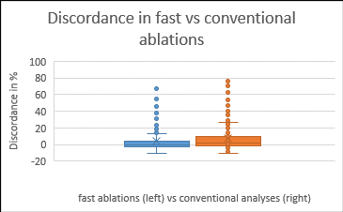

Figure S7: Box and whisker plot of discordance in 150 of the same grains in the rapid (left) vs. follow up conventional analysis sessions (orange).

**Acknowledgements:**

The GeoHistory Facility, JdLC, Curtin University is partially supported by AuScope (auscope.org.au) and the Australian Government via the National Collaborative Research Infrastructure Strategy (NCRIS). The NPII multi-collector was purchased through ARC LIEF LE150100013.

**References:**

Aleinikoff, J.N., Wintsch, R., Tollo, R.P., Unruh, D.M, Fanning, C.M. Schmitz M.D, 2007, Ages and origins of rocks of the Killingworth dome, south-central Connecticut: implications for the tectonic evolution of southern New England. Am. J. Sci., v. 307, no. 1, p. 63-118.

Allmendinger, R. W., Cardozo, N. C., and Fisher, D., 2013, Structural Geology Algorithms: Vectors & Tensors: Cambridge, England, Cambridge University Press, 289 pp.

Bouvier, A., Vervoort, J.D., and Patchett, P.J., 2008, The Lu-Hf and Sm-Nd isotopic composition of CHUR: Constraints from unequilibrated chondrites and implications for the bulk composition of terrestrial planets: Earth and Planetary Science Letters, v. 273, no. 1-2

Box, S.E., Pritchard, C., Stephens, T.S., and O’Sullivan, P.B., 2020, Between the supercontinents - Mesoproterozoic Deer Trail Group, an intermediate age unit between the Mesoproterozoic Belt-Purcell Supergroup and the Neoproterozoic Windermere Supergroup in northeastern Washington, U.S.A.: Canadian Journal of Earth Sciences, v. 17, p. 1–17, doi:10.1139/cjes-2019-0188.

Blichert-Toft, J., and Albarède, F., 1997, The Lu-Hf isotope geochemistry of chondrites and the evolution of the mantle-crust system: Earth and Planetary Science Letters, v. 148, no. 1, p. 243-258.

Campbell, I. & Loofbourow J.S., 1962, Geology of the Magnesite Belt of Stevens County, Washington. U.S. Geological Survey, Bulletin 1142-F, 53p.

Cardozo, N., and Allmendinger, R. W., 2013, Spherical projections with OSXStereonet: Computers & Geosciences, v. 51, no. 0, p. 193 - 205, doi: 10.1016/j.cageo.2012.07.021

Copeland, P., 2020, On the use of geochronology of detrital grains in determining the time of deposition of clastic sedimentary strata: Basin Research, p. 1–15, doi:10.1111/bre.12441.

Coutts, D.S., Matthews, W.A., and Hubbard, S.M., 2019, Assessment of widely used methods to derive depositional ages from detrital zircon populations: Geoscience Frontiers, v. 10, p. 1421–1435, doi:10.1016/j.gsf.2018.11.002.

Chu, N.-C., Taylor, R. N., Chavagnac, V., Nesbitt, R. W., Boella, R. M., Milton, J. A., German, C. R., Bayon, G., and Burton, K., 2002, Hf isotope ratio analysis using multi-collector inductively coupled plasma mass spectrometry: an evaluation of isobaric interference corrections: Journal of Analytical Atomic Spectrometry, v. 17, no. 12, p. 1567-1574.

Decelles, P.G., Langford, R.P., and Schwartz, R.K., 1983, Two new methods of paleocurrent determination from trough cross- stratification.: Journal of Sedimentary Petrology, v. 53, p. 629–642, doi:10.1306/212F824C-2B24-11D7-8648000102C1865D.

Dehler, C.M., Fanning, C.M., Link, P.K., Kingsbury, E.M., and Rybczynski, D., 2010, Maximum depositional age and provenance of the Uinta Mountain group and big cottonwood formation, northern Utah: Paleogeography of rifting western Laurentia: Geological Society of America Bulletin, v. 122, p. 1686–1699, doi:10.1130/B30094.1.

Dehler, C., Gehrels, G., Porter, S., Heizler, M., Karlstrom, K., Cox, G., Crossey, L., and Timmons, M., 2017, Synthesis of the 780-740 ma chuar, Uinta Mountain, and Pahrump (ChUMP) groups, western USA: Implications for laurentia-wide cratonic marine basins: Geological Society of America Bulletin, v. 129, p. 607–624, doi:10.1130/B31532.1.

Dickinson, W.R., and Gehrels, G.E., 2009, Use of U-Pb ages of detrital zircons to infer maximum depositional ages of strata: A test against a Colorado Plateau Mesozoic database: Earth and Planetary Science Letters, v. 288, p. 115–125, doi:10.1016/j.epsl.2009.09.013.

Evans, J.G., 1987, Geology of the Stensgar Mountain Quadrangle, Stevens County, Washington: U.S. Geological Survey Bulletin 1679, 30 p.

Harlan, S.S., Heaman, L., LeCheminant, A.N., and Premo, W.R., 2003, Gunbarrel mafic magmatic event: A key 780 Ma time marker for Rodinia plate reconstructions: Geology, v. 31, p. 1053–1056, doi:10.1130/G19944.1.

Heaman L.M., 2009, The application of U-Pb geochronology to mafic, ultramaficand alkaline rocks: An evaluation of three mineral standards: Chemical Geology, no. 261, p. 43–52.

Jackson, S.E., Pearson, N.J., Griffin, W.L. and Belousova, E.A., 2004. The application of laser ablation-inductively coupled-mass spectrometry to in situ U-Pb zircon geochronology. Chemical Geology, no. 211, p. 47-69.

Kemp, A.I.S., Vervoort, J.D., Bjorkman, K. and Iaccheri, L.M., 2017. Hafnium isotope characteristics of Palaeoarchaean zircon OG1/PGC from the Owens Gully Diorite, Pilbara Craton, Western Australia. Geostandards and Geoanalytical researach. doi: 10.1111/ggr.12182

Kingsbury-Stewart, E.M., Osterhout, S.L., Link, P.K., and Dehler, C.M., 2013, Sequence stratigraphy and formalization of the Middle Uinta Mountain Group (Neoproterozoic), central Uinta Mountains, Utah: A closer look at the western Laurentian Seaway at ca. 750Ma: Precambrian Research, v. 236, p. 65–84, doi:10.1016/j.precamres.2013.06.015.

Klaus Peter Jochum, Uwe Nohl, Kirstin Herwig, Esin Lammel, Brigitte Stoll, and Albrecht W. Hofmann, 2005, GeoReM: A New Geochemical Database for Reference Materials and Isotopic Standards. Geostandards and Geoanalytical Research. v. 29, no. 3, p. 333-338.

Liu et al., 2010, Reappraisement and refinement of zircon U-Pb isotope and trace element analyses by LA-ICP-MS: Chinese Science Bulletin, v. 55, no. 15, p. 1535-1546.

Ludwig, K.R., 1998, On the treatment of concordant uranium-lead ages. Geochim. Cosmochim. Acta v. 62, no. 4, p. 665-676

Luvizotto, G. and Zack, T., 2009, Nb and Zr behavior in rutile during high-grade metamorphism and retrogression: An example from the Ivrea-Verbano Zone: Chemical Geology, v. 261, no. 3-4, p. 303-317

Macdonald, F.A., Schmitz, M.D., Crowley, J.L., Roots, C.F., Jones, D.S., Maloof, A.C., Strauss, J. V, Cohen, P.A., Johnston, D.T., and Schrag, D.P., 2010, Calibrating the Cryogenian: Science, v. 327, p. 1241–1244, doi:10.1126/science.1183325.

Mahon, R.C., Dehler, C.M., Link, P.K., Karlstrom, K.E., and Gehrels, G.E., 2014, Detrital zircon provenance and paleogeography of the Pahrump Group and overlying strata, Death Valley, California: Precambrian Research, v. 251, p. 102–117, doi:10.1016/j.precamres.2014.06.005

Miller, F.K., 1996, Geologic map of the Empey Mountain area, Stevens County, Washington: U.S. Geological Survey Miscellaneous Investigation Series I-2492, scale 1:48,000.

Miller, F. K., & Whipple, J. W., 1989, The Deer Trail Group: Is it part of the Belt Supergroup? In Joseph, N.L. et al., (Eds), Geologic Guidebook for Washington and adjacent areas: Washington Division of Geology and Earth Resources Information Circular no. 86.

Morel, M.L.A., Nebel, O., Nebel-Jacobsen, Y.J., Miller, J.S. and Vroon, P.Z. 2008. Hafnium isotope characterisation of the GJ-1 zircon reference material by solution and laser-ablation MC-ICPMS. Chemical Geology, no. 255, p. 231-235.

Neal, J., and Abreu, V., 2009, Sequence stratigraphy hierarchy and the accommodation succession method: Geology, v. 37, p. 779–782, doi:10.1130/G25722A.1.

Patchett, P. J., and Tatsumoto, M., 1980, Hafnium isotope variations in oceanic basalts: Geophysical Research Letters, v. 7, no. 12, p. 1077-1080.

Paton, C., Hellstrom, J., Paul, B., Woodhead, J. and Hergt, J. 2011. Iolite: freeware for the visualization and processing of mass spectrometer data. Journal of Analytical Atomic Spectrometry, no. 26, p. 2508-2518.

Scherer, E., Munker, C., Mezger, K., 2001, Calibration of the Lutetium-Hafnium clock. Science, no. 293, p. 683-687.

Schmitz, M., Bowring, S. A., and Ireland, T. R., 2003, Evaluation of Duluth Complex anorthositic series (AS3) zircon as a U–Pb geochronological standard: New high‐precision isotope dilution thermal ionization mass spectrometry results: Geochimica et Cosmochimica Acta, v. 67, p. 3665–3672.

Schoene, B., Bowring, S.A. 2006, U–Pb systematics of the McClure Mountain syenite: thermochronological constraints on the age of the 40Ar/39Ar standard MMhb: Contrib. Mineral. Petrol., v. 151, no. 5, p. 615-630.

Sláma, J., Košler, J., Condon, D.J., Crowley, J.L., Gerdes, A., Hanchar, J.M., Horstwood, M.S.A., Morris, G.A., Nasdala, L., Norberg, N., Schaltegger, U., Schoene, B., Tubrett, M.N. and Whitehouse, M.J. 2008. Plesovice zircon – A new natural reference material for U-Pb and Hf isotopic microanalysis. Chemical Geology v. 249, p. 1-35.

Spandler et al., 2016, MKED1: A new titanite standard for in situ analysis of Sm–Nd isotopes and U–Pb geochronology. Chemical Geology no. 425, p. 110-126.

Spencer, C.J., Hoiland, C.W., Harris, R.A., Link, P.K., and Balgord, E.A., 2012, Constraining the timing and provenance of the Neoproterozoic Little Willow and Big Cottonwood Formations, Utah: Expanding the sedimentary record for early rifting of Rodinia: Precambrian Research, v. 204–205, p. 57–65, doi:10.1016/j.precamres.2012.02.009.

Stacey, J.S. and Kramers, J.D., 1975, Approximation of terrestrial lead isotope evolution by a two-stage model: Earth and Planetary Science Letters, v. 26, no. 2, p. 207-221.

Stern, R.A., Bodorkos, S., Kamo, S.L., Hickman, A.H. and Corfu, F. 2009. Measurement of SIMS instrumental mass fractionation of Pb isotopes during zircon dating. Geostandards and Geoanalytical Research, v. 33, p. 145-168.

Thomas, W.A., Gehrels, G.E., Greb, S.F., Nadon, G.C., Satkoski, A.M., and Romero, M.C., 2017, Detrital zircons and sediment dispersal in the Appalachian foreland: Geosphere, v. 13, no. 6, p. 2206–2230, https://doi.org/ 10.1130/GES01525.1.

Thomson S.N., Gehrels G.E., Ruiz J., Buchwaldt R., 2012, Routine low-damage apatite U–Pb dating using laser ablation-multicollector-ICPMS. Geochem. Geophys. Geosyst., v. 13

Thirlwall, M., and Anczkiewicz, R., 2004, Multidynamic isotope ratio analysis using MC–ICP–MS and the causes of secular drift in Hf, Nd and Pb isotope ratios: International Journal of Mass Spectrometry, v. 235, no. 1, p. 59-81.

Vermeesch, P., 2012, On the visualisation of detrital age distributions: Chemical Geology, v. 312–313, p. 190–194, doi:10.1016/j.chemgeo.2012.04.021.

Vermeesch P., 2018, IsoplotR: a free and open toolbox for geochronology: Geoscience Frontiers, no. 9, p. 1479-1493.

Vermeesch, P., 2020, Maximum depositional age estimation revisited: Geoscience Frontiers, doi:10.1016/j.gsf.2020.08.008.

Wiedenbeck, M., Alle, P., Corfu, F., Meier, M., Overli, F, Vod Quadt, A., Roddick, J.C. and Spiegel, W. 1995. Three natural zircon standards for U-Th-Pb, Lu-Hf, trace element and REE analysis. Geostandards Newsletter, p. 1-23.

Woodhead, J., Hergt, J., Shelley, M., Eggins, S., and Kemp, R., 2004, Zircon Hf-isotope analysis analysis with an excimer laser, depth profiling, ablation of complex geometries and comcomitant age estimation. Chemical Geology, v. 209, p. 121-135.

Woodhead and Hergt, (2005) A preliminary appraisal of seven natural zircon reference materials for in situ Hf isotope determination. Geostandards and Geoanalytical Research, v. 29, p. 183-195.

Yonkee, W.A., Dehler, C.D., Link, P.K., Balgord, E.A., Keeley, J.A., Hayes, D.S., Wells, M.L., Fanning, C.M., and Johnston, S.M., 2014, Tectono-stratigraphic framework of Neoproterozoic to Cambrian strata, west-central U.S.: Protracted rifting, glaciation, and evolution of the North American Cordilleran margin: Earth-Science Reviews, v. 136, p. 59–95, doi:10.1016/j.earscirev.2014.05.004.

Zack et al., 2011, In situ U–Pb rutile dating by LA-ICP-MS: 208Pb correction and prospects for geological applications. Contributions to Mineralogy and Petrology: v. 162, no. 3, p. 515-530.

Zhang, X., Pease, V., Skogseid, J., and Wohlgemuth-Ueberwasser, C., 2016, Reconstruction of tectonic events on the northern Eurasia margin of the Arctic, from U-Pb detrital zircon provenance investigations of late Paleozoic to Mesozoic sandstones in southern Taimyr Peninsula: Geological Society of America Bulletin, v. 128, p. 29–46, doi:10.1130/B31241.1.