Supplementary Information
Modeled raypaths and comparisons to picked arrivals are shown here for the refractions in sediment layers 1 (Fig. S1) and 2 (Fig. S2), the reflections from the bottoms of sediment layers 1 (Fig. S3) and 2 (Fig. S4), the refraction from the bottom of the crustal velocity layer (Fig. S5), and the head-wave from the bottom of the crustal-velocity layer (Fig. S6).

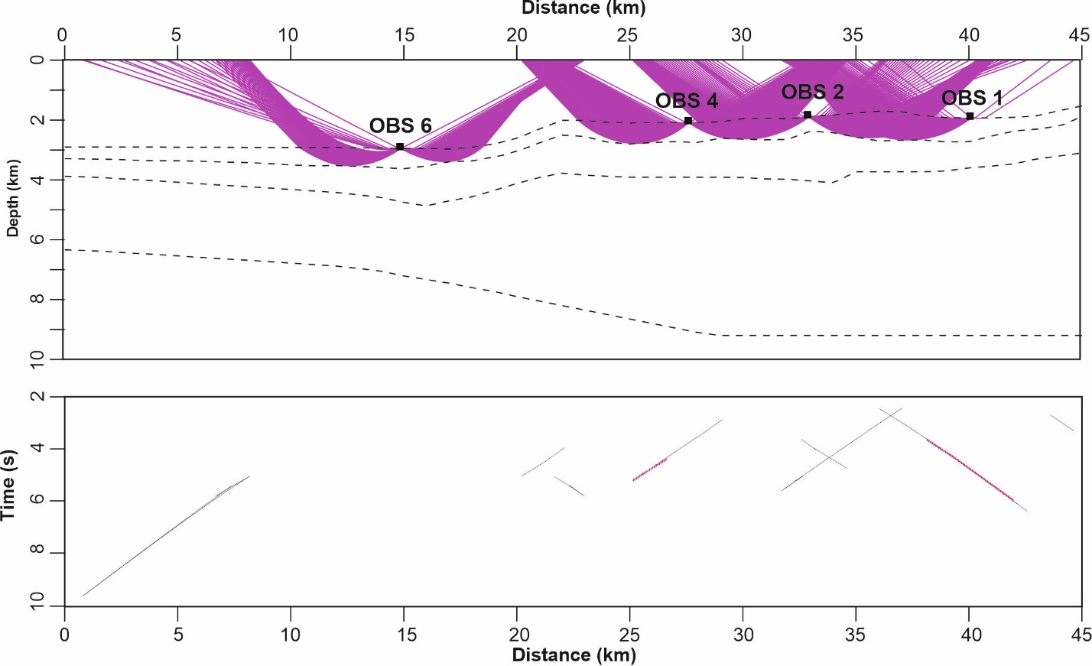
Figure S1. Modeled raypaths (upper panel) and comparison to picked arrivals (lower panel) for the refraction in sediment layer 1.

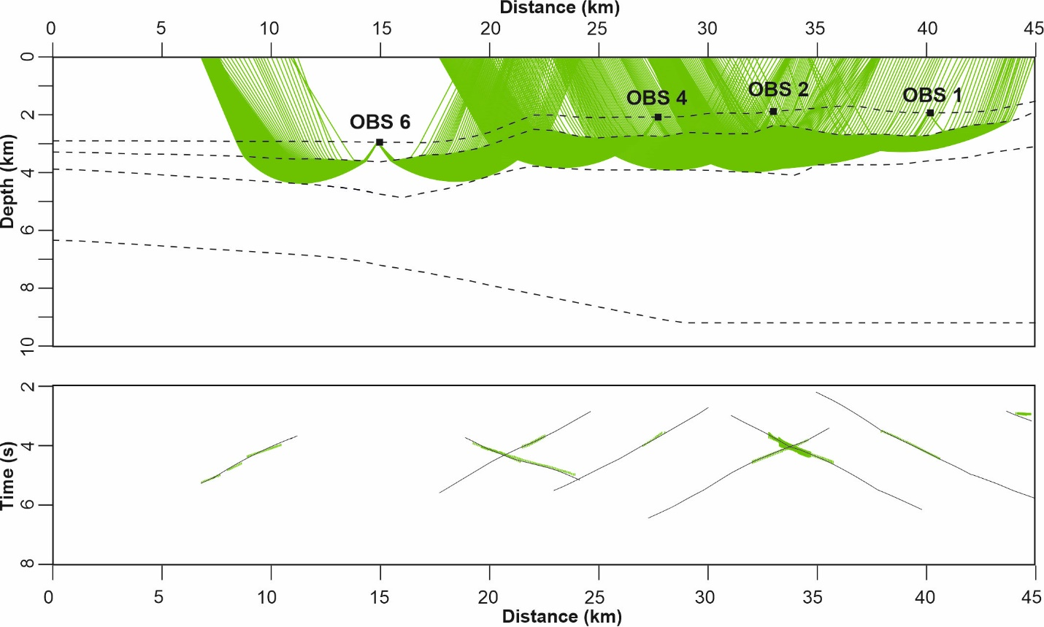
Figure S2. Modeled raypaths (upper panel) and comparison to picked arrivals (lower panel) for the refraction in sediment layer 2.

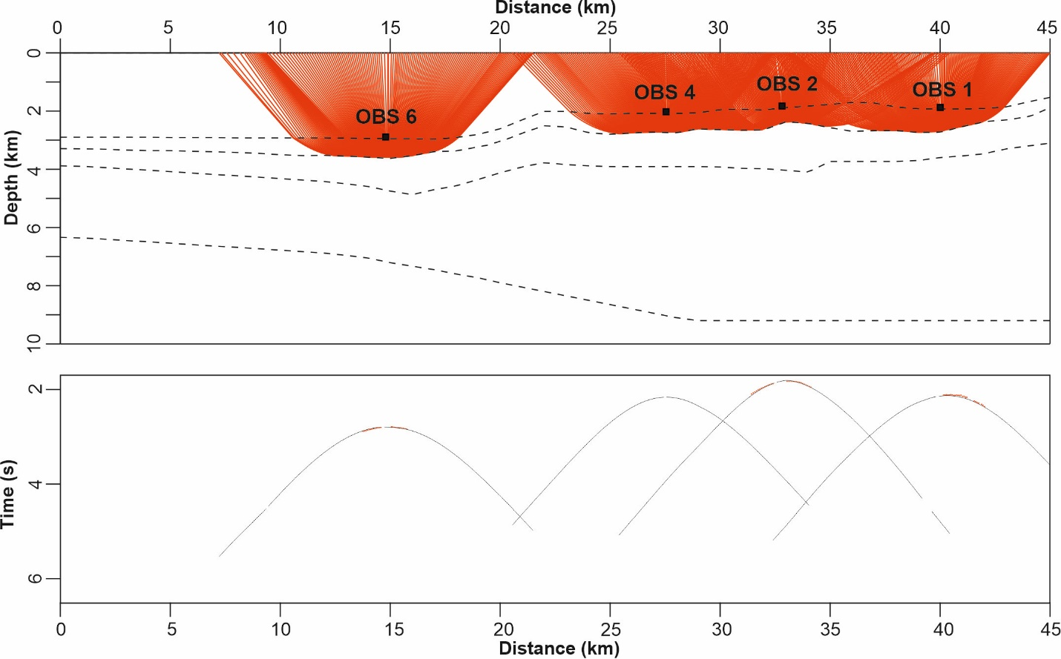
Figure S3. Modeled raypaths (upper panel) and comparison to picked arrivals (lower panel) for the reflection from bottom of sediment layer 1.

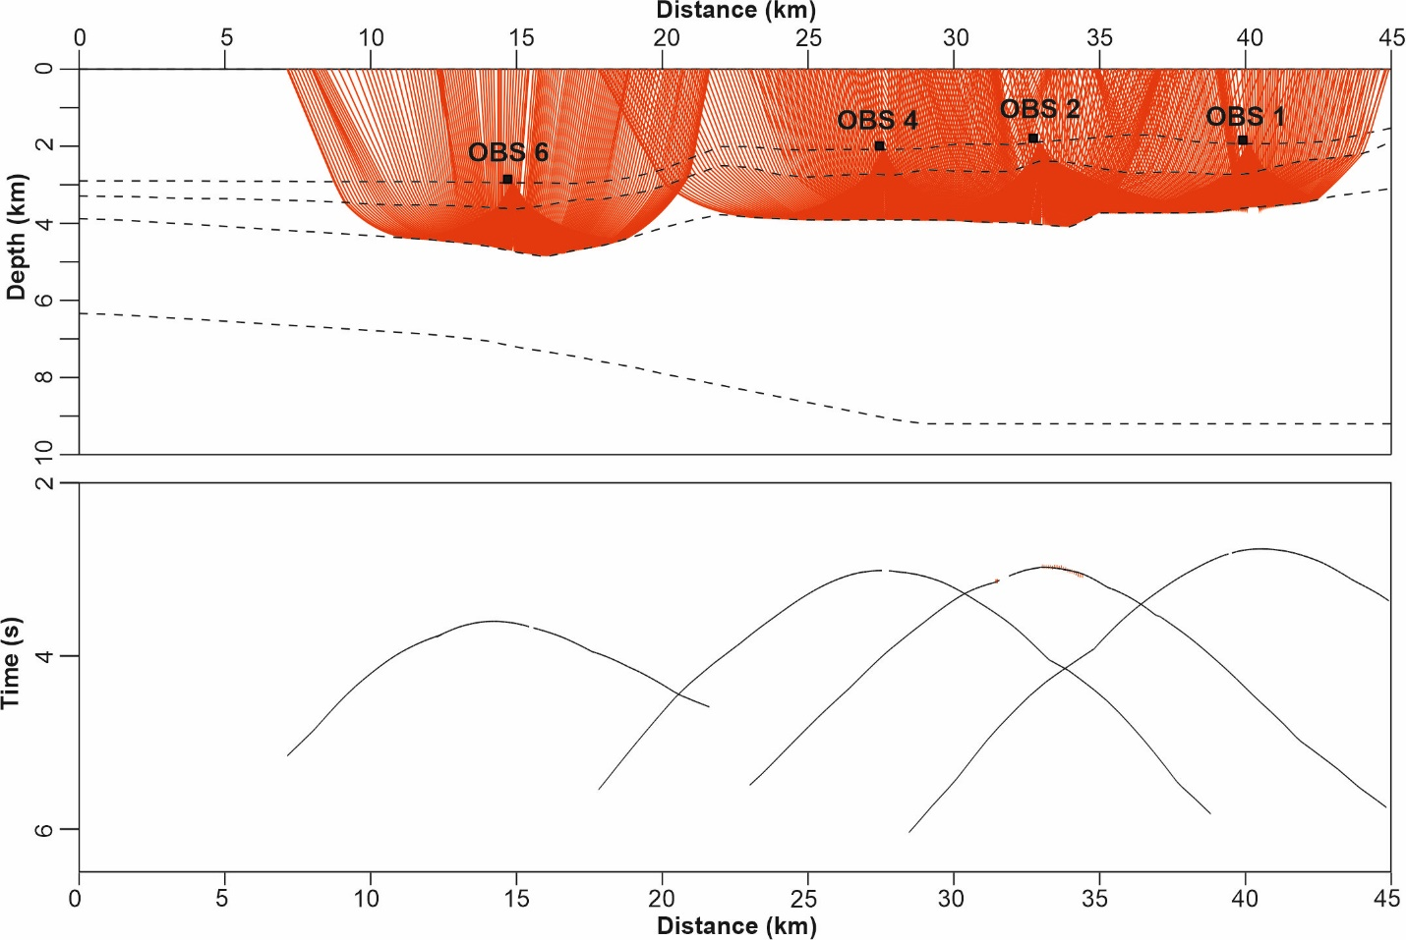
Figure S4. Modeled raypaths (upper panel) and comparison to picked arrivals (lower panel) for the reflection from the bottom of sediment layer 2.

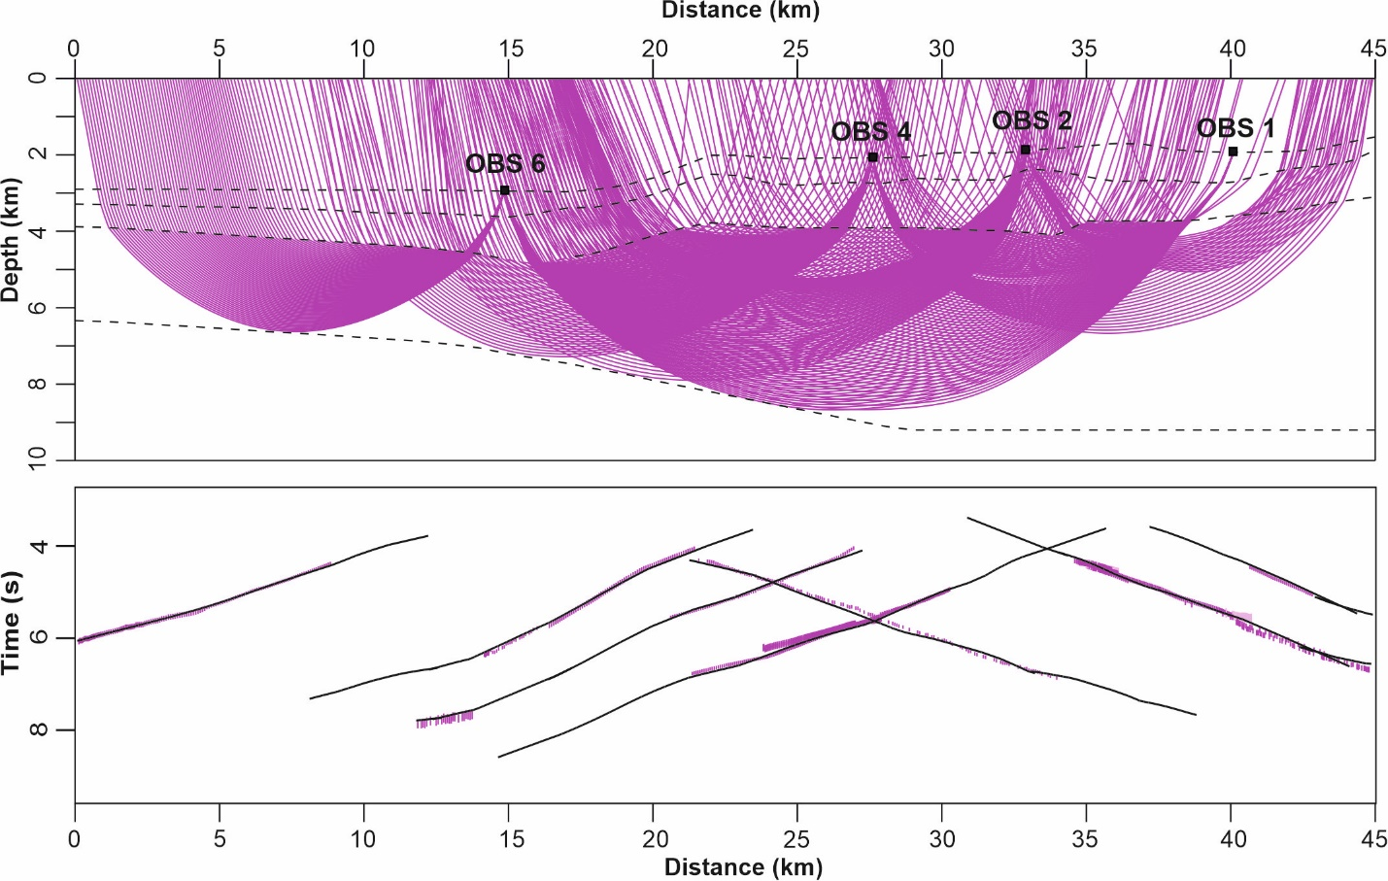
Figure S5. Modeled raypaths (upper panel) and comparison to picked arrivals (lower panel) for the refraction in crustal-velocity layer.

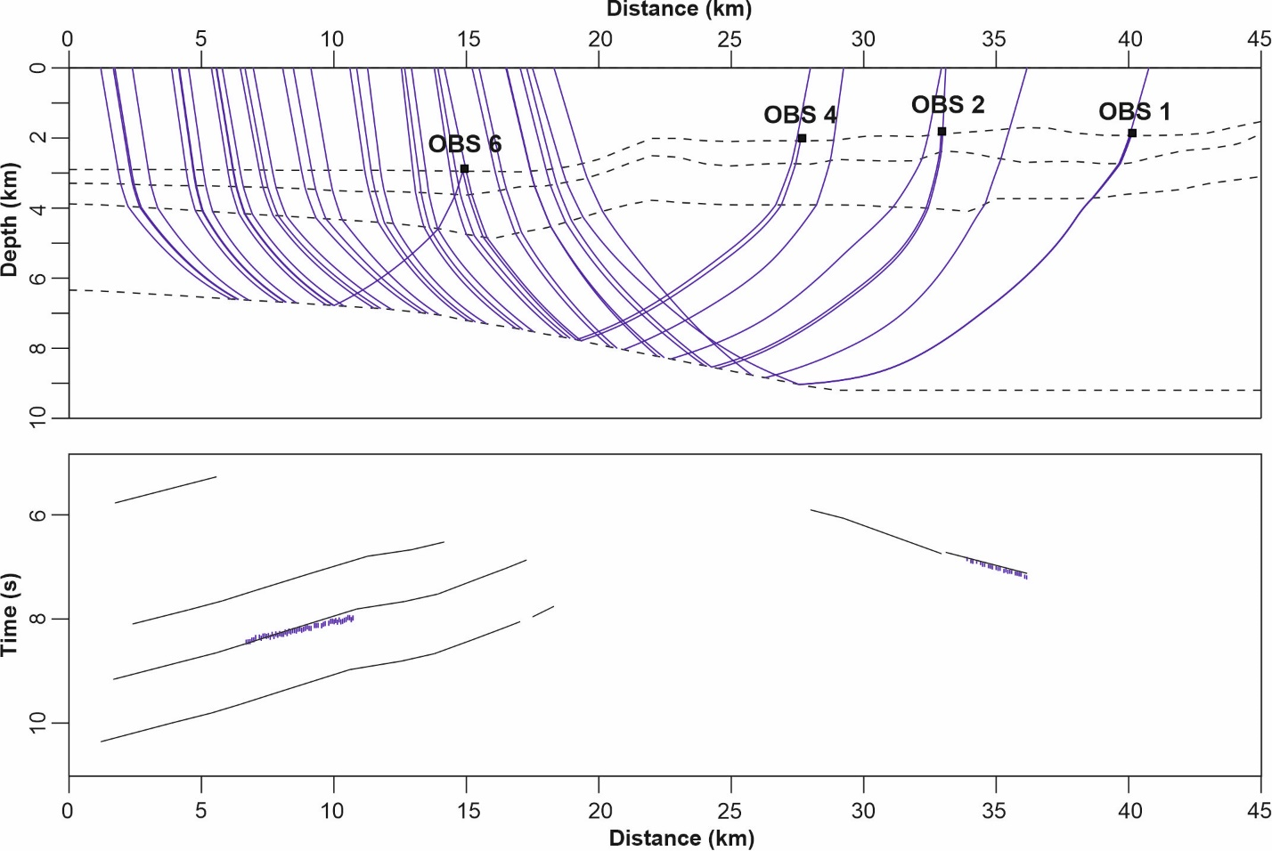
Figure S6. Modeled raypaths (upper panel) and comparison to picked arrivals (lower panel) for the head-wave from the bottom of the crustal-velocity layer.

