Wan, B., et al., 2021, Long-lived seamount subduction in ancient orogens: Evidence from the Paleozoic South Tianshan: Geology, v. 49, https://doi.org/10.1130/G48547.1

Supplementary figures:
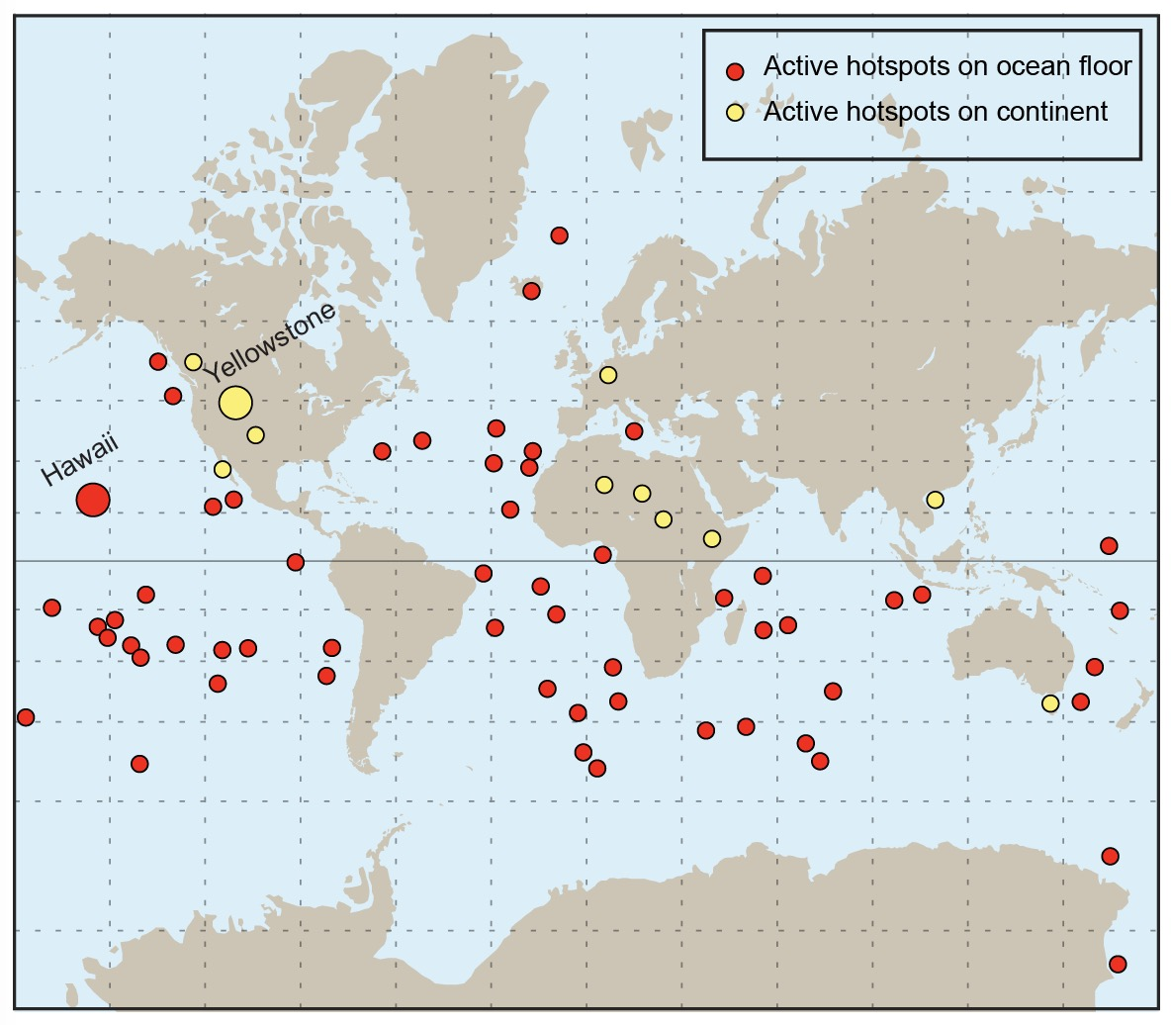
Fig. S1 Active mantle plume related hotspots in continent and ocean floor. Data was in Table. S1

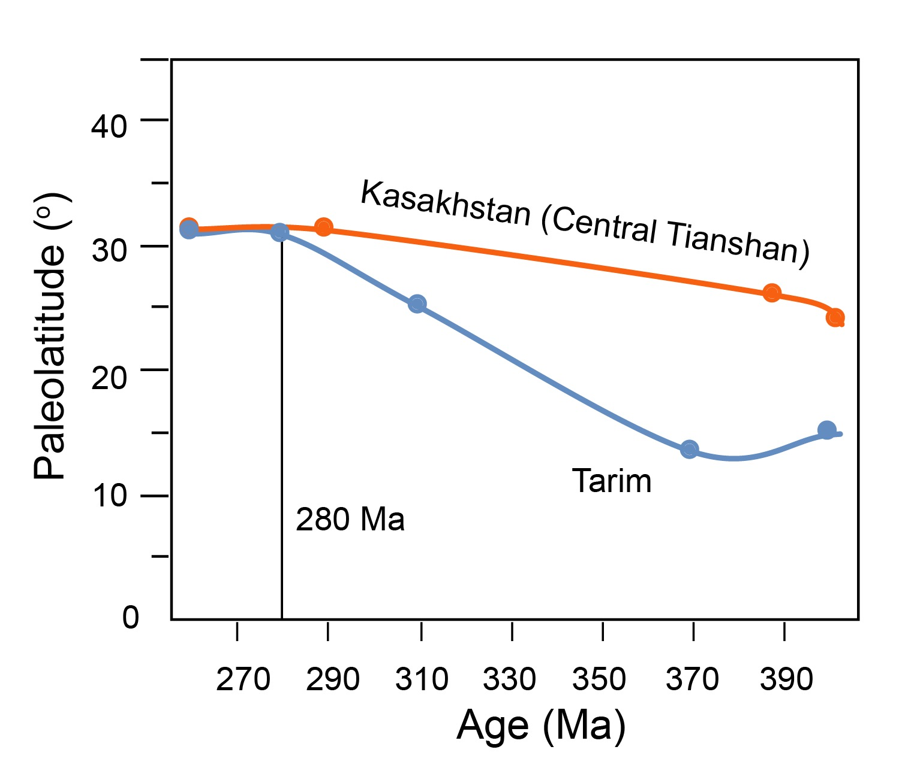
Fig. S2 Relative paleolatitude variation of the Tarim-Kashakhstan block from 410 Ma to 250 Ma. Data were calibrated by the paleomagnetic data on the reference point of 40°N,79°E. The data was in Table. S3 in the GSA Data Repository). The two blocks have similar path since 280 Ma, indicative of assembly together. The Tarim craton and Yili-CTB converged by ~1,000 km in paleolatitude between ~400-280 Ma, which is a minimum estimate not considering longitude. Such a difference in paleolatitudes indicates that there was enough space on the South Tianshan seafloor to host multiple seamounts of considerable chain length.

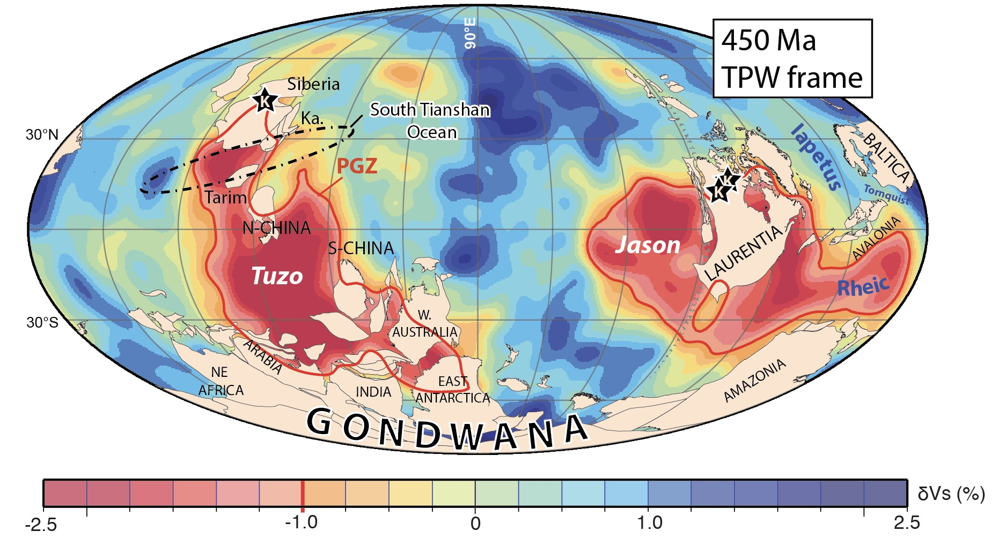
Fig. S3. 450 Ma true polar wander (TPW)-corrected mantle frame reconstruction draped on the SMEAN tomographic model and the plume generation zones (PGZs; 1% slow SMEAN contour) as the 90º E to the center. K-kimberlites. Ka Kazakhstan (including Central Tianshan Block). Tuzo and Jason refer to Africa and Pacific deep mantle domain, respectively. Revised from Torsvik et al. (2014).

