Table S2. Multi-zircon aliquot U-Pb analyses determined by isotope dilution thermal ionization mass spectrometry at University of Kansas Isotope Geochemistry Laboratory. Analyzed May, 1991. Isotopic ratios are corrected for blank and common Pb from ²⁰⁴Pb and Stacey and Kramers (1975) Pb evolution model. Assumed ²³⁸U/²³⁵U= 137.82 (Hiess et al., 2012).
Sample aliquot | U ppm | ²⁰⁶Pb/²³⁸U | ±1σ (%) | ²⁰⁷Pb/²⁰⁶Pb | ±1σ (%) | ²⁰⁷Pb/²³⁵U | ±1σ (%) | Rho | ²⁰⁶Pb/²³⁸U  date (Ma) | ±1σ (Ma)
South Merrimac
151S-1 | 863 | 0.0207799 | 0.476 | 0.048775 | 0.112 | 0.1397 | 0.489 | 0.97 | 132.6 | 0.6
151S-2 | 944 | 0.0209001 | 0.518 | 0.0481443 | 0.155 | 0.1387 | 0.541 | 0.96 | 133.3 | 0.7
151S-3 | 2137 | 0.0210257 | 0.482 | 0.0488731 | 0.0545 | 0.1416 | 0.485 | 0.99 | 134.1 | 0.6
North Merrimac
235N-1 | 281 | 0.0217989 | 0.534 | 0.0488039 | 0.155 | 0.1466 | 0.556 | 0.96 | 139.0 | 0.7
235N-2 | 134 | 0.0220643 | 0.468 | 0.0488198 | 0.144 | 0.1485 | 0.490 | 0.96 | 140.7 | 0.7
235N-3 | 278 | 0.0211874 | 0.536 | 0.0487506 | 0.693 | 0.1424 | 0.876 | 0.61 | 135.2 | 0.7

REFERENCES:
Hiess, J., Condon, D.J., McLean, N., and Noble, S.R., 2012, ²³⁸U/²³⁵U systematics in terrestrial uranium-bearing minerals: Science, v. 335, p. 1610-1614.
Stacey, J.S., and Kramers, J.D., 1975, Approximation of terrestrial lead isotope evolution by a two-stage model: Earth and Planetary Science Letters, v. 26, p. 207-221.
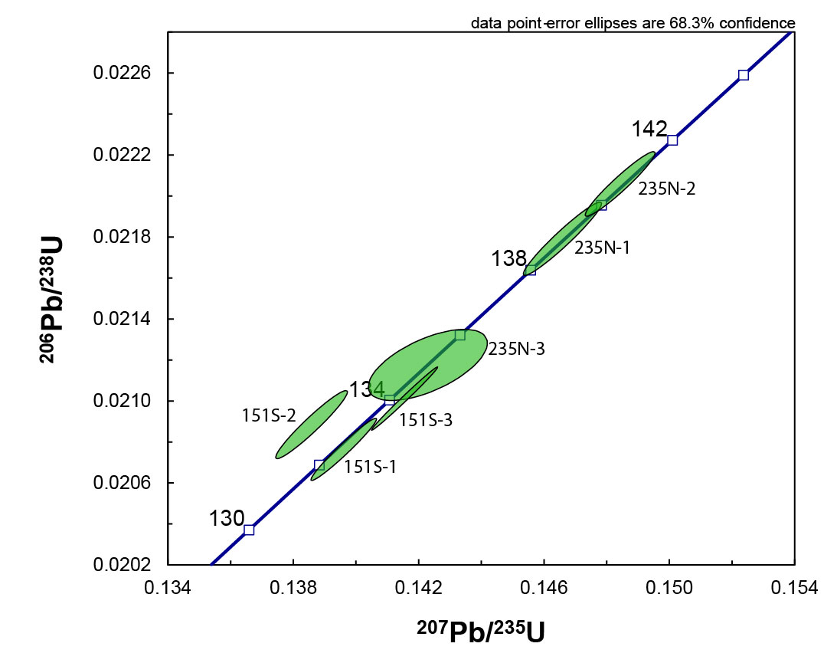
Figure S1. Concordia plot of data in Table S2.

