Supplementary information 2

Karoo, Ecca Group
Removal of the 6300-meter overburden displaces the trajectory significantly. Moreover, Trajectory gradients are increased by decompaction. The main observation is that the slightly falling -0.30ᵒ distal end of the Baviaans-North profile (wfC 5,6,7,8) is adjusted to a 0.05ᵒ flat trajectory (figure 11). Sequential decompaction indicates no significant alteration of syn-depositional clinoform geometries. A third observation is a loss of curvature and general flattening in the geometry of the unit F formation; the oldest formation in the Ecca-group clinoformal succession (Jones et al., 2015).
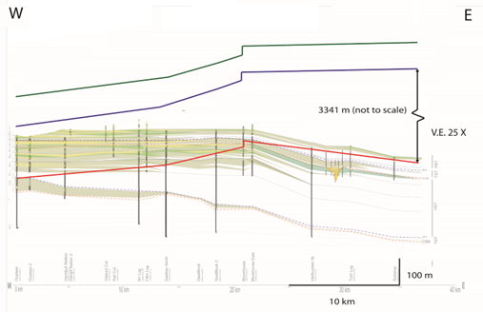

Columbus Basin
The Columbus Basin profile illustrates a stepwise aggradation dominated/progradation dominated shelf-edge trajectory. Because there is a limited overburden, there is only a small change in the trajectory following non-sequential decompaction. Sequential decompaction causes an overall increase in gradient with a downward to upward trajectory adjustment in the fourth sequence of the succession (TP44). Extremely steep sequentially decompacted trajectory intervals indicate extensive aggradation, this is further exaggerated following decompaction. Note that the profile is not depth-converted, this means that the absolute values for trajectory angles cannot he be determined, relative alterations in gradient and orientation after decompaction can however be recognised.
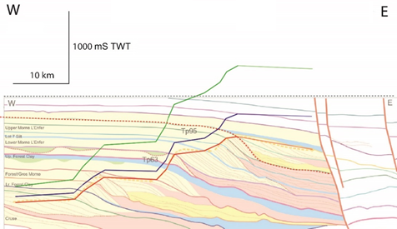

Chen, S., Steel, R.J. and Olariu, C., 2016. Upper-slope to shelf-edge delta architecture, Miocene Cruse Formation, Orinoco shelf margin, Trinidad. Journal of Sedimentary Research, 86(2), pp.87-106.
JONES, G. E., HODGSON, D. M. & FLINT, S. S. 2015. Lateral variability in clinoform trajectory, process regime, and sediment dispersal patterns beyond the shelf‐edge rollover in exhumed basin margin‐scale clinothems. Basin Research, 27, 657-680.
Poyatos-Moré, M., Jones, G.D., Brunt, R.L., Hodgson, D.M., Wild, R.J. and Flint, S.S., 2016. Mud-dominated basin-margin progradation: processes and implications. Journal of Sedimentary Research, 86(8), pp.863-878.

