- a dip-section image of a clinoform bearing succession is selected from literature. Example: Washakie Basin obtained from (Carvajal and Steel, 2012).
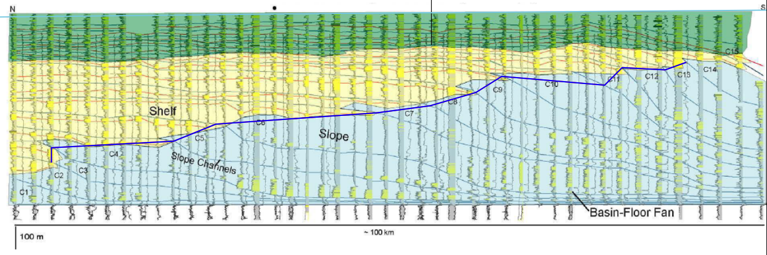
- Image is important into Midland Valley Move software and scaled appropriately. The basinal overburden is added (in this case 3300 m).
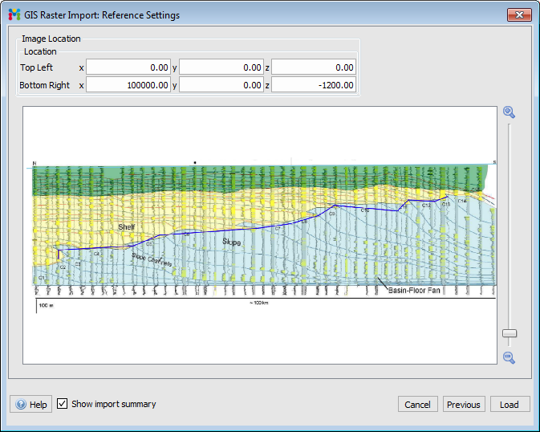
- Horizons are constructed to delineate clinothems. The overburden is constructed.
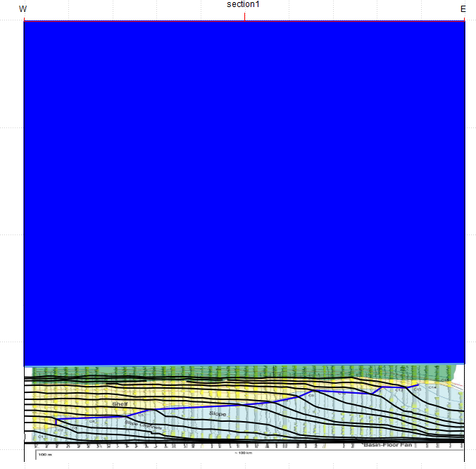4. A polygon is constructed for each topset (green), foreset (yellow) and bottomset (red) compartment in the succession.
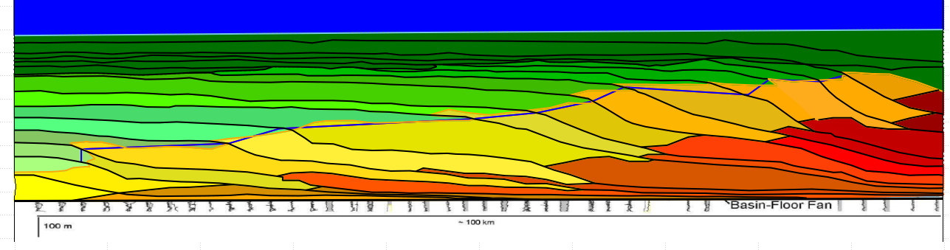

5a. Vshale ratios are obtained from literature, in this case (Carvajal and Steel 2012).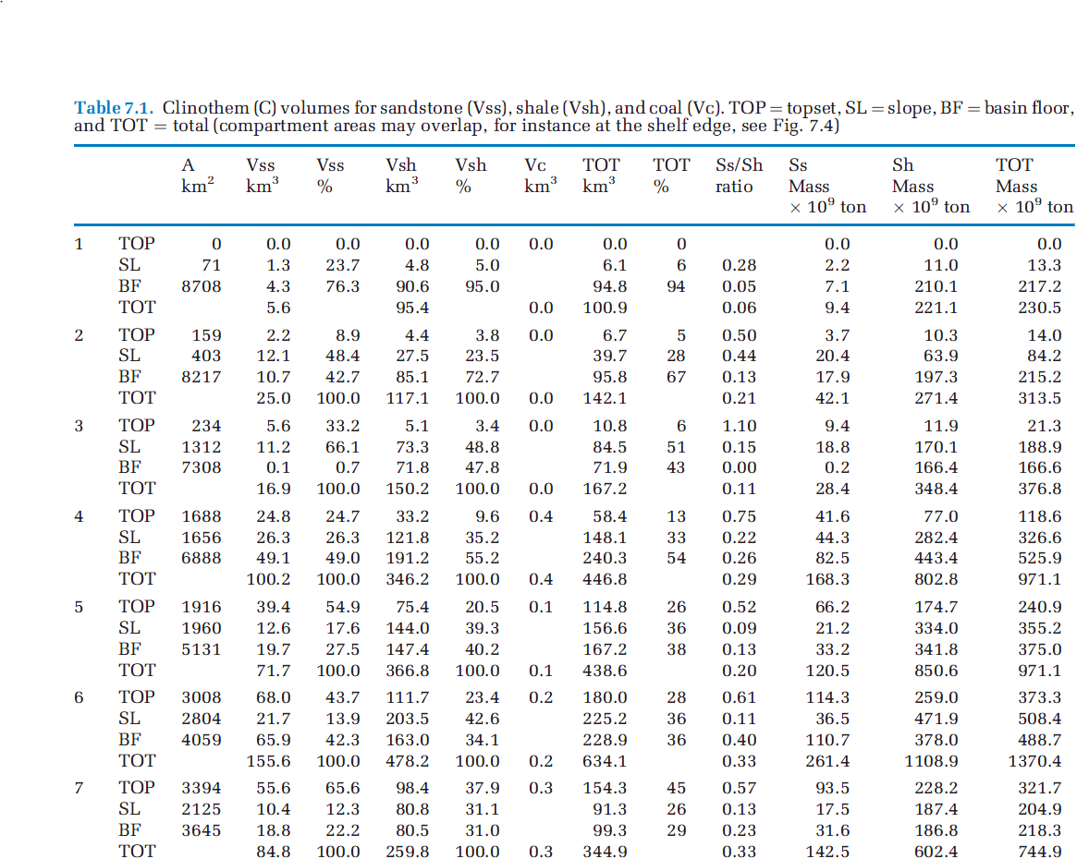
5b.In case Vshale numbers cannot be obtain from literature, they are derived from images of published well logs using image compartmentalization and color segmentation tools (magic wand tool in Adobe Photoshop). Number of pixels is counted in order to determine the relative contribution of sand vs shale. Example: Taranaki Basin, log published in (M. Salazar et. al 2015) 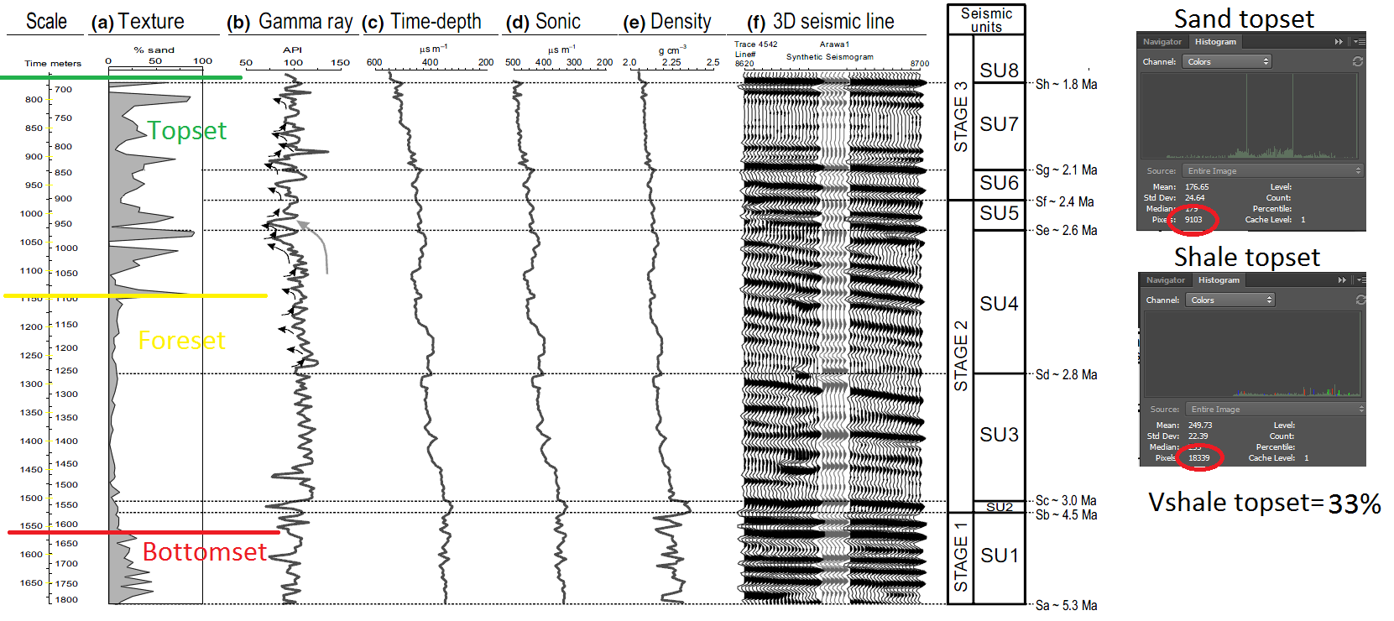
6. A Vshale number is designated for each compartment. Afterwards, compartmental compaction curves are constructed using empirically derived compaction relations from (Sclater Christie, 1980). relation is: $f=f_{0}(e^{-cy})$ Where f is present day porosity at depth, f₀ is the porosity at the surface, c is the porosity-depth coefficient (km⁻¹) and y is depth.

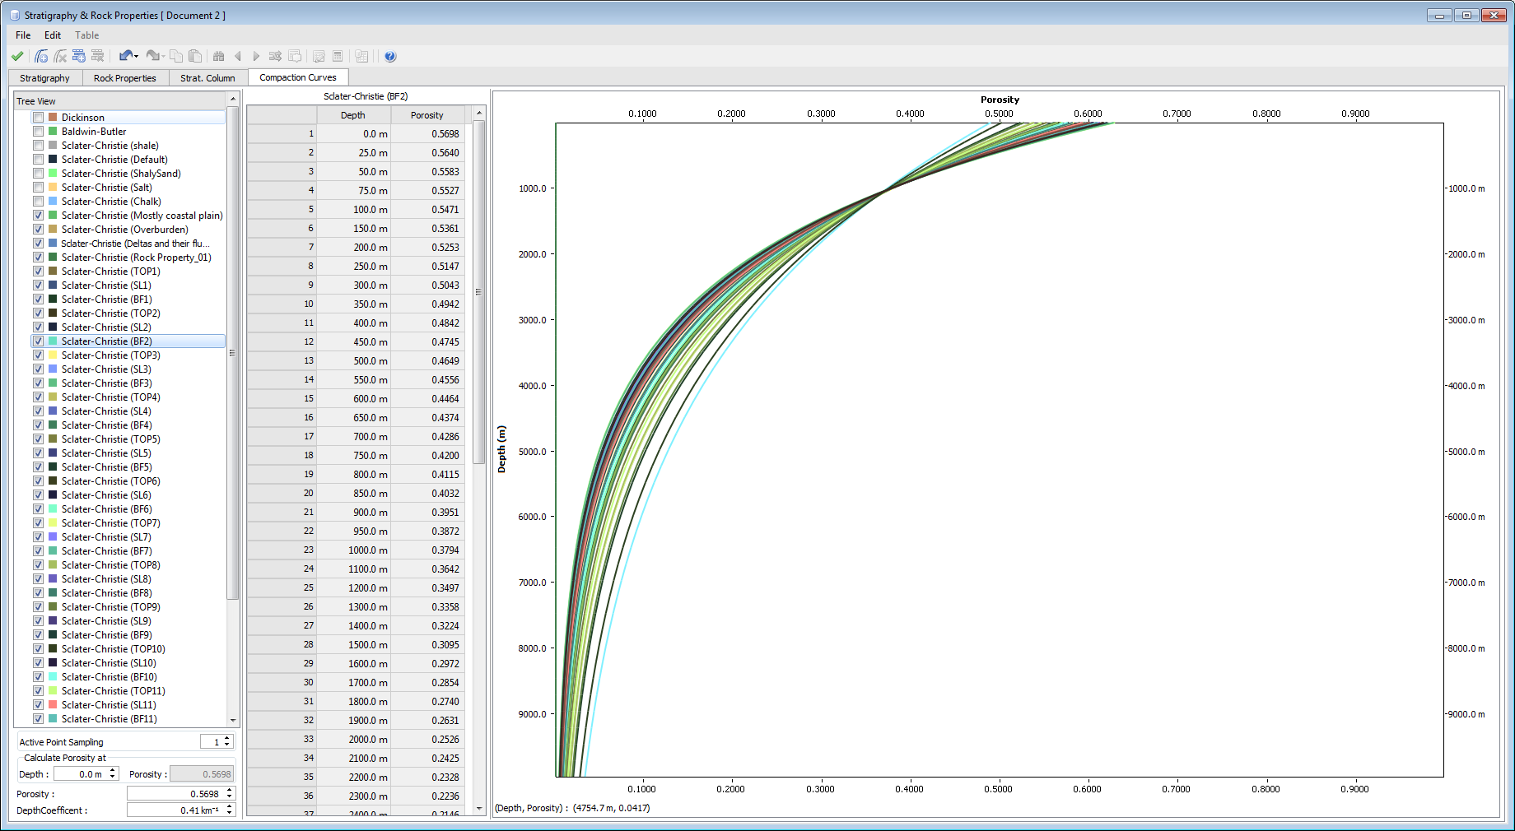
7.Non-sequential compaction of the succession overburden is applied. During each decompaction experiment, 100-1000 equally spaced, one-dimensional vertical columns along the succession are constructed. After a selected clinothem is backstripped, volume increase is calculated by upscaling the length of the columns based on reducing porosity loss in accordance with the porosity/depth relation. The following animation shows non-sequential decompaction of the Washakie Basin dataset. Full overburden was decompacted in three phases in order to show intermediate stages of non-sequential compaction.(Double click to open animation).
8. Afterwards, each clinothem is decompacted successively starting from the youngest, most distal to the oldest, most proximal. The following video shows sequential decompaction of the Washakie Basin dataset. In this example, polygons are visualized on the model. Dip-section is from (Koo et al. 2016). (Double click to open animation).
9. After each phase of decompaction, the position and orientation of every reconstructed trajectory increment is recorded.
10. Trajectory increments are assembled end-to-end. This corrects for the isostatic readjustments that occur after each step. These Isostatic readjustments due to unloading are calculated through applying an Airy isostasy (Airy, 1856). The following relation is applied:
$$Z=\frac{S-\left(H1-H2\right)ρ_{c}-ρ_{w}}{ρ_{m}-ρ_{w}}$$Where Z is the amount of subsidence (relative to a basement datum), S is the thickness of the unloaded sediment. H1 is crustal thickness before sediment load, H2 crustal thickness after sediment load. ρ_{c} ρ_{m} and ρ_{w} are the densities of crust, mantle and water respectively. As indicated by these models.
