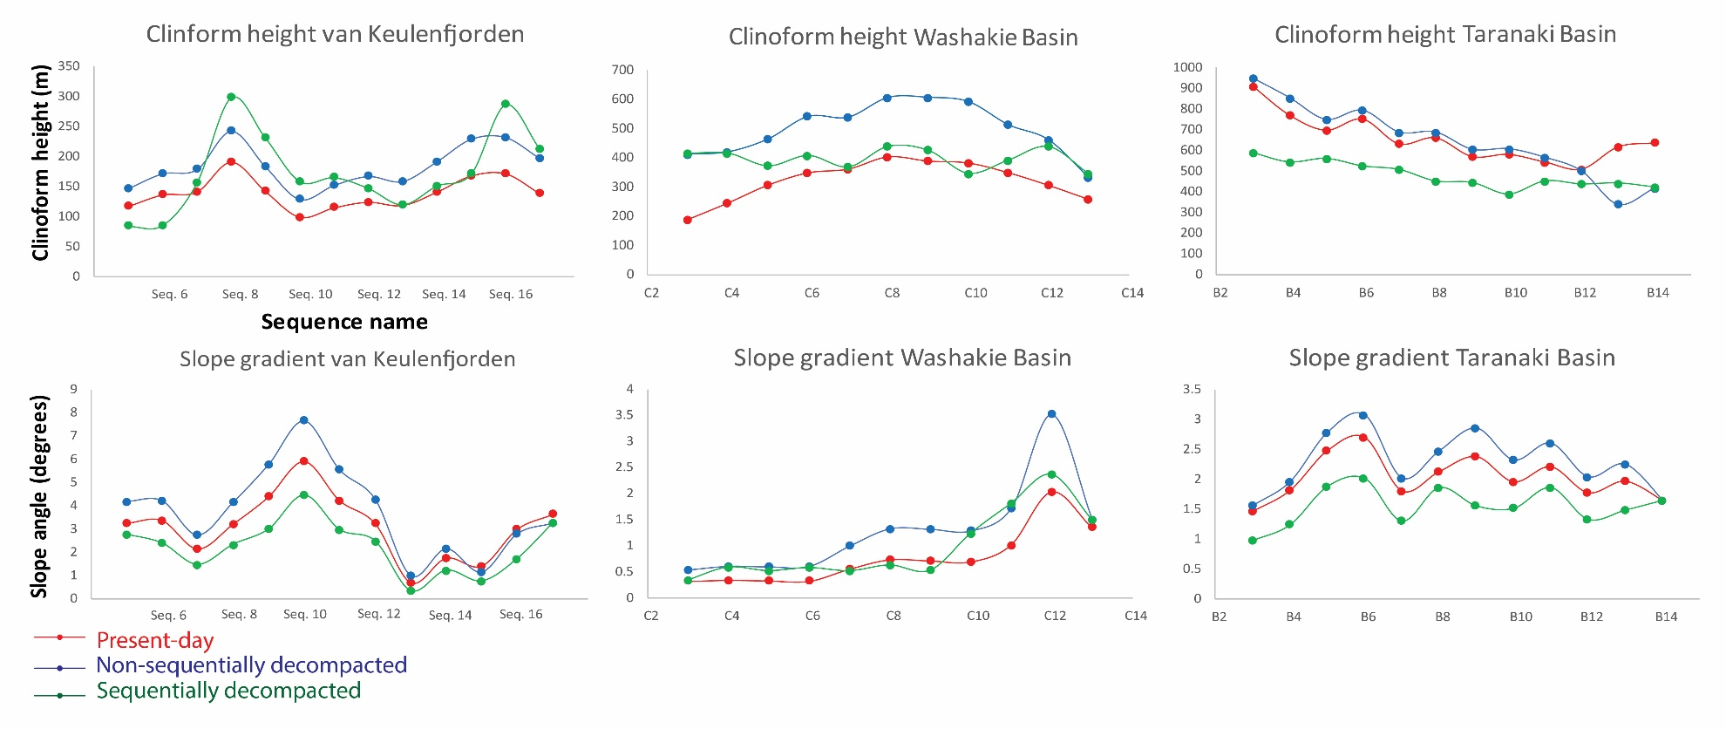

Basinward variations of slope gradients and clinoform heights for outcrop (van Keulenfjorden), well log correlation (Washakie) and seismic (Taranaki) data. Slope gradient is the average gradient surface of the foreset. Clinoform height is the vertical distance between the rollover point and the basin floor. Note that non-sequential decompaction results in a uniform upwards translation in along-dip trends while sequential decompaction erratically alters values (Washakie Basin) sometimes lowering them to below present-day. This is due to the case-specific effects of differential compaction and the effects of lithological heterogeneities in this dataset. In case Vshale inputs are are extrapolated (van Keulenfjorden and Taranaki) there is a uniform downwards translation of values resulting from sequential decompaction.

