Salt-marsh foraminiferal record of ten large Holocene (last 7500 yrs) earthquakes on a subducting plate margin, Hawkes Bay, New Zealand
Bruce W Hayward, Hugh R. Grenfell, Ashwaq T. Sabaa, Kate J. Clark, Ursula A. Cochran, Laura Wallace and Alan S. Palmer

Supplementary file 5. Localities where 1010 New Zealand paralic and inner shelf modern faunal samples have been sourced from for use in the modern analogue technique estimates of tidal elevation.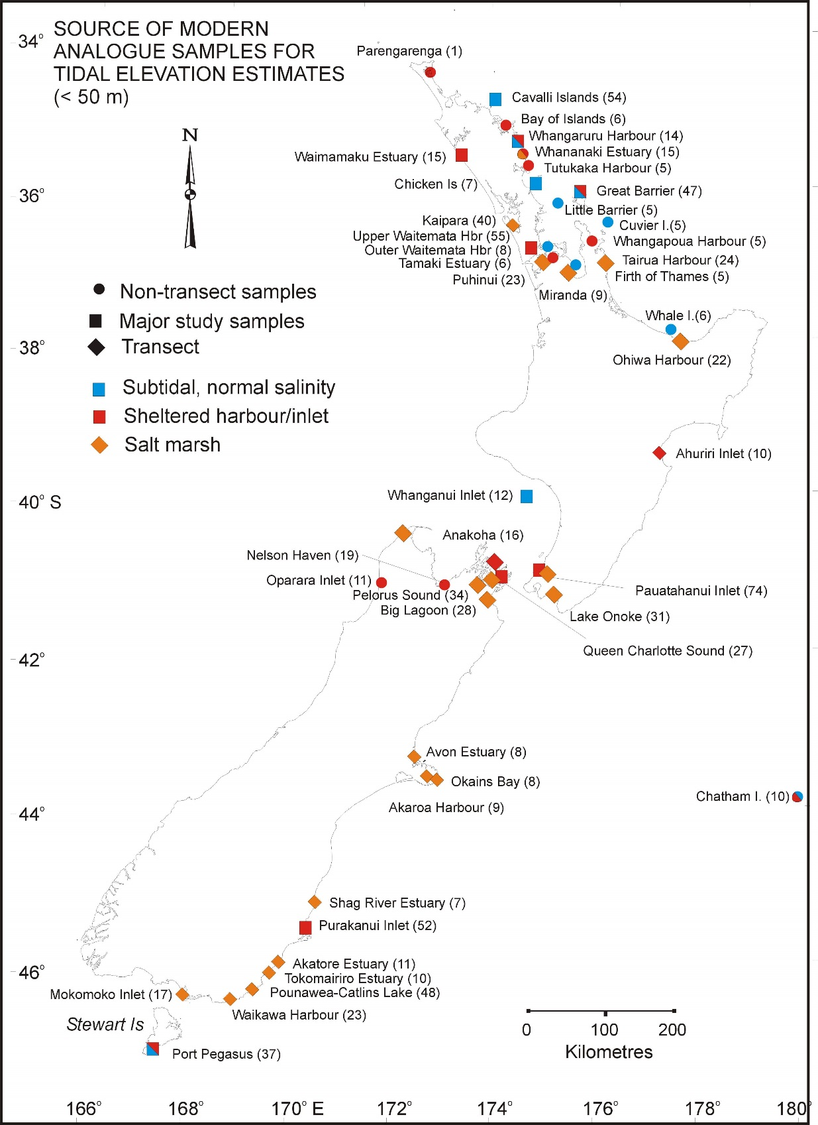
Sample prefixes for localities of modern analog samples:

A, B = Kaipara transects A & B Hayward et al. 1999a
Ah = Ahuriri transect unpubl Carter et al., 2000
Ak = Akatore Estuary transect Hayward et al 2007a
AU & L + outer Waitemata Hbr, unpublished
AuckI = Auckland I Hayward et al 2007b
AVT = Avon Transect 2012 unpublished
BL = Big Lagoon transects & spots Hayward et al 2010c & unpublished
BLT = Big Lagoon SE cnr transect unpublished
c = Cavalli Islands Hayward, 1982a
CampI = Campbell Island Hayward et al 2007b
Chk = Chicken Islands Hayward et al. 1984
CL = Catlins Lake Hayward et al 2007a
CP5, CP6 = Tairua transects 2012 unpublished
D = Miranda transect D Hayward et al 1999a
E, F = Pauatahanui transects E & F Hayward et al 1999a
FT = Firth of Thames spots Hayward et al. 2008
g = Great barrier spots Hayward & Grenfell 1994
h = Helena Bay Hayward & Hollis 1994
i = Bay of Islands Hayward, 1981
k = Purakanaui spots Hayward et al, 1996
Kp = Kaipara Hbr Spartina Hayward et al 2008
l = Whale Island Hayward 1990
m = Chatham Islands spots Hayward and Grenfell 1999
Mh = Mahurangi Hbr surface samples Hayward et al 2008, Grenfell et al 2007
Mok = Mokomoko transect 0-1 cm Gehrels unpublished
MSAn = Marlborough Sounds Anakoha transect Hayward et al 2010b
MSK = Marlborough Sounds Kaiuma Bay transect Hayward et al 2010a
MSM = Marlborough Sound Mahakipawa Arm transect Hayward et al 2010a
N, NH = Nelson Haven surface samples unpublished
o = Oparara Inlet spots Hayward & Hollis 1994
OH1, OH2 = Ohiwa Hbr transects 1, 2 Hayward et al 2004
Ok = Lake Onoke spots Hayward et al 2011
OkBT = Okains Bay transect 2012 unpublished
OkT = Lake Onoke transect Hayward et al 2011
p = Pegasus spots Hayward et al. 1994
pg = Parengarenga spot Hayward et al 1999b
PHT = Puhinui transects Grenfell et al 2012
Po = Pounawea transect Southall et al 2006
q = Queen Charlotte Sound Hayward et al. 1997a
r = Little Barrier Hayward 1982b
RH = Raglan Hbr Spartina Hayward et al 2008
S = Shakespeare Bay, Marlborough Sounds Hayward et al 2010a
SRT = Shag River transect Hayward et al. 2012
t = Tutukaka Harbour Brook et al. 1981
TB = Akaroa transect Figueira 2012
TE = Tamaki Estuary Musculista Haywarde t al 2008
TH = Thames Spartina Hayward et al 2008
THC = Avon transect 2009 unpublished
Tt = Tautuku Estuary transect low tide unpublished
Tw = Taiwawe Bay Reid & Hayward 1997
u = Pauatahanui Inlet, Hayward & Triggs 1994
v = Cuvier Island Hayward & Grace 1981
w = Waitemata Harbour Hayward et al. 1997b
wh = Whangapoua Harbour transect unpublished
WHA,WHB = Whanganui Inlet transects Figueira 2012
wk = Whananaki Estuary Hayward unpubl.
WKN, WKS = Waikawa Hbr transect, less mixed samples Figueira 2012, Hayward et al. submitted 2014
WN, WS = Whanganui Inlet acidification transects unpublished

References:
Brook, F.J., Grace, R.V., Hayward, B.W., 1981. Soft-bottom benthic faunal associations of Tutukaka Harbour, Northland, New Zealand. Tane 27, 69-92.
Carter, R., Hayward, B.W., Grenfell, H.R., Lipps, J.H., 2000. Initial report: Foraminiferal documentation of earthquake-related vertical displacements in Holocene coastal lagoon sediments, Hawkes Bay, New Zealand. Unpublished report, BWH 75/00, 71 p.
Figueira, B.O., 2012. Salt marsh proxy record of late Holocene sea-level rise, South Island, New Zealand. Unpublished PhD thesis, University of Auckland, 205 p.
Grenfell, H.R., Hayward, B.W., Horrocks, M., 2007. Foraminiferal record of ecological impact of deforestation and oyster farms, Mahurangi Harbour, New Zealand. Marine and Freshwater Research 58, 475-491.
Grenfell, H.R., Hayward, B.W., Nomura, R., Sabaa, A.T., 2012. Proxy record of 20th century sea-level rise in the Manukau Harbour, New Zealand. Marine and Freshwater Research 63, 370-384.
Hayward, B.W., 1981. Foraminifera in near-shore sediments of the eastern Bay of Islands, New Zealand. Tane 27, 123-134.
Hayward, B.W., 1982a. Associations of benthic foraminifera (Protozoa:Sarcodina) of inner shelf sediments around the Cavalli Islands, north-east New Zealand. New Zealand Journal of Marine and Freshwater research 16, 27-56.
Hayward, B.W., 1982b. Foraminifera and ostracoda in nearshore sediments, Little Barrier Island, northen New Zealand. Tane 28, 53-66.
Hayward, B.W., 1990. Foraminifera in nearshore sediments, Whale island, Bay of Plenty. Tane 32, 93-99.
Hayward, B.W., Grace, R.V., 1981. Soft bottom macrofauna and foraminiferal microfauna off Cuvier Island, north-east New Zealand. Tane 27, 43-54.
Hayward, B.W., Grenfell, H.R., 1994. Foraminiferal associations around northern Great Barrier Island, New Zealand. Records of Auckland Institute and Museum 31, 231-273.
Hayward, B.W., Grenfell, H.R., 1999. Chatham Island foraminifera (Protista), New Zealand. New Zealand Natural Sciences 24, 69-88.
Hayward, B.W., Hollis, C., 1994. Brackish foraminifera in New Zealand: A taxonomic and ecologic review. Micropaleontology 40, 185-222.
Hayward, B.W., Triggs, C.M., 1994. Computer analysis of benthic foraminiferal associations in a tidal New Zealand inlet. Journal of Micropaleontology 13, 103-117.
Hayward, B.W., Grace, R.V., Bull, V.H., 1984. Soft bottom macrofauna, foraminifera and sediments off the Chickens Islands, northern New Zealand. Tane 30, 141-164.
Hayward, B.W., Hollis, C.J., Grenfell, H., 1994. Foraminiferal associations in Port Pegasus, Stewart Island, New Zealand. New Zealand Journal of Marine and Freshwater Research 28, 69-95.
Hayward, B.W., Grenfell, H., Cairns, G.A., Smith, 1996. Environmental controls on benthic foraminiferal and thecamoebian associations in a New Zealand tidal inlet. Journal of Foraminiferal Research 26, 150-171.
Hayward, B.W., Grenfell, H.R., Reid, C., 1997a. Foraminiferal associations in Wanganui Bight and Queen Charlotte Sound, New Zealand. New Zealand Journal of Marine and Freshwater Research 31, 337-365.
Hayward, B.W., Grenfell, H.R., Pullin, A.D., Reid, C., Hollis, C.J., 1997b. Foraminiferal associations in the upper Waitemata Harbour, Auckland, New Zealand. Journal of the Royal Society of New Zealand 27, 21-51.
Hayward, B.W., Grenfell, H.R., Scott, D.B., 1999a. Tidal range of marsh foraminifera for determining former sea-level heights in New Zealand. New Zealand Journal of Geology and Geophysics 42, 395-413.
Hayward, B.W., Grenfell, H.R., Reid, C.M., Hayward, K.A., 1999b. Recent New Zealand shallow-water benthic foraminifera: Taxonomy, ecologic distribution, biogeography, and use in paleoenvironmental assessment. Institute of Geological and Nuclear Sciences Monograph 21, 258 p.
Hayward, B.W., Cochran, U., Southall, K., Wiggins, E., Grenfell, H.R., Sabaa, A.S., Shane, P.A.R., Gehrels, R., 2004. Micropalaeontological evidence for the Holocene earthquake history of the eastern Bay of Plenty, New Zealand. Quaternary Science Reviews 23, 1651-1667.
Hayward, B.W., Grenfell, H.R., Sabaa, A.T., Southall, K.E., Gehrels, W.R., 2007a. Foraminiferal evidence of Holocene fault displacements in coastal South Otago, New Zealand. Journal of Foraminiferal Research 37, 344-359.
Hayward, B.W., Grenfell, H.R., Sabaa, A.T., Daymond-King, R., 2007b. Biogeography and ecological distribution of shallow-water benthic foraminifera from the Auckland and Campbell Islands, subantarctic south-west Pacific. Journal of Micropalaeontology 26, 127-143.
Hayward, B.W., Grenfell, H.R., Sabaa, A.T., Morley, M.S., 2008. Ecological impact of the introduction to New Zealand of Asian date mussels and cordgrass - the foraminiferal, ostracod and molluscan record. Estuaries and Coasts 31, 941-959.
Hayward, B.W., Grenfell, H.R., Sabaa, A.T., Kay, J., Daymond-King, R., Cochran, U., 2010a. Holocene subsidence at the transition between strike-slip and subduction on the Pacific-Australian plate boundary, Marlborough Sounds, New Zealand. Quaternary Science Reviews 29, 648-661.
Hayward, B.W., Grenfell, H.R., Sabaa, A.T., Kay, J., 2010b. Using foraminiferal faunas as proxies for low tide level in the estimation of Holocene tectonic subsidence close to the Pacific-Australian plate boundary, New Zealand. Marine Micropaleontology 76, 23-36.
Hayward, B.W., Wilson, K., Morley, M.S., Cochran, U., Grenfell, H.R., Sabaa, A.T., Daymond-King, R., 2010c. Microfossil record of the Holocene evolution of coastal wetlands in a tectonically-active region of New Zealand. The Holocene 20, 405-421.
Hayward, B.W., Grenfell, H.R., Sabaa, A.T., Kay, J., Clark, K., 2011. Ecological distribution of the foraminifera in a tidal lagoon-brackish lake, New Zealand, and its Holocene origins. Journal of Foraminiferal Research 41, 124-137.
Hayward, B.W., Grenfell, H.R., Sabaa, A.T., 2012. Marine submersion of an archaic moa-hunter occupational site, Shag River estuary, North Otago. New Zealand Journal of Geology & Geophysics 55, 127-136.
Reid, C.M., Hayward, B.W., 1997. Near-shore foraminifera from Taiwawe Bay, Northland, New Zealand. Tane 36, 113-130.
Southall, K.E., Gehrels, W.R., Hayward, B.W., 2006. Foraminifera in a New Zealand salt marsh and their suitability as sea-level indicators. Marine Micropaleontology 60, 167-179.

