Supplemental Material For:
Intrarift Fault Fabric, Segmentation, and Basin Evolution of the Lake Malawi (Nyasa) Rift, East Africa

Christopher A. Scholz¹, Donna J. Shillington^{2*}, Lachlan Wright¹, Natalie Accardo^{2**}, James B. Gaherty^{1*}, Patrick Chindandali³
¹Department of Earth Sciences, 204 Heroy Geology Laboratory, Syracuse University, Syracuse NY,13244 USA
² Lamont-Doherty Earth Observatory, Columbia University, P.O. Box 1000, 61 Route 9W, Palisades, NY 10964 USA
³ Geological Survey of Malawi, P.O. Box 27, Zomba, Malawi
* Now at Northern Arizona University, School of Earth and Sustainability, 624 Knoles Dr, Flagstaff, AZ 86011 USA
** Now at NewGen Strategies & Solutions, Denver, CO, USA
Corresponding author: cascholz@syr.edu
INRODUCTION
This Supplementary Information document provides additional background to the methodologies used for the analysis presented in the main paper. It presents 1) background context to the SEGMeNT Project; 2) a summary of the seismic data acquisition; 3 & 4) SEGMeNT data processing and legacy data reprocessing; 5) seismic data interpretation and integration; 6) analysis of local relief in the rift; 7) structural restoration methods; 8) summary of volcanic load estimates and methods; 9) a summary of the lineament analyses; and 10) a discussion of the age of the Malawi Rift.
- SEGMeNT PROJECT BACKGROUND
The SEGMeNT project collected ~2000 line-km of 2D basin-scale seismic reflection data from the North and Central Basins of the Lake Malawi (Nyasa) rift in 2015. The hydrophone array used had a nominal active section length of 1200 m, but array length over the entire survey varied from 300 m to 1500 m, depending upon scientific objectives and operational considerations. The seismic source for the survey varied from 500 c.i. to 2580 c.i., depending upon scientific objectives and operational considerations. In addition to standard streamer reflection data, wide angle reflection and refraction data were collected using lake bottom seismometers (see Shillington et al., 2016; Accardo et al., 2018 for additional details). Standard processing routines were used for processing of the CMP data through time migration. Selected lines were processed through prestack depth migration. The project acquired data in the North and Central Basins of the Lake Malawi (Nyasa) rift, primarily in an orthogonal grid with lines spacing averaging ~8 km. In some areas of focused interest, profiles oblique to the strike of the rift were also acquired. The 2D seismic reflection data were acquired during a 29-day cruise aboard the M/V Katundu from March 8 to April 5, 2015 (see Fig. 2 in main body of text and Shillington et al., 2016). The MCS lines included a series of dip and strike profiles in the northern and central basins intended to be orthogonal to structures or well-suited for along-strike correlations.
- SEGMeNT PROJECT DATA ACQUISITION
Seismic Source
The seismic source for both the common mid-point reflection profiles as well as the wide-angle refraction lines was an array of G-guns from GEUS/Aarhus University in Denmark. Parameters for the profiles varied depending on the objectives of the profile and upon operational considerations. The available seismic source consisted of two 1040 cu. in. linear airgun clusters and one 500 cu in linear cluster for a total possible volume of 2580 cu in. The 1040 cu in cluster was built with two Sercel 520 cu in G-guns. The 500 cu in cluster consisted of two Sercel 250 cu in. G-guns. The guns were shot on distance at intervals of 12.5 m to 250 m, depending on the size of array, and the science objectives of each profile.
Profiles dedicated to refraction data collection utilized the maximum size array (2580 cu. in.), whereas profiles intended for maximum reflection data penetration used intermediate sized arrays, and a few profiles focused in imaging features in the sedimentary basin in some cases used a small subarray, but with tighter shot spacing. The three backbone profiles (001, 002, and 003) were each shot twice, once for wide angle data and once for reflection data.
The array sizes used in this experiment include: 500 cu in. @ 140 bar, 1020 cu in. @ 140 bar, 1540 cu in. @ 140 bar, 2580 cu in. @ 140 bar and 2580 cu in. @ 180 bar. The pressurized air was produced by two Hamworthy 185E_MK2 70mm Series Air Compressors and two Bauer K23 High Pressure Compressor units.
Seismic streamer and recording system
The seismic streamer was a Hydroscience digital streamer with 12.5-m channel spacing from Syracuse University. Several sets of acquisition parameters were used over the course of the cruise to optimize the tradeoffs between source volume, shot interval and recording time with the goal of imaging the top of basement and structures in the deep sediments and upper crust. The streamer length was generally between 1200-1500 m.
Wide-angle seismic refraction data were acquired by an array of 27 autonomous lake-bottom seismometers that were deployed prior to the active-source program on the Katundu and recovered afterwards, such that they were able to record all air gun shots fired during the active-source program.
Data were recorded on a Hydroscience NTRS3 recording system that consisted of a single 36” rack of equipment including, a CPU/Windows XP 2U computer, a streamer power supply, a dual array interface card, a NAS network drive system, backed up on an uninterruptable power supply. Signals are delivered to the system rack via a 30-m deck cable from the Streamer winch. Data were recorded in standard SEG-D format. Data record lengths varied from 5 to 18 seconds, depending upon line-specific science objectives. Sample rates were 2 ms, except at end of cruise several select lines were collected with 1 ms sample rates, using the 500 c.i. source array. The total # channels varied from a maximum of 120, to a minimum of 24. Most CMP recording utilized 96 channels.
Navigation
Three separate GPS units were used for positioning of the seismic equipment through the cruise, and data logging software NaviPac from EIVA A/S were used to integrate the navigation data and interface with the gun control system and recording systems. GPS units included one Ashtech DG16 and two Trimble AgGPS132 units. The Ashtech DG16 GPS has a built-in beacon and WAAS/EGOS receivers for differential corrections. The Trimble AG123 (DGPS 1 and 2) have a license-based differential system, Omnistar. NaviPac received antenna coordinates from all three GPS’s. The priority of the GPS’s were varied during the survey between the three GPS’s.
The geodetic datum for all positions recorded or calculated (except for the offsets for coordinates in the local vessel coordinate system) during the survey was WGS84, and no datum shift has been applied to the data. Hence all latitude and longitude coordinates are in WGS84 datum. NaviPac used the UTM south projection, zone 36 and all x and y coordinates are given in UTM projection and WGS84 datum.
3) SEGMeNT PROJECT DATA PROCESSING
Most data processing for all profiles was completed using the Halliburton-Landmark software Seispace™. This processing software, formerly known as Promax, has been an industry standard for thirty years. Paradigm Geophysical software package Echos™ was additionally used for some pre- and post-stack data cleaning at Columbia University. Syracuse University and Columbia University were responsible for data processing of lines from the Central Basin and North Basin, respectively.
Navigation and Geometry
Survey data were acquired over four different cruise legs, which for operational reasons resulted in slightly different streamer geometries. Even within legs, there were changes in streamer geometry due to events (e.g. lightning strikes near the ship) that affected acquisition equipment. Accordingly, each line required careful reconsideration and new geometry definition at the start of each processing step.
Initial Data Conditioning
4The first processing steps included the following standard processes:
• SEG-D Read-in
• Anti-Alias Filter: – high fidelity, zero phase
• Minimum Phase and Deghost:
- low frequency filter 4.6 Hz
- low frequency slope 6 dB/Octave
- high frequency filter 206 Hz
- high frequency slope 214.3 dB/Octave
- shot ghost delay time (water depth of airguns x 2000) / 1480)
• Geometry Definition: varied leg by leg, and in some cases line by line
• Trace/Kill Edit: varied leg by leg, and in some cases line by line.
Initial Velocity Analysis and Multiple Suppression
• Preliminary Velocity Analysis: Data were collected into super gathers consisting of 7 CMP gathers, and semblance analyses were conducted every 25-100 CMPs along each profile.
• Brute Stack: Data subjected to normal move-out using first-pass smoothed velocities, and then stacked a brute stack of each profile.
• Multiple Removal: A variety of multiple suppression techniques were tested, and we generally found that wave equation multiple removal and surface related multiple elimination (SRME) worked best. However, owing to the relatively short streamer and modest differences in velocity between multiples and primary reflections, removing all of the multiple energy was not possible from some lines.
Wave Equation Multiple Removal: Water bottom horizon and geometry data was used to calculate multiple removal.
Surface-Related Multiple Elimination: Predicts multiples through a series of convolutions and removed them from data via adaptive subtraction method.• 2nd/3rd Velocity Analysis: Adjusted the first velocity picks after different phases of multiple removal.
• Iterative stack
• Spherical Divergence correction
• Spike & Noise burst edit
• Predictive Deconvolution: L2 Norm Adaptive
- Rate of adaption 0.2
- Horizontal window length 10 traces
- Filter length 7 samples
- Time window length 300
- Time window overlap 100
- F-X filter start 8 Hz
- F-X filter end 250 Hz
•Third Velocity Analysis
•Iterative Stack
Final Stack
• Final velocity analysis
• Final stack
• Amplitude balance
• Time-variant filter

Time Migration Processing
- Velocity Analysis (2-3 iterations) CDP increment 25, supergather combined 7 CDP
- Velocity smoothing, percentage reduction varied but generally 1-5%
- Kirchoff Time Migration: maximum frequency 80 Hz, maximum dip 180.

4) LEGACY DATA PROCESSING
The 1980’s era data was reprocessed by ION Geophysical in 2016. Similar routines to those shown above were used with some additional steps, including:
- Debubble to zero phase conversion
- Additional predictive deconvolution
- Noise Attenuation (primarily in the deeper section)-
- Demultiple steps included using SRME, and a cascaded adaptive subtraction; Apex-shifted multiple attenuation
- Time-variant filter and FX deconvolution
- Additional Post-processing routines included time-variant band-pass filter, scaling and coherency smoothing.
Pre-Stack Depth Migration workflows were similar to those described above, and were carried out on all legacy profiles.
A smoothed velocity brick for the full rift zone to 6 s TWTT was generated from the Pre-Stack Time Migration velocity data sets.
5) SEISMIC DATA INTERPRETATION AND INTEGRATION
A harmonized basement fault map is presented in the main body of the paper and used all available 2D data (Fig. 5 in main body of paper). A digital version of the basement surface and a separate fault heave file are provided with the supplement. Seismic interpretations were completed in the time domain, then vetted using depth-converted profiles (note that not all SEGMeNT profiles were prestack depth migrated). Because new LBS-based velocity data were available for the North and Central Basins only, we used prestack time migration velocities based upon the legacy data over the entire lake to create a smoothed velocity brick for the full offshore rift zone. This was completed iteratively using the LBS velocity data as a check on smoothing of the CMP velocities. The interpreted basement surfaces were then converted to depth using the full-rift velocity brick. The structure contour map of the late-Cenozoic synrift basement of the Lake Malawi Rift was generated from the interpreted seismic reflection data using a least-squares algorithm with a 12000 m search radius, 750 m x750 m grid cell size, and a 4x biharmonic smoothing parameter. Sediment thickness map is generated by subtracting water depth from the basement structure grid using the 750 m basement grid cell size.
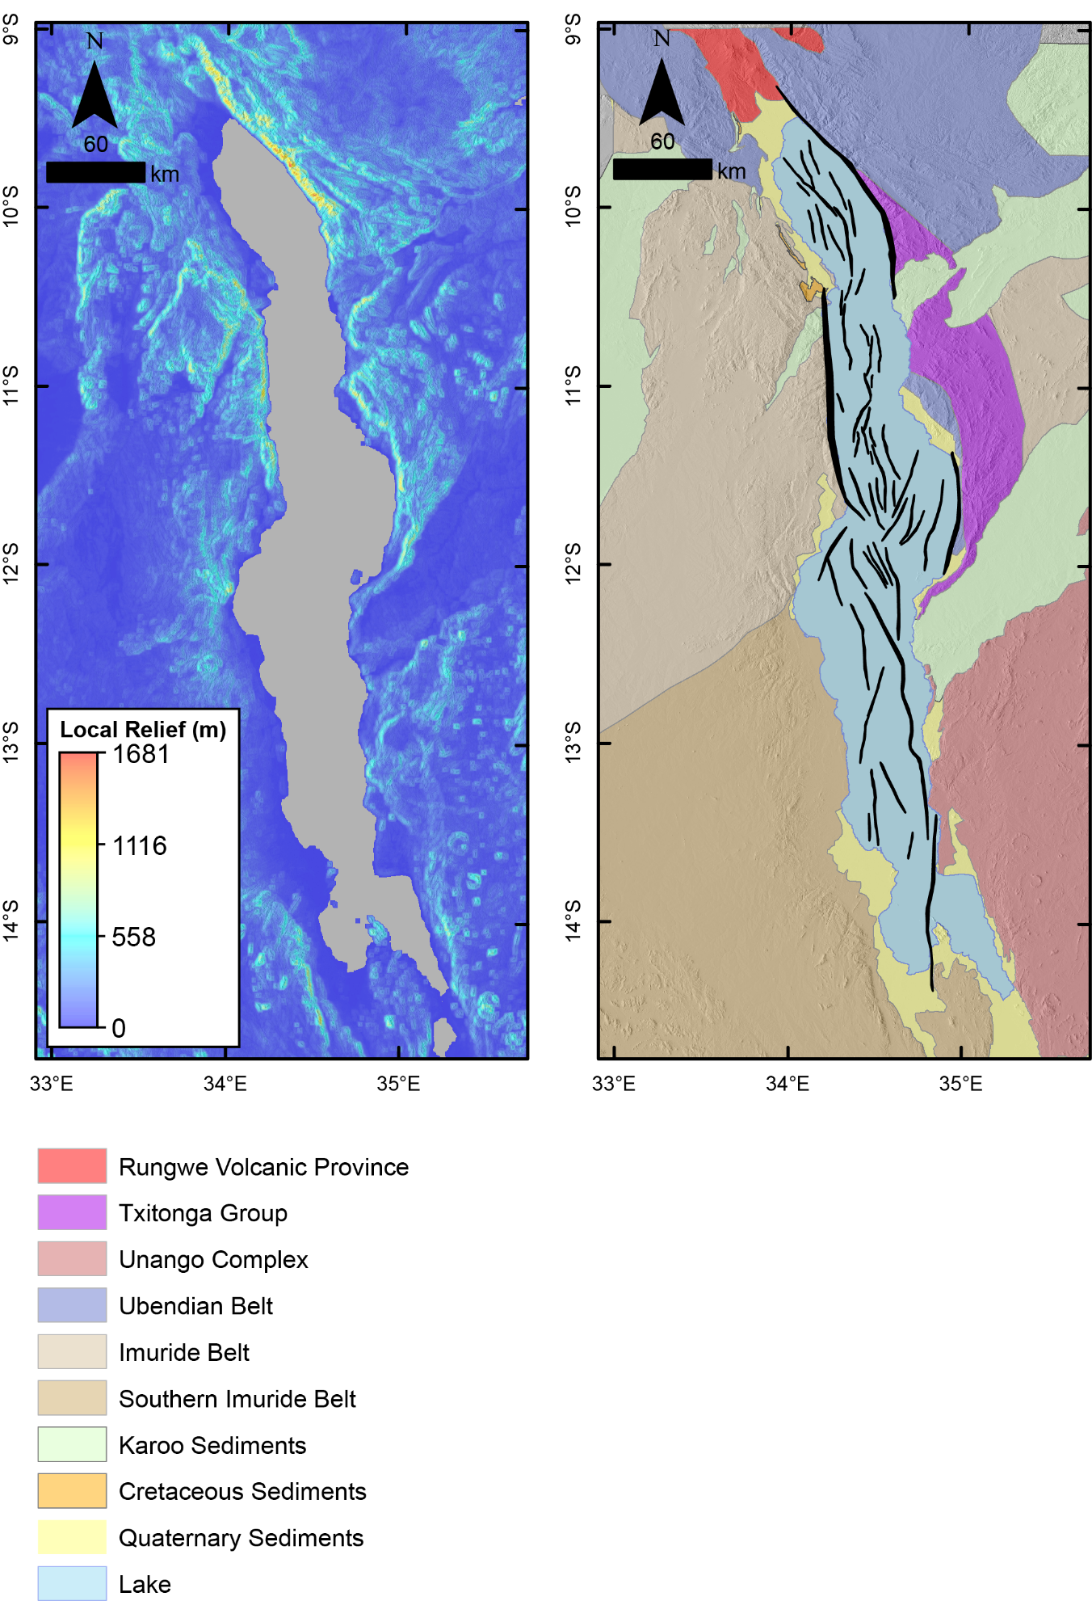

Figure S-1: A) Local relief measured in a 2.5-km radius moving window. B) Simplified geologic map of the Lake Malawi (Nyasa) region, black polygons represent basement-rooted faults.

6) ANALYSIS OF REGIONAL AND LOCAL RELIEF
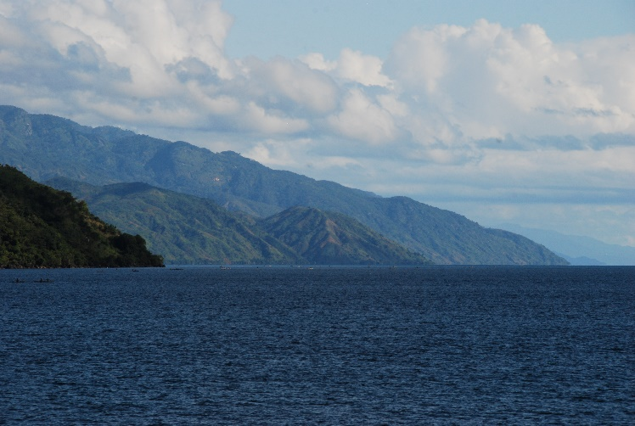
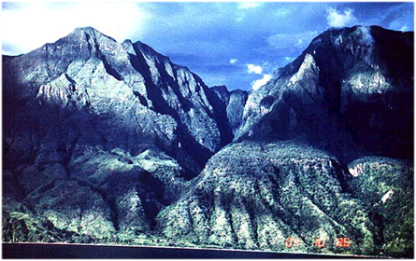
The digital elevation model presented in the main text is a standard linear color display of the SRTM 1 arc-second (~30 m resolution) data set. Because of significant relict relief in the region, outside of the rift valley, this representation conceals somewhat the local short-wavelength relief associated with the footwall uplifts of individual rift segments. Here we compute local relief in the study area, using a 2.5-km smoothing parameter (Fig. S-1). Local relief (e.g. Ahnert, 1970; DiBiase et al., 2010; Forte et al., 2016) is the difference between maximum and minimum elevations within a specified distance (here 2.5 km). This topographic metric shows established correlations with erosion rate in other settings (e.g. Kirby and Whipple, 2012; Lague, 2014; Forte et al., 2016) thus also correlating with and highlighting the short wavelength border fault footwall uplifts, incipient drainages, and lithologic changes. Also included here are images of the faulted coastlines of the North and Central Basins of the Malawi Rift.

Figure S-2. Left photo is of the Livingstone Mountains which rise ~1500 m above the adjacent lake on the northeastern shore of the North Basin of the Malawi Rift. Water depth at the site of the photo is approximately 500 m, and synrift sediment thickness in that location is >4.5 km, indicating border fault throw in excess of 6.5 km. Right photo is the Usisya Fault located on the western side of the Central Basin of the Malawi Rift (photo credit – C. Scholz).

7) STRUCTURAL RESTORATIONS
We construct and balance three regional geo-seismic cross-sections (e.g. Gibbs, 1983; Rowan and Kligfield, 1989) along the Lake Malawi Rift (Figure 9 in main body of text), in the North, Central and Southern Basins using the Lithotect™ structural restoration software (Fig S-3, S-4, S-5). Stratigraphic architecture and fault geometry beneath the lake are constrained by reflection seismic data interpretations from the SEGMeNT and ION-PROBE Pre-stack Kirchhoff depth-migrated multichannel reflection seismic data sets in the North & Central, and Southern Basins respectively.
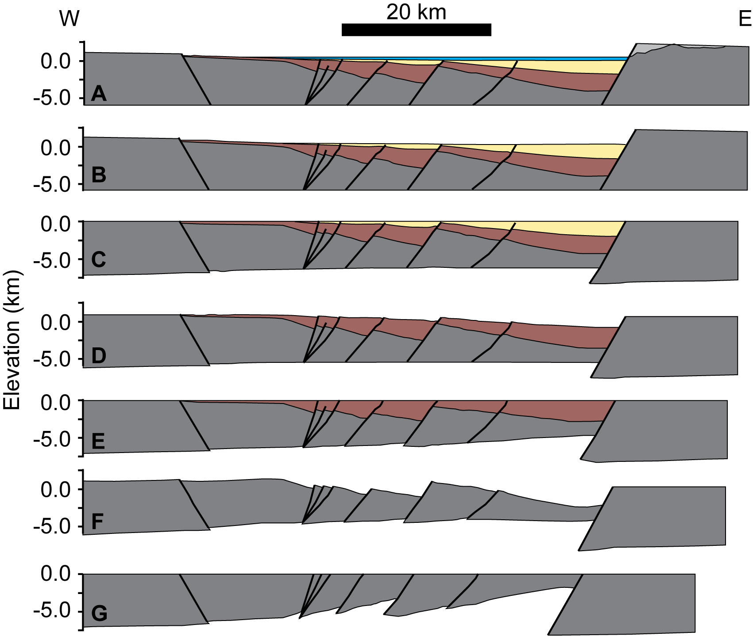
Figure S-3. Sequential structural restoration across the North Basin, see main text Figure 9 for key to syn-rift sequences. A) Present day configuration, note that lighter grey shading represents the area added during the correction for erosion. B) Removal of the water column, decompaction of the syn-rift sediments & flexural isostatic correction. C) Restoration of lake floor and border fault footwalls to a flat datum. D) Decompaction of Baobab-Nyasa sequence and flexural isostatic correction following the removal of the recent-1.3 Ma sequence. E) Restoration of Baobab-Nyasa sequence. F) Flexural isostatic correction of the Basement, note the Basement does not decompact as it is an incompressible solid. G) Restoration of the Basement. All restorations at 1:1 V:H.

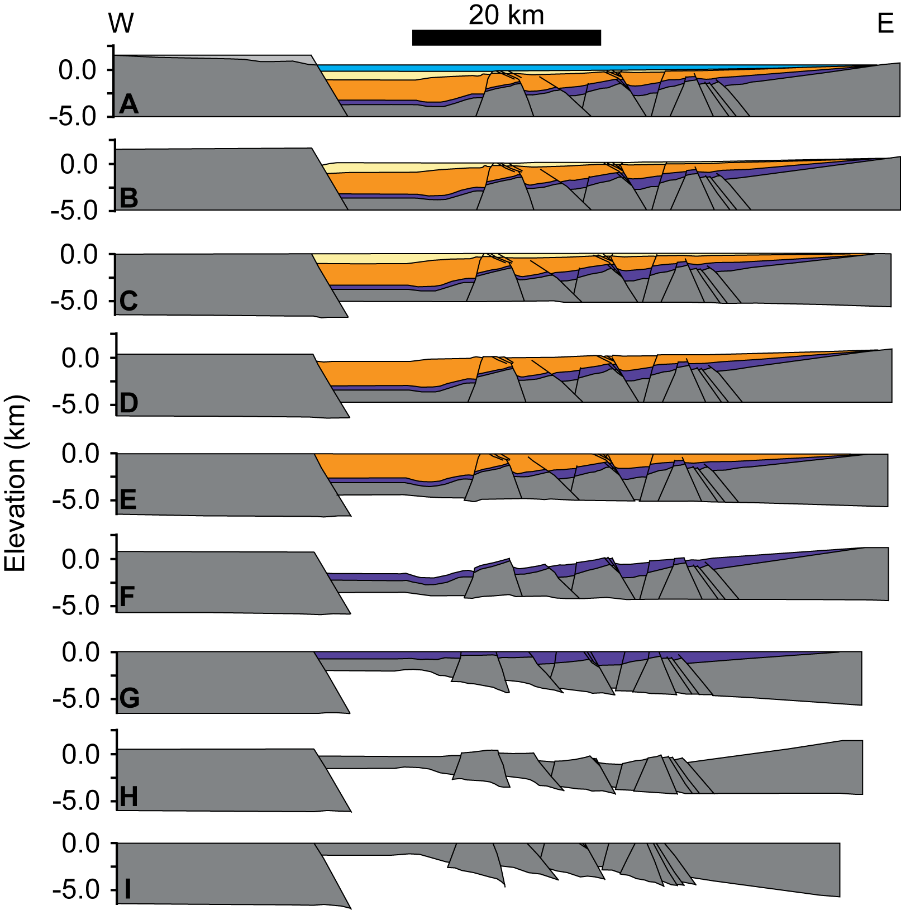
Figure S-4. Sequential structural restoration across the Central Basin, see main text Figure 9 for key to syn-rift sequences. A) Present day configuration, note that lighter grey shading represents the area added during the correction for erosion. B) Removal of the water column, decompaction of the syn-rift sediments & flexural isostatic correction. C) Restoration of lake floor and border fault footwalls to a flat datum. D) Removal of the Recent-1.3 Ma sequence, decompaction of the underlying Baobab & Nyasa sequences, and flexural isostatic correction. E) Restoration to the top of the Baobab Sequence. F) Removal of the Baobab Sequence, decompaction of the underlying Nyasa Sequence, and flexural isostatic correction. G) Restoration to the top of the Nyasa Sequence. H) Removal of the Nyasa Sequence and flexural isostatic correction. I) Restoration of the Basement, note the Basement is an incompressible solid and therefore does not decompact. All restorations at 1:1 V:H.

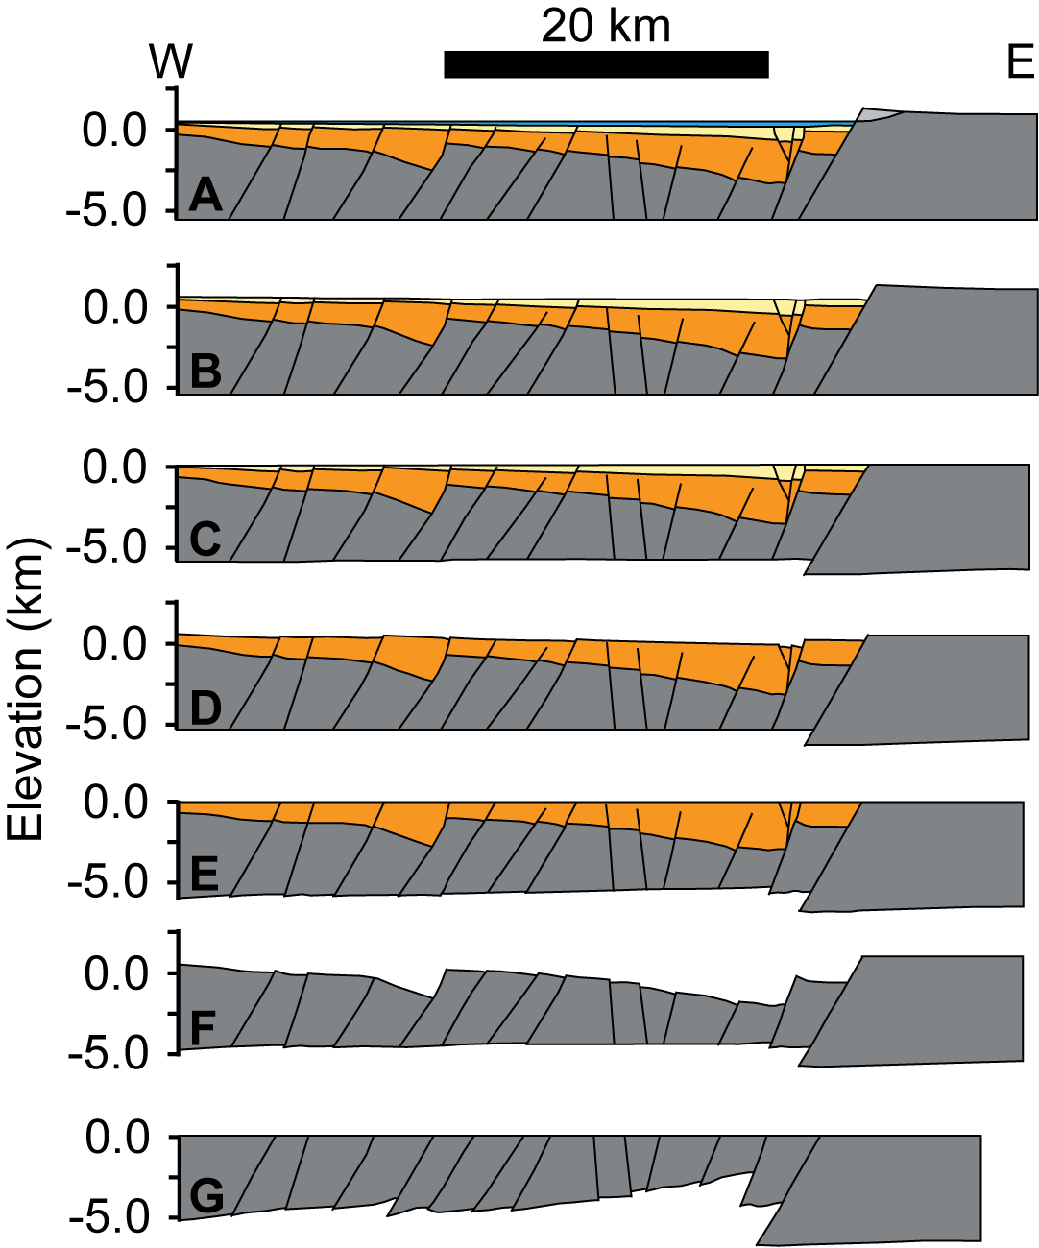
Figure S-5. Sequential structural restoration across the South Basin, see main text Figure 9 for key to syn-rift sequences. A) Present day configuration, note that lighter grey shading represents the area added during the correction for erosion. B) Removal of the water column, decompaction of the syn-rift sediments & flexural isostatic correction. C) Restoration to the top of the Recent-1.3 Ma Sequence. D) Removal of the Recent-1.3 Ma Sequence, decompaction of the underlying Baobab sequence, and flexural isostatic correction. E) Restoration to the top of the Baobab Sequence. F) Removal of Baobab Sequence and flexural isostatic correction. G) Restoration of the Basement, note the Basement is an incompressible solid and does not decompact. All restorations at 1:1 V:H.

Footwall uplifts within the Western Branch of the East African Rift System follow the shape of the long-wavelength topography (Ebinger et al., 1991) and the regional elevation and pin-point is defined as the point where this long-wavelength uplift decays away. We constrain these using the ETOPO30 DEM in the Central and Southern Basins, and the 90m SRTM DEM in the Northern Basin. The SRTM data is down-sampled to the same resolution (~ 1 km) as ETOPO30 for consistency.
Faults laying outside the Rift Lake are constrained through the analysis of pre-existing structures described earlier. In areas where the geometry of a fault is not constrained, it is assumed to be Andersonian (i.e. 60˚ dip and planar geometry). Focal mechanisms from earthquakes on intrarift faults indicate dips of 40-65º (Gaherty et al., 2019; Ebinger et al., 2019), so assuming a 60º dip will yield conservative estimates of extension.
Cross-sections are orientated parallel to the modeled regional extension directions for Lake Malawi from Delvaux and Barth (2010) in the Northern Basin, and Saria et al. (2014), in the Central and Southern Basins; these extension directions are also rift-normal (i.e. perpendicular to border fault orientation). 2D restorations assume no flow into or out of the plane of section, thus if sections do not balance it is attributed to 1) a component of deformation occurring through out-of-plane motion, 2) erroneous interpretations (Gibbs, 1983, 1984; Groshong, 2006) or 3) erroneous depth conversions. Thus, we project our seismic interpretations into the regional extension directions using Lithotect’s built in algorithms to correctly interpret the structure.
Restoration Method
Sections are restored using the vertical simple-shear kinematic model of Gibbs (1983, 1984), which is considered to be a good geometrical approximation to distributed brittle deformation at the cross section scale within unconsolidated and well bedded sediments (Rowan and Kligfield, 1989)(Fig. S-6). We conserve area within fault blocks & to the base of our sections during the restoration process, whereas the area of section beneath the basement (white areas Figures S3-5) is not required to remain constant and may freely flow into and out of the plane (Schultz-Ela, 1992). Finally, we assume plane-strain in all our restorations (i.e. that extension is parallel to the line of section).
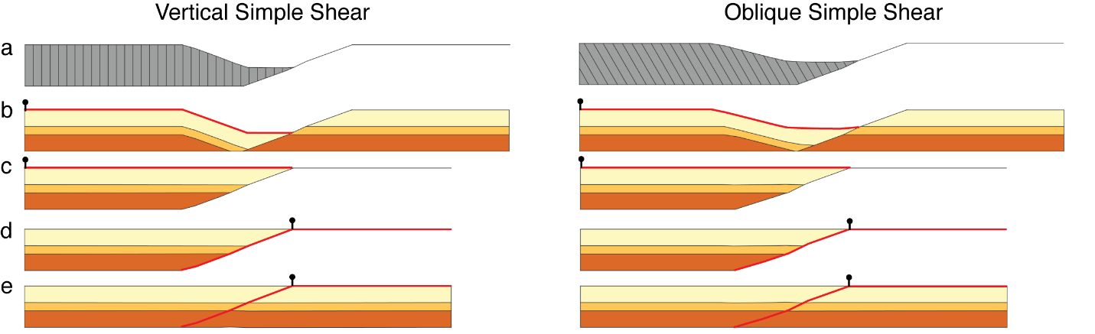
Figure S-6. Modeled restorations in Lithotect following the approach described in the main text and SI using both vertical simple shear and oblique simple shear kinematic models. Black pins indicate local pinpoints and red lines indicate the deformed and restored reference lines for each fault block. a) Slip vector orientation is vertical (90°) or oblique (60°). b) Initial deformed state, note the deformed reference line and pin location. c) From the horizontal orientation of beds in the hanging wall away from the fault we assume a horizontal initial state and restore the hanging wall block to a horizontal top datum with a left-hand pinpoint. d) For the footwall block we again assume an undeformed state and choose a fault and horizontal top datum reference line, note pinpoint location. e) Restored models, which show the same restored geometries and extension independent of the kinematic model applied during the restoration.

Restoration begins with correcting for eroded section by projecting hanging wall cutoffs to the projected up dip intersection of faults (light grey area Figures S3-7). We then remove the topmost unit, decompact the underlying sequences using methods in Lithotect following Sclater and Christie (1980) and correct our sections for the flexural-isostatic response of the associated unloading using Lithotect’s in-built algorithm. During this flexural isostatic correction, we use an elastic thickness (T_{e}) of 45 km from Ebinger et al. (1991).We also assume that the border fault footwall is ‘fixed’, and that the hanging wall is a broken-plate (e.g. Turcotte & Schubert, 2002). In the decompaction process in Lithotect we assign each sequence a solidity function (i.e. how porosity varies with depth) from the interpreted facies of each sequence (e.g. Wright et al., 2020).These assumptions are consistent with the recent observations of deep seismicity at depth, and the thick crust in the region (Ebinger et al. 2019). We then restore fault block by fault block to a horizontal datum for the interpreted sequence boundaries within each cross-section correcting for missing section as required. The above is then repeated for each sequence down to the basement.
We restore all sequences to a horizontal datum as they do not appear to infill relic topography. Our structural restorations restore to the regional pin point during each rift stage, and this method minimizes topography on the uplifted rift flanks and results in zero accommodation space in the basin. Therefore, the observed border fault configuration during the restored stages does not represent the true rift topography during rifting.
8) ANALYSIS OF RUNGWE VOLCANIC LOAD
The theoretical plate deflection and extensional strains from a lithosphere load can be modelled using the method of Turcotte and Schubert (1982), described in Billings and Kattenhorn (2005), where a vertical line-load is applied to an elastic plate. The broken plate deflection profile across the border fault hanging wall from Billings and Kattenhorn (2005) is:
ω = ω₀ e^{-x/α} cos (x/α)
where ω₀ is the maximum deflection, x defines the position away from the load along the
deflecting plate, and α is defined by:
α = [Eh³/(3ρ₀g (1 – υ²))]^{1/4}
where E is Young’s modulus, υ is Poisson’s ratio (0.25), g is acceleration due to gravity, h is
the thickness of the plate, and ρ₀ is the density of the underlying layer (mafic lower crust is ~3,300 kg m⁻³).
A forebulge is characteristic of the deflection profile and represents the location where the plate warps upward at the surface near the outer edge of the deflection profile. Billings and Kattenhorn (2005) calculated the distance to the forebulge, x_{b}, by maximizing the deflection profile to obtain
x_{b} = 3πα/4.
Turcotte and Schubert (2002) show that the area of subsidence for an elastic plate impacted by a vertical load will be determined primarily by the thickness (h) and elastic properties (Young’s modulus (E) and Poisson’s ratio (v)) of the subsiding elastic layer. Using relations in Turcotte & Schubert (2002) and elastic properties from Shillington et al. (2020) (h = 38 km, E = 2-4 Gpa, v = 0.25), the estimated distance from the summit of Rungwe volcano to the flexural forebulge (i.e., radius of the subsiding region) is calculated to range between 78 and 93 km and extends into the northern part of the North Basin, thus supporting the potential role of volcanic loading in enhancing subsidence at the northern end of the Malawi Rift.
9) LINEAMENT ANALYSES
The regional distribution of faulting outside of Lake Malawi was mapped and analyzed in the study region through the use of the 30 m SRTM (both DEM data and hillshades) (Fig. 10 of main text). Linear surface features, with lengths >10 km and exhibiting observable surficial scarps (minimum relief of 30 m), were interpreted as fault segments; however, if these scarps were part of a slope forming a ridge, they were classified as basement lineaments. These throw value thresholds are well above the vertical precision of the SRTM digital elevation model (DEM) dataset on the African continent (7.6 m to 95% confidence; (Rodriguez et al., 2005; Muirhead et al., 2016). Segments were interpreted to form part of a longer, segmented fault if they (1) exhibited relay zones with small offsets relative to the segment length, (2) had similar dip directions, and (3) displayed regular and systematic changes in throw patterns between segments, indicating that segments are geometrically and kinematically coherent (e.g. Vétel et al., 2005). Consistent with the extensional tectonic setting, and focal mechanisms of earthquake events in the region, all faults were assumed to be normal dip-slip structures, although some faults in the region are observed to have components of oblique-slip on geological timescales (Wheeler and Karson, 1994). The interpreted faults still maintain the typical geomorphic, surface expression of recently active normal faults (Stewart and Hancock, 1990; Leeder et al., 1991), and are thus expected to be related to EARS rifting, which may have begun in the region as early as 25 Ma (e.g., maximum age of the Rukwa rift; Roberts et al., 2012). The SRTM fault analysis has two primarily limitations: (1) smaller normal faults were not included in the analyses, and (2) the analyses do not consider any potential strike-slip components along the fault plane. However, as we have mapped only the largest geomorphically expressed EARS faults in the region (i.e., lengths >10 km, throws >30 m), that have accrued the greatest amount of throw presumably over the course of rifting, we expect these analyses to be a reasonable representation of the time-averaged deformation patterns during evolution of the rift. Finally, as focal mechanisms of earthquake events in this part of the Western rift branch are dominantly dip-slip, we assume that the strike-slip component along these faults is relatively small (Delvaux and Barth, 2010; McCartney and Scholz, 2016; Morley, 2010).
Pre-existing basement structures (e.g., fractures, shear zones) were compared with interpreted lineaments from the 30 m SRTM. Consistent with previous remote mapping studies of structural features in the EARS (Isola et al., 2014; Delcamp et al., 2016), long linear features within 75 km of the lake shoreline were characterized as representing pre-existing fabrics if they had lengths >10 km and no visible scarp. so as not to falsely characterize recently active faults as pre-existing structures. As these structural features do not exhibit a scarp, they form as long, linear ridges or valleys. These features were enhanced visually by applying hillshades at various angles and calculating the second derivative of the elevation data of the 30 m SRTM.
10) AGE RELATIONS, THE ONSET OF LATE-CENOZIC RIFTING, AND THE NATURE OF THE DEEP ‘EARLY/PRE-RIFT SEQUENCE IN THE NORTH AND CENTRAL BASINS
The age of initiation of rifting in the western branch of the East African Rift has been the subject of discussion and research (e.g. Ebinger et al., 1989; Cohen et al., 1993; Roberts et al., 2012), yet conclusive data on the age of the origin Lake Malawi Rift are absent, due to the lack of sample material from deep within the synrift sedimentary section. In 2005 an international team sampled and age-dated the upper 380 m of sedimentary section in the central basin of the Rift (Lyons et al., 2015), which determined that the basal age of the core was 1.3 million years. Since the drill core extended only into ~20% of the syn-rift section (Scholz et al., 2006, 2011), we estimate a Miocene basal age of the syn-rift section deposited in the most recent rifting event. Because the deepest synrift sedimentary package appears to be missing in the South Basin of the rift, we infer that this estimated Miocene basal age holds for the Central and North Basins of the rift only. The presence of additional sedimentary material with “intermediate” velocities (Accardo et al, 2018), suggests that a substantially older section may underlie the syn-rift deposits in the deeper parts of the Central Basin. The presence of Cretaceous and Karoo deposits onshore at the latitude of the northern accommodation zone between the Central and North Basins suggests that these rocks may in fact be present at depth within the rift as well, but data in-hand cannot disprove the presence of possible earlier Cenozoic deposits, such as have been identified in the Rukwa region (Roberts et al., 2012).
REFERENCES
Accardo, N.J., Shillington, D.J., Gaherty, J.B., Scholz, C.A., Nyblade, A.A., Chindandali, P.R.N., Kamihanda, G., McCartney, T., Wood, D., and Wambura Ferdinand, R., 2018, Constraints on Rift Basin Structure and Border Fault Growth in the Northern Malawi Rift From 3-D Seismic Refraction Imaging: Journal of Geophysical Research: Solid Earth, v. 123, p. 10,003-10,025, doi:10.1029/2018JB016504.
Ahnert, F., 1970, Functional relationships between denudation, relief, and uplift in large, mid-latitude drainage basins: American Journal of Science, doi:10.2475/ajs.268.3.243.
Billings, S.E., and Kattenhorn, S.A., 2005, The great thickness debate: Ice shell thickness models for Europa and comparisons with estimates based on flexure at ridges: Icarus, doi:10.1016/j.icarus.2005.03.013.
Cohen, A.S., Soreghan, M.J., and Scholz, C.A., 1993, Estimating the age of formation of lakes: an example from Lake Tanganyika, East African Rift system: Geology, v. 21, doi:10.1130/0091-7613(1993)021<0511:ETAOFO>2.3.CO;2.
Delcamp, A., Delvaux, D., Kwelwa, S., Macheyeki, A., and Kervyn, M., 2016, Sector collapse events at volcanoes in the North Tanzanian divergence zone and their implications for regional tectonics: Bulletin of the Geological Society of America, doi:10.1130/B31119.1.
Delvaux, D., and Barth, A., 2010, African stress pattern from formal inversion of focal mechanism data: Tectonophysics, v. 482, p. 105–128, doi:10.1016/j.tecto.2009.05.009.
DiBiase, R.A., Whipple, K.X., Heimsath, A.M., and Ouimet, W.B., 2010, Landscape form and millennial erosion rates in the San Gabriel Mountains, CA: Earth and Planetary Science Letters, v. 289, p. 134–144, doi:10.1016/J.EPSL.2009.10.036.
Ebinger, C.J. et al., 2019, Kinematics of Active Deformation in the Malawi Rift and Rungwe Volcanic Province, Africa: Geochemistry, Geophysics, Geosystems, v. 20, p. 3928–3951, doi:10.1029/2019GC008354.
Ebinger, C.J., Deino, A.L., Drake, R.E., and Tesha, A.L., 1989, Chronology of Volcanism and Rift Basin Propagation: Rungwe Volcanic Province, East Africa: JOURNAL OF GEOPHYSICAL RESEARCH, v. 94, p. 15,785-15,80.
Ebinger, C.J., Karner, G.D., and Weissel, J.K., 1991, Mechanical strength of extended continental lithosphere: Constraints from the Western Rift System, East Africa: Tectonics, v. 10, p. 1239–1256, doi:10.1029/91TC00579.
Forte, A.M., Whipple, K.X., Bookhagen, B., and Rossi, M.W., 2016, Decoupling of modern shortening rates, climate, and topography in the Caucasus: Earth and Planetary Science Letters, v. 449, p. 282–294, doi:10.1016/J.EPSL.2016.06.013.
Gaherty, J.B. et al., 2019, Faulting processes during early-stage rifting: Seismic and geodetic analysis of the 2009-2010 Northern Malawi earthquake sequence: Geophysical Journal International, v. 217, doi:10.1093/gji/ggz119.
Gibbs, A.D., 1983, Balanced cross-section construction from seismic sections in areas of extensional tectonics: Journal of Structural Geology, doi:10.1016/0191-8141(83)90040-8.
Gibbs, A.D., 1984, Structural evolution of extensional basin margins: Journal of the Geological Society, v. 141, p. 609 LP – 620, doi:10.1144/gsjgs.141.4.0609.
Groshong, R.H., 2006, 3-D structural geology: A practical guide to quantitative surface and subsurface map interpretation:, doi:10.1007/978-3-540-31055-6.
Isola, I., Mazzarini, F., Bonini, M., and Corti, G., 2014, Spatial variability of volcanic features in early-stage rift settings: The case of the Tanzania Divergence, East African rift system: Terra Nova, v. 26, p. 461–468, doi:10.1111/ter.12121.
Kirby, E., and Whipple, K.X., 2012, Expression of active tectonics in erosional landscapes: Journal of Structural Geology, doi:10.1016/j.jsg.2012.07.009.
Lague, D., 2014, The stream power river incision model: evidence, theory and beyond: Earth Surface Processes and Landforms, v. 39, p. 38–61, doi:10.1002/esp.3462.
Leeder, M.R., Seger, M.J., and Stark, C.P., 1991, Sedimentation and tectonic geomorphology adjacent to major active and inactive normal faults, southern Greece: Journal of the Geological Society, doi:10.1144/gsjgs.148.2.0331.
Lyons, R.P. et al., 2015, Continuous 1.3-million-year record of East African hydroclimate, and implications for patterns of evolution and biodiversity: Proceedings of the National Academy of Sciences of the United States of America, v. 112, p. 15568–15573, doi:10.1073/pnas.1512864112.
McCartney, T., and Scholz, C.A., 2016, A 1.3 million year record of synchronous faulting in the hangingwall and border fault of a half-graben in the Malawi (Nyasa) Rift: Journal of Structural Geology, v. 91, doi:10.1016/j.jsg.2016.08.012.
Morley, C.K., 2010, Stress re-orientation along zones of weak fabrics in rifts: An explanation for pure extension in “oblique” rift segments? Earth and Planetary Science Letters, v. 297, p. 667–673, doi:10.1016/j.epsl.2010.07.022.
Muirhead, J.D., Kattenhorn, S.A., Lee, H., Mana, S., Turrin, B.D., Fischer, T.P., Kianji, G., Dindi, E., and Stamps, D.S., 2016, Evolution of upper crustal faulting assisted by magmatic volatile release during early-stage continental rift development in the East African Rift: Geosphere, doi:10.1130/GES01375.1.
Roberts, E.M., Stevens, N.J., O’Connor, P.M., Dirks, P.H.G.M., Gottfried, M.D., Clyde, W.C., Armstrong, R.A., Kemp, A.I.S., and Hemming, S., 2012, Initiation of the western branch of the East African Rift coeval with the eastern branch: Nature Geoscience, v. 5, p. 289–294, doi:10.1038/ngeo1432.
Rodriguez, E., Morris, C.S., Belz, J.E., Chapin, E.C., Martin, J.M., Daffer, W., and Hensley, S., 2005, An assessment of the SRTM topographic products, Technical Report JPL D-31639: Jet Propulsion Laboratory,.
Rowan, M.G., and Kligfield, R., 1989, Cross section restoration and balancing as aid to seismic interpretation in extensional terranes: AAPG Bulletin, v. 73, p. 955–966, https://www.osti.gov/servlets/purl/5461301.
Saria, E., Calais, E., Stamps, D.S., Delvaux, D., and Hartnady, C.J.H., 2014, Present-day kinematics of the East African Rift: Journal of Geophysical Research: Solid Earth, v. 119, p. 3584–3600, doi:10.1002/2013JB010901.
Scholz, C.A., Cohen, A.S., Johnson, T.C., King, J.W., and Moran, K., 2006, The 2005 Lake Malawi Scientific Drilling Project: Scientific Drilling, p. 2005–2007, doi:10.2204/iodp.sd.2.04.2006.
Scholz, C.A., Cohen, A.S., Johnson, T.C., King, J., Talbot, M.R., and Brown, E.T., 2011, Scientific drilling in the Great Rift Valley: The 2005 Lake Malawi Scientific Drilling Project - An overview of the past 145,000years of climate variability in Southern Hemisphere East Africa: Palaeogeography, Palaeoclimatology, Palaeoecology, v. 303, doi:10.1016/j.palaeo.2010.10.030.
Schultz-Ela, D.D., 1992, Restoration of cross-sections to constrain deformation processes of extensional terranes: Marine and Petroleum Geology, v. 9, p. 372–388, doi:10.1016/0264-8172(92)90049-K.
Sclater, J.G., and Christie, P.A.F., 1980, Continental Stretching: An Explanation Of The Post-Mid-Cretaceous Subsidence Of The Central North Sea Basin: Journal of Geophysical Research, v. 85, p. 3711–3739.
Shillington, D.J. et al., 2016, Acquisition of a unique onshore/offshore geophysical and geochemical dataset in the northern Malawi (Nyasa) rift: Seismological Research Letters, v. 87, doi:10.1785/0220160112.
Shillington, D.J., Scholz, C.A., Chindandali, P., Gaherty, J.B., Acccardo, N.J., Onyango, E., Ebinger, C.J., and Nyblade, A.A., 2020, Controls on intrarift faulting in the North Basin of the Malawi (Nyasa) Rift, East Africa: Tectonics, v. 39, p. e2019TC005633, doi:https://doi.org/10.1029/2019TC005633.
Stewart, I.S., and Hancock, P.L., 1990, What is a fault scarp: Episodes, v. 13, p. 256–263.
Turcotte, D., and Schubert, G., 1982, Geodynamics : applications of continuum physics to geological problems: New York, John Wiley & Sons, Ltd, 450 p.
Turcotte, D., and Schubert, G., 2002, Geodynamics: Cambridge University Press.
Vétel, W., Le Gall, B., and Walsh, J.J., 2005, Geometry and growth of an inner rift fault pattern: the Kino Sogo Fault Belt, Turkana Rift (North Kenya): Journal of Structural Geology, v. 27, p. 2204–2222, doi:10.1016/J.JSG.2005.07.003.
Wheeler, W.H., and Karson, J.A., 1994, Extension and subsidence adjacent to a “weak” continental transform: An example from the Rukwa rift, East Africa: Geology, v. 22, p. 625–628, doi:10.1130/0091-7613(1994)022<0625:EASATA>2.3.CO;2.
Wright, L.J.M., Muirhead, J.D., and Scholz, C.A., 2020, Spatiotemporal Variations in Upper Crustal Extension Across the Different Basement Terranes of the Lake Tanganyika Rift, East Africa: Tectonics, v. 39, p. e2019TC006019, doi:10.1029/2019TC006019.

