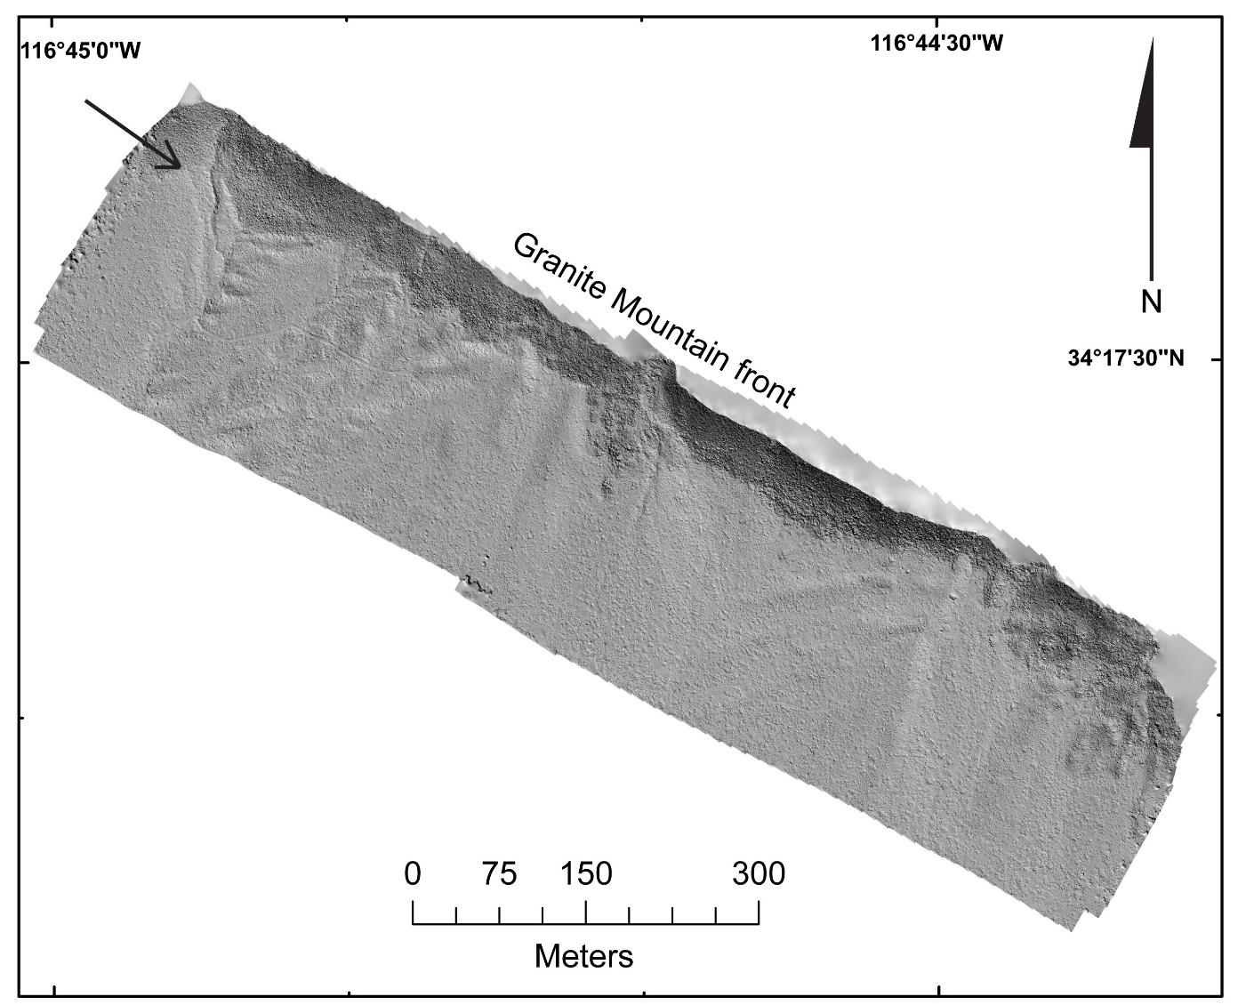
Figure 1. UAV-derived hillshade of the northeastern side of Lone Valley (see figure 3 for location). Lineaments along the mountain front present little evidence for recent faulting. No channel offsets or displaced alluvium could be found, both in the field and using high-resolution topography. While this is a most probable location for faulting prior to the Pleistocene? we suggest the northeast side of Lone Valley to be inactive.

Figure 2. Uninterpreted hillshade from the Lone Valley fault. Find the interpreted figure as Figure 4 in the main body of the text.

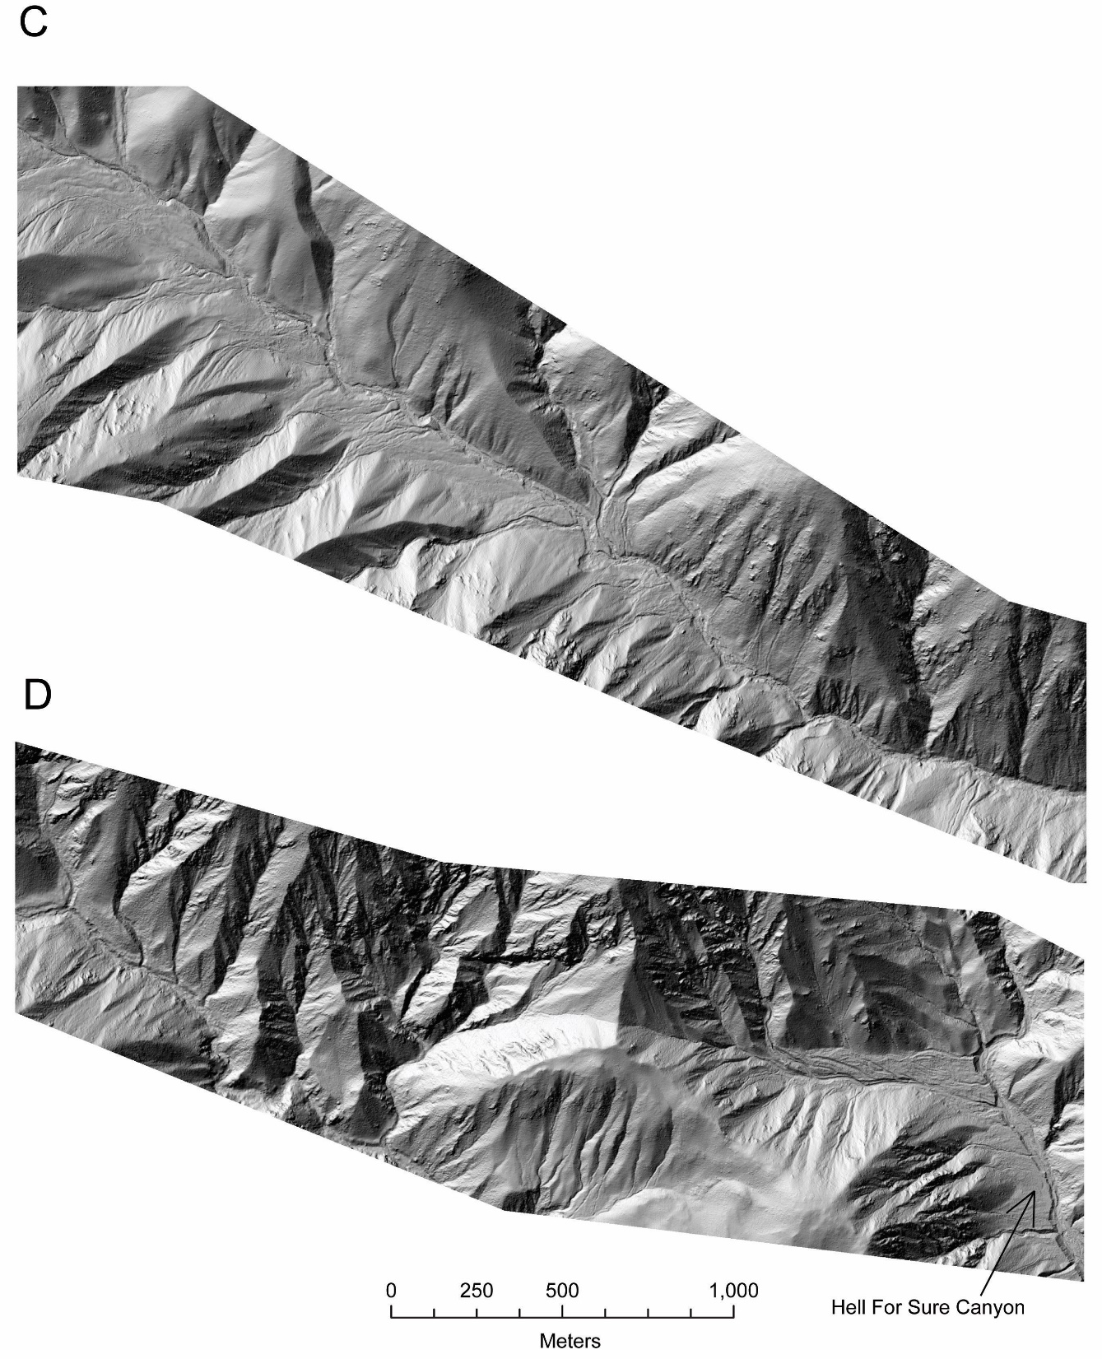
Figure 3. Uninterpreted panels A-D of 1m-resolution lidar data. Find the interpreted figure as Figure 8A-D in the main body of the text.

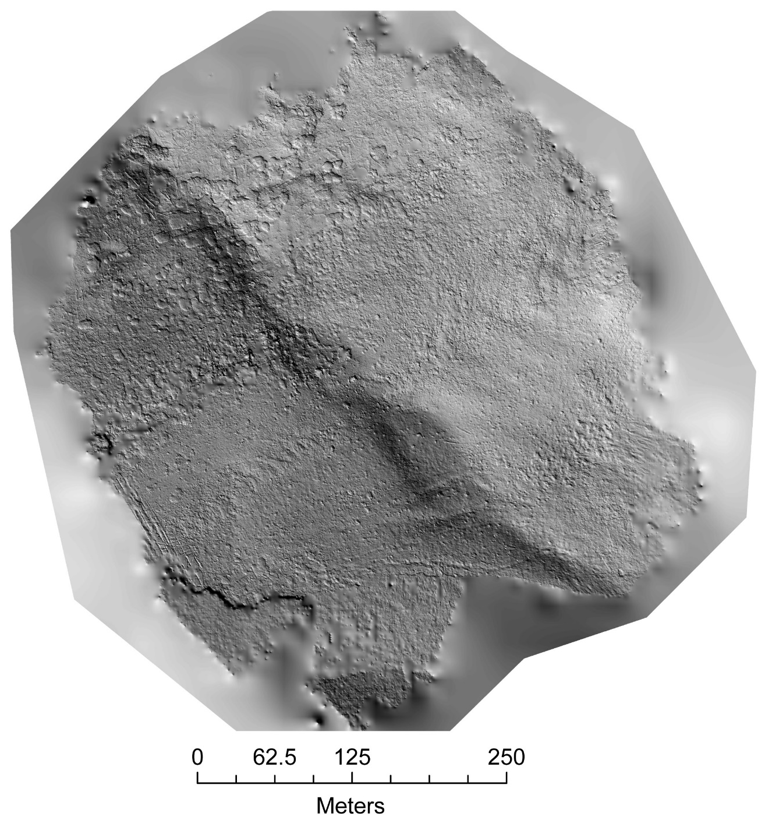
Figure 4. UAV-sourced, uninterpreted hillshade using photogrammetry from the Lake Peak fault in the San Bernardino Mountains. Lighting direction is from the SW. The point cloud was classified to remove vegetation and other surface debris. Find the annotated figure as Figure 9 in the main body of the text.

