Supplementary Material for “Controls on the Structural and Stratigraphic Evolution of the Megaflap-bearing Sinbad Valley Salt Wall, NE Paradox Basin, SW Colorado” by Thompson Jobe and coauthors.

Detailed Megaflap Facies Descriptions:
CL-I comprises multistory packages of pebble conglomerates with a medium- to coarse-grained sandy matrix interbedded with horizontally and cross stratified, rippled sandstones and laminated siltstones. The pebble clasts are commonly subangular and poorly sorted, and comprise granites and feldspars. Beds are 5-20 cm thick and are interbedded with fine- to coarse-grained sandstones. This facies comprises the lower part of both sections. We interpret this environment to be channel sands and overbank deposits deposited in a medial to distal fluvial braided environment. This facies is similar to the CL-V facies of Gianniny and Miskell-Gerhardt (2009) in the uppermost Hermosa Group.
CL-II is an interbedded succession of reddish-brown or tan micaceous, horizontally and cross-stratified fine- to medium-grained sandstones and laminated siltstones. Beds are commonly 5-20 cm thick and have planar laminations 1-2 mm thick. We interpret this facies to be deposited from suspension on a meandering fluvial floodplain during waning flow conditions (Miall, 1996). This facies is similar to CL-VI of Gianniny and Miskell-Gerhardt (2009) of the uppermost Hermosa Group.
CA-I comprises crystalline limestone with slightly to coarsely crystalline texture that does not contain visible fossils or ghosts of fossils. The beds are commonly 5-20 cm thick, and are locally nodular and dolomitized. These limestones commonly have a gray-tan weathered surface and a dark grey fresh surface. Crystalline limestones in the upper Hermosa Group (analogous to the Honaker Trail) are interpreted to have been deposited under open marine conditions (Herman and Barkell, 1957).
CA-II is a fossiliferous mud-supported wackestone to packstone. It has abundant phylloidal algae with bivalves and uncommon crinoids in a micritic matrix, and beds 5-40 cm thick. We interpret this facies to represent deposition in relatively calm, shallow waters, possibly subtidal below storm wave base.
CA-III is a fossiliferous grain-supported packstone to grainstone. It has primarily crinoid and bryozoan grains with a micritic matrix, and also includes phylloid algae, bivalves, and brachiopods. The beds are <2 m thick. This facies is interpreted to have been deposited in a shallow tidal to intertidal environment, under moderate energy. Most of the grains are broken and appear to be reworked.
CA-IV is a dolomitized carbonate wackestone to mudstone, with minor quartz clasts present and no visible fossils. Beds are commonly 1-2 m thick. We interpret this facies to represent deposition in calm, shallow waters of an intertidal, possibly lagoonal, environment, followed by diagenetic alteration.
CA-V is a micritic mudstone, with beds that are commonly 10 to 30 cm thick. There are no visible fossils, but some beds exhibit wavy laminations. We interpret this facies to have been deposited in a shallow, calm environment, and may represent lagoon mud banks.

TABLE S1. SELECTED WELL FORMATION TOPS
Well Name | Top Wingate | Top Chinle | Top Moenkopi | Top Cutler | Top Honaker Trail/Hermosa | Top Ismay | Top Paradox Salt | Top Leadville
Federal Sinbad  Ridge 14-14 | 1999 | 1889 | 1770 | 1599 | 905* | -93 | -354 | N.D.
Geyser Creek | 2641 | 2582 | N.D. | 1496 | -411 | N.D. | N.D. | -1454
Haukelid 35-1 | N.D. | N.D. | 1701 | 1658 | -1298 | N.D. | N.D. | -2362
Huskey Huber 2 | N.D. | 1935 | 1907 | 1590 | 587* | N.D. | -750 | -874
Pace State 1 | 2314 | 2202 | N.D. | 2014 | N.D. | N.D. | N.D. | -2292
Taylor Creek | 2537 | N.D. | N.D. | 2199 | -1093 | N.D. | N.D. | -2265
Note: well tops are meters of elevation relative to sea level.
* marks suspected incorrect formation top from regional analysis

TABLE S2. THICKNESSES FROM SELECTED WELLS
Well Name | Wingate | Chinle | Moenkopi | Cutler | Honaker Trail/Hermosa | Ismay | Paradox Salt
Federal Sinbad  Ridge 14-14 | 110 | 119 | 171 | 693 | 998* | 88 | N.D.
Geyser Creek | 58 | 1086 |  | 1908 | 999
Haukelid 35-1 | N.D. | N.D. | 43 | 2956 | 1031
Huskey Huber 2 | N.D. | 12 | 317 | 1002 | 1338* | N.D. | 123
Pace State 1 | 111 | 189 |  | 4291
Taylor Creek | 338 |  |  | 3291 | 1173
Note: thicknesses in meters
* marks suspected incorrect formation top from regional analysis

TABLE S3. VELOCITIES USED FOR DEPTH CONVERSION
Interval | Velocity (m/s)
Surface to Top Honaker Trail | 3353
Honaker Trail | 4029
Paradox Formation | 4267
Basement | 5639

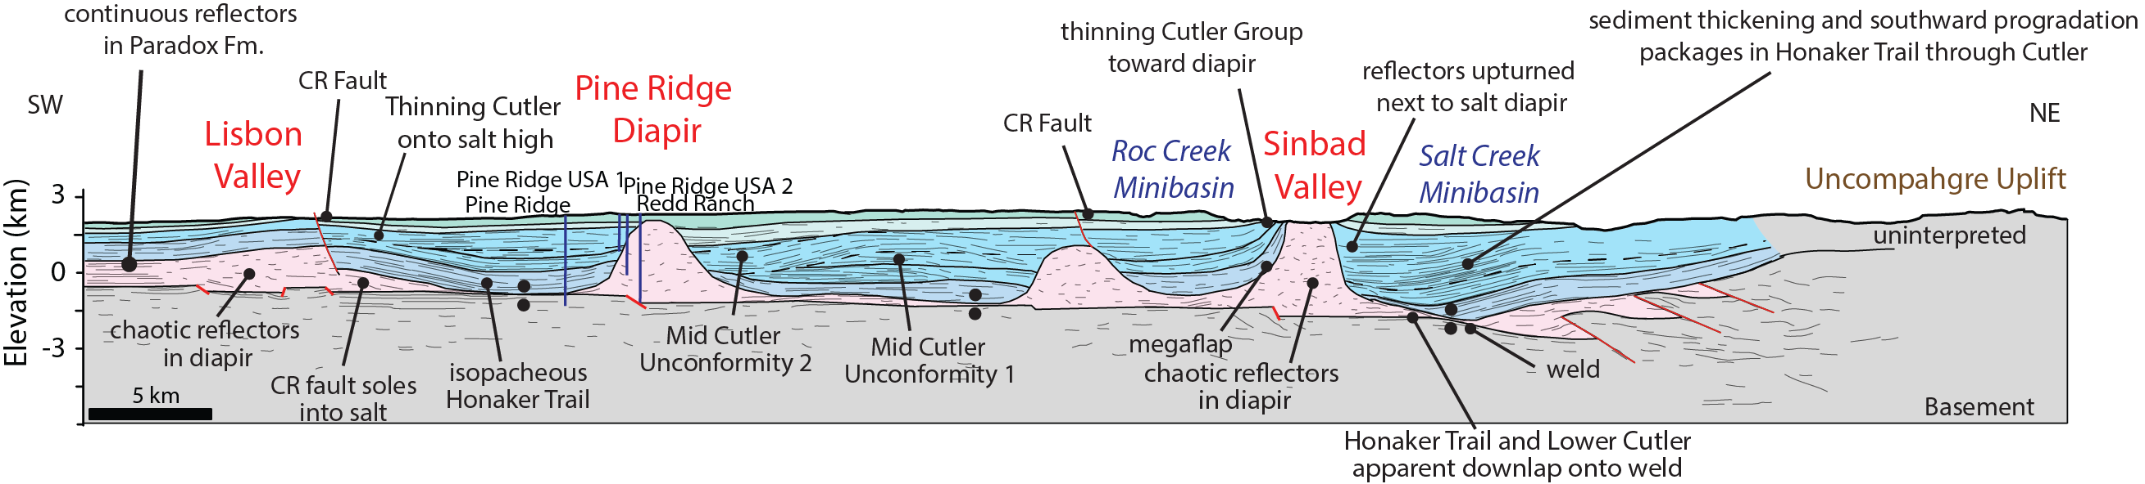
Fig. S1. Regional 2D depth-converted line drawing across the Paradox Basin, crossing the northwestern end of Sinbad Valley.

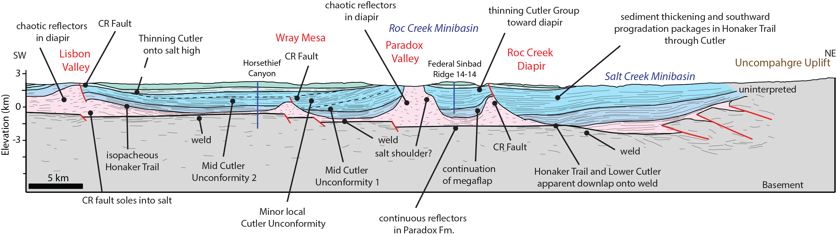
Fig. S2. Regional 2D depth-converted line drawing across the Paradox Basin, crossing the Roc Creek Diapir to the southeast of Sinbad Valley.

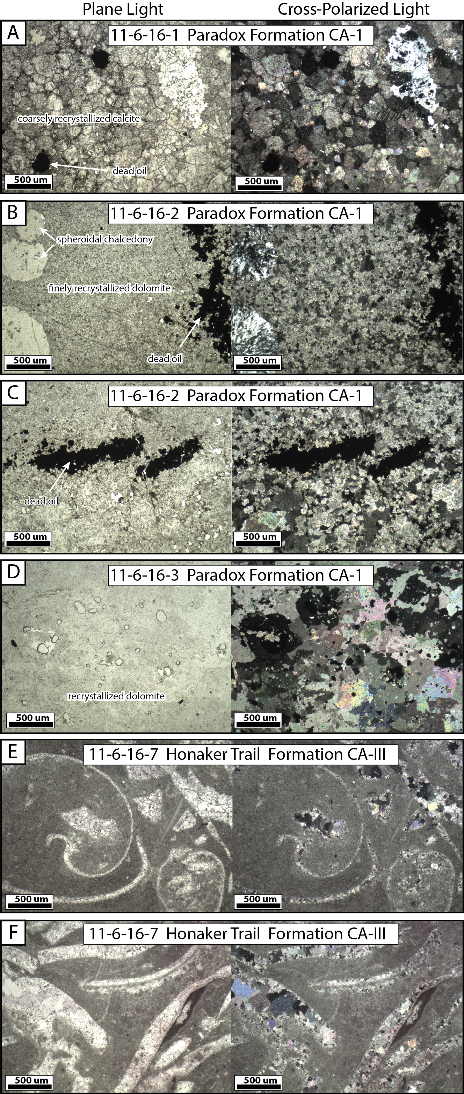
Fig. S3. Thin section photos (left – plane light, right – cross-polarized light) of carbonate megaflap strata of the Paradox and Honaker Trail Formations (A) Sample 11-6-16-1: Paradox Formation crystalline limestone (CA-1), illustrating dead oil and silica replacement. (B) 11-6-16-2: Paradox Formation recrystallized dolomite (CA-1), showing dead oil and spheroidal chalcedony. (C) 11-6-16-2: Paradox Formation recrystallized dolomite (CA-1), with dead oil and baroque dolomite. (D) 11-6-16-3: Paradox Formation recrystallized dolomite (CA-1), illustrating secondary porosity. (E) 11-6-16-7: Honaker Trail Formation skeletal wackestone to packstone, with brachiopod, bivalve, phylloid algae, minor bryozoans, and an echinoid spine. (F) 11-6-16-7: Honaker Trail Formation skeletal wackestone to packstone, with phylloid algae, bivalve, and encrusting bryozoan.

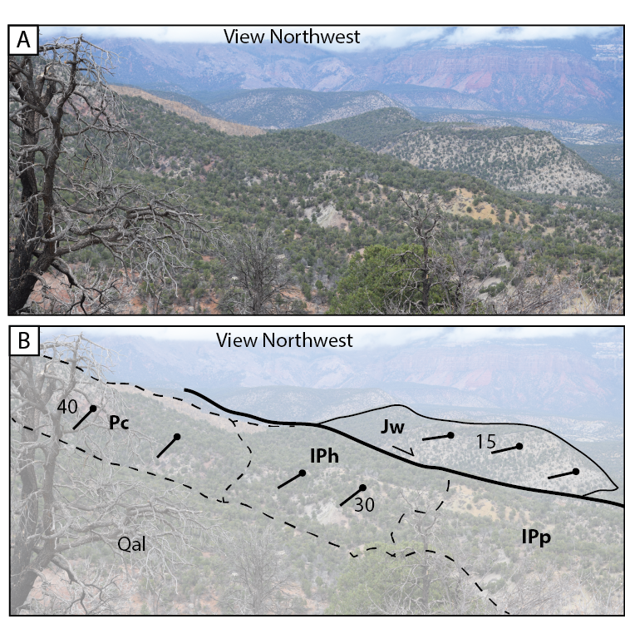
Fig. S4. Field photo of Structural Domain B from the central-southeastern end of the megaflap, illustrating the typical exposure in the field area and orientations of the strata in view.

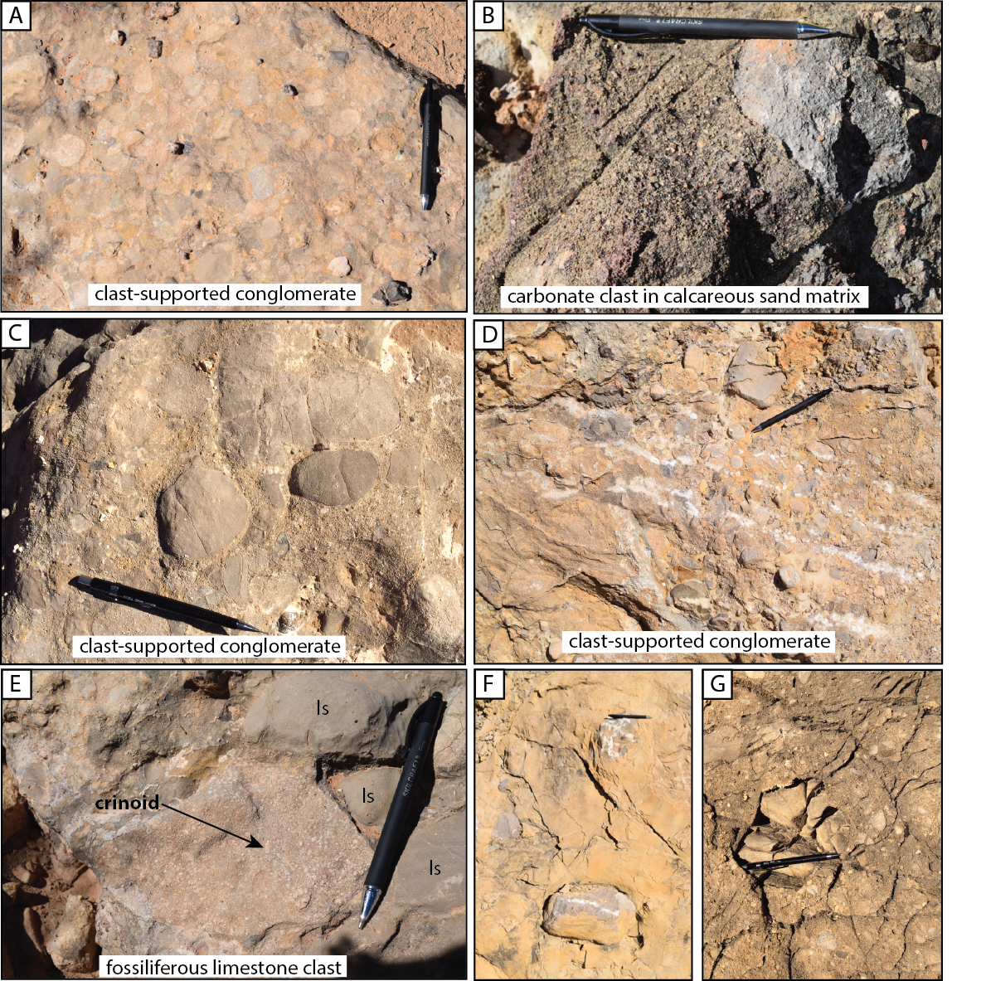

Fig. S5. Additional photos of limestone clast conglomerates within the Paradox Formation: (a) clast-supported conglomerate, (b) carbonate clast within a calcareous coarse sand matrix, (c) clast-supported conglomerate, (d) fractured clast-supported conglomerate, (e) fossiliferous limestone clasts within clast-supported conglomerates; note presence of large crinoids. (f) and (g) fractured carbonate clasts within matrix-supported conglomerate.

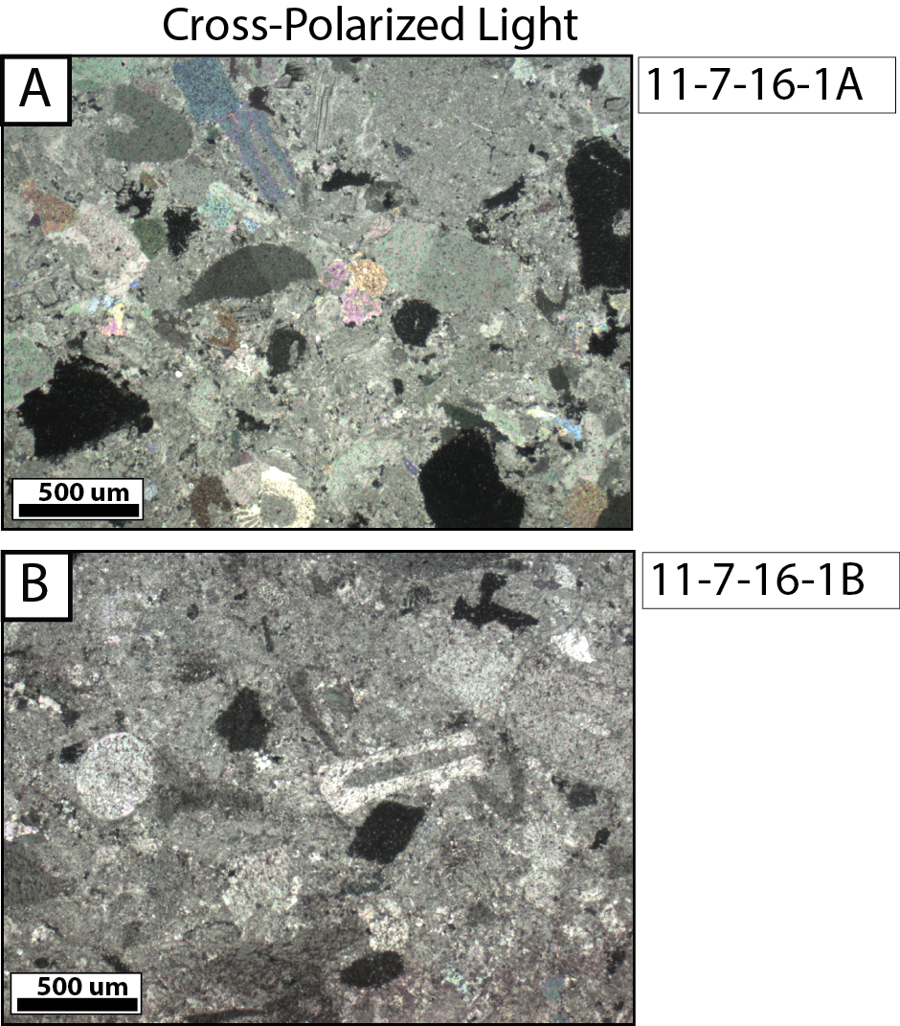

Fig. S6. Thin section photos (cross-polarized light) of the fossiliferous limestones in the Paradox Conglomerates in the center of Sinbad Valley. Locations marked on Fig. 14 in the main text.

