Supplemental File

Seismic Data Playback (SDP)

1. Overview

Seismic Data Playback (SDP) is a code developed at the OVSM-IPGP (Observatoire Volcanologique et Sismologique de Martinique – Institut de Physique du Globe de Paris). It is available on the GitHub platform, at the address https://github.com/ovsm-dev/sdp.
SDP is a semi-automatic interface for the post-campaign seismic data processing. It detects and extracts seismic events on past seismic records, and sends them on a SeisComp3 database to allow their localizations. It uses Python 2.7 and the ObsPy toolbox. SDP is based on the ‘short-time-average through long-time-average trigger' (STA/LTA) that is the most broadly used algorithm in weak-motion seismology (Trnkoczy, 2012). It continuously calculates the average values of the absolute amplitude of a seismic signal in two consecutive moving-time windows. The short time window (STA) is sensitive to seismic events while the long time window (LTA) provides information about the temporal amplitude of seismic noise at the site. When the ratio of both exceeds a pre-set value, an event is 'declared' and data starts being recorded in a file.

2. Parameters

SDP code is based on a STA/LTA ratio which depend on 5 parameters:

STA (Short Time Average)
LTA (Long Time Average)
Threshold ON (Trigger)
Threshold OFF (Detrigger)
Threshold SUM

STA and LTA are average absolute amplitudes over short and long periods of time respectively. User chooses the short and long periods of time in seconds, with STA always lower than LTA. Threshold ON parameter corresponds to the minimum value of ratio STA/LTA for which the beginning of a seismic event is considered. Threshold OFF parameter is the ratio value that determines the end of the seismic event. Threshold SUM parameter is the minimum number of stations that should have record the seismic event to save it.

3. Optimization of the parameters

Several tests were done to choose appropriate parameters for Trans-Haiti data. Trans-Haiti data are relatively noisy and the specific north-south distribution of the seismic stations result in a high dependency of the triggering events on the choice of the STA/LTA parameters. For example, we used visualization software to select a 12 hours period with a high number of seismic events. We selected the January 20th 2014 from 06:40 am to 06:40 pm where 6 seismic events were identified.

The SDP code was then ran on this period of time with several couple of STA/LTA parameters (Fig. S1). The objective is to found the best couple of STA/LTA values that detects all the seismic events and a minimum of false events (noise). Note that on the Fig. S1 there is a lack of information for LTA values of 20 to 23 and STA value over 3.5. When the LTA value increases, the number of false events increases too.

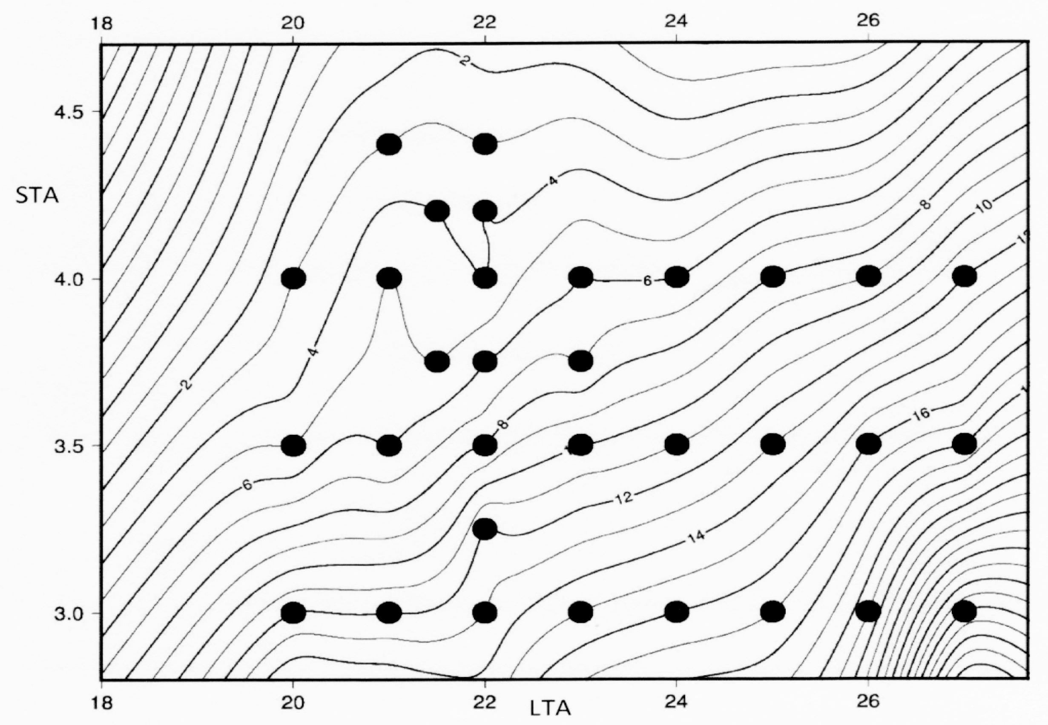
Figure S1: example of number of detected events (seismic events and noise) in function of STA and LTA. Black dots correspond to the different STA/LTA couples tested.

The second step of the optimization precises the best STA/LTA parameters by varying the values between 2.7-3 and 22-23 respectively, and by changing the threshold ON between 3 and 4. The final choice of STA/LTA parameters will also depend on the noise recorded by the stations, which could change during the network deployment.

In this study, we typically ran SDP with the set of STA/LTA parameters of 2.8s and 22.5s respectively, with a threshold ON of 3.5, a threshold OFF of 1.15 and a threshold SUM of 3.

5. Reference
Trnkoczy, A., 2012, Understanding and parameter setting of STA/LTA trigger algorithm, in Bormann, P., ed., New Manual of Seismological Observatory Practice 2 (NMSOP-2): Potsdam, Deutsches Geo Forschungs Zentrum, p. 1-20.

