# SUPPLEMENTARY DATA: METHODS

High-resolution seismic-reflection data were acquired by the use of a Huntec DTS sparker system, towed around 100 m below sea level. Power output was 480 Joules at 4 kV, fired at 1-1.5 s, and a 7.3 m-long, 24 element (AQ-16 cartridges), oil filled streamer towed behind the fish was used for the signal recording. Signals were filtered at 500-3500 Hz and recorded in digital format and analogue hard copy on an EPC9800 thermal chart at a 0.25 s sweep.

A total of 85 cores were collected from Orphan Basin using the AGC Long Corer (Driscoll et al., 1989), which recovered cores up to 12 m long, and a smaller Benthos piston corer, which recovered cores <5 m in length. Trigger-weight gravity cores were used for better recovery of the upper metre of sediment. Shipboard samples for water content and torvane shear strength measurements were taken every 1.5 m to verify that laboratory measurements were not compromised by storage. The cores were sealed with beeswax and stored upright at 4°C for 1–6 months prior to analyses. P-wave velocity, bulk density (using gamma ray attenuation as a proxy) and magnetic susceptibility data were obtained on whole-round core sections using the GEOTEK Multi-Sensor Core Logger (MSCL). Cores were split lengthwise, photographed, and detailed visual sedimentological descriptions were made. Quantitative sediment colour was measured using a Minolta CM-2002 spectrophotometer at 0.05 m intervals along the core and plotted based on the CIE (Commission Internationale de l’Eclairage/International Commission on Illumination) L*a*b* (L: luminance, a: from green to red, b: from blue to yellow) colour space model described by Debret et al. (2011). Peak undrained shear strength data were obtained on split cores every 0.1 m in muddy sediment using an automated laboratory miniature shear vane (ASTM 4648-94). Measurements were omitted at intervals where drained conditions existed (i.e., sandy sediments) and where the sediments contained numerous clasts. Subsamples were analysed for bulk density, moisture content, void ratio and grain size.

Atterberg limit determination, consolidation tests and isotropically consolidated undrained triaxial tests were conducted at 4.6 m and 6.7 m for core 2003033-19 (Figs. 2, 3). Consolidation testing was conducted using a GeoTest back-pressure system. Loads were applied using a load increment ratio of 1.0 until the sample was in a state of normal consolidation and the virgin compression line (VCL) was established. Once the VCL was defined the sample was unloaded. The Casagrande construction and work methods (Becker et al., 1987) were used to determine the preconsolidation stress (*σ'c*).

Multi-stage isotropically consolidated, undrained (CIU) triaxial tests were conducted on a GDS Instruments automated stress path triaxial system. The samples were backpressured to 240 kPa and the *B* pore water coefficient (Skempton, 1954) of greater than 0.95 indicated 100% saturation. Each sample was isotropically consolidated to three different confining pressures. The samples were then sheared at a rate of 3.0 %/hr after each consolidation stage. The axial loading stages were stopped when the stress-strain curve began to level off, generally at 3 to 4% axial strain. A single undrained unconsolidated (UU) test was also conducted

A continuous profile of undrained shear strength (*Su*) was calculated using a modified Mohr-Coulomb relationship (Bradshaw et al., 2004):

 (1)

where *σ′v* = the effective vertical overburden stress (kPa), *φ′* = internal angle of friction , *Af* = pore pressure parameter at failure (Skempton 1954) and *K0* ≈ 1-sin*φ′*. The CIU triaxial test results were used to calculate normalized undrained shear strengths (Roberts and Cramp, 1996) using

:

 (2)

where Ac = correction for anisotropic consolidation, Ar = correction for cyclic loading, S = the ratio of the measured S*u* to triaxial consolidation stress or overconsolidation ratio (OCR) = 1 and *m =* a soil constant. The value of =1 means there is no effect on strength by cyclic loading while =0.8 implies that shear strength measured in the laboratory is higher than its true value due to isotropic consolidation.

Methods of slope stability assessment traditionally rely on limit equilibrium analysis (Poulos, 1988). The simplest of the limit equilibrium methods is the infinite slope method which uses force equilibrium theory to evaluate both the resisting and stress of the overlying sediment or load on an assumed sliding surface (Poulos, 1988). The Factor of Safety (*FS*) for a potential failure plane is defined as



Instability occurs when the stress of the overlying sediments is greater than the strength of the soil. Sediments are considered to be unstable if the *FS* is equal to or less than 1. The *FS* was calculated at the 24 core sites for gravity alone and for earthquake activity. The factor of safety was estimated using both vane shear measurements and triaxial test data.

A factor of safety can be calculated if the physical properties and the undrained shear strength of the sediment are known. The factor of safety due to gravity is therefore,

 (3)

An earthquake is assumed to produce a horizontal acceleration, kx, as a fraction of gravity, that adds a horizontal force. The factor of safety becomes

 (4)

The static factor of safety can be obtained using eq. 3 for the 24 cores analysed using the miniature shear vane data (Table 1). In addition, the critical slope inclination βc, and the critical slope thickness Hc, can be calculated by solving eq. 3 for β and H when the factor of safety is unity. The critical earthquake acceleration coefficient kc, can be calculated by solving eq. 4 for ax, when the factor of safety is unity. Miniature shear vane measurements taken in disturbed core sections and obvious erroneous measurements were not included. There was only one site where the factor of safety was less than unity and the slope angle for this site was 11°.

Lee and Edwards (1986) used the following relationship for the calculation of the critical pseudo-static acceleration (kc) to cause failure

 (5)

# Further data including core and seismic locations

All location data is available from the Expedition Database: [*http://ed.gdr.nrcan.gc.ca/index_e.php*](http://ed.gdr.nrcan.gc.ca/index_e.php)

In addition, more detailed information on both cores and seismic are available in the Open File report by Tripsanas et al. (2007), available at:[*https://geoscan.nrcan.gc.ca/starweb/geoscan/servlet.starweb?path=geoscan/downloade.web&search1=R=223224*](https://geoscan.nrcan.gc.ca/starweb/geoscan/servlet.starweb?path=geoscan/downloade.web&search1=R=223224)

## Additional references

Becker, D.E., Crooks, J.H.A., Been, K., and Jefferies, M.G., 1987, Work as a criterion for determining *in situ* and yield stresses in clays: Canadian Geotechnical Journal, v. 24, p. 549-564.

Poulos, H. (1988). The nature of submarine soils. In H. Poulos, *Marine Geotechnics* (pp. 61-62). London, U.K.: Unwin Hyman Ltd.

Roberts, J.A. and Cramp, A., 1996, Sediment stability on the western flanks of the Canary Islands: Marine Geology, v. 134, p. 13-30

Skempton, A.W., 1954. The pore-pressure coefficients *A* and *B*. Géotechnique, v. 4, p. 143–147.

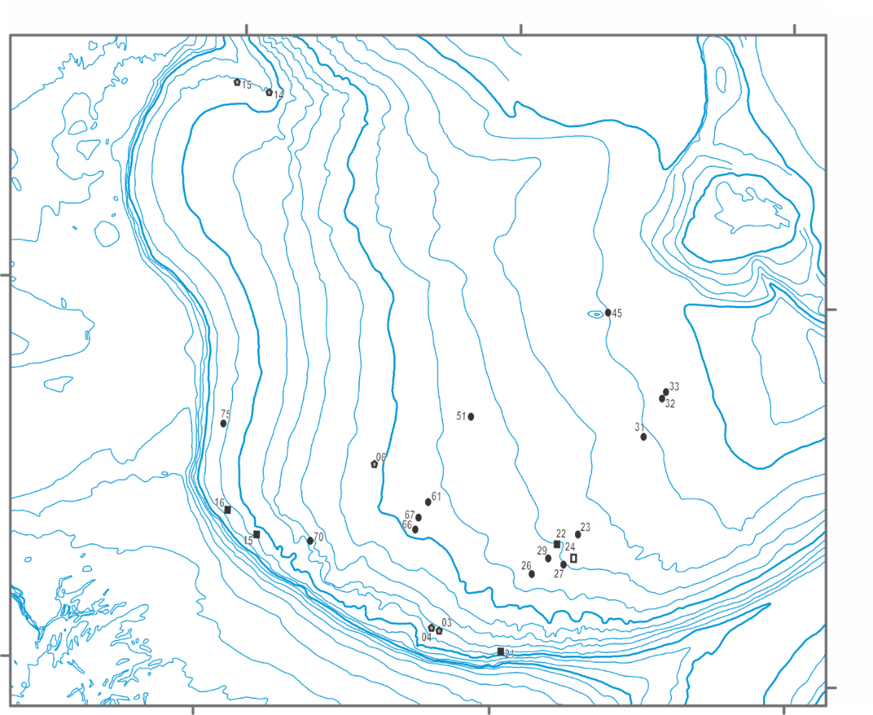

Supplementary Figure 1: Location of cores with geotechnical data summarized in Table 1