# SUPPLEMENTARY MATERIAL

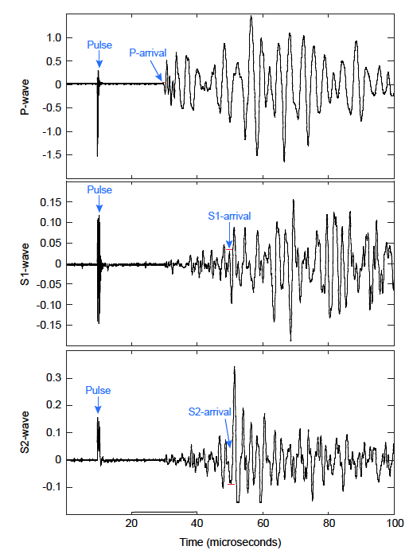

Figure S1. Example of raw waveforms acquired at the University of Wisconsin - Madison on sample 15R1 at 68 MPa. Red bars show the maximum uncertainty in the picked arrival.

Figure S2. Example of raw waveforms acquired at Kochi University for sample 7R1 at 18 MPa. Red bars show the maximum uncertainty in the picked arrival.

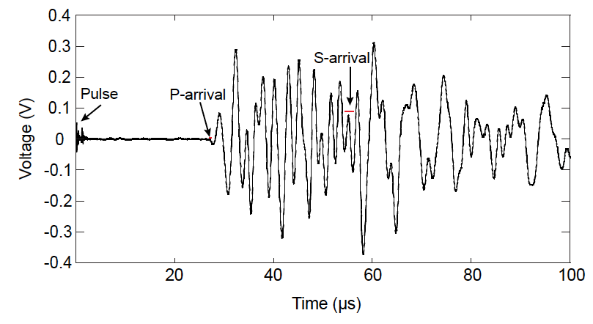

Figure S3. Variations in (A) P-wave and (B) S-wave velocity measurements with both increasing and decreasing effective pressure for JFAST core samples. The two orthogonal S-wave measurements showed little to no anisotropy so only one S-wave vibration direction is shown here. The sample from unit 5 (orange) is similar to the samples from unit 3 (blue).

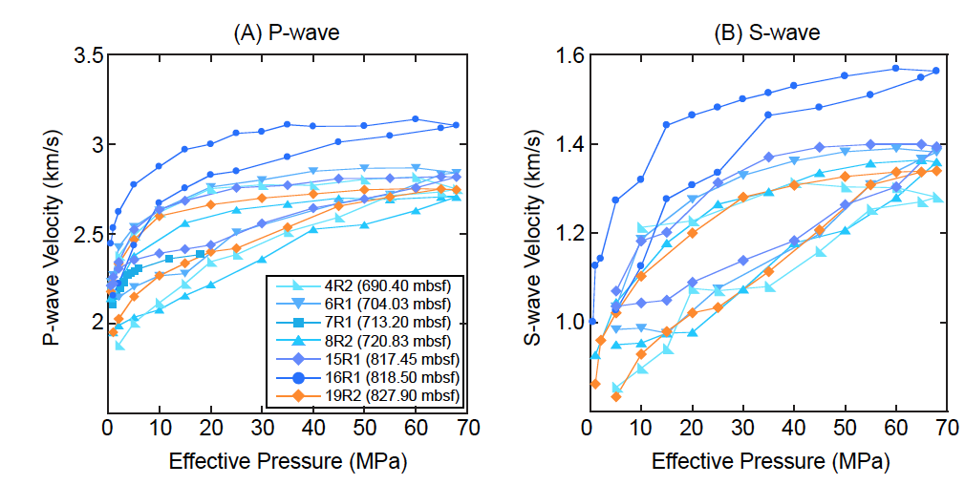

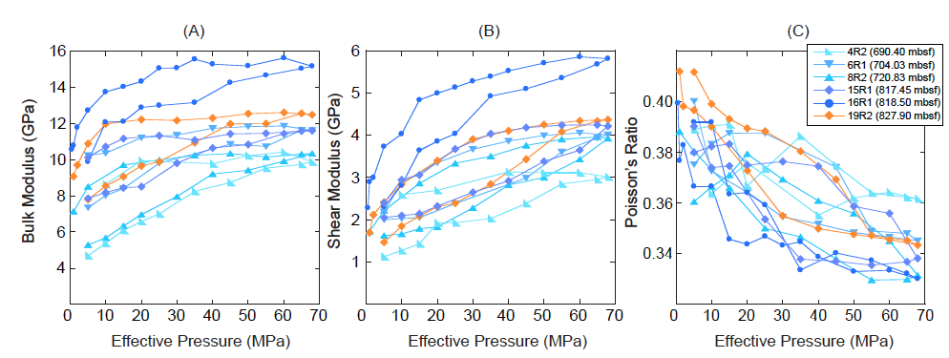

Figure S4. Variations in (A) bulk modulus, (B) shear modulus, and (C) Poisson’s ratio with both increasing and decreasing effective pressure calculated from laboratory velocity and density data show that the sediments are very compliant.

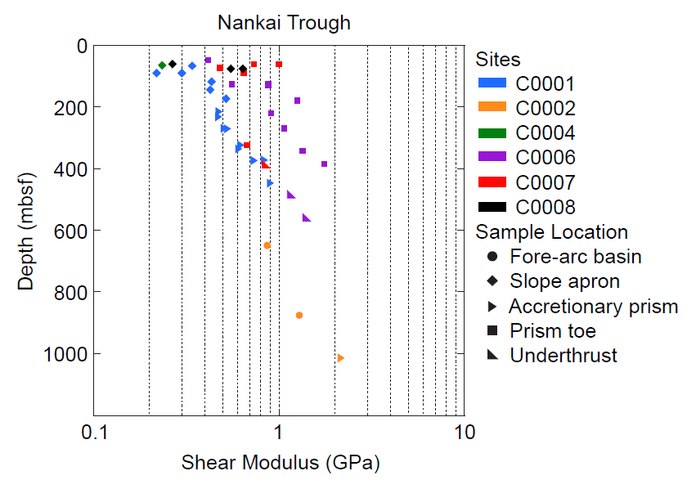

Figure S5. Variations in shear modulus with depth in sediments from the Nankai Trough indicate that samples with different histories follow slightly different rigidity-depth trends. Data from Hashimoto et al. (2010), Raimbourg et al. (2011), and Schumann et al. (2014).