SUPPLEMENTARY MATERIAL

Appalachian Basin basement model

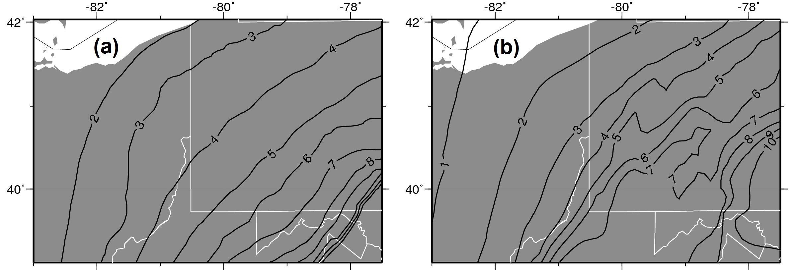
Figure S1. Maps showing contours of estimated basement depth in the Appalachian Basin from (a) Mooney and Kaban (2010), (b) our compilation from Baranoski (2013), Alexander et al. (2005), and Patchen et al. (2006).

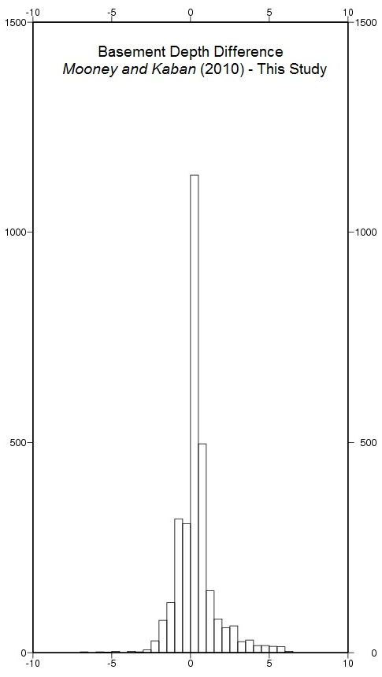
Figure S2. Histogram of the vertical differences between the basement depth model suggested by Mooney and Kaban (2010) and this study for the Appalachian Basin. Models are compared at every 0.1 degree grid point that is within 50 km of a HF or WD well. Maximum differences are ~7 km and mean absolute difference is ~0.5 km, with the Mooney and Kaban (2010) depths are skewed deeper (positive values) in some areas.

Analysis of induced seismicity in Pennsylvania
In March 2014, earthquakes up to M 3 were induced by hydraulic fracturing in Poland Township, Ohio targeting the Utica formation (Skoumal et al., 2015a) (Figure S3). One of the first Utica hydraulic fracturing operations in Pennsylvania was located in North Beaver Township, ~6 km east of the Poland Township well. Seismicity up to M 1.9 was detected during HF of the 10H and 12H legs of the North Beaver Township NC well. Shortly after the M 1.9 event, operations at the well were voluntarily halted by Hilcorp Energy Co with 6 stages left on 10H and 12H.
We constructed a template from the M 1.9 event using Transportable Array stations N53A and M53A. We implemented a modified version of the empirical subspace detector approach (Barrett and Beroza, 2014; Skoumal et al., 2015b). The top 20 matches to the largest event were run as templates themselves, as well as the stack of the originally detected events and the time derivative of the M 1.9. The temporal pattern of matched events shows strong, evenly spaced clustering on April 24 and 25 that are consistent with the seismicity being induced by individual stages of HF as seen in the Poland Township case (Skoumal et al., 2015a). The magnitude distributions of each cluster appears to alternate over this time frame, consistent with a "zipper frac" completion, where adjacent well laterals (e.g., 10H and 12H) are alternatingly fractured in sequence with one well holding pressure while the other well is stimulated. We have not been able to obtain the precise stage timing to potentially correlate with the bursts of seismicity.
Using a broader set of stations (M53A, M55A, N53A, O53A, and PSBV), we determined the absolute location of the M 1.9 earthquake with elocate (Herrmann, 2004) to be directly beneath the 12H leg (Figure S3, S4), but the depth is poorly determined. Using this absolute location, a hypoDD double-difference relocation algorithm (Waldhauser and Ellsworth, 2000; Waldhauser, 2001) was used to determine the relative location of the other detected events. The event locations appear to display an east-west trend similar to what was observed in the Poland Township case (Skoumal et al., 2015a), although the absolute locations do not suggest these sequences are occurring on a single through-going fault. While the magnitudes of the North Beaver Township events are too small and the focal sphere coverage is too limited for us to determine a focal mechanism, the largest Poland Township event produced a left-lateral strike-slip mechanism (Skoumal et al., 2015a). It indicates the east-west faults triggered by HF in these cases are optimally oriented in the regional stress field.

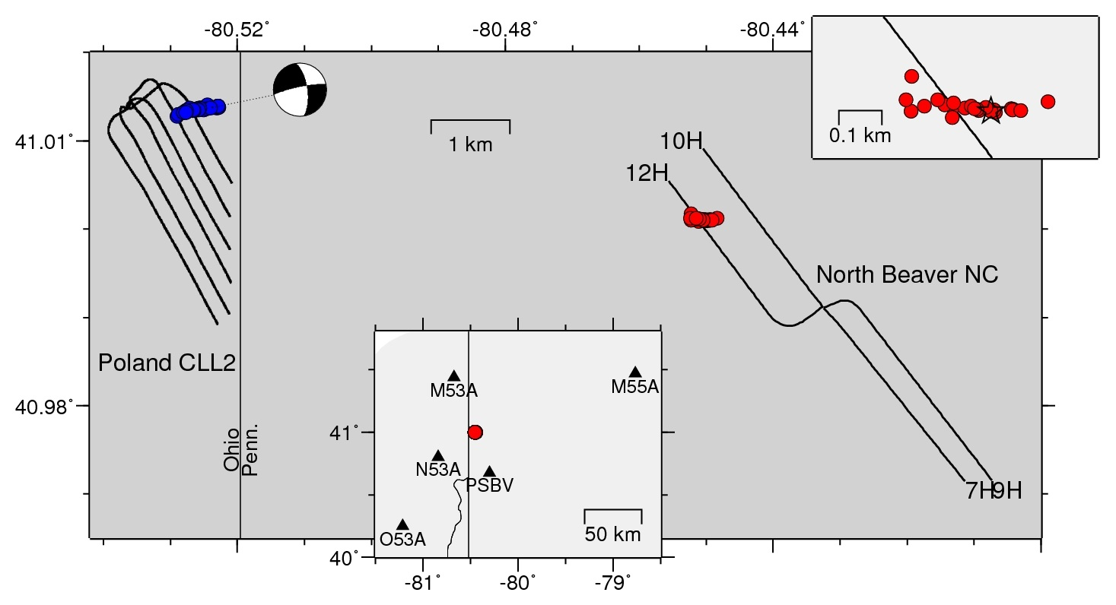
Figure S3. Map of the Ohio-Pennsylvania border region showing a new sequence in North Beaver Township (red), not far from the prior HF induced seismicity in Poland Township (blue) (Skoumal et al., 2015a). Upper inset shows zoomed view of epicenters, lower inset shows stations used to relocate matched events. Circles show relative location results from hypodd using cross-correlation relative times. Absolute locations are pinned to the best determined hypocenter. An apparent east-west trend in the locations is consistent with a left-lateral strike-slip fault from the focal mechanism that is optimally oriented in the regional stress field (Skoumal et al., 2015a). Curves show HF well laterals.
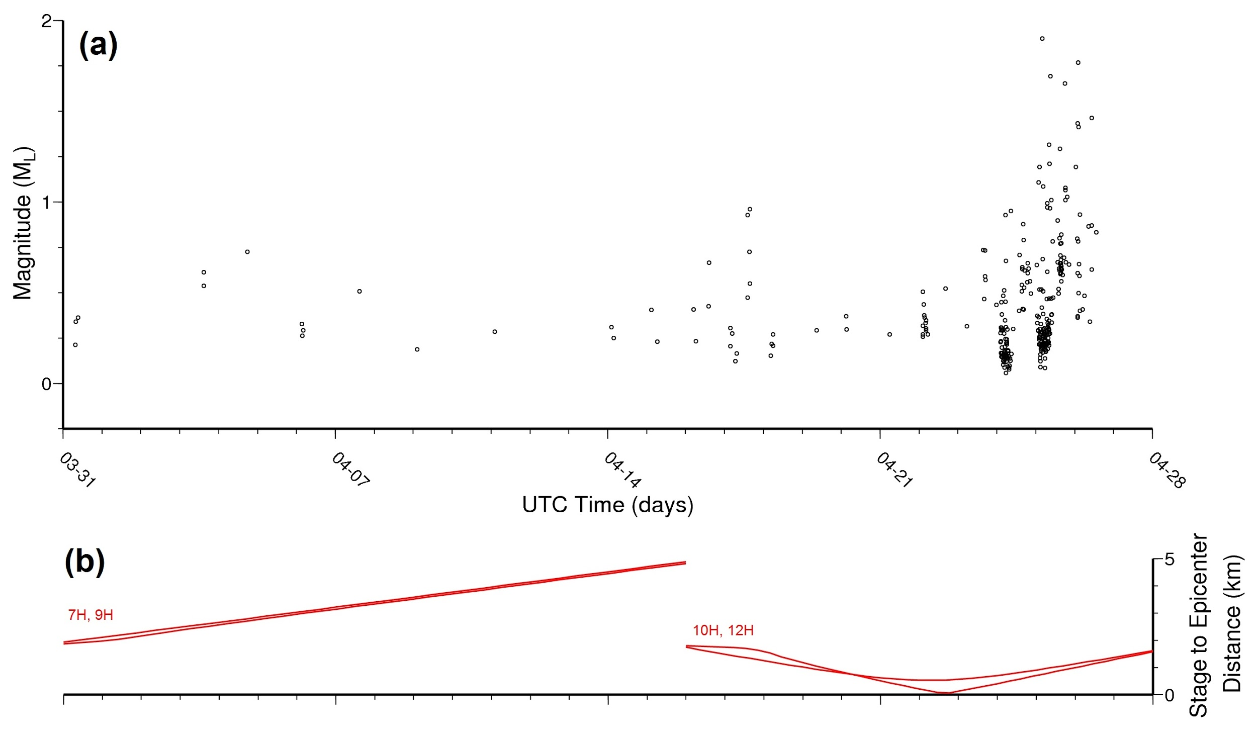
Figure S4. Results of template matching for the North Beaver NC sequence, starting with the first NEIC detected event as a template, and then using an empirical subspace detector to grow the number of detections (Skoumal et al., 2015b). (a) Magnitude of event detections. (b) Distance between epicenter of the M 1.9 event and the HF stimulation stages done along the well laterals shown in Figure S3. Seismicity is clustered during apparent HF stages of wells 10H and 12H and stops when the operator voluntarily halted stimulations.

Analysis of induced seismicity in West Virginia
Historically, there have been several dozen cataloged earthquakes in western West Virginia within or adjacent to the Rome Trough. This structure is a fault-bounded graben involving basement rocks thought to be related to failed rifting of the North American plate during the Precambrian. The template matching analysis we performed in this study revealed two cases near the southern border of the Rome Trough (Figure S5a), with a swarm-like nature similar to previously documented cases of induced seismicity.

Braxton County Wastewater Disposal Well
Between April and July 2010, a series of 8 earthquakes were cataloged in Braxton County within a few kilometers of an active wastewater injection well (API# 4700702539), including a M 3.4. The West Virginia Department of Environmental Protection (WVDEP) reduced the injection rate at this well soon after these events began, and WVDEP further restricted both the volume and the rate after an additional M 2.8 earthquake occurred in January 2012 (Figure S5b). Since most of these events occurred before late 2010 when the first EarthScope stations were installed, we needed to construct templates from longer-standing stations to scan back to 2009 when injection began (Figure S5a). This form of template matching was able to grow the catalog of detected events to 35. For cataloged events after late 2010, we also employed template matching using the 3 stations from the initial Ohio analysis (N54A, M54A, O56A), which achieved our final catalog of 54 events (Figure S5b). The increased number of events show a distinct decrease in seismicity rate since the rate and volume reductions have been enacted, which was not visible with the NEIC catalog alone.
Work by the Midwest Regional Carbon Sequestration Partnership (MRCSP, 2009) suggested the presence of a fault in the vicinity of the Braxton County disposal well based on the subsurface structure of the Devonian Oriskany Sandstone (Figure S6). 3-D modeling of the Oriskany structure in the Braxton County area indicates that the suspected normal fault is down-thrown to the west in the vicinity of the disposal well and the fault cuts the injection interval (McDowell et al., 2014). Available injection data, when compared to the timing of earthquake events in the county reported by the NEIC, did not immediately suggest a direct link between injection volumes over time (McDowell et al., 2014).

Gilmer County Hydraulic Fracturing
Three M ~2.7 earthquakes were recorded by NEIC between 20 July 2013 - 16 August 2013 in Gilmer County, and an additional 2 earthquakes were identified by the EarthScope ANF. There were no active injection wells in the vicinity, but hydraulic fracturing occurred with several horizontal laterals completed around the time of these earthquakes, within ~3 km of the epicenters. This is particularly noteworthy because no other horizontal wells have been hydraulic fractured in this county of West Virginia. Constructing templates for these events using the 3 stations from the initial Ohio analysis (N54A, M54A, O56A) revealed 52 unique matching events (Figure S5c), beginning soon after the hydraulic fracturing started and ending soon after the last completion. Using EarthScope TA stations closer to these events (Q54A, Q53A, and P53A), we were able to construct a set of templates centered around this area that revealed 161 matched events (Figure S5d).
Figure S5. Seismicity in West Virginia induced by hydraulic fracturing (orange) and wastewater injection (blue) that has occurred in the Rome Trough (dark grey). (a) Map showing matched events as circles scaled to relative Richter magnitude and locations based on the best correlated template event. Inset shows broader region and stations used to perform template matching. (b) Magnitudes of matched events in Braxton Co. using long-standing regional stations (map inset, white triangles). Blue lines show start of injection, rate decrease, and volume+rate decrease. (c) Network normalized correlation coefficient of matched events in Gilmer Co. using long-standing EarthScope TA stations (map inset, black triangles). (d) Magnitudes of matched events using nearby EarthScope TA stations (map inset, open triangles). Shading indicates stimulation timing of hydraulic fracturing at wells Norm 1C, 1D, 1E, and 1F (gray) and Norm 1G (orange). The completion report for Norm 1H does not list stimulation times, so we speculate when it may have occurred based on the seismicity.
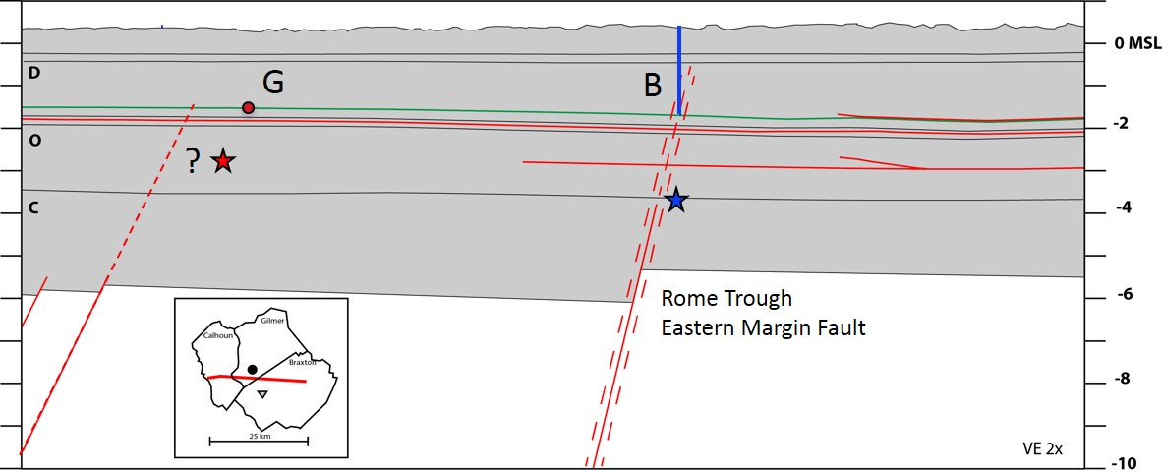
Figure S6. East-west stratigraphic cross-section through Gilmer (G) and Braxton (B) cases, modified from Ryder et al. (2008) and McDowell et al. (2014). Blue line marks injection well, red circle marks hydraulic fracture target. Stars mark earthquake hypocenters, which are near the upward projection of west-dipping basement faults, including the eastern margin of the Rome Trough. Sub horizontal red lines represent frontal décollements of the Alleghenian fold and thrust belt.

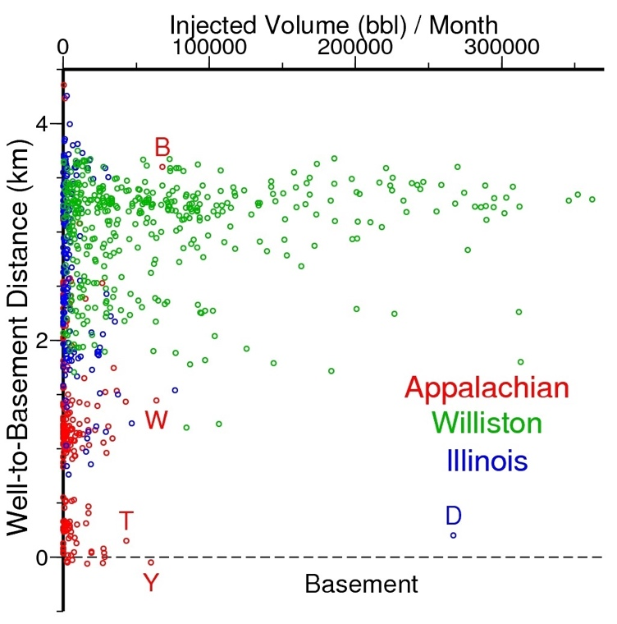
Figure S7. Comparison of average injected volume per month versus distance to basement for all Class II disposal wells and the carbon sequestration well (Decatur) in our study areas. Letters label the 4 published cases of induced seismicity from the disposal/sequestration wells (B: Braxton Co.; D: Decatur, T: Trumbull Co., W: Washington Co., Y: Youngstown) (Kaven et al., 2015; Skoumal et al., 2014; Skoumal et al., 2015a; Skoumal et al., 2015b).

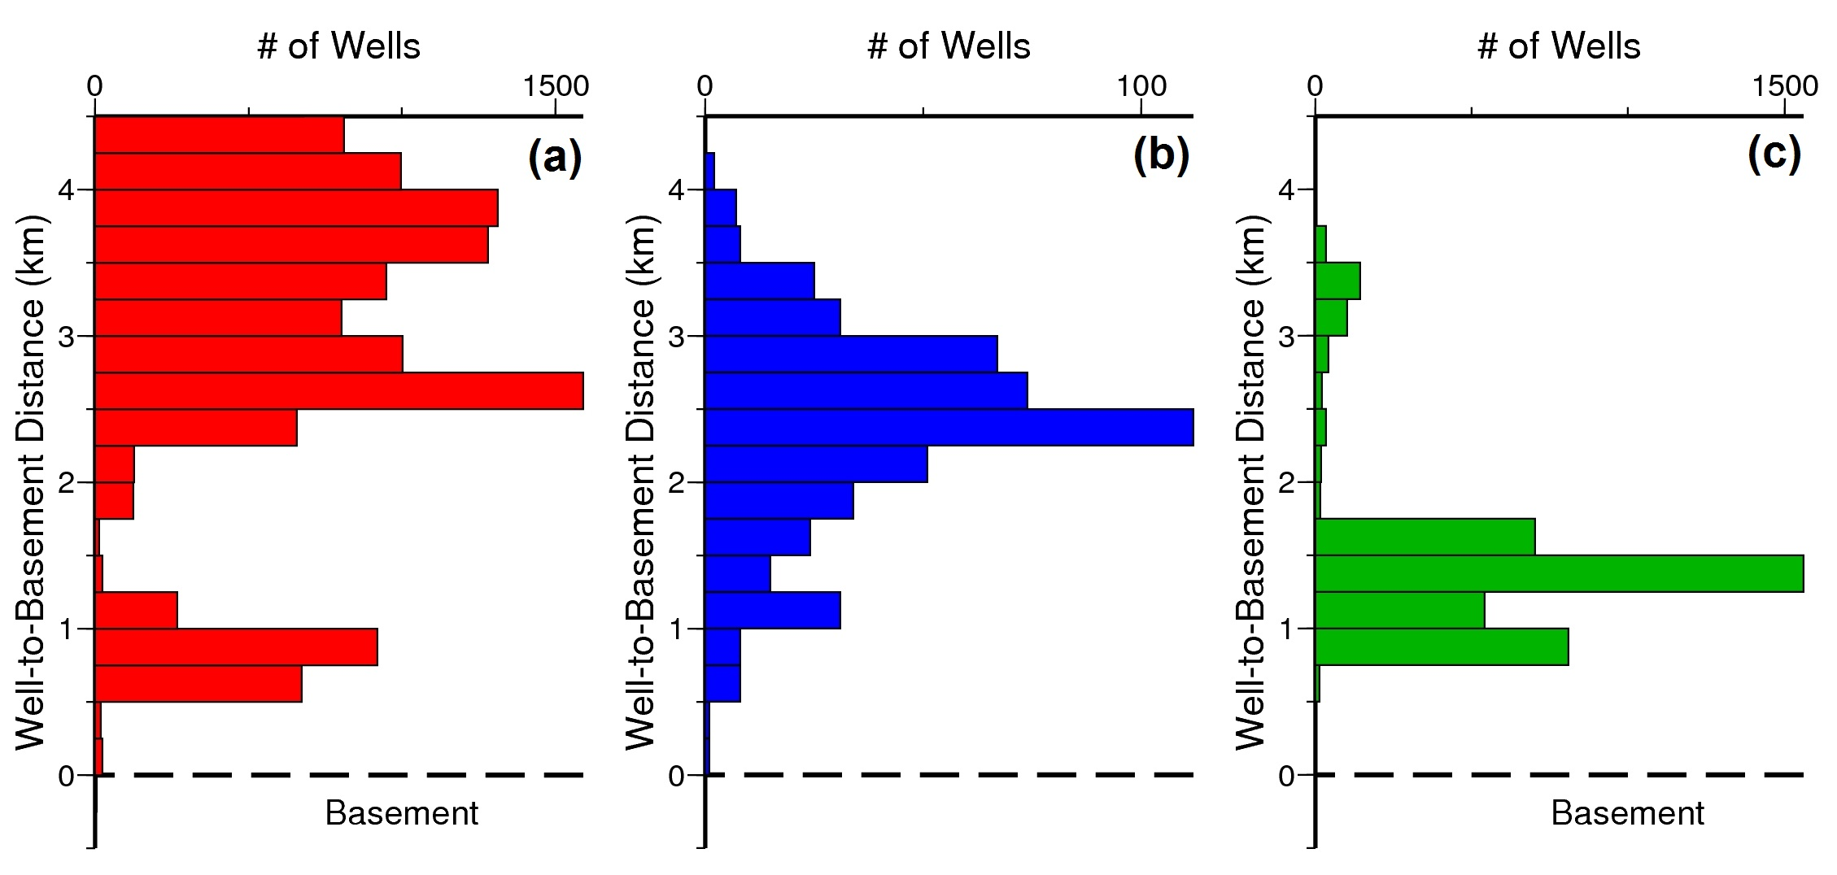
Figure S8. Histograms showing the number of wells (HF and WD) in each 0.25 km histogram bin of depth between well and basement. Format as in Figure 10a, but separated for each basin: (a) Appalachian Basin, (b) Illinois Basin, (c) Williston Basin.

References Cited for Supplementary Material
Alexander, S. S., Cakir, R., Doden, A. G., Gold, D.P., and Root, S. I., 2005, Basement depth and related geospatial database for Pennsylvania: Pennsylvania Geological Survey, 4th ser., Open-File Report OFGG 05-01.0, 1 map, scale 1:500,000.
Baranoski, M.T., 2013, Structure contour map on the Precambrian unconformity surface in Ohio and related basement features: Ohio Department of Natural Resources, Geological Survey Map PG-23, scale 1:500,000, 17.
Barrett, S. A., and Beroza, G.C., 2014, An empirical approach to subspace detection, Seismol. Res. Lett. 85, no. 3, 594–600, doi: 10.1785/0220130152.
Herrmann, R.-B., 2004, Computer programs in seismology, version 3.30-GSAC. Available at: http://www.eas.slu.edu/eqc/eqc_cps/CPS/CPS330.html
McDowell, R.R., Lewis, J.E., Dinterman, P.A., 2014. West Virginia earthquakes: Crustal adjustments along the Rome Trough or something else? In Geological Society of America Abstracts with Programs (Vol. 46, No. 2, p. 71).
Midwest Regional Carbon Sequestration Partnership (MRCSP), 2009, Characterization of Geologic Sequestration Opportunities in the MRCSP Region: Middle Devonian-Middle Silurian Formations: Project Final Report, 149 p.
Mooney, W.D., and Kaban, M.K., 2010, The North American upper mantle: Density, composition, and evolution. Journal of Geophysical Research: Solid Earth (1978–2012), 115(B12).
Patchen, D.G., Hickman, J.B., Harris, D.C., Drahovzal, J.A., Lake, P.D., Smith, L.B., Nyahay, Richard, Schulze, Rose, Riley, R.A., Baranoski, M.T., Wickstrom, L.H., Laughrey, C.D., Kostelnik, Jaime, Harper, J.A., Avary, K.L., Bocan, John, Hohn, M.E., and McDowell, R., 2006, A geologic play book for Trenton-Black River Appalachian Basin exploration: Morgantown, W. Va., U.S. Department of Energy Report, DOE Award Number DE-FC26- 03NT41856, 601p. accessible at <http://www.wvgs.wvnet.edu/www/tbr/project_reports.asp>.
Ryder, R.T., Swezey, C.S., Crangle, R.D., and Trippi, M.H., 2008, Geologic Cross Section E-E’ through the Appalachian Basin from the Findlay Arch, Wood County, Ohio to the Valley and Ridge Province, Pendleton County, West Virginia: USGS Scientific Investigation Map 2985, Cross Section, 48 p.
Skoumal, R.J., Brudzinski, M.R., and Currie, B.S., 2015a, Earthquakes induced by hydraulic fracturing in Poland Township, Ohio, Bulletin of the Seismological Society of America, 105 1. doi: 10.1785/0120140168.
Skoumal, R.J., Brudzinski, M.R., and Currie, B.S., 2015b, Microseismicity induced by deep wastewater injection in southern Trumbull County, Ohio, Seismological Research Letters, doi: 10.1785/0220150055.
Underground Injection Control National Technical Workgroup (UICNTW). 2014. Minimizing and Managing Potential Impacts of Injection-Induced Seismicity from Class II Disposal Wells: Practical Approaches. US Environmental Protection Agency. Retrieved from http://www.slideshare.net/MarcellusDN/epa-report-minimizing-and-managing-potential-impacts-of-injectioninduced-seismicity-from-class-ii-disposal-wells-practical-approaches on April 18, 2016.
Waldhauser, F., 2001, Hypodd: A computer program to compute double-difference earthquake locations, U.S. Geol. Surv. Open-File Rept. 01-113.
Waldhauser, F., and Ellsworth, W.L., 2000, A double-difference earthquake location algorithm: Method and application to the northern Hayward fault, California, Bull. Seismol. Soc. Am. 90, 1353–1368.

