Figure S1. Primitive-mantle-normalized multi-element plot for Monte Arcuentu volcanic rocks. The grey field shows the total range of concentrations for each element. Individual samples plotted are those analyzed for Hf and Pb isotopes in this study. Normalizing values from Sun and McDonough (1989).
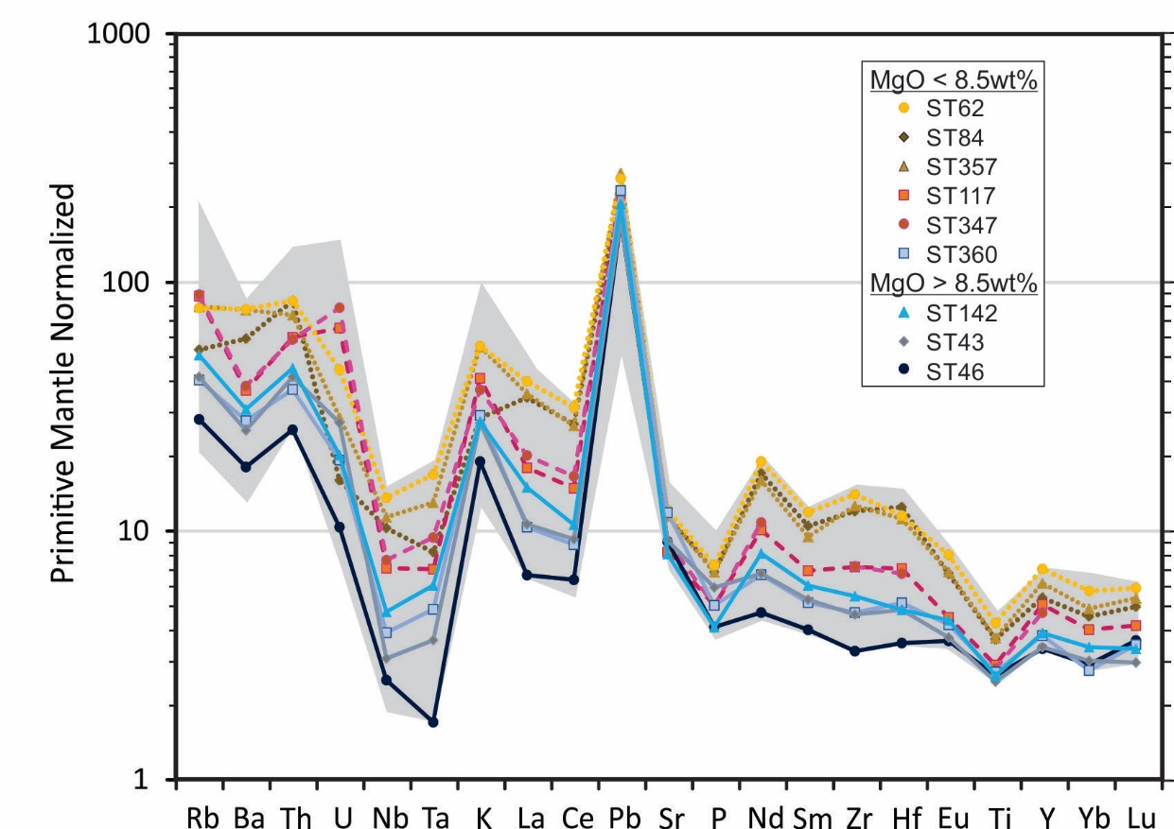

Sun, S.S. and McDonough, W.F., 1989, Chemical and isotopic systematics of oceanic basalts; implications for mantle composition and processes, in Magmatism in the ocean basins. Saunders, A.D. and Norry, M.J., eds., Geological Society of London, London, v. 42, p. 313-345.

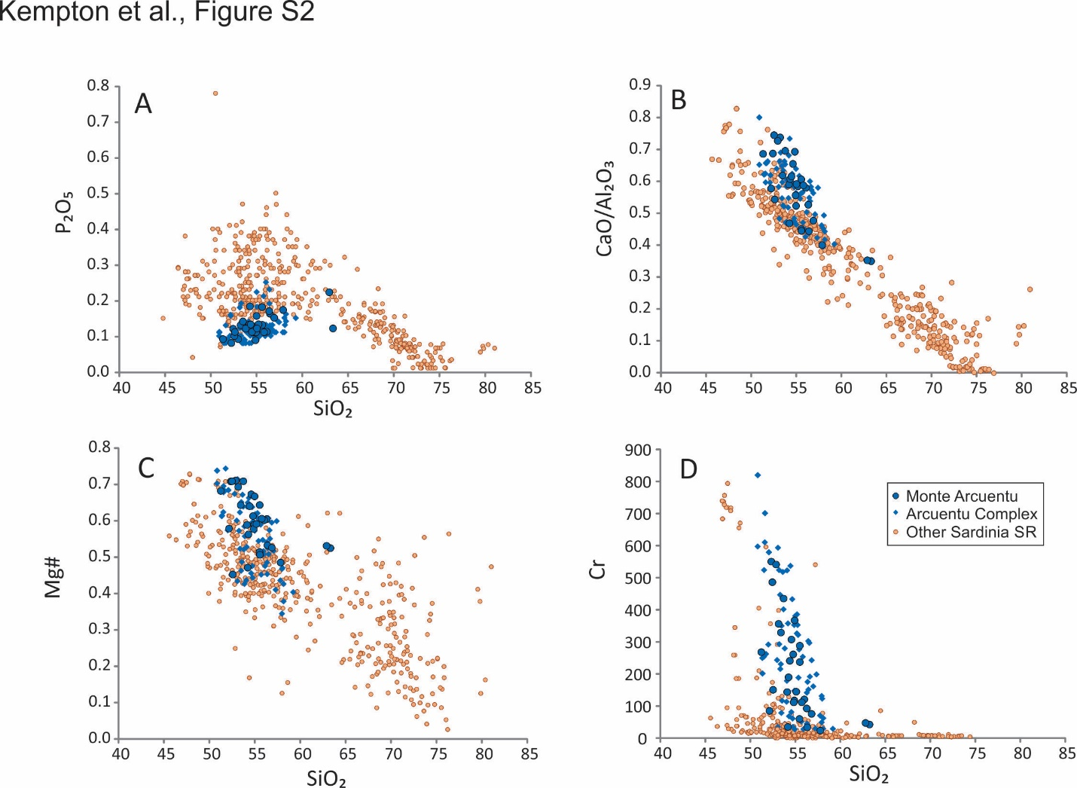
Figure S2. SiO₂ vs selected major and trace elements from Monte Arcuentu and other Sardinia SR rocks. Data sources as in Figure 2.

Figure S3. Detailed ⁸⁷Sr/⁸⁶Sr v SiO₂ variations for Andean rocks in support of Figure 9A
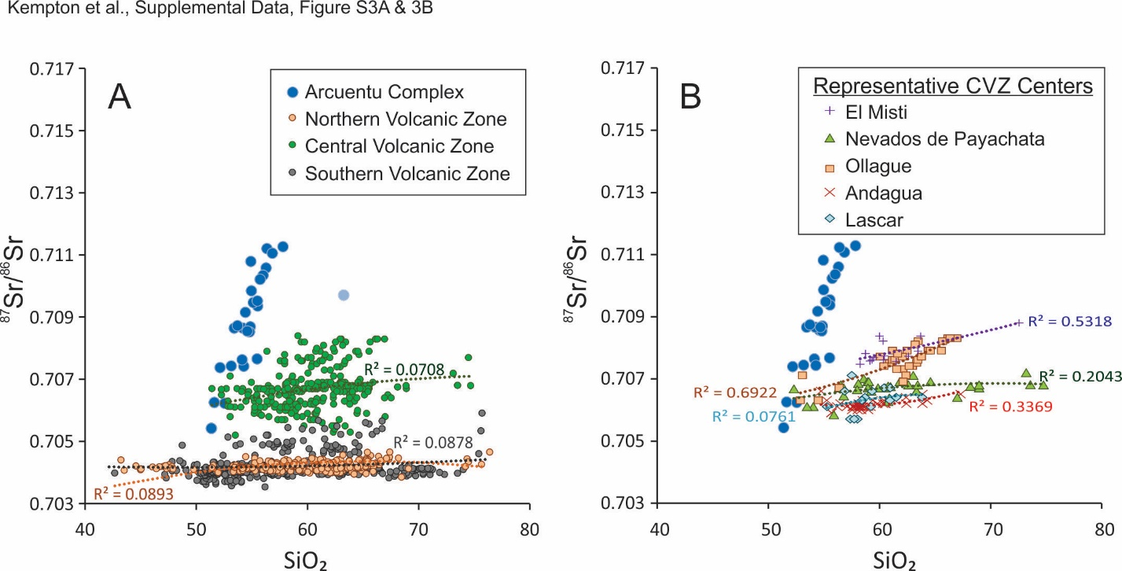
Data used to construct the fields in Figure 9A for the frontal arcs of the Northern, Central and Southern Volcanic Zones (NVZ, CVZ, SVZ) of the Andes are shown relative to the data for the Arcuentu Complex in Figure S3A. Data sources are as given in Figure 9. Dotted lines are second order polynomial regressions fitted to each data set as indicated in the figure key. The CVZ shows the greatest compositional diversity, but for all three regions the increase in ⁸⁷Sr/⁸⁶Sr with increasing SiO₂ is significantly less than that for the Arcuentu Complex. Note that, in contrast to Monte Arcuentu, which is a single volcanic complex, the Andean data encompass multiple volcanic centers along several thousand kilometers of arc length. Although an exhaustive survey is beyond the scope of this paper, individual stratovolcanoes within the CVZ show similar shallow slopes on this diagram. In the interest of clarity, only five representative localities are shown in Figure S3B, but other arc-front centers examined show similar variations.
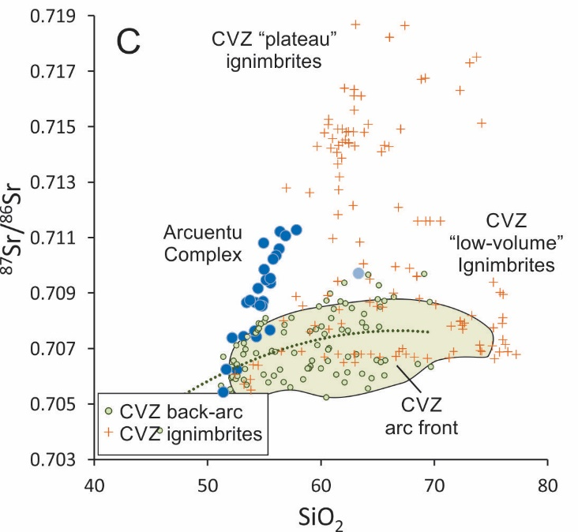
Volcanic products from regions behind the main arc are compositionally more heterogeneous, particularly in the Altiplano-Puna region east of the CVZ. Again, a detailed analysis is beyond the scope of this paper, but Figure S3C shows that the ⁸⁷Sr/⁸⁶Sr for most CVZ back-arc eruptive products, other than ignimbrites, fall within a narrow range of 0.7050 – 0.7085 and overlap the field for the CVZ arc front (shaded field). Ignimbrites encompass a wide range of compositions, some of which appear to lie on an extension of the trend shown by the Arcuentu Complex. However, CVZ ignimbrites have been described by Freymuth et al. (2015) as falling into two groups: “low-volume” rhyolitic ignimbrites that are typically less than a few hundred km³ in size and dacitic to rhyolitic “plateau” ignimbrites that reach volumes up to several thousand km³. In both cases, ignimbrite petrogenesis involves residence time in the middle to upper crust, where significant assimilation and fractional crystallization (AFC) occur (de Silva 1989; Lindsay et al., 2001; Kay et al., 2010; Freymuth et al. 2015). Low-volume ignimbrites tend to overlap the compositions of stratovolcanoes from the arc front (Fig. S3C), suggesting a similar mass balance of crustal and mantle components (Freymuth et al., 2015). Plateau ignimbrites are compositionally more variable, with ⁸⁷Sr/⁸⁶Sr values up to 0.719 (Fig. S3C). These radiogenic Sr-isotope values have been ascribed to addition of significant amounts of middle to upper crust; model estimates range from 20% to 70% crustal contribution to the melt, depending on the selection of parental magma and crustal contaminant end members (Kay et al., 2010; Freymuth et al., 2015). With such large crustal contributions to the melt, much of the isotopic variability shown by plateau ignimbrites is a reflection of regional differences in middle/upper crust composition. While a role for assimilation in the deep crust is often inferred, based on steep heavy REE patterns that require a garnet residue, it is generally acknowledged that middle/upper crustal AFC processes largely obscure the earlier stages of magma evolution (Kay et al., 2010). Furthermore, as reported by Kay et al. (2010), “A commonly made and key observation is that [ignimbrite] ⁸⁷Sr/⁸⁶Sr ratios are highly variable at the same SiO₂ content in rocks from different Puna andesitic to rhyolitic centers but tend to be similar over a long range in SiO₂ content within the same center” (see Kay et al. Figure 11). Therefore, although Andean volcanism collectively exhibits a wide range in ⁸⁷Sr/⁸⁶Sr and aspects of the variation with SiO₂ may superficially resemble that exhibited by the Arcuentu Complex, the correlation between these two parameters within individual Andean volcanic centers is markedly different from that of the Arcuentu Complex. The isotopic compositions that appear to be most similar to Arcuentu Complex rocks are from ignimbrites, which are lithologically and petrogenetically distinct.

de Silva, S.L., 1989, Geochronology and stratigraphy of the ignimbrites from the 21.30′S to 23.30′S portion of the Central Andes of northern Chile. Journal of Volcanology and Geothermal Research: v. 37, p. 93-131
Freymuth, H., Brandmeier, M., Wörner, G., 2015, The origin and crust/mantle mass balance of Central Andean ignimbrite magmatism constrained by oxygen and strontium isotopes and erupted volumes: ontrib Mineral Petrol v. 169, article ID 58, DOI 10.1007/s00410-015-1152-5.
Mahlburg Kay, S., Coira, B.L., Caffe, P.J., Chen, C-H., 2010, Regional chemical diversity, crustal and mantle sources and evolution of central Andean Puna plateau ignimbrites: Journal of Volcanology and Geothermal Research, v. 198, p. 81-111.
Lindsay, J.M., Schmitt, A.K., Trumbull, R.B., de Silva, S.L., Siebel, W., Emmermann, R., 2001, Magmatic evolution of the La Pacana Caldera System, Central Andes, Chile: compositional variation of two cogenetic, large-volume felsic ignimbrites: Journal of Petrology, v. 42, p. 459-486.

Figure S4. Source Heterogeneity - peridotite vs pyroxenite
Given the increasing recognition that olivine-poor lithologies, e.g., pyroxenitic and/or eclogitic components, in the peridotitic mantle may be major contributors to the enriched compositions of some E-MORB and OIB (Yang et al., 2016, and references therein), it is worth briefly considering this possibility for the origin of Monte Arcuentu rocks.
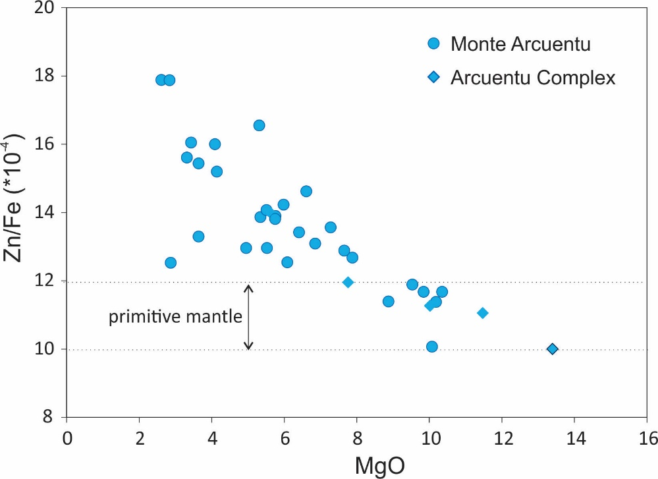
Ratios of Zn/Fe, for example, have been used to identify pyroxenitic source lithologies (Le Roux et al., 2010). This is because Zn and Fe partition equally between olivine and orthopyroxene under mantle conditions, whereas Zn is more incompatible than Fe in garnet and clinopyroxene. Melts generated from pure peridotitic mantle are expected to have Zn/Fe ratios of 10-12, whereas pyroxenitic melts are higher, e.g., around 14 (Yang et al., 2016). However, high Zn/Fe melts can also be produced from a peridotite source if fluid metasomatism has enriched it in Zn (Le Roux et al., 2010), which is obviously a concern for the arc environment, where hydrous fluids are released from subducting slabs. The most primitive Arcuentu rocks (i.e. those with MgO > 8wt%) have Zn/Fe ratios of 10-12 (Fig. S4A), which is the same as the range predicted for melts generated from primitive mantle (Yang et al., 2016). More evolved Arcuentu rocks have Zn/Fe ratios up to 18. However, these higher values, at low MgO, may simply be the product of clinopyroxene fractionation (Sheldrick et al., 2017).
Figure S4A. Zn/Fe vs. MgO for Monte Arcuentu. Range for melts derived from primitive mantle from Yang et al. (2016)
A potentially more robust approach for distinguishing pyroxenitic vs. peridotitic sources, based on key major elements, has been proposed by Yang and Zhou (2013). These authors show that melts derived from a pyroxenitic source have high FC3MS values greater than 0.5, where FC3MS = (FeO_{T}/CaO - 3*MgO/SiO₂). Melts derived from peridotite are typically lower than 0.5, with 0.65 believed to be a maximum for melts derived from peridotite mantle. Values lower than 0.5 are possible for pyroxenitic melts, where degrees of melting are large, e.g., 30% or greater.
FC3MS values for the most primitive Arcuentu rocks are all less than 0.5 and plot within the peridotite field (Fig. S4B). More evolved compositions trend to higher values (up to 0.8), but this is consistent with fractionation of olivine and clinopyroxene. Therefore, although an unambiguous method for distinguishing pyroxenitic components in a sub-arc mantle has yet to be identified (Yang et al., 2016), the analysis above strongly suggests that a heterogeneous, pyroxenite-rich source is not the main source of compositional heterogeneity within the Arcuentu volcanic suite.
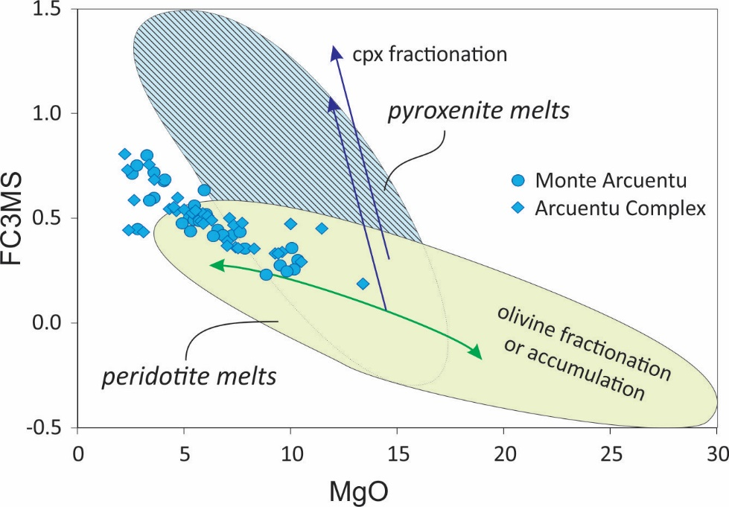

Figure S4B. FC3MS vs MgO. Fields for peridotite and pyroxenite melts from Yang et al. (2016). Arrows indicating clinopyroxene and olivine fractionation or accumulation also from Yang et al. (2016).

Le Roux, V., Lee, C.-T.A., Turner, S.J., 2010, Zn/Fe systematics in mafic and ultramafic systems: Implications for detecting major element heterogeneities in the Earth’s mantle: Geochimica et Cosmochimica Acta, v. 74, p. 2779–2796.

Sheldrick, T.C., Barry, T.L., Van Hinsbergen, J.J., Kempton, P.D., 2017, Constraining lithospheric removal and asthenospheric input to melts in Central Asia: a geochemical study of Triassic to Cretaceous magmatic rocks in the Gobi Altai (Mongolia): Lithos, https://doi.org/10.1016/j.lithos.2017.11.016 (in press).

Yang, Z.F. and Zhou, J.H., 2013, Can we identify source lithology of basalt? Scientific reports, v. 3, 1856; DOI:10.1038/srep01856.

Yang, Z.F., Li, J., Liang, W.F. and Luo, Z.H., 2016, On the chemical markers of pyroxenite contributions in continental basalts in Eastern China: Implications for source lithology and the origin of basalts: Earth-Science Reviews, v. 157, p.18-31.

Figure S5. Selected major and trace elements vs MgO for Monte Arcuentu and other Sardinia SR rocks. Data sources as in Figure 2.
