Supplemental Material for:
The process of subduction termination through progressive slab deformation across eastern Mediterranean subduction zones from updated P-wave tomography beneath Anatolia
Daniel Evan Portner¹, Jonathan R. Delph², C. Berk Biryol³, Susan L. Beck¹, George Zandt¹, A. Arda Özacar⁴, Eric Sandvol⁵, Niyazi Türkelli⁶
¹Department of Geosciences, University of Arizona, Tucson, Arizona, USA
²Department of Earth, Environmental, and Planetary Science, Rice University, Houston, Texas, USA
³Department of Geological Sciences, University of North Carolina, Chapel Hill, North Carolina, USA
⁴ Department of Geological Engineering, Middle East Technical University, Ankara, Turkey
⁵Department of Geological Sciences, University of Missouri, Columbia, Missouri, USA
⁶Kandilli Observatory and Earthquake Research Institute, Department of Geophysics, Boğazici University, Istanbul, Turkey

SUPPLEMENTAL FIGURES

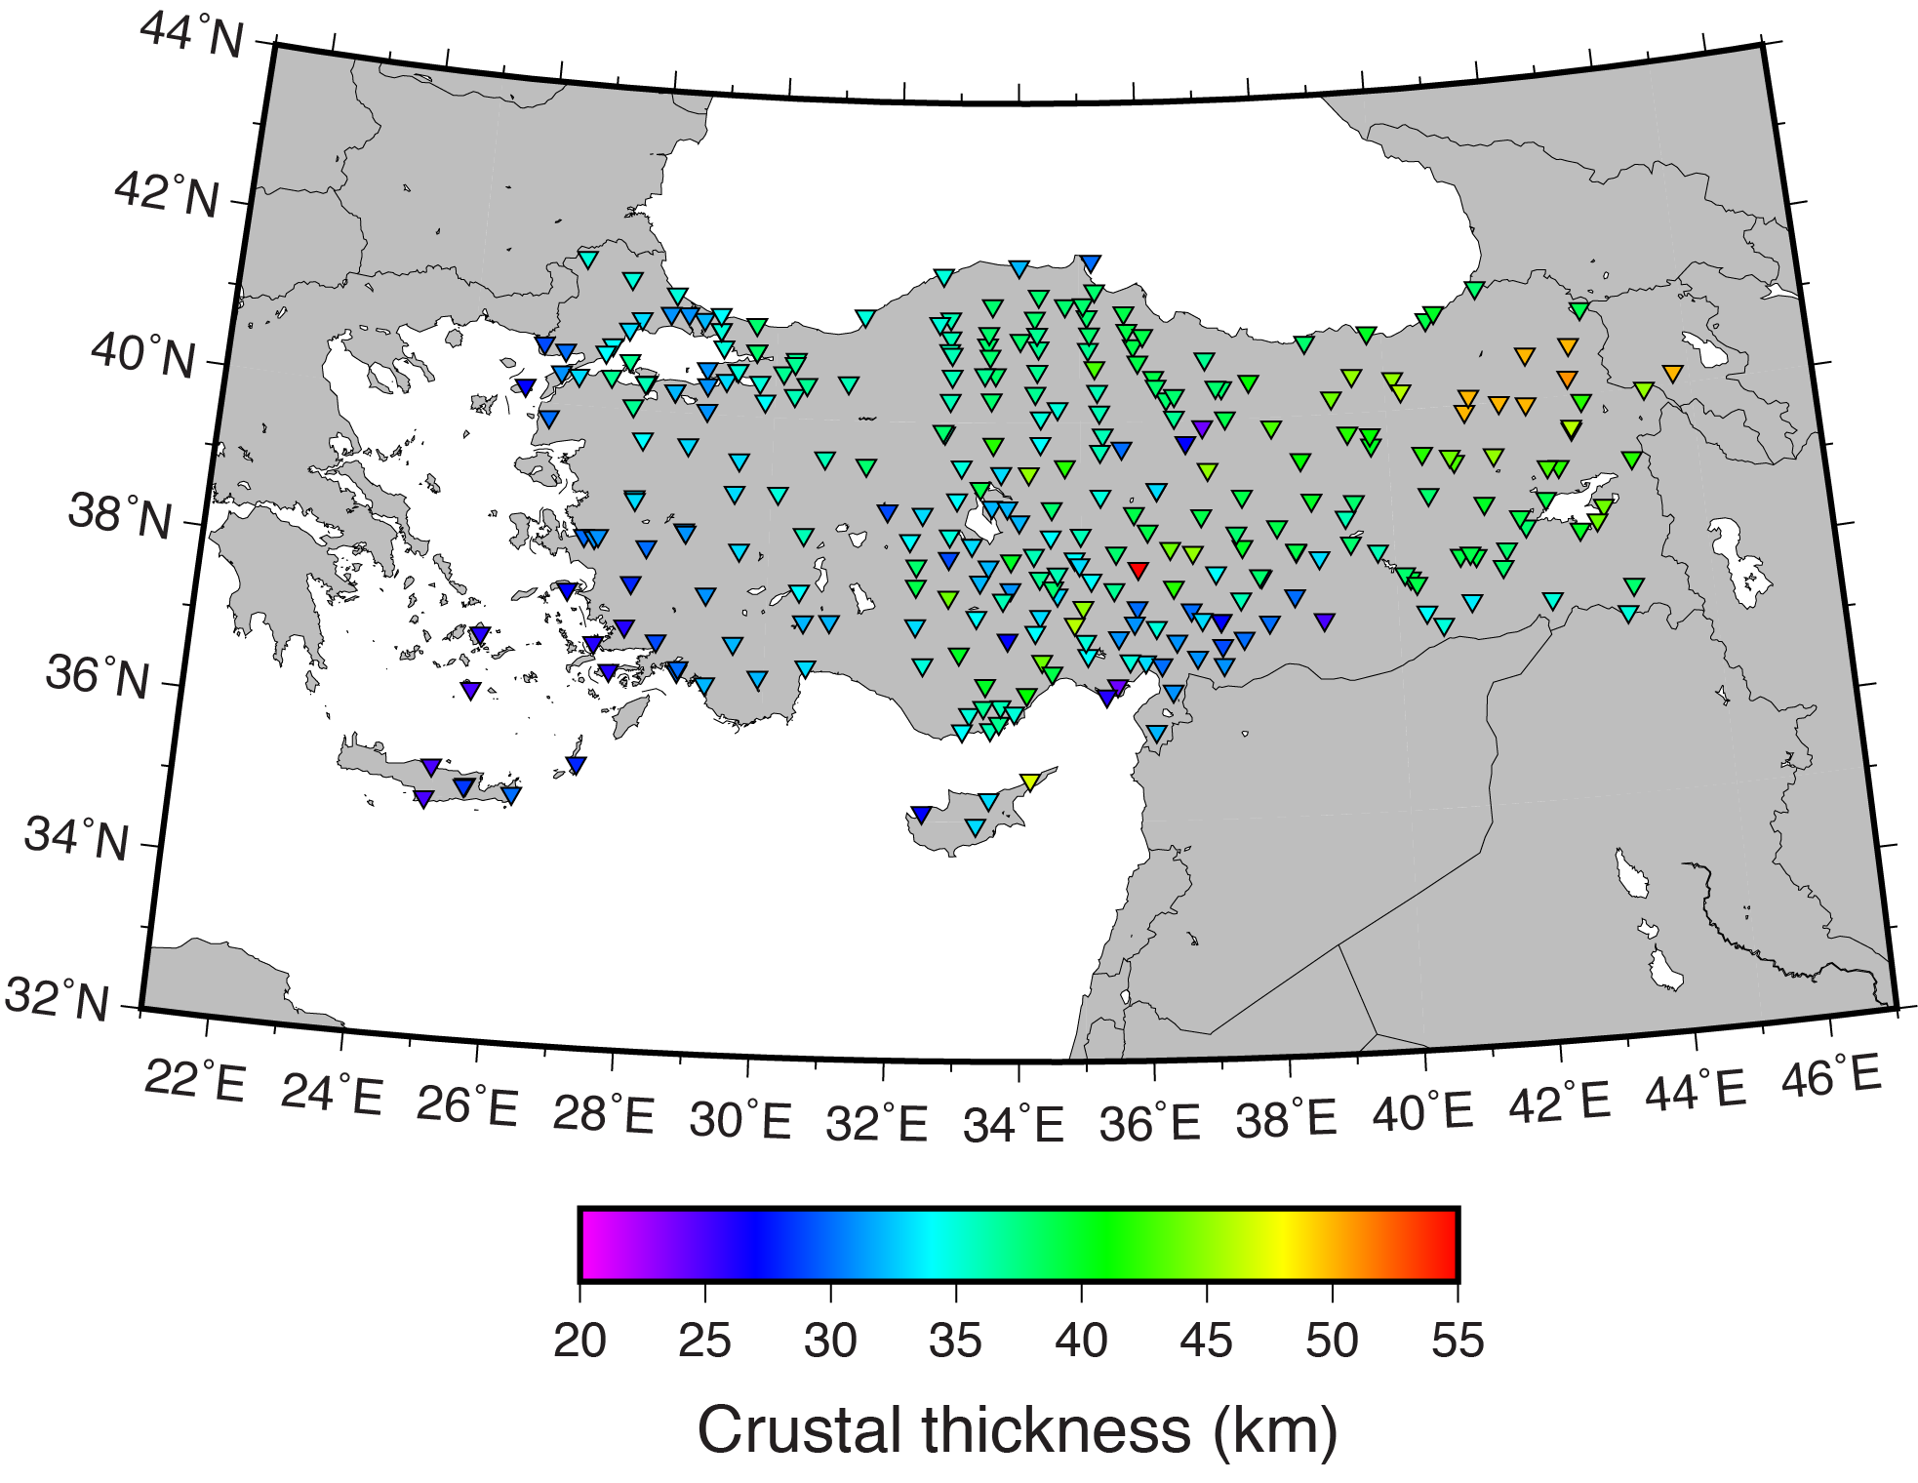
Figure S1. Map of seismic stations recording data used for this study, with color scaled by the crustal thickness at each station used for the crustal correction. Crustal thickness measurements are from the Moho maps of Vanacore et al. (2013) and Abgarmi et al. (2017). Outside of these models, crustal thickness was manually extrapolated.

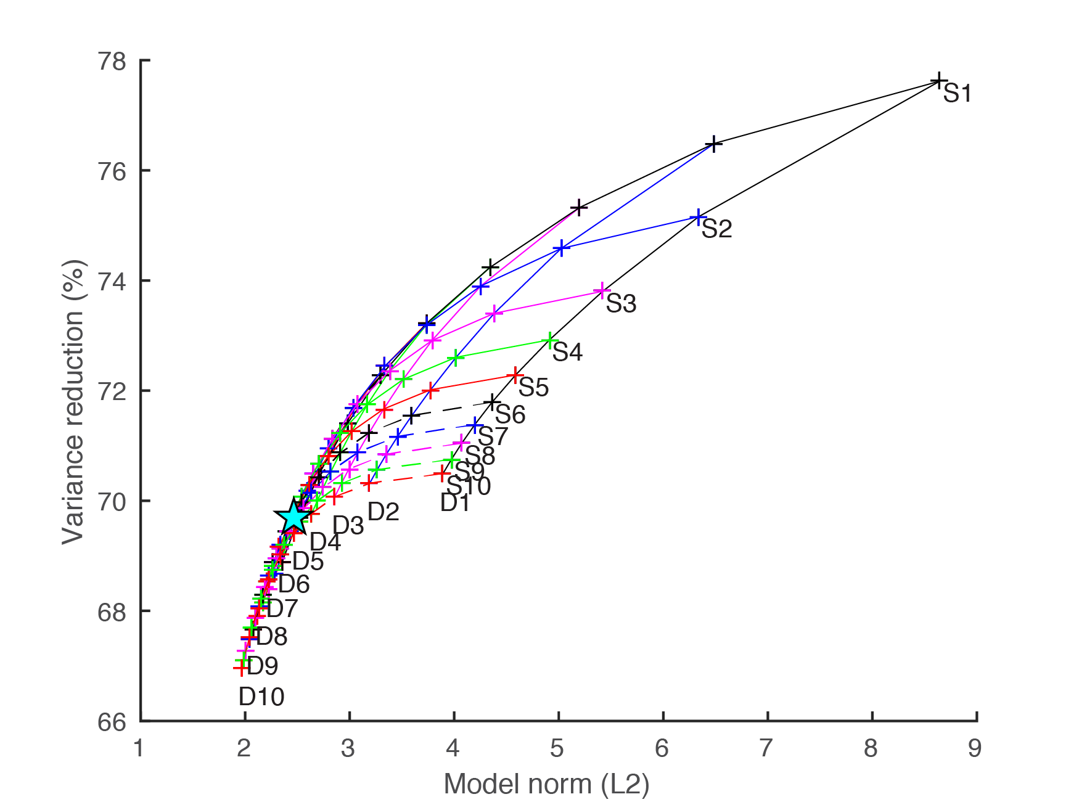
Figure S2. Tradeoff analysis between variance reduction and L2 model norm of inversions with varying damping (D1-D10) and smoothing (S1-S10) parameters. The final inversion was run with damping and smoothing parameters of 6 and 7, respectively (blue star).

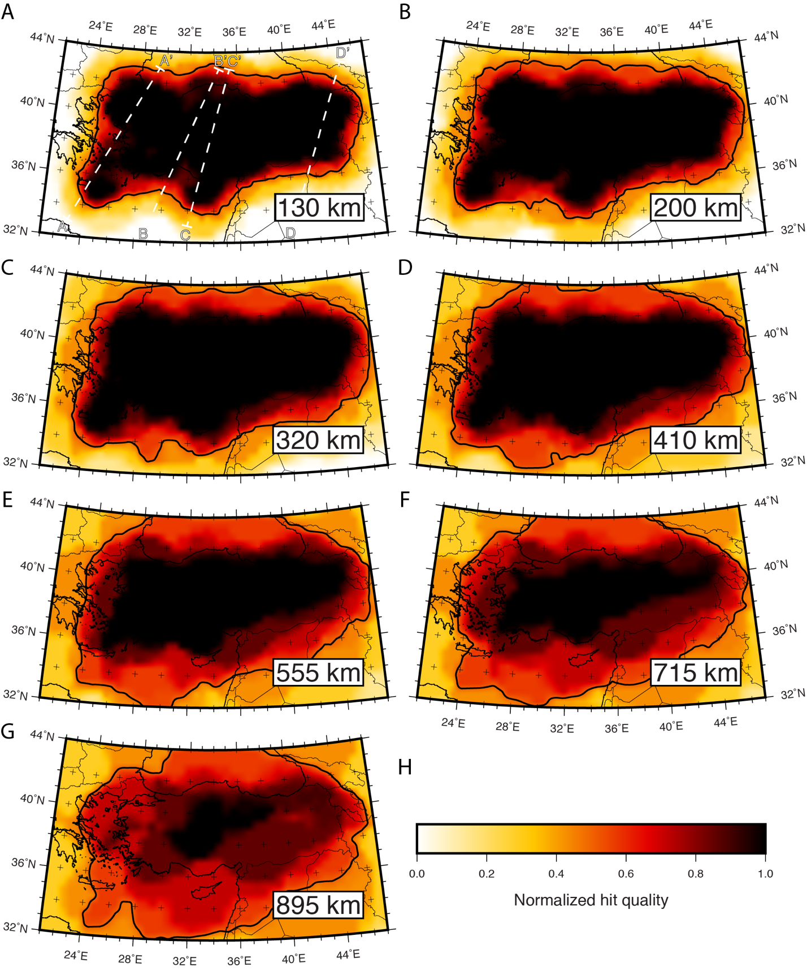
Figure S3. Map of normalized hit quality at depths of A) 130 km, B) 200 km, C) 320 km, D) 410 km, E) 555 km, F) 715 km, and G) 895 km (corresponding to depth slices in Figure 6). H) Color scale for normalized hit quality. The thick, solid black line is the 0.5 hit quality contour. Hit quality quantitatively asses the quantity and backazimuthal distribution of rays sampling a given node. To calculate hit quality, direct rays are separated into 60˚ backazimuthal bins, with core phases representing a seventh bin. Then rays are counted in each bin up to a maximum of five rays per bin and divided by a maximum total of 35. Thus, a hit quality of “1” signifies sampling of at least 5 rays within each bin for the given node and a hit quality of “0” means a complete lack of sampling of the node. This figure shows high hit quality throughout the upper mantle, and extending into the lower mantle. In the deepest layer (895 km depth), all of Anatolia is covered with hit quality >0.6, while hit quality is >0.2 across the whole region. We use a hit quality contour of 0.5 (pictured) as a proxy for the well resolved region of the model because it best represents the region of recovered amplitude at all depths. The dashed white lines in (A) indicate the traces for the cross sections in Figures S7 and S12.

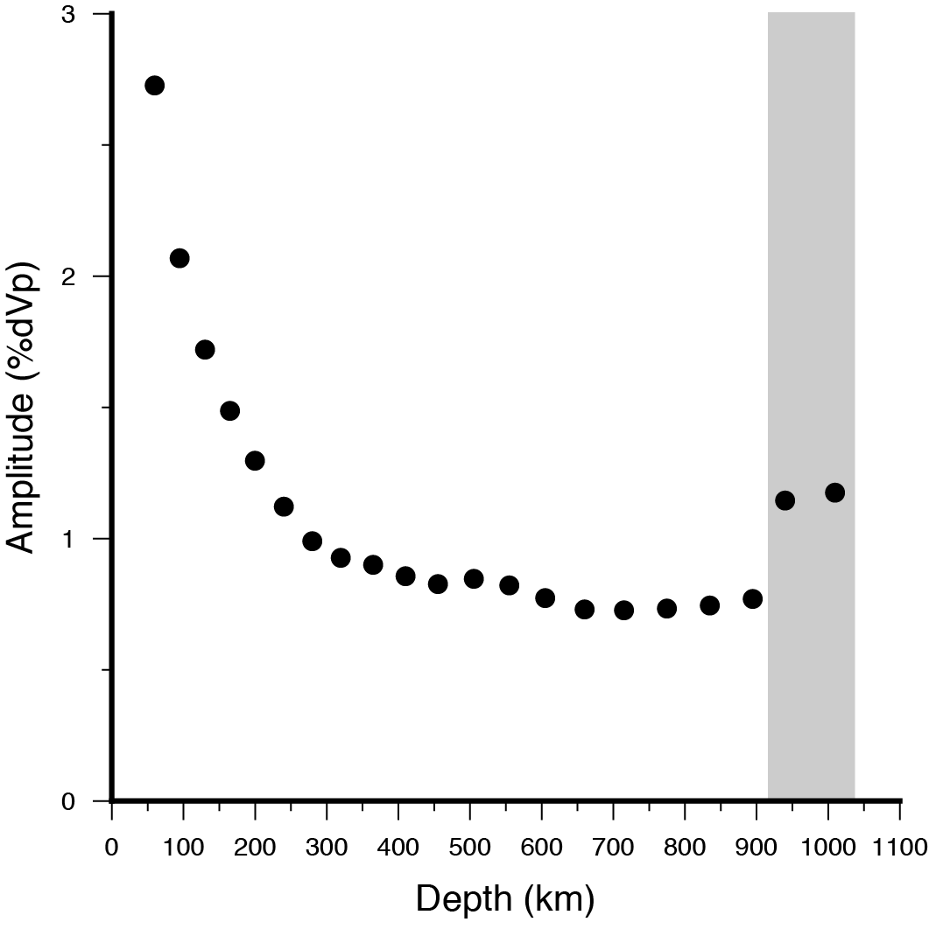
Figure S4. Average amplitude of velocity perturbation for each layer in the tomography model. This value was calculated by taking the average of the absolute value of velocity for the nodes in each layer with a hit quality >0.5. Note the clear decaying trend over the upper 19 layers. The deepest two layers, denoted by the shaded region, are outliers to this trend, supporting our interpretation that high amplitudes in the deepest two layers are an inversion artifact. Thus, we ignore the deepest two layers in our interpretations.

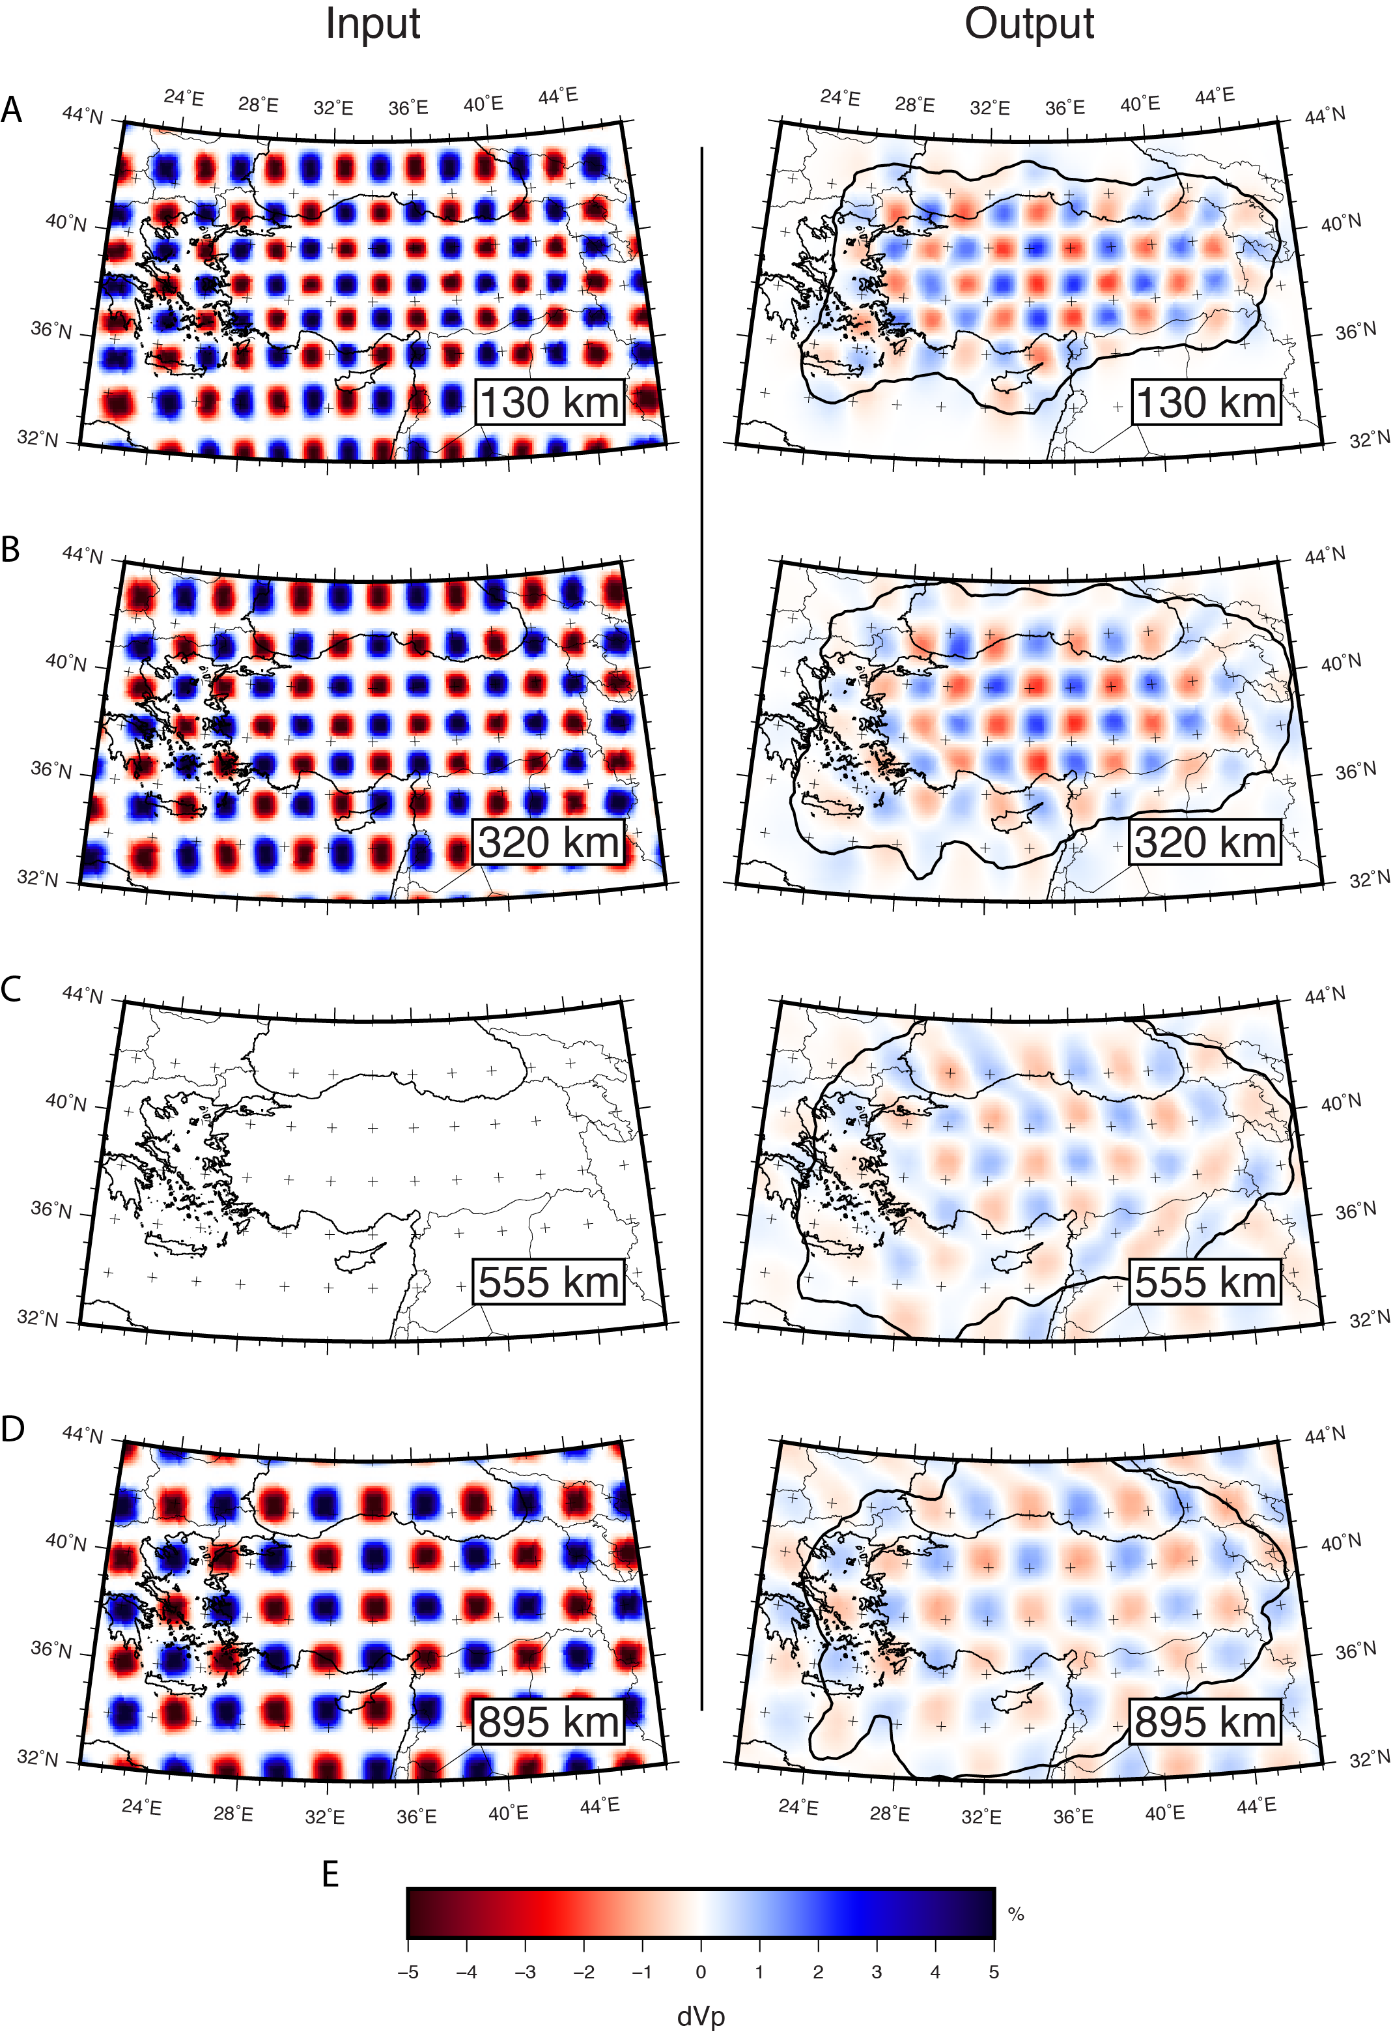
Figure S5. Results of a checkerboard recovery test are shown in map view at A) 130 km, B) 320 km, C) 555 km, and D) 895 km depth. E) shows the color scale for P-wave velocity perturbations. The input model for each layer is shown in the left column while the output is shown on the right. The thick solid black line in the output column represents a hit quality contour of 0.5. Note that the input at 555 km depth is neutral. Non-zero velocities in the output at 555 km depth indicate some vertical smearing. Overall, the checkerboard structure is best recovered below continental Anatolia where there are stations.

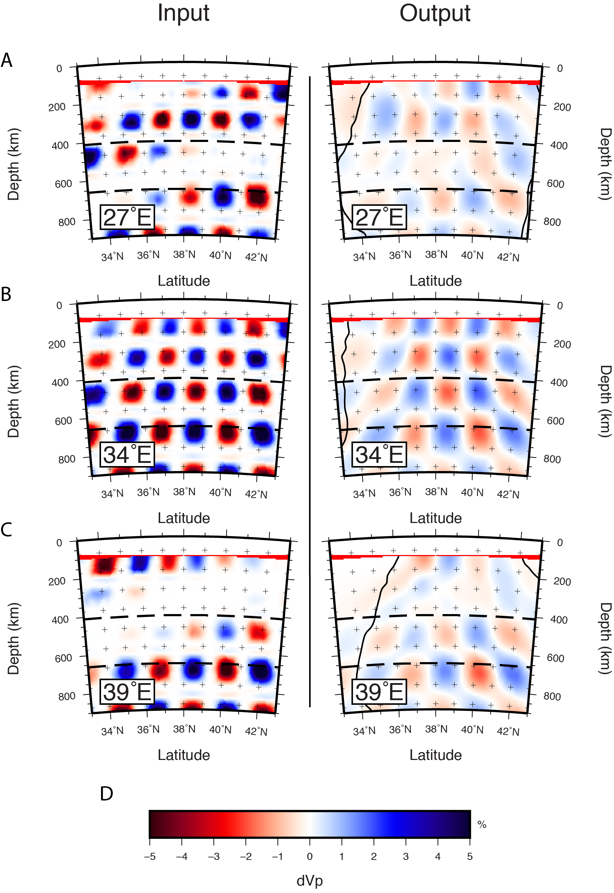
Figure S6. Results of a checkerboard recovery test are shown in cross section view along longitudes A) 27˚E, B) 34˚E, and C) 39˚E. D) shows the color scale for P-wave velocity perturbations. The input model for each layer is shown in the left column while the output is shown on the right. The thick solid black line in the output column represents a hit quality contour of 0.5. Note the correlation between neutral input and lower amplitude, indicating that while there is some smearing, there is good recovery of structure when present. Note also the lower amplitude recovery outside of the hit quality contour. The thin red layers at shallowest depths are plotting artifacts and not velocity perturbations.

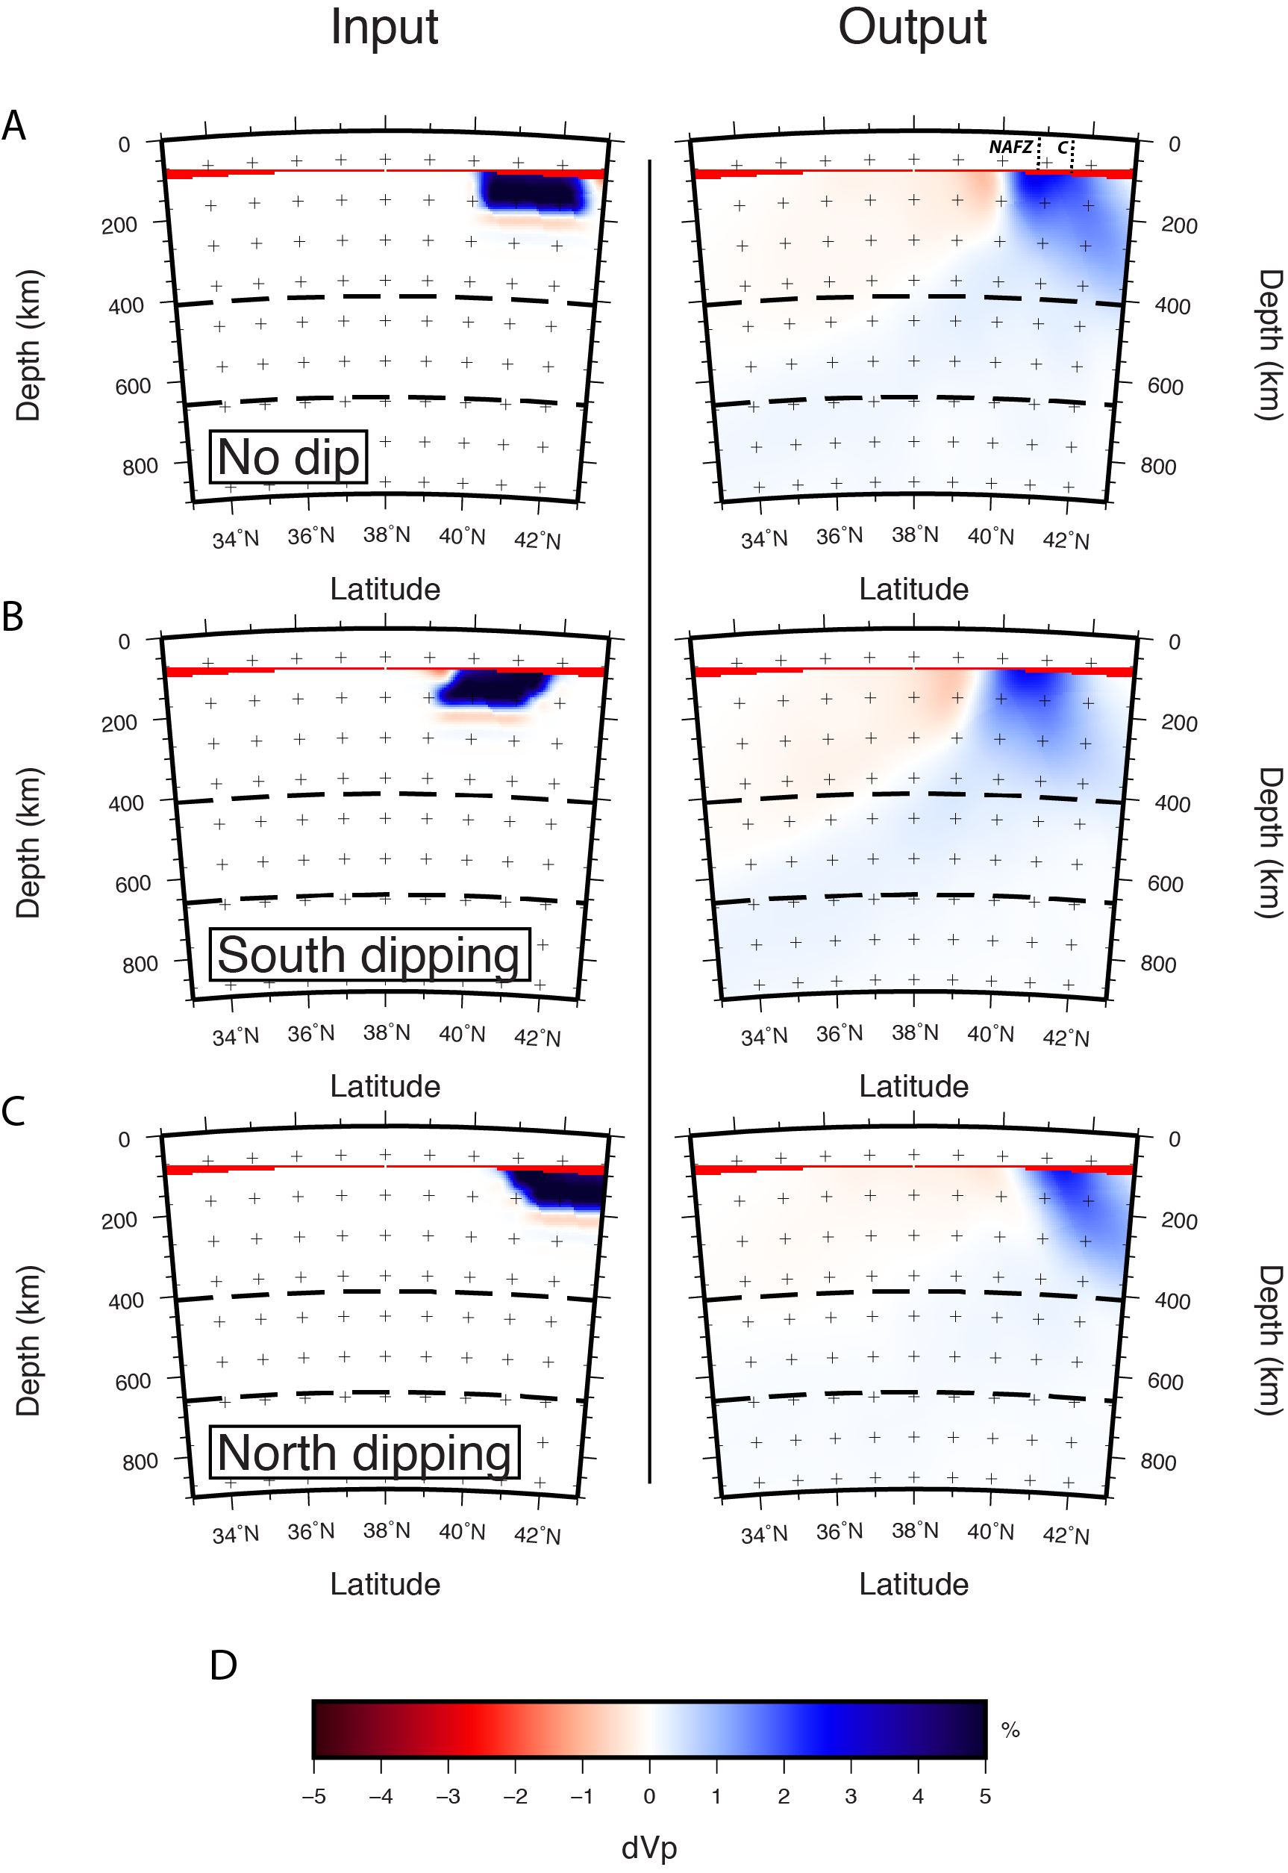
Figure S7. Results of several synthetic recovery tests are shown in cross section along longitude 30˚E. Synthetic anomalies are continuous fast velocity anomalies at shallow depth beneath northern Anatolia and the southern Black Sea with A) no dip, B) southward dip, and C) northward dip. The input anomaly (left column) is 5% for each test. Low amplitude slow velocity anomalies appearing in the input are artifacts of interpolation and not included in the input model. Note amplitude reduction in the output (right column) for each test. Note also the similarity in recovered structure between each test. Abbreviations and adjacent dashed lines indicate the intersection of the cross section with the North Anatolian Fault Zone (NAFZ) and the Black Sea coastline (C). C marks a distinct recovered amplitude boundary, with higher amplitudes recovered below Anatolia and lower amplitude recovered below the Black Sea. D) shows the color scale for P-wave velocity perturbations. The thin red layers at shallowest depths are plotting artifacts and not velocity perturbations.

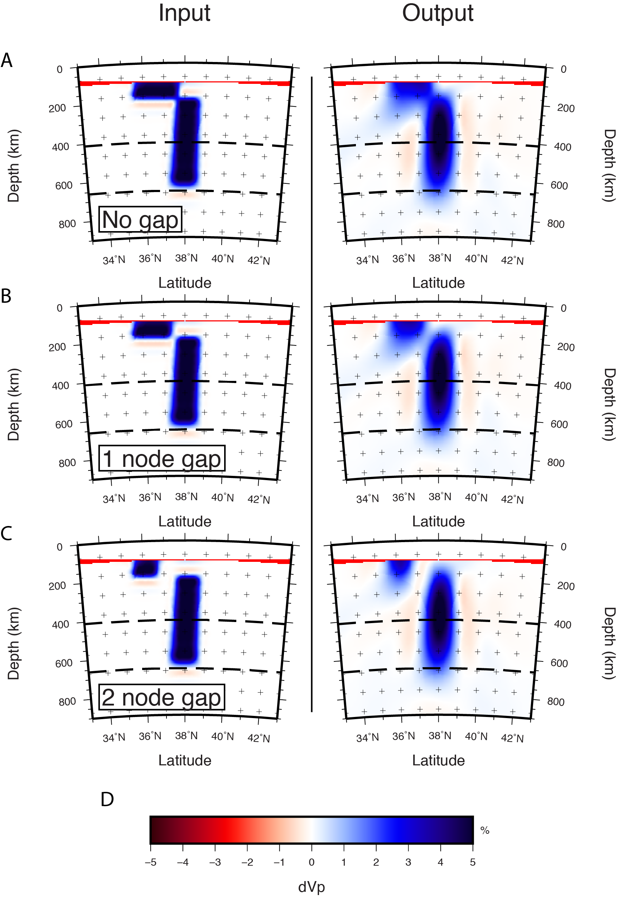
Figure S8. Results of several synthetic recovery tests are shown in cross section along cross-section C-C’ from Figure 6. Synthetic anomalies are fast velocity anomalies in the upper mantle beneath central Anatolia, meant to duplicate the recovered east Cyprean slab. Each test shows the east Cyprean slab with A) no separation between anomaly synthetic anomaly EC and EC2, B) a gap of one node between anomalies, and C) a gap of two nodes between anomalies. The input anomaly (left column) is 5% for each test. Low amplitude slow velocity anomalies appearing in the input are artifacts of interpolation and not included in the input model. Note the smearing between anomalies in (B) and (C). These tests indicate that a physical gap between anomaly EC and EC2 is required to allow for slow velocities to separate the two. Thus, a continuous slab is recoverable and the gap between the two anomalies noted in Figure 7C is likely not an artifact. E) shows the color scale for P-wave velocity perturbations. The thin red layers at shallowest depths are plotting artifacts and not velocity perturbations.

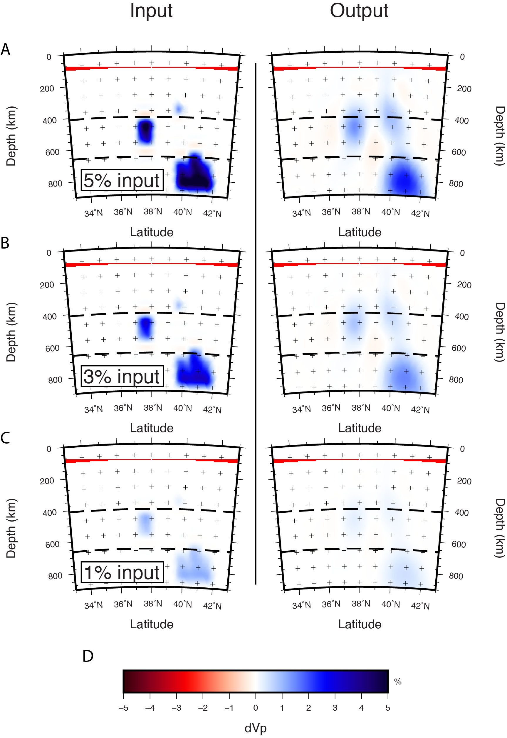
Figure S9. Results of several synthetic recovery tests are shown in cross section along cross-section D-D’ from Figure 6. Synthetic anomalies are fast velocity anomalies beneath eastern Anatolia, meant to duplicate some of the recovered fragments of the Bitlis slab. Each test shows the same synthetic fragments with A) 5%dVp input anomalies, B) 3%dVp input anomalies, and C) 1%dVp input anomalies. Low amplitude slow velocity anomalies appearing in the input are artifacts of interpolation and not included in the input model. Note the reduced amplitude recovery in the output models, indicating that recovered velocities underestimate true velocities. Note also that larger, contiguous input anomalies yield a higher recovery. Lastly, note that (B) most closely represents the fragments in Figure 7D, indicating that true velocity anomalies of at least 3% may be necessary to produce the observed velocities and that the observed anomalies are unlikely to be artifacts of the inversion. D) shows the color scale for P-wave velocity perturbations. The thin red layers at shallowest depths are plotting artifacts and not velocity perturbations.

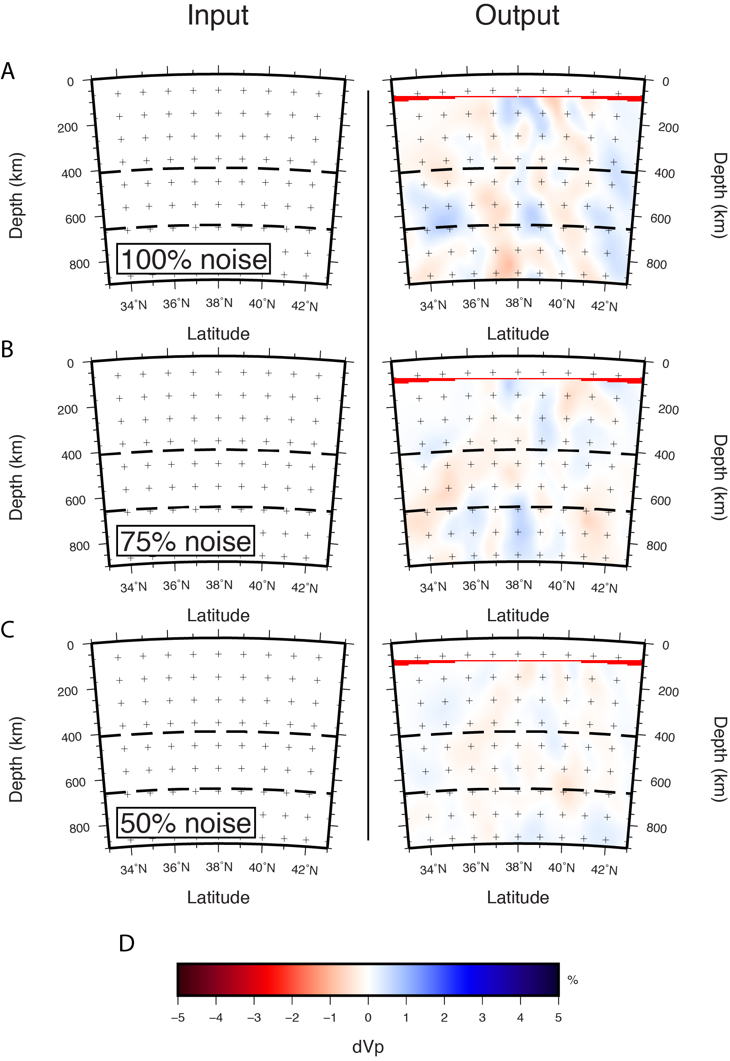
Figure S10. Results of several synthetic recovery tests are shown in cross section along cross-section D-D’ from Figure 6. In each synthetic test, the input model contains no velocity anomalies. Random Gaussian noise is then added to the synthetic data before inversion. The standard deviation of the Gaussian used for each inversion is A) 100%, B) 75%, and C) 50% of the standard deviation of data misfit after the tomographic inversion. Thus, a standard deviation of 100% (A) represents the assumption that all remaining misfit after inversion is the result of data noise and not due to simplifications of the forward problem. Note that only at 100% noise (A) do noise-induced anomaly amplitudes approach those interpreted as slab fragments. 100% and higher noise is unreasonably high, indicating that reasonable data noise alone is unlikely to produce the fast velocity anomalies interpreted as fragments, again suggesting that the interpreted fragments are likely not artifacts of the inversion. D) shows the color scale for P-wave velocity perturbations. The thin red layers at shallowest depths are plotting artifacts and not velocity perturbations.

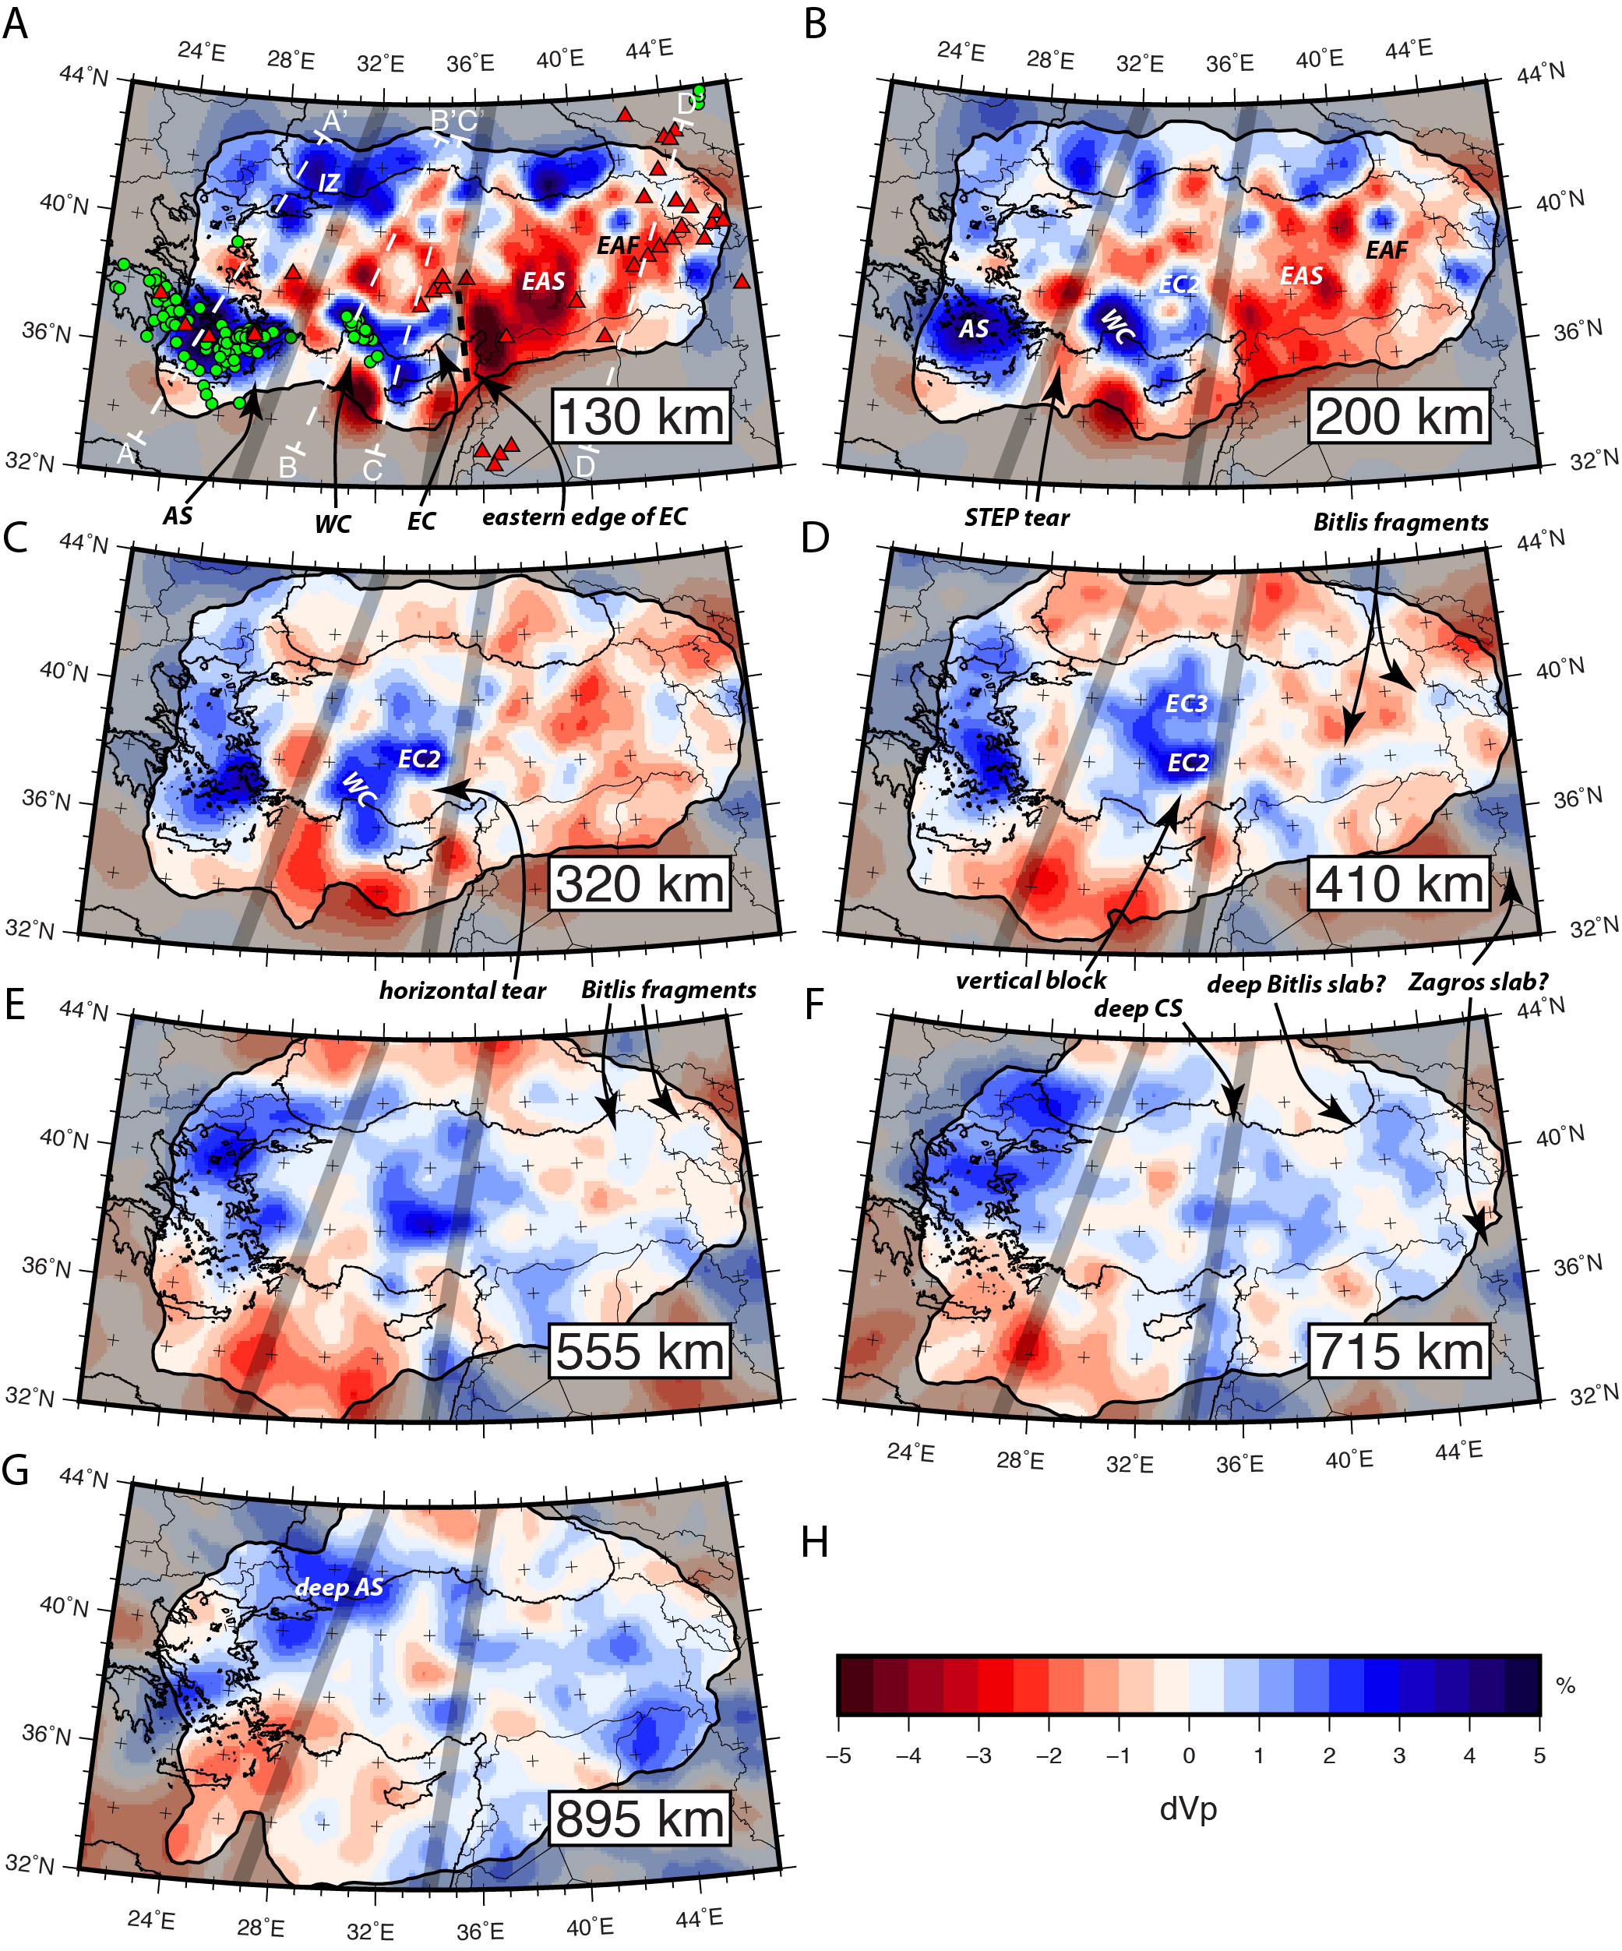
Figure S11. Same as Figure 6 except with a discrete color scale to better assess precise velocity perturbations to 0.5%dVp. Results from the tomographic inversion at depths of A) 130 km, B) 200 km, C) 320 km, D) 410 km, E) 555 km, F) 715 km, and G) 895 km. H) Color scale for P-wave velocity perturbations. Solid black line surrounded by dark shading represents the 0.5 hit quality contour. The dashed white lines in (A) indicate the traces for the cross sections in Figure S12. Green circles are earthquake locations from the USGS ComCat. As in Figure 1, red triangles indicate volcanoes active in the Holocene and thick gray lines separate the three convergent domains. Abbreviations are as follows: AS, Aegean slab; CS, Cyprean slab; EAF, East Anatolian fast anomaly; EAS, East Anatolian slow anomaly; EC, east Cyprean slab; IZ, İstanbul Zone; WC, west Cyprean slab.

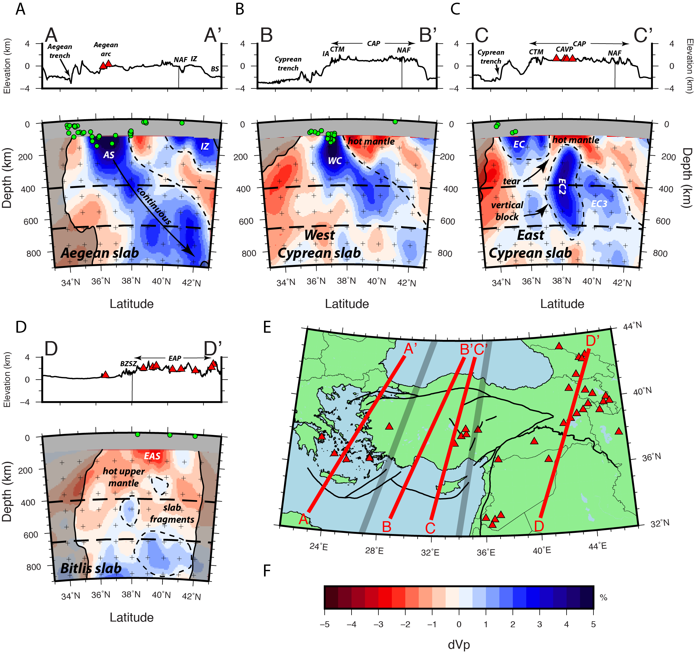
Figure S12. Same as Figure 7 except with a discrete color scale to better assess precise velocity perturbations to 0.5%dVp. Cross sections through the tomography model at locations oriented down-dip of the A) Aegean slab, B) West Cyprean slab, C) East Cyprean slab, and D) Bitlis-Zagros Suture. Topography and tectonic features are labeled above the profiles. Volcanoes, earthquakes, and convergent domains are as in Figs. 1 and 4. E) Map indicating the surface traces of the cross sections. F) Color scale for P-wave velocity perturbations. Abbreviations are as follows: AS, Aegean slab; BS, Black Sea; BZSZ, Bitlis-Zagros Suture Zone; CAP, Central Anatolian Plateau; CAVP, Central Anatolian Volcanic Province; CTM, Central Taurus Mountains; EAP, East Anatolian Plateau; EAS, East Anatolian slow anomaly; EC, east Cyprean slab; IA, Isparta Angle; IZ, İstanbul Zone; NAF, North Anatolian Fault; WC, west Cyprean slab.

