Supplemental Material
Causes and consequences of flat slab subduction in southern Peru
Brandon T. Bishop¹, Susan L. Beck¹, George Zandt¹, Lara Wagner², Maureen Long³, Sanja Knezevic Antonijevic⁴, Abhash Kumar⁵, Hernando Tavera⁶
¹Department of Geosciences, University of Arizona, 1040 East 4th Street, Tucson, Arizona 85721, USA
²Department of Terrestrial Magnetism, Carnegie Institution for Science, 5241 Broad Branch Road NW, Washington DC 20015, USA
³Department of Geology and Geophysics, Yale University, 210 Whitney Avenue, New Haven, Connecticut 06511, USA
⁴University of North Carolina at Chapel Hill, CB #3312, Chapel Hill, North Carolina, 27599, USA
⁵National Energy Technology Laboratory, 626 Cochrans Mill Road, Pittsburgh, PA 15236, USA
⁶Instituto Geofísico del Perú, Calle Badajoz 169, Lima 15012, Peru
RECEIVER FUNCTION METHOD DETAILS
We obtained records of teleseismic direct P-phases (≥5.0 Mw, 30° and 90° distance, 1431 usable station-event pairs), PP-phases (≥6.0 Mw, 90° and 150° distance, 1202 usable station-event pairs), and PKP-phases (≥6.0 Mw, 110° and 160° distance, 119 usable station-event pairs, PKP- phase was not used for PeruSE stations as overlapping station coverage provided sufficient P-, PP-phase arrivals) arrivals from each seismometer for the calculation of teleseismic receiver functions (Langston, 1979) via the iterative time domain deconvolution technique (Ligorría and Ammon, 1999) using a Gaussian pulse width of 2.5 (equivalent to a low-pass filter with a corner frequency of 1.2 Hz). This gave us a total of 2752 receiver functions. In addition we obtained records for 9 local events with hypocenters >30 km depth reported in the Instituto Geofísico del Perú catalogue to find direct P- and direct S-phase arrivals (175 waveforms with both clear P- and S-phases) to better constrain the regional average Vp/Vs ratio using a modified Wadati Plot (Chatterjee et al., 1985) shown in Figure S1.
We have utilized a regionally representative layer over half-space model to migrate our RF data to depth and corrected for elevation using the Common Conversion Point (CCP) stacking method with bin spacing, bin sharing, and orientations as described in the main text (Dueker and Sheehan, 1997, Sheehan et al., 2000). CCP-stacks were bootstrapped for 400 iterations. We used the high number of iterations to compensate for our 0.1 km vertical bin thickness. This fine vertical spacing (finer than our theoretical RF resolution) was selected to avoid potentially clipping the peaks of high amplitude arrivals. All CCP-stacks plot only bins containing 4 or more RFs to dampen the possible effects of noise or a single, spurious RF trace.
Our crustal layer is based on a regional crustal velocity study which found a vertically averaged P-wave velocity of 6.0 km/s (Dorbath, 1996) and the Vp/Vs value of 1.75 +/- 0.01 we obtained from our modified Wadati plot, comparable to values determined elsewhere in central Andes (e.g. Dorbath and Granet, 1996, Phillips et al., 2012 Chulick et al., 2013, Ryan et al., 2016). The mantle half-space extends to 200 km depth and was assigned a P-wave velocity of 8.1 km/s and a Vp/Vs of 1.8 (equivalent to IASP91 mantle P-wave velocity and Vp/Vs values averaged to 200 km depth). Forward modeling shows that a feature at 60 km depth in our CCP stacks can be moved only ~0.8 km by Vp/Vs variations of 0.01 or only ~2.6 km by a 5% change in the average P-wave velocity of the entire crustal column.
DISTINGUISHING PRIMARY (Ps) RF ARRIVALS OF DEEP (50-100 KM) STRUCTURE FROM CRUSTAL MULTIPLE (PpPs) RF ARRIVALS
One of the challenges confronting interpretation of P-wave RFs lies in distinguishing Ps phases generated from interfaces in the lower crust and upper mantle from reverberations generated by the reflection of the P-wave (and its conversions) between an upper crustal interface and the surface (referred to as “multiples”, see Cassidy (1992) for discussion). For the case of a non-dipping or shallowly dipping interface, the first multiple to arrive after a Ps conversion (PpPs) has the same polarity as the Ps conversion while the second multiple (PpSs or PsPs) has a polarity opposite to the Ps conversion (Cassidy, 1992). For the case of a dipping interface, the first multiple (PpPp phase) will possess a highly varying polarity (negative when arriving from the up dip direction, positive when from the down dip direction) and may arrive over a much wider time window than other multiples (Cassidy, 1992). The high variability of this PpPp is unlikely to be stacked coherently during the CCP-stacking process and while acknowledging this phase may locally complicate our interpretation of the continental Moho Ps and slab Moho Ps arrivals we do not attempt detailed modeling of this phase. Instead we consider in greater detail the PpPs and PpSs/PsPs phase multiples generated by crustal structure as these are the most likely phases to affect our interpretation.
Supplemental Figures S2A and S2B show details of our CCP cross-section A-A’ from Figure 3. Section A-A’ shows a great variety of arrivals generated by crustal interfaces and shows the smallest amplitude arrivals that we interpret to be from slab oceanic Moho Ps. This makes A-A’ a representative test case for the influence of multiples on our interpretations. We examine this influence by utilizing the equations from Zhu and Kanamori (2000) describing the predicted arrival time of the PpPs phase and PpSs/PsPs phase:
T_{PpPs} = H * [ SQRT ( 1 / V_{s}² – p² ) + SQRT ( 1 / V_{p}² – p² ) ], (1)
T_{PpSs/PsPs} = H * 2 * [ SQRT ( 1 / V_{s}² – p² ) ]. (2)
where T_{PpPs} is the arrival time of the PpPs phase, T_{PpSs/PsPs} is the arrival time of the PpSs/PsPs phases, H is the depth to the interface generating the multiple phases, V_{s} is the S-wave velocity, V_{P} is the P-wave velocity, and p is the ray parameter.
We then migrate these theoretical times to depth using our CCP-stack velocity model. As we are interested only in positive amplitude arrivals we do not consider the second multiple of positive Ps arrivals and the first multiple of negative Ps arrivals.
The ray path of a multiple is affected only by material separating an interface and the surface, and this consideration allows us to place limits on the P-wave velocity used to predict the multiples’ arrival times. We choose values of 5.0 km/s and 7.0 km/s (corresponding to a felsic and mafic dominated composition respectively) to provide a minimum and maximum arrival time for each multiple along with values of 5.6 km/s and 6.3 km/s based on crustal velocity models proposed by Phillips et al. (2012) and Ma and Clayton (2014) respectively for our study region. We define our S-wave velocity using Vp/Vs ratios reported for the crust to the north and south of our study region. The values of Vp/Vs recorded by Condori et al. (2017) and Phillips et al. (2012) are dominantly contained within a range of 1.70 and 1.90; we take these as our minimum and maximum bounds for our models. An average Vp/Vs value of 1.75 has been repeatedly found to hold for our region through multiple methods (see above and Phillips et al., 2012, Ryan et al., 2016), and we have also used this value in our modeling.
In the forearc (Figure S2A), we observe a single positive Ps arrival above our interpreted forearc Moho (filled black line). This phase arrives at 1.94 seconds (after correcting for ~0.6 km average station elevation). We find that the first multiple should arrive at: 6.67 seconds for a velocity structure with Vp = 5.0 km/s, Vp/Vs = 1.70; 4.82 seconds for Vp = 7.0 km/s, Vp/Vs = 1.9; 6.10 seconds for Vp = 5.6 km/s, Vp/Vs = 1.75; and 5.94 seconds for Vp = 6.3 km/s, Vp/Vs = 1.75. Migrated with our CCP-stack velocity structure, these values translate to depths of 50.6 km, 36.5 km, 46.3 km, and 45.0 km respectively. These values are plotted as dashed lines in Figure S2A (the 46.3 km and 45.0 km are too close to distinguish at the scale of Fig. S2A), and appear to correspond to an arrival that cross-cuts the feature we interpret as the forearc Moho. While this locally complicates our interpretation, we are able to identify the dipping Ps arrival corresponding to the continental Moho throughout much of the forearc along A-A’.
The crustal structure in the segment of A-A’ highlighted in Figure S2B is significantly more complicated than the forearc. Here four positive arrivals mark potential interfaces which could generate PpPs positive multiples that may complicate our interpreted slab Moho arrival, as well as a large negative arrival that could generate a PpSs/PsPs positive multiple. The earliest phase, after correcting for an average station elevation of ~2.8 km, arrives at 1.77 seconds (solid black line in Figure S2B). The first multiple (dashed black line in Figure S2B) should arrive at: 6.08 seconds for a velocity structure with Vp = 5.0 km/s, Vp/Vs = 1.70; 4.40 seconds for Vp = 7.0 km/s, Vp/Vs = 1.9; 5.57 seconds for Vp = 5.6 km/s, Vp/Vs = 1.75; and 5.42 seconds for Vp = 6.3 km/s, Vp/Vs = 1.75. Migrated with our CCP-stack velocity structure, these values translate to depths of 46.1 km, 33.4 km, 42.2 km, and 41.1 km respectively (note that the 42.2 km and 41.1 km markers are again too close to distinguish at the scale of Fig. S2B). These values all lie above the continental Moho Ps arrival and as such have no effect on our interpretation of the slab. Likewise, the positive arrival at 2.53 seconds (white solid line in Figure S2B) would have multiples (white dashed lines in Figure S2B) arrive at 8.70 seconds (66.0 km), 6.29 seconds (47.7 km), 7.96 seconds (60.4 km), or 7.74 seconds (58.7 km)—all of which are well above our interpreted slab Moho Ps arrival (again, note the 60.4 km and 58.7 km markers are too close to distinguish at this scale). The deeper positive arrivals at 5.01 seconds (solid green line in Figure S2B) and 5.45 seconds (solid purple line in Figure S2B) should generate multiples that would arrive significantly below our interpreted slab Ps. The 5.01 second feature’s first multiple (dashed green lines in Figure S2B) may arrive at 17.22 seconds (142.1 km), 12.45 seconds (94.4 km), 15.76 seconds (128.5 km), or 15.33 seconds (124.8 km). The 5.45 second arrival’s first multiple (dashed purple line in Figure S2B) is likely to arrive sometime between 18.73 seconds (155.6 km, not shown), 13.54 seconds (108.4 km), 17.14 seconds (141.4 km) or 16.68 seconds (137.2 km).
While the first multiple for the negative amplitude arrival at 3.56 seconds in Figure S2B would arrive as a negative, its second multiple would arrive at a positive and potentially affect our interpretation of the slab arrival. We find that the second multiple would arrive in the range of 15.29 seconds (124.4 km), 11.25 seconds (87.4 km), 14.06 seconds (113.2 km), and 13.76 seconds (110.4 km). We recognize that the 11.25 second/87.4 km arrival, requiring a high (7.0 km/s) P-wave velocity and unusually high (1.90) Vp/Vs, could potentially complicate our interpretation. However we note that no strong, negative first multiple is observed beneath the Ps arrival, suggesting that the first multiple is highly attenuated and indicating that the second multiple would be further attenuated and likely of a smaller amplitude than our interpreted slab arrival; likewise the positive arrival between 70 km and 80 km depth and slab seismicity (white circles in Figure S2B) suggests this feature is associated with the slab.
In locations where crustal arrivals are less complicated, we have followed more qualitative standards to help distinguished the slab Moho arrival from crustal multiples. In locations near the Eastern Cordillera/Subandes, we have found that many crustal Ps arrivals have an opposite sense of dip from our slab Moho Ps arrivals. The amplitude and polarity of multiples of a dipping structure vary strongly by back azimuth (Cassidy, 1992), behavior that is incapable of explaining the arrival we interpret as the slab Moho Ps. We have also found that the use of intersecting CCP-stack cross-sections is helpful in distinguishing Ps arrivals from multiple arrivals (see Figure S2C). Many arrivals in the upper crust are discontinuous or decrease significantly in amplitude in either the trench parallel or trench perpendicular direction while deeper arrivals we associate with the continental forearc Moho or subducted slab oceanic Moho extend laterally well beyond these upper crustal features without noticeable changes in amplitude. These deeper arrivals cannot be fully attributed to crustal multiples given their comparatively much greater lateral extent and high amplitude. In locations (notably the forearc, see between lines C and B/D in Figure S2C) where arrivals appear broad and possess more than one peak we have inferred the lower or slightly stronger feature as a potential Moho arrival while acknowledging this interpretation is much more uncertain than in other locations.
DISTINGUISHING SUBDUCTED OCEANIC MOHO AND CONTINENTAL MOHO OF THE OVERRIDNG PLATE
The importance of examining intersecting CCP-stack lines to determine the geometry of the subducted Nazca plate’s oceanic Moho and to distinguish it from the overlying continental Moho of the South American plate is strongly emphasized in Figures S3A and S3B. The intersection of CCP cross-sections 2-2’ and C-C’ show a clear separation between a positive arrival near ~60 km depth and a second positive arrival around 100 km depth. This deeper feature is associated with normal to strike-slip intermediate depth seismicity (Kumar et al., 2016; white circles in Figure S3A,B mark hypocenter locations); this pattern of intermediate depth seismicity is consistent with prior studies of local seismicity by Dorbath (1996) and Suárez et al. (1990) that overlapped the region shown by our C-C’ section. The association of this seismicity and a positive RF arrival is consistent both with the long-standing interpretation of intermediate depth seismicity with dehydration processes in the uppermost slab mantle or lower slab subducted oceanic crust (e.g. Kirby et al., 1996) and with our interpretation of the RF arrival as the slab subducted oceanic Moho.
The small lateral separation between the slab subducted oceanic Moho beneath the forearc and the continental Moho of the Western Cordillera (see Figure S3B) must be less than our lateral bin spacing (~22.5 km accounting for possible bin sharing effects). Without constraints from seismicity and cross-section 2-2’, the most straight-forward interpretation of C-C’ would be that the RF arrival beneath the Western and Eastern Cordillera at ~60 km depth is the slab subducted oceanic Moho. However, with the additional constraints provided by seismicity and intersecting cross-sections, it is clear that this interpretation is incorrect.
EFFECTS OF BIN SHARING AND STATION COVERAGE
Since the CCP-stack bins used in our study are overlapped to improve lateral continuity of features, we have been generally reluctant to interpret features in the shallow crust. Figures S4A (25 km x 25 km bins with no bin sharing), S4B (25 km x 25 km bins with 1.5 bin sharing), and S4C (50 km x 50 km bins with 1.5 bin sharing) show that while even the relatively sparse PULSE array has sufficient station coverage to resolve many features at continental Moho or slab depths, the shallow crust is much less sampled. This indicates that shallow features may be much less laterally extensive than they appear in our bin-sharing results. Furthermore, Fig. S4C indicates that using significantly larger bin sizes will greatly reduce our ability to resolve both the continental and slab Mohos.
We have generally avoided interpreting abrupt changes in the slab subducted oceanic Moho or continental Moho depth as these may be artifacts of bin sharing (hence our use of dashed lines for the interpreted continental Moho near 12.58˚S,74.89˚W on cross-section 2-2’ in Figures 4 and S3B). However, one feature that appears to be robust is the rapid offset in the subducted slab oceanic Moho near the projection of the Nazca Ridge’s northern edge (left orange line in Figure S3A,B). We interpret both the relatively weak positive arrival at ~80 to 100 km depth north of this projection and strong positive arrival at ~70 km depth south of this projection as the slab Moho due to their close association with normal to strike-slip seismicity documented at these depths by Kumar et al. (2016) (see discussion above for more details). This ~25 km change in slab depth must occur over less than the lateral distance of 1 bin width (25 km), much more rapidly than the transition to the south outlined through slab seismicity.
ADDITIONAL INFORMATION ON CONTINENTAL MOHO AND SUBDUCTED OCEANIC MOHO CONSTRAINTS
Supplemental Figure S5 shows constraints used to create the maps in Figure 5.
Figure S5A shows the location constraints for the South American continental Moho. To obtain the Moho depth from crustal thickness estimates, we subtracted the elevation, rounded to the nearest 0.1 km, at each location from the values reported by McGlashan et al. (2008) and James and Snoke (1994). While some of our array does sample the forearc Moho beneath the Pacific Ocean, lateral coverage is limited and we do not interpret these locations. In order to avoid the introduction of artifacts at the edges of the map, we have included a number of locations from Tassara and Echaurren (2012) and Ryan et al. (2016) outside of the mapped region. See Supplemental Table 1 for a list of the latitude, longitude, and depth to Moho of all constraints, including those outside of the mapped region.
Figure S5B shows the location of the points we used to constrain the subducted Nazca plate. Within the much of the array (region covered by green dots), we interpret this surface to represent the subducted oceanic Moho of the Nazca plate. At other locations, this surface may represent other features within the Nazca plate. We emphasize that the depths we report represent the subducted Slab Moho only at the locations marked by green dots in Fig. S2B. Locations from Slab1.0 (orange dots) represent, following Hayes et al. (2012)’s interpretation, the top of the subducting oceanic crust, while those from Scire et al. (2016) (blue dots) represent the center of a fast P-wave anomaly, which can be interpreted as the core of the subducting Nazca plate. Locations based on earthquake locations recorded in Kumar et al. (2016) and plotted in Dougherty and Clayton (2015) (yellow dots) are by definition depth to the subducting Nazca plate’s Wadati-Benioff Zone, however this may approximate the depth to the subducting Nazca plate’s oceanic Moho in this location. We note that where the earhtquake hypocenter data set overlaps our RF results (see Figure 3), the earthquakes are predominantly located near or slightly below the imaged subducted oceanic Moho. We are unable to test if this relationship holds at depth as we lack the station coverage to image the deeper parts of the slab and as the slab oceanic Moho Ps conversion weakens with increasing distance from the trench. To avoid artifacts near the edge of our map, we included points from Scire et al. (2016) and Hayes et al. (2012) well to the north and south of our region. See Supplemental Table 2 for a full list latitudes, longitudes, and depths of constaints used to calculate the slab surface, including those outside of the map area.
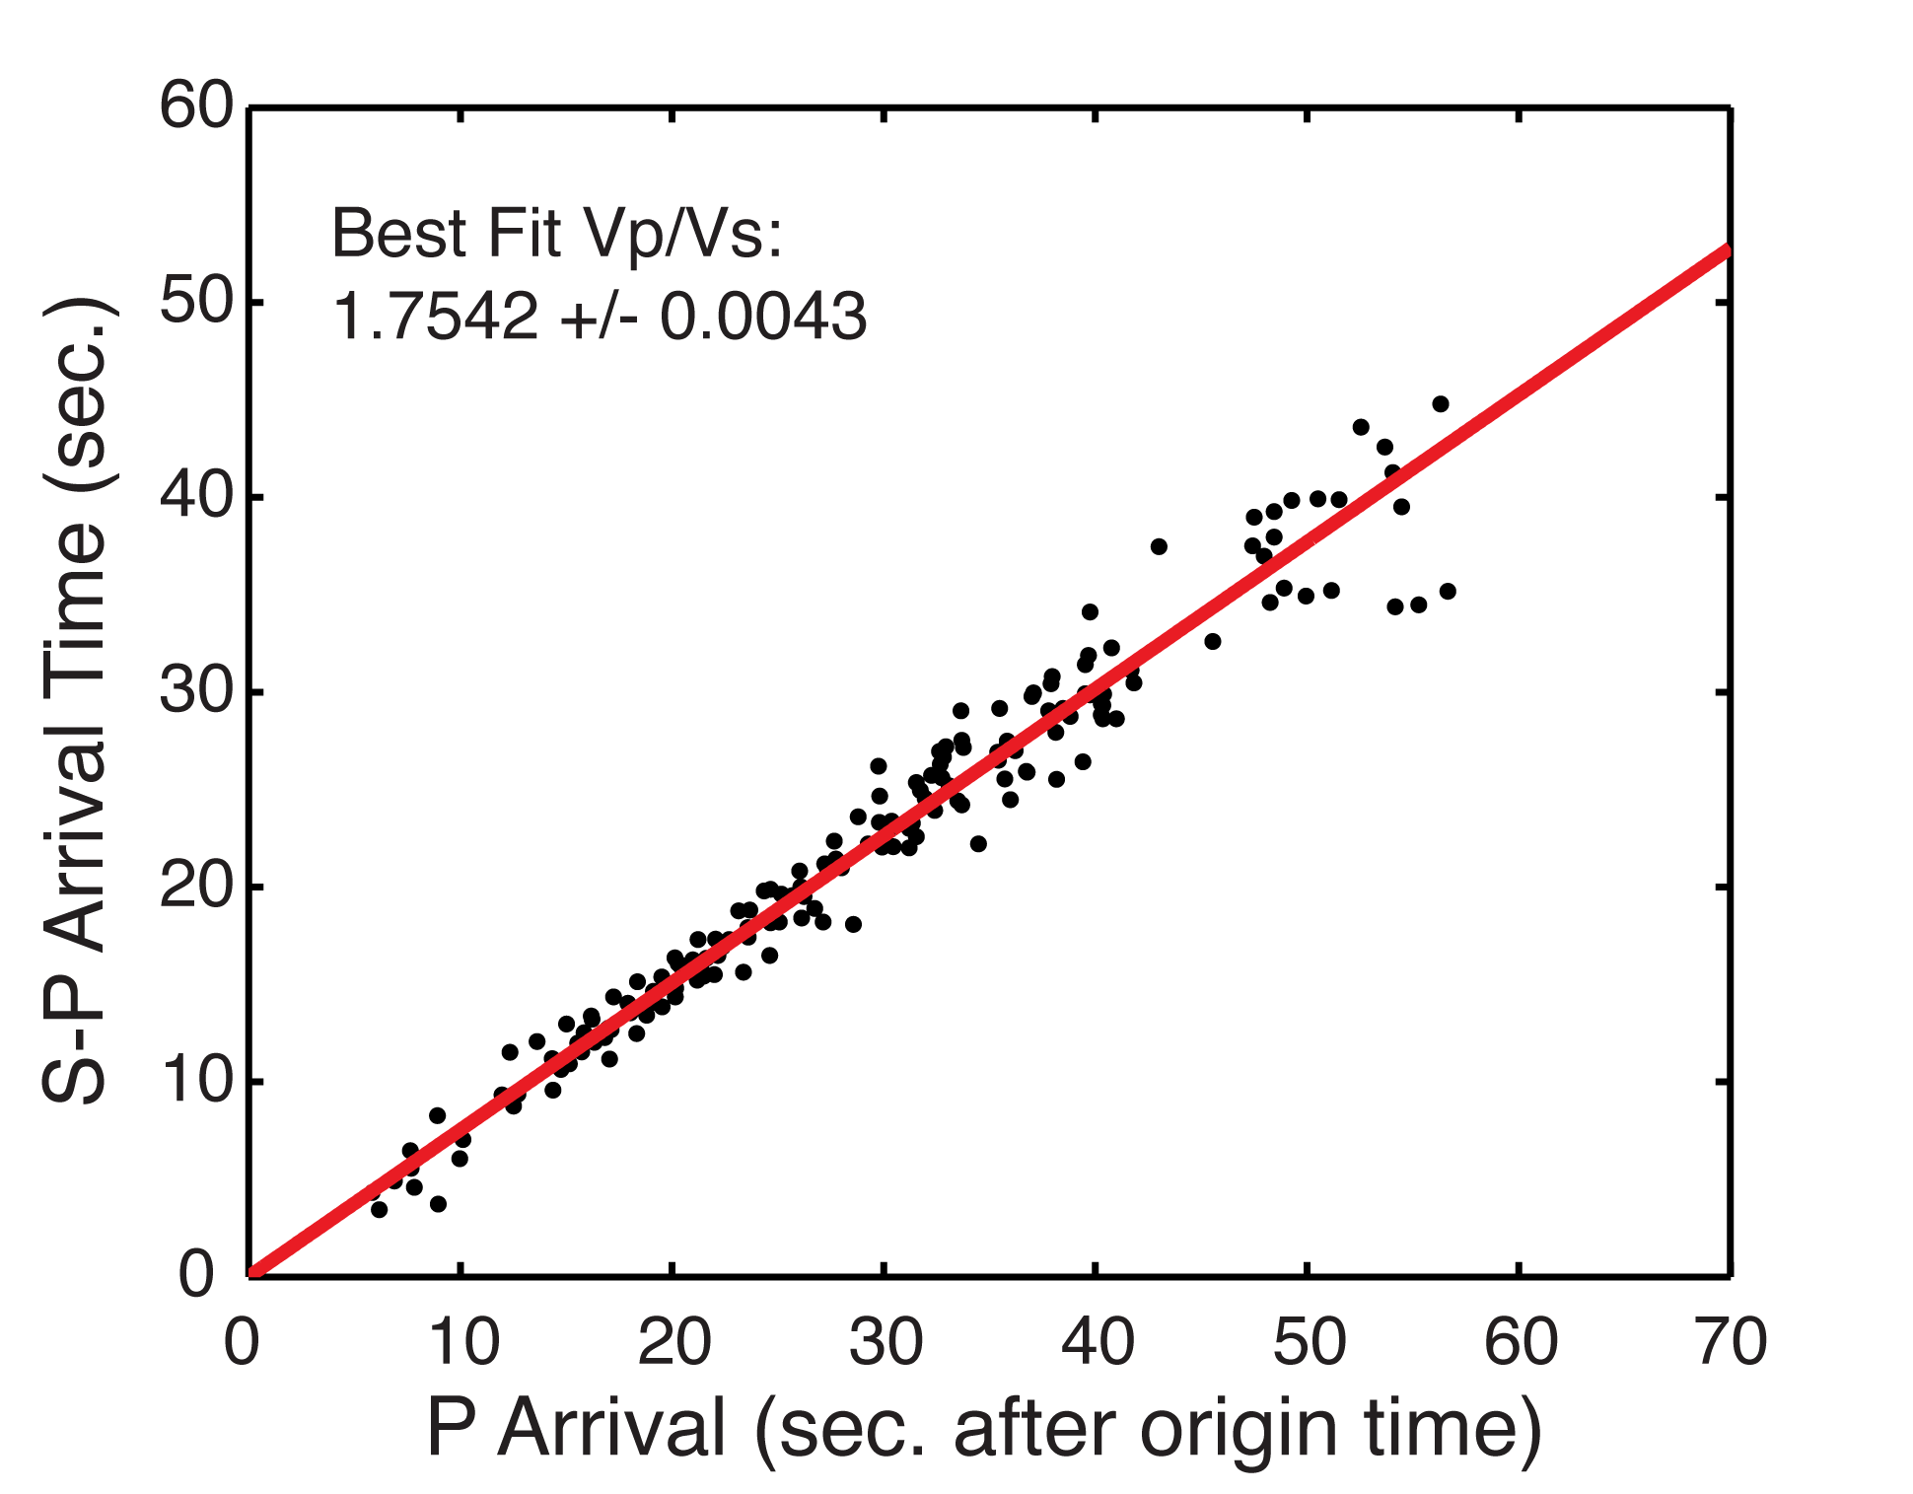
Figure S1. Modified Wadati Plot for 9 local events recorded by the PULSE network.

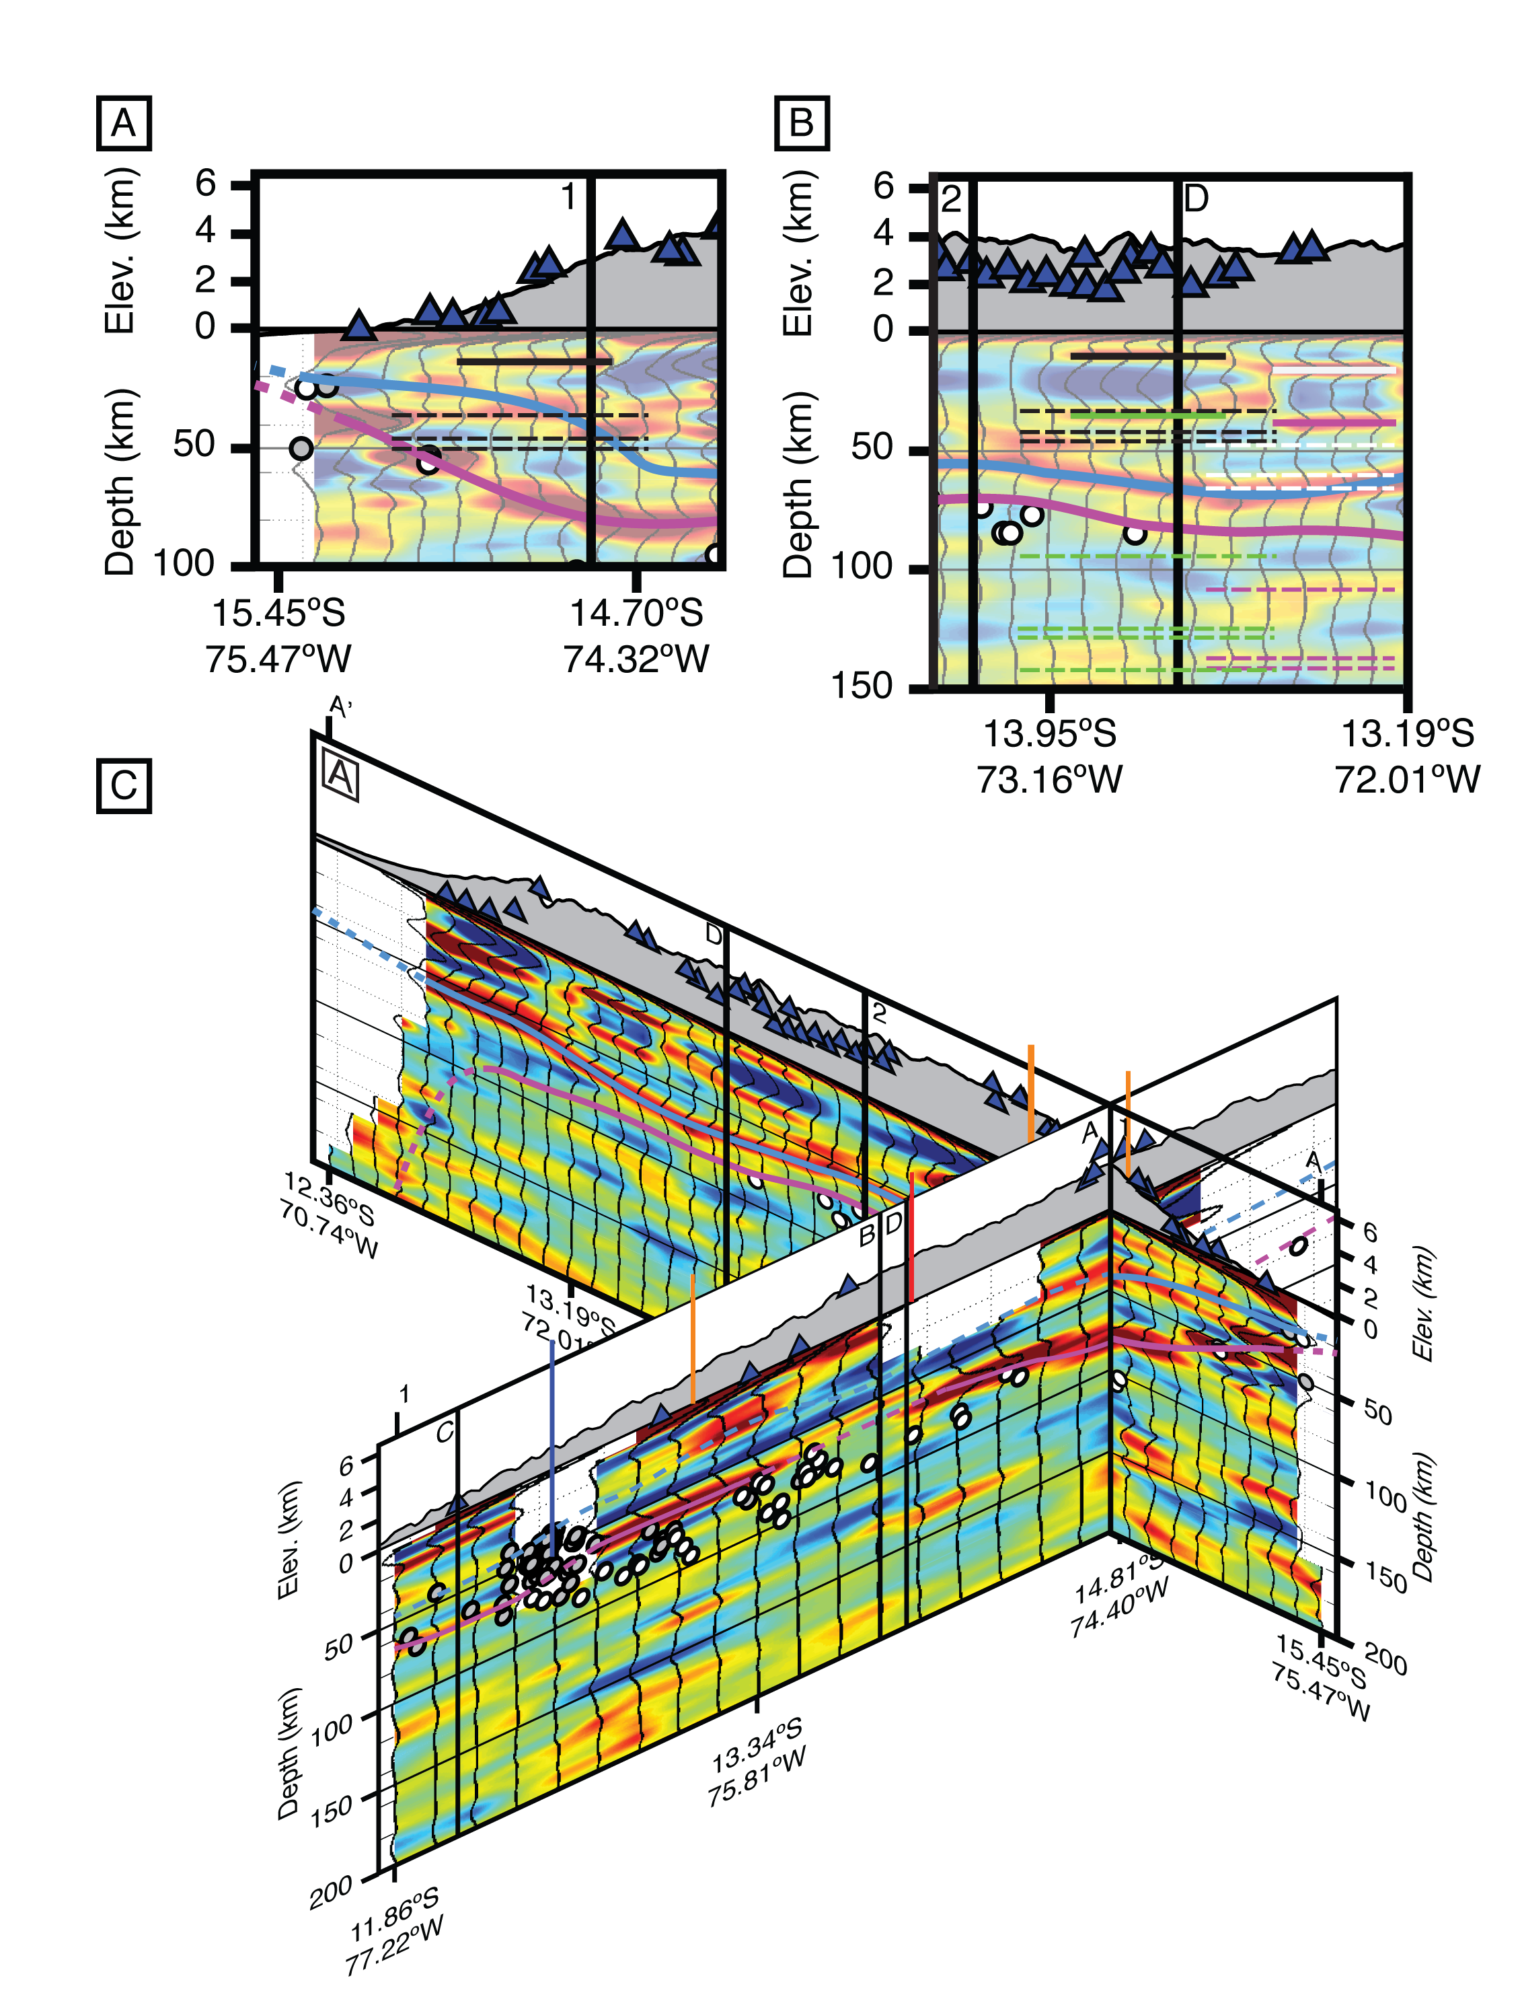
Figure S2 A) Comparison of our interpreted forearc Moho (blue line) and predicted first mulitples (dashed black lines) for a shallow interface in the forearc crust (solid black line). B) Comparison of our interpreted subducted oceanic Moho (Purple line) and predicted first mutiples (dashed lines) for potential crustal interfaces (sold lines). Colors of multiples correspond to colors of interfaces. C) Cross-sectons 1-1’ and A-A’ oriented about their intersection to show how identification of forearc continental and subducted oceanic Mohos may be aided through comparsion of intersecting cross-sections. Note that the significant decrease in the shallow continental crustal arrival amplitude on 1-1’ and the continued high amplitude forearc continental Moho arrival directly below suggests that the Moho arrival is not significantly affected by crustal multiples.

Figure S3 A) Cross-section 2-2’ and C-C’ arranged about their point of intersection, viewed from southeast. B) Same cross-sections viewd from southwest. When cross-sections are viewed separately, the subducted oceanic Moho of C-C’ in the forearc blends into Moho of the overriding plate, obscuring both features. When viewed together, and with slab seismicity, the subducted oceanic Moho beyond the forearc can be readily identified at ~100 km depth.
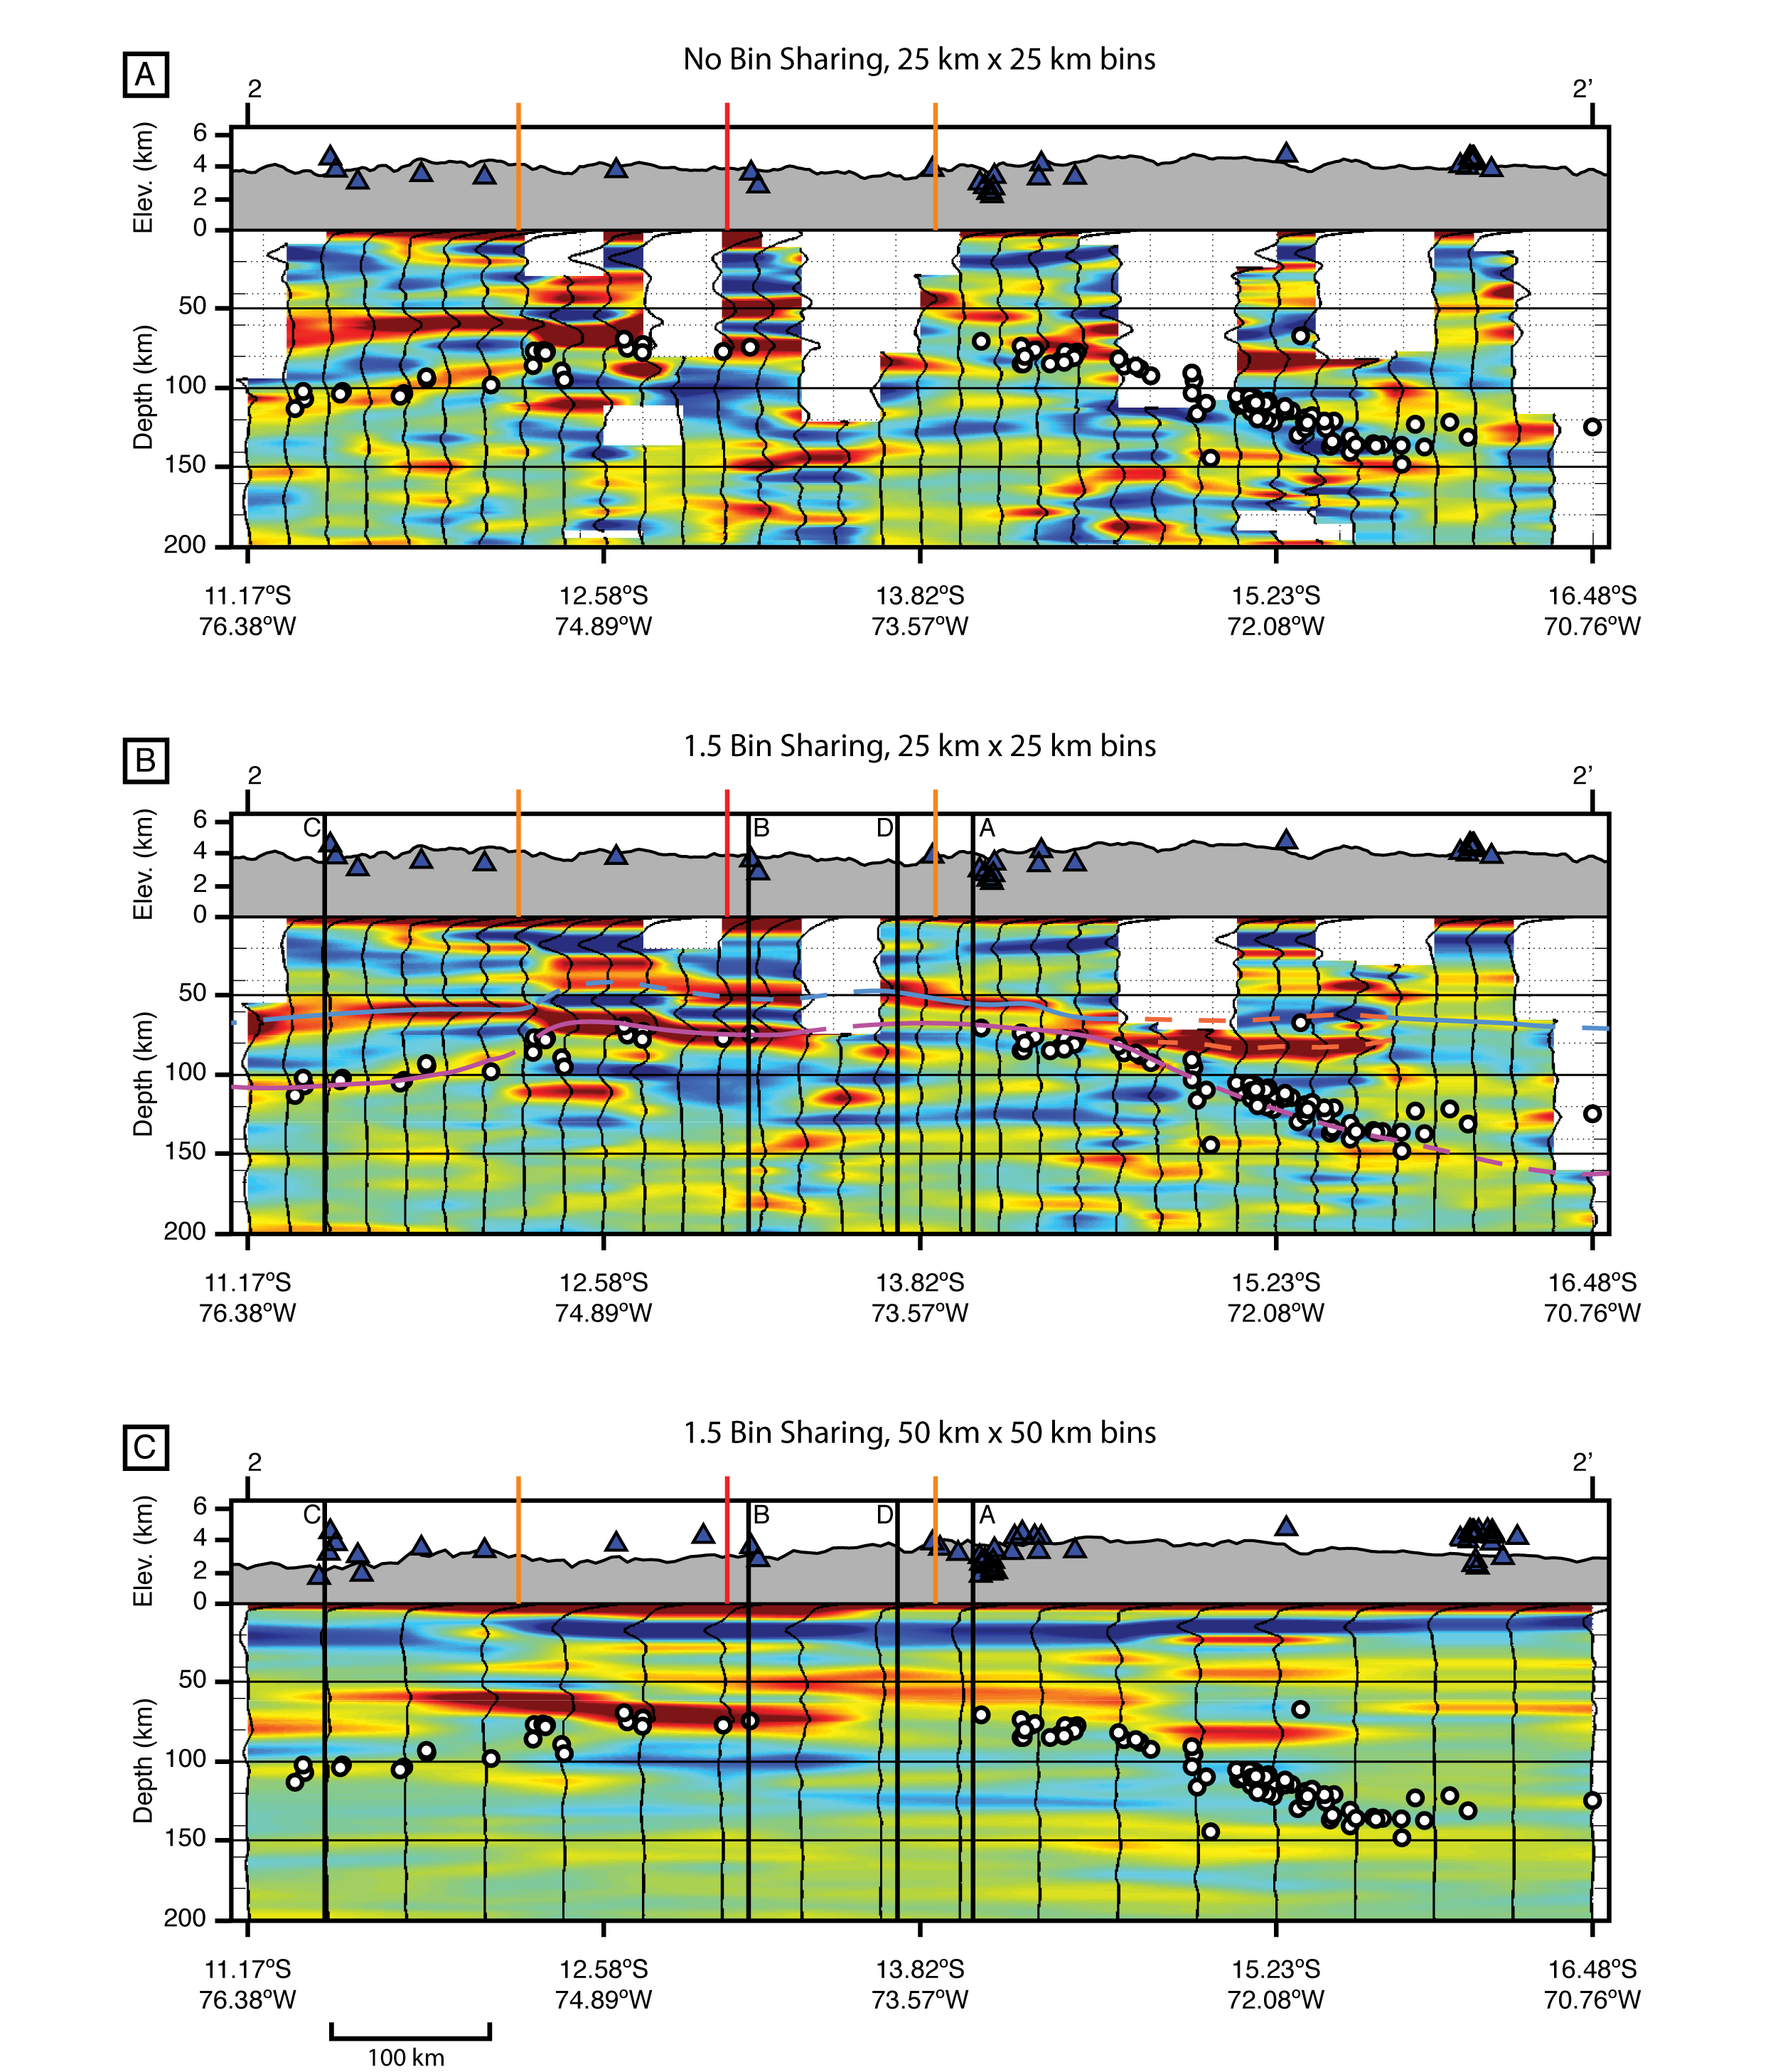
Figure S4 A) Example of Cross-Section 2-2’ calculated using no bin sharing (25 km x 25 km bins with no overlap). B) Example of 2-2’ calculated with bin sharing of 1.5 (effectively 37.5 km x 37.5 km bins, overlapping one another by 12.5 km). Note that the relatively abrupt offset in the subducted oceanic Moho arrival (break in purple line in B below left orange line) corresponding to northern projection of Nazca Ridge edge (left orange line in B) is also present in no bin sharing case. Also note that the subducted slab Moho immedately south of this offset merges with the continetnal Moho arrival in A, indicating that the transition between these to features occurs within the lateral resolution of the PULSE array (<25 km in this location). C) Example of 2-2’ calculated using 50 km x 50 km bins with bin sharing of 1.5 (effectively 75 km x 75 km bin, overlapping one another by 25 km). Note that average topography on each cross-section is calculated as a function of bin spacing. Limited lateral resolution causes difficulty in distingushing continental and slab Moho arrivals throughout this cross-section. See text for additional discussion.

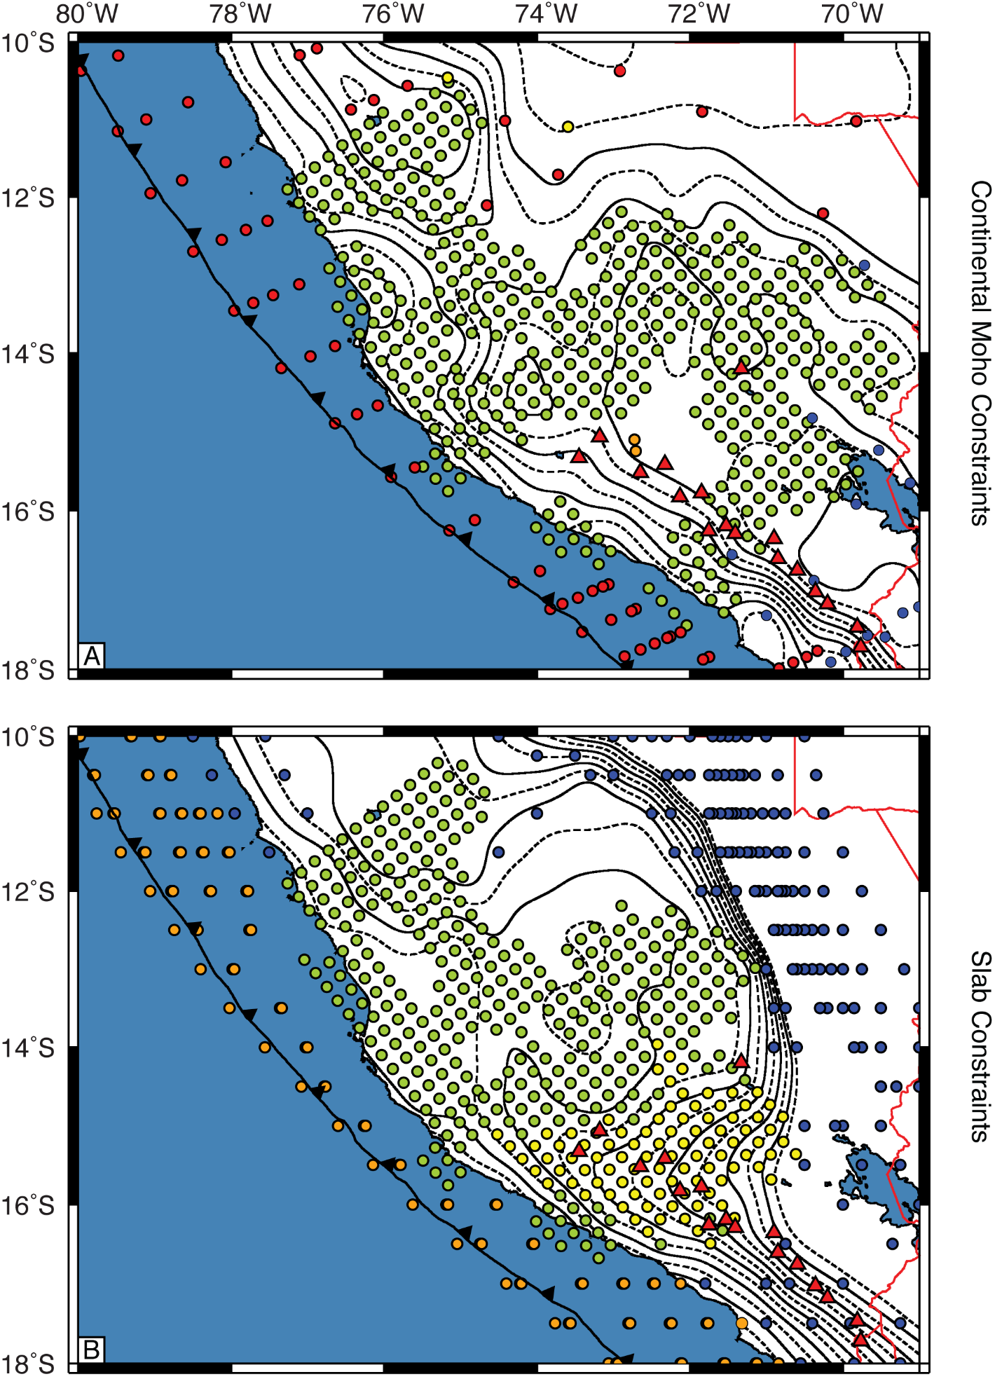 Figure S5 A) Location of constraints for South American continental Moho. Green dots mark the latitude and longitute of locations of individual RF CCP-stack gathers calculated in our study. Blue dots mark the locations with Moho depths from Ryan et al. (2016) based on RF results. Red dots mark locations with Moho depths derived from gravity modeling from Tassara and Echaurren (2012). Orange dots and yellow dots mark crustal thicknesses based on underside reflections (McGlashan et al., 2008) and converted P-to-S phases (James and Snoke, 1994) respectively. Other symbols and contours are as in Figure 5. B) Location of constraints for Nazca plate subducted Slab. Green dots mark the latitude and longitute of locations where individual RF CCP stack gathers were calculated for our study. Yellow dots mark the points where the depth to slab seismicity could be determined from the hypocenters reported by Kumar et al. (2016) and the EHB hypocenters plotted in Dougherty and Clayton (2015) (EHB hypocenters plotted by Dougherty and Clayton (2015) consistantly appear to be a better spatial match for the relocated hypocenters reported by Kumar et al. (2016) than the more extensive ISC events also plotted by Dougherty and Clayton (2015), suggesting these events record similar features within the Nazca plate). Blue dots mark P-wave tomography slab depths reported by Scire et al. (2016). Orange dots mark Slab1.0 depths calculated in Hayes et al. (2012). As Slab1.0 has a much denser sampling rate than any other data set, we have incorporated only those points immediately above and below a 10 km slab depth contour and the shallowest points from Hayes et al. (2012). Other symbols and contours are as in Figure 5.

REFERENCES
Cassidy, J.F., 1992, Numerical experiments in broadband receiver function analysis: Bulletin of the Seismological Society of America, v. 82, no. 3, p. 1453-1474.
Chatterjee, S.N., Pitt, A.M., and Iyer, H.M., 1985, Vp/Vs ratios in the Yellowstone National Park region, Wyoming: Journal of Volcanology and Geothermal Research, v. 26, p. 213-230, doi: 10.1016/0377-0273(85)90057-5.
Chulick, G.S., Detweiler, S., and Mooney, W.D., 2013, Seismic structure of the crust and uppermost mantle of South America and surrounding oceanic basins: Journal of South American Earth Sciences, v. 42, p. 260-276, doi: 10.1016/j.jsames.2012.06.002.
Condori, C., França, G.S., Tavera, H.J., Albuquerque, D.F., Bishop, B.T., and Beck, S.L., 2017, Crustal structure of north Peru from analysis of teleseismic receiver functions: Journal of South American Earth Sciences, v. 76, p. 11-24, doi: 10.1016/j.jsames.2017.02.006.
Dorbath, C., 1996, Velocity structure of the Andes of central Peru from locally recorded earthquakes: Geophysical Research Letters, v. 23, p. 205-208, doi: 10.1029/95GL03778.
Dorbath, C., and Granet, M., 1996, Local earthquake tomography of the Altiplano and the Eastern Cordillera of northern Bolivia: Tectonophysics, v. 259, p. 117-136, doi: 10.1016/0040-1951(95)00052-6.
Dougherty, S.L., and Clayton, R.W., 2015, Seismic structure in southern Peru: Evidence for a smooth contortion between flat and normal subduction of the Nazca Plate: Geophysical Journal International, v. 200, p. 534-555, doi: 10.1093/gji/ggu415.
Dueker, K.G., and Sheehan, A.F., 1997, Mantle discontinuity structure from midpoint stacks of converted P to S waves across the Yellowstone hotspot track, Journal of Geophysical Research, v. 102, p. 8313-8327, doi: 10.1029/96JB03857.
Hayes, G.P., Wald, D.J., and Johnson, R.L., 2012, Slab1.0: A three-dimensional model of global subduction zone geometries, v. 117, B01302, doi: 10.1029/2011JB008524.
James, D.E., and Snoke, A., 1994, Structure and tectonics in the region of flat subduction beneath central Peru: Crust and uppermost mantle: Journal of Geophysical Research, v. 99, p. 6899-6912, doi: 10.1029/93JB03112.
Kirby, S., Engdahl, E.R., and Denlinger, R., 1996, Intermediate-depth intraslab earthquakes and arc volcanism as physical expressions of crustal and uppermost mantle metamorphism in subducting slabs, in Bebout, G.E., Scholl, D.W., Kirby, S.H., and Platt, J.P., eds., Subduction Top to Bottom: Washington, D.C., American Geophysical Union, doi: 10.1029/GM096p0195.
Kumar, A., Wagner, L.S., Beck, S.L., Long, M.D., Zandt, G., Young, B., Tavera, H., and Minaya, E., 2016, Seismicity and state of stress in the central and southern Peruvian flat slab: Earth and Planetary Science Letters, v. 441, p. 71-80, doi: 10.1016/j.epsl.2006.02.023.
Langston, C.A., 1979, Structure under Mount Rainier, Washington, inferred from teleseismic body waves: Journal of Geophysical Research, v. 84, p. 4749-4762, doi: 10.1029/JB084iB09p04749.
Ligorría, J.P., and Ammon, C.J., 1999, Iterative deconvolution and receiver-function estimation: Bulletin of the Seismological Society of America, v. 89, p. 1395-1400.
Ma, Y., and Clayton, R.W., 2014, The crust and uppermost mantle structure of Southern Peru from ambient noise and earthquake generated surface wave analysis: Earth and Planetary Science Letters, v. 395, p. 61-70, doi: 10.1016/j.epsl.2014.03.013.
McGlashan, N., Brown, L., and Kay, S., 2008, Crustal thickness in the central Andes from teleseismically recorded depth phase precursors: Geophysical Journal International, v. 175, p. 1013-1022, doi: 10.1111/j.1365-246X.2008.03897.x.
Phillips, K., Clayton, R.W., Davis, P., Tavera, H., Guy, R., Skinner, S., Stubailo, I., Audin, L., and Aguilar, V., 2012, Structure of the subduction system in southern Peru from seismic array data: Journal of Geophysical Research, v. 117, B11306, doi: 10.1029/2012JB009540.
Ryan, J., Beck, S., Zandt, G., Wagner, L., Minaya, E., and Tavera, H., 2016, Central Andean crustal structure from receiver function analysis: Tectonophysics, v. 682, p. 120-133, doi: 10.1016/j.tecto.2016.04.048.
Scire, A., Zandt, G., Beck, S., Long, M., Wagner, L., Minaya, E., and Tavera, H., 2016, Imaging the transition from flat to normal subduction: variations in the structure of the Nazca slab and upper mantle under southern Peru and northwestern Bolivia: Geophysical Journal International, v. 204, p. 457-479, doi: 10.1093/gji/ggv452.
Sheehan, A.F., Shearer, P.M., Gilbert, H.J., and Dueker, K.G., 2000, Seismic migration processing of P-SV converted phases for mantle discontinuity structure beneath the Snake River Plane, western United States: Journal of Geophysical Research, v. 105, p. 19055-19065, doi: 10.1029/2000JB900112.
Suárez, G., Gagnepain J., Cisternas, A., Hatzfeld, D., Molnar, P, Ocola, L., Roecker, S.W., and Viodé, J.P., 1990, Tectonic deformation of the Andes and the configuration of the subducted slab in central Peru: results from a microseismic experiment: Geophysical Journal International, v. 103, p. 1-12, doi: 10.1111/j.1365-246X.1990.tb01747.x.
Tassara, A., and Echaurren, A., 2012, Anatomy of the Andean subduction zone: Three-dimensional density model upgraded and compared against global-scale models: Geophysical Journal International, v. 189, p. 161-168, doi: 10.1111/j.1365-246X.2012.05397.x.
Zhu, L., and Kanamori, H., 2000, Moho depth variation in southern California from teleseismic receiver functions: Journal of Geophysical Research Solid Earth, v. 105, p. 2969-2980, doi:10.1029/1999JB900322.

