Downs et al., 2013, GES00965.1
Supplemental File

Table DR1. Representative major and trace element analyses of lithofacies pumice and rhyolite lavas.
Sample: | 047a | 120f | 120g | 120h | 125a | 125b | 125c | 125e | 341a | 341b | 341c | 341d | 341e | 341i | 341j | 341k
Rock Type: | Pumice | Pumice | Pumice | Pumice | Pumice | Pumice | Pumice | Pumice | Pumice | Pumice | Pumice | Pumice | Pumice | Pumice | Pumice | Pumice
Deposit: | Ohakuri | Ohakuri | Ohakuri | Ohakuri | Ohakuri | Ohakuri | Ohakuri | Ohakuri | Ohakuri | Ohakuri | Ohakuri | Ohakuri | Ohakuri | Ohakuri | Ohakuri | Ohakuri
wt %
SiO₂ | 74.87 | 75.94 | 76.76 | 76.57 | 76.06 | 76.07 | 70.92 | 74.43 | 71.33 | 73.55 | 75.73 | 72.48 | 74.41 | 75.39 | 73.73 | 73.63
TiO₂ | 0.33 | 0.18 | 0.15 | 0.18 | 0.21 | 0.20 | 0.48 | 0.27 | 0.42 | 0.33 | 0.23 | 0.40 | 0.28 | 0.22 | 0.32 | 0.32
Al₂O₃ | 13.97 | 14.05 | 13.17 | 13.18 | 13.24 | 13.28 | 14.93 | 13.80 | 15.16 | 14.30 | 13.17 | 14.37 | 13.81 | 13.42 | 14.02 | 13.89
Fe₂O₃ | 2.13 | 1.87 | 1.64 | 1.72 | 1.91 | 1.68 | 3.53 | 2.16 | 3.23 | 2.45 | 2.07 | 3.08 | 2.35 | 2.05 | 2.51 | 2.60
MnO | 0.05 | 0.06 | 0.05 | 0.06 | 0.06 | 0.05 | 0.10 | 0.06 | 0.09 | 0.07 | 0.07 | 0.09 | 0.07 | 0.08 | 0.08 | 0.08
MgO | 0.23 | 0.45 | 0.22 | 0.27 | 0.24 | 0.17 | 0.63 | 0.30 | 0.60 | 0.39 | 0.27 | 0.61 | 0.37 | 0.30 | 0.44 | 0.54
CaO | 1.55 | 1.08 | 1.06 | 1.16 | 1.20 | 1.32 | 2.55 | 1.57 | 2.32 | 1.98 | 1.31 | 2.15 | 1.64 | 1.89 | 1.81 | 1.92
Na₂O | 3.11 | 2.67 | 2.97 | 2.88 | 3.24 | 2.39 | 3.33 | 3.43 | 3.59 | 3.30 | 3.09 | 3.26 | 3.15 | 2.61 | 3.44 | 3.46
K₂O | 3.73 | 3.69 | 3.96 | 3.97 | 3.80 | 4.81 | 3.42 | 3.93 | 3.23 | 3.60 | 4.05 | 3.53 | 3.90 | 4.01 | 3.61 | 3.49
P₂O₅ | 0.02 | 0.01 | 0.01 | 0.01 | 0.04 | 0.02 | 0.11 | 0.04 | 0.02 | 0.02 | 0.02 | 0.03 | 0.02 | 0.02 | 0.04 | 0.06
(LOI) | 4.12 | 5.30 | 4.82 | 4.64 | 4.57 | 5.40 | 4.26 | 3.73 | 4.38 | 4.95 | 4.93 | 4.69 | 4.71 | 5.47 | 4.33 | 4.16
(Total) | 99.85 | 99.86 | 99.86 | 99.86 | 99.85 | 99.85 | 99.84 | 99.86 | 99.85 | 99.85 | 99.83 | 99.84 | 99.85 | 99.85 | 99.85 | 99.86
ppm
Zn | 70 | 57 | 51 | 50 | 52 | 55 | 70 | 58 | 65 | 54 | 55 | 64 | 56 | 51 | 58 | 60
Rb | 133 | 132 | 137 | 132 | 131 | 183 | 124 | 123 | 112 | 132 | 143 | 138 | 139 | 134 | 120 | 119
Sr | 130 | 94 | 95 | 107 | 101 | 121 | 217 | 132 | 199 | 177 | 113 | 176 | 141 | 166 | 160 | 152
Y | 29 | 32 | 32 | 33 | 32 | 35 | 30 | 30 | 26 | 28 | 33 | 29 | 28 | 31 | 30 | 30
Zr | 228 | 223 | 194 | 210 | 204 | 234 | 308 | 239 | 328 | 277 | 206 | 251 | 264 | 251 | 281 | 245
Nb | 9 | 11 | 10 | 10 | 10 | 11 | 11 | 11 | 10 | 10 | 11 | 10 | 11 | 10 | 10 | 9
Ba | 700 | 699 | 728 | 762 | 730 | 819 | 669 | 738 | 634 | 706 | 773 | 681 | 695 | 838 | 711 | 715
La | 29 | 34 | 30 | 27 | 31 | 33 | 23 | 27 | 25 | 25 | 33 | 25 | 26 | 28 | 28 | 25
Ce | 44 | 48 | 48 | 39 | 58 | 44 | 38 | 46 | 41 | 41 | 62 | 26 | 34 | 49 | 29 | 37
Pb | 23 | 21 | 23 | 21 | 22 | 20 | 18 | 23 | 18 | 19 | 24 | 21 | 21 | 23 | 21 | 20
Th | 18 | 20 | 15 | 13 | 14 | 8 | 7 | 10 | 12 | 11 | 12 | 10 | 11 | 14 | 8 | 11
Table DR1. (Continued)
Sample: | 341l | 040a | 042a | 127a | 132a | 132b | 132c | 134a | 335a | 335b | 335c | 335d | 347a | 347b | 348a | 348b
Rock Type: | Pumice | Pumice | Pumice | Pumice | Pumice | Pumice | Pumice | Pumice | Pumice | Pumice | Pumice | Pumice | Pumice | Pumice | Pumice | Pumice
Deposit: | Ohakuri | Ohakuri | Ohakuri | Ohakuri | Ohakuri | Ohakuri | Ohakuri | Ohakuri | Ohakuri | Ohakuri | Ohakuri | Ohakuri | Ohakuri | Ohakuri | Ohakuri | Ohakuri
wt %
SiO₂ | 70.05 | 76.75 | 76.74 | 74.52 | 75.91 | 75.32 | 75.75 | 74.22 | 73.82 | 75.28 | 75.39 | 76.30 | 71.59 | 74.47 | 76.14 | 75.47
TiO₂ | 0.56 | 0.16 | 0.17 | 0.25 | 0.18 | 0.21 | 0.18 | 0.19 | 0.33 | 0.24 | 0.23 | 0.19 | 0.45 | 0.25 | 0.18 | 0.20
Al₂O₃ | 14.81 | 13.67 | 13.24 | 13.54 | 12.98 | 13.13 | 13.11 | 14.59 | 13.92 | 13.49 | 13.35 | 13.05 | 14.67 | 13.91 | 13.07 | 13.35
Fe₂O₃ | 3.99 | 1.54 | 1.88 | 2.11 | 1.90 | 2.04 | 1.95 | 2.17 | 2.58 | 2.07 | 2.17 | 1.91 | 3.44 | 2.14 | 1.86 | 1.95
MnO | 0.11 | 0.05 | 0.07 | 0.06 | 0.06 | 0.06 | 0.06 | 0.07 | 0.08 | 0.07 | 0.06 | 0.06 | 0.09 | 0.07 | 0.06 | 0.06
MgO | 0.91 | 0.23 | 0.27 | 0.27 | 0.19 | 0.25 | 0.19 | 0.16 | 0.42 | 0.27 | 0.31 | 0.22 | 0.62 | 0.30 | 0.20 | 0.21
CaO | 2.79 | 1.06 | 1.13 | 1.70 | 1.18 | 1.32 | 1.14 | 1.13 | 1.90 | 1.48 | 1.44 | 1.16 | 2.32 | 1.51 | 1.13 | 1.26
Na₂O | 3.58 | 2.13 | 2.60 | 2.10 | 3.58 | 4.03 | 3.89 | 4.02 | 3.56 | 3.47 | 3.39 | 3.12 | 3.74 | 3.60 | 3.18 | 3.35
K₂O | 3.13 | 4.39 | 3.88 | 5.41 | 4.00 | 3.60 | 3.71 | 3.44 | 3.31 | 3.59 | 3.62 | 3.95 | 3.00 | 3.73 | 4.15 | 4.11
P₂O₅ | 0.07 | 0.01 | 0.02 | 0.03 | 0.02 | 0.03 | 0.02 | 0.01 | 0.07 | 0.04 | 0.04 | 0.03 | 0.08 | 0.03 | 0.03 | 0.04
(LOI) | 3.64 | 4.97 | 5.19 | 4.88 | 4.38 | 4.01 | 4.28 | 3.39 | 4.79 | 4.78 | 4.73 | 4.98 | 3.34 | 4.21 | 4.53 | 4.44
(Total) | 99.84 | 99.87 | 99.85 | 99.86 | 99.85 | 99.85 | 99.85 | 99.85 | 99.86 | 99.87 | 99.85 | 99.85 | 99.85 | 99.84 | 99.87 | 99.85
ppm
Zn | 73 | 48 | 61 | 56 | 53 | 52 | 77 | 57 | 60 | 55 | 56 | 53 | 63 | 52 | 52 | 53
Rb | 105 | 139 | 143 | 145 | 152 | 127 | 126 | 120 | 117 | 127 | 126 | 136 | 105 | 125 | 139 | 135
Sr | 225 | 89 | 99 | 153 | 103 | 110 | 100 | 102 | 161 | 125 | 116 | 98 | 182 | 133 | 95 | 110
Y | 28 | 31 | 35 | 32 | 34 | 30 | 31 | 32 | 31 | 31 | 32 | 33 | 30 | 30 | 34 | 32
Zr | 289 | 175 | 232 | 238 | 216 | 222 | 225 | 272 | 259 | 256 | 232 | 203 | 255 | 271 | 206 | 246
Nb | 10 | 9 | 9 | 10 | 11 | 10 | 10 | 12 | 11 | 11 | 10 | 10 | 10 | 9 | 11 | 10
Ba | 643 | 730 | 740 | 753 | 793 | 717 | 721 | 706 | 690 | 734 | 717 | 746 | 650 | 714 | 756 | 774
La | 21 | 32 | 32 | 27 | 31 | 29 | 30 | 28 | 25 | 30 | 27 | 30 | 31 | 29 | 25 | 28
Ce | 28 | 41 | 47 | 44 | 49 | 47 | 48 | 44 | 43 | 57 | 53 | 52 | 43 | 53 | 37 | 49
Pb | 17 | 24 | 23 | 20 | 24 | 22 | 25 | 24 | 23 | 20 | 20 | 24 | 18 | 18 | 23 | 23
Th | 6 | 19 | 26 | 12 | 12 | 19 | 17 | 15 | 12 | 11 | 9 | 12 | 20 | 11 | 16 | 16

Table DR1. (Continued)
Sample: | 348c | TKR12a | TKR13a | TKR25a | TKR25b | TKR25c | TKR25d | TKR25e | 183a | 183b | 183c | 183d | CR1a | CR1b | CR1c | CR1d
Rock Type: | Pumice | Pumice | Pumice | Pumice | Pumice | Pumice | Pumice | Pumice | Pumice | Pumice | Pumice | Pumice | Pumice | Pumice | Pumice | Pumice
Deposit: | Ohakuri | Ohakuri | Ohakuri | Ohakuri | Ohakuri | Ohakuri | Ohakuri | Ohakuri | Kaingaroa | Kaingaroa | Kaingaroa | Kaingaroa | Kaingaroa | Kaingaroa | Kaingaroa | Kaingaroa
wt %
SiO₂ | 70.44 | 76.84 | 76.24 | 74.79 | 75.65 | 76.35 | 74.22 | 75.31 | 72.48 | 74.84 | 75.01 | 75.76 | 76.12 | 74.69 | 75.30 | 74.51
TiO₂ | 0.51 | 0.15 | 0.17 | 0.27 | 0.17 | 0.15 | 0.31 | 0.23 | 0.21 | 0.18 | 0.18 | 0.15 | 0.17 | 0.23 | 0.22 | 0.21
Al₂O₃ | 14.78 | 12.73 | 12.99 | 13.55 | 13.12 | 12.84 | 13.70 | 13.51 | 16.83 | 14.85 | 14.79 | 14.51 | 13.29 | 14.27 | 13.85 | 14.62
Fe₂O₃ | 3.76 | 1.54 | 1.72 | 1.79 | 1.97 | 1.65 | 2.05 | 2.06 | 3.01 | 2.23 | 1.92 | 1.78 | 1.65 | 1.98 | 1.68 | 1.97
MnO | 0.10 | 0.06 | 0.06 | 0.07 | 0.05 | 0.06 | 0.08 | 0.05 | 0.04 | 0.04 | 0.04 | 0.04 | 0.05 | 0.06 | 0.05 | 0.06
MgO | 0.85 | 0.13 | 0.17 | 0.37 | 0.22 | 0.20 | 0.52 | 0.30 | 0.61 | 0.39 | 0.24 | 0.26 | 0.18 | 0.22 | 0.20 | 0.20
CaO | 2.77 | 0.94 | 1.10 | 1.53 | 1.23 | 0.95 | 1.65 | 1.39 | 1.27 | 1.11 | 1.16 | 1.02 | 1.03 | 1.24 | 1.18 | 1.13
Na₂O | 3.80 | 3.39 | 3.45 | 4.09 | 3.81 | 3.89 | 3.90 | 3.41 | 2.13 | 2.28 | 2.82 | 2.27 | 3.49 | 3.70 | 3.66 | 3.68
K₂O | 2.88 | 4.21 | 4.07 | 3.49 | 3.76 | 3.88 | 3.51 | 3.70 | 3.39 | 4.07 | 3.82 | 4.19 | 4.01 | 3.59 | 3.84 | 3.61
P₂O₅ | 0.11 | 0.01 | 0.02 | 0.05 | 0.02 | 0.02 | 0.06 | 0.04 | 0.01 | 0.01 | 0.01 | 0.01 | 0.02 | 0.02 | 0.02 | 0.01
(LOI) | 3.13 | 4.39 | 4.59 | 3.03 | 3.00 | 0.33 | 0.49 | 0.58 | 5.77 | 5.09 | 4.64 | 5.11 | 2.84 | 3.19 | 2.98 | 3.43
(Total) | 99.84 | 99.88 | 99.87 | 99.87 | 99.86 | 99.88 | 99.85 | 99.86 | 99.87 | 99.87 | 99.84 | 99.84 | 99.84 | 99.84 | 99.87 | 99.85
ppm
Zn | 66 | 48 | 52 | 56 | 46 | 49 | 54 | 45 | 78 | 62 | 53 | 54 | 29 | 35 | 27 | 33
Rb | 104 | 134 | 129 | 110 | 129 | 129 | 107 | 129 | 111 | 138 | 137 | 183 | 134 | 125 | 131 | 126
Sr | 199 | 78 | 95 | 126 | 104 | 80 | 133 | 126 | 101 | 92 | 107 | 86 | 92 | 113 | 110 | 105
Y | 29 | 35 | 35 | 38 | 29 | 37 | 38 | 34 | 27 | 32 | 31 | 31 | 33 | 32 | 31 | 30
Zr | 271 | 185 | 214 | 231 | 198 | 188 | 256 | 231 | 274 | 240 | 232 | 193 | 178 | 219 | 208 | 216
Nb | 10 | 10 | 10 | 10 | 10 | 10 | 10 | 9 | 11 | 11 | 10 | 10 | 9 | 9 | 9 | 10
Ba | 622 | 766 | 746 | 702 | 728 | 776 | 697 | 750 | 598 | 699 | 724 | 922 | 746 | 769 | 767 | 774
La | 24 | 33 | 30 | 33 | 34 | 31 | 33 | 32 | 32 | 28 | 24 | 30 | 29 | 33 | 29 | 30
Ce | 45 | 45 | 53 | 51 | 42 | 41 | 41 | 34 | 35 | 42 | 47 | 42 | 44 | 52 | 51 | 43
Pb | 19 | 22 | 23 | 16 | 22 | 22 | 17 | 26 | 25 | 22 | 22 | 24 | 17 | 18 | 15 | 18
Th | 12 | 14 | 16 | 9 | 14 | 11 | 10 | 16 | 27 | 18 | 24 | 19 | 21 | 14 | 11 | 14

Table DR1. (Continued)
Sample: | CR1e | P121c | 072a | 072b | 306a | 306b | 306d | 306e | 307a | 407a | 407d | P121a | P121b | P129a | P129b
Rock Type: | Pumice | Pumice | Pumice | Pumice | Pumice | Pumice | Pumice | Pumice | Pumice | Pumice | Pumice | Pumice | Pumice | Pumice | Pumice
Deposit: | Kaingaroa | Kaingaroa | Kaingaroa | Kaingaroa | Kaingaroa | Kaingaroa | Kaingaroa | Kaingaroa | Kaingaroa | Kaingaroa | Kaingaroa | Kaingaroa | Kaingaroa | Kaingaroa | Kaingaroa
wt %
SiO₂ | 74.12 | 76.39 | 76.04 | 75.49 | 76.82 | 76.62 | 77.70 | 76.51 | 79.14 | 76.38 | 75.96 | 75.37 | 74.07 | 73.60 | 72.66
TiO₂ | 0.23 | 0.15 | 0.18 | 0.18 | 0.15 | 0.11 | 0.11 | 0.12 | 0.15 | 0.18 | 0.17 | 0.16 | 0.19 | 0.19 | 0.20
Al₂O₃ | 15.02 | 13.14 | 13.61 | 14.34 | 12.76 | 12.66 | 12.50 | 12.73 | 11.69 | 13.54 | 13.98 | 13.82 | 15.36 | 15.26 | 16.29
Fe₂O₃ | 2.08 | 1.35 | 1.85 | 1.91 | 1.49 | 2.27 | 1.24 | 2.10 | 1.50 | 1.79 | 1.63 | 1.84 | 2.07 | 2.27 | 2.52
MnO | 0.06 | 0.05 | 0.05 | 0.05 | 0.05 | 0.05 | 0.04 | 0.06 | 0.05 | 0.05 | 0.05 | 0.08 | 0.07 | 0.09 | 0.09
MgO | 0.23 | 0.13 | 0.19 | 0.20 | 0.14 | 0.22 | 0.18 | 0.23 | 0.11 | 0.13 | 0.12 | 0.13 | 0.15 | 0.17 | 0.18
CaO | 1.15 | 0.96 | 1.13 | 1.14 | 1.08 | 0.84 | 0.94 | 0.95 | 1.01 | 1.05 | 1.00 | 0.96 | 1.14 | 1.16 | 1.08
Na₂O | 3.63 | 3.06 | 2.74 | 2.42 | 2.19 | 2.45 | 2.40 | 2.62 | 2.50 | 2.12 | 2.66 | 2.66 | 2.70 | 3.28 | 3.07
K₂O | 3.45 | 4.76 | 4.19 | 4.24 | 5.29 | 4.75 | 4.87 | 4.65 | 3.82 | 4.73 | 4.40 | 4.64 | 4.21 | 3.90 | 3.73
P₂O₅ | 0.02 | 0.01 | 0.01 | 0.03 | 0.02 | 0.03 | 0.02 | 0.03 | 0.02 | 0.03 | 0.03 | 0.33 | 0.04 | 0.07 | 0.18
(LOI) | 3.31 | 3.71 | 4.57 | 4.52 | 5.25 | 4.35 | 4.46 | 4.59 | 3.97 | 4.88 | 4.77 | 5.73 | 5.01 | 5.64 | 5.95
(Total) | 99.86 | 99.86 | 99.85 | 99.87 | 99.85 | 99.86 | 99.86 | 99.87 | 99.88 | 99.86 | 99.86 | 99.86 | 99.86 | 99.86 | 99.85
ppm
Zn | 32 | 52 | 53 | 50 | 48 | 58 | 44 | 52 | 45 | 50 | 51 | 62 | 78 | 109 | 88
Rb | 121 | 145 | 138 | 153 | 228 | 175 | 205 | 173 | 129 | 178 | 137 | 144 | 132 | 128 | 126
Sr | 107 | 80 | 102 | 108 | 85 | 84 | 88 | 76 | 92 | 93 | 93 | 86 | 108 | 107 | 101
Y | 33 | 32 | 33 | 31 | 35 | 33 | 31 | 31 | 30 | 36 | 34 | 33 | 29 | 31 | 29
Zr | 220 | 182 | 241 | 239 | 193 | 133 | 136 | 142 | 212 | 220 | 212 | 194 | 240 | 251 | 253
Nb | 10 | 11 | 10 | 11 | 11 | 10 | 10 | 9 | 9 | 11 | 11 | 11 | 10 | 11 | 11
Ba | 770 | 771 | 762 | 695 | 762 | 809 | 913 | 726 | 687 | 762 | 783 | 747 | 697 | 797 | 690
La | 32 | 25 | 28 | 30 | 33 | 33 | 29 | 30 | 24 | 26 | 28 | 31 | 28 | 27 | 29
Ce | 33 | 43 | 53 | 37 | 39 | 50 | 39 | 51 | 34 | 54 | 56 | 45 | 51 | 56 | 57
Pb | 16 | 25 | 23 | 23 | 23 | 21 | 24 | 24 | 21 | 25 | 24 | 23 | 30 | 26 | 28
Th | 12 | 15 | 15 | 13 | 15 | 18 | 12 | 15 | 15 | 13 | 14 | 23 | 17 | 14 | 13

Table DR1. (Continued)
Sample: | P184a | Cd22a | Cd22b | Cd22c | Cd22d | Cd22e | MR9a | MR9b | MR9c | MR9d | MR9e | MR9f | MR9g | MR9h | MR9i | MR9j
Rock Type: | Pumice | Pumice | Pumice | Pumice | Pumice | Pumice | Pumice | Pumice | Pumice | Lava | Lava | Lava | Lava | Pumice | Pumice | Pumice
Deposit: | Kaingaroa | Mihi | Mihi | Mihi | Mihi | Mihi | Mihi | Mihi | Mihi | Mihi | Mihi | Mihi | Mihi | Mihi | Mihi | Mihi
wt %
SiO₂ | 76.54 | 76.61 | 76.53 | 77.26 | 77.40 | 75.66 | 77.40 | 77.29 | 77.28 | 76.80 | 77.67 | 77.27 | 75.56 | 75.44 | 77.18 | 75.56
TiO₂ | 0.15 | 0.14 | 0.14 | 0.14 | 0.14 | 0.22 | 0.14 | 0.14 | 0.14 | 0.15 | 0.14 | 0.14 | 0.22 | 0.22 | 0.14 | 0.21
Al₂O₃ | 12.89 | 13.24 | 13.26 | 12.31 | 12.36 | 13.08 | 12.28 | 12.33 | 12.37 | 12.70 | 12.28 | 12.34 | 12.98 | 12.97 | 12.33 | 12.99
Fe₂O₃ | 1.75 | 1.47 | 1.48 | 1.39 | 1.36 | 1.74 | 1.38 | 1.39 | 1.40 | 1.52 | 1.40 | 1.37 | 1.84 | 1.90 | 1.42 | 1.87
MnO | 0.05 | 0.05 | 0.05 | 0.05 | 0.05 | 0.05 | 0.05 | 0.05 | 0.05 | 0.04 | 0.06 | 0.05 | 0.04 | 0.05 | 0.05 | 0.04
MgO | 0.19 | 0.13 | 0.14 | 0.14 | 0.14 | 0.24 | 0.15 | 0.15 | 0.15 | 0.19 | 0.20 | 0.21 | 0.27 | 0.29 | 0.20 | 0.26
CaO | 1.03 | 0.78 | 0.80 | 0.83 | 0.83 | 1.23 | 0.78 | 0.81 | 0.82 | 0.82 | 0.81 | 0.83 | 1.22 | 1.24 | 0.80 | 1.22
Na₂O | 3.19 | 4.00 | 3.99 | 4.01 | 3.94 | 4.22 | 4.00 | 4.01 | 3.95 | 4.13 | 3.48 | 4.03 | 4.21 | 4.19 | 4.22 | 4.23
K₂O | 4.19 | 3.58 | 3.60 | 3.87 | 3.77 | 3.55 | 3.79 | 3.83 | 3.83 | 3.64 | 3.95 | 3.73 | 3.65 | 3.69 | 3.65 | 3.61
P₂O₅ | 0.01 | 0.01 | 0.01 | 0.01 | 0.01 | 0.02 | 0.01 | 0.01 | 0.01 | 0.01 | 0.01 | 0.01 | 0.02 | 0.02 | 0.01 | 0.02
(LOI) | 3.37 | 2.93 | 3.13 | 2.81 | 3.13 | 0.27 | 2.26 | 2.26 | 2.74 | 1.11 | 0.79 | 0.50 | 0.71 | 0.66 | 0.83 | 1.14
(Total) | 99.88 | 99.86 | 99.87 | 99.87 | 99.87 | 99.87 | 99.88 | 99.86 | 99.87 | 99.86 | 99.86 | 99.88 | 99.86 | 99.85 | 99.87 | 99.86
ppm
Zn | 48 | 43 | 45 | 41 | 43 | 41 | 45 | 45 | 44 | 41 | 44 | 40 | 42 | 42 | 43 | 39
Rb | 137 | 127 | 125 | 132 | 129 | 130 | 128 | 126 | 129 | 122 | 129 | 125 | 128 | 129 | 127 | 127
Sr | 90 | 62 | 63 | 62 | 65 | 107 | 61 | 64 | 62 | 66 | 63 | 65 | 108 | 108 | 62 | 107
Y | 31 | 33 | 33 | 36 | 34 | 26 | 36 | 36 | 36 | 33 | 36 | 36 | 27 | 27 | 36 | 26
Zr | 179 | 156 | 150 | 142 | 144 | 202 | 145 | 146 | 147 | 148 | 143 | 143 | 210 | 210 | 145 | 209
Nb | 9 | 10 | 9 | 10 | 9 | 8 | 10 | 10 | 11 | 10 | 10 | 10 | 9 | 9 | 9 | 9
Ba | 738 | 748 | 744 | 787 | 756 | 725 | 739 | 752 | 770 | 774 | 758 | 753 | 772 | 770 | 753 | 728
La | 28 | 29 | 29 | 28 | 31 | 32 | 30 | 27 | 29 | 30 | 25 | 31 | 28 | 28 | 31 | 23
Ce | 51 | 51 | 57 | 35 | 39 | 42 | 41 | 49 | 51 | 48 | 49 | 48 | 46 | 42 | 36 | 44
Pb | 20 | 23 | 23 | 21 | 24 | 21 | 20 | 23 | 22 | 21 | 21 | 21 | 23 | 23 | 19 | 23
Th | 12 | 25 | 23 | 11 | 18 | 23 | 11 | 10 | 12 | 16 | 16 | 10 | 17 | 17 | 17 | 17

Table DR1. (Continued)
Sample: | 143a | 143b | 143c | 144a | 145a | 357b | 358a | MR1a | MR1b | MR1c | MR1d | MR1e | MR1f | MR1g | MR1h | MR1i
Rock Type: | Pumice | Pumice | Pumice | Pumice | Pumice | Pumice | Pumice | Pumice | Pumice | Pumice | Pumice | Pumice | Pumice | Pumice | Pumice | Pumice
Deposit: | Mihi | Mihi | Mihi | Mihi | Mihi | Mihi | Mihi | Mihi | Mihi | Mihi | Mihi | Mihi | Mihi | Mihi | Mihi | Mihi
wt %
SiO₂ | 76.30 | 76.46 | 73.52 | 76.83 | 75.61 | 77.00 | 75.23 | 76.58 | 75.01 | 75.27 | 76.48 | 76.33 | 75.88 | 75.56 | 76.60 | 74.88
TiO₂ | 0.19 | 0.14 | 0.27 | 0.15 | 0.22 | 0.14 | 0.22 | 0.11 | 0.18 | 0.20 | 0.12 | 0.12 | 0.22 | 0.19 | 0.11 | 0.16
Al₂O₃ | 12.98 | 12.56 | 14.23 | 12.99 | 13.67 | 12.80 | 13.61 | 12.77 | 13.52 | 13.66 | 12.75 | 12.83 | 13.04 | 13.16 | 12.83 | 13.04
Fe₂O₃ | 1.53 | 1.51 | 2.52 | 1.52 | 1.61 | 1.46 | 1.89 | 1.54 | 1.80 | 1.95 | 1.63 | 1.65 | 1.78 | 1.94 | 1.61 | 2.24
MnO | 0.05 | 0.05 | 0.07 | 0.05 | 0.07 | 0.05 | 0.05 | 0.05 | 0.05 | 0.06 | 0.05 | 0.05 | 0.06 | 0.07 | 0.05 | 0.06
MgO | 0.23 | 0.25 | 0.44 | 0.18 | 0.31 | 0.12 | 0.20 | 0.14 | 0.30 | 0.23 | 0.13 | 0.14 | 0.28 | 0.21 | 0.16 | 0.73
CaO | 1.11 | 0.89 | 1.70 | 0.91 | 1.27 | 0.93 | 1.31 | 1.06 | 1.71 | 1.18 | 1.11 | 1.15 | 1.28 | 1.27 | 1.12 | 1.68
Na₂O | 3.64 | 3.33 | 3.56 | 3.18 | 3.03 | 2.99 | 3.21 | 3.93 | 3.76 | 3.78 | 3.89 | 3.90 | 3.58 | 4.08 | 3.66 | 3.74
K₂O | 3.96 | 4.80 | 3.63 | 4.18 | 4.20 | 4.49 | 4.26 | 3.80 | 3.64 | 3.65 | 3.83 | 3.81 | 3.86 | 3.51 | 3.84 | 3.45
P₂O₅ | 0.02 | 0.01 | 0.06 | 0.01 | 0.02 | 0.01 | 0.01 | 0.01 | 0.02 | 0.02 | 0.01 | 0.02 | 0.02 | 0.02 | 0.01 | 0.02
(LOI) | 3.14 | 4.27 | 3.46 | 4.06 | 3.62 | 4.51 | 4.27 | 3.22 | 3.26 | 3.04 | 3.00 | 3.06 | 3.11 | 3.40 | 3.63 | 3.03
(Total) | 99.86 | 99.86 | 99.86 | 99.87 | 99.87 | 99.86 | 99.86 | 99.89 | 99.88 | 99.89 | 99.86 | 99.88 | 99.87 | 99.86 | 99.88 | 99.87
ppm
Zn | 42 | 46 | 60 | 49 | 45 | 49 | 54 | 39 | 34 | 56 | 42 | 43 | 45 | 54 | 40 | 45
Rb | 134 | 158 | 116 | 139 | 131 | 141 | 130 | 136 | 126 | 111 | 137 | 138 | 130 | 116 | 136 | 121
Sr | 97 | 75 | 145 | 75 | 112 | 79 | 120 | 89 | 143 | 105 | 93 | 97 | 115 | 112 | 95 | 157
Y | 28 | 32 | 26 | 33 | 27 | 35 | 34 | 29 | 22 | 31 | 28 | 28 | 27 | 33 | 28 | 27
Zr | 169 | 177 | 287 | 183 | 202 | 188 | 224 | 138 | 159 | 234 | 147 | 153 | 199 | 221 | 150 | 136
Nb | 8 | 10 | 9 | 10 | 8 | 10 | 11 | 8 | 7 | 9 | 7 | 8 | 9 | 9 | 8 | 7
Ba | 739 | 758 | 674 | 767 | 704 | 762 | 722 | 651 | 681 | 666 | 669 | 676 | 701 | 676 | 652 | 607
La | 28 | 32 | 29 | 35 | 29 | 31 | 25 | 27 | 29 | 26 | 27 | 27 | 28 | 24 | 23 | 29
Ce | 46 | 63 | 47 | 44 | 49 | 49 | 43 | 44 | 40 | 32 | 31 | 32 | 35 | 50 | 39 | 43
Pb | 21 | 22 | 22 | 23 | 19 | 25 | 23 | 15 | 18 | 23 | 18 | 16 | 17 | 17 | 17 | 17
Th | 20 | 18 | 22 | 16 | 13 | 14 | 15 | 13 | 14 | 16 | 14 | 14 | 11 | 14 | 16 | 8

Table DR1. (Continued)
Sample: | MS4a | MS4c | Cd110a | Cd110b | Cd110c | Cd110d | Cd110e | 153a | 153b | 154a | 154b | Mac1 | Miers2
Rock Type: | Pumice | Pumice | Pumice | Pumice | Pumice | Pumice | Pumice | Lava | Lava | Lava | Lava | Lava | Lava
Deposit: | Mihi | Mihi | Lag | Lag | Lag | Lag | Lag | Deer Hill | Deer Hill | Pukekahu | Pukekahu | Kairuru | Kairuru
wt %
SiO₂ | 75.58 | 74.75 | 75.37 | 75.91 | 72.61 | 75.86 | 75.72 | 75.67 | 75.99 | 76.04 | 76.19 | 77.31 | 77.78
TiO₂ | 0.18 | 0.31 | 0.13 | 0.11 | 0.20 | 0.12 | 0.11 | 0.25 | 0.22 | 0.21 | 0.20 | 0.14 | 0.14
Al₂O₃ | 13.62 | 14.25 | 12.72 | 12.96 | 13.12 | 13.02 | 12.94 | 13.58 | 13.09 | 13.34 | 13.32 | 12.57 | 12.60
Fe₂O₃ | 2.13 | 1.91 | 1.70 | 1.55 | 2.66 | 1.57 | 1.56 | 1.38 | 1.62 | 1.20 | 1.24 | 1.28 | 0.68
MnO | 0.04 | 0.06 | 0.04 | 0.04 | 0.06 | 0.04 | 0.05 | 0.03 | 0.02 | 0.02 | 0.02 | 0.03 | 0.02
MgO | 0.53 | 0.49 | 0.80 | 0.22 | 1.67 | 0.39 | 0.25 | 0.14 | 0.16 | 0.15 | 0.17 | 0.10 | 0.08
CaO | 1.21 | 1.66 | 1.76 | 1.41 | 2.73 | 1.61 | 1.32 | 1.17 | 1.13 | 1.17 | 1.06 | 0.76 | 0.73
Na₂O | 2.49 | 2.69 | 2.30 | 1.61 | 2.48 | 2.35 | 1.43 | 4.02 | 4.03 | 4.12 | 3.96 | 4.18 | 4.28
K₂O | 4.20 | 3.85 | 5.15 | 6.16 | 4.42 | 5.01 | 6.60 | 3.75 | 3.71 | 3.73 | 3.82 | 3.62 | 3.68
P₂O₅ | 0.01 | 0.02 | 0.03 | 0.02 | 0.04 | 0.02 | 0.02 | 0.02 | 0.03 | 0.03 | 0.02 | 0.01 | 0.01
(LOI) | 4.53 | 4.51 | 5.85 | 5.45 | 4.09 | 5.91 | 4.82 | 0.46 | 0.53 | 0.59 | 0.46 | 0.46 | 0.41
(Total) | 99.86 | 99.86 | 99.85 | 99.84 | 99.85 | 99.84 | 99.86 | 99.85 | 99.87 | 99.85 | 99.86 | 99.86 | 99.87
ppm
Zn | 52 | 50 | 43 | 42 | 50 | 42 | 44 | 31 | 31 | 28 | 30 | 36 | 29
Rb | 135 | 114 | 165 | 279 | 159 | 204 | 260 | 132 | 131 | 132 | 140 | 122 | 125
Sr | 103 | 145 | 171 | 140 | 244 | 159 | 124 | 113 | 104 | 106 | 101 | 68 | 62
Y | 28 | 24 | 32 | 32 | 28 | 31 | 32 | 21 | 24 | 27 | 23 | 22 | 18
Zr | 193 | 192 | 152 | 153 | 140 | 151 | 149 | 232 | 215 | 209 | 203 | 147 | 150
Nb | 9 | 7 | 8 | 8 | 8 | 8 | 8 | 10 | 10 | 9 | 9 | 10 | 10
Ba | 701 | 630 | 786 | 814 | 609 | 783 | 706 | 754 | 737 | 770 | 755 | 786 | 745
La | 30 | 24 | 28 | 26 | 25 | 25 | 22 | 23 | 23 | 35 | 33 | 33 | 23
Ce | 44 | 38 | 41 | 45 | 35 | 45 | 44 | 42 | 42 | 34 | 36 | 57 | 45
Pb | 21 | 16 | 13 | 15 | 12 | 16 | 13 | 19 | 22 | 21 | 23 | 29 | 19
Th | 13 | 8 | 10 | 20 | 7 | 16 | 18 | 10 | 14 | 10 | 11 | 12 | 8
Values for major oxides are summed to 100%, but the original analytical totals and loss on ignition (LOI) values are given for reference.

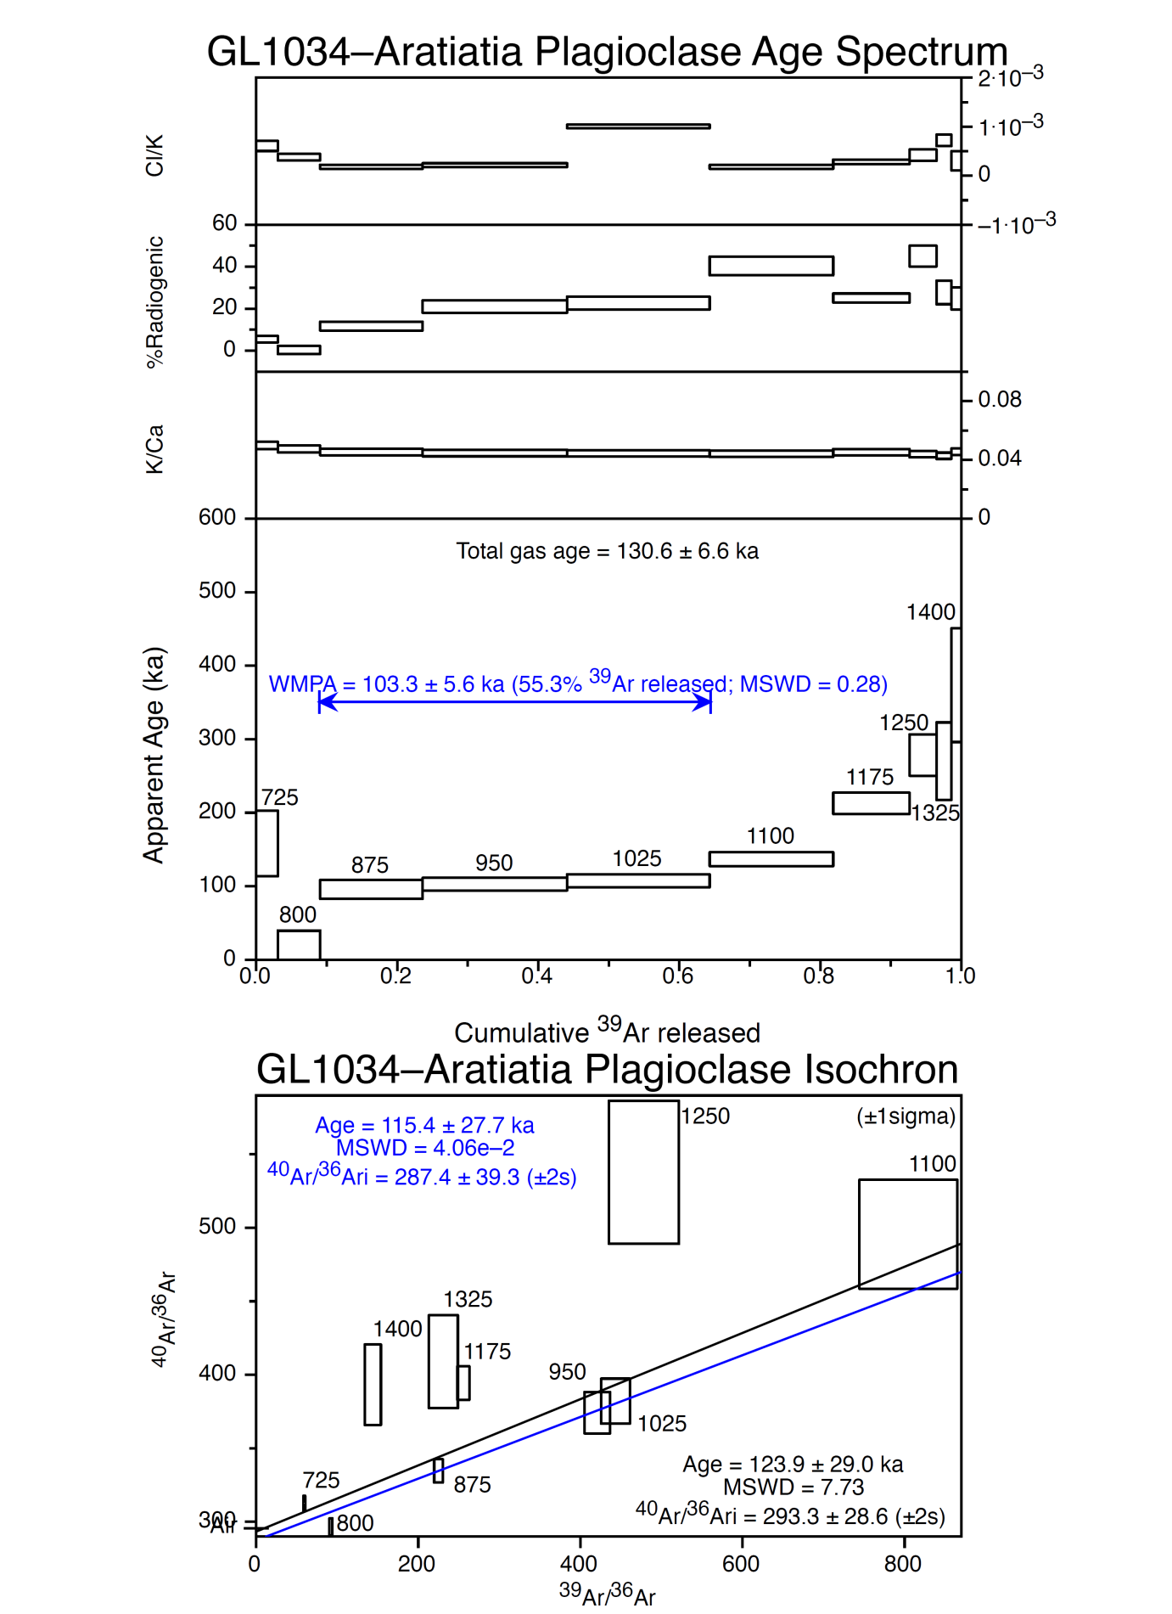
Figure DR1. Age-data for sample GL1034: Aratiatia rhyolite lava.
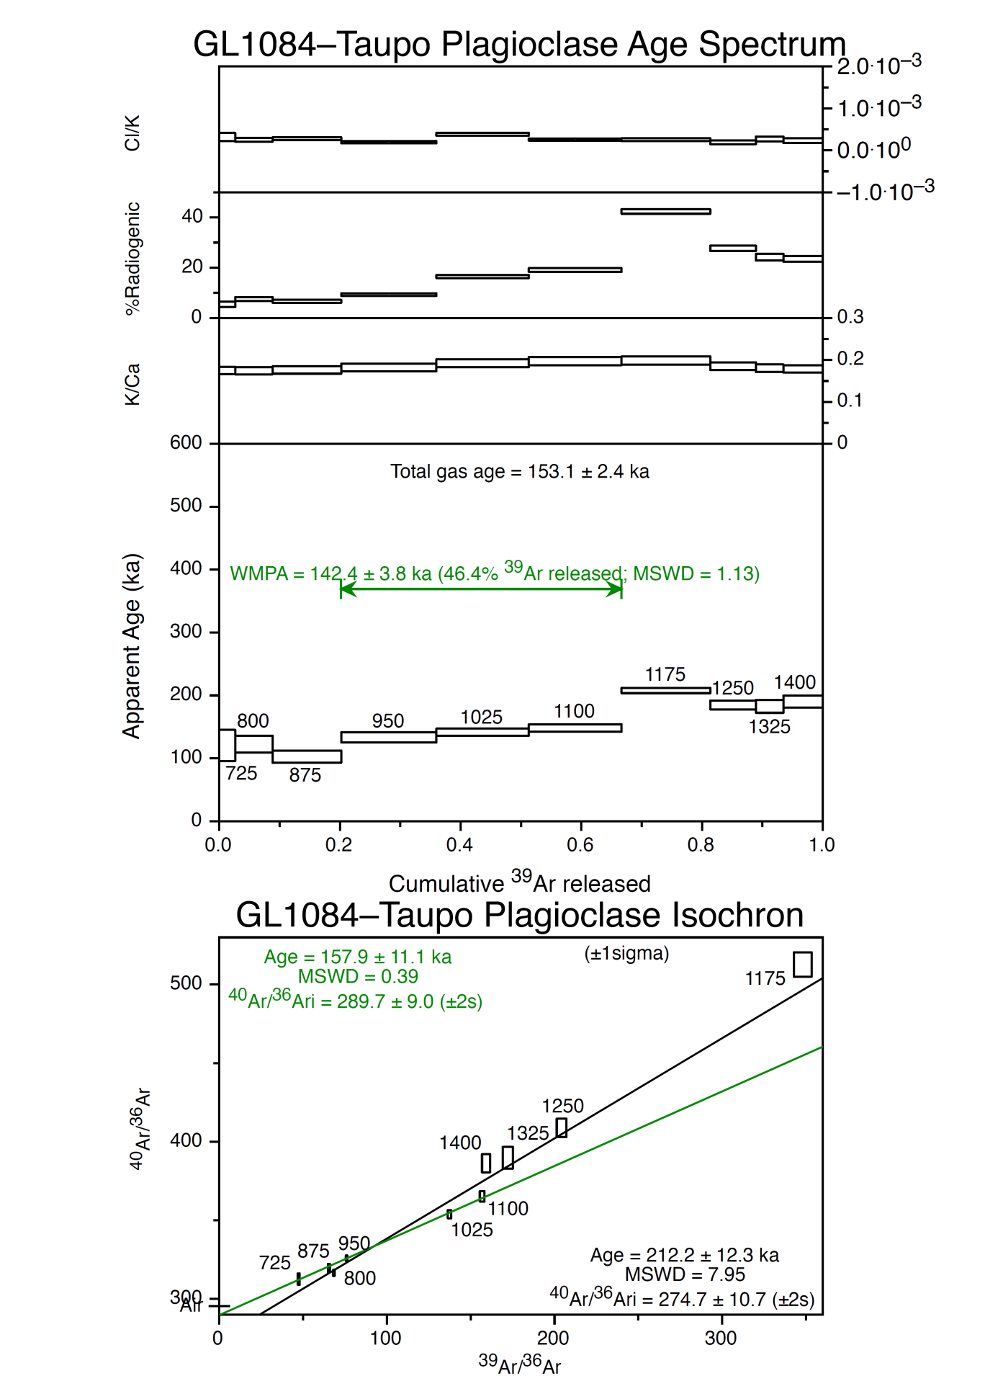
Figure DR2. Age-data for sample GL1084: Orakei rhyolite lava.
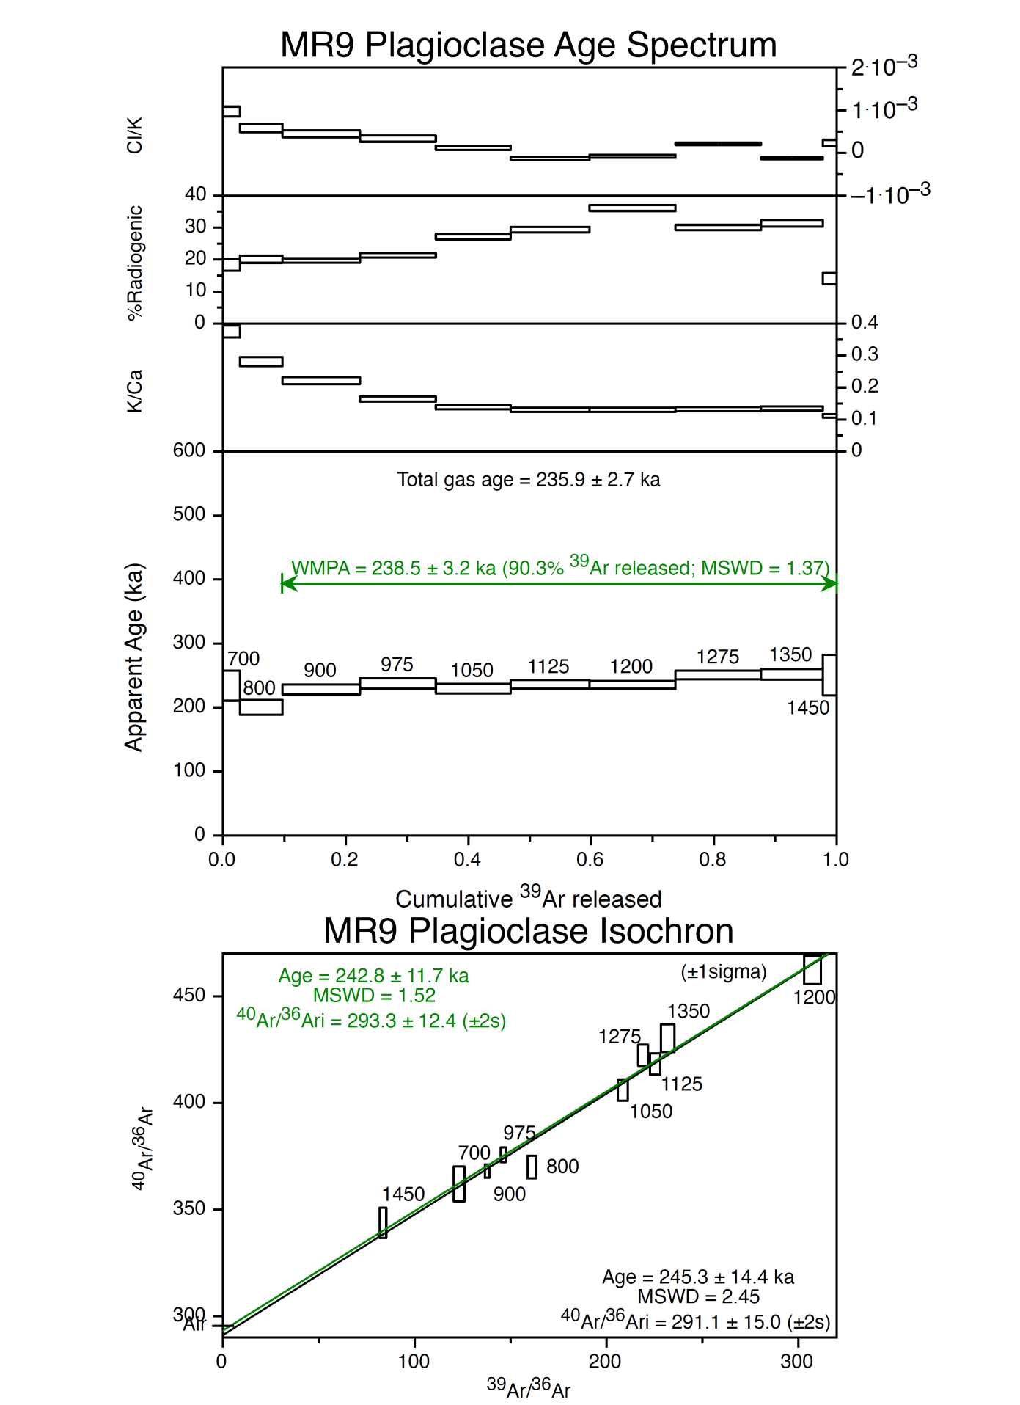
Figure DR3. Age-data for sample MR9: Mihi Breccia.
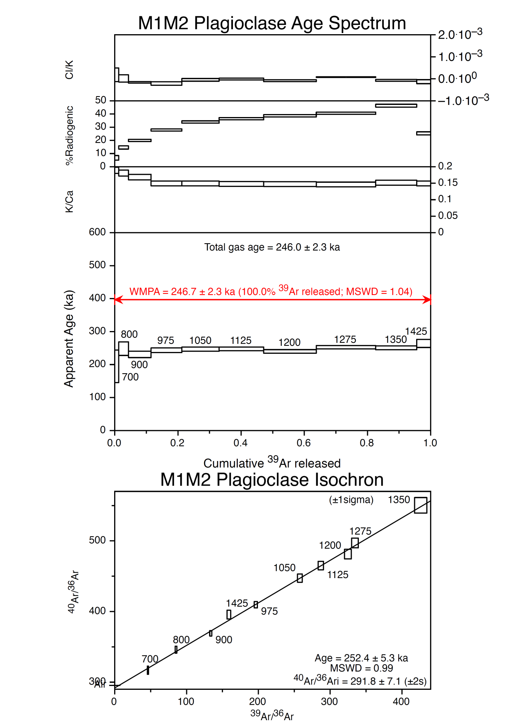
Figure DR4. Age-data for sample M1M2: Kairuru rhyolite lava.
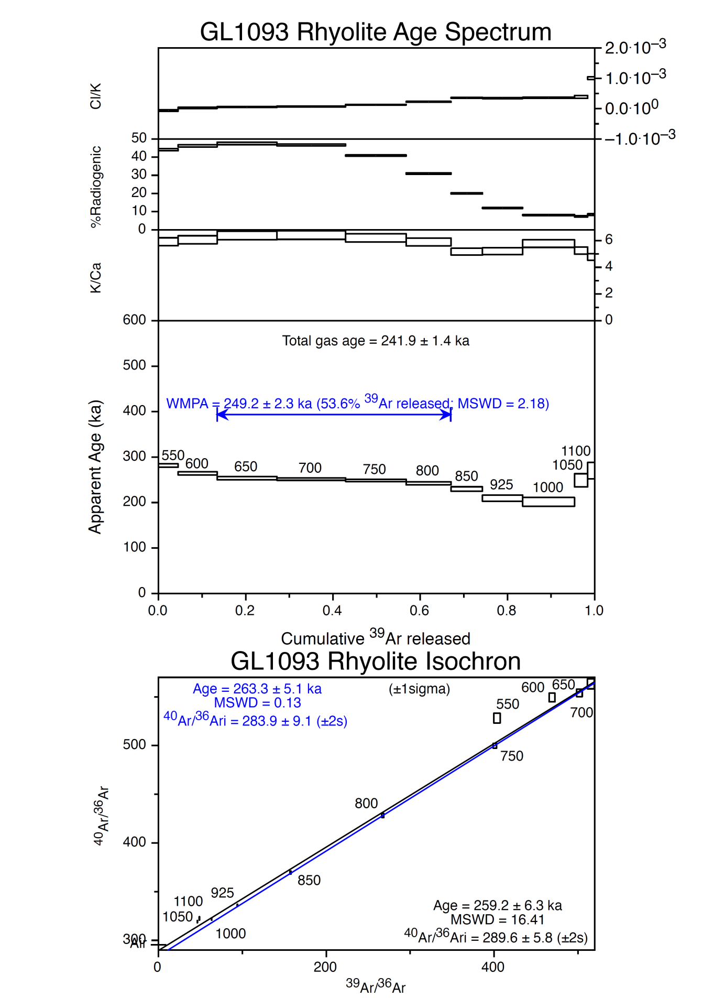
Figure DR5. Age-data for sample GL1093: Pukekahu rhyolite lava.
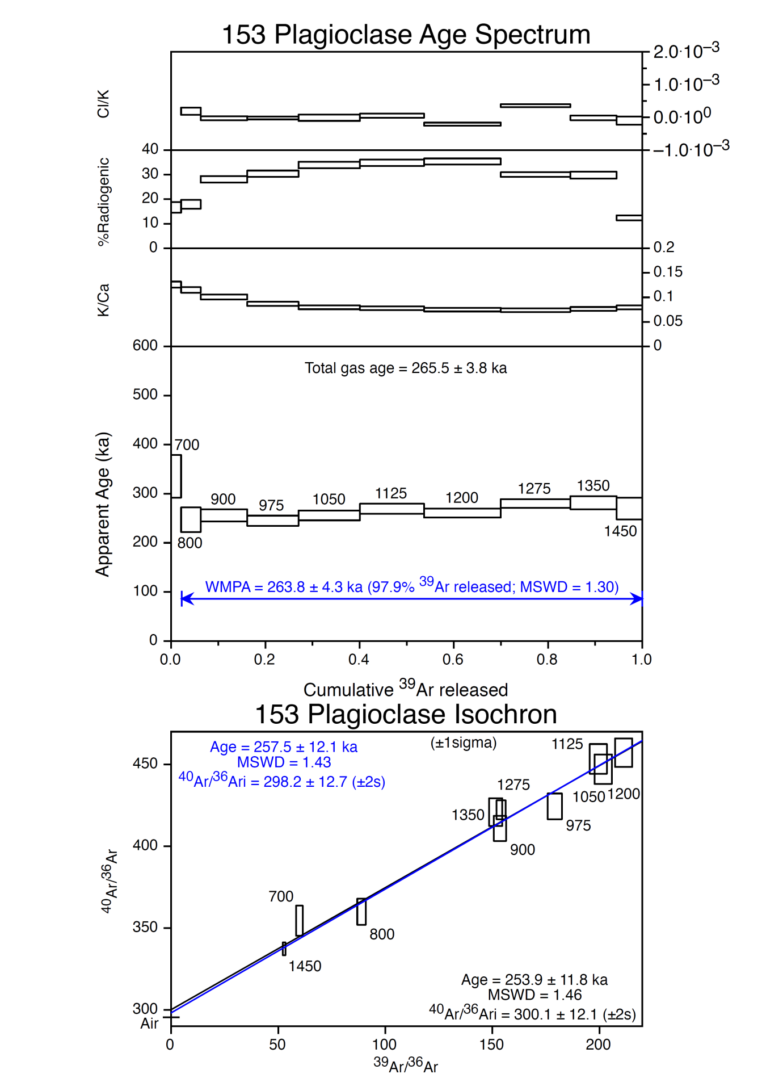
Figure DR6. Age-data for sample 153: Deer Hill rhyolite lava.
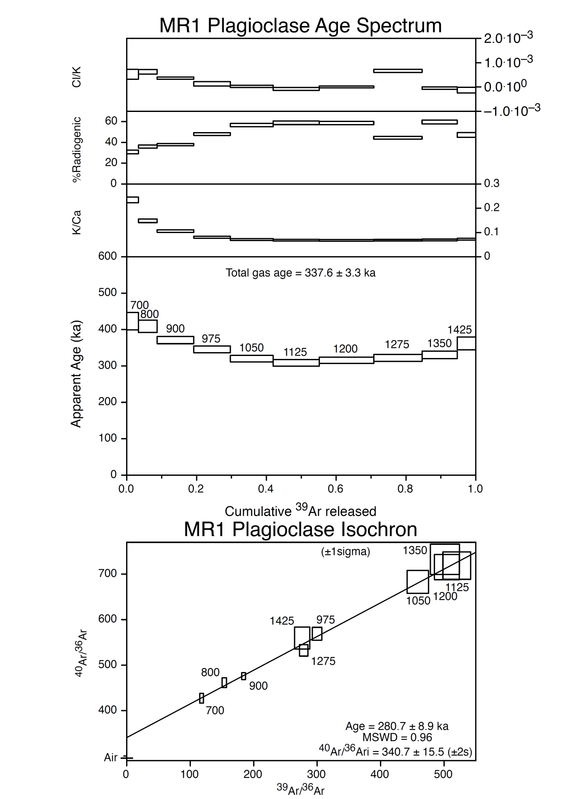
Figure DR7. Age-data for sample MR1: Mihi Breccia.
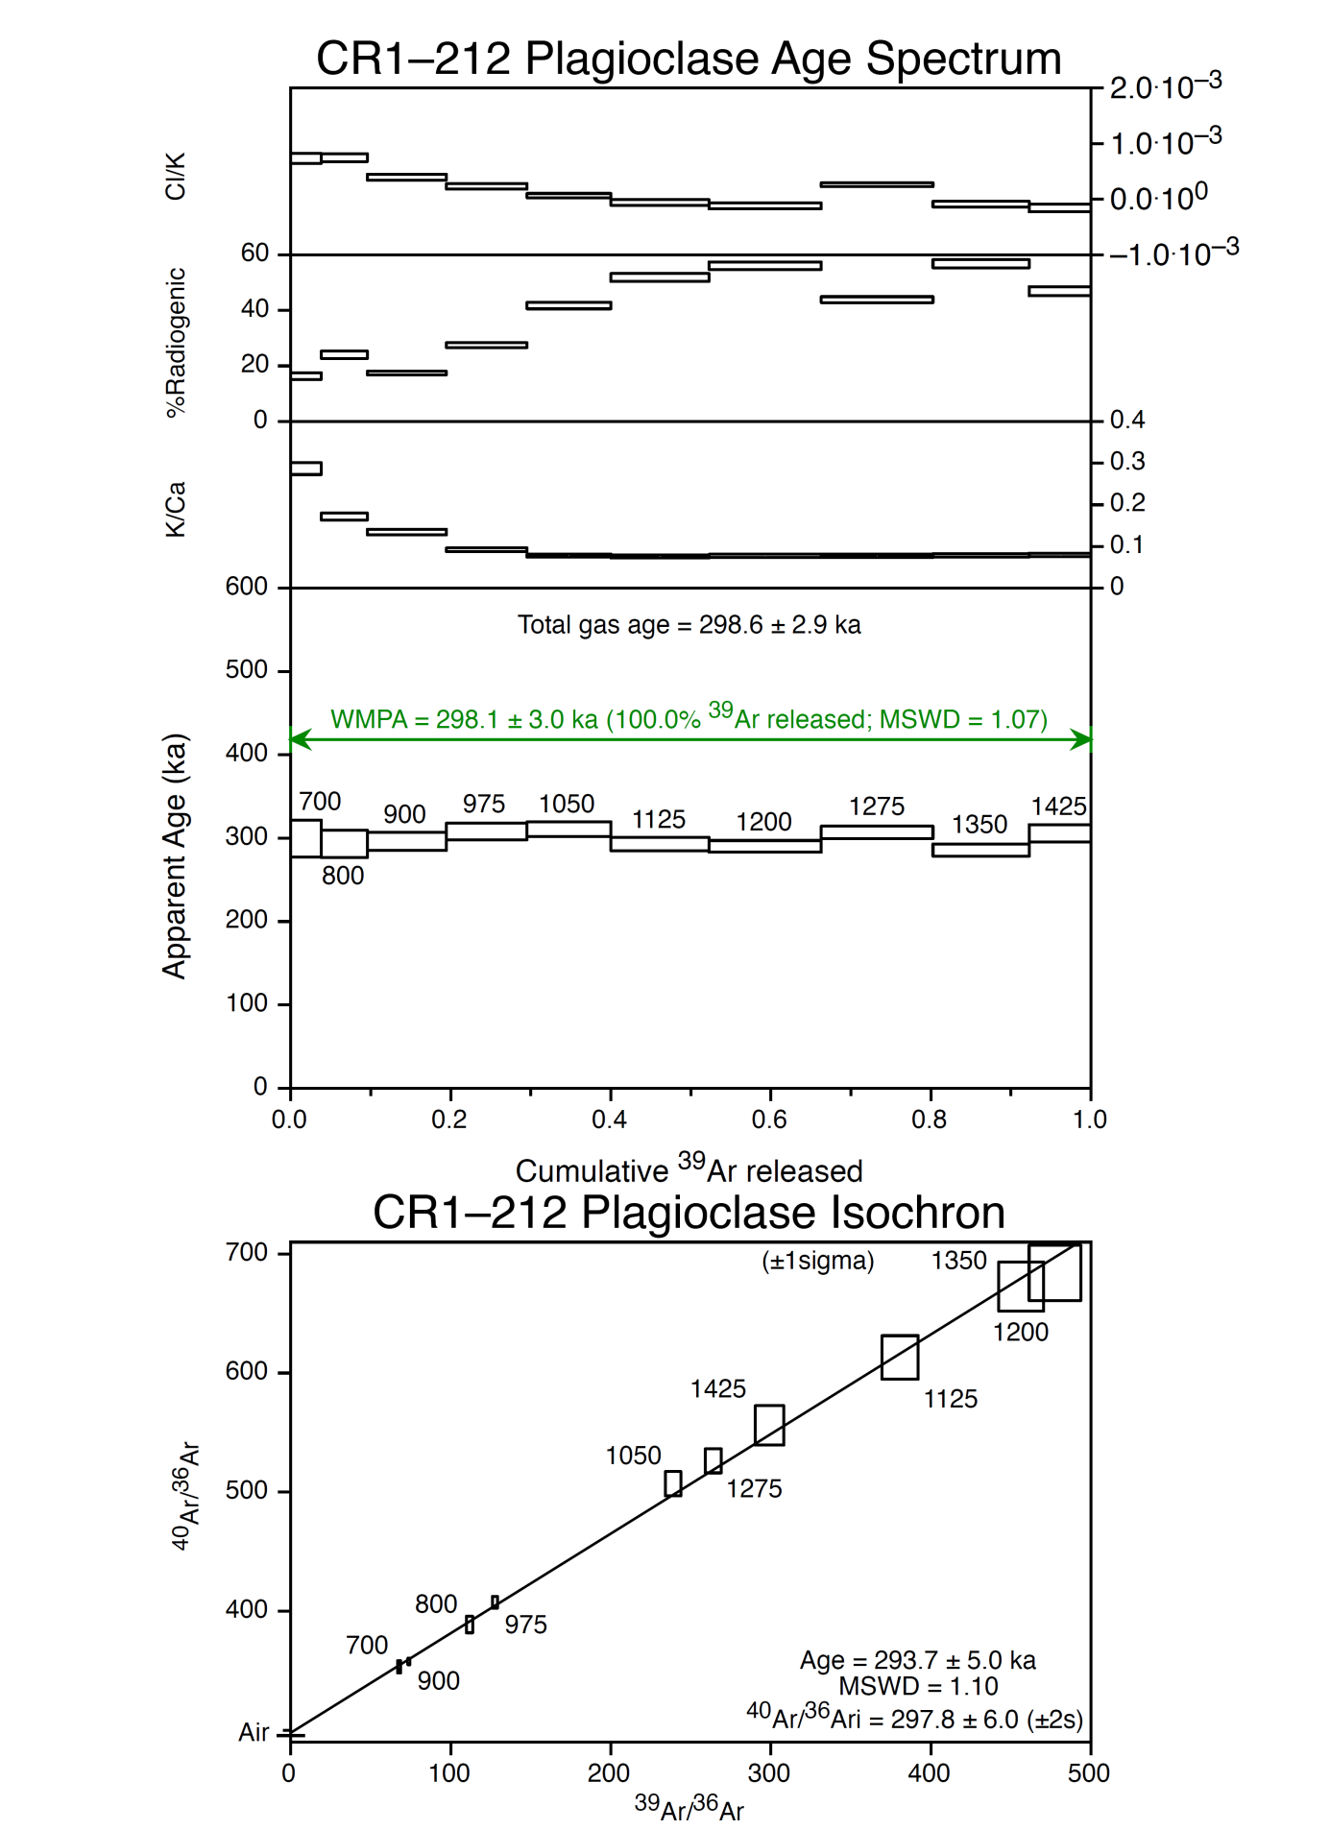
Figure DR8. Age-data for sample CR1: Kaingaroa Formation.
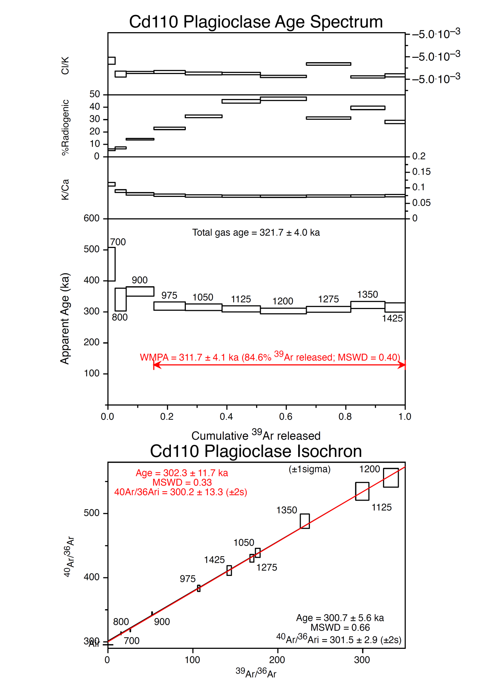
Figure DR9. Age-data for sample Cd110: lag breccia.
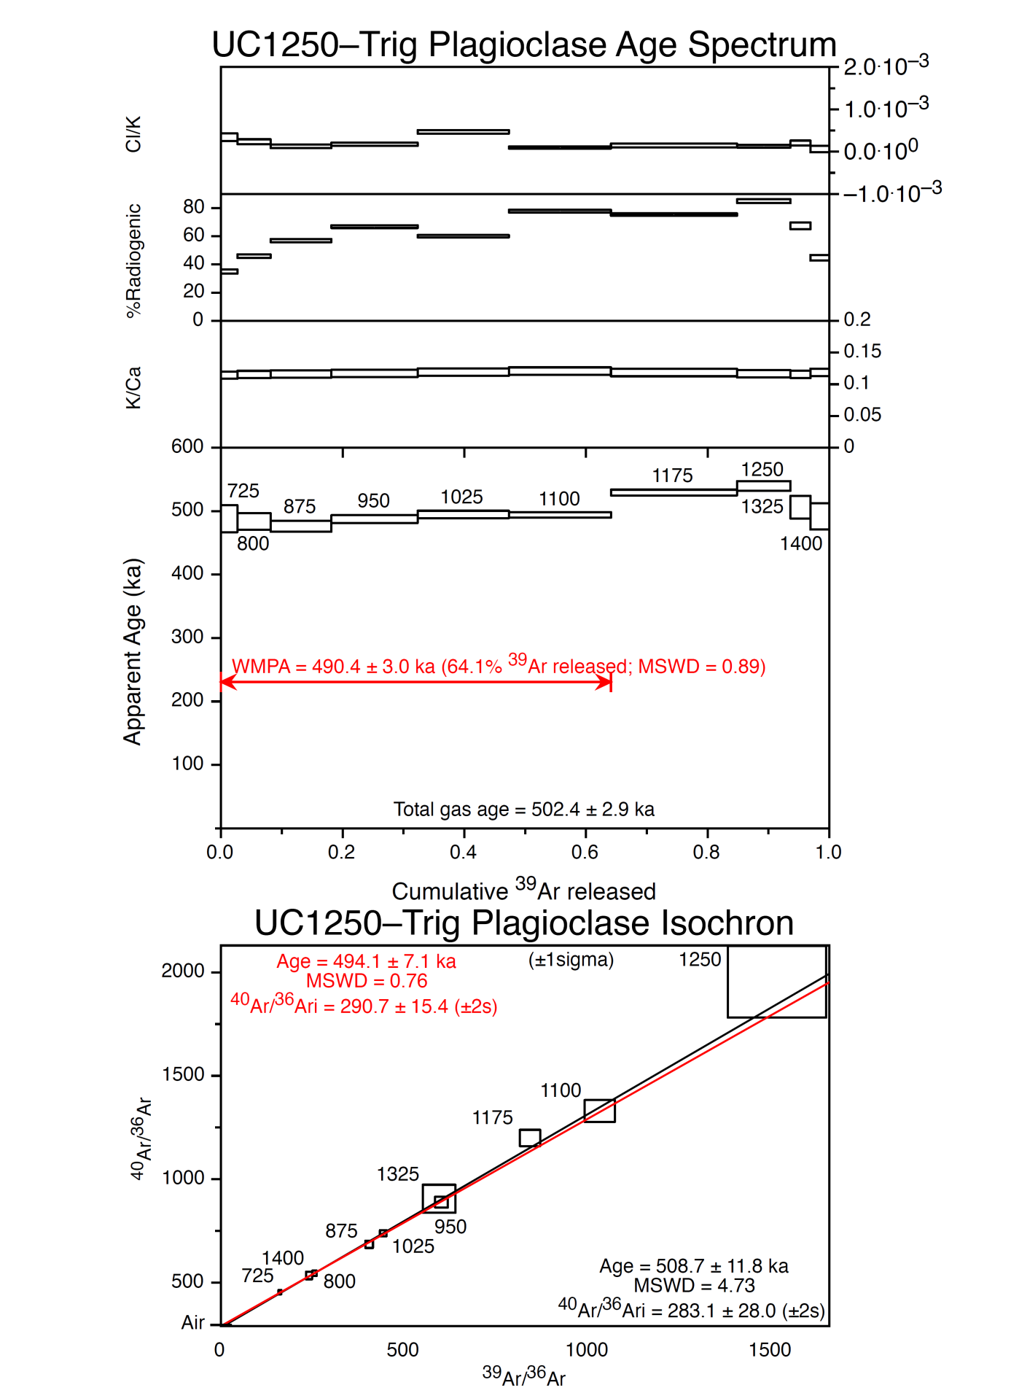
Figure DR10. Age-data for sample GL1089/UC1250: Trig 8566 rhyolite lava.
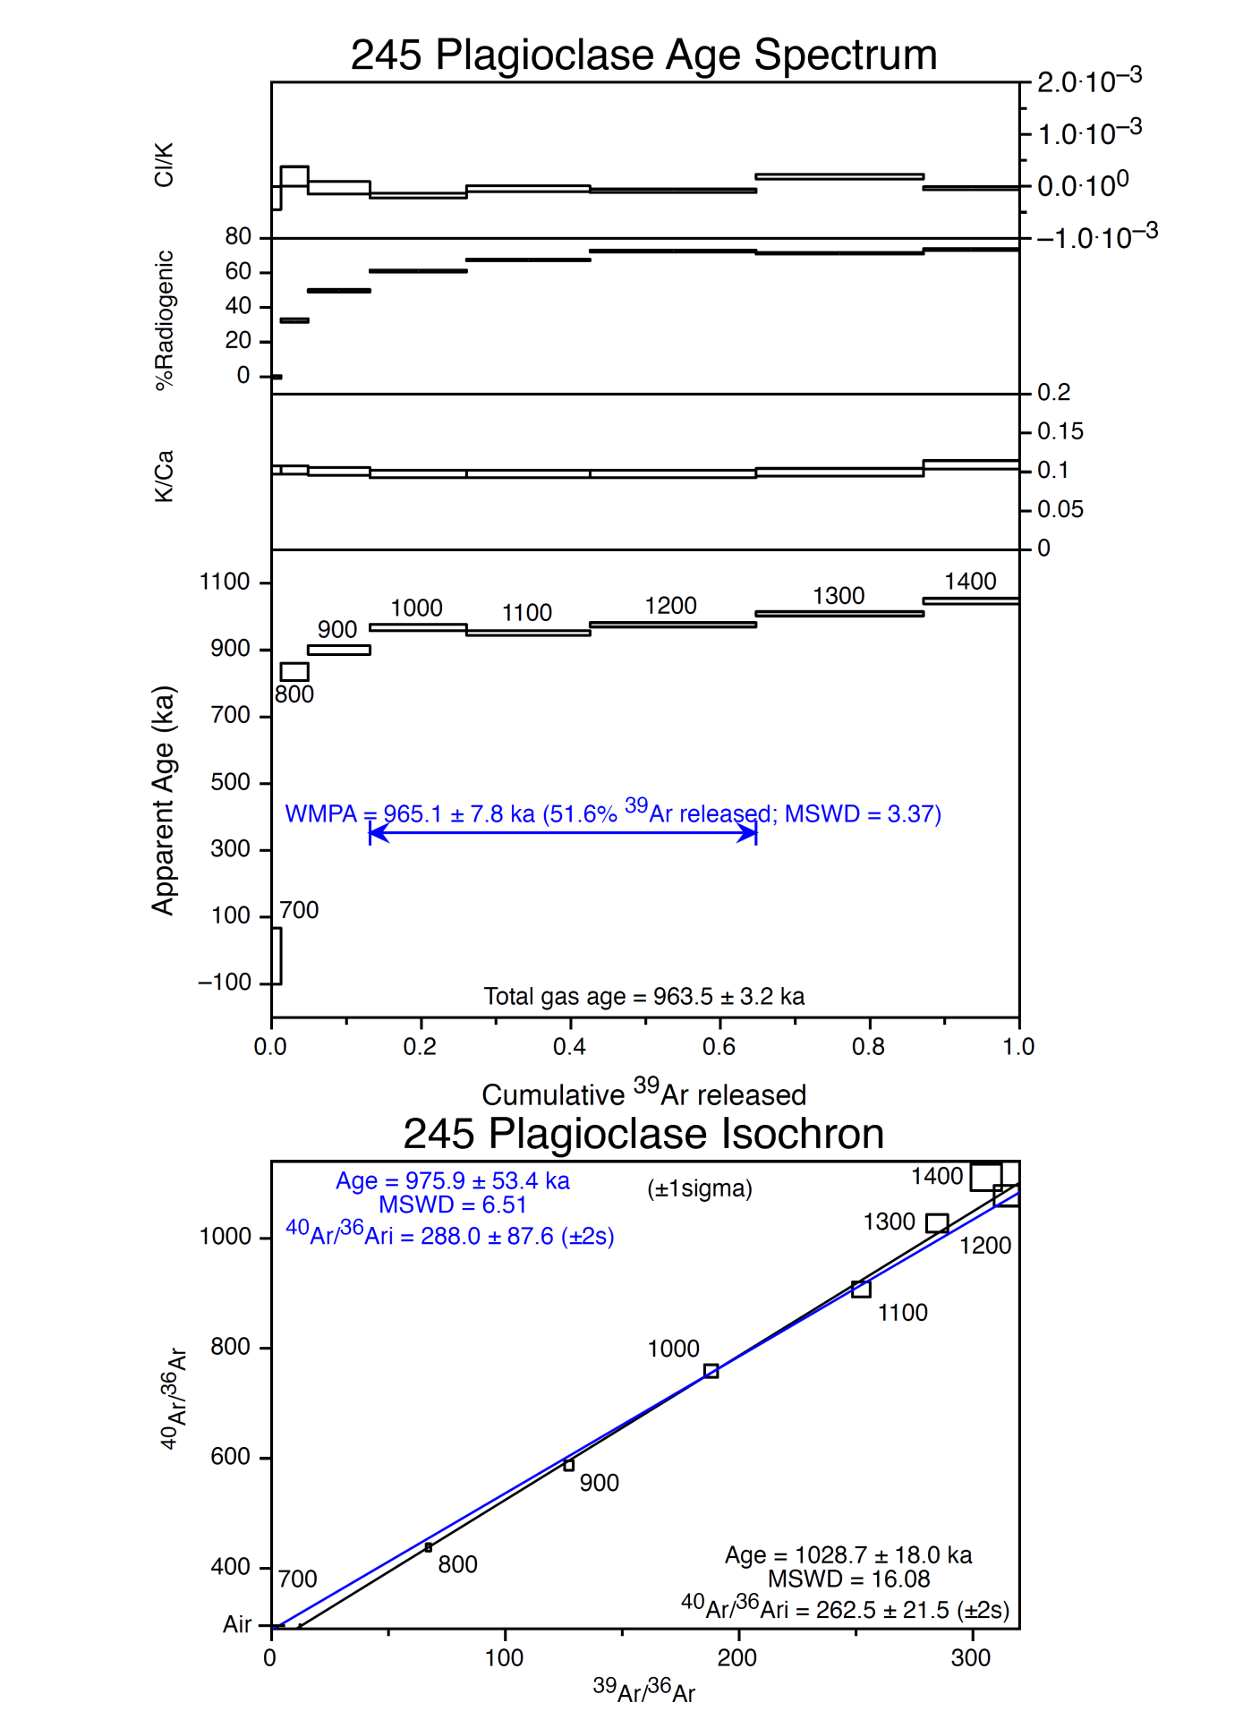
Figure DR11. Age-data for sample 245: Ngapouri rhyolite lava.

