Supplementary Materials: GEOCHRONOLOGY METHODS

The CA-TIMS method of zircon analysis works to remove domains within the zircon grain which have undergone Pb loss, yielding more accurate and less discordant age dates by dissolving metamict, high-U domains and non-metamict, low-U domains separately (Mattinson, 2005; Schoene et al., 2006). Zircons and titanites analyzed in this study were concentrated with conventional separation techniques at the University of Wyoming. Zircons were mechanically abraded to remove any possible metamorphic overgrowths, then annealed and dissolved in steps following the CA-TIMS method of Mattinson (2005). First, zircons were annealed for 48 hours at 850°C. Then samples were dissolved in concentrated HF and HNO₃ in two steps. The first step partially dissolved the grains at 180°C for 12 hours. The solute was discarded and the remaining solid material was rinsed and spiked with a mixed ²⁰⁵Pb-²³³U-²³⁵U tracer (ET535) prior to complete dissolution at 240°C for 30 hours. The tracer used was ET535, a mixed ²⁰⁵Pb-²³³U-²³⁵U spike produced and calibrated at MIT in 2006 as part of the EARTHTIME project. U and Pb were purified by ion exchange chemistry, and Pb and U samples were loaded onto single rhenium filaments with silica gel and graphite, respectively. Isotopic data were measured in multi-collector, static mode on a VG Sector 54 mass spectrometer at the University of Wyoming. Mass discrimination of 0.072 ± 0.04 %/amu for Pb was determined by replicate analyses of NIST SRM 981. Data reduction followed Ludwig (1980, 1988, 1991) and employed Excel-based software PbMacDat and Isoplot (Ludwig, 1991, 1998).
The Concordia coordinates from the data were corrected for initial Pb with the average Pb isotopic values from 9 galena analyses in the Langkilen deposit of the Helgeland Nappe complex (Birkeland et al., 1993). Calculations used 0.014% for tracer calibration error (Schoene et al., 2006 and University of Wyoming standard lab calibrations) and 0.11% ²³⁸U and 0.14% ²³⁵U for decay constant errors (Jaffey et al., 1971). Error propagation follows Ludwig (2000). Uncertainty is based solely on analytical errors and does not include either tracer calibration or U-decay constant errors. These sources of error would bias all analyzed data in the same magnitude and direction and thus, can be excluded for discussions of the relative dates of samples processed at the same lab.
Results
For sample AND-12, all of the data are concordant (Table 1; Figure A3). The weighted mean ²⁰⁶Pb/²³⁸U date of the five youngest analyses is 442.67±0.14 Ma (MSWD of 1.17). The ‘Concordia age’ (Ludwig 1998) for this sample is 442.85±0.40 Ma (MSWD of concordance of 1.3 (0.25 probability). This age includes decay-constant errors and incorporates both the ²⁰⁶Pb/²³⁸U and ²⁰⁷Pb/²³5U data. One analysis was excluded from the weighted mean calculation. This zircon analysis had a slightly older ²⁰⁶Pb/²³⁸U age, which could record inclusion of a slight amount of inherited zircon. Including this analysis produces the same date within error (²⁰⁶Pb/²³⁸U weighted mean date of 442.76±0.26 Ma) but increases the MSWD to 2.6 with a low probability of fit. A large single grain of dark titanite yielded a ²⁰⁶Pb/²³⁸U date of 441.30 ±0.21 Ma, 1 to 1.5 Ma later than the zircon date.
Analysis of 9 zircons was employed for sample NAY06-05. All of the data are concordant but have a range of ²⁰⁶Pb/²³⁸U dates from 444.82 to 441.29 Ma (Table 1; Figure A4). The best estimate for the zircon crystallization age of this sample comes from the weighted mean of the four youngest analyses, which is 441.53±0.40 Ma (MSWD of 0.46; Table 1; Fig. A4). Based upon the spread in ages, the other 5 zircons are interpreted to contain minor amounts of inheritance. The ‘Concordia age’ for this sample is 441.67 ±0.75 Ma (MSWD of concordance of 0.97; 0.33 probability), which was calculated by ISOPLOT v3 (Ludwig, 1991 and subsequent updates) following Ludwig (1998). This age includes decay-constant errors and incorporates both the ²⁰⁶Pb/²³⁸U and ²⁰⁷Pb/²³⁵U data.
Two single grain titanite analyses yield slightly younger ages than the zircon and have overlapping ²⁰⁷Pb/²⁰⁶Pb dates. The weighted mean ²⁰⁷Pb/²⁰⁶Pb titanite date is 436.1±2.8 Ma. Both of these analyses have reasonably high ²⁰⁶Pb/²⁰⁴Pb values, 224 and 436, respectively, so the dates are relatively insensitive to the choice of initial Pb isotopic compositions. Average Pb isotopic values from 9 galena analyses in the Langkilen deposit of the Helgeland Nappe complex (Birkeland et al., 1993) were used to correct the titanite data for initial Pb.

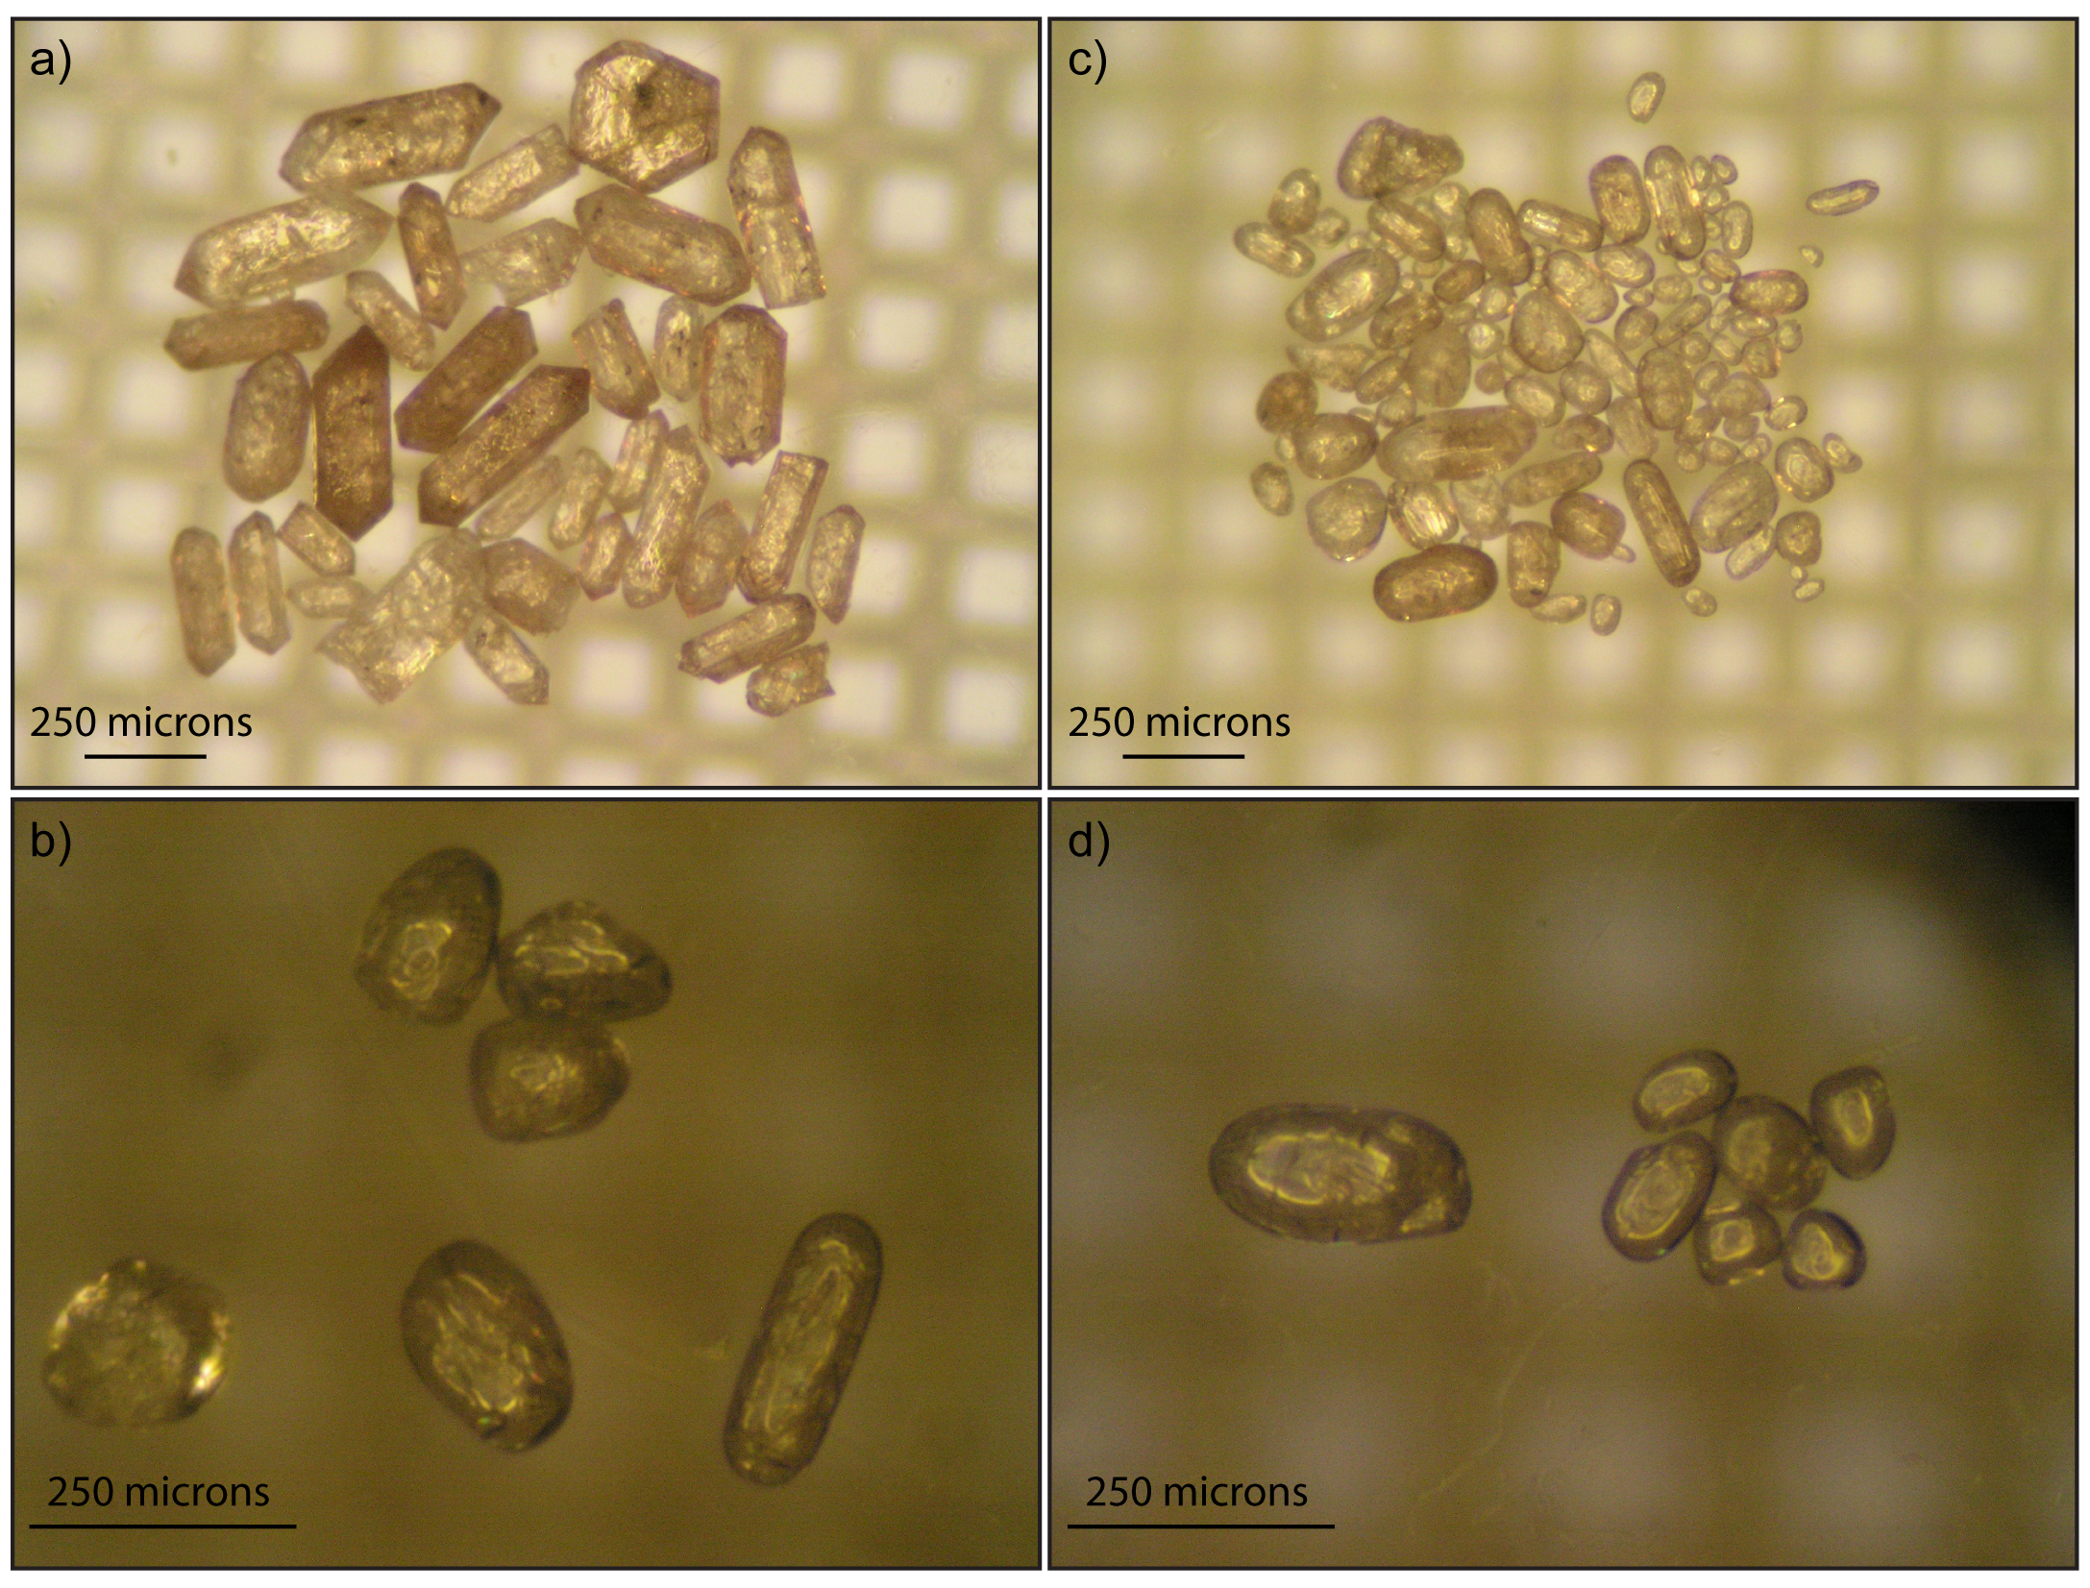
Figure A1. Zircon grain images for sample AND-12; a) Examples of typical zircon grains from sample AND-12; plain light. b) Single grains B, C, D (bottom, left to right) and 3-grain pick 2 (top cluster). c) Bulk grains after mechanical abrasion, prior to annealing. d) Single grain A selected for analysis and 6 small to medium sized grains dissolved as pick 1.

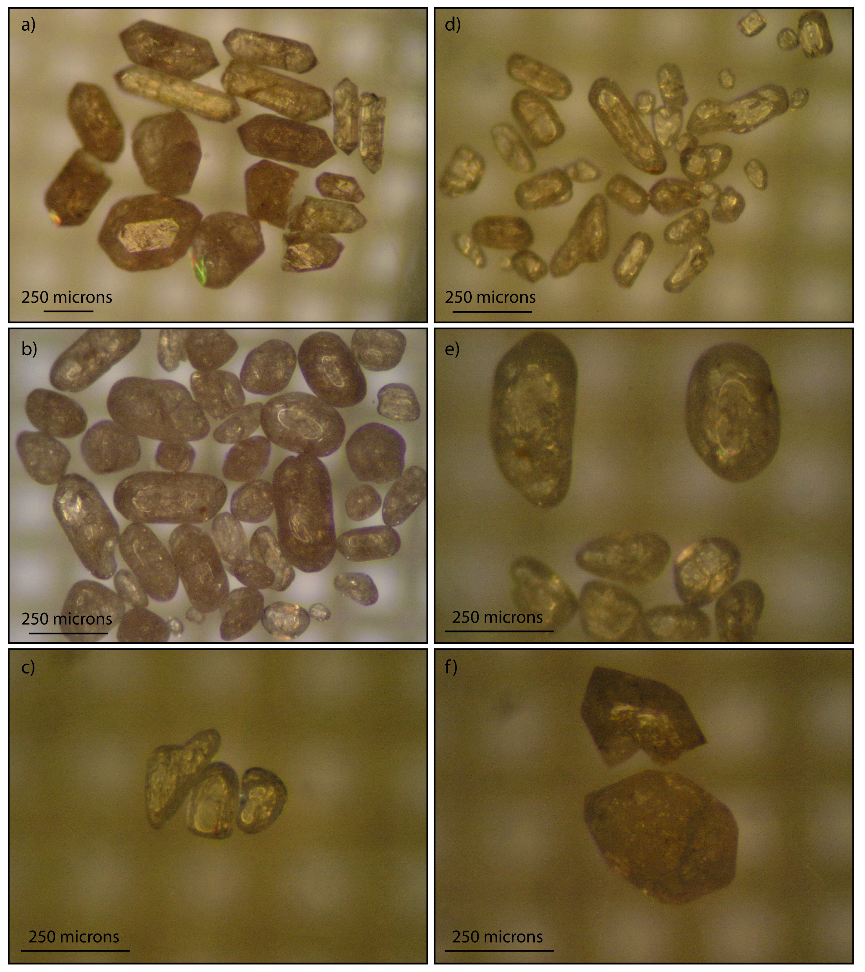
Figure A2. Zircon grain images for sample NAY06-05. a) Typical, extra-large zircon crystals with abundant cracks and internal defects. b) Bulk examples of extra large grains after mechanical abrasion. Internal cracks and defects are present. Single grains A, B, E, F, and G and pick 1 (ck aa xl pl 6gr) came from this subset. c) NAY06-05 pk2. Large, clear, mechanically-abraded zircons, analysis [cl aa lg p2 3 gr] in Table A.2. d) Large, relatively clear subset of zircon grains pictured after mechanically abrasion. Pick 2, (image c) came from this zircon fraction. e) Mechanically abraded single grains A and B along with a 6 grain pick 1 [cl aa xl pl 6 gr]. Each of these grains has abundant cracks and internal defects. f) Single grains C and D, which were analyzed without mechanical abrasion to test for possible metamorphic rims. ²⁰⁶Pb/²³⁸U dates from these grains overlap within error with data obtained from grains F and G (not pictured), which were mechanically abraded. The overlap of ²⁰⁶Pb/²³⁸U dates is interpreted to indicate that the existence of younger metamorphic rims on these zircon grains is unlikely.
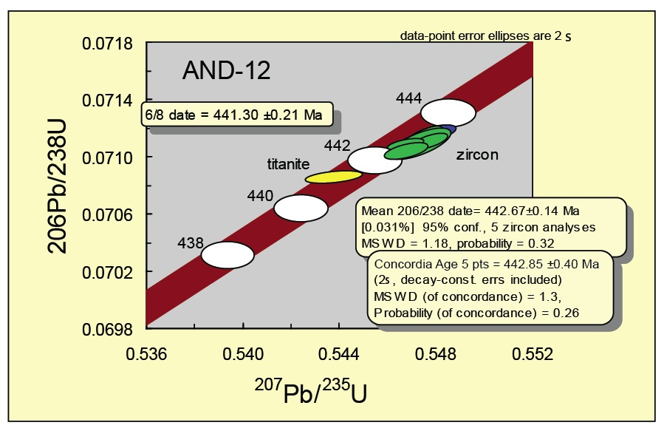
Figure A.3. Concordia plot for U-Pb CATIMS data for sample AND-12.
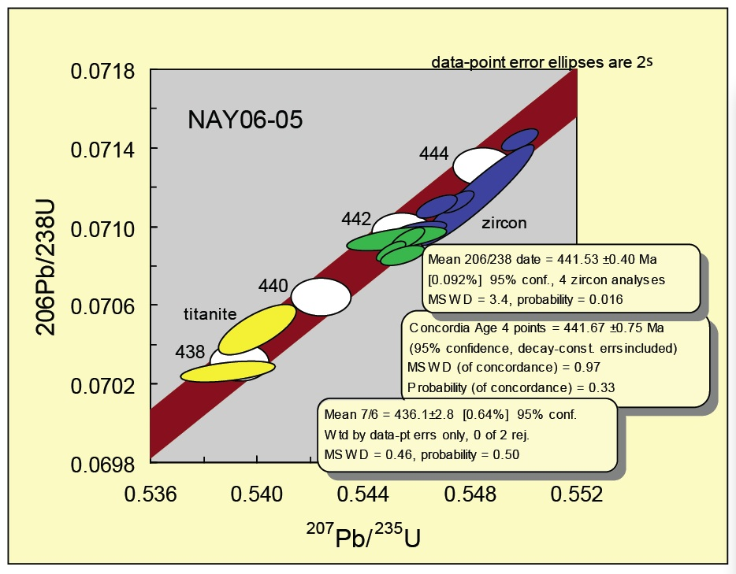Figure A.4. Concordia plot for U-Pb CATIMS data for sample NAY06-05.

References Cited
Birkeland, A., Nordgulen, O., Cumming, G.L., and Bjorlkke, A., 1993, Pb-Nd-Sr isotopic constraints on the origin of the Caledonian Bindal batholith, central Norway: Lithos, v. 29, p. 257-271.
Jaffey, A.H., Flynn, K.F., Glendenin, L.E., Bentley, W.C., and Essling, A.M. 1971, Precision measurements of half-lives and specific activities of ²³⁵U and ²³⁸U: Physical Review C, v. 4, p. 1889-1906.
Ludwig, K.R., 1980, Calculation of uncertainties of U-Pb isotope data: Earth and Planetary Science Letters, v. 46, p. 210-220.
Ludwig, K.R., l988, PBDAT for MS-DOS, a computer program for IBM-PC compatibles for processing raw Pb-U-Th isotope data, version 1.24: U.S. Geological Survey, Open-File Report 88-542.
Ludwig, K.R., l991, ISOPLOT for MS-DOS, a plotting and regression program for radiogenic-isotope data, for IBM-PC compatible computers, version 2.75: U.S. Geological Survey, Open-File Report 91-445.
Ludwig, K.R., 1998, On the treatment of concordant uranium-lead ages: Journal of The Geochemical Society and The Meteorological Society, v. 62, p. 665-676.
Ludwig, K.R., 2000, Decay constant errors in U-Pb Concordia-intercept ages: Journal of Chemical Geology, v. 166, p. 315-318.
Mattinson, J.M, 2005, Zircon U-Pb chemical abrasion (“CA-TIMS”) method: combined annealing and multi-step partial dissolution analysis for improved precision and accuracy of zircon ages: Chemical Geology, v. 220, p. 47-66.
Schoene, B., Crowley, J.L., Condon, D.J., Schmitz, M.D., and Bowring, S.A., 2006, Reassessing the uranium decay constants for geochronology using ID-TIMS U–Pb data. Geochimica et Cosmochimica Acta Volume 70, Issue 2, Pages 426-445.

