Morriss, M.C., Karlstrom, L., Nasholds, M., and Wolff, J., 2020, The Chief Joseph dike swarm of the Columbia River flood basalts, and the legacy data set of William H. Taubeneck: Geosphere, v. 16, <https://doi.org/10.1130/GES02173.1>.

**SUPPLEMENTAL FIGURES**



**Supplementary Figure S1**. Dike bearing, binned by host rock type. This plot shows the predominance of the NNW orientation and how these orientations are consistent across rock types.



**Supplementary Figure S2.** Dike segment length, broken out by host rock type. Dike segments hosted within granitoids dominate.



**Figure S3.** En echelon or stepped offsets of dike segments were measured across the CJDS. Offsets were classified as “left-stepping” and “right-stepping” as indicated by inset figures. The hypotheses tested by this figure is the presence of a gradient or rotation in the orientation of principal horizontal stresses, which could drive a systematic shift in en echelon segmentation of dikes (Pollard et al., 1982).



**Figure S4.** Base 10 logarithm of dike segment length, broken out by different swarms and subswarms (Plate 1). **A)** The Ice Harbor dikes. **B)** The Monument Dike Swarm dikes. **C)** The Steens dikes. **D)** Chief Joseph Dike Swarm dikes (note larger number than other swarms).

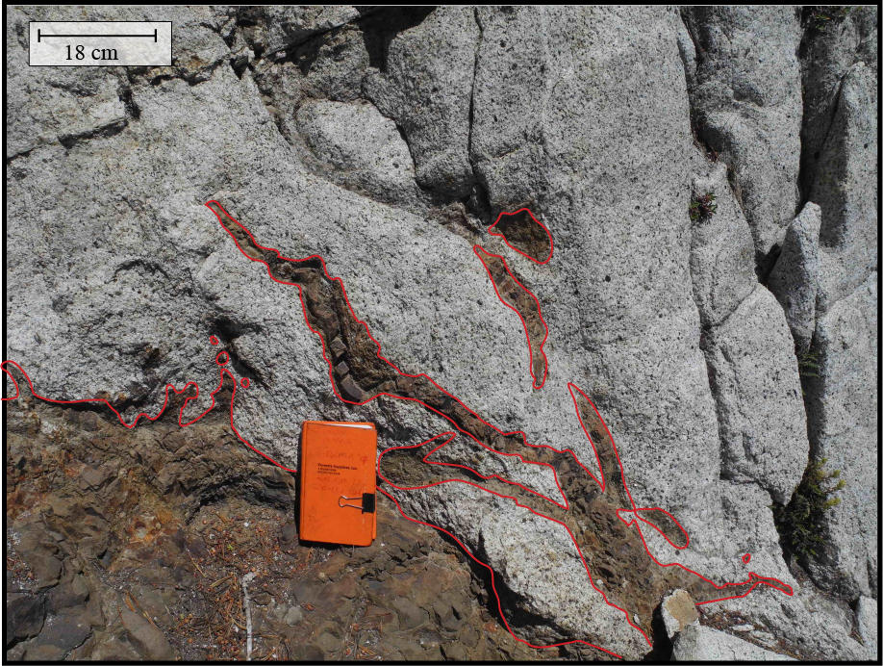

**Figure S5:** An example of flame-like structure in a host-rock (granitoid) within the CJDS. This type of host-rock-dike interaction was only seen once in the 2016 and 2017 field seasons. The approximate location of this outcrop: 45.040663° N, 117.252655° W. Red lines are drawn around dike margins to highlight the degree of fragmentation



**Figure S6:** Complete hypsometry of NE Oregon Dikes (**A**); Topography (**B**); and major rock types (**C-F**).



**Figure S7**: WHT journal derived data regarding dike width versus inclusion scale, grain size, and vesiculation. **A.** Dike width versus a relative inclusion density. This relative scale for inclusions is described in the primary text. No discernable trend is visible nor was there a relationship that provided statistically significant. **B.** Dike width versus relative grain size. The dike grainsize scale originated in the WHT journal entries. No trend is visually apparent nor statistically significant. **C.** Dike width versus a relative vesicularity scale. No relationship was directly discernable from this data.



**Figure S8:** Dike elevation versus inclusion scale, grain size, and vesicularity. All of these data are taken directly from the WHT journal collection. **A.** Dike elevation in meters versus a relative scale of inclusion density. While there is a left-skewed distribution, no statistically significant relationship could be discerned. **B.** Dike elevation versus dike grain size. There is no visually discernable relationship between these two variables, nor is there a statistically significant relationship. **C.** Dike elevation versus vesicularity. Here again, there is no discernable trend. Elevation can in certain areas of the CJDS be related to paleo-depth, so the lack of a greater vesicularity trend may have implications for degassing.

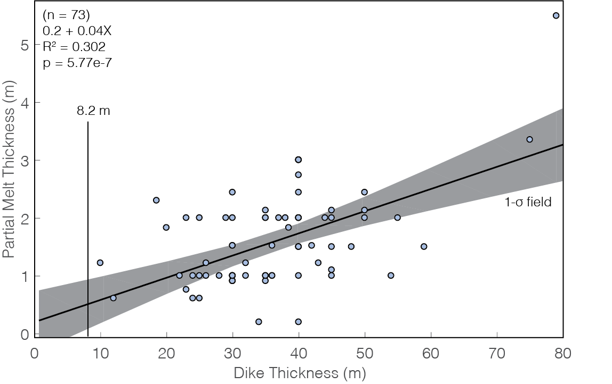

**Figure S9.** Relationship between dike width and thickness of partial melt of host rock from WHT notebooks. Note that all of these dikes with partial melt are significantly thicker than the median dike width. This may imply that these dikes experienced multiple magma injections. The R2 of ~0.3 indicates that 30% of the scatter in the plot above is explained well by the linear model above. The p-value for this model is 5.7 *x* 10-7, indicating we can robustly say there is a positive relationship between dike thickness and the width of the partial melt zone.

**References:**

Pollard, D.D., Segall, P., and Delaney, P.T., 1982, Formation and interpretation of dilatant echelon cracks.: Geological Society of America Bulletin, v. 93, p. 1291–1303, doi: 10.1130/0016-7606(1982)93<1291:FAIODE>2.0.CO.